console_privilage_telnet_şifreleme

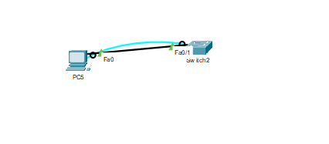

Console Password Koyma;

Switch(config) # line console 0

Switch(config-line ) # password 123

Switch(config-line) # login

Enable Mod’a password Koymak;

Switch(config) # enable password 123

Switch(config) # enable secret 321

Switch(config) # service password-encryption

TELNET Şifreleme

Switch(config) # line vty 0 15

Switch(config-line) # password 123

Switch(config-line) # login

Tarih-saat_Banner_Description

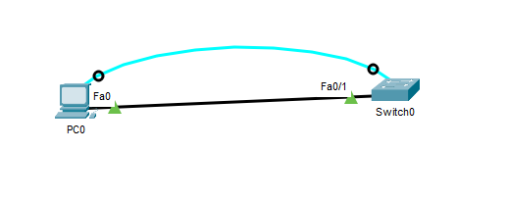

Tarih-Saat

Switch(config) # service timestamps log datetime msec

Switch(config) # clock set 15:00:00 24 March 2020

Banner MOD

Switch(config) # banner motd #

Ilyas Mertcan Cegil

Sadece Yetkili Kisiler #

Description

Switch(config) # int range fa0/1-20

Switch(config-if) # description Ilyas Mertcan Cegil Misafir Network

SVI-Telnet-ile-uzaktan-bağlantı

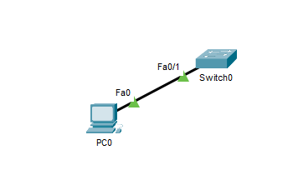

Switch(config) # enable secret 123

Switch(config) # line vty 0 4

Switch(config-line) # password 123

Switch(config-line) # login

Switch(config) # int vlan 1

Switch(config-if) # ip address 192.168.1.254

Switch(config) # ping 192.168.1.100 (PC IP addresi)

TFTP_Kaydetme

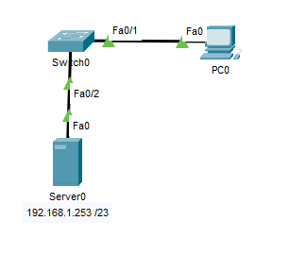

Switch üzerinde değişiklik yapıldıktan sonra

Switch(config) # copy running-config tftp:

Address or name of remote host []? 192.168.1.253

Destination filename [Switch-confg] ? Ilyas_Mertcan_Yedek

TFTP den switch’e geri alma

Switch(config) # copy tftp: running-config

Address or name of remote host []? 192.168.1.253

Destination filename [Switch-confg] ? Ilyas_Mertcan_Yedek

VLAN,trunk,native vlan,CDP

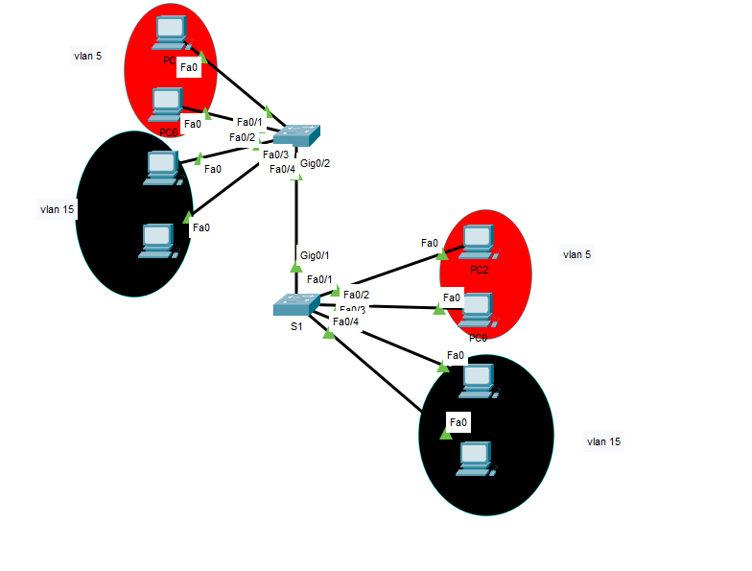

SW1 İÇİN

S1(config) # vlan 5

S1(config-vlan) # name ACADEMIC

S1(config) # vlan 15

S1(config-vlan) # name STUDENT

S1(config) # vlan 99

S1(config-vlan) # name MANAGEMENT

Switch(config) # int range fa0/1-2

Switch(config-if) # switchport mode access

Switch(config-if) # switchport Access vlan 5

Switch(config) # int range fa0/3-4

Switch(config-if) # switchport mode Access

Switch(config-if) # switchport Access vlan 15

Switch(config) # int gig0/1

Switch(config-if) # switchport mode trunk

Switch(config-if) # switchport trunk native vlan 199

Switch(config) # int range fa0/1-4

Switch(config-range-if) # no cdp enable

Switch(config) # no cdp run

SW2 için

S1(config) # vlan 5

S1(config-vlan) # name ACADEMIC

S1(config) # vlan 15

S1(config-vlan) # name STUDENT

S1(config) # vlan 99

S1(config-vlan) # name MANAGEMENT

Switch(config) # int range fa0/1-2

Switch(config-if) # switchport mode access

Switch(config-if) # switchport Access vlan 5

Switch(config) # int range fa0/3-4

Switch(config-if) # switchport mode Access

Switch(config-if) # switchport Access vlan 15

Switch(config) # int gig0/2

Switch(config-if) # switchport mode trunk

Switch(config-if) # switchport trunk native vlan 199

Switch(config) # int range fa0/1-4

Switch(config-range-if) # no cdp enable

Switch(config) # no cdp run

STP(ROOT_BRİDGE, BLOKLU_SWİTCH_ARAYÜZÜ)

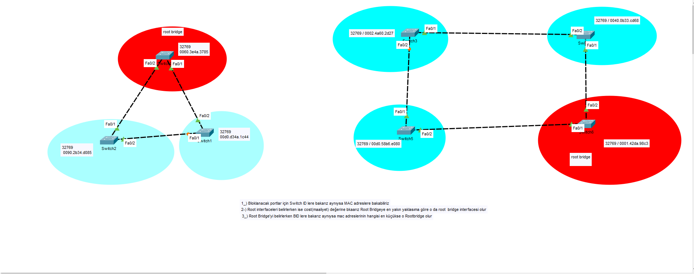

Her bir Switch için

SWTİCHLER(Config) # Show interface vlan 1 (olarak mac adreslere bakılır)

SWTİCHLER(Config) # Show spanning-tree (Yazılarak SWİTCH ID lere bakılır)

inter-VLAN_ROUTİNG,_ROAS

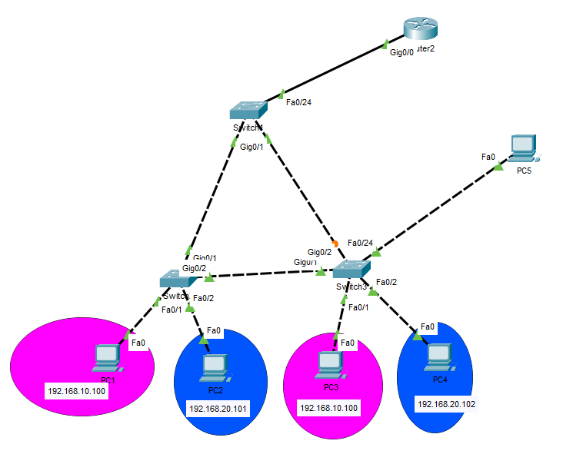

SWİTCH1 için

Switch(config) # vlan 10

Switch(config-vlan) # name YBS

Switch(config) # vlan 19

Switch(config-vlan) # name YONETICI

Switch(config) # vlan 20

Switch(config-vlan) # name GASTRONOMI

Switch(config) # vlan 999

Switch(config-vlan) # name BOS

Switch(config)# int fa0/1

Switch(config-if)# switchport mode Access

Switch(config-if)# switchport Access vlan 10

Switch(config) # int range gig0/1-2

Switch(config) # switchport mode trunk

SWİTCH2 için

Switch(config) # vlan 10

Switch(config-vlan) # name YBS

Switch(config) # vlan 19

Switch(config-vlan) # name YONETICI

Switch(config) # vlan 20

Switch(config-vlan) # name GASTRONOMI

Switch(config) # vlan 999

Switch(config-vlan) # name BOS

Switch(config)# int fa0/1

Switch(config)# int fa0/1

Switch(config-if)# switchport mode Access

Switch(config-if)# switchport Access vlan 10

Switch(config) # int range gig0/1-2

Switch(config) # switchport mode trunk

SWTİCH3 için

Switch(config) # vlan 10

Switch(config-vlan) # name YBS

Switch(config) # vlan 19

Switch(config-vlan) # name YONETICI

Switch(config) # vlan 20

Switch(config-vlan) # name GASTRONOMI

Switch(config) # vlan 999

Switch(config-vlan) # name BOS

ROUTER içi;

Router(config)# int gig0/0

Router(config-if)# no shutdown

Router(config-if)# exit

Router(config)# int gig0/0.10

Router(config-if)# encapsulation dot1Q 10

Router(config-if)# ip add 192.169.10.1 255.255.255.0

Router(config)# int gig0/0.10

Router(config-if)# encapsulation dot1Q 20

Router(config-if)# ip add 192.169.20.1 255.255.255.0

Static_Route-Administrative_Distance-Floating_static

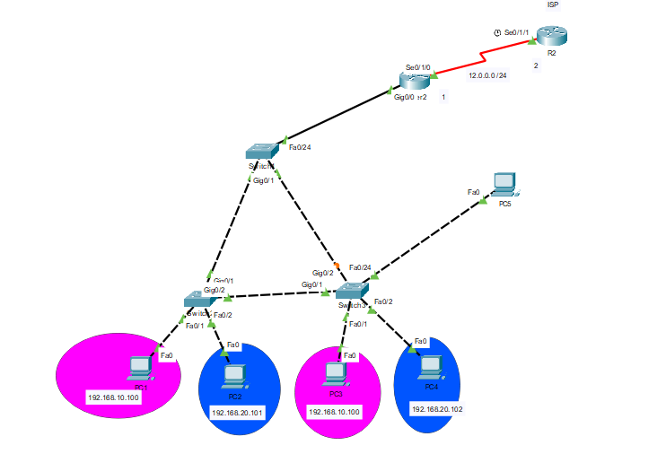

SWİTCH1 için

Switch(config) # vlan 10

Switch(config-vlan) # name YBS

Switch(config) # vlan 19

Switch(config-vlan) # name YONETICI

Switch(config) # vlan 20

Switch(config-vlan) # name GASTRONOMI

Switch(config) # vlan 999

Switch(config-vlan) # name BOS

Switch(config)# int fa0/1

Switch(config-if)# switchport mode Access

Switch(config-if)# switchport Access vlan 10

Switch(config) # int range gig0/1-2

Switch(config) # switchport mode trunk

SWİTCH2 için

Switch(config) # vlan 10

Switch(config-vlan) # name YBS

Switch(config) # vlan 19

Switch(config-vlan) # name YONETICI

Switch(config) # vlan 20

Switch(config-vlan) # name GASTRONOMI

Switch(config) # vlan 999

Switch(config-vlan) # name BOS

Switch(config)# int fa0/1

Switch(config)# int fa0/1

Switch(config-if)# switchport mode Access

Switch(config-if)# switchport Access vlan 10

Switch(config) # int range gig0/1-2

Switch(config) # switchport mode trunk

SWTİCH3 için

Switch(config) # vlan 10

Switch(config-vlan) # name YBS

Switch(config) # vlan 19

Switch(config-vlan) # name YONETICI

Switch(config) # vlan 20

Switch(config-vlan) # name GASTRONOMI

Switch(config) # vlan 999

Switch(config-vlan) # name BOS

ROUTER1 için;

Router(config)# int gig0/0

Router(config-if)# no shutdown

Router(config-if)# exit

Router(config)# int gig0/0.10

Router(config-if)# encapsulation dot1Q 10

Router(config-if)# ip add 192.169.10.1 255.255.255.0

Router(config)# int gig0/0.10

Router(config-if)# encapsulation dot1Q 20

Router(config-if)# ip add 192.169.20.1 255.255.255.0

Router(config)# int s0/1/0

Router(config-if)# ip add 12.0.0.1 255.255.255.0

Router(config-if)# no shutdown

Router(config-if)# exit

ROUTER2 için;

Router(config)# int s0/1/1

Router(config-if)# ip add 12.0.0.1 255.255.255.0

Router(config-if)# no shutdown

Router(config-if)# exit

Router(config)# ip route 192.168.10.0 255.255.255.0 s0/1/1

Router(config)# ip route 192.168.20.0 255.255.255.0 s0/1/1

Default_Route

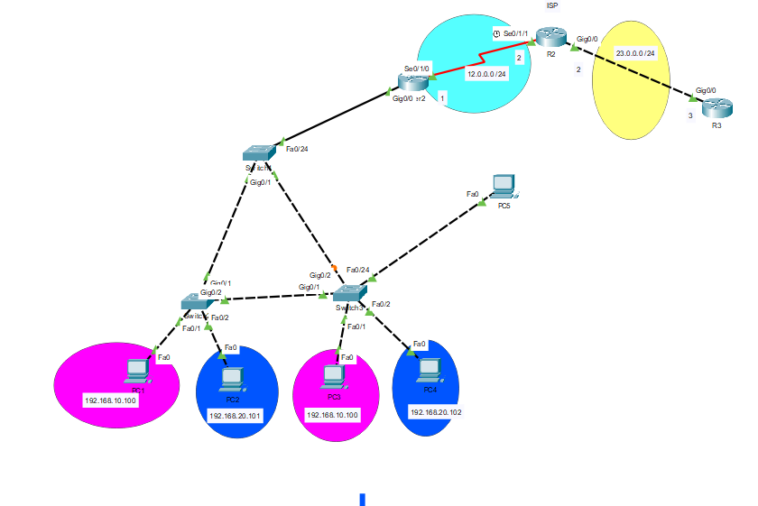

Switch configurasyonu aynı

R1 Default Routing Configurasyonu için

R1(config)# ip route 0.0.0.0 0.0.0.0 12.0.0.2

R2 static uygulanmalıdır ISP olduğundan dolayı;

R2(config)# ip route 192.168.10.0 255.255.255.0 12.0.0.1

R2(config)# ip route 192.168.20.0 255.255.255.0 12.0.0.1

R3 Default Routing Configurasyonu için

R3(config)# ip config 0.0.0.0 0.0.0.0 23.0.0.2

LOOPBACK_INTERFACE

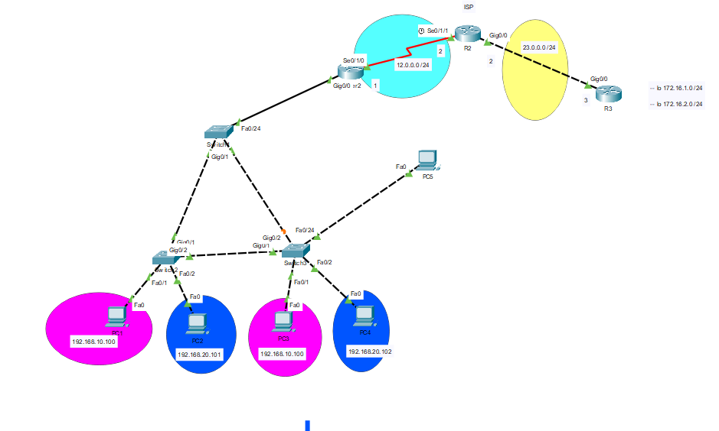

Yukarıdaki çalışmaya ellemeyip onun üzerinden yapılandırma

R3 için;

R3(config)# interface loopback 1

R3(config-if)# ip address 172.16.1.1 255.255.255.0

R3(config)# interface loopback 2

R3(config-if)# ip address 172.16.2.1 255.255.255.0

R2 için;

R2(config)# ip route 172.16.1.0 255.255.255.0 23.0.0.3

R2(config)# ip route 172.16.2.0 255.255.255.0 23.0.0.3

SWICH_GATEWAY_ATAMA

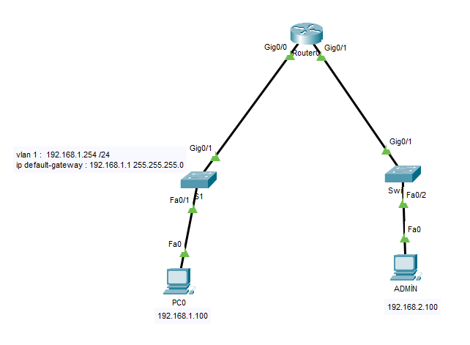

Switch1 için;

Swtich(config)# int vlan 1

Switch(config-if)# ip address 192.168.1.254 255.255.255.0

Switch(config)# ip default-gateway 192.168.1.1 255.255.255.0

Router için;

Router(config)# int gig0/1

Router(config-if)# ip address 192.168.2.1 255.255.255.0

Router(config-if)# no shutdown

Router(config)# int gig0/0

Router(config-if)# ip address 192.168.1.1 255.255.255.0

Router(config-if)# no shutdown

FLSM

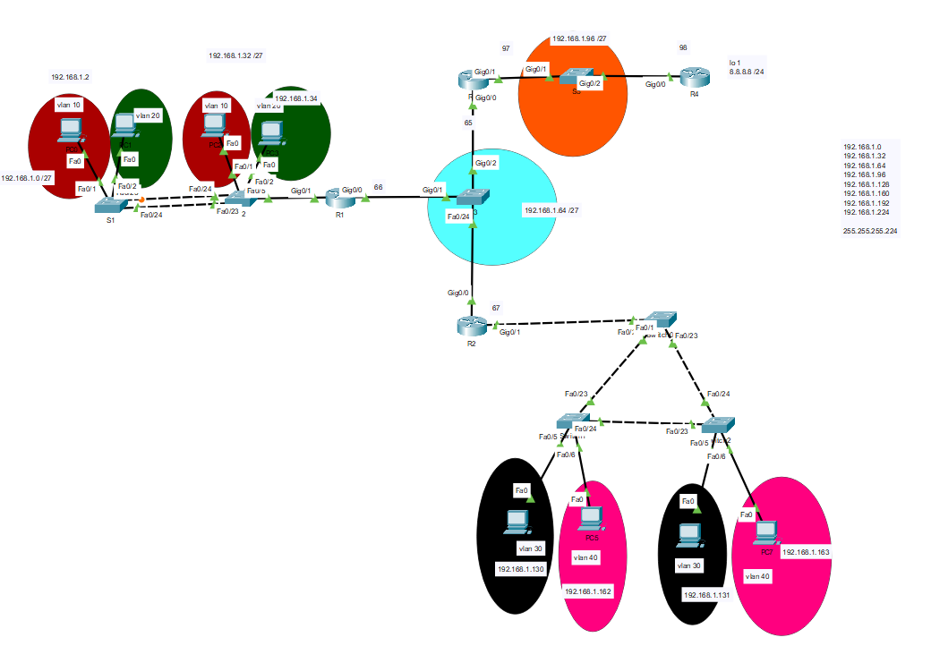

S1 için;

Switch(config)# vlan 10

Switch(config-vlan)# name ON

Switch(config-vlan)# exit

Switch(config)# vlan 20

Switch(config-vlan)# name YIRMI

Switch(config-vlan)# exit

Switch(config)# int fa0/1

Switch(config-if)# sw

Switch(config-if)# switchport mo acc

Switch(config-if)# sw ac vlan 10

Switch(config-if)# exit

Switch(config)# int fa0/2

Switch(config-if)# sw mo acc

Switch(config-if)# sw acc vlan 20

Switch(config-if)# int range fa0/23-24

Switch(config-if-range)# sw mo trunk

S2 için;

Switch(config)# vlan 10

Switch(config-vlan)# name ON

Switch(config-vlan)# exit

Switch(config)# vlan 20

Switch(config-vlan)# name YIRMI

Switch(config-vlan)# exit

Switch(config)# int fa0/1

Switch(config-if)# sw

Switch(config-if)# switchport mo acc

Switch(config-if)# sw ac vlan 10

Switch(config-if)# exit

Switch(config)# int fa0/2

Switch(config-if)# sw mo acc

Switch(config-if)# sw acc vlan 20

Switch(config-if)# int range fa0/23-24

Switch(config-if-range)# sw mo trunk

S6 için;

Switch(config)# vlan 30

Switch(config-vlan)# name OTUZ

Switch(config-vlan)# exit

Switch(config)# vlan 40

Switch(config-vlan)# name KIRK

Switch(config-vlan)# exit

Switch(config)# int fa0/5

Switch(config-if)# sw

Switch(config-if)# switchport mo acc

Switch(config-if)#s w ac vlan 30

Switch(config-if)# exit

Switch(config)# int fa0/6

Switch(config-if)# sw mo acc

Switch(config-if)# sw acc vlan 40

Switch(config-if)# int range fa0/23-24

Switch(config-if-range)# sw mo trunk

S7 için;

Switch(config)# vlan 30

Switch(config-vlan)# name OTUZ

Switch(config-vlan)# exit

Switch(config)# vlan 40

Switch(config-vlan)# name KIRK

Switch(config-vlan)# exit

Switch(config)# int fa0/5

Switch(config-if)# sw

Switch(config-if)# switchport mo acc

Switch(config-if)#s w ac vlan 30

Switch(config-if)# exit

Switch(config)# int fa0/6

Switch(config-if)# sw mo acc

Switch(config-if)# sw acc vlan 40

Switch(config-if)# int range fa0/23-24

Switch(config-if-range)# sw mo trunk

S4 için;

Switch(config)# int fa0/1

Switch(config-if)# switch mod trunk

R1 için;

Router(config)# int gig0/1

Router(config-if)# no sh

Router(config-if)# exit

Router(config)# int gig0/1.10

Router(config-subif)# encap dot 10

Router(config-subif)# ip add 192.168.1.1 255.255.255.224

Router(config-subif)# int gig0/1.20

Router(config-subif)# encap dot 20

Router(config-subif)# ip add 192.168.1.33 255.255.255.224

Router(config-subif)# exit

Router(config)#int gig0/0

Router(config-if)# ip add 192.168.1.66 255.255.255.224

Router(config-if)# no sh

Router(config-if)# exit

Router(config)# ip route 192.168.1.128 255.255.255.224 192.168.1.67

Router(config)# ip route 192.168.1.160 255.255.255.224 192.168.1.67

Router(config)# ip route 192.168.1.96 255.255.255.224 192.168.1.65

R2 için;

Router(config)# int gig0/1

Router(config-if)# no sh

Router(config-if)# exit

Router(config)# int gig0/1.30

Router(config-subif)# encap dot 30

Router(config-subif)# ip add 192.168.1.129 255.255.255.224

Router(config-subif)# int gig0/1.40

Router(config-subif)# encap dot 40

Router(config-subif)# ip add 192.168.1.161 255.255.255.224Router(config-subif)# exit

Router(config)#i nt gig0/0

Router(config-if)# ip add 192.168.1.67 255.255.255.224

Router(config-if)# no sh

Router(config-if)# exit

Router(config)# ip route 192.168.1.0 255.255.255.224 192.168.1.66

Router(config)# ip route 192.168.1.32 255.255.255.224 192.168.1.66

Router(config)# ip route 192.168.1.96 255.255.255.224 192.168.1.65

Router(config)# ip route 0.0.0.0 0.0.0.0 192.168.1.65

R3 için;

Router(config)# int gig0/0

Router(config-if)# ip add 192.168.1.97 255.255.255.224

Router(config-if)# no sh

Router(config-if)# exit

Router(config)# ip route 0.0.0.0 0.0.0.0 192.168.1.98

Router(config)# ip route 192.168.1.0 255.255.255.224 192.168.1.66

Router(config)# ip route 192.168.1.32 255.255.255.224 192.168.1.66

Router(config)# ip route 192.168.1.128 255.255.255.224 192.168.1.67

Router(config)# ip route 192.168.1.160 255.255.255.224 192.168.1.67

R4 için;

Router(config)# int gig0/1

Router(config-if)# ip add 192.168.1.98 255.255.255.224

Router(config-if)# no sh

Router(config-if)# exit

Router(config)# ip route 192.168.1.0 255.255.255.224 192.168.1.97

Router(config)# ip route 192.168.1.32 255.255.255.224 192.168.1.97

Router(config)# ip route 192.168.1.64 255.255.255.224 192.168.1.97

Router(config)# ip route 192.168.1.128 255.255.255.224 192.168.1.97

Router(config)# ip route 192.168.1.160 255.255.255.224 192.168.1.97

Router(config)# interface loopback 1

Router(config-if)# ip address 8.8.8.8 255.255.255.255

Router(config)# ip route 0.0.0.0 0.0.0.0 lo 1

VLSM

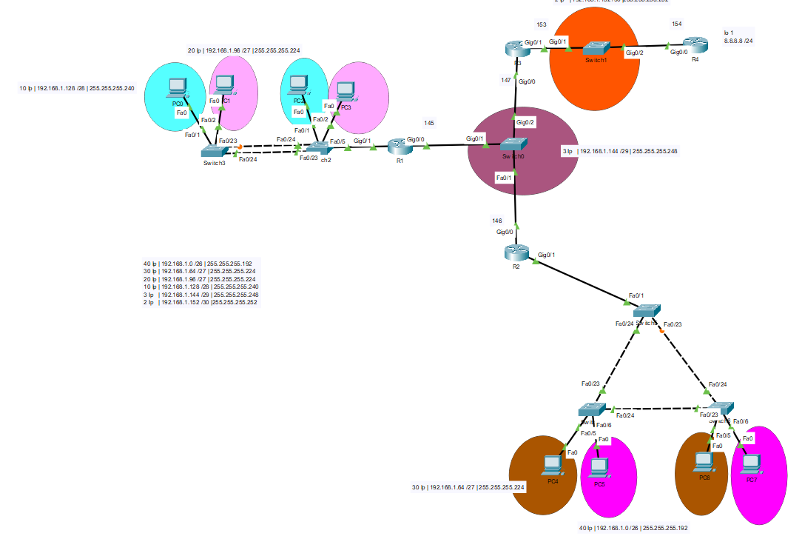

Sadece IP leri VLSM mantığıyla dağıttım configurasyon üsteki FLSM mantığıyla aynı

Summarization

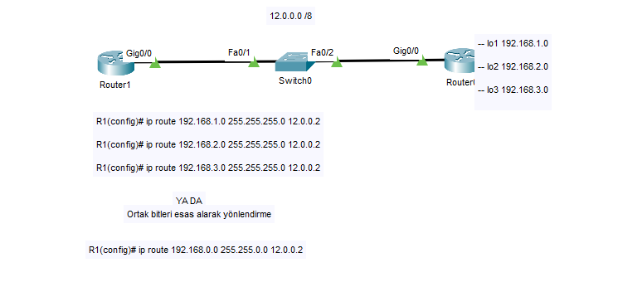

Summarization-2

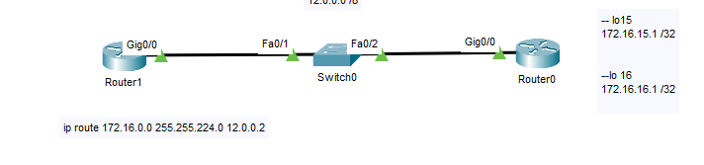

Layer_3_cihaz_üzerinde_VLSM

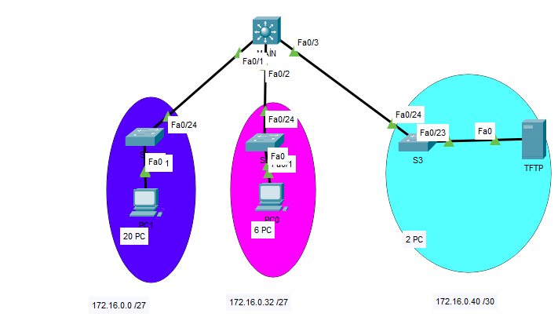

MAIN için;

Main(config)# int fa0/1

Main(config-if)# no switchport

Main(config-if)# ip address 172.16.0.1 255.255.255.224

Main(config-if)# exit

Main(config)# int fa0/2

Main(config-if)# no switchport

Main(config-if)# ip address 172.16.0.33 255.255.255.248

Main(config-if)# exit

Main(config)# int fa0/3

Main(config-if)# no switchport

Main(config-if)# ip address 172.16.0.41 255.255.255.252

Main(config-if)# exit

Main(config)# ip routing

OSPF

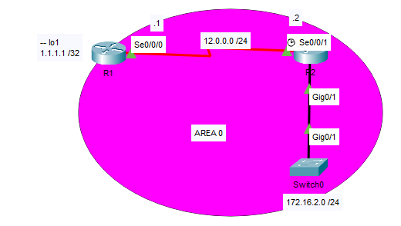

R1 için;

R1(config)# int s0/0/0

R1(config-if)# ip address 12.0.0.1 255.255.255.0

R1(config-if)# no shutdown

R1(config-if)# exit

R1(config)# interface loopback 1

R1(config-if)# ip address 1.1.1.1 255.255.255.255

R1(config)# router ospf 1

R1(config-router)# network 12.0.0.0 0.0.0.255 area 0

R1(config-router)# network 1.1.1.1 0.0.0.0 area 0

R2 için;

R2(config)# int s0/0/1

R2(config-if)# ip address 12.0.0.2 255.255.255.0

R2(config-if)# no shutdown

R2(config-if)# exit

R2(config)# int gig0/1

R2(config-if)# ip address 172.16.2.1 255.255.255.0

R2(config-if)# no shutdown

R2(config-if)# exit

R2(config)# router ospf 1

R2(config-router)# network 172.16.2.0 0.0.0.255 area 0

R2(config-router)# network 12.0.0.0 0.0.0.255 area 0

DR_BDR_DROTHER_OSP_configuration

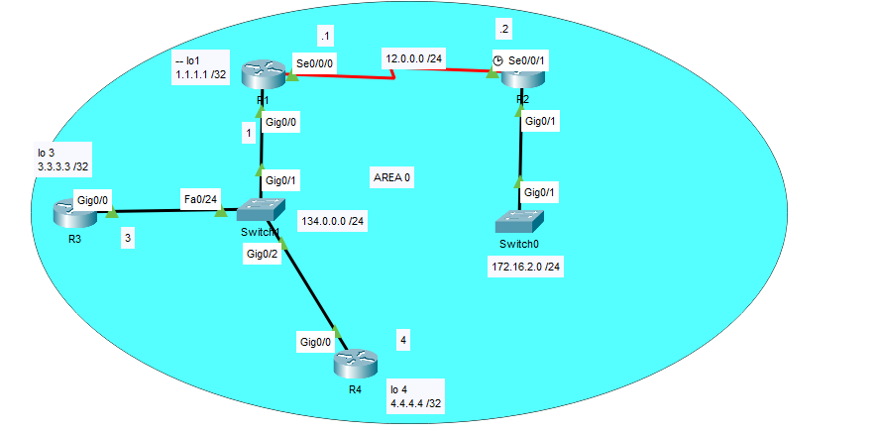

DR : Router Id- en yüksek olan DR (router ID bakabilmek için her router’a Router(config)# Show ip protocols yapmak yeterlidir)

SONRASI ROUTER-ID’YE GÖRE DR,BDR,DROTHER olarak devam eder

Configurasyon için;

R1 için;

R1(config)# int s0/0/0

R1(config-if)# ip address 12.0.0.1 255.255.255.0

R1(config-if)# no shutdown

R1(config-if)# exit

R1(config)# interface loopback 1

R1(config-if)# ip address 1.1.1.1 255.255.255.255

R1(config)# router ospf 1

R1(config-router)# network 12.0.0.0 0.0.0.255 area 0

R1(config-router)# network 1.1.1.1 0.0.0.0 area 0

R1(config-router)# network 134.0.0.0 0.0.0.255 area 0

R2 için;

R2(config)# int s0/0/1

R2(config-if)# ip address 12.0.0.2 255.255.255.0

R2(config-if)# no shutdown

R2(config-if)# exit

R2(config)# int gig0/1

R2(config-if)# ip address 172.16.2.1 255.255.255.0

R2(config-if)# no shutdown

R2(config-if)# exit

R2(config)# int gig0/0

R2(config-if)# ip address 134.0.0.1 255.255.255.0

R2(config-if)# no shutdown

R2(config-if)# exit

R2(config)# router ospf 1

R2(config-router)# network 172.16.2.0 0.0.0.255 area 0

R2(config-router)# network 12.0.0.0 0.0.0.255 area 0

R3 için;

R2(config)# int gig0/0

R2(config-if)# ip address 134.0.0.3 255.255.255.0

R2(config-if)# no shutdown

R2(config)# interface loopback 3

R2(config-if)# ip address 3.3.3.3 255.255.255.255

R2(config-if)# exit

R2(config)# router ospf 1

R2(config-router)# network 134.0.0.0 0.0.0.255 area 0

R2(config-router)# network 3.3.3.3 0.0.0.0 area 0

R4 için;

R2(config)# int gig0/0

R2(config-if)# ip address 134.0.0.3 255.255.255.0

R2(config-if)# no shutdown

R2(config)# interface loopback 3

R2(config-if)# ip address 4.4.4.4 255.255.255.255

R2(config-if)# exit

R2(config)# router ospf 1

R2(config-router)# network 134.0.0.0 0.0.0.255 area 0

R2(config-router)# network 4.4.4.4 0.0.0.0 area 0

OSPF_PASİF_interFACE_ve_DEF_ROUTE_DAĞITMA

Üstteki ile aynı configurasyon olduğu için aynısını yapıp eklemeler yaptım

R2 için;

Router(config)# router ospf 1

Router(config-router)# passive-interaface gig0/1

Router(config)# interface lo

Router(config)# interface loopback 2

Router(config-if)# ip address 8.8.8.8 255.255.255.255

Router(config)# ip route 0.0.0.0 0.0.0.0 loopback 2

Tekrara hepsi için def router’ı dağıtsın diye uğraşmayıp ospf hello paketleri içinde taşınması için yine R2 router’ın içine bunları yazıyorum

Router(config)# router ospf 1

Router(config-router)# default-information originate

R1’de görünen

Gateway of last resort is 12.0.0.2 to network 0.0.0.0

O*E2 0.0.0.0/0 [110/1] via 12.0.0.2, 00:02:06, Serial0/0/0

R3’de görünen

Gateway of last resort is 134.0.0.1 to network 0.0.0.0

O*E2 0.0.0.0/0 [110/1] via 134.0.0.1, 00:02:48, GigabitEthernet0/0

R4’de görünen

Gateway of last resort is 134.0.0.1 to network 0.0.0.0

O*E2 0.0.0.0/0 [110/1] via 134.0.0.1, 00:03:33, GigabitEthernet0/0

OSPF_AUTHENTİCATİON

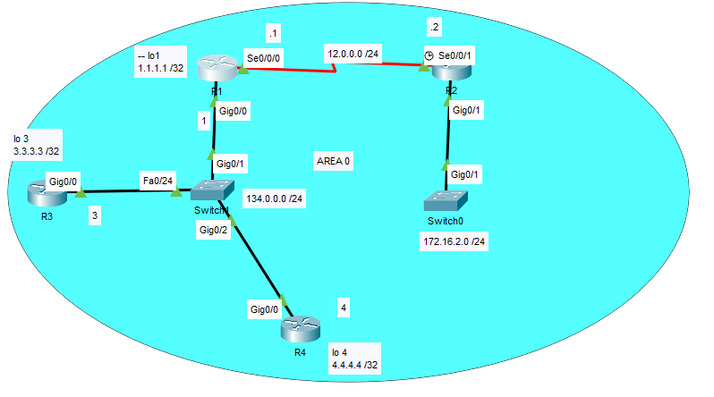

R1 için;

Router(config)# router ospf 1

Router(config-router)# area 0 authentication message-digest

Router(config-router)# exit

Router(config)# int gig0/0

Router(config-if)# ip ospf message-digest-key 1 md5 cisco

Router(config)# int s0/0/0

Router(config-if)# ip ospf message-digest-key 1 md5 cisco

R2 için;

Router(config)# router ospf 1

Router(config-router)# area 0 authentication message-digest

Router(config-router)# exit

Router(config)# int s0/0/1

Router(config-if)# ip ospf message-digest-key 1 md5 cisco

R3 için;

Router(config)# router ospf 1

Router(config-router)# area 0 authentication message-digest

Router(config-router)# exit

Router(config)# int gig0/0

Router(config-if)# ip ospf message-digest-key 1 md5 cisco

R4 için;

Router(config)# router ospf 1

Router(config-router)# area 0 authentication message-digest

Router(config-router)# exit

Router(config)# int gig0/0

Router(config-if)# ip ospf message-digest-key 1 md5 cisco

MULTİ_LAYER_CONFİGURASYON

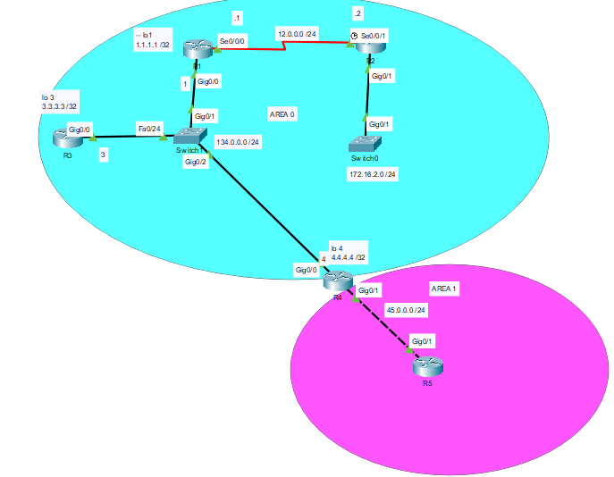

AREA 0 için OSPF konfigürasyonu aynı ama çoklu için R4 ve R5 i yapılandırıyorum.

R4 için;

R4(config)# int gig0/1

R4(config-if)# ip address 45.0.0.4 255.255.255.0

R4(config-if)# no shutdown

R4(config-if)# exit

R4(config)# router ospf 1

R4(config-router)# network 45.0.0.0 0.0.0.255 area 1

R5 için;

R5(config)# int gig0/1

R5(config-if)# ip address 45.0.0.5 255.255.255.0

R5(config-if)# no shutdown

R5(config-if)# exit

R5(config)# router ospf 1

R5(config-router)# network 45.0.0.0 0.0.0.255 area 1

R5(config-router)# exit

DHCP

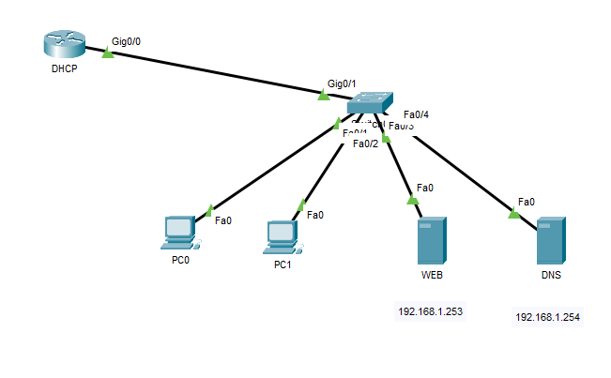

DHCP router içinde ;

DHCP (config)# İnt gig0/0

DHCP (config-if)# ip address 192.168.1.1

DHCP (config-if)# exit

DHCP (config)# ip dhcp pool GAST_POOL

DHCP (config-config)# network 192.168.1.0 255.255.255.0

DHCP (config-config)# default-router 192.168.1.1

DHCP (config-config)# dns-server 192.168.1.254

DHCP (config-config)# exit

(DHCP ile atamak istemediğin IP ler)

DHCP (config)# ip dhcp excluded-address 192.168.1.1 192.168.1.10

DHCP_Relay_Agent

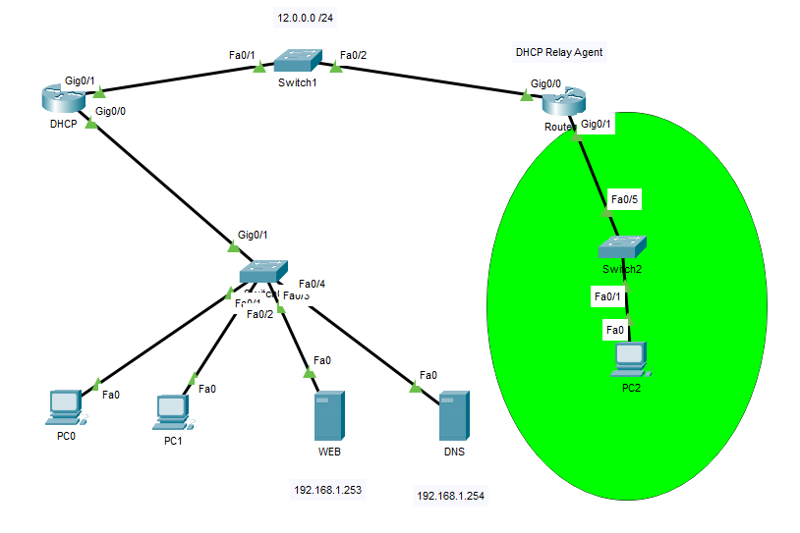

DHCP router içinde ;

DHCP (config)# İnt gig0/0

DHCP (config-if)# ip address 192.168.1.1 255.255.255.0

DHCP (config-if)# exit

DHCP (config)# İnt gig0/1

DHCP (config-if)# ip address 12.0.0.1 255.255.255.0

DHCP (config-if)# exit

DHCP (config)# ip dhcp pool GAST_POOL

DHCP (config-config)# network 192.168.1.0 255.255.255.0

DHCP (config-config)# default-router 192.168.1.1

DHCP (config-config)# dns-server 192.168.1.254

DHCP (config-config)# exit

(DHCP ile atamak istemediğin IP ler)

DHCP (config)# ip dhcp excluded-address 192.168.1.1 192.168.1.10

DHCP (config)# ip route 192.168.2.0 255.255.255.0 12.0.0.2

DHCP Relay Agent için;

DHCP (config)# İnt gig0/0

DHCP (config-if)# ip address 12.0.0.2 255.255.255.0

DHCP (config-if)# exit

DHCP (config)# İnt gig0/1

DHCP (config-if)# ip address 192.168.2.1 255.255.255.0

DHCP (config-if)# exit

DHCP (config)# int gig0/1

DHCP (config-if)# ip helper-address 12.0.0.1

STATİK_NAT

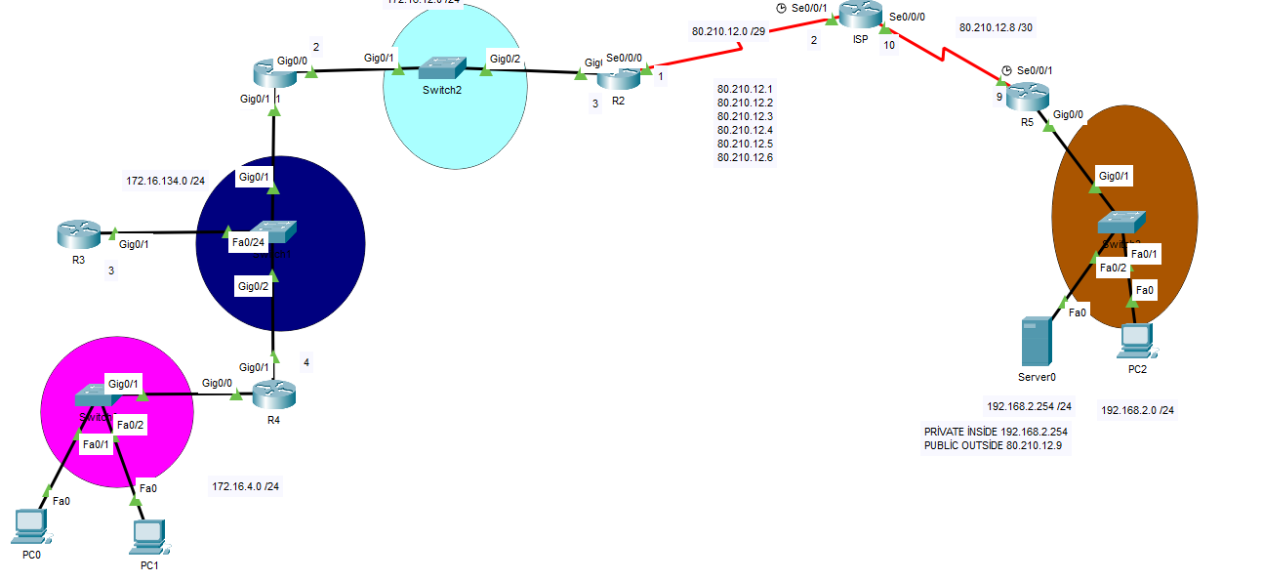

R4 için;

R4 (config)# İnt gig0/0

R4 (config-if)# ip address 172.16.4.1 255.255.255.0

R4 (config-if)# no shutdown

R4 (config-if)# exit

R4 (config)# int gig0/1

R4 (config-if)# ip address 172.16.134.4 255.255.255.0

R4 (config-if)# no shutdown

R4 (config-if)# exit

R4 (config)# router ospf 1

R4 (config-router)# network 172.16.4.0 255.255.255.0 area 0

R4 (config-router)# network 172.16.134.0 255.255.255.0 area 0

R3 için;

R3 (config)# int gig0/1

R3 (config-if)# ip address 172.16.134.3 255.255.255.0

R3 (config-if)# no shutdown

R3 (config-if)# exit

R3 (config)# router ospf 1

R3 (config-router)# network 172.16.4.0 255.255.255.0 area 0

R3 (config-router)# network 172.16.134.0 255.255.255.0 area 0

R1 için;

R1 (config)# int gig0/1

R1 (config-if)# ip address 172.16.134.2 255.255.255.0

R1 (config-if)# no shutdown

R1 (config-if)# exit

R1 (config)# int gig0/1

R1 (config-if)# ip address 172.16.12.0 255.255.255.0

R1 (config-if)# no shutdown

R1 (config-if)# exit

R1 (config)# router ospf 1

R1 (config-router)# network 172.16.12.0 0.0.0.255 area 0

R1 (config-router)# network 172.16.134.0 0.0.0.255 area 0

R2 için; (NAT’ın OLDUĞU ROUTER)

R2 (config)# int gig0/1

R2 (config-if)# ip address 172.16.12.3 255.255.255.0

R2 (config-if)# no shutdown

R2 (config-if)# exit

R2 (config)# int s0/0/0

R2 (config-if)# ip address 80.210.12.1 255.255.255.248

R2 (config-if)# no shutdown

R2 (config-if)# exit

R2 (config)# router ospf 1

R2 (config-router)# network 80.210.12.0 0.0.0.8 area 0

R2 (config-router)# network 80.210.12.8 0.0.0.3 area 0

R2 (config-router)# network 80.210.12.0 0.0.0.255 area 0

R2 (config)-router# exit

R2 (config)# ip nat inside source static 172.16.4.100 80.210.12.3

R2 (config)# int gig0/0

R2 (config-if)# ip nat inside

R2 (config-if)# exit

R2 (config)# int s0/0/0

R2 (config-if)# ip nat outside

ISP için;

ISP (config)# int s0/0/1

ISP (config-if)# ip address 80.210.12.0 255.255.255.248

ISP (config-if)# no shutdown

ISP (config-if)# exit

ISP (config)# int s0/0/0

ISP (config-if)# ip address 80.210.12.10 255.255.255.252

ISP (config-if)# no shutdown

ISP (config-if)# exit

ISP (config)# router ospf 1

ISP (config-router)# network 80.210.12.0 0.0.0.7 area 0

ISP (config-router)# network 80.210.12.8 0.0.0.3 area 0

ISP (config-router)# network 80.210.12.0 0.0.0.255 area 0

R5 için;

R5 (config)# int gig0/0

R5 (config-if)# ip address 192.168.2.1 255.255.255.0

R5 (config-if)# exit

R5 (config)# int s0/0/1

R5 (config-if)# ip address 80.210.12.9 255.255.255.252

R5 (config-if)# no shutdown

R5 (config-if)# exit

R5 (config)# ip route 0.0.0.0 0.0.0.0 s0/0/1

R5 (config)# router ospf 1

R5 (config-router)# network 80.210.12.8 0.0.0.3 area 0

R5 (config-router)# network 80.210.12.0 0.0.0.255 area 0

R5 (config-router)# network 192.168.2.0 0.0.0.255 area 0

STATİK_NAT_2

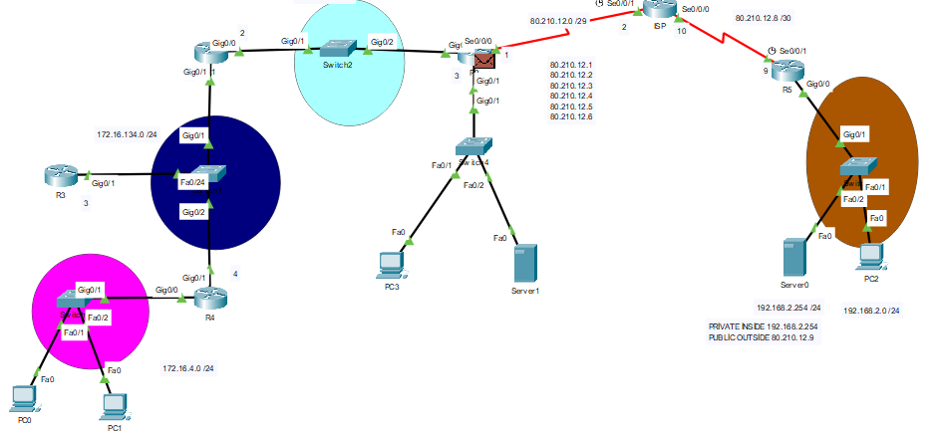

Yukarıdaki ile aynı sadece eklenmesi gereken yerleri ekliyorum

R2 için;

R2(config)# int gig0/1

R2(config-if)# ip address 172.16.2.1 255.255.255.0

R2(config-if)# no shutdown

R2(config-if)# ip nat inside

R2(config-if)# exit

R2(config)# ip nat inside source static 172.16.2.254 110.10.9.9

R2(config)# router ospf 1

R2(config-router)# network 172.16.2.0 0.0.0.255 area 0

R3 için;

R3(config)# ip route 110.10.9.0 255.255.255.0 s0/0/1

DİNAMİK_NAT

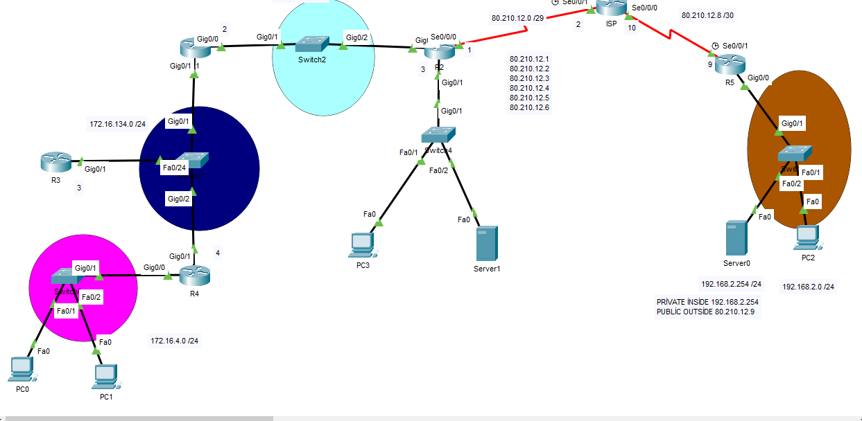

Configurasyon aynı sadece dynamik nat için R2 ve R5 i kulandım

R2 için;

R2(config)# Access-list 1 permit 172.16.0.0 0.0.255.255

R2(config)# ip nat pool KAMPUS_POOL 80.210.12.3 80.210.12.7 netmask 255.255.255.248

R2(config)# ip nat inside source list 1 pool KAMPUS_POOL

R5 için;

R2(config)# Access-list 1 permit 192.168.2.0 0.0.0.255

R2(config)# ip nat pool 192_POOL 80.210.12.9 80.210.12.10 netmask 255.255.255.252

R2(config)# ip nat inside source list 1 pool 192_POOL