E-Commerce Adoption and the Digital Divide in the European Union (2013-2024):
Trends, Demographic Differences, and the COVID-19 Effect

Ahmet Mert Çaralan
Department of Information Systems and Technologies
University of Bilkent
Çankaya, Ankara
mert.caralan@ug.bilkent.edu.tr
Abstract - This paper provides a descriptive analysis of e-commerce adoption across European Union (EU) countries over the period 2013–2024. Using harmonized secondary data from Eurostat, the study documents temporal trends, cross-country heterogeneity, and associations between online shopping adoption and key dimensions of the digital divide, including internet access, broadband infrastructure, economic capacity (real GDP per capita), and digital skills. In addition, the paper examines the structural shift associated with the COVID-19 pandemic by comparing pre- and post-2020 adoption patterns and by contrasting country-level outcomes in 2019 and 2024. The results indicate a sustained increase in online shopping adoption across the EU, with a pronounced acceleration following the onset of the pandemic. However, substantial disparities across member states persist, suggesting that structural digital inequalities continue to shape participation in the digital economy.

I. INTRODUCTION
Electronic commerce has become a central component of modern economic activity, fundamentally transforming the way individuals search for products, compare prices, and complete purchases. Advances in information and communication technologies (ICT), combined with

Mikhail Mushkarenko
Department of Information Systems and Technologies
University of Bilkent
Çankaya, Ankara
mikhail@ug.bilkent.edu.tr
increased internet penetration and the proliferation of digital platforms, have enabled online shopping to expand rapidly across the European Union (EU). As a result, e-commerce has evolved from a supplementary retail channel into a mainstream mode of consumption.
Despite this overall expansion, e-commerce adoption has not occurred uniformly across EU member states. Significant differences persist in the share of individuals who engage in online shopping, reflecting broader inequalities in economic development, technological infrastructure, and digital readiness. These differences are commonly discussed within the framework of the digital divide, which captures inequalities in access to digital technologies, affordability, skills, and the ability to effectively benefit from digital services.
In the context of online shopping, the digital divide operates through multiple channels. Reliable internet access is a basic prerequisite for participation in e-commerce, while income levels influence purchasing power and the availability of complementary services such as digital payment systems and logistics networks. Moreover, digital skills affect individuals’ ability to navigate online interfaces, assess information credibility, and manage risks related to privacy and security. Consequently, differences in these dimensions can translate into substantial variation in e-commerce adoption across countries.
The COVID-19 pandemic represents a major structural shock that further accelerated the shift toward online consumption. Lockdowns, mobility restrictions, and temporary closures of physical retail outlets increased reliance on online shopping across many countries. While this shock affected all EU member states, it remains unclear whether it reduced pre-existing adoption gaps by encouraging widespread digital uptake or reinforced them by disproportionately benefiting countries with stronger digital infrastructure and capabilities.
Against this background, this study aims to provide a comprehensive descriptive overview of e-commerce adoption in the EU between 2013 and 2024. Specifically, the paper seeks to (i) document long-term trends in online shopping adoption, (ii) describe cross-country differences and distributional patterns, (iii) explore associations between adoption and selected digital divide indicators, and (iv) examine changes associated with the COVID-19 period. The analysis is exploratory and descriptive in nature and does not attempt to establish causal relationships.

II. LITERATURE REVIEW

A. The digital divide as a multidimensional concept
The concept of the digital divide has evolved from a narrow focus on access to digital technologies toward a broader, multidimensional framework. Early studies emphasized first-level digital divides, defined primarily by differences in physical access to the internet and ICT infrastructure. While access remains a necessary condition for digital participation, subsequent research highlights that access alone is insufficient to ensure meaningful engagement with digital services.
Second-level digital divides refer to differences in skills, usage patterns, and the ability to effectively utilize digital technologies. In the context of e-commerce, this includes competencies such as searching for products, comparing prices, evaluating seller credibility, and completing online transactions securely. Even when access is widespread, insufficient digital skills can limit participation in online shopping.
More recent work emphasizes third-level digital divides, which focus on unequal outcomes and benefits derived from digital participation. From this perspective, countries or individuals may use digital technologies but still experience unequal economic or social returns. In the EU context, these dimensions of the digital divide often align with broader patterns of economic development and institutional capacity.

B. Determinants of e-commerce adoption
A large empirical literature examines the determinants of e-commerce adoption at both the individual and aggregate levels. At the macro level, internet penetration and broadband quality consistently emerge as strong predictors of online shopping participation. Improved connectivity reduces transaction costs and increases the feasibility of engaging with online platforms.
Economic capacity, commonly measured by income or GDP per capita, is also closely linked to e-commerce adoption. Higher income levels increase purchasing power and encourage firms to invest in online distribution channels. However, existing studies emphasize that income alone does not fully explain adoption differences, as countries with similar income levels can exhibit divergent e-commerce outcomes.
Human capital, particularly digital skills, represents another important determinant. Individuals with higher levels of digital competence are more likely to adopt online shopping due to lower perceived risks and greater confidence in navigating digital environments. Nevertheless, the relative importance of skills compared to access and income varies across contexts.

C. COVID-19 and digital consumption
Recent literature documents a substantial increase in digital consumption during the COVID-19 pandemic. Restrictions on physical mobility accelerated the adoption of online services, including e-commerce, remote work, and digital entertainment. Some studies suggest that the pandemic lowered psychological and informational barriers to digital adoption by forcing individuals to experiment with online alternatives.
At the same time, several authors caution that the pandemic may have reinforced existing digital inequalities. Countries and populations with better infrastructure and skills were better positioned to benefit from the digital shift, while others faced constraints. From a descriptive perspective, the pandemic thus provides an opportunity to examine whether observed adoption patterns reflect convergence or persistence of pre-existing disparities.

III. DATA AND METHODOLOGY
The analysis relies on secondary data obtained from Eurostat’s Digital Economy and Society database, which provides harmonized indicators across EU member states. The primary outcome variable is the percentage of individuals who reported making online purchases in the last 12 months, a standard measure of e-commerce adoption used in EU statistics.
The dataset covers the period from 2013 to 2024. To capture key dimensions of the digital divide, the analysis includes several additional indicators: internet access, broadband coverage, real GDP per capita measured in purchasing power standards, and the share of individuals with at least basic digital skills. Due to data availability constraints, digital skills indicators are available only up to 2019.
All datasets were cleaned and merged at the country-year level. Observations with missing values were excluded on a figure-specific basis to maximize the use of available information. The analysis employs descriptive statistics and graphical methods, including heatmaps, boxplots, scatter plots with fitted linear trends, and distributional comparisons. The reported relationships are descriptive associations and should not be interpreted as causal effects.

IV. DESCRIPTIVE STATISTICS
Before presenting graphical results, the main variables are summarized using descriptive statistics. Standard summary measures include the number of observations, mean, standard deviation, minimum, median, and maximum values. These statistics provide an overview of the magnitude and dispersion of e-commerce adoption and digital divide indicators across countries and over time.
Variable | Online shopping (last 12 month, %) | Internet access (%) | GDP per capita (PPS) | Broadband coverage (%) | Digital skills (%)
n | 1026898 | 1026895 | 1026898 | 1026898 | 997409
mean | 51.28 | 83.88 | 28392.49 | 73.63 | 36.75
sd | 18.63 | 8.43 | 19606.12 | 25.18 | 28.50
median | 51.43 | 83.61 | 20810 | 79.10 | 28.38
trimmed | 51.54 | 84.23 | 25371.74 | 77.31 | 34.55
mad | 21.54 | 9.30 | 1248.32 | 24.91 | 28.53
min | 8.32 | 53.71 | 6130 | 0 | 0
max | 93.54 | 99.18 | 99760 | 100 | 100
range | 85.22 | 45.47 | 93630 | 100 | 100
1st. Qua | 38.14 | 78.51 | 14150 | 60 | 13.65
3rd. Qua | 66.59 | 90.43 | 39970 | 95.50 | 59.81
skew | -0.06 | -0.31 | 1.66 | -1.06 | 0.59
kurtosis | -0.88 | -0.33 | 3.08 | 0.46 | -0.88
se | 0.02 | 0.01 | 19.35 | 0.02 | 0.03

Descriptive statistics highlight substantial heterogeneity in online shopping adoption across country-year observations. While average adoption rates increase over time, the range between minimum and maximum values remains large, indicating persistent cross-country differences. Similar dispersion is observed in internet access, GDP per capita, and digital skills, suggesting that EU member states differ markedly in their levels of digital readiness and economic capacity.
These summary patterns motivate the subsequent visual analysis, which illustrates how adoption and associated indicators evolve over time and how they relate to one another across countries

V. TRENDS IN E-COMMERCE ADOPTION

A. Temporal evolution across countries
As shown in Figure 1, online shopping adoption exhibits a clear upward trend across most EU countries between 2013 and 2024, with particularly strong increases observed after 2020.
The heatmap provides a country-by-year overview of adoption patterns, where each cell represents a country-year observation, allowing simultaneous inspection of temporal trends and cross-country differences.
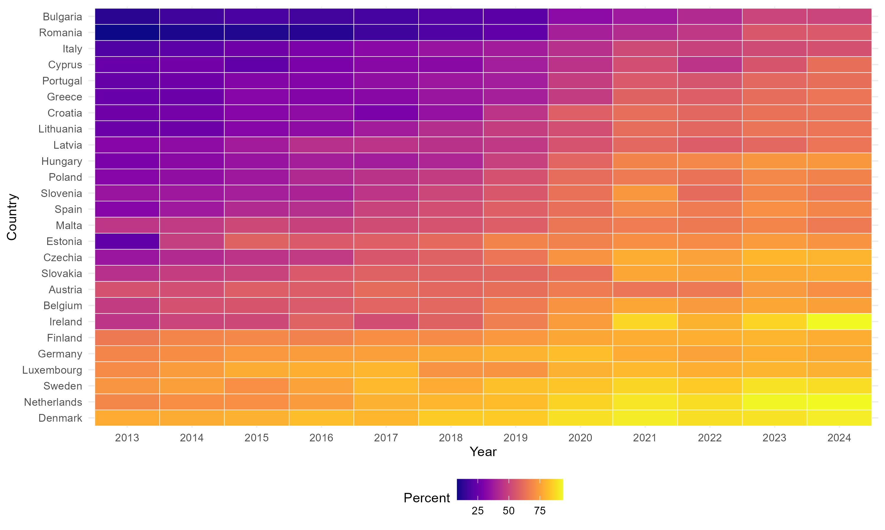
Figure 1. Temporal evolution of online shopping adoption across EU countries (2013–2024).
At the same time, the heatmap shows persistent differences between countries. Northern and Western European countries consistently exhibit higher adoption levels, while several Southern and Eastern European countries remain at lower levels throughout much of the period. This pattern suggests that aggregate growth does not necessarily imply convergence across member states.

B. Distributional changes over time
Figure 2 summarizes the yearly distribution of online shopping adoption across EU countries using boxplots.
The upward shift in the median indicates that growth is broad-based rather than driven by a small subset of countries. However, the interquartile range and the presence of outliers suggest that dispersion across countries remains substantial.
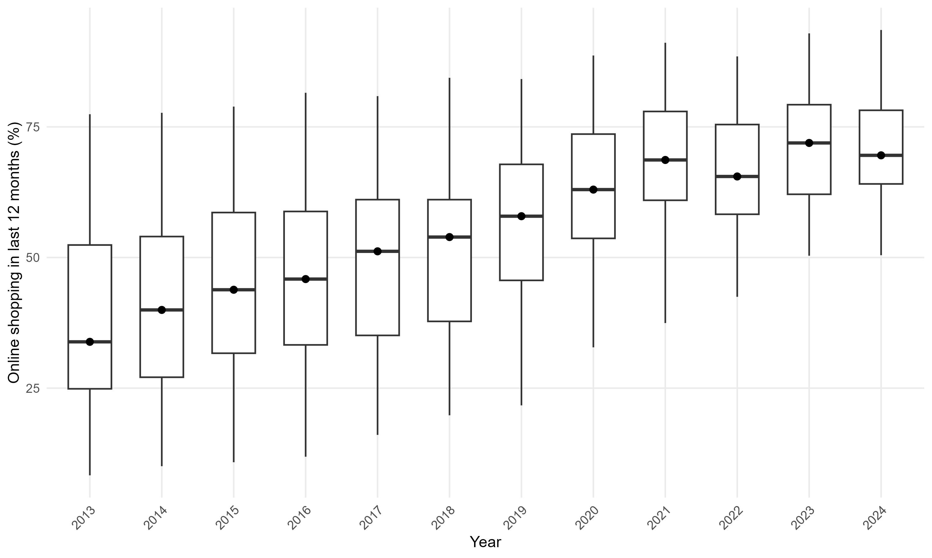
Figure 2. Distribution of online shopping adoption across EU countries by year (2013–2024).

From a descriptive perspective, changes in dispersion are informative about convergence or divergence. If dispersion narrows over time, this will indicate convergence in adoption levels; if it remains stable or widens, it suggests persistent or increasing inequality.

VI. DIGITAL DIVIDE FACTORS AND ONLINE SHOPPING

A. Internet access
Figure 3 illustrates a strong positive association between internet access and online shopping adoption across EU country-year observations.
Internet access represents a foundational prerequisite for participation in online shopping, and countries with higher access rates tend to exhibit higher adoption levels, consistent with a first-level digital divide interpretation.
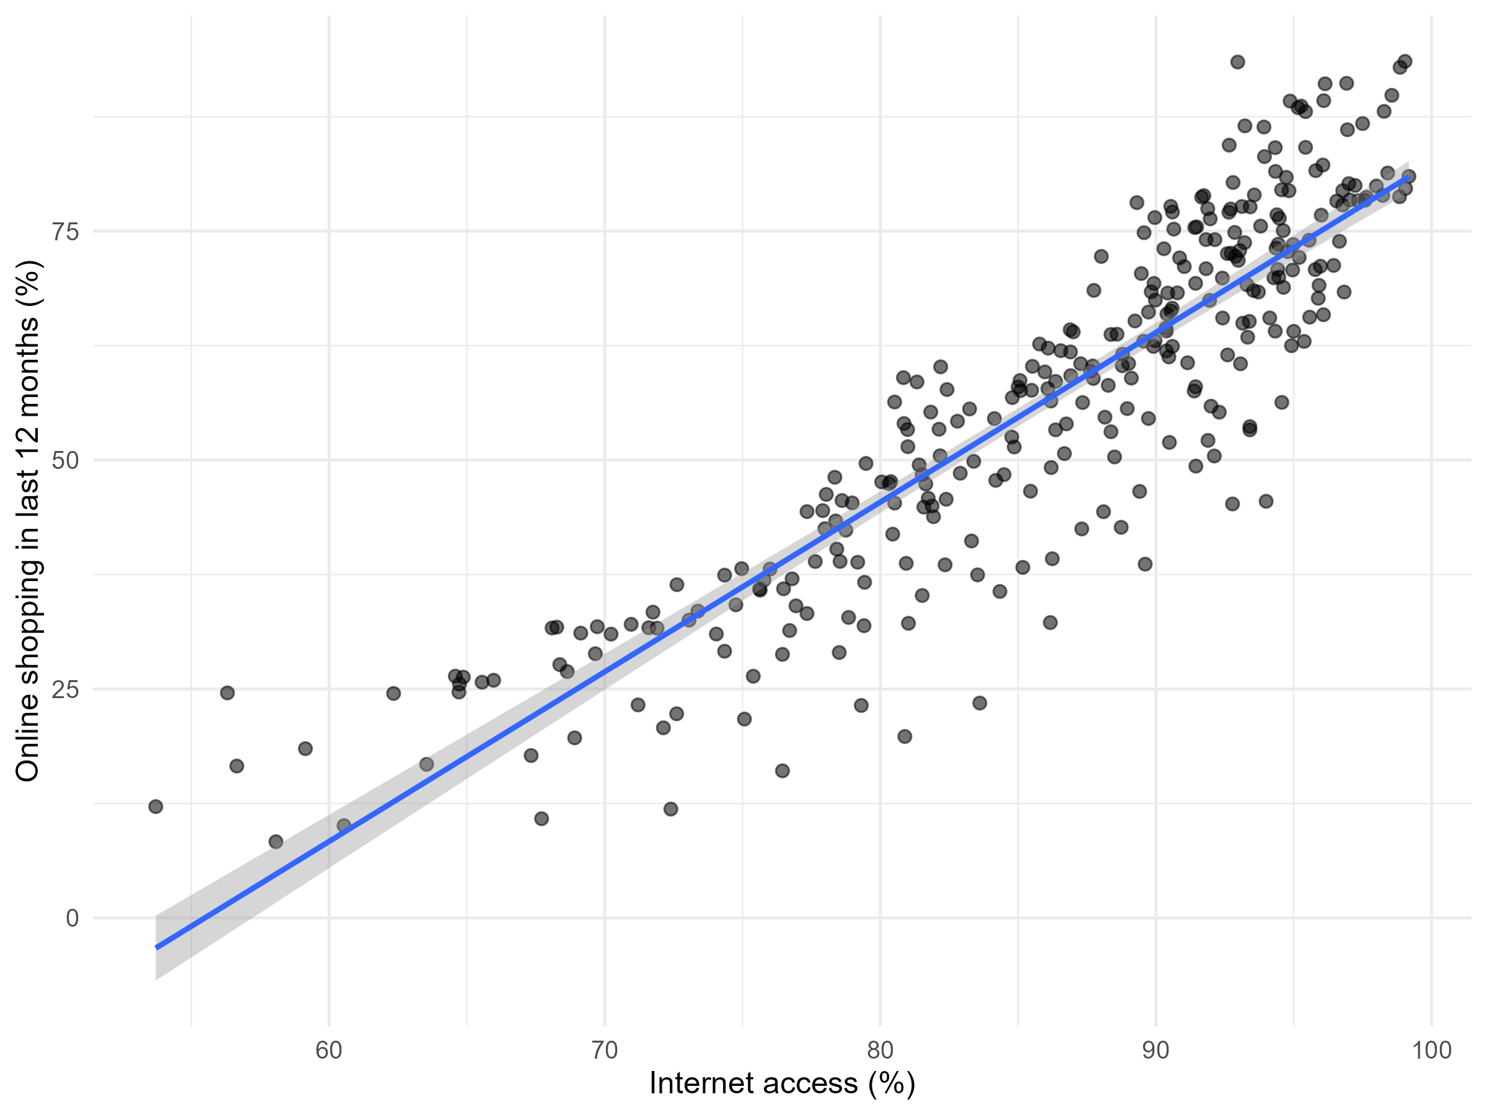
Figure 3. Internet access and online shopping adoption in the EU (2013–2024).

Nevertheless, dispersion around the fitted trend line indicates that access alone does not fully determine adoption. Countries with similar access levels can display different adoption rates, implying that additional factors such as income, skills, and institutional conditions also play a role.

B. Economic capacity (GDP per capita)
As shown in Figure 4, real GDP per capita is positively associated with online shopping adoption across EU countries.
Higher-income countries generally report higher participation in e-commerce, reflecting greater purchasing power and more developed digital ecosystems. The use of a logarithmic scale highlights this relationship across a wide income distribution.
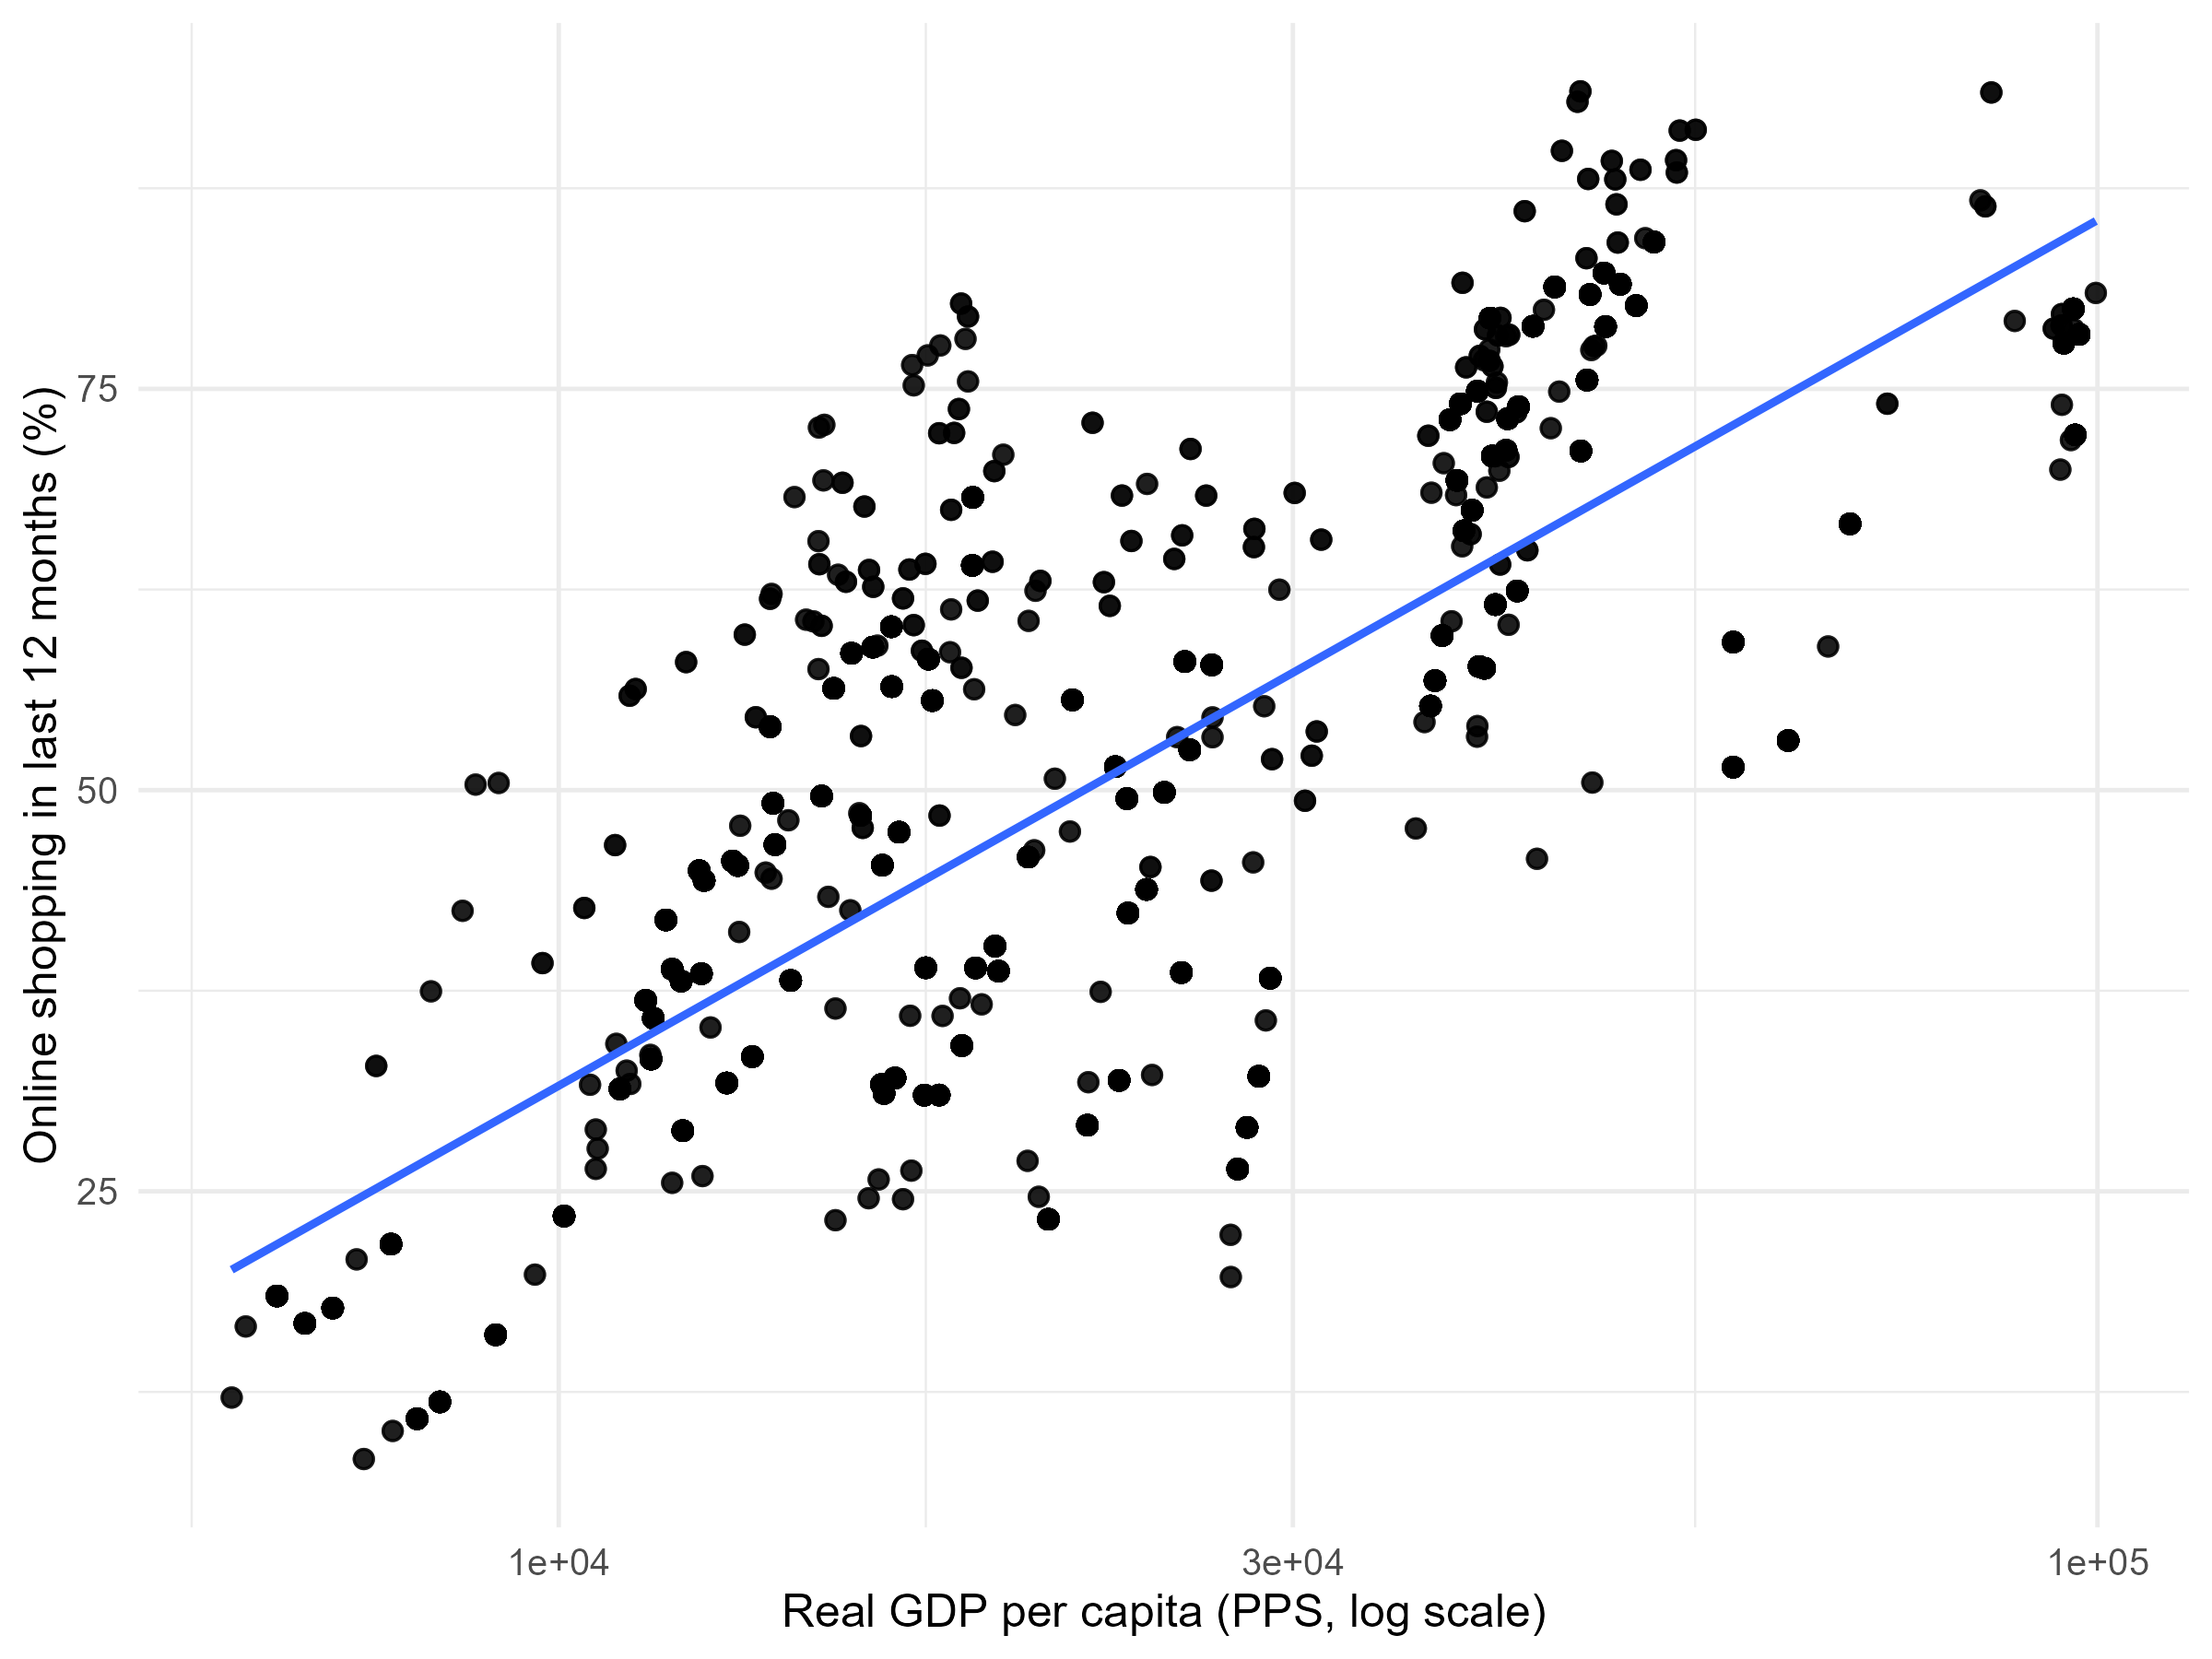
Figure 4. Relationship between GDP per capita (log scale) and online shopping adoption in the EU (2013–2024).

However, the observed dispersion suggests that income is not the sole determinant of adoption. Countries with comparable GDP per capita can differ in adoption outcomes, underscoring the importance of complementary factors beyond economic capacity.

C. Digital skills
Figure 5 shows a positive association between digital skills and online shopping adoption across EU countries in the pre-2020 period.
Digital skills represent a second-level digital divide dimension, suggesting that human capital plays an important role in facilitating effective participation in e-commerce.
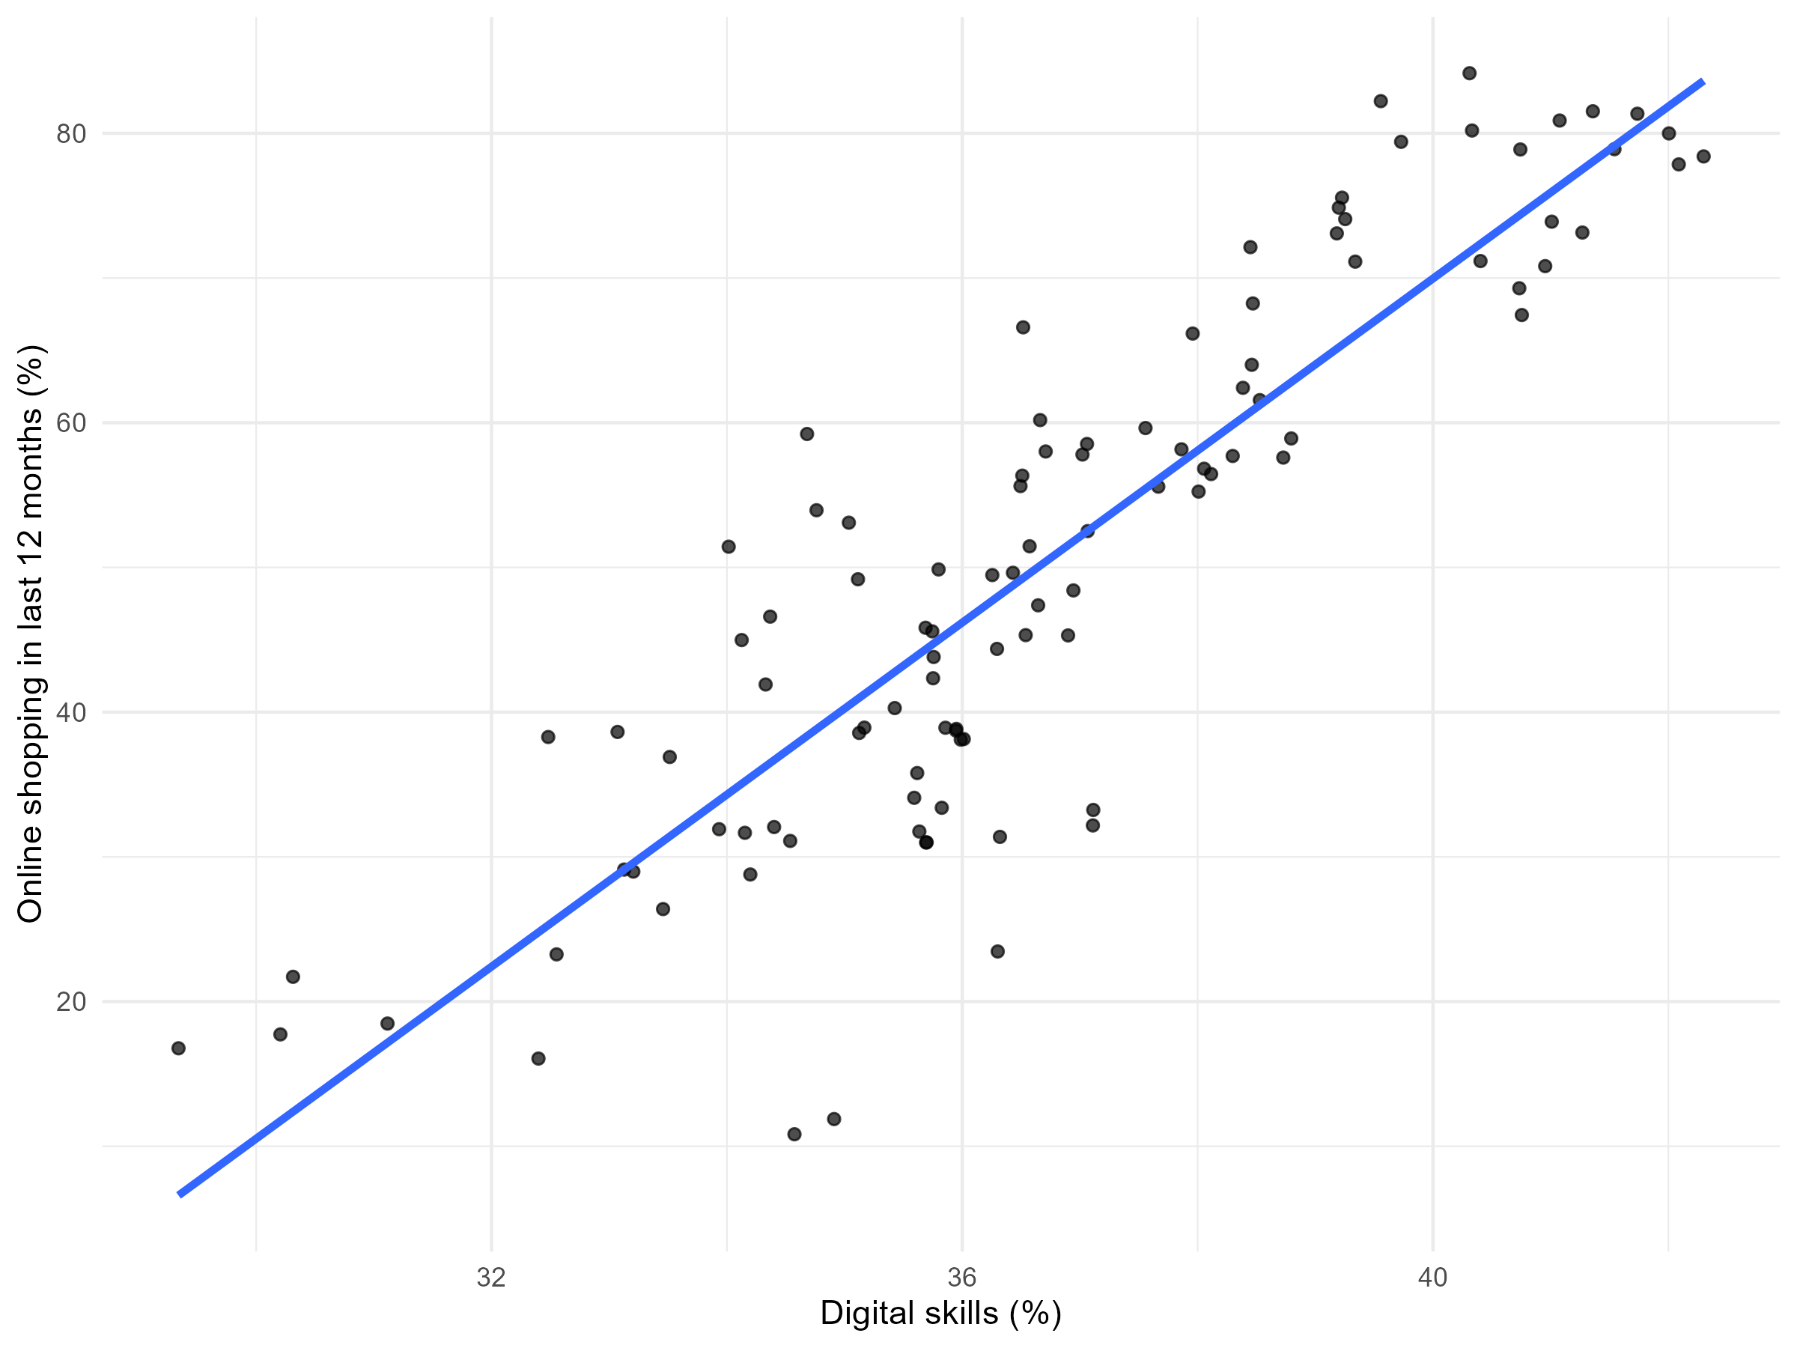
Figure 5. Digital skills and online shopping adoption in the EU (2013–2019).

Because digital skills data are not available after 2019, post-pandemic dynamics cannot be directly assessed within this framework. Nonetheless, the observed relationship supports the interpretation that skills help translate access and income into actual usage.

VII. THE COVID-19 EFFECT

A. Pre- and post-pandemic distributions
Figure 6 compares the distribution of online shopping adoption before and after the COVID-19 pandemic.
Distributional comparisons between the pre-COVID (2013–2019) and post-COVID (2020–2024) periods reveal a clear upward shift in adoption levels. The post-pandemic distribution is more concentrated in higher adoption categories, indicating widespread acceleration in online shopping.
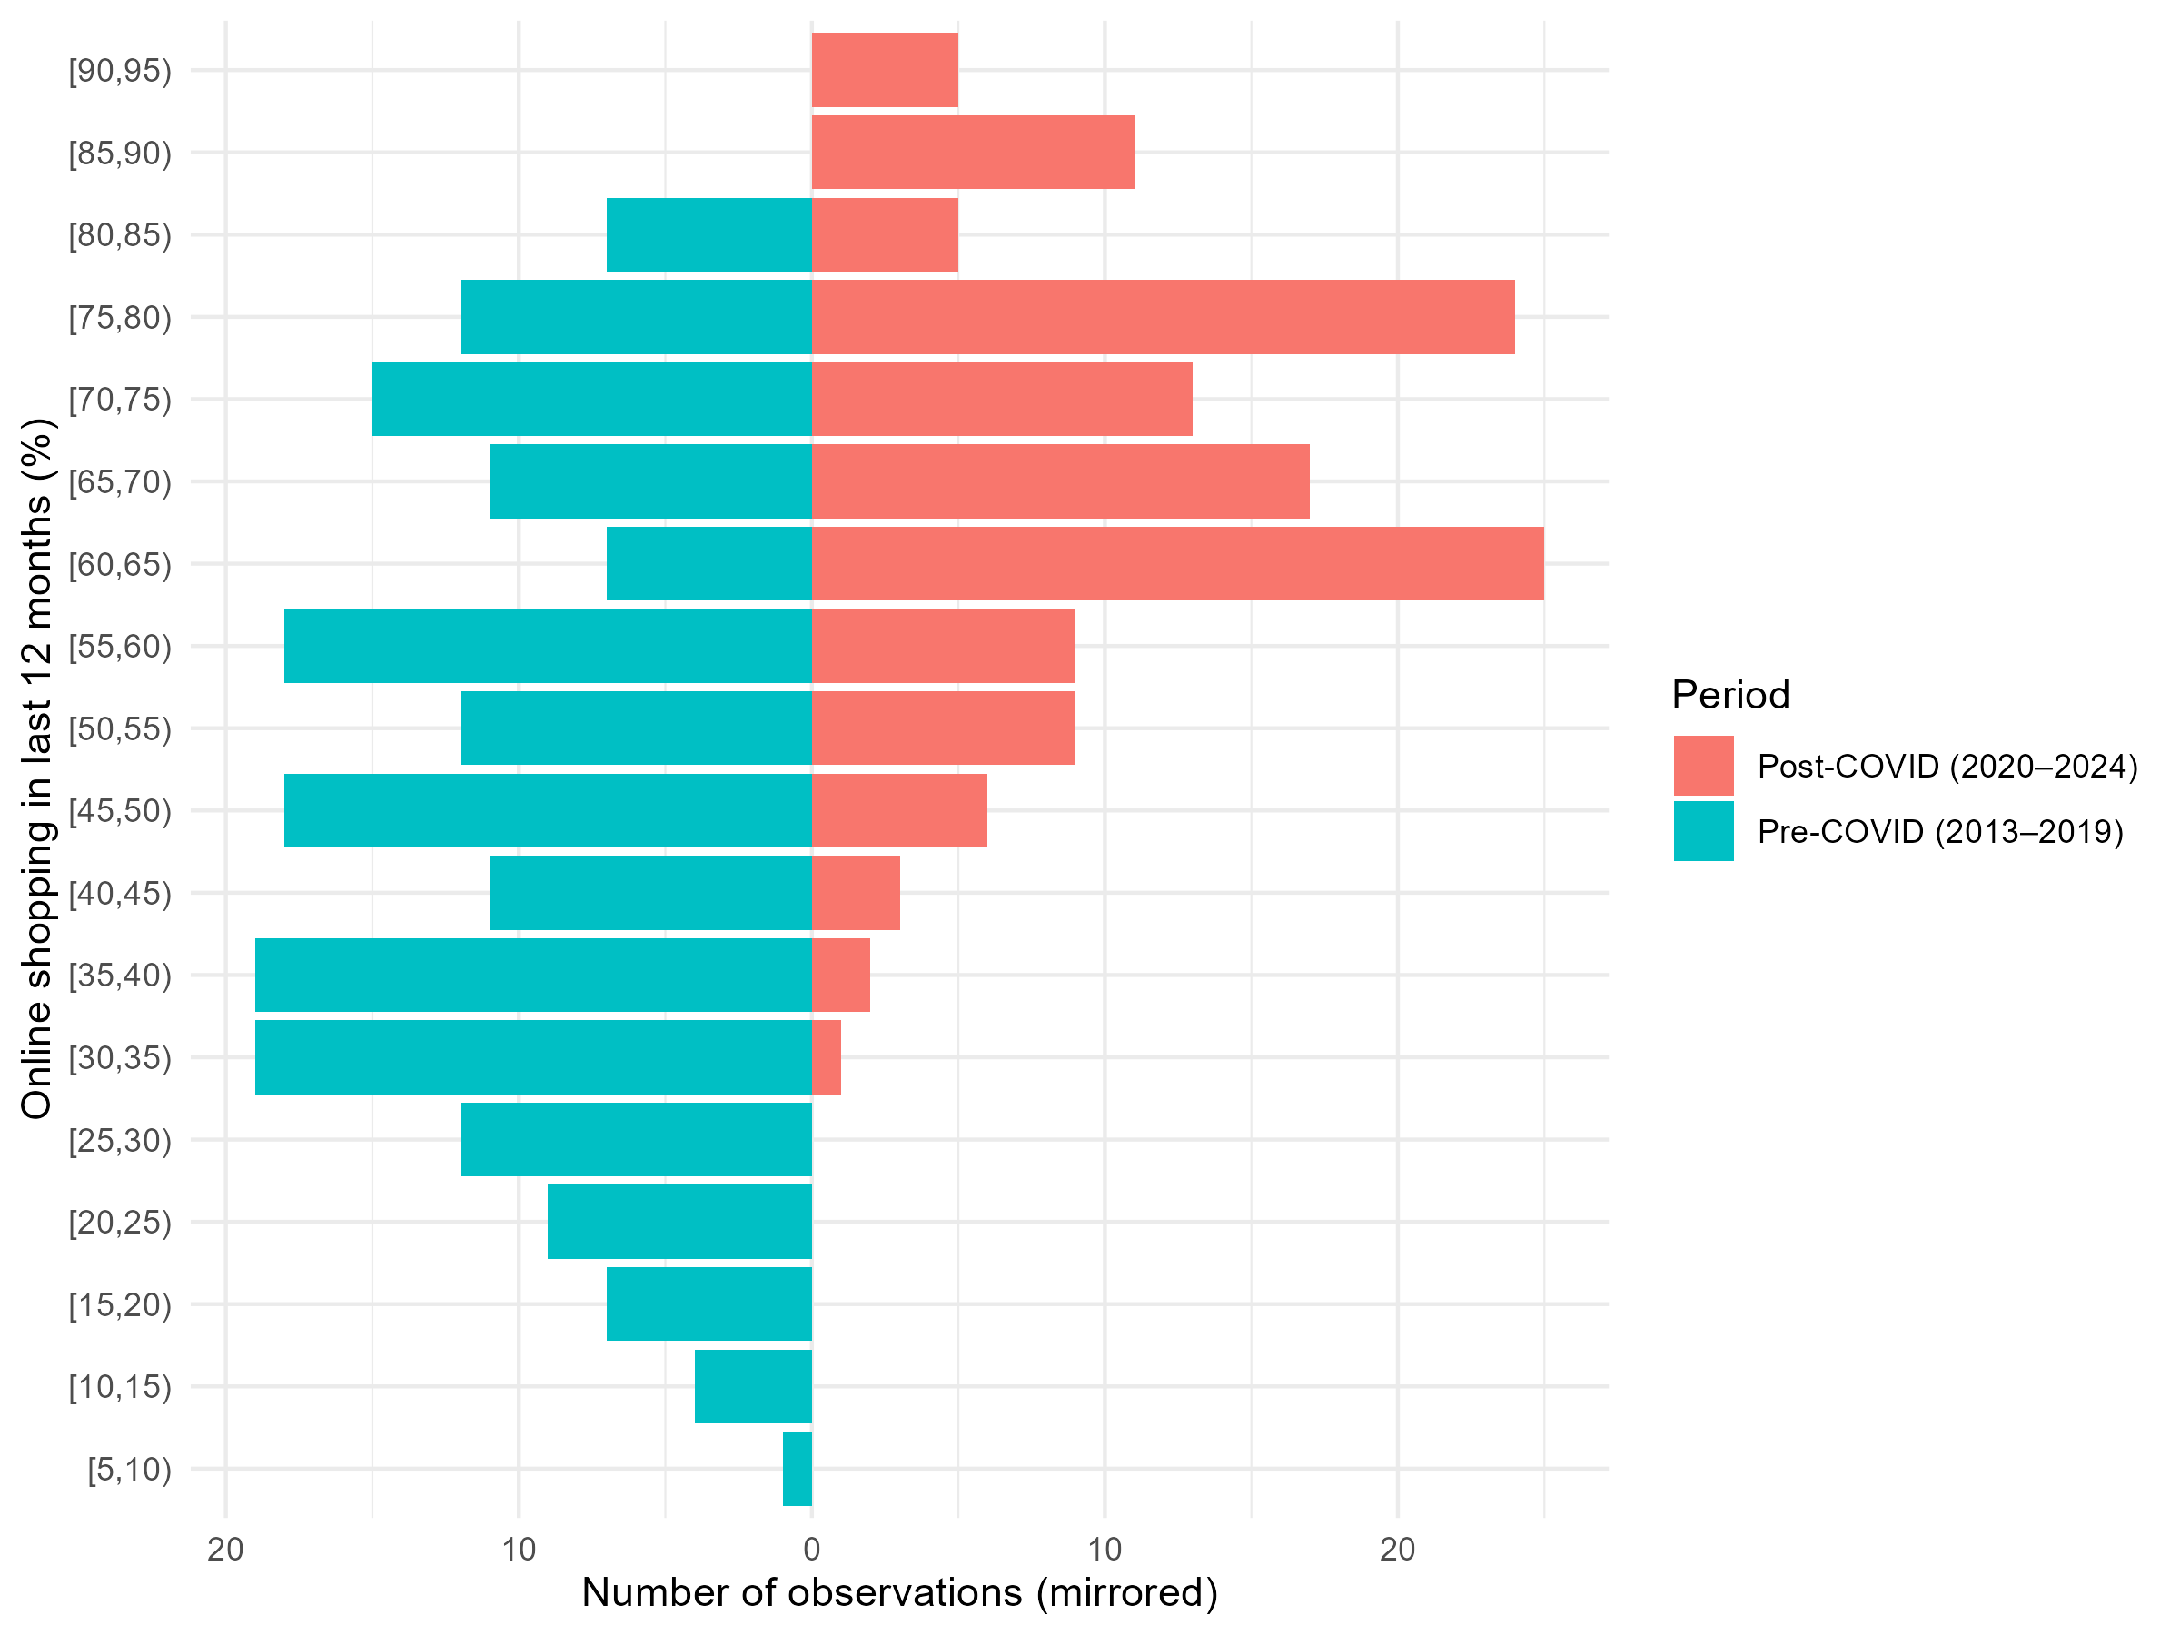
Figure 6. Distribution of online shopping adoption before (2013–2019) and after COVID-19 (2020–2024).

This shift suggests that the pandemic acted as a catalyst for digital consumption across the EU. However, the persistence of dispersion implies that structural differences across countries were not eliminated.

B. Country-level comparison: 2019 vs 2024
Figure 7 provides a country-level comparison of online shopping adoption rates in 2019 and 2024.
A direct comparison shows substantial increases for nearly all EU member states. While absolute adoption levels rose, relative differences between countries remained broadly stable.
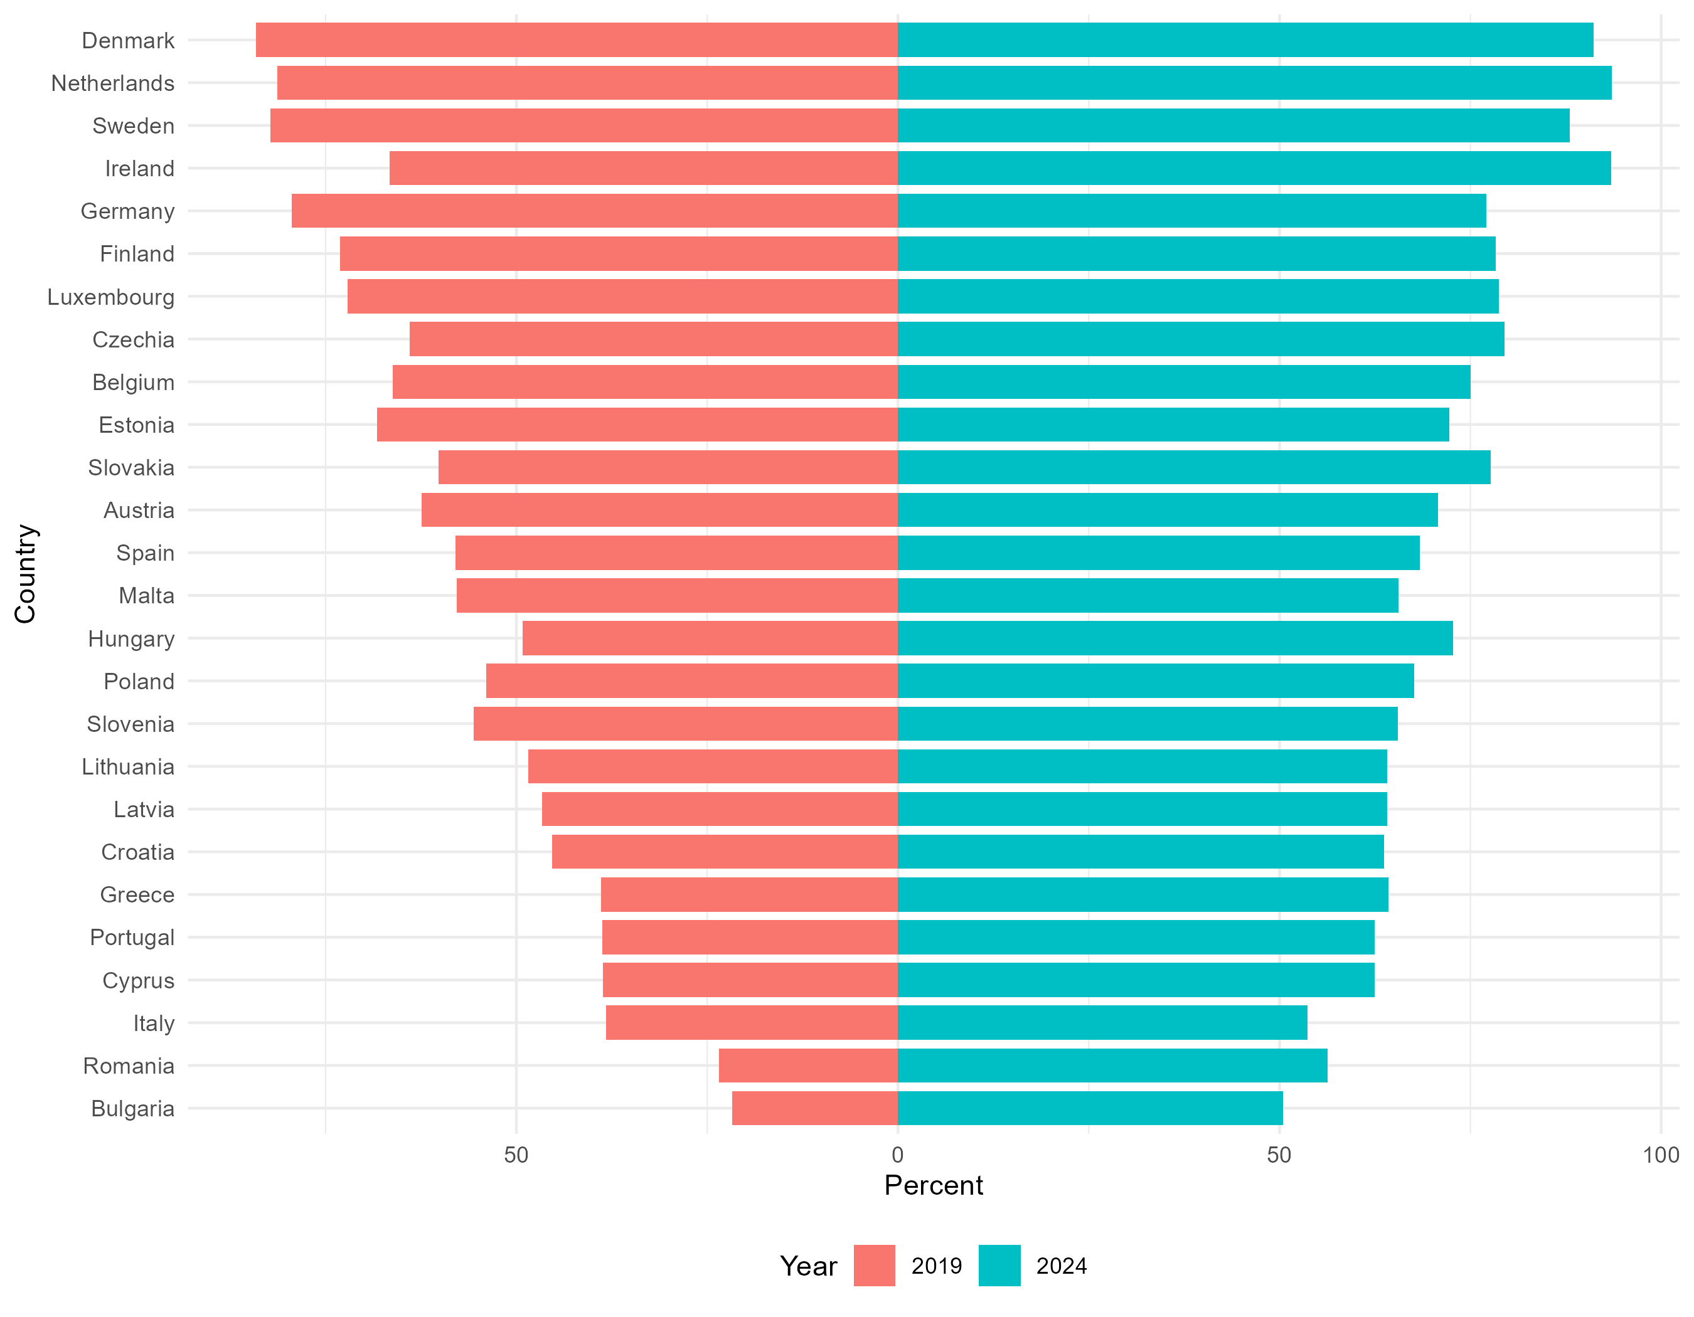
Figure 7. Online shopping adoption across EU countries: 2019 versus 2024.

From a descriptive perspective, this pattern indicates that COVID-19 functioned primarily as an accelerator rather than an equalizer. Countries that were already more digitally advanced continued to exhibit higher adoption levels after the pandemic.

VIII. DISCUSSION
Taken together, the findings document sustained growth in e-commerce adoption across the EU alongside persistent cross-country disparities. Associations with internet access and GDP per capita highlight the importance of first-level digital divide dimensions, while digital skills contribute additional explanatory power where data are available.
The pandemic-induced acceleration in adoption did not eliminate structural inequalities. Instead, it raised adoption levels across the distribution while preserving relative differences between countries. This pattern is consistent with interpretations of the digital divide as a multidimensional and path-dependent phenomenon.
From a policy perspective, the results suggest that expanding infrastructure alone may be insufficient to achieve convergence in digital participation. Complementary investments in digital skills, affordability, and trust-building measures may be necessary to ensure more inclusive outcomes.

IX. LIMITATIONS
This study is subject to several limitations. First, the analysis is descriptive and does not establish causal relationships. Second, limitations in data availability restrict the analysis of digital skills to the pre-2020 period. Third, the use of country-level aggregates may mask substantial within-country inequalities related to region, age, or socioeconomic status.

X. CONCLUSION
This paper provided a descriptive overview of e-commerce adoption across EU countries between 2013 and 2024. While online shopping participation increased substantially, particularly following the COVID-19 pandemic, significant cross-country differences persist. The evidence suggests that connectivity, economic capacity, and digital skills are all important correlates of adoption. Addressing structural digital inequalities remains a key challenge for achieving inclusive participation in the EU digital economy.

REFERENCE
[1] Eurostat, “E-commerce statistics for individuals,” Statistics Explained, 2024. [Online].
Available: https://ec.europa.eu/eurostat/statistics-explained/index.php?title=E-
commerce_statistics_for_individuals

[2] OECD, Bridging the Digital Divide: Inclusive Growth in the Digital Age, OECD Digital Economy
Papers, No. 284, 2019.
[3] M. R. Vicente and A. J. López, “Assessing the regional digital divide across the European
Union-27,” Telecommunications Policy, vol. 35, no. 3, pp. 220-237, 2011.

[4] A. J. A. M. Van Deursen and J. A. G. M. Van Dijk, “The digital divide shifts to differences in
usage,” New Media & Society, vol. 16, no. 3, pp. 507-526, 2014.

[5] Eurofound, E-commerce and COVID-19: Impact on Employment and Consumer Behavior,
2021.

[6] N. Kshetri, “The emerging role of Big Data in key development issues: Opportunities,
challenges, and concerns,” Big Data & Society, vol. 1, no. 2, 2014.

[7] N. Donthu and A. Gustafsson, “Effects of COVID-19 on business and research,” Journal of
Business Research, vol. 117, pp. 284-289, 2020.

[8] European Commission, Digital Economy and Society Index (DESI) 2023 Report, Brussels,
2023.

[9] Eurostat, Digital Economy and Society - 2023 Edition, Luxembourg: Publications Office of the
European Union, 2023.

[10] T. Acheampong, “Impact of COVID-19 on e-Commerce in the European Union,”
ENTRENOVA - Enterprise Research Innovation Conference, vol. 7, pp. 89-98, 2021. DOI:
10.54820/VPRD4547.

[11] Eurostat, Digital Economy and Society Database, [Online]. Available:
https://ec.europa.eu/eurostat/web/digital-economy-and-society/database

