Does AI Research Output Predict AI Market Performance?

Ali Mert Çaylak – 33925
DSA 210 Project
Spring 2025

1. Overview
This project investigates whether the daily volume of Artificial Intelligence research publications on arXiv carries a meaningful predictive signal for the financial performance of the Global X Robotics & AI ETF (BOTZ). The study covers September 2016 to December 2023, encompassing 1,836 trading days and two independent data sources.
The first data source is BOTZ adjusted daily closing prices retrieved via the Yahoo Finance API. The second is daily counts of new cs.AI paper submissions harvested from arXiv using the OAI-PMH. One of the key methodological challenges in the project was merging these two datasets, since arXiv receives submissions every day of the week while markets are only open on weekdays. A weekend accumulation strategy was implemented to roll Saturday and Sunday paper counts forward to the following Monday, retaining 100% of all submissions (a naive date-merge would have silently discarded 18.8% of total papers).
The analysis was structured across four phases. First, exploratory data analysis (EDA) to understand the shape and behaviour of both series individually and together. Second, formal hypothesis testing using Granger causality to assess whether paper volume statistically predicts returns. Third, an event study examining the market reaction around 11 landmark AI publications. And fourth, machine learning experiments using regression, classification, and clustering models to test whether predictive structure can be extracted from the data.
The central finding of the project is that the apparent strong correlation between the two series (r ≈ 0.49) is entirely spurious, driven by shared long-run growth trends and not genuine co-movement. After removing trends, the stationary correlation collapses to r ≈ −0.02. Machine learning models of all types produced negative R² on out-of-sample data, consistent with the Efficient Market Hypothesis. A statistically significant but economically negligible 3-day Granger precedence was found, and the event study revealed selective abnormal trading volume around landmark papers but no significant abnormal returns.

2. Visualizations
The figures below document the exploratory data analysis phase of the project. They are presented in the order they were generated in the EDA notebook.

ArXiv cs.AI Paper Count Over Time (2016–2023)
The first figure shows the daily arXiv cs.AI submission counts along with a 30-day moving average and a ±1 standard deviation band. The lower panel shows year-over-year growth. Paper volume grew rapidly throughout the period, with year-over-year growth rates ranging from +15% (2019) to +75% (2021). The series is strongly right skewed with occasional extreme spikes driven by arXiv submission deadlines and conference season bursts.
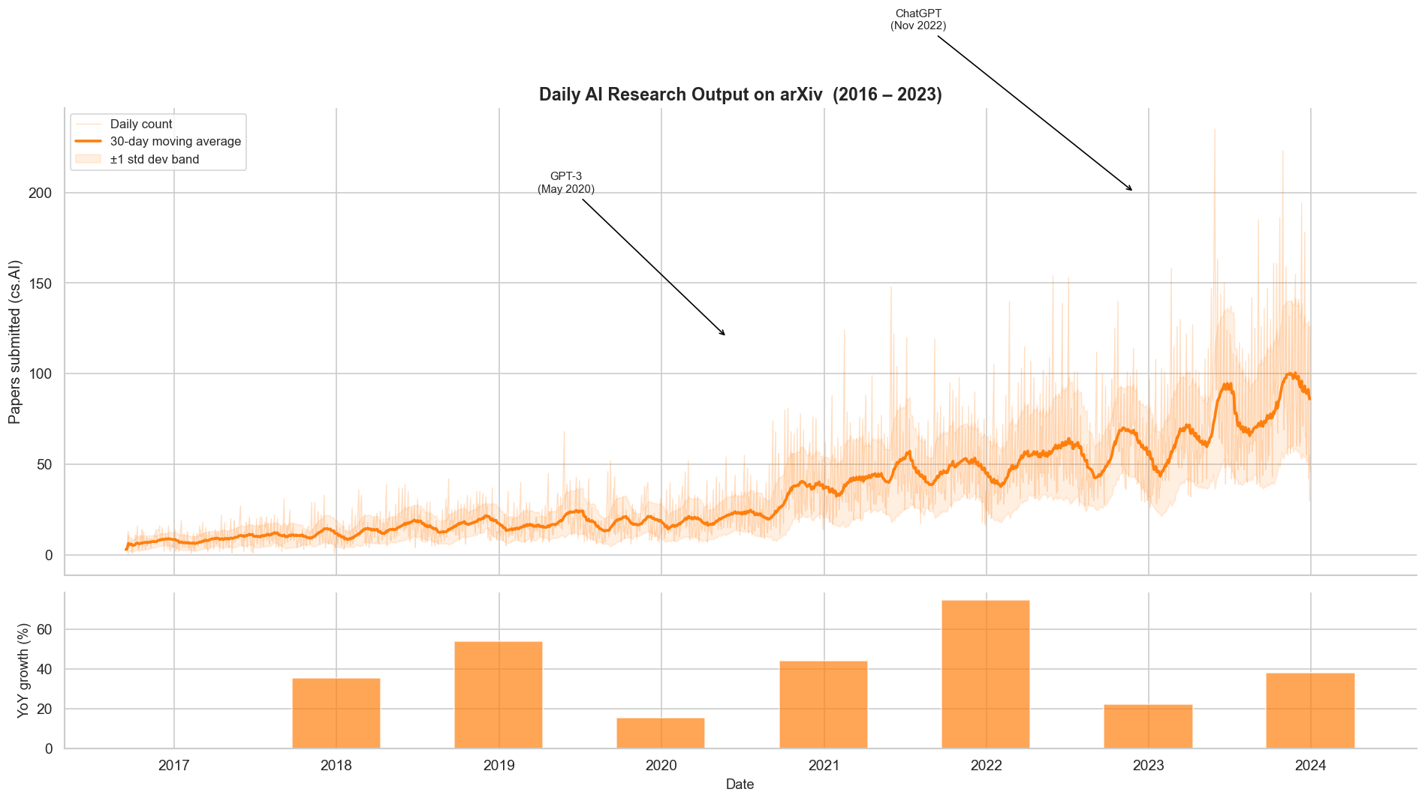
Figure 1. Daily arXiv cs.AI paper submissions with 30-day moving average and YoY growth (2016–2023).

BOTZ ETF: Price, Returns, and Volatility
The second figure shows three panels for the BOTZ ETF: the adjusted closing price, daily percentage returns, and rolling 30-day annualised volatility. The ETF peaked at $39.34 in November 2021 and fell sharply during the 2022 interest rate hike cycle. The worst single day was −12.41% on March 16, 2020 (COVID crash), and the best was +12.77% on March 24, 2020. Average annualised volatility over the full period was 23.1%. Volatility clustering is clearly visible — turbulent and calm periods each persist for extended stretches.
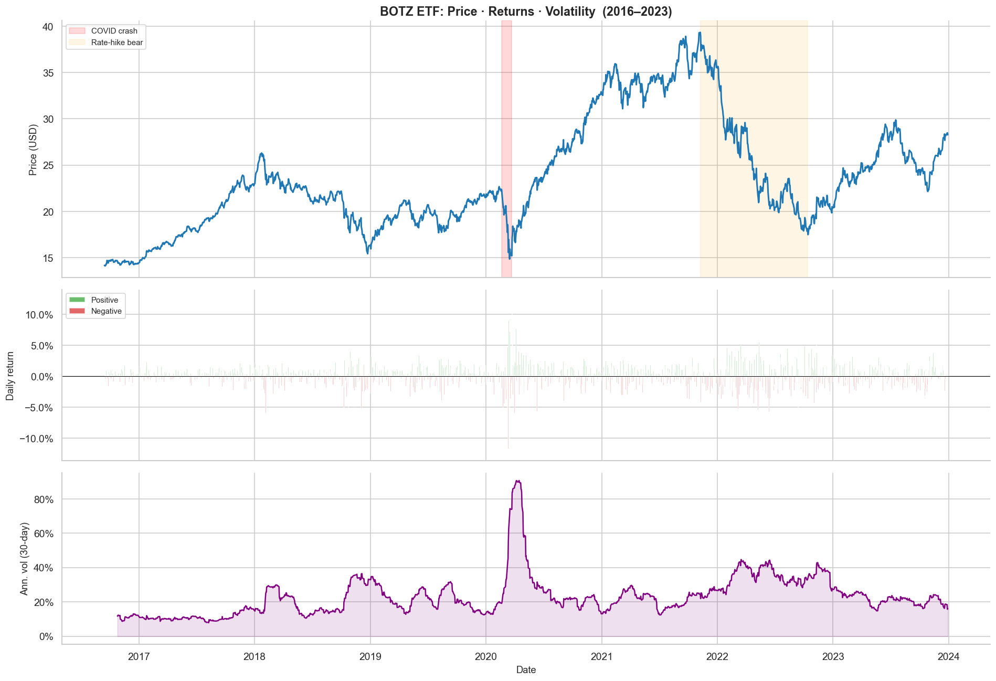
Figure 2. BOTZ ETF adjusted price (top), daily returns (middle), and 30-day rolling annualised volatility (bottom).

Distribution Analysis
The distribution plots confirm two important properties. Paper counts are strongly right-skewed (skewness = 1.92, excess kurtosis = 5.18) due to deadline spikes and conference season rushes — this motivated using a log transformation for all modelling. Daily returns have near-zero mean and fat tails relative to the Normal distribution (excess kurtosis = 7.18), which violates OLS assumptions and supports using robust non-parametric tests.
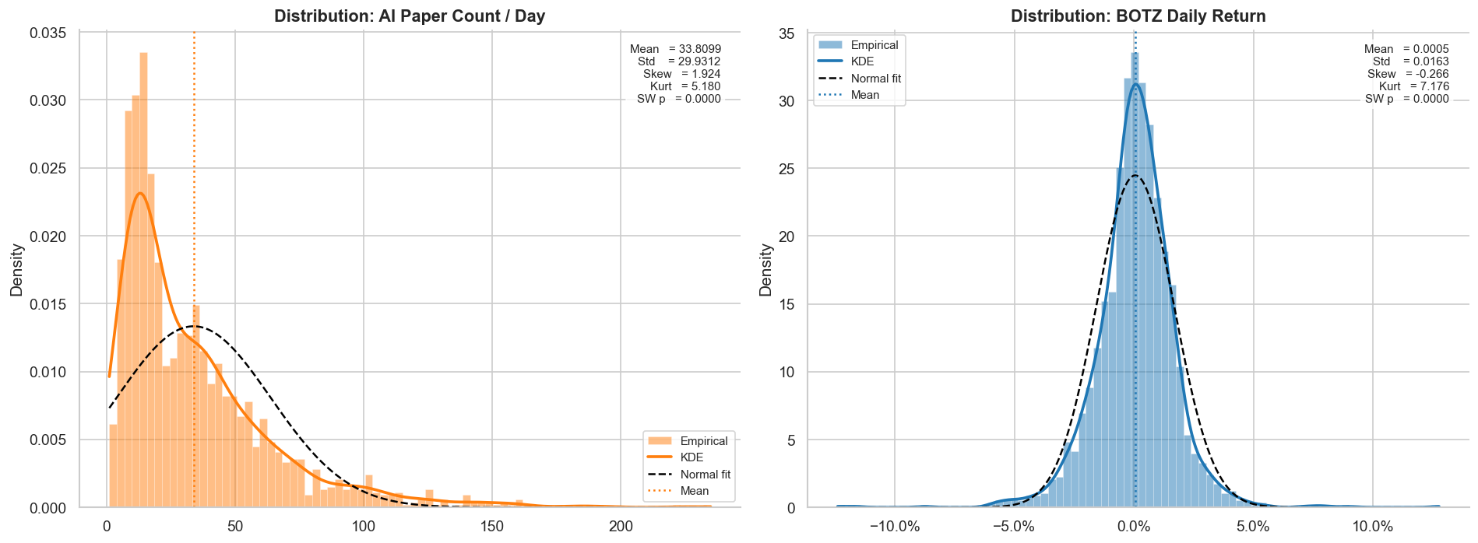
Figure 3. Empirical distributions of arXiv paper counts (left) and BOTZ daily returns (right) with Normal and KDE overlays.
Dual-Axis Overlay: Innovation vs. Market
This is the centrepiece visualisation of the EDA phase. Both series are plotted on a single timeline with key AI and macroeconomic milestones annotated: the Transformer paper (June 2017), COVID crash (March 2020), GPT-3 (May 2020), Fed rate hikes (March 2022), CHIPS Act (August 2022), ChatGPT (November 2022), and GPT-4 (March 2023). The visual impression of co-movement is strong — but as Section 4 establishes, it is entirely driven by shared long-run growth trends and disappears once those trends are removed.
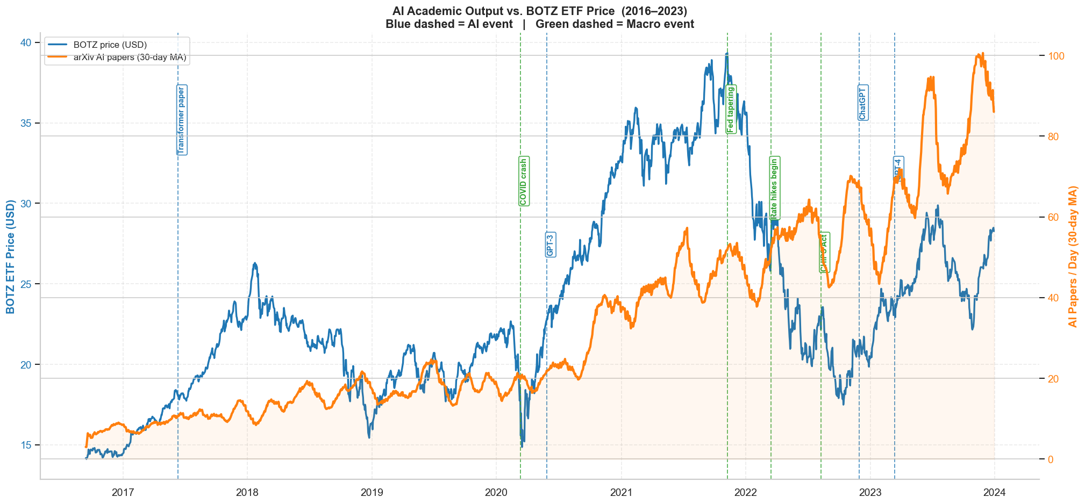
Figure 4. Dual-axis overlay of BOTZ ETF price and arXiv paper volume with annotated AI and macroeconomic milestones.
Day-of-Week Seasonality
ArXiv's submission cutoff is Sunday 14:00 US Eastern, meaning weekend submissions are announced on Monday. As a result, Monday receives on average 62% more papers than the weekly average. This day-of-week seasonality is an important artefact that any model must account for — without correction it creates spurious short-lag correlations between paper counts and market data. The right panel shows that absolute market returns have no strong day-of-week pattern.
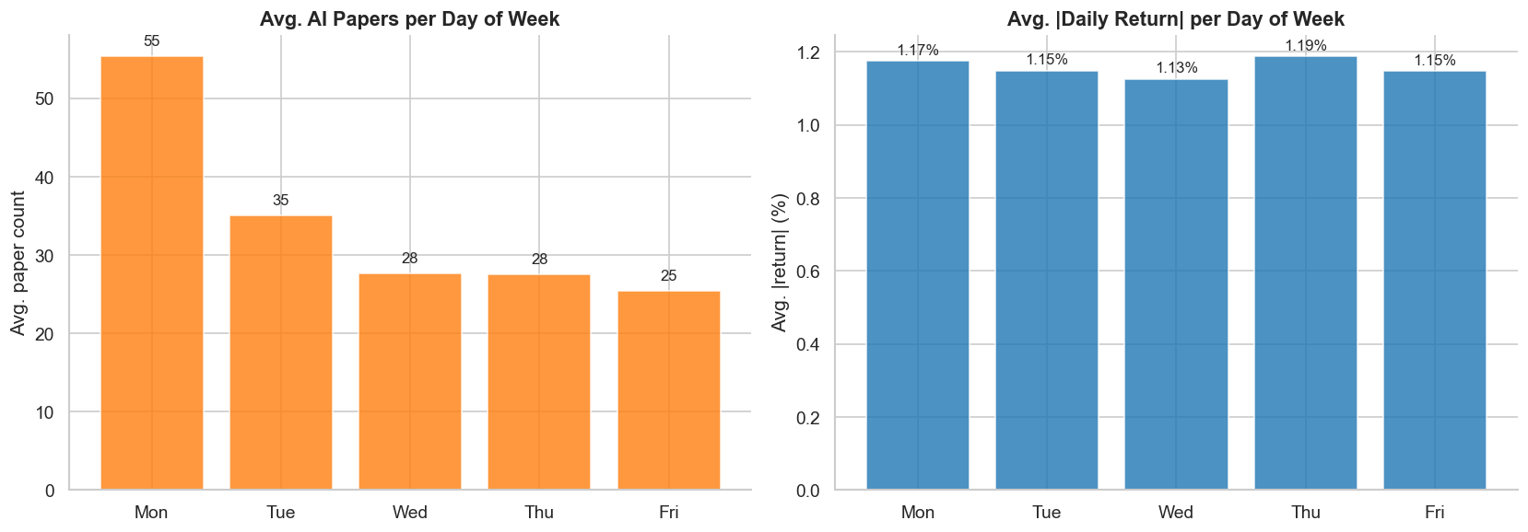
Figure 5. Average arXiv paper counts by day of week (left) and average absolute BOTZ returns by day of week (right).
Raw vs. Stationary Correlation
This is the most important plot in the EDA. The left scatter shows the raw correlation between the 30-day paper MA and BOTZ price (r = +0.49, p < 0.0001). The right scatter shows the stationary correlation between log-differenced paper counts and daily returns (r = −0.02, p = 0.32). The collapse from r ≈ 0.49 to r ≈ −0.02 after de-trending is the textbook definition of a spurious correlation.
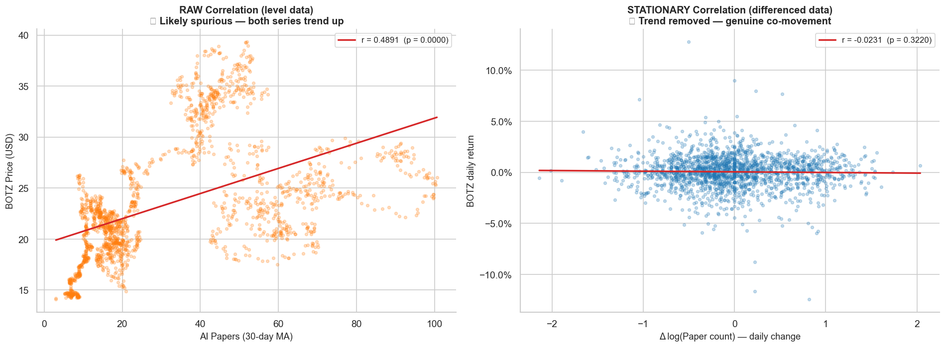
Figure 6. Scatter plots of raw levels correlation (left, r = +0.49, spurious) vs. stationary correlation (right, r = −0.02, genuine).

3. Hypothesis Testing
The hypothesis testing phase follows directly from the EDA finding that raw correlations are spurious. The formal tests are conducted on stationary versions of both variables: BOTZ daily percentage returns and log-differenced paper counts (Δlog (1 + count)).
Stationarity Tests
Before running any causality tests, both series were confirmed stationary using the Augmented Dickey-Fuller (ADF) test:
- BOTZ Daily Return: ADF statistic = −13.65, p < 0.0001, 8 lags (AIC) → Stationary
- AI Papers (log-diff): ADF statistic = −12.52, p < 0.0001, 22 lags (AIC) → Stationary

The stationarity dashboards below show the rolling mean and standard deviation for each series, along with ACF and PACF plots. Both series have flat rolling means and quickly decaying autocorrelations, confirming they satisfy the prerequisites for Granger testing.
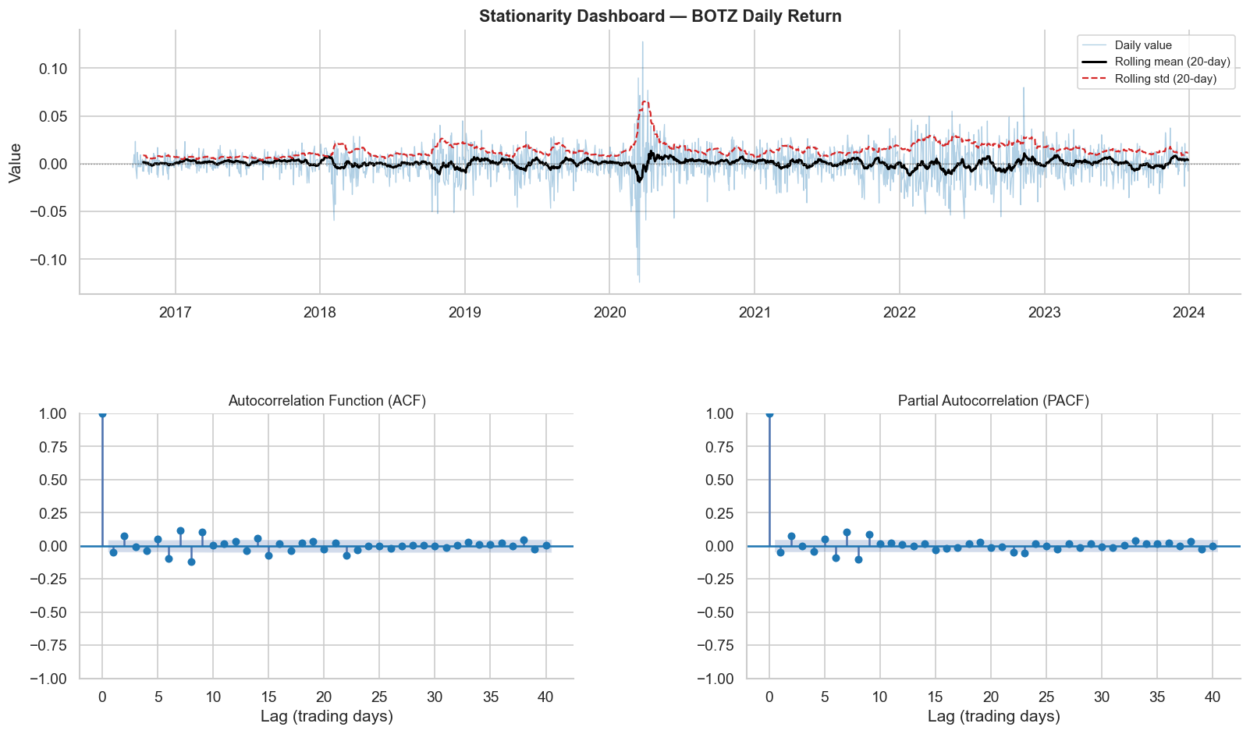
Figure 8. Stationarity dashboard for BOTZ daily returns: rolling stats (top), ACF and PACF (bottom).

Lag Selection
The number of lags to include in the Granger test was selected by fitting a Vector Autoregression (VAR) model and minimising AIC and BIC over a search range of 1–30 lags. AIC selected 18 days and BIC selected 9 days. Both optimal lags, as well as a range of economically motivated horizons (3, 5, 14, 30, 60, 90, 120, 180 days), were tested.
Granger Causality Results
Two directional hypotheses were tested:
- Hypothesis A — H₀: Past AI paper volumes do NOT Granger-cause BOTZ returns.
- Hypothesis B — H₀: Past BOTZ returns do NOT Granger-cause AI paper volumes.

The results across all tested lags are summarised in the visualisation below:
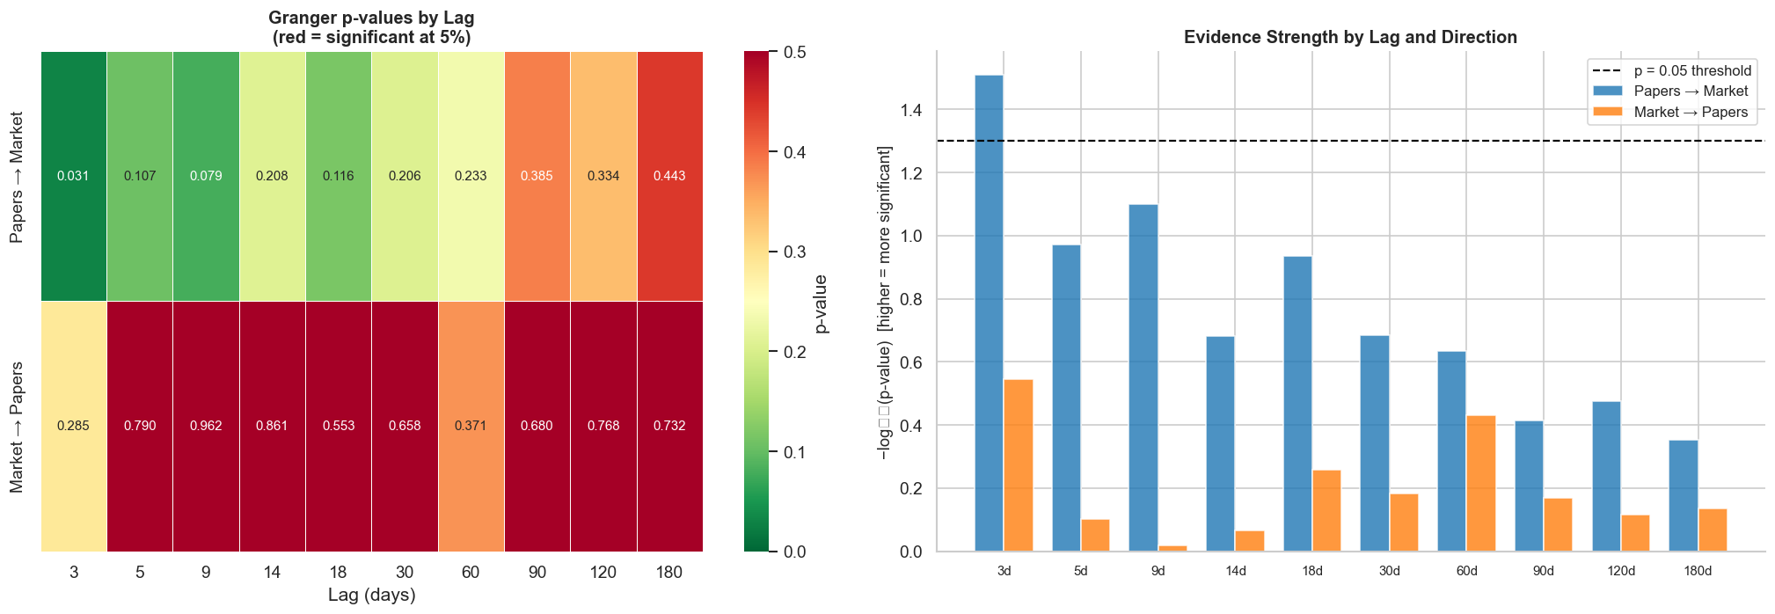
Figure 10. Granger causality results: p-value heatmap (left) and −log₁₀(p) bar chart (right) across all tested lags. Dashed line = α = 0.05.

Key results:
- Papers → BOTZ: Only the 3-day lag is significant (F = 2.97, p = 0.031). All other lags fail to reject H₀.
- BOTZ → Papers: Not significant at any tested lag (all p > 0.28). Market performance does not drive research output.
- Effect size: The 3-day lagged correlation is r ≈ −0.039, implying R² < 0.002. Paper counts explain less than 0.2% of the variance in daily returns. Statistical significance does not imply economic significance.

Lagged Scatter
The figure below visualises the 3-day lagged relationship directly. The left panel shows the contemporaneous scatter (r = −0.023), and the right panel shows the 3-day lagged scatter (r = −0.039). Even the significant relationship is visually indistinguishable from noise — which reflects the tiny effect size.
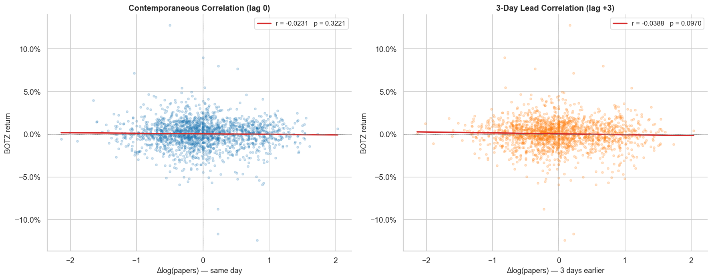
Figure 12. Contemporaneous scatter (left, r = −0.023) and 3-day lagged scatter (right, r = −0.039) between Δlog(papers) and BOTZ return.

Overall conclusion from hypothesis testing: the raw correlation is spurious, a very weak short-term Granger precedence exists at 3 days but is not stable across time, and there is no reverse causality. The relationship is not strong enough to support any practical forecasting or trading application.

4. Event Study — Landmark AI Publications
The event study examines whether individual milestone arXiv publications trigger measurable abnormal trading activity around the publication date. This is a more targeted question than the aggregate analysis above — even if daily paper counts carry no signal, a single breakthrough paper might move markets.
11 landmark AI publications were selected from September 2016 to December 2023, with a minimum 60-day inter-event spacing to prevent estimation window contamination. The events are Grad-CAM (Oct 2016), GCN (Mar 2017), Transformer (Jun 2017), BERT (Oct 2018), EfficientNet (May 2019), GPT-3 (May 2020), ViT (Oct 2020), CLIP (Feb 2021), LoRA (Jun 2021), AlphaFold 2 (Jul 2021), and GPT-4 Technical Report (Mar 2023).
Two metrics were computed for each event using a 110-day estimation window (t−120 to t−10):
- SCAV (Standardised Cumulative Abnormal Volume): measures abnormal trading volume relative to the BOTZ/QQQ volume ratio baseline.
- CAR (Cumulative Abnormal Return): measures abnormal return relative to a simple market model (BOTZ ~ α + β × QQQ), with the market benchmark controlling for broad tech sentiment.
Abnormal Volume
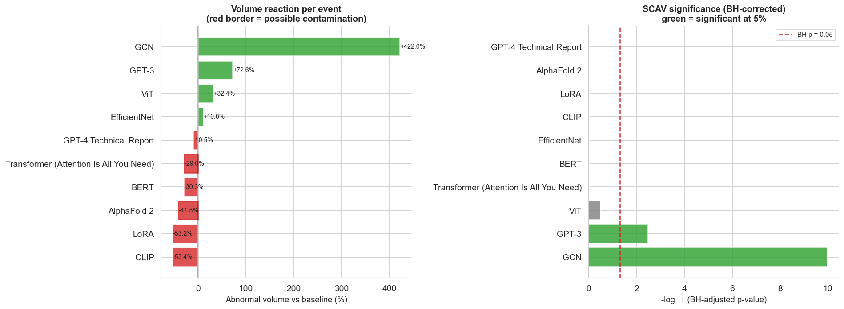
Figure 13. Abnormal volume (%) and SCAV z-scores for each event in the primary [−1, +1] window. Hatched bars = contaminated event.

Results for volume:
- GCN (Mar 2017): abnormal volume = +422%, SCAV = 6.69 → highly significant (BH-corrected p < 0.001)
- GPT-3 (May 2020): abnormal volume = +73%, SCAV = 3.21 → significant (BH-corrected p = 0.003)
- All other events: SCAV not significant after BH-FDR correction
- Aggregate Wilcoxon test (H₁: mean SCAV > 0): p = 0.577 → Fail to reject H₀
Cumulative Abnormal Returns (CAR)
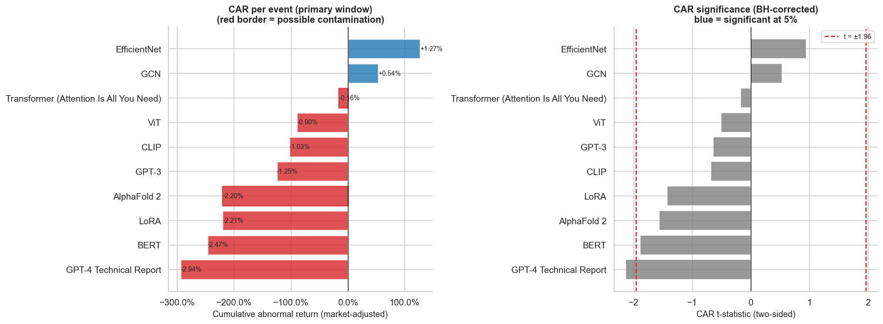
Figure 14. CAR (%) and t-statistics for each event in the primary [−1, +1] window.
Results for returns:
- No individual event produces a significant abnormal return after BH-FDR correction (minimum BH-adjusted p = 0.30)
- CARs are predominantly negative across events, ranging from −2.47% (BERT) to +1.27% (EfficientNet)
- Aggregate Wilcoxon test (H₁: mean CAR ≠ 0): p = 0.049 → Reject H₀ (primarily driven by negative CARs)
- Volume and return divergence: GCN and GPT-3 showed significant volume spikes but negligible price impact, suggesting increased trading activity without directional consensus
Multi-Window Robustness
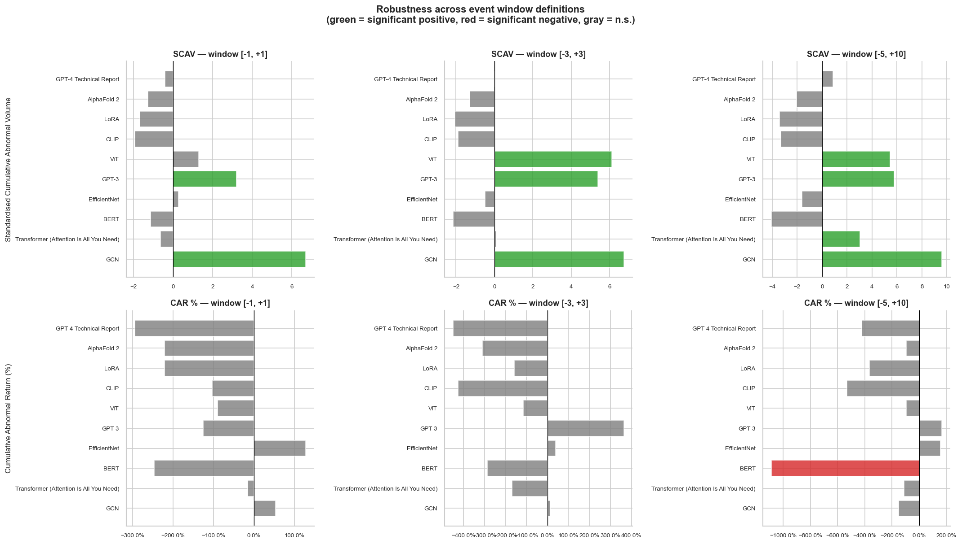
Figure 15. SCAV (top) and CAR (bottom) across three event windows: [−1,+1], [−3,+3], [−5,+10].

The number of SCAV-significant events grows from 2 in [−1,+1] to 4 in [−5,+10], suggesting trading attention persists for several days after a landmark publication. CAR remains mostly insignificant across all windows.
Average Event-Time Plot
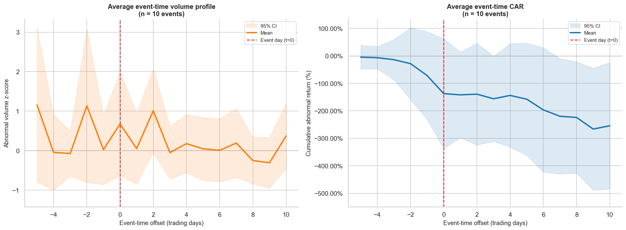
Figure 16. Average abnormal volume z-score (left) and average CAR (right) across all events in event time [t−5, t+10].

The average event-time plots show no systematic spike in volume at t=0 on average, and no clear directional drift in returns around the event date. This confirms that while some individual papers (GCN, GPT-3) generated large volume responses, the average effect across all 11 events is not distinguishable from noise.

5. Machine Learning Analysis
The machine learning phase asks whether non-linear models can extract a predictive signal that simple correlation and Granger analysis missed. The dataset was split chronologically 80/20 into a training set (Oct 2016 – Jul 2022, n = 1,445) and a held-out test set (Jul 2022 – Dec 2023, n = 362). TimeSeriesSplit cross-validation was used for all hyperparameter searches to prevent future data from leaking into training.
16 features were constructed from the master dataset:
- Paper-based: paper counts at lags 1/3/5/10 days, 7-day and 30-day moving averages, paper momentum (MA7 − MA30), log-differenced paper count
- Return-based: return at lags 1 and 5 days, absolute return lag 1 (volatility proxy)
- Calendar: day-of-week dummies (Monday through Thursday) to capture arXiv deadline effects
Feature Correlations with Target
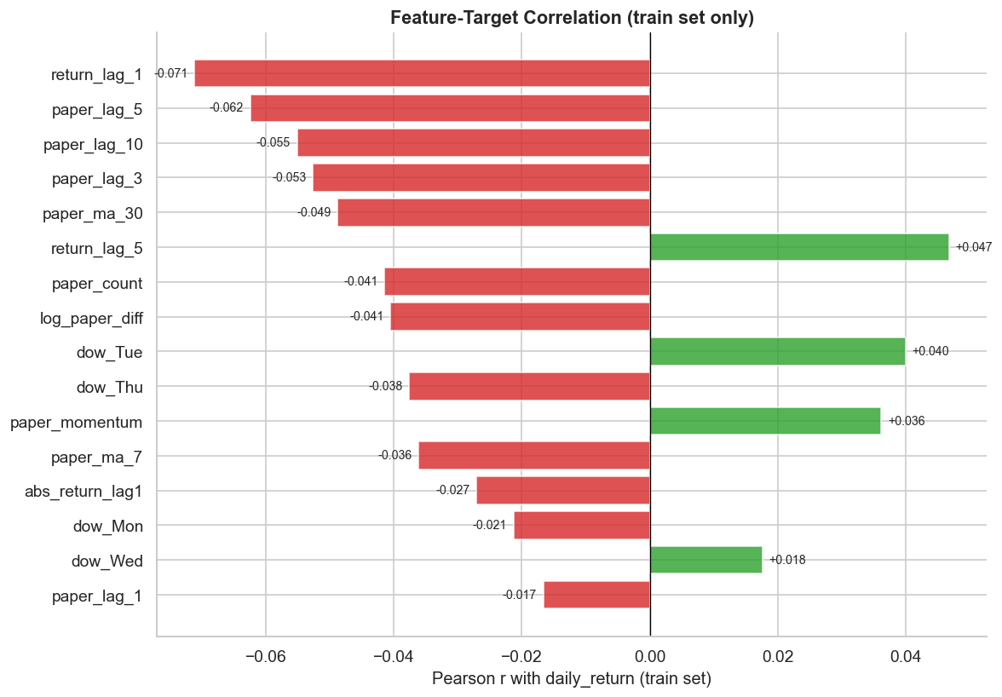
Figure 17. Pearson correlation of each feature with the next-day BOTZ return. Paper-based features are all near zero.

Return lag features have the highest (though still modest) correlations with the target. All paper-based features show correlations close to zero, directly confirming the HT findings at the individual feature level.
Regression Results
Five regression models were trained and evaluated on the held-out test set. Results:
- XGBoost: RMSE = 0.01650, R² = −0.027 (best performer)
- Random Forest: RMSE = 0.01668, R² = −0.049
- SVR (best kernel: linear): RMSE = 0.01681, R² = −0.066
- Linear Regression: RMSE = 0.01691, R² = −0.078
- LSTM (10-day sequences): RMSE = 0.01762, R² = −0.171 (worst)

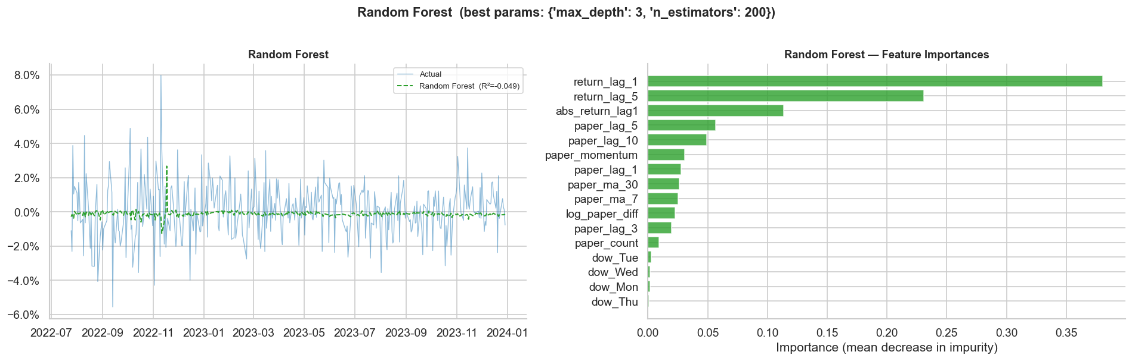
Figure 18. Random Forest regression: actual vs. predicted returns (left) and feature importances (right).

All five models produced negative R² on the held-out test set, meaning every model performs worse than simply predicting the mean return each day. XGBoost and SVR converged to shallow/wide configurations, consistent with a high-noise, low-signal dataset. The LSTM training loss converged smoothly, ruling out a training failure — the bottleneck is feature quality, not model architecture. Random Forest assigned 72.4% of importance to return-based features and only 26.8% to paper-based features, effectively ignoring the arXiv data.
Classification Results
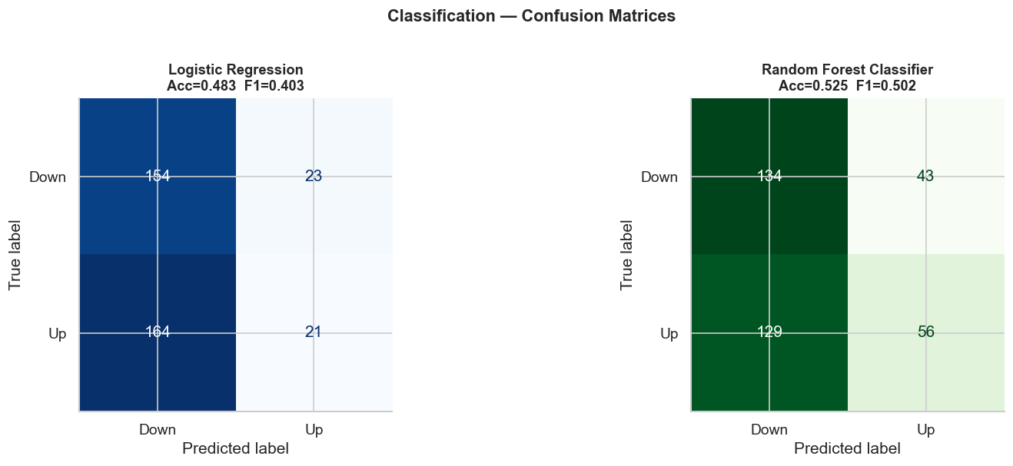
Figure 19. Confusion matrices for Random Forest Classifier (left) and Logistic Regression (right).

Classification results:
- Random Forest Classifier: accuracy = 52.5%, Macro F1 = 0.502 — marginally above the 50% random-guessing baseline
- Logistic Regression: accuracy = 48.3%, Macro F1 = 0.403 — below baseline due to strong class-prediction bias toward "Down"
- Neither model demonstrates reliable directional forecasting ability
K-Means Clustering
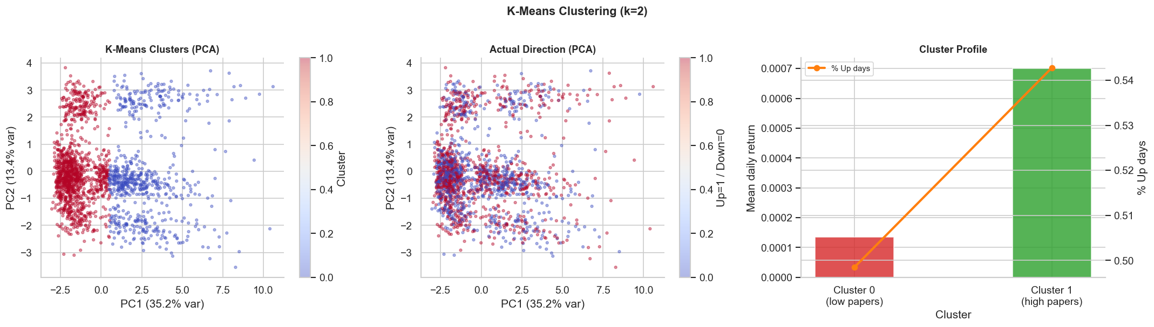
Figure 20. K-Means clustering: PCA projection of 2-cluster solution with mean return and paper count profiles per cluster.
K-Means with k = 2 (selected by elbow method and silhouette score = 0.266) discovered two regimes driven primarily by publication volume:
- Cluster 0 (High-Publication, 650 days): avg 63.4 papers/day, mean return = +0.013%, 49.8% up-days
- Cluster 1 (Low-Publication, 1,157 days): avg 17.9 papers/day, mean return = +0.070%, 54.3% up-days
- Adjusted Rand Index vs. market direction = 0.0024 → clusters do not align with Up/Down returns
- The mildly higher returns on low-publication days may reflect a lag effect: by the time a flood of papers arrives, the market has already priced in the underlying AI developments

Model Comparison Dashboard
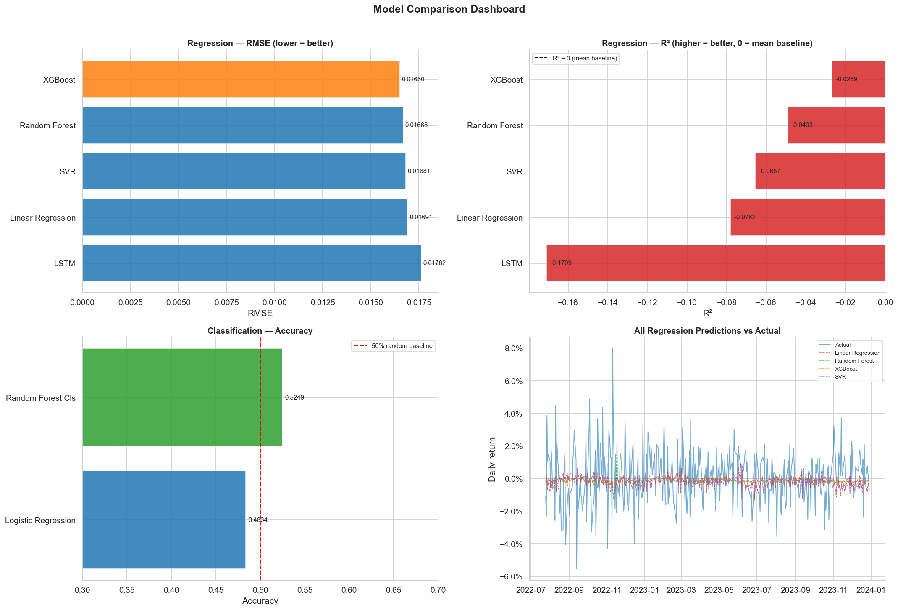
Figure 21. Full model comparison: regression RMSE and R² (top), classification accuracy and F1 (bottom).

6. Conclusion
This project set out to answer one question: does the daily volume of AI research publications on arXiv contain a predictive signal for the performance of the BOTZ ETF? The answer, across four complementary analytical phases, is no — at least not at a level that is economically meaningful or practically exploitable.
The raw correlation between paper counts and ETF price (r ≈ 0.49) is a textbook spurious correlation, entirely explained by two series that both happen to trend upward from 2016 to 2023. Once trends are removed, the correlation collapses to r ≈ −0.02. A weak 3-day Granger precedence survives formal testing (p = 0.031) but explains less than 0.2% of return variance and is not stable across different market sub-periods. Machine learning models of every type — linear, tree-based, kernel-based, and deep learning — produce negative out-of-sample R², confirming there is no exploitable non-linear structure either. The event study shows that a handful of landmark papers (GCN, GPT-3) briefly spike trading volume but produce no significant abnormal returns after controlling for broad market movements.
These results are fully consistent with the semi-strong form of the Efficient Market Hypothesis: arXiv paper counts are publicly available information that is rapidly incorporated into prices. By the time a paper appears on arXiv, the underlying research development has likely already influenced the expectations of informed market participants.
Limitations of the study include:
- Only paper count was used as a signal — sentiment analysis or topic modelling of abstracts might carry richer information
- No macroeconomic control variables (VIX, interest rates, sector rotation indices) were included, which may introduce omitted variable bias
- The Granger test assumes linear relationships; non-linear threshold effects during AI hype cycles are not captured
- Event dates are arXiv submission dates, not the dates when investors first learned about the paper — this mismatch attenuates the measured event effect
- The event study sample is small (n = 11), limiting statistical power

Future directions could include abstract-level NLP features, weekly aggregation to reduce daily noise, cross-asset testing (e.g. NVIDIA, ASML), and extending the sample to post-2023 to cover the large language model era more fully.

7. References
Data Sources
- BOTZ ETF daily price data: Yahoo Finance via yfinance Python library (Ticker: BOTZ, Sep 2016 – Dec 2023)
- arXiv cs.AI paper metadata: arXiv OAI-PMH API via sickle Python library (set: cs:cs:AI, 2016–2023)

Python Libraries
- pandas, numpy — data wrangling and feature engineering
- matplotlib, seaborn — visualisation
- scipy.stats, statsmodels — ADF test, Granger causality, VAR model, BH-FDR correction
- scikit-learn — Linear/Logistic Regression, Random Forest, SVR, K-Means, TimeSeriesSplit
- XGBoost — gradient boosted trees
- PyTorch — LSTM sequence model
- yfinance — market data retrieval
- sickle — OAI-PMH harvesting

