



Essay / Assignment Title: Developing an End-to-End Big Data Pipeline Using Hadoop, Spark, Hive, and MLlib

Programme title: MSc Data Analytic

Name: Mert Efe Akillioglu

Year: 2025/2026

TABLE OF CONTENTS

TABLE OF CONTENTS 2
List of Figures 3
Problem Definition and Business Context 5
Environment Setup and Data Storage 8
2.1 Dataset Source and Accessibility 8
2.2 Platform Preference and System Architecture 8
2.3 Cluster Configuration 9
2.4 Creating a Hive Table and Preparing the Data Set 10
3. Data Processing with Spark and Hive 11
3.1 Data Transformation and Analysis with Spark 11
3.2 Data Transformation and Analysis with Hive 13
3.3 Spark vs Hive Comparison 16
4. Advanced Analytics and Machine Learning 18
4.1 Random Forest Classifier 18
4.2 Feature Engineering 18
4.3 Performance evaluation of model 19
4.4 Features Importance 20
4.5 Visualisations 20
4.6. Relating with Business Problem 20
5. Reflection and Recommendations 21
5.1 Challenges Encountered 21
5.2 Suggestions for Improvement 21
5.3 Environment Comparison: Cloud, Docker, Local IDE 22
BIBLIOGRAPHY 23
APPENDIX 24

List of Figures

Figure 1 Roc Curve and Confusion Matrix 19

Statement of compliance with academic ethics and the avoidance of plagiarism

I honestly declare that this dissertation is entirely my own work and none of its part has been copied from printed or electronic sources, translated from foreign sources and reproduced from essays of other researchers or students. Wherever I have been based on ideas or other people texts I clearly declare it through the good use of references following academic ethics.
(In the case that is proved that part of the essay does not constitute an original work, but a copy of an already published essay or from another source, the student will be expelled permanently from the program).

MERT EFE AKILLIOGLU

Date: 17/06/2025

Problem Definition and Business Context

Data has emerged as an important asset with the digital transformation in the way cities are being planned and how urban transportation is being managed. Such characteristic of Big Data in the transportation sector in particular is associated with the fact that the volumes of data created to provide the analysis of traffic accidents or road conditions under consideration are too big, fast, various and complicated to process with the help of the traditional approaches.
Big data is usually unstructured or semi-structured and this data is processed by applying latest technologies to make the valuable information out of it. Big data analysis requires machine learning, artificial intelligence, and distributed data processing systems as the basics. Over recent years, the paradigm of road safety studies has changed in that reactive solutions are no longer relevant towards road safety and instead prove the use of artificial intelligence and machine learning as predictive and preventive solutions (Alkinani and Alabdulatif, 2023).
Particularly, big data analytics and machine learning approach can be utilized in providing insights about the cause, severity of the effects of traffic accidents. Information like time and date of road accidents, the location of the accident, weather conditions, roads, vehicles in the accidents and how long the accident lasted can give us good information. Research in this area reveals the excellent potential of big data solutions in resolving issues like the volume and velocity of traffic accidents (Alkinani and Alabdulatif, 2023).
The purpose of this project will be to derive informative results with the help of big data analytics and machine learning tools. In this regard, the data employed in the project is referred to as the US Accidents was downloaded on Kaggle. The size of the dataset is about 3.1 GB, and it includes over 7.7 million traffic accidents data. It contains numerous specific variables including the location data at the moment of accident, date, time, conditions of the road, weather conditions and the length of the matter. This dense structure also renders this dataset to be used in the definition of big data in its volume and diversity. Examples of useful decisions that can be made with the help of the obtained information include accident prediction, enhancement of traffic safety, and planning of the infrastructure.

The primary difficulties associated with the work with data are caused by different factors that need to be managed properly in case of big data analysis:
Volume: Traditional systems cannot handle the collection, storage and processing of large volumes of data. There is a technical challenge of scalable and high performance infrastructure to analyze traffic accidents.
Variety: Data sets of different sources are structured, semi-structured, and unstructured, which makes the process of data integration and analysis difficult. Traffic accident data in various formats should be analysed with the help of special solutions.
Velocity: The continuing and fast data generated is equally a big challenge, especially in the on time data analysis program. In order to be able to perform analysis on this information and generate some meaningful results, companies will need to use complex data processing techniques, which are capable of working with this information in real-time.
Ethics and Privacy: Privacy and security of the data when using personal information related to traffic accidents is linked to the issue of data privacy, security and ethics. This is a vital activity and it is necessary to guard data adequately and ensure that laws are put into practice (Kitchin, 2014).
This project used a Dataproc infrastructure on Google Cloud Platform (GCP) which runs on Spark. This has improved the power of big data analysis because of its advantages which entail scalability, fast processing of data and cloud optimisation.
Data analysis was done using techniques like Spark SQL, HiveQL and Random Forest. Complex queries in big data were processed with the help of Spark SQL and HiveQL, and the Random Forest algorithm was utilized to predict the impact of traffic accidents and analyze them with the help of machine learning techniques. Machine learning algorithms, especially ensemble techniques, like Random Forest and XGBoost, show high-level accuracy rates in predicting both severity and causes of traffic accidents (Korkmaz, 2024).
So it was achieved by combining the bulk data processing and machine learning strategies resulting in a complete data analysis and significant insights associated with traffic safety were derived.

Environment Setup and Data Storage

The large-scale analysis of traffic accidents was conducted in this project using the open data set named US Accidents (2016-2023). The data file is about 3.1 GB large and has more than 7.7 million records. Effective analyses of such large dataset necessitate the need of cloud-based, scalable systems which feature parallel processing. Thus, the configuration of the analysis process was done at the Google Cloud Platform (GCP).

2.1 Dataset Source and Accessibility
With regards to this project, we worked with the dataset labeled the US Accidents (2016 projections through 2023) available on Kaggle. This is a rich, complete dataset with more than 7.7 million records on the traffic accidents that happened in 2016-2023, and this will be a suitable dataset to analyze in large scale. Every entry in the record is well information with the coordinates of the location, time and date, road condition, weather and the duration of the case.
The data, which is in the form of CSV, was loaded into a Google cloud storage (GCS) bucket, called us-accidents bucket-g6. We directly loaded the CSV file to the PySpark DataFrame in GCS by converting CSV file to the DataFrame using the read.csv() function.

2.2 Platform Preference and System Architecture
In this project, an Apache Spark and Apache Hive component of Dataproc cluster was operated on the Google Cloud Platform (GCP) to implement a big data analysis in machine learning operations. This architecture took the advantage of robust parallel processing ability of Spark whilst offering effective data storage integration with Google Cloud Storage (GCS). They were compared to the benefits provided by Spark and GCS rather than on the traditional Hadoop elements (HDFS, YARN).
Apache Spark was selected due to in-memory property as it facilitated a speedy and fast process of manipulating huge amounts of data on traffic accidents in the project. This has made it possible to achieve high performance with low latency to enable filtering, groups and machine learning operations within a short period of time. The user-friendly nature of the PySpark API also simplified programme development and data processing tasks, accelerating the workflow. These features of Spark played a key role in meeting the project's expectations for fast and efficient results.
Cluster resources were optimised according to the processing needs of different stages of the project. In particular, nodes with low RAM were preferred due to the resource limitations offered by GCP's free trial version.

2.3 Cluster Configuration
The Dataproc cluster used from the beginning of the project was configured in two main phases to accommodate different processing loads:
Data Analysis and General Processing Phase: During the first steps of the data, the following cluster setup was utilized to fulfill general data analysis tasks like data exploration, cleaning and Hive queries:
Master Node: n1-standard-2 type of machine (2 vCPU, 7.5 GB memory).
Workers: 2 n1-standard-2 machine (type 2 vCPU, 7.5 GB memory).
Disk Space: Each worker node was constituted of 100 GB permanent disk space.Machine Learning Model Training Phase (Random Forest): For training the Random Forest machine learning algorithm, which requires more intensive computation, the same Dataproc cluster was resized. This optimised model training times:
Master Node: n1-standard-4 machine type (4 vCPUs, 7.5 GB memory). The processing power of the master node has been increased to better manage complex modelling processes.
Worker Nodes: 3 n1-standard-4 machine types (each with 4 vCPUs and 7.5 GB of memory). Increasing the number of worker nodes and using more powerful machine types has increased parallel processing capacity.
Disk Space: 200 GB of persistent disk space has been allocated for each worker node. This increased disk capacity has improved I/O performance, especially when working with large data
All data sets used in the project were loaded into the system using Google Cloud Storage (GCS) buckets, Google Cloud Platform's scalable and secure storage service. This strategy not only enabled Dataproc clusters to access data directly and quickly but also provided high flexibility in terms of data management and accessibility. GCS served as the primary storage layer for distributed processing frameworks such as Spark and Hive in the Dataproc environment.

2.4 Creating a Hive Table and Preparing the Data Set
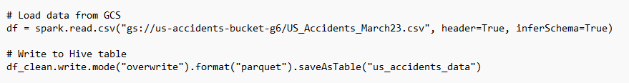
In order to make the data set accessible in an optimised format in the Hive environment for analysis and machine learning, the raw CSV data in GCS was read, cleaned, and written to a Hive table named us_accidents_data. This process improved query performance by storing the data in Parquet format.
Queries via Hive:
Start_Time: Shows the start time of the accident.
End_Time: Shows the end time of the accident.
State: Indicates the state where the accident occurred.
City: Indicates the city where the accident occurred.
Weather_Condition: Describes the weather conditions at the time of the accident.

3. Data Processing with Spark and Hive

3.1 Data Transformation and Analysis with Spark
Spark, with its ability to perform parallel processing on big data, has been used in data cleaning, transformation, and analysis steps. The following operations have been performed via PySpark:
- Total record count
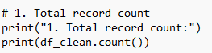
- Accidents in March 2023
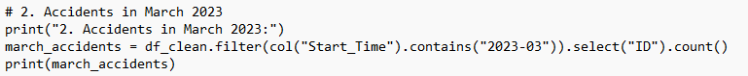
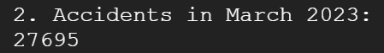
- Accidents per state
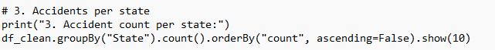
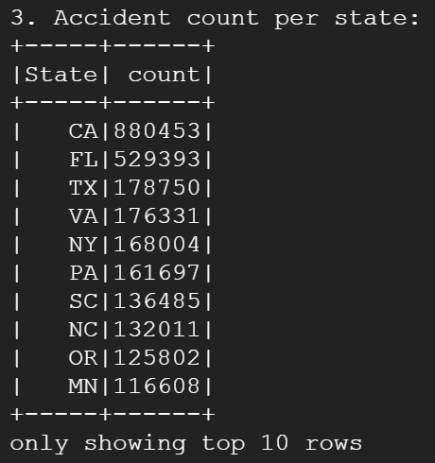

- Average accident duration
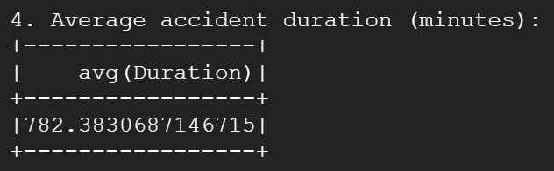
- Top 5 cities with most accidents
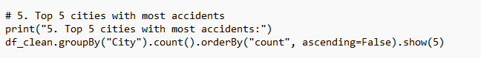
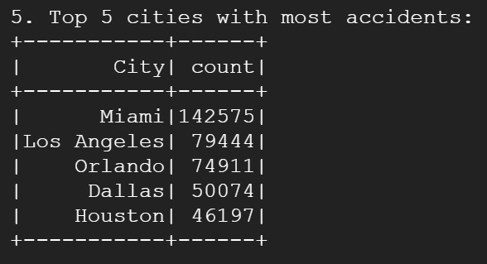
- Accidents in rainy weather
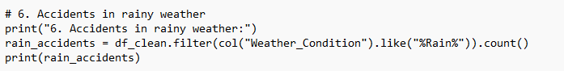
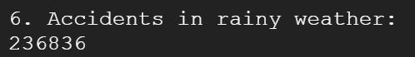
Observations
PySpark was used to perform fast calculations on high-volume data.
Data could be dynamically filtered and transformed.
PySpark's DataFrame API was highly flexible and performed well.

3.2 Data Transformation and Analysis with Hive

- Total record count
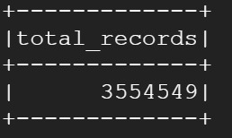

- Accidents in March 2023
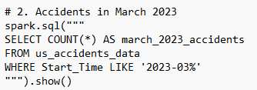
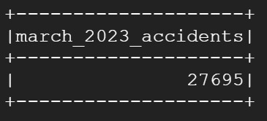
- Accidents per state
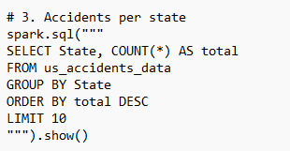
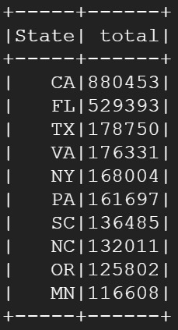

- Average accident duration
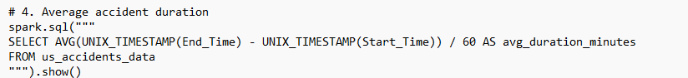
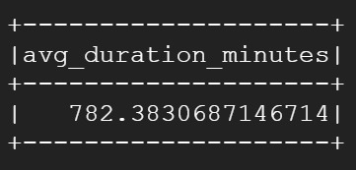
- Top 5 cities with most accidents
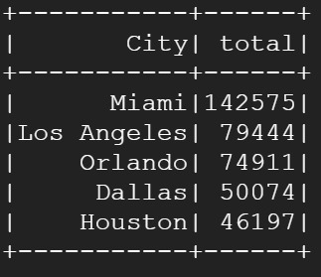
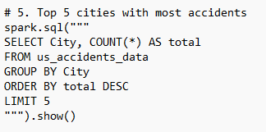

- Accidents in rainy weather
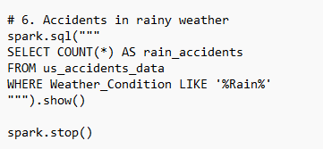
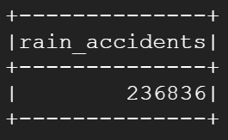
Observations
Hive provides quick and readable summary statistics related to data.
It facilitates processing with SQL-like expressions in big data.
It is less flexible than Spark but more user-friendly.

3.3 Spark vs Hive Comparison
Comparing Spark and Hive, it can be observed that the two systems provide comparable results under the same data set; i.e. consistent and reliable. There is a complete correspondence between the output of Hive and Spark on all the criteria including the total number of records, number of accidents in the month March 2023, accident that took place in rainy weather, distribution of accidents by states and by city and average duration of accidents. In our case, 3,554,549 records would be reported in both systems. The 27,695 accidents that composed the accidents in March 2023, 236,836 accidents in rainy weather as well as the average time of accidents that is around 782.38 minutes are all exactly the same. Moreover, the results of country and city-scale analysis were identical regarding the number of accidents in the city and the most accident-prone destinations; the cities reporting the highest and the number of accidents were Miami, Los Angeles, and Orlando. These consistencies show that the data has been processed correctly in both systems. Technically, however, Spark provides a better performance since it does in-memory work and Hive has a more traditional structure, disk-based. Spark can query much faster, particularly when querying large data sets, and can also be used to perform more advanced analysis with flexible APIs with the use of programming languages (like Python and Scala). To conclude, the two systems are identical in attributes of data accuracy, but in terms of performance and flexibility of development, Spark can be applied.

4. Advanced Analytics and Machine Learning
During this stage, a machine learning model was created on the big data with the help of Apache Spark. The core desire of the project is to forecast the tendency whether a traffic accident will be more than two hours. This is a binary type of classification problem.

4.1 Random Forest Classifier
The machine learning algorithm that was selected is RandomForestClassifier of the Spark MLlib library. The random forest algorithm uses the ensemble model whereby there are more than a single decision tree in it. The key benefits of this algorithm are high accuracy, adversity to overlearning and interpretability of the outputs.
Some modifications of hyperparameters were done in order to enhance the models performance. The decision trees were fixed at 100, consequently enhancing the learning ability of the model. The depth of the trees was amped at 10, which meant the model would not be too complicated, falling into the trap of overlearning. Also, there were setups of the maxBins value to 200 so that the categorical variables can be processed in a more detail way.
Due to these configurations, the model generated higher accuracy and more balanced classification measurement than the baseline model.

4.2 Feature Engineering
The feature engineering analysis that preceded the model, rendered the data more meaningful and processable. To begin with, the event duration was computed and a label column developed based on whether that time was more than two hours or not on each of the accident records. This variable was the label that the model was predicting.
Time information was refined and new attributes acquired. These were the data on what time the accident occurred, the day of the week, and whether the occurrence occurred on a weekend. Measurements such as severity, temperature, humidity, visibility and wind speed were among the numerical variables. The model held these variables after the missing data tests.

One of the categorical variables, Weather_Condition, was transformed into numeric format by use of StringIndexer and presented in a manner understandable by the model. All these features were transformed into one feature vector through VectorAssembler and the model was ready to be trained.

4.3 Performance evaluation of model
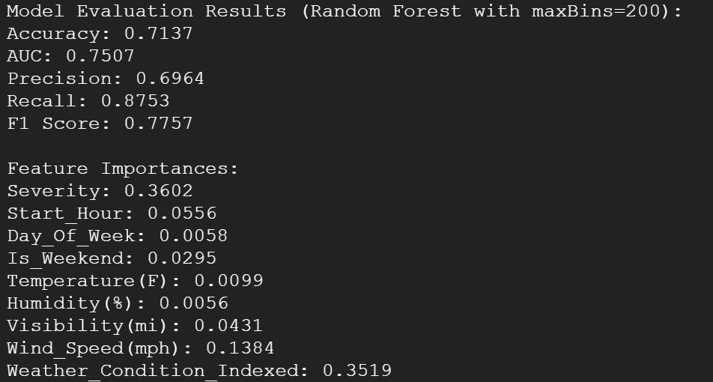
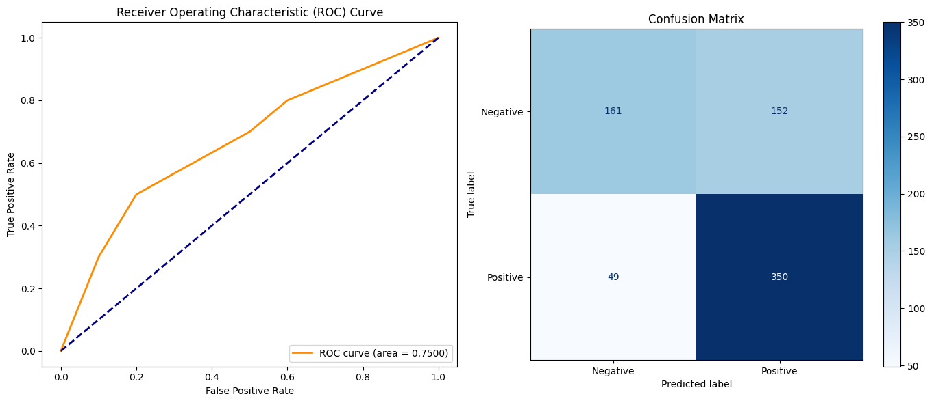
Figure 1 Roc Curve and Confusion Matrix

The model was tested by using diverse metrics of classification. Based on the results achieved, the accuracy of the accuracy was about 0.7137. The value of area under the ROC curve (AUC) is 0.7507 which is good with respect to the overall discrimination of the model. The precision and the recall were 0.6964 and 0.8753 respectively. It indicates that with a high success, the model can identify accidents that take more than two hours, and especially the positive class of accidents. Its f1-Score equal to 0.7757 means that the model produces balanced predictions accurately.

4.4 Features Importance
A Random Forest model can calculate how much contribution each variable can make to the forecasting performance. Accident severity, weather condition and wind speed were the most significant features identified by this model in the given project. It was noted that these are variables that mostly lead to the accidents taking longer. The other considerations are time and environmental characteristics like time of the accident, visibility and whether the accident was at weekend.

4.5 Visualisations
Outcomes of the model were copied to Google Colab and several visualization were generated. ROC curve illustrates the graphical presentation of performance of the classification of the model. The model has several correct and incorrect classes which are visualised with the assistance of Confusion Matrix. Besides, attribute importance levels are in graph form to indicate clearly the variables that contribute to the model and to what magnitude. Such visualisations allow concluding that the model is consistent both regarding the business logic and technically successful.

4.6. Relating with Business Problem
The model that has been developed can forecast the duration of accidents in the traffic. It will allow planning of resources well advanced and route optimisation of municipal teams, emergency response units or navigation service providers. In this respect, the achievement of data science is not only a technical accomplishment but also a direct input of operation decision support functions.

5. Reflection and Recommendations

5.1 Challenges Encountered
There were technical and operation challenges that were faced in the project. The size of the data was the most significant among them. The information amounting to 3.1 GB and comprising 7.7 m rows of data was beyond the capacity of local machines to process. So cloud based solution like Google Cloud Dataproc was favored preferably.
Upon using the Random Forest algorithm, maxBins parameter received an error of limit of categorical features value and this parameter could not have received its default value. The solution of this issue lies in the modification of the maxBins value to 200. Also the model preparation and the analysis procedures were at times longer than Forty-five minutes." The intermediate results were taken regularly in order to make certain that these processes could not be interrupted.
In the course of feature engineering and data cleaning, the data with time information, weather etc., could not be dealt with automatically. These were some of the steps which were crucial processes which directly influenced the achievement of the model.

5.2 Suggestions for Improvement
To enhance the success of the project, there are some recommendations that may be proposed. To begin with, weather data may be processed more thoroughly. As an example, storms, fog or snow are special conditions that can be modelled as an independent variable. Moreover, there might be other variables like the traffic density or other kinds of road included into the model.
Hyperparameter optimisation can be done, using techniques like Grid Search or Random Search. These operations can be enabled on small sample datasets using libraries like scikit-learn since spark MLlib does not support this. Comparison between models on other algorithms will also serve performance evaluation purposes. Particularly, such as XGBoost, logistic regression or artificial neural networks can be used to conduct comparative analyses.

Moreover, the developed model results of prediction can be in a form of API. In such a way, greater area of usage may be achieved through the offer of integration in real-time applications.

5.3 Environment Comparison: Cloud, Docker, Local IDE
It compared the various development environments applied in the project. The cloud-based systems were beneficial in big data processing capacity and automatic scaling. Docker environment can be valuable when running tests on the side of developers or when the application needs to be transported across platforms, and local IDE like Jupyter and Google Colab are more conducive in situations involving training and prototyping. Google Cloud Dataproc environment has proven to be the most appropriate in the case of this particular project given the size of data and the computing capacity required. Spark, Hive and MLlib tools were effectively applied in a syndicated way on this platform.

BIBLIOGRAPHY

Alkinani, M. & Alabdulatif, A., 2023. Road Car Accident Prediction Using a Machine-Learning-Enabled Data Analysis. Sustainability, 15(7), p. 5939.
Kitchin, R., 2014. The Data Revolution: Big Data, Open Data, Data Infrastructures & Their Consequences. Sage Publications.
Korkmaz, H., 2024. Prediction of Traffic Accident Duration Based on Vehicle Accident Data. PhD Thesis, Istanbul University Institute of Science.

APPENDIX

https://www.kaggle.com/datasets/sobhanmoosavi/us-accidents
https://colab.research.google.com/drive/1zUWUwXX7JFGdwk6slxJxKRdKpVM64bnd
https://github.com/mertefeakillioglu/BDA-MERT-EFE-

