**Q2)**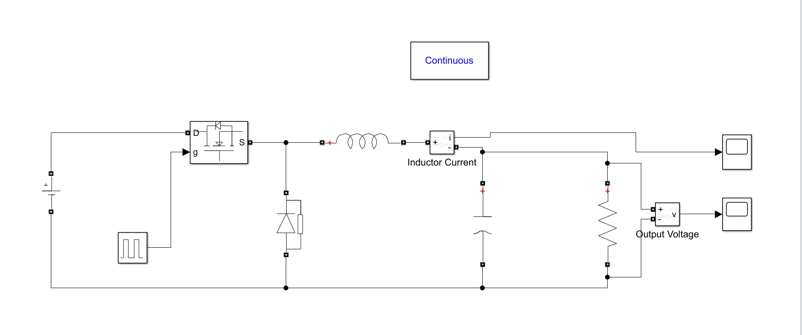

Figure : The circuit schematic of Buck Converter

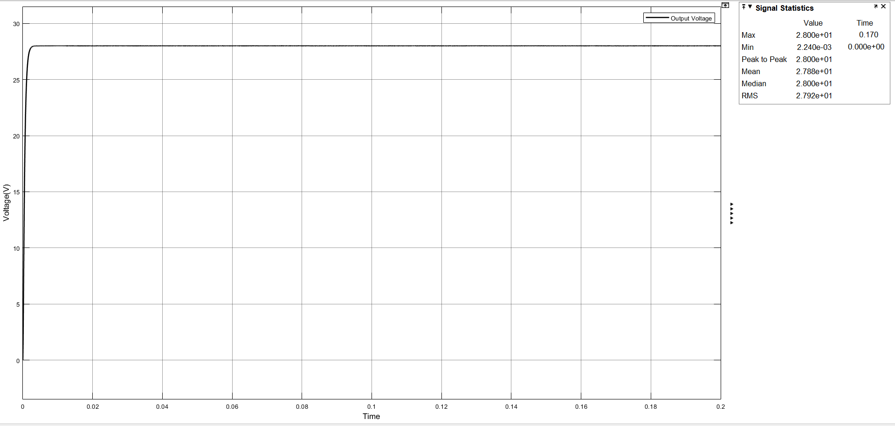

Figure : The simulation result for output voltage

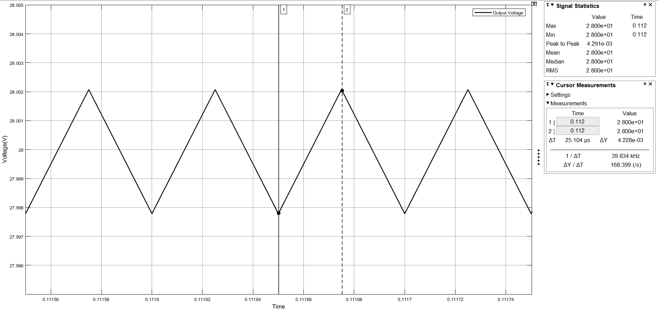

Figure : The simulation result for output voltage at steady state

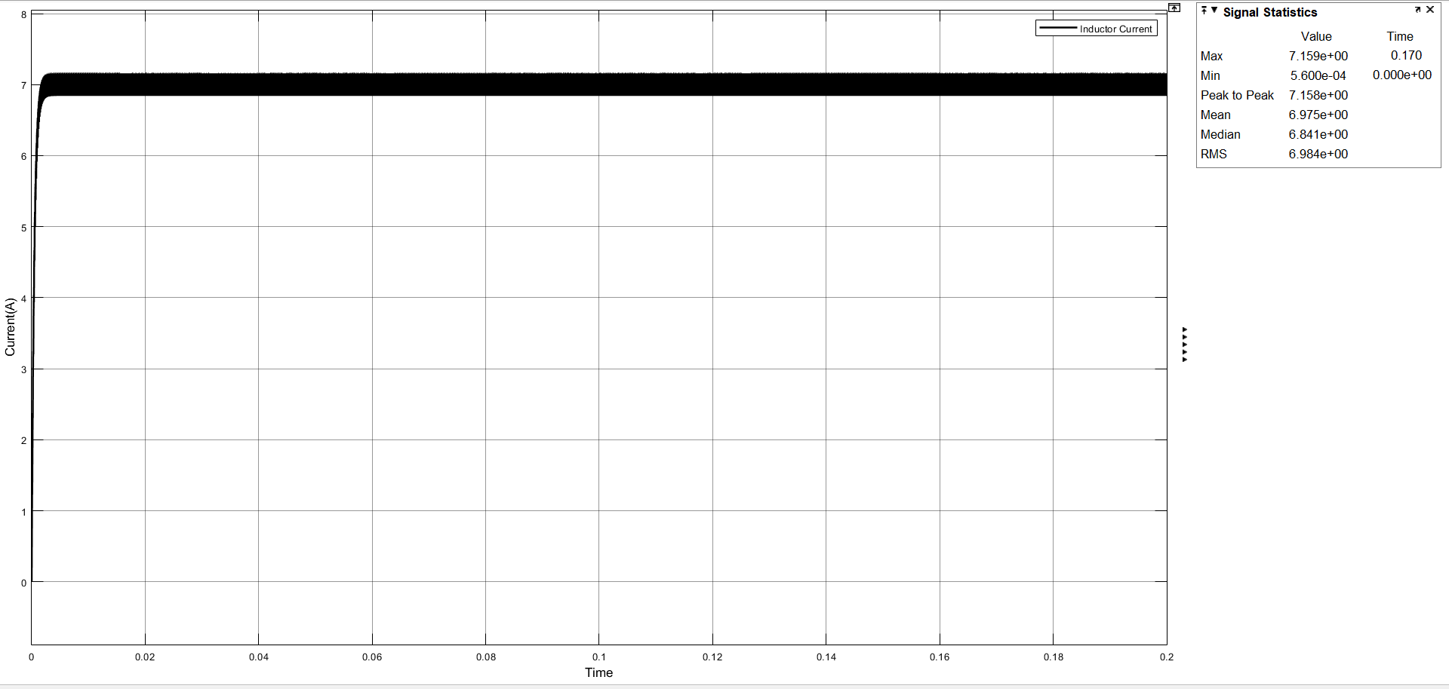

Figure : The simulation result for inductor current

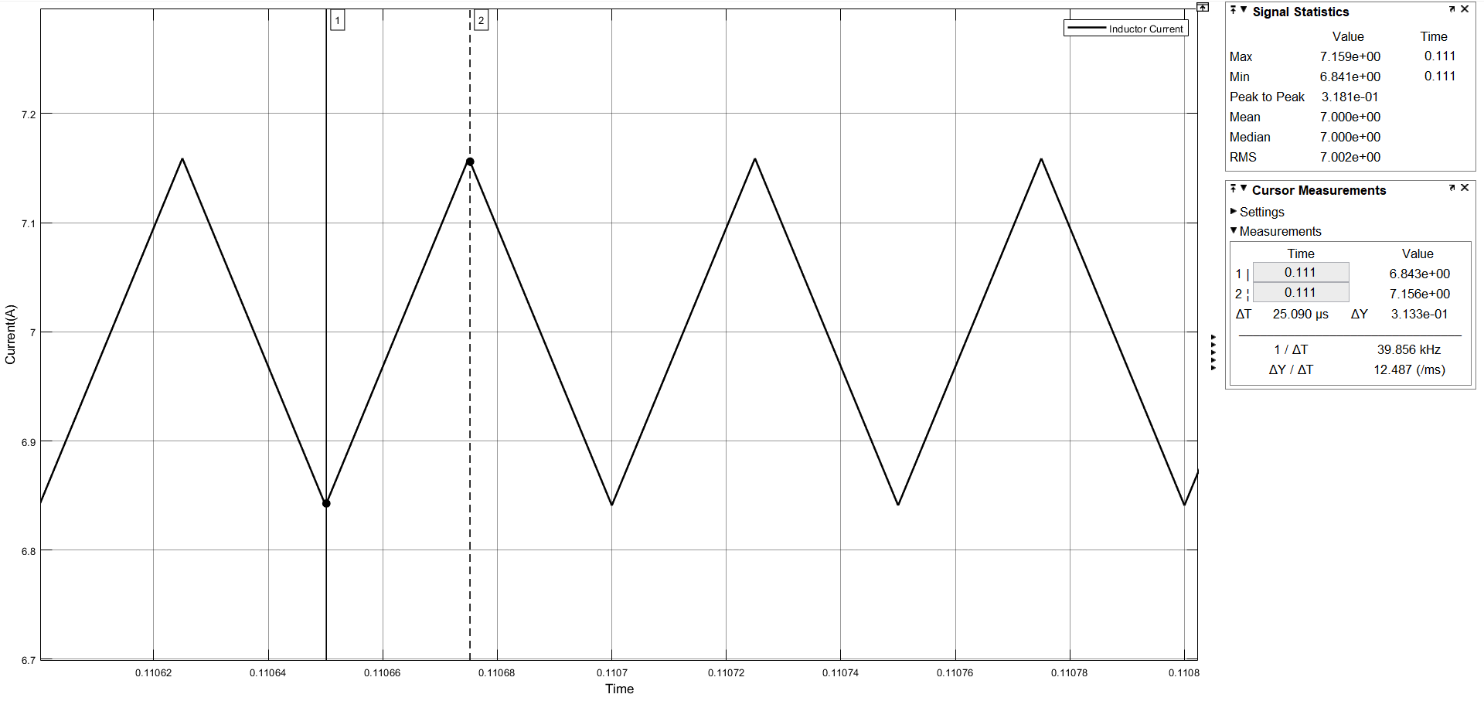

Figure : The simulation result for inductor current at steady state

**Specifications:**

-Load (R) : 4 Ohm

-Input Voltage (Vin) : 56V

-Output Voltage (Vout) : 28V

-Switching Frequency (fs) : 20kHz

-Inductor Current Ripple (∆IL) : ~ 300mA

-Output Voltage Ripple (∆Vout) : ~ 4mV

(∆Vout) = where Ts : switching period and D: duty cycle

We designed our buck converter circuit with respect to equation given above and selected switching frequency as 20kHz . Also,inductor and capacitor values in our design:

L = 2.2 mH

C = 22 uF

**Circuit Elements**

- Inductor

Mouser Part No: [AISR-01-222J](https://eu.mouser.com/ProductDetail/ABRACON/AISR-01-222J?qs=sGAEpiMZZMsg%252by3WlYCkU8J7Iu4O7azjw%2fMd%2f%2fMfLeo%3d)

Manufacturer Part Number: AISR-01-222J

DC Resistance: 43 mOhms

Cost: 0,987 € ( $1.13 )

- Capacitor

Digi-Key Part Number: [493-15394-ND](https://www.digikey.com/product-detail/en/nichicon/UKL1J220KPD/493-15394-ND/2598504)

Manufacturer Part Number: UKL1J220KPD

Cost: $0.56

- Diode

Digi-Key Part Number: [497-7544-5-ND](https://www.digikey.com/product-detail/en/stmicroelectronics/STPS10L60D/497-7544-5-ND/1039596)

Manufacturer Part Number: STPS10L60D

VF = 600 mV

Reverse Voltage = 60V

Cost: $1.48

- MOSFET

Digi-Key Part Number: [FDS5672CT-ND](https://www.digikey.com/product-detail/en/on-semiconductor/FDS5672/FDS5672CT-ND/2053096)

Manufacturer Part Number: FDS5672

Rds(on) (Drain to Source On Resistance) = 10 mOhms

Breakdown voltage = 60V

Internal diode forward voltage = 1V

Cost: $1.77

**Total Cost: $4.94**

**For efficieny calculation:**

Pout = Iout x Vout = 7 x 28 = 196 W

-Losses:

From MOSFET (ignore switching loss) : Ploss = Iout^2 x Rds(on) x D = 0.245W

From diode (ignore switching loss) : Ploss = VF x Iout x (1-D) = 2.1 W

From Inductor : Ploss = Iout^2 x Rdc = 2.11 W

Efficieny = [(Pout) / (Pout + Total loss) ] x 100% = 97.77%