November 14, 2021

EE463 Static Power Conversion 1

HOMEWORK-1 REPORT

Zeynep Çöklü,2231694

Mert Eren Kandilli,2304855

# Introduction

This homework will analyze the simple single-phase half wave and full-wave rectifier and the three-phase full-wave rectifier. The output voltage waveform will be observed. The average voltage and total harmonic distortion values will be calculated and compared with the simulation results. In addition, the effect of the grid side inductance will be observed. The different types of rectifier concepts will be clear after the simulation and observations.

## PART 1: The Single-Phase Half-Bridge Rectifier

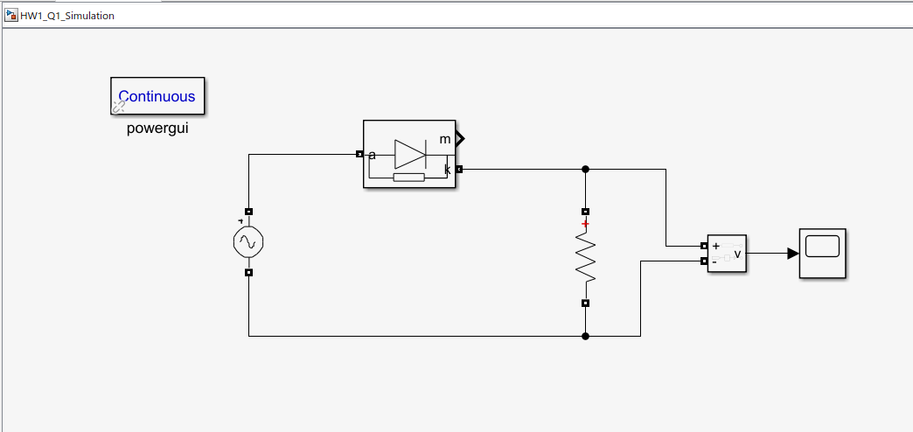

Figure : The Circuit Schematic for Single Phase Half-Wave Rectifier

1. For Part-a, the circuit schematic above is simulated with different time steps such as 1 ns, 0.1 ms, and 1 ms. Note that RL is 80 ohm and the AC voltage source generates 230 Vrms at 50 Hz, the Turkish electricity grid phase neutral voltage. However, the AC source in Simulink requires giving a peak value of voltage. Therefore, 230 Vrms is multiplied with a square root of 2. The output voltage waveforms are given in below.

Figure : The Output Voltage Waveform for Time-Step 1 ns

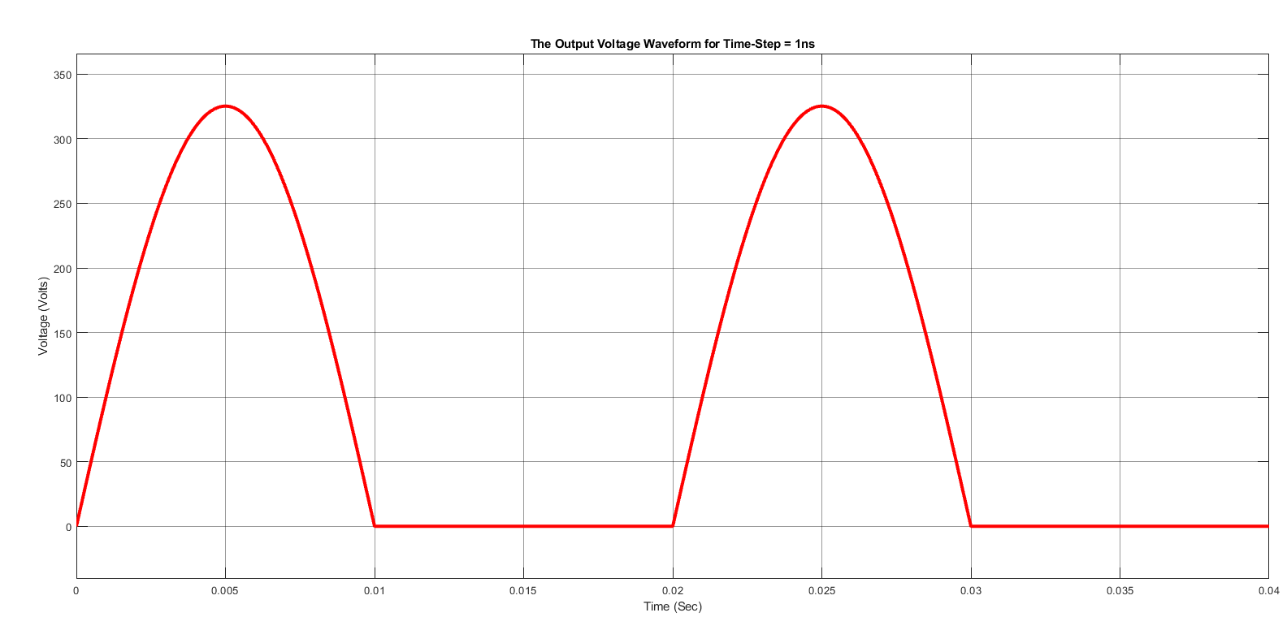

Figure : The Output Voltage Waveform for Time Step 0.1 ms

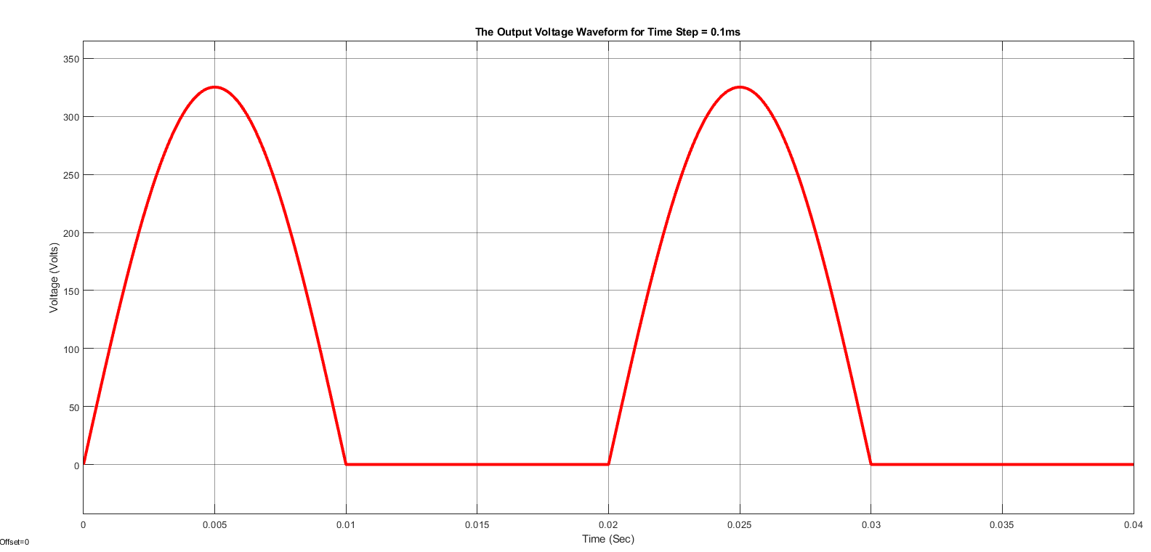

Figure : The Output Voltage Waveform for Time Step 1 ms

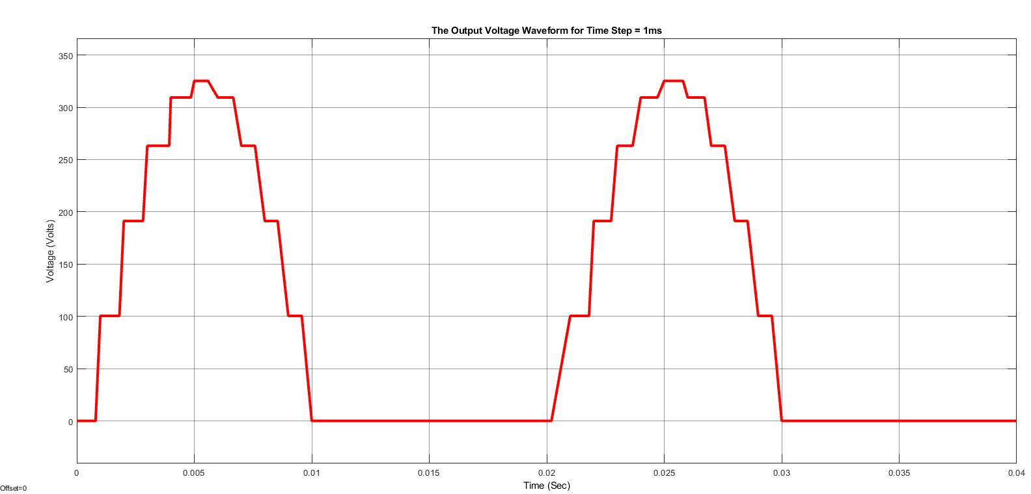

1. As can be seen from the figures in part-a, the waveform for time-step 1 ms is distorted. It is because the time step is too large to create a smooth waveform. Since the output voltage has many harmonics inside, the proper step time is necessary to see the waveform clearly. Another way around, if the step time is too short, the simulation takes too much time, and it creates not a good observation for the user. The proper value can be determined by looking at the frequency of the voltage. In this case, the best option to simulate is 0.1 ms.
2. Calculation of the average output voltage waveform and THD:

To calculate THD, first, the Fourier components are needed to find.

Figure : The Circuit Schematic to obtain THD and Mean Voltage

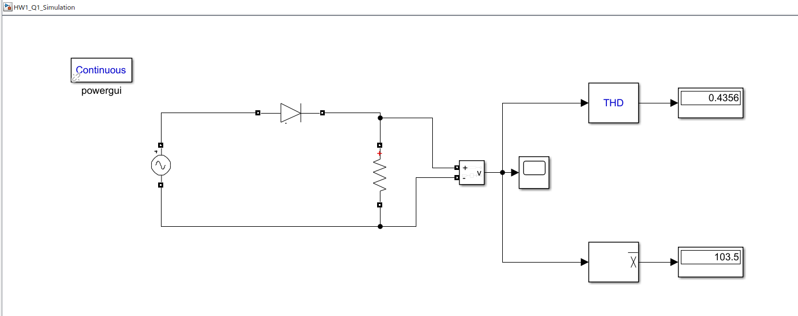

1. As shown in Figure 5, the average voltage equals 103.5 Volts, which is consistent with the analytical calculation. In a single-phase half-bridge rectifier, the mean voltage of the output is roughly equal to 0.45Vrms. In this case, the Vrms value for the AC voltage source is 230 Volts. Then:

Also, the calculated THD in part-c and the measured THD in Figure 5 are consistent. The simulation results are as expected since the diode is set ideal. There is no non-ideality for this single-phase half-bridge rectifier.

## PART 2: The Single-Phase Full-Bridge Rectifier

1. In practical applications, Ls and Rs on the given circuit refers to the internal inductance and resistance value of the AC Voltage source
2. In part b, we are asked to obtain 3% output voltage peak-to-peak ripple voltage to mean ratio by adjusting the capacitor accordingly. In this circuit, the capacitor carries out a filtering operation. When a source is connected to the circuit first capacitor draws current and becomes charged. When AC voltage is lower than the capacitor voltage, the capacitor feeds the load to obtain more DC-like output voltage. Therefore, capacitance value should be chosen wisely. For example, if the capacitance value is chosen too large, then, in the beginning, it draws a large amount of current that might harm the diodes. Moreover, if the capacitance value is too small, the capacitor will not be enough to feed the circuit; this leads to worse DC-like output voltage.

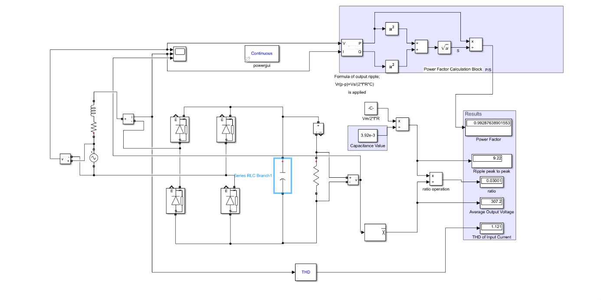

Figure : The Circuit Diagram of Single Phase Full Bridge Rectifier

This diagram shows all the measurements, and the 3% ratio is obtained with C= 3.92 mF.

Figure : The Output,Input Voltage and Current of the Single Phase Full Bridge Rectifier with Rs and Ls

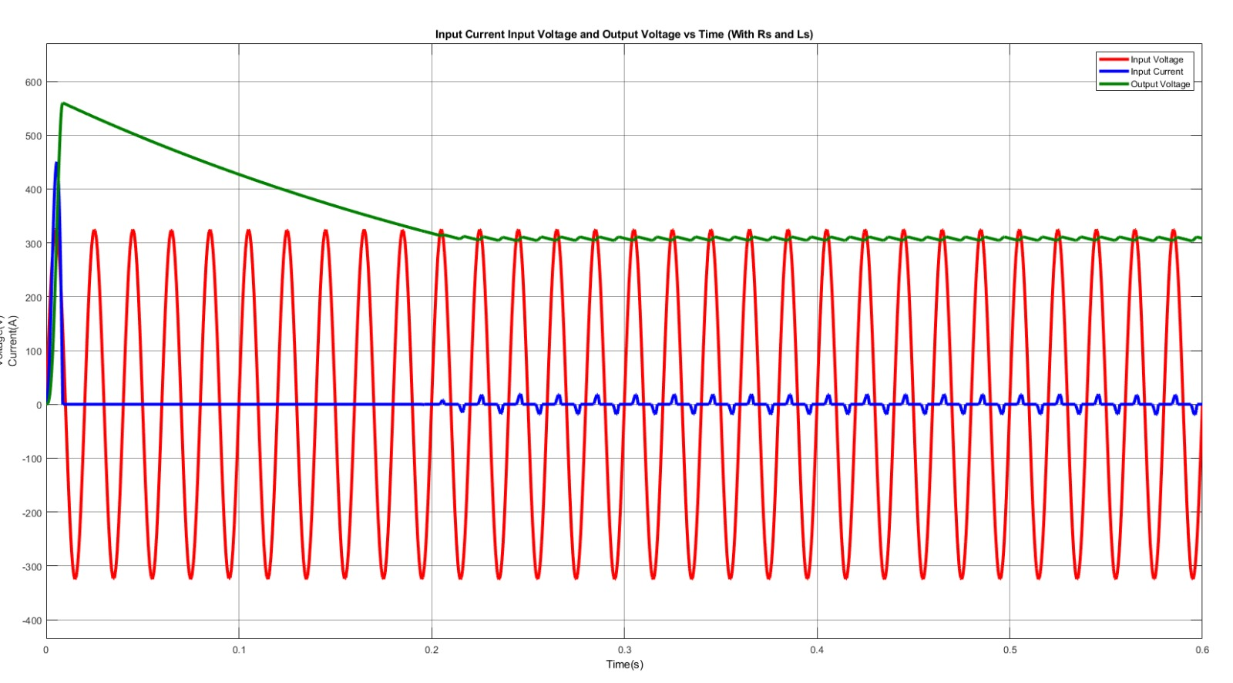

As mentioned in the beginning, there is a jump on the current graph due to the capacitor. Also, we can say that the capacitance value affects the time required for the circuit to become stable.

1. In part (b), necessary measurements are shown.
2. In part (e), Ls and Rs are removed; we assumed that the AC voltage source is ideal.

Figure : The Output,Input Voltage and Current of the Single Phase Full Bridge Rectifier without Rs and Ls

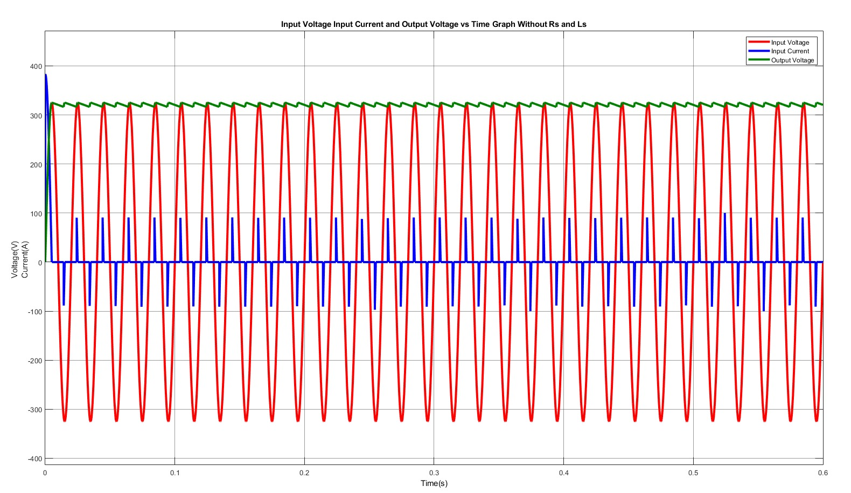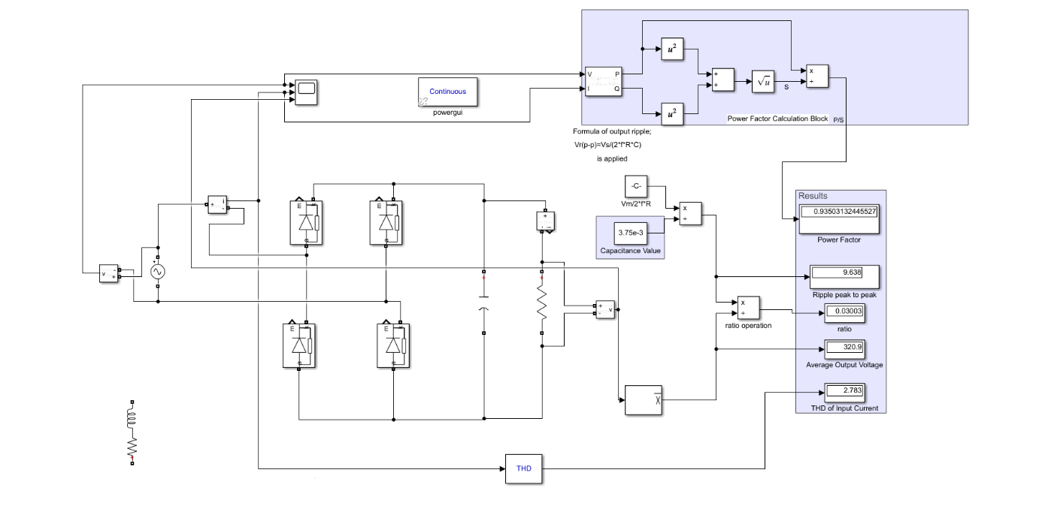

Figure : The Circuit Diagram of Single Phase Full Bridge Rectifier without Rs and Ls

When Ls and Rs are removed, we observed that now the current have sharp transitions. These transitions are because of an inductor in the circuit, and it prevents the sharp current transitions because it results in infinite voltage on the inductor. This leads the input current to increase suddenly, so we can say that the charging time of the capacitor (time required for stabilization of the circuit) is decreased. In addition to these, the following differences are obtained.

* Average output voltage increased.
* Capacitance value required to have 3% ratio decreased.
* Input current increased and has sharp edges.
* Power factor decreased.
* THD increased.

## PART 3: The Three-Phase Full-Bridge Rectifier

1. In Part-a, the circuit schematic is simulated in Figure 10. The three-phase voltage source is arranged to 400 Vrms and 50 Hz as in Turkey electricity grid. Also, the DC source is equal to 60 Amps.

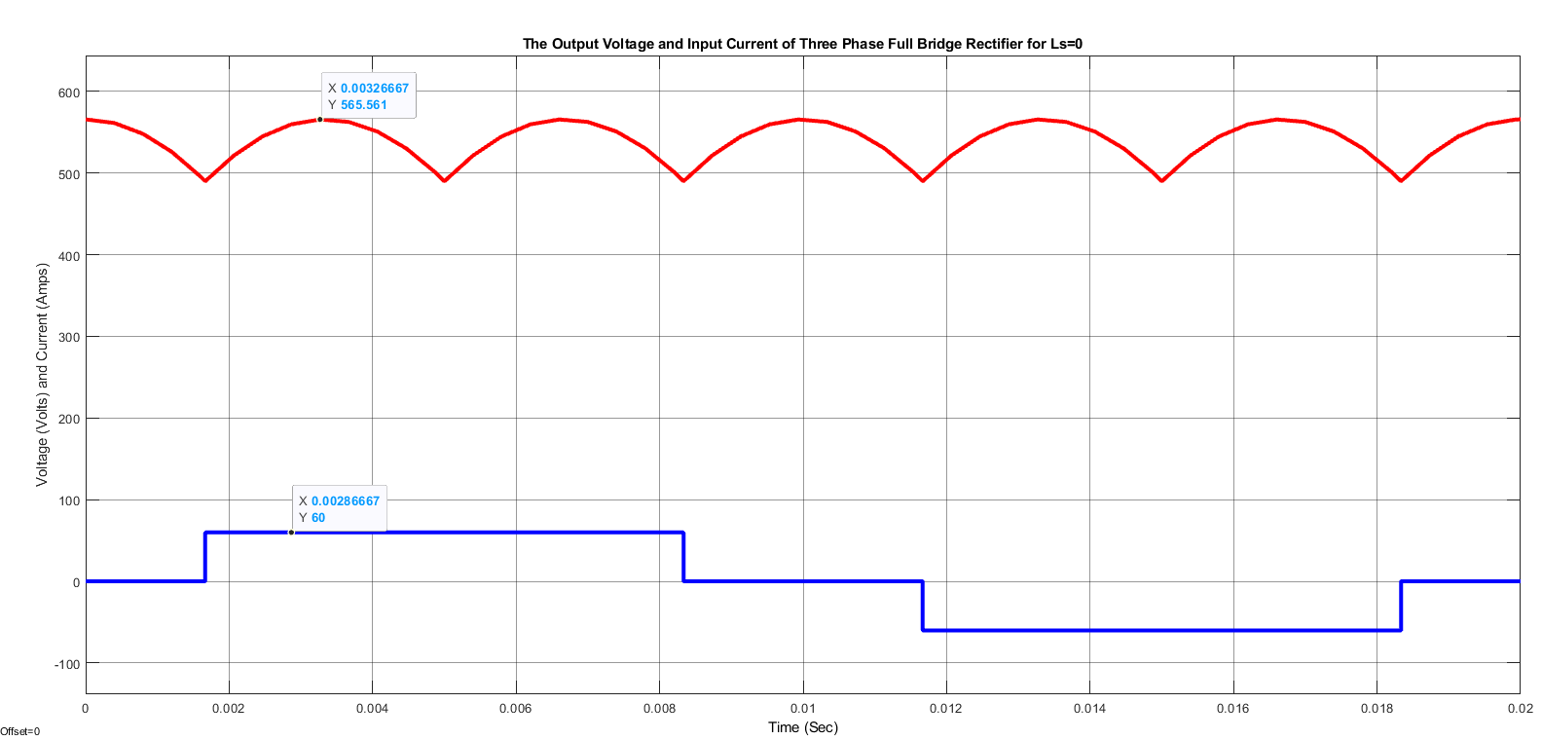

Figure 11: The Output Voltage and Input Current Waveforms for Three-Phase Full Bridge Rectifier without Ls

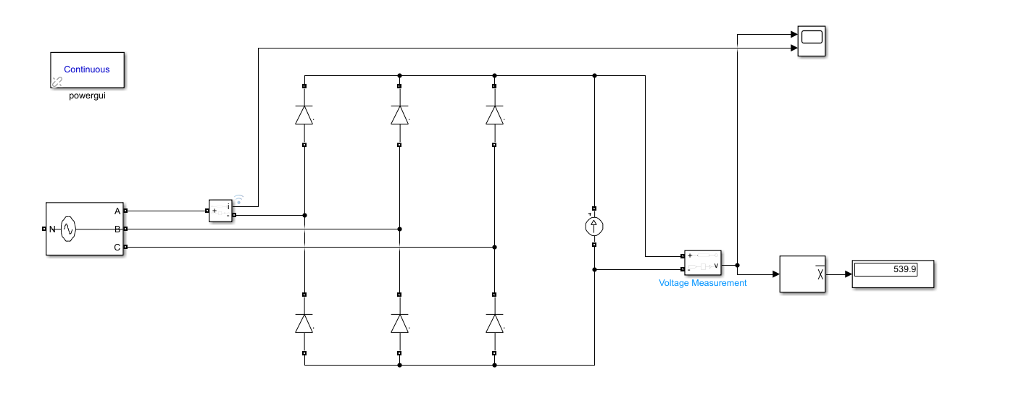

Figure 10: The Circuit Diagram for Three Phase Full Bridge Rectifier without Ls

The output voltage waveform and input current waveform are given in Figure 11. As can be seen, the peak value of the output voltage is equal to which is roughly equal to 565 Volts. Also, the input current waveform is a square waveform, as expected. The peak value is 60 Amps like the DC source.

Unlike single-phase rectifiers, we do not observe a square input current waveform, but there is some interval that no input current is supplied.

1. To find the mean voltage of a three-phase full-bridge rectifier:

As can be seen from the simulation figure, the mean output voltage is observed 539.9 Volts, which is nearly the exact theoretical value.

1. By using the FFT analyzer in *powergui,* the harmonic analysis is made as follows.

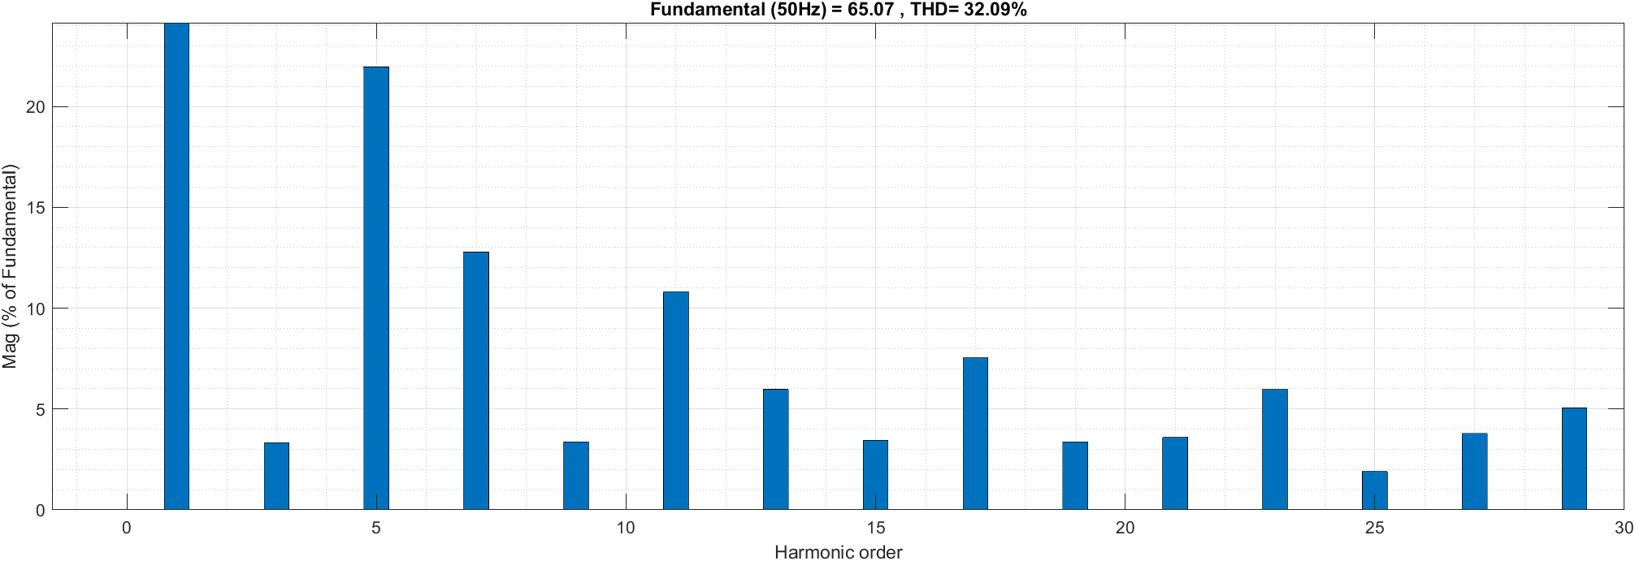

Figure : The Harmonic Analysis of the Input Current (without Ls)

As can be seen from Figure 12, the majority of harmonic content for the input current waveform is the 5th harmonic. The 7th harmonic follows it. Notice that the third harmonic has minimal effect on the input current, which is expected.

For the output voltage, the harmonic analysis is also performed in Figure 13.

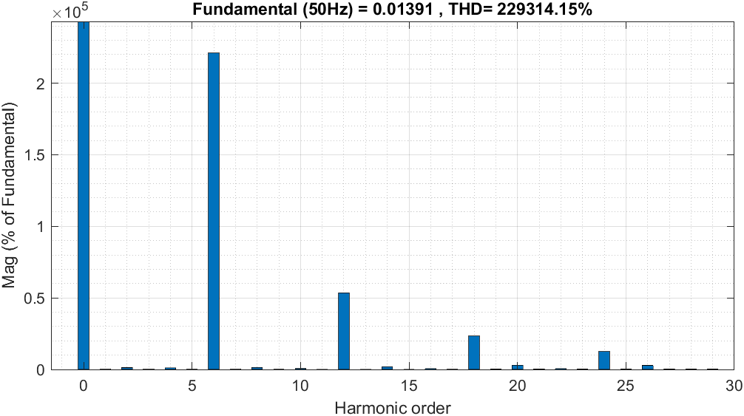

Figure : The Harmonic Analysis of the Output Voltage (without Ls)

1. The circuit diagram of a three-phase full-bridge rectifier with Ls=1.mH is given in Figure 14.

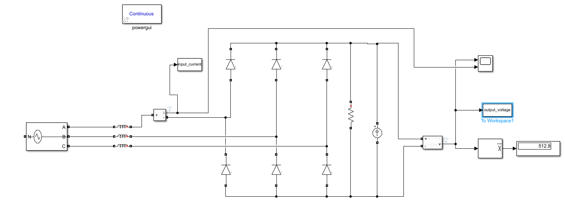

Figure : The Circuit Diagram for Three Phase Full Bridge Rectifier with Ls=1.5mH

As can be seen from the figure, the resistance is connected parallel to the DC source because the Simulink creates an error when the inductances are connected to the current source directly. Therefore, 1 Mohm resistance is connected parallel to diodes.

The output voltage and input current waveforms of the three-phase full-bridge rectifier with Ls=1.5 mH are shown in Figure 15 below.

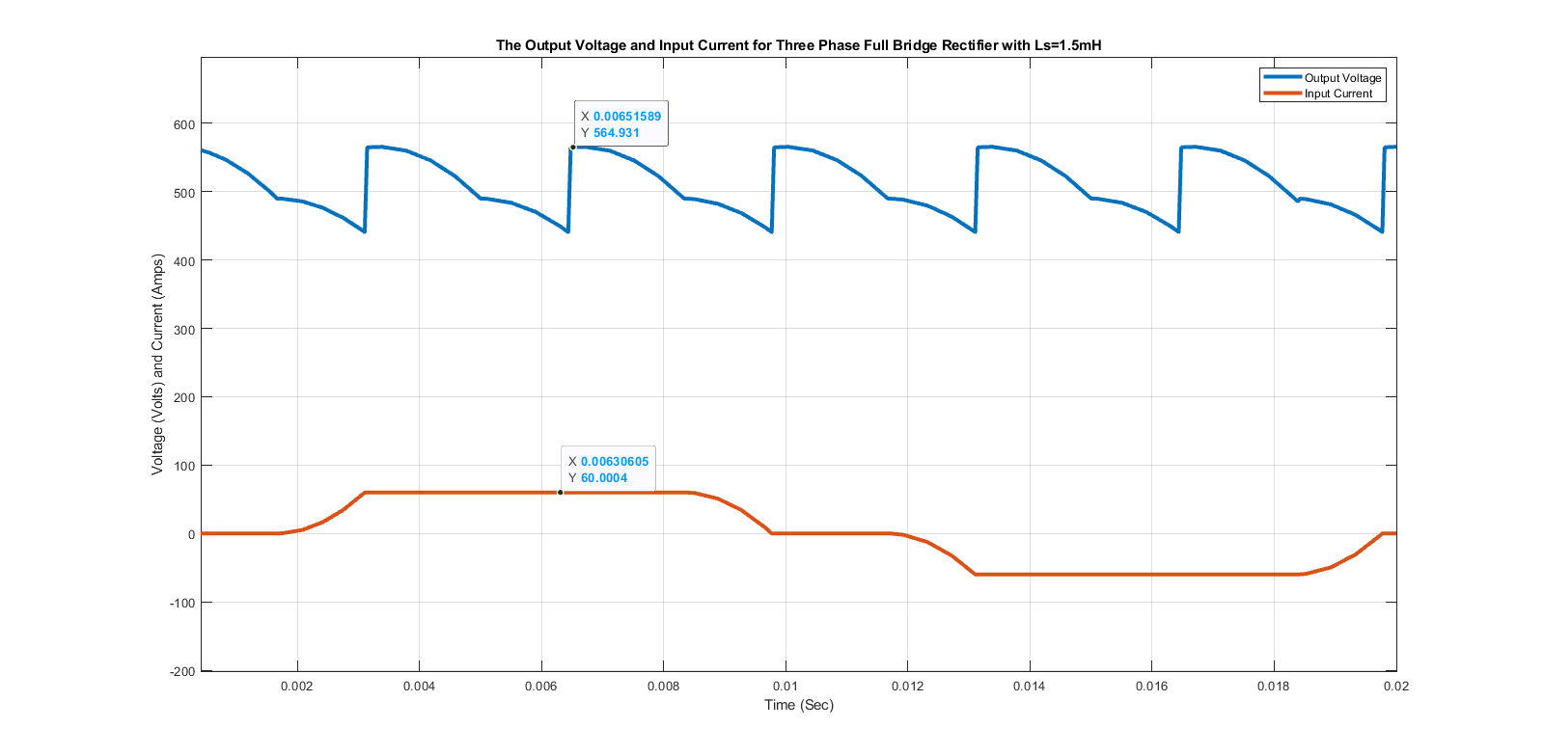

Figure :The Output Voltage and Input Current Waveforms for Three-Phase Full Bridge Rectifier with Ls=1.5mH

When the source inductances are added to the three-phase full-bridge rectifier, the commutation or overlap happens. Because of the inductances, diodes cannot close immediately; therefore, in a short period, two phases are conducted at the same time.

Because of the commutation, the average voltage decreases with a small amount which is :

This equation implies the area lost in the output voltage waveform. Another significant change is in the input current waveform. Because of the differential relation between inductance voltage and current, the current cannot change immediately. Therefore, it follows the way in Figure 15.

1. The average output voltage with commutation can be calculated as follows :

The frequency of the three-phase voltage source is 50 Hz which means . Also, the inductance value is 1.5 mH, and the DC is 60 Amps. Hence :

Also, the average output voltage is measured from the simulation program, as shown in Figure 14. The measured value is 512.8 Volts which is very near to the theoretical value.

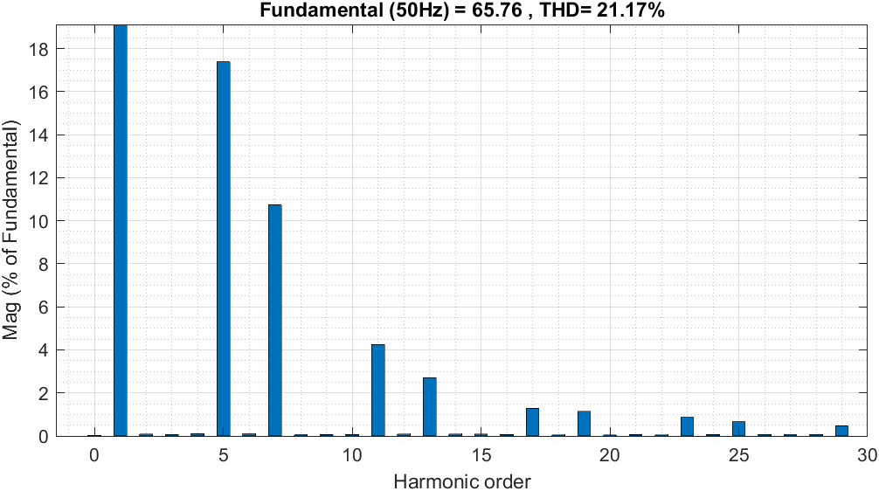

Figure 17: The Harmonic Analysis of the Input Current with Ls=1.5mH

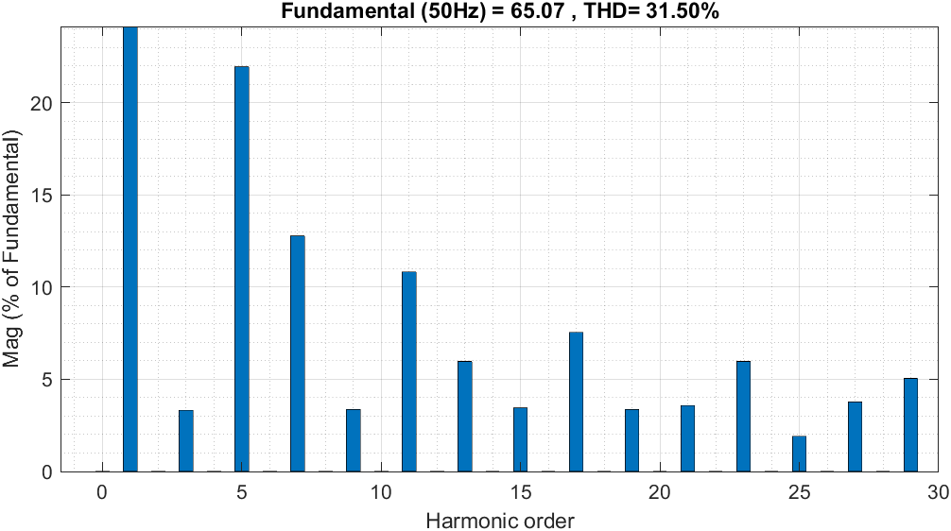

Figure 16: The Harmonic Analysis of the Input Current with Ls=0

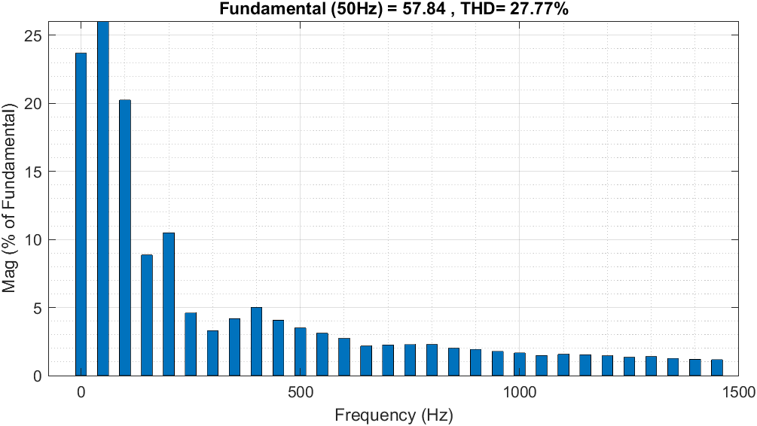

Figure : The Harmonic Analysis of the Input Current with Ls=15mH

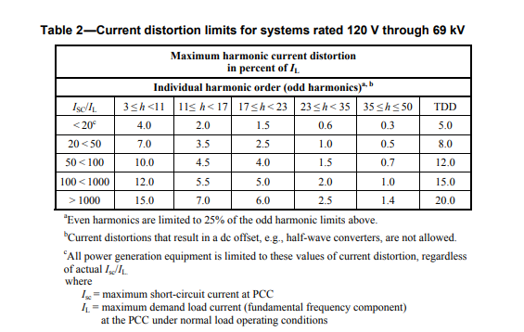The harmonic analysis for three different line inductances is given in Figures 16-17 and 18. According to IEEE 519-2014 Standart, the current distortion values are given in Table-2.

When the harmonics analyses are examined, the rectifier, which has the line inductance, has 1.5 mH comforts the IEEE standard most. Since it has the most significant harmonic at 5th and after that, it has almost no harmonics. Also, the THD value for this 1.5 mH is lower than other options.

Notice that when the line inductance is getting more significant, the most effective harmonics are getting smaller in the 15 mH cases. Since the most effective harmonics is near the fundamental frequency, it is harder to filter it.

The simulations are performed, and THD values are measured from the THD box in Simulink. Hence, the THD values for 0,1.5 and 15 mH are given in Table 1 below, respectively:

Table 1: THD Values according to the Line Inductance.

|  |  |
| --- | --- |
| The Line Inductance | Total Harmonic Distortion (THD) |
| 0 mH | 0.3604 |
| 1.5 mH | 0.3427 |
| 15 mH | 0.4235 |

As shown in Table 1, the lowest THD value belongs to the circuit with a 1.5 mH line inductance. According to IEEE 519-2014 Standard, the THD value should be lower than 8%. Hence, all of them satisfy this condition, but the second one is the most applicable one. Since lower THD values in power systems imply fewer peak currents, less heating, and high efficiency, because of these reasons, low THD is a desirable property for power systems. The high THD values may cause significant or minor malfunctions of the equipment [1]. The high THD value in the input current can result in higher current peaks and higher core losses. These core losses create heating; therefore, the increasing temperature may damage the operating grid and equipment.

## REFERENCES

[1] “IEEE Std 519™-2014, IEEE Recommended Practice and ...” [Online]. Available: https://edisciplinas.usp.br/pluginfile.php/1589263/mod_resource/content/1/IEE%20Std%20519-2014.pdf. [Accessed: 14-Nov-2021].