1)

a)In order to have 12V output voltage with the input voltage of 16V in a buck boost converter

$$V_{O}=\frac{D}{1-D}×V_{D}$$

$$D ≅0.429$$

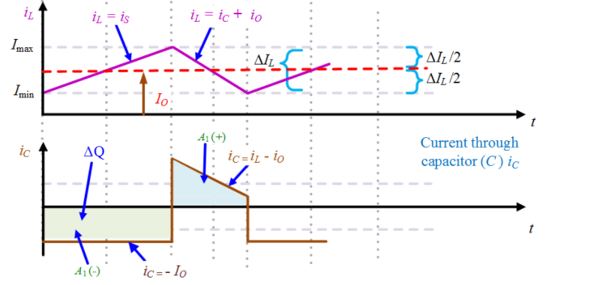

Figure x: Buck Boost Converter Waveforms

$$∆I_{L}= \frac{1}{L}\int{V_{L}dt}= \frac{1}{L}{×V}_{D}×D{×T}_{S}$$

$$∆I_{L}=I_{O}×0.1$$

The output power is 24W and the output voltage is 12V. Therefore

$$I_{O}=\frac{24W}{12V}=2A and ∆I_{L}=I_{O}×0.1=0.2A$$

$$L=\frac{V_{D}×D{×T}_{S}}{∆I_{L}}=0.685mH$$

b) In order to calculate voltage ripple at the output, one needs to consider charging and/or discharging operation of capacitor.

$$∆Q=C×∆V_{o}$$

$∆Q=D×T_{S}×I_{O}$

$∆V_{o}=V_{o}×0.02$ (2% output voltage ripple)

$$∆Q=0.429×\frac{1}{50kHz}×2A=17.16μC$$

$$C= \frac{∆Q}{∆V_{o}}= \frac{17.16μC}{12×0.02}=71.5μF$$

**c) Component Selection**

**Table xx: Selected Products with Ratings for Buck-Boost Converter**

|  |  |  |  |  |  |
| --- | --- | --- | --- | --- | --- |
| Component | Product | Voltage Rating | Current Rating | Price | Amount |
| L | **744375 29203681** | **-** | **4.8A** | **$9.16000** | **1** |
| C | **C1608X5R1E225K080AB** | **25V** | **-** | **$0.19000** | **1** |
| Diode | **CDBA540-HF** | **40V** | **5A** | **$0.44000** | **1** |
| MOSFET | **2156-FDS5692Z-FSTR-ND** | **50V** | **5.8A** | **$0.99000** | **1** |
|  |  |  | Total Price | $10.78 |  |

Because components ratings are the same as the Cuk Converter, we choose the same components as the Cuk Converter. Component selection reasonings are mentioned in the Question 2.

**d)**