**2)**

**a)** In order to have 12V output voltage with the input voltage of 16V in a buck boost converter

$$V_{O}=\frac{D}{1-D}×V_{D}$$

$$D ≅0.429$$

When the switch is ON L1 charges by input source. Therefore,

$$∆I_{L}= \frac{1}{L}\int{V_{L}dt}= \frac{1}{L}{×V}_{D}×D{×T}_{S}$$

$$∆I_{L1}=I_{L1}×0.1$$

$$I_{L1}=\frac{24W}{16V}=1.5A and ∆I_{L}=I_{L1}×0.1=0.15A$$

$$L_{1}=\frac{V_{D}×D{×T}_{S}}{∆I_{L}}=0.915mH$$

When the switch is OFF, voltage drop on L2 is equal to -VO. So it discharges with -VO.

**b)**

Figure x: Capacitor Charging Graph

C2 charges up when IL2 is larger than average output current. Area of ΔQ is;

C1 charges up by a constant current, therefore;

$$∆Q= I_{L1} ×\left(1-D\right)× T_{S}= C∆V$$

Notice that for ΔV for C1 is 12+16 = 28V. Therefore, using the equation above one can find C1 as

**c) Component Selection**

**Table x: Selected Products with Ratings for Cuk Converter**

|  |  |  |  |  |  |
| --- | --- | --- | --- | --- | --- |
| Component | Product | Voltage Rating | Current Rating | Price | Amount |
| L1 | **CTX1000-1-52LPR** | **-** | **2.1A** | **$6.31860** | **1** |
| L2 | **744375 29203681** | **-** | **4.8A** | **$9.16000** | **1** |
| C1 | **C2012X5R1V685K125AC** | **35V** | **-** | **$0.67000** | **1** |
| C2 | **C1608X5R1E225K080AB** | **25V** | **-** | **$0.19000** | **1** |
| Diode | **CDBA540-HF** | **40V** | **5A** | **$0.44000** | **1** |
| MOSFET | **2156-FDS5692Z-FSTR-ND** | **50V** | **5.8A** | **$0.99000** | **1** |
|  |  |  | Total Price | $17.77 |  |

Ratings of the products are given in the **Table xx**.

To choose inductor for L1, we first simulate the circuit and check the current on L1. According to the results, the max current is about 1.65A. Considering that, we choose an inductor with the current rating of 2.1A. To choose L2, again using the simulation it is seen that maximum current on L2 is about 2A. In order to satisfy the current requirement we choose the inductor L2 given in the **Table xx**.

For capacitors, we consider their voltage ratings. Using the simulation it is seen that voltage rating of C1 needs to be higher than both input and output voltage, which is expected. Maximum voltage on C1 is about 28V, so we choose a capacitor with the voltage rating of 35V. Also for C2 we choose a capacitor with voltage rating of 25V, since it is output filter capacitor and output voltage is about 12V, this capacitor satisfies the operation. In addition, since ceramic capacitors have lower ESR value especially at high frequencies, we choose our capacitor as ceramic capacitors.

According to the simulation results of diode and switch, they both need voltage rating of about 30V and current rating of 5A. Therefore, given products are choosen.

**d)**

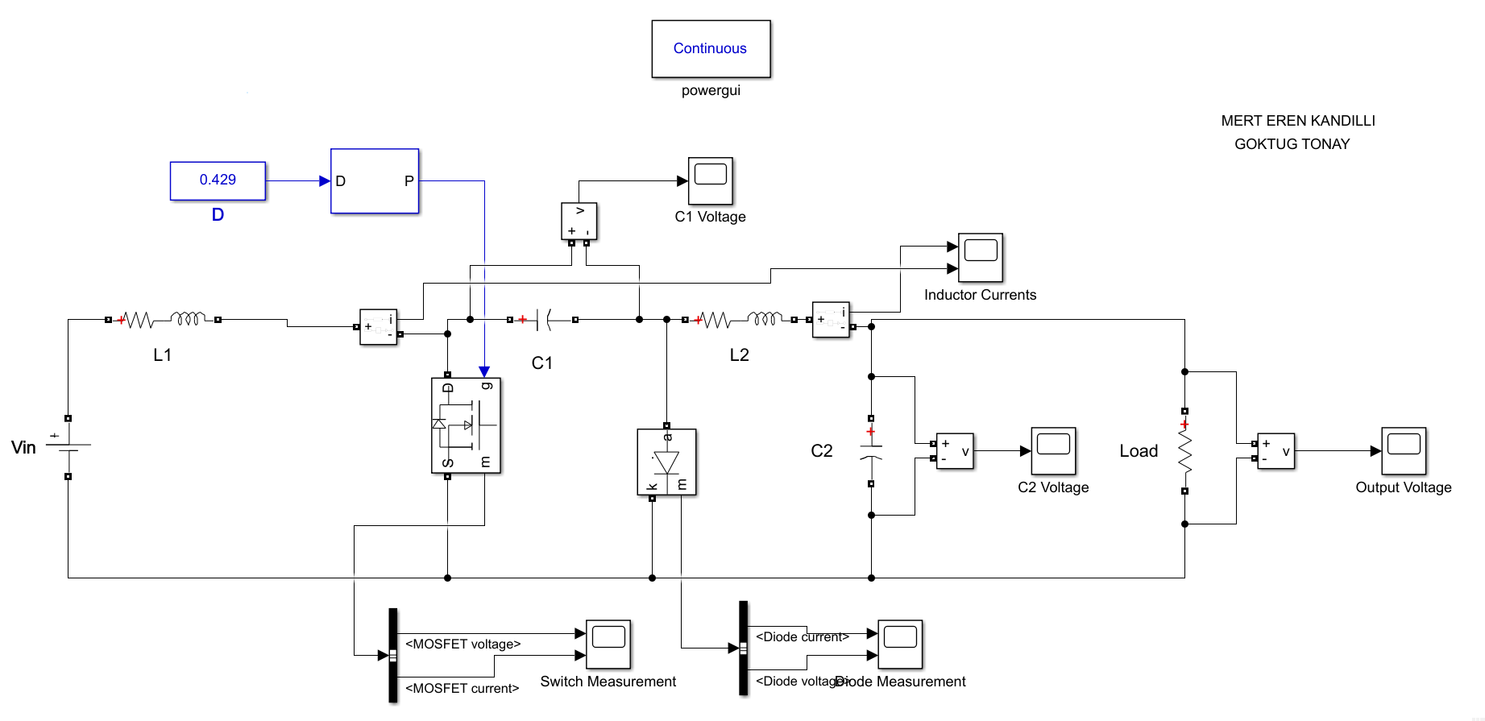

**Figure xx: Circuit Schematic of Cuk Converter**

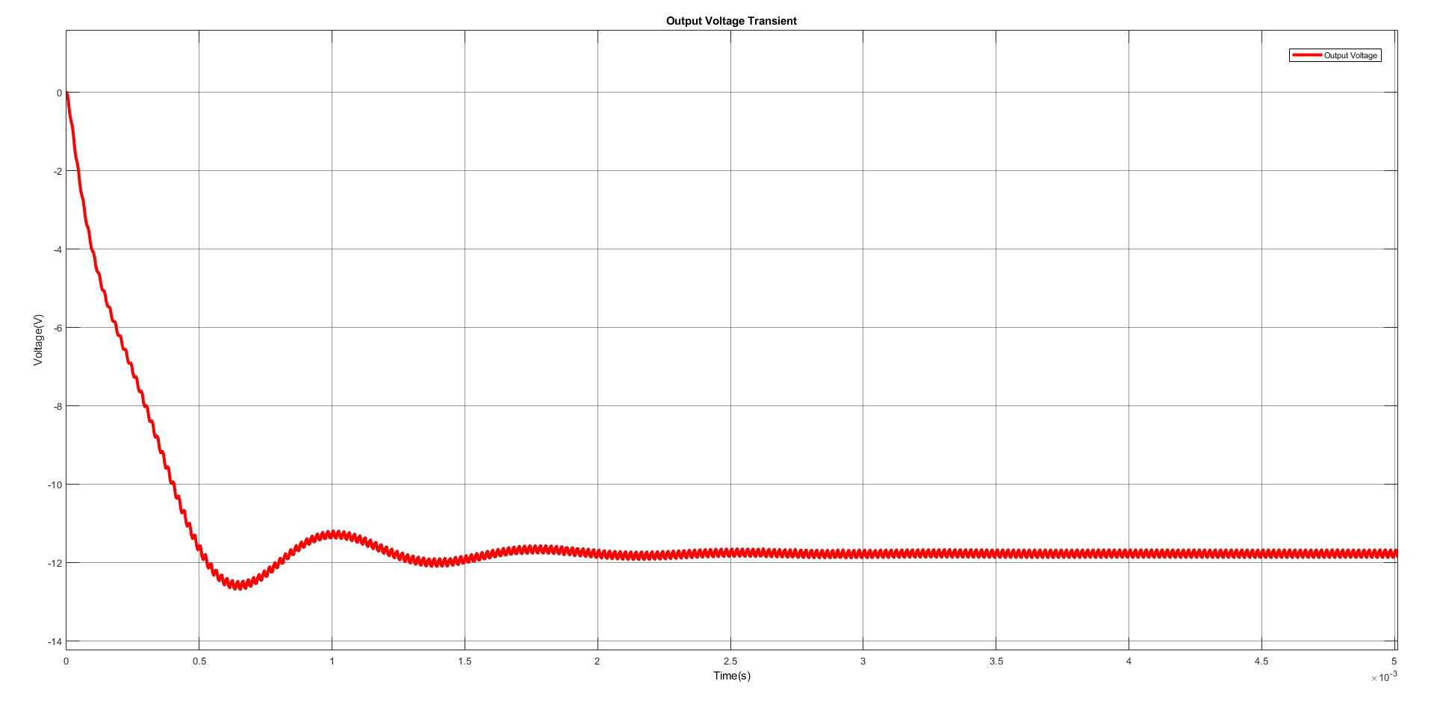

**Figure xx: Output Voltage Waveform**

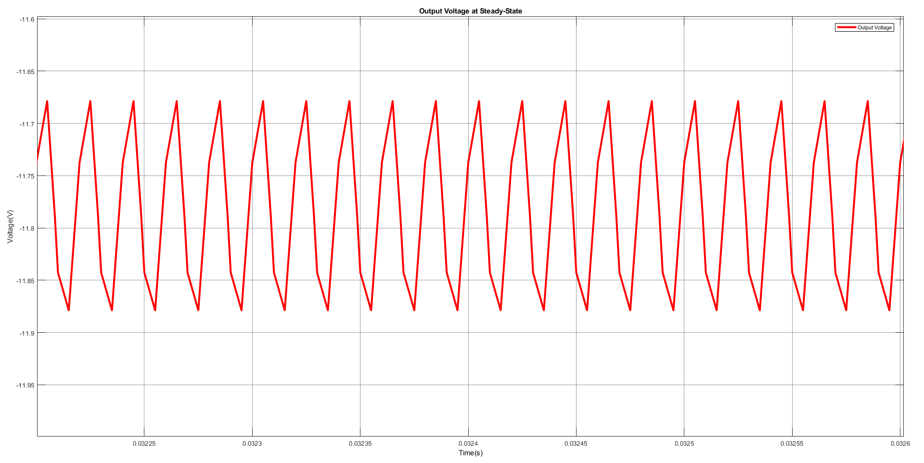

**Figure xx: Output Voltage Waveform at the Steady State**

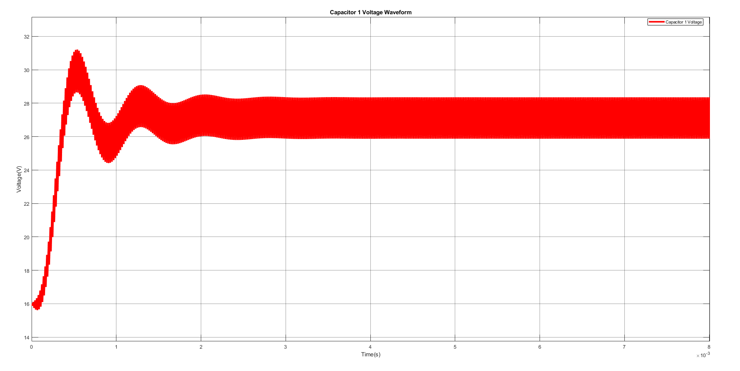

**Figure xx: Capacitor Voltage Waveform**

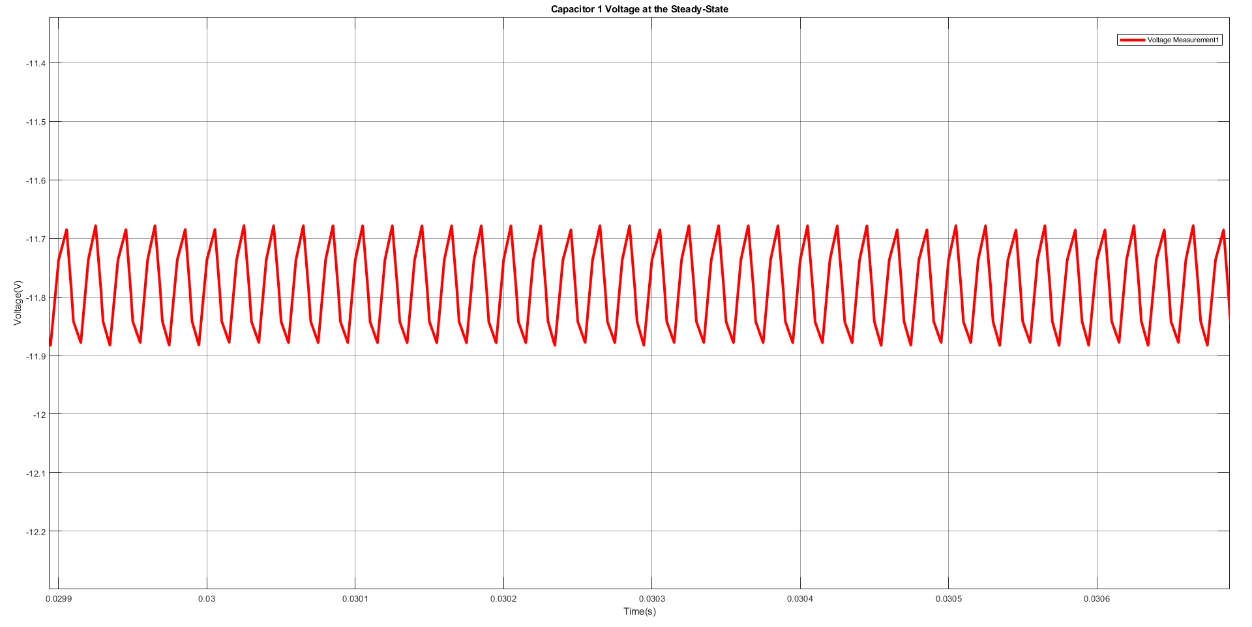

**Figure xx: Capacitor Voltage Waveform at the Steady State**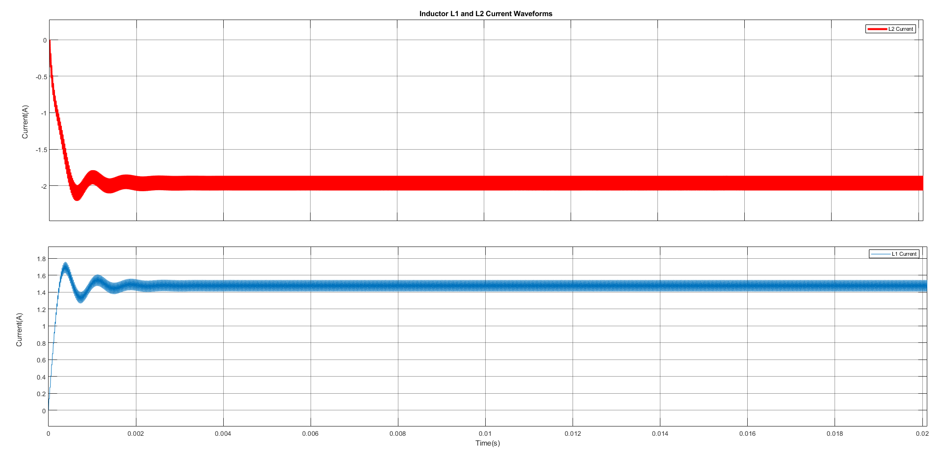

**Figure xx: Inductor Current Waveforms**

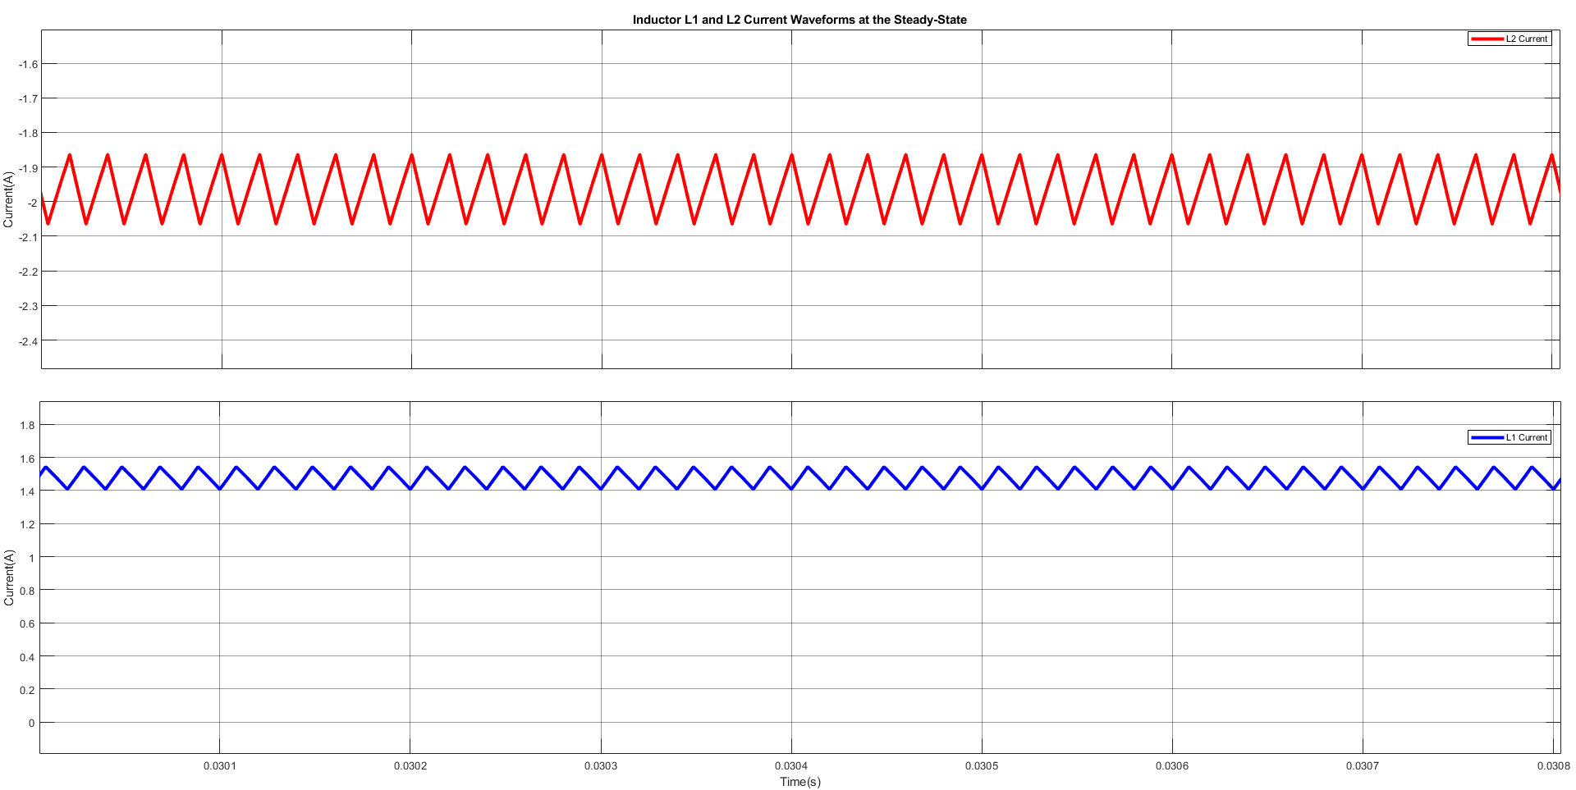

**Figure xx: Inductor Current Waveforms at the Steady State**