# 3)

**a)** We know that average current through at steady state is zero.  
   
, → and   
, (100% efficiency assumed) →

We know that , then for our values   
 ,   
   
We also know that our switching frequency is equal to 50Khz, this means that our period is equal to 20µS. Since we know that while the switch in conduction, capacitor supplies power to the load. This means that for capacitor is discharging.  
  
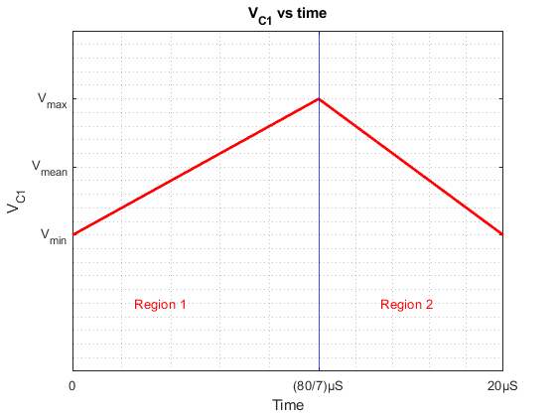  
*Figure 3.1 Capacitor voltage vs time graph*  
  
Figure 3.1 shows the capacitor voltage in one period of switching, we know that mean capacitor voltage is equal to 12V.  
  
  
  
  
We also know that in region 1, switch is not in conduction and capacitor is charging. Moreover, in region 2, switch is in conduction and supplies power to the load.  
  
For the 2% voltage ripple, . This means that and   
  
Since this is first homework, we will make this calculation, first assuming that capacitor is discharging with constant current, then by assuming that current is not constant but converter is loaded with constant R load.  
  
If we assume constant discharge current of 2A then  
  
Solving this equation yields, C = 71.43µF.   
  
If we assume constant R load

Solving this differential equation,   
  
If we check for t=0, we can find that K=12.12V, then to satisfy the 0.24V voltage drop in 60/7µs our capacitor must be equal to 71.42µF. This means that constant current method is a good method.