

EE464 HOMEWORK1

**Student 1: Göktuğ Tonay**

**Student 2: Mert Eren Kandilli / 2304855**

**INTRODUCTION**

In this homework, different types of converters, namely Buck-Boost, Cuk and SEPIC Converters will be investigated. For each of these converters, a converter that steps 16V down to 12V (24W) will be desinged and simulated. Their differences, advantages and the disadvantages will be discussed.

1)

a)In order to have 12V output voltage with the input voltage of 16V in a buck boost converter

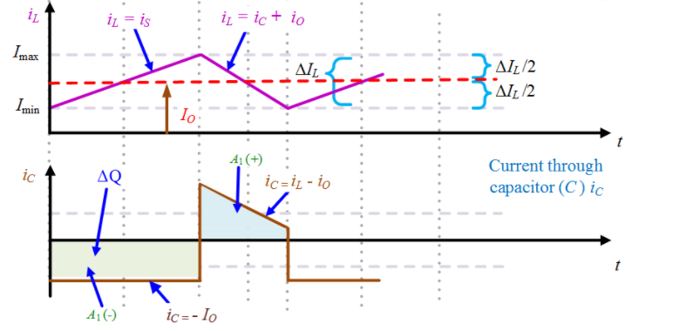

**Figure 1: Buck Boost Converter Waveforms**

The output power is 24W and the output voltage is 12V. Therefore

b) In order to calculate voltage ripple at the output, one needs to consider charging and/or discharging operation of capacitor.

(2% output voltage ripple)

**c) Component Selection**

**Table 1: Selected Products with Ratings for Buck-Boost Converter**

|  |  |  |  |  |  |
| --- | --- | --- | --- | --- | --- |
| Component | Product | Voltage Rating | Current Rating | Price | Amount |
| L | **744375 29203681** | **-** | **4.8A** | **$9.16000** | **1** |
| C | **C1608X5R1E225K080AB** | **25V** | **-** | **$0.19000** | **1** |
| Diode | **CDBA540-HF** | **40V** | **5A** | **$0.44000** | **1** |
| MOSFET | **2156-FDS5692Z-FSTR-ND** | **50V** | **5.8A** | **$0.99000** | **1** |
|  |  |  | Total Price | $10.78 |  |

Because components ratings are the same as the Cuk Converter, we choose the same components as the Cuk Converter. Component selection reasonings are mentioned in the Question 2.

**d)**

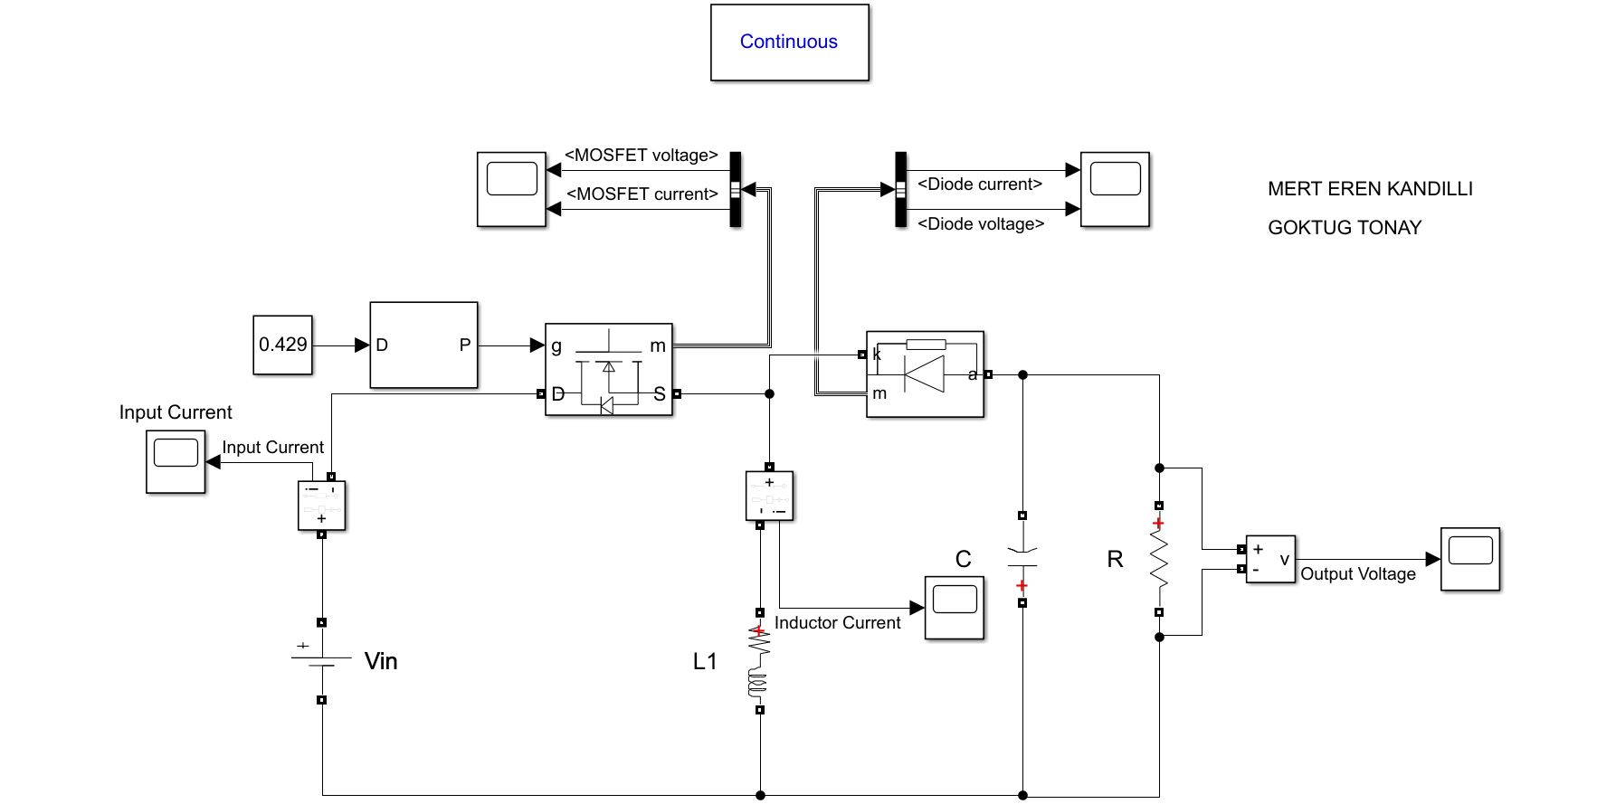

**Figure 2: Circuit Schematic of Buck-Boost Converter**

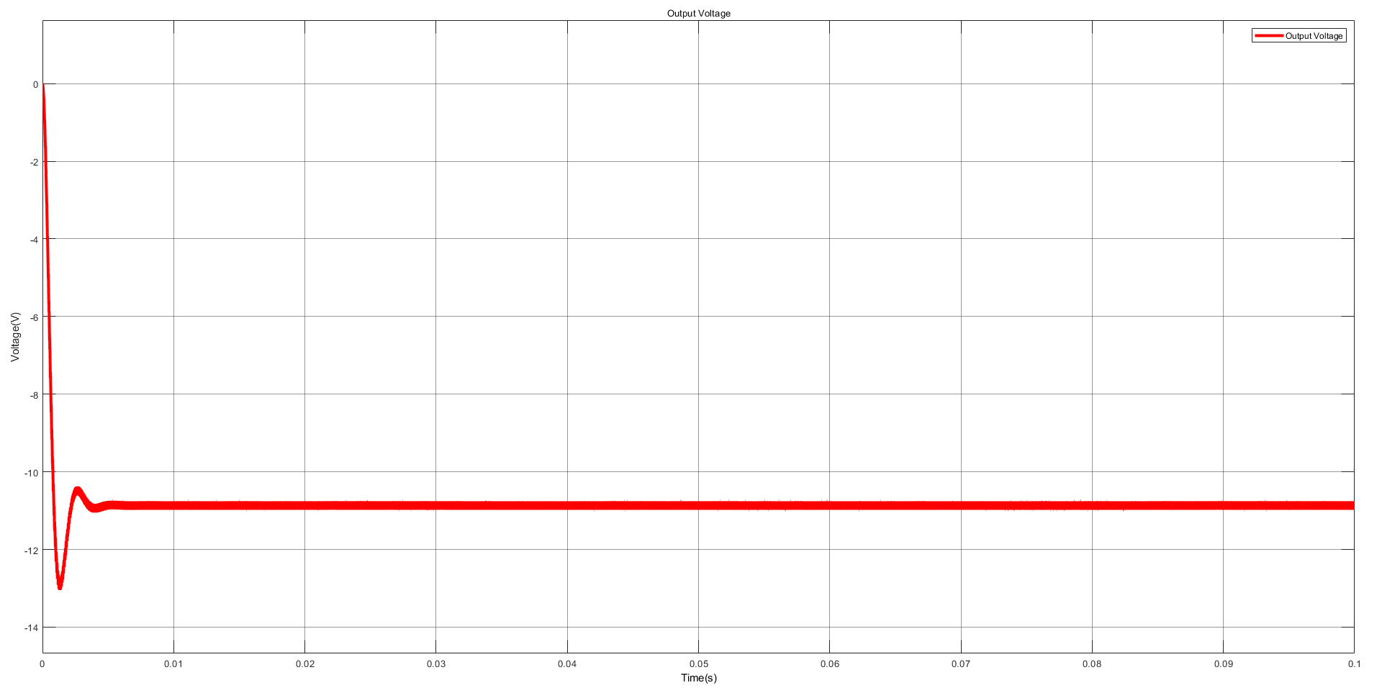

**Figure 3: Output Voltage Waveform**

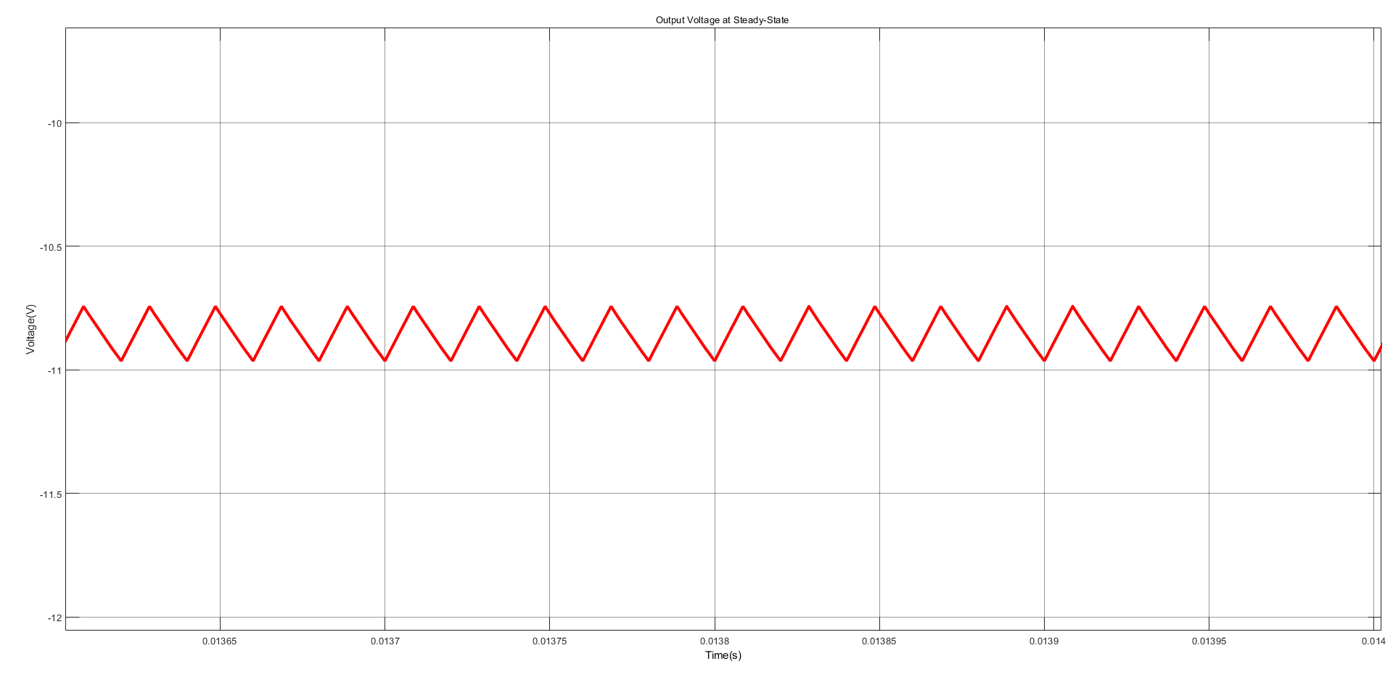

**Figure 4: Output Voltage Waveform at the Steady-State**

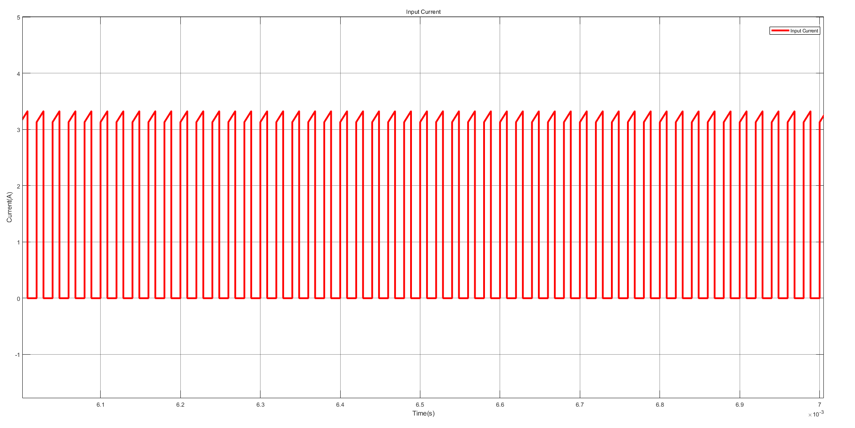

**Figure 5: Input Current Waveform at the Steady-State**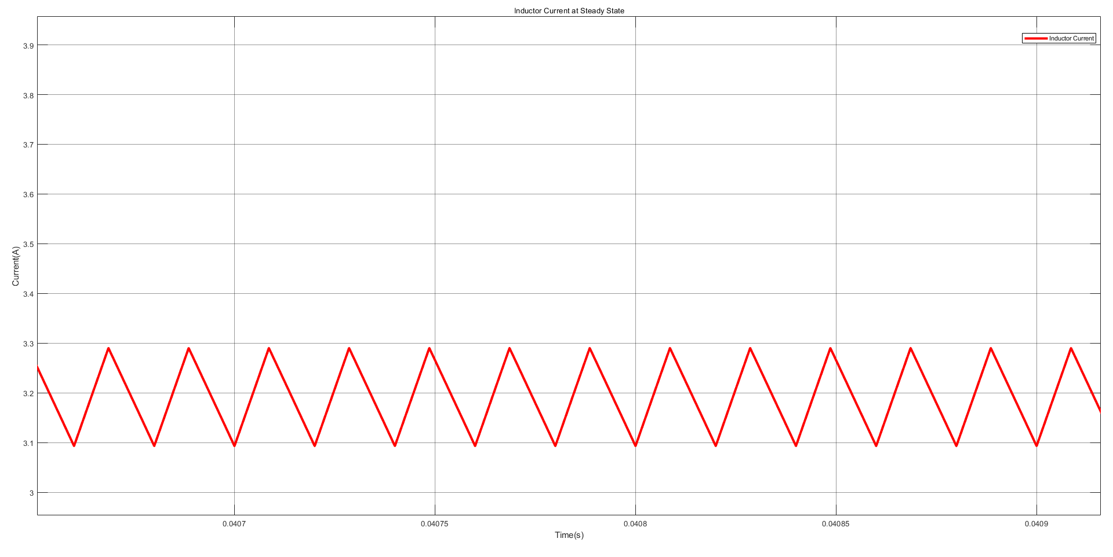

**Figure 6: Inductor Current Waveform at the Steady-State**

Considering the results, one can say that since there is no inductor in the input side, input current has high ripple compared to the Cuk Converter. Also, when we include the non-idealities, it is observed that the average output voltage is decreased but not significantly. It is expected because with non-idealities, there is now voltage drop on diode and switch.

**2a)** In order to have 12V output voltage with the input voltage of 16V in a buck boost converter

When the switch is ON L1 charges by input source. Therefore,

When the switch is OFF, voltage drop on L2 is equal to -VO. So it discharges with -VO.

**b)**

**Figure 7: Capacitor Charging Graph**

C2 charges up when IL2 is larger than average output current. Area of ΔQ is;

C1 charges up by a constant current, therefore;

Notice that for ΔV for C1 is 12+16 = 28V. Therefore, using the equation above one can find C1 as

**c) Component Selection**

**Table 2: Selected Products with Ratings for Cuk Converter**

|  |  |  |  |  |  |
| --- | --- | --- | --- | --- | --- |
| Component | Product | Voltage Rating | Current Rating | Price | Amount |
| L1 | **CTX1000-1-52LPR** | **-** | **2.1A** | **$6.31860** | **1** |
| L2 | **744375 29203681** | **-** | **4.8A** | **$9.16000** | **1** |
| C1 | **C2012X5R1V685K125AC** | **35V** | **-** | **$0.67000** | **1** |
| C2 | **C1608X5R1E225K080AB** | **25V** | **-** | **$0.19000** | **1** |
| Diode | **CDBA540-HF** | **40V** | **5A** | **$0.44000** | **1** |
| MOSFET | **2156-FDS5692Z-FSTR-ND** | **50V** | **5.8A** | **$0.99000** | **1** |
|  |  |  | Total Price | $17.77 |  |

Ratings of the products are given in the Table 2.

To choose inductor for L1, we first simulate the circuit and check the current on L1. According to the results, the max current is about 1.65A. Considering that, we choose an inductor with the current rating of 2.1A. To choose L2, again using the simulation it is seen that maximum current on L2 is about 2A. In order to satisfy the current requirement we choose the inductor L2 given in the Table 2.

For capacitors, we consider their voltage ratings. Using the simulation it is seen that voltage rating of C1 needs to be higher than both input and output voltage, which is expected. Maximum voltage on C1 is about 28V, so we choose a capacitor with the voltage rating of 35V. Also for C2 we choose a capacitor with voltage rating of 25V, since it is output filter capacitor and output voltage is about 12V, this capacitor satisfies the operation. In addition, since ceramic capacitors have lower ESR value especially at high frequencies, we choose our capacitor as ceramic capacitors.

According to the simulation results of diode and switch, they both need voltage rating of about 30V and current rating of 5A. Therefore, given products are choosen.

**d)**

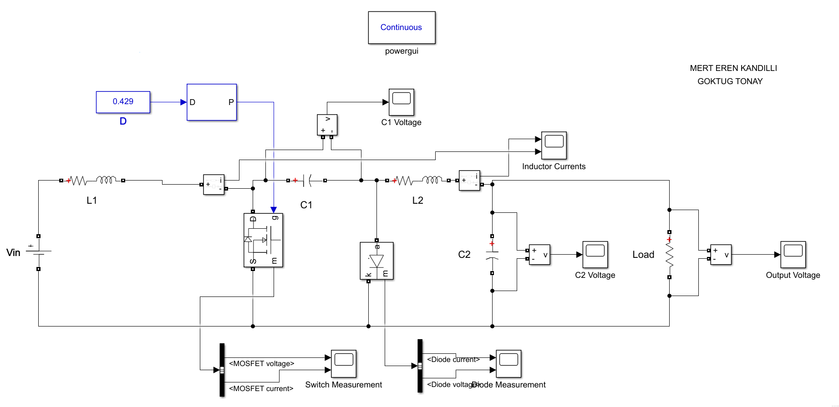

**Figure 8: Circuit Schematic of Cuk Converter**

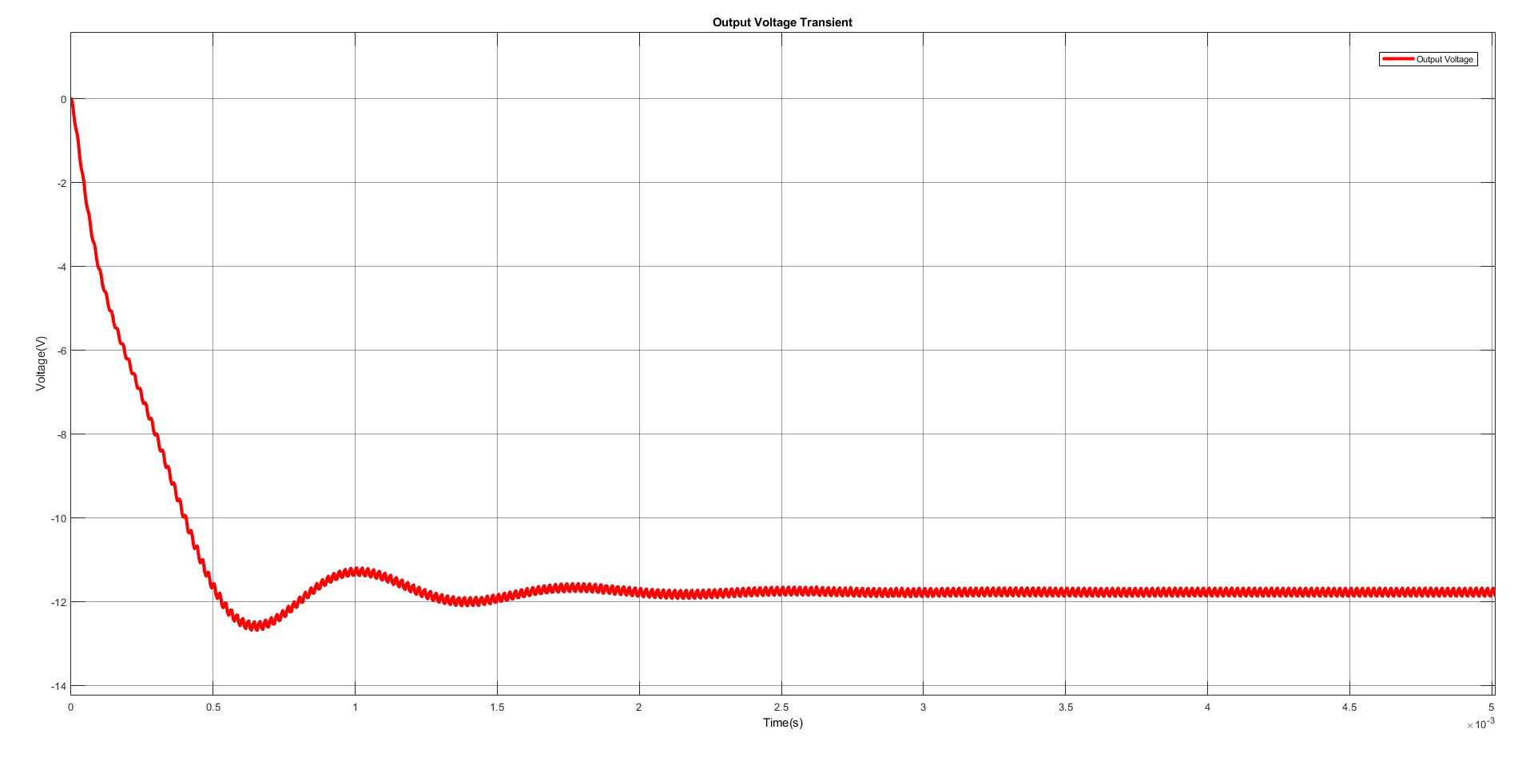

**Figure 9: Output Voltage Waveform**

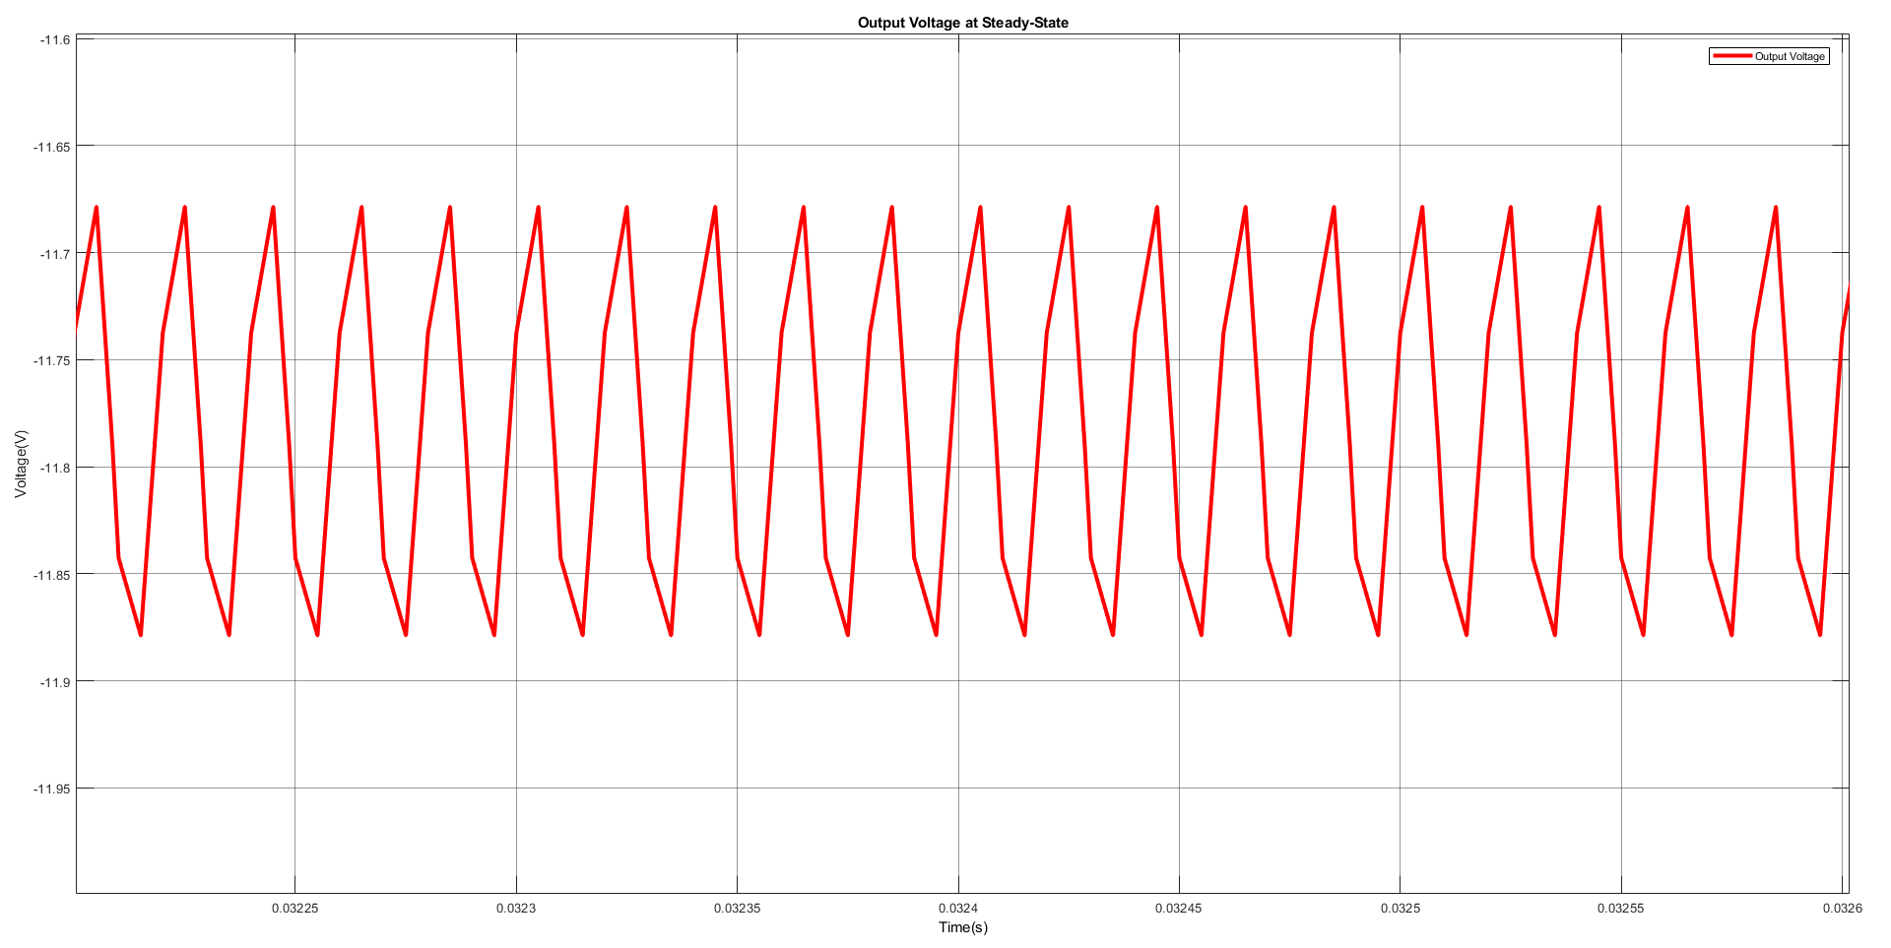

**Figure 10: Output Voltage Waveform at the Steady State**

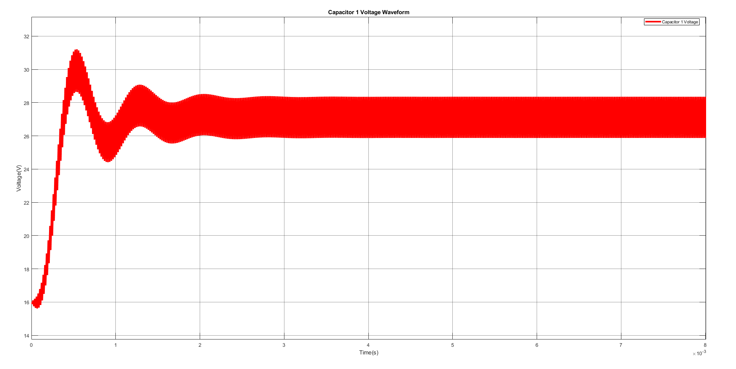

**Figure 11: Capacitor Voltage Waveform**

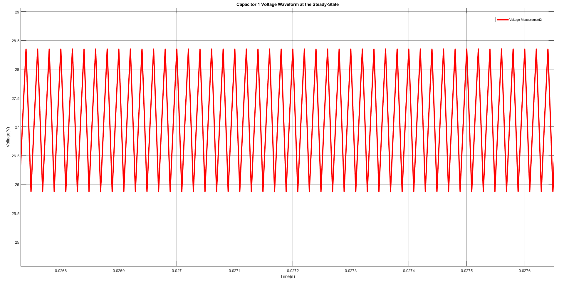

**Figure 12: Capacitor Voltage Waveform at the Steady State**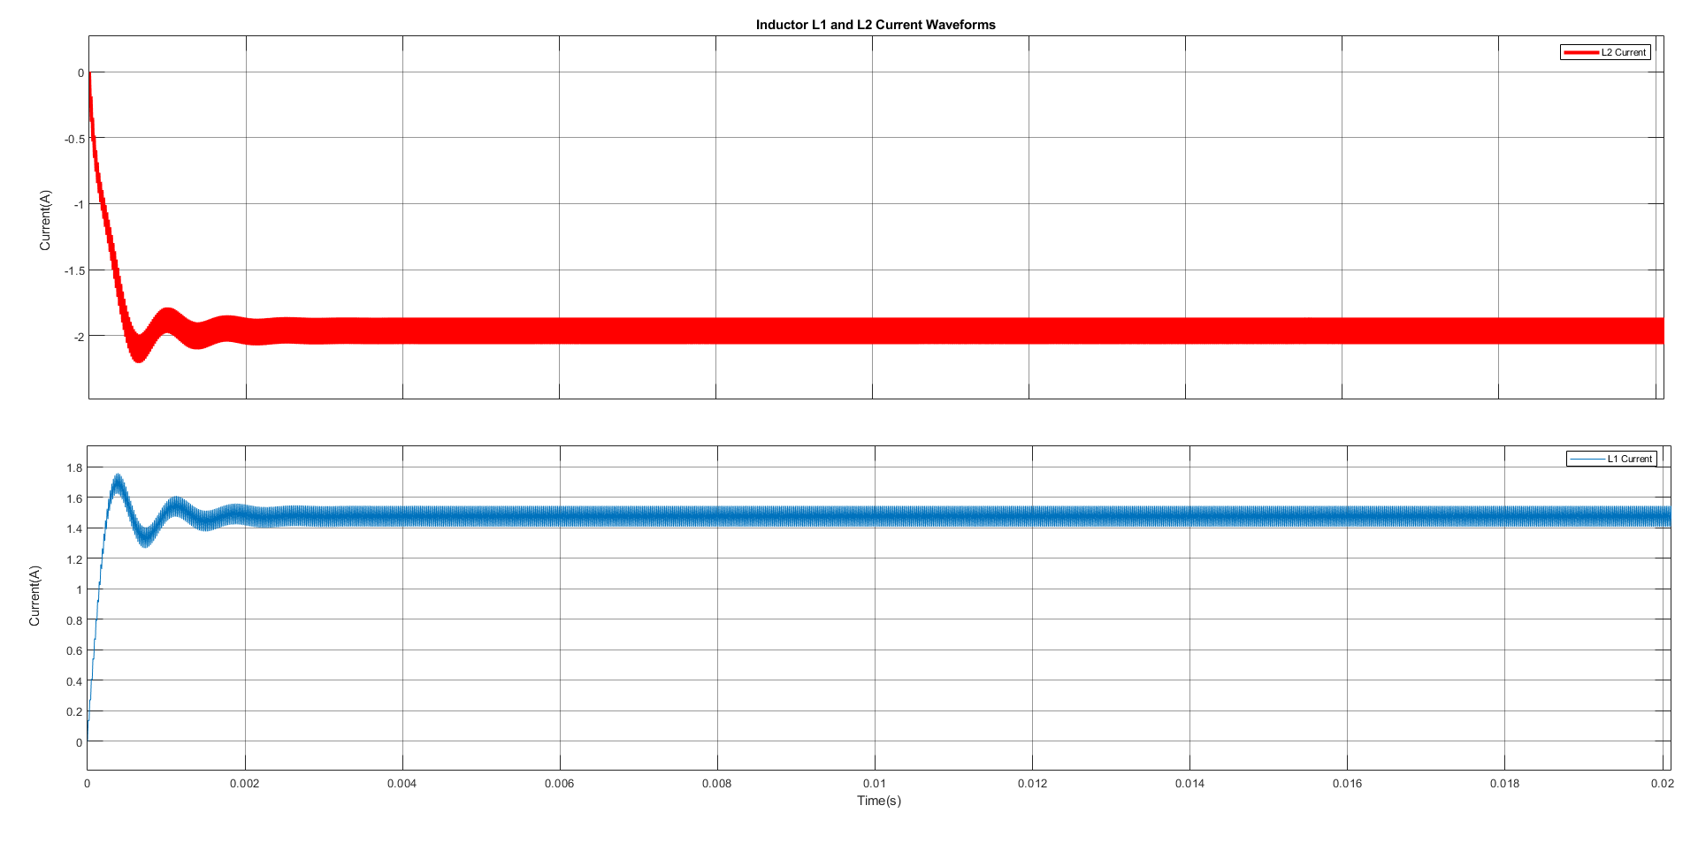

**Figure 13: Inductor Current Waveforms**

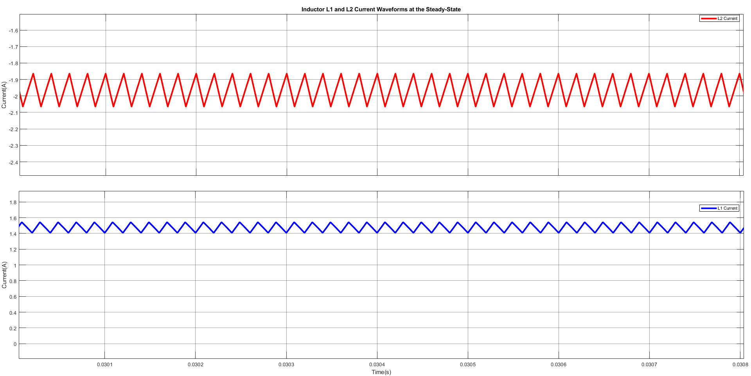

**Figure 14: Inductor Current Waveforms at the Steady State**

For Cuk Converter, our results (not in the homework) show that there is significant decrease in the ripple of the input current compared to the Buck-Boost Converter. It is expected because there is an inductor in the input side of the Cuk Converter. It is also seen that there is about 2.8V ripple in the capacitor voltage which satisfies the design requirements. Also, due to the nature of the Cuk Converter, a higher voltage drops on the first capacitor is observed than the input and output voltage. This phenomenon is also proved in Q2-Part (b).