Quantitative Analysis of Grappling and Striking
Metrics on UFC Fighter Success
DSA210 Spring 2026 — Final Report
Mert Erpolat | Student ID: 32236
Sabanci University

1. Motivation
As a dedicated UFC follower for nearly three years — and someone who has also gone back to study fights from the 1990s — I have always been fascinated by the debate in the MMA community: are grapplers truly more dominant than strikers? This argument is heard everywhere, from media commentary to casual fan discussions. Almost universally, it seems to be that wrestlers and grapplers hold a structural advantage over pure strikers.
Rather than accepting this as conventional wisdom, I wanted to test it scientifically. Can the claim that grappling is more dominant than striking be supported with real historical data and quantitative analysis? This question became the central motivation for this project.
The UFC dataset, spanning over 6,000 fights from 1993 to 2021, provides an ideal laboratory for this investigation. By applying statistical hypothesis testing and machine learning, this project attempts to move the debate from opinion to evidence.

2. Data Source and Collection

Primary Dataset
The dataset was obtained from Kaggle (UFC Fight Historical Data), which was originally scraped from the official UFC statistics database. It consists of two CSV files:
• data.csv — Fight-by-fight metrics for over 6,012 bouts spanning 1993 to 2021, containing 144 variables including per-fighter averages for strikes, takedowns, submissions, and fight outcomes.
• raw_fighter_details.csv — Physical attributes and biographical data for approximately 3,596 unique fighters, including height, weight, reach, stance, and career statistics.

Data Enrichment
To satisfy the project's enrichment requirement and enable the machine learning phase, a new feature, Experience_Level, was derived directly from the fight data. Each fighter's total number of appearances in data.csv was counted. Fighters with more than 10 career bouts were labeled Veteran; all others were labeled Prospect. This enrichment transforms the dataset from a fight-level view to a fighter-level view.

Property | Details
Total fights | 6,012
Total unique fighters | 3,596
Date range | 1993 – 2021
Total variables (data.csv) | 144
Veterans (> 10 fights) | 327 (15.3%)
Prospects (≤ 10 fights) | 1,812 (84.7%)

Table 1: Dataset summary statistics

3. Data Analysis

Data Cleaning and Feature Engineering
Before any analysis, the raw data required substantial cleaning:
• Percentage strings (e.g. '57%') in columns such as Str_Acc, TD_Acc, Str_Def, and TD_Def were converted to float values by removing the percent sign and dividing by 100.
• Physical measurements stored as strings (Height: '5' 11"', Weight: '185 lbs.', Reach: '76"') were parsed into metric numeric values (centimeters and kilograms).
• Missing numeric values were imputed using column means, the standard approach for continuous sports statistics.
• Stance (categorical, nominal) was encoded using One-Hot Encoding. Experience_Level (categorical, ordered) was encoded using Label Encoding (Prospect = 0, Veteran = 1).
Two composite features were engineered to directly address the research question:
• Grappling_Score = TD_Avg + TD_Acc + Sub_Avg (combines takedown volume, accuracy, and submission attempts)
• Striking_Score = SLpM + Str_Acc (combines strikes landed per minute and accuracy)
• Grappling_Striking_Ratio = Grappling_Score / Striking_Score — a single number capturing a fighter's stylistic bias

Exploratory Data Analysis and Visualizations
Four visualizations were produced during the EDA phase to understand the data before formal testing.
Figure 1 — Distribution Plots: The histograms below show the distributions of takedown accuracy and striking accuracy across all fights.
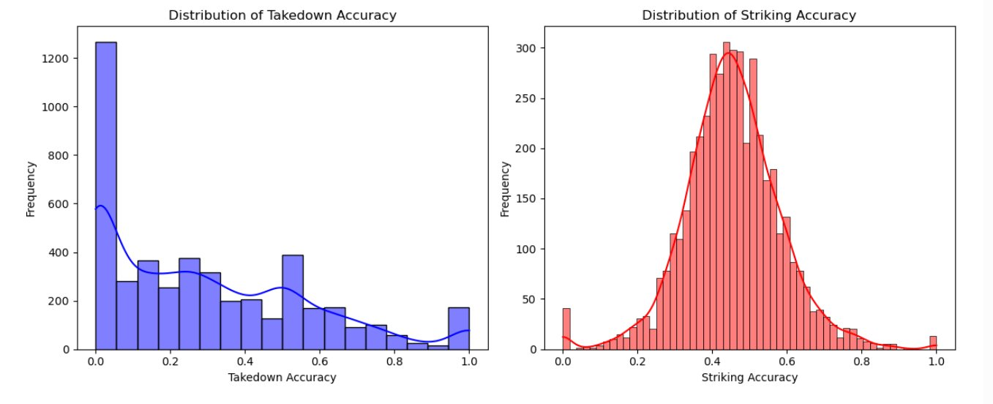
Figure 1: Distribution of Takedown Accuracy (left) and Striking Accuracy (right)
Takedown accuracy is heavily right-skewed with a large spike at 0, meaning many fighters attempt few or no takedowns. Striking accuracy follows a more bell-shaped distribution centered around 0.40-0.45. The contrasting shapes suggest these two metrics capture fundamentally different aspects of fighter performance, justifying their separate treatment in the hypothesis test and ML models.

Figure 2 — Scatter Plot: Striking Accuracy vs. Takedown Accuracy, colored by fight winner (Red, Blue, Draw).
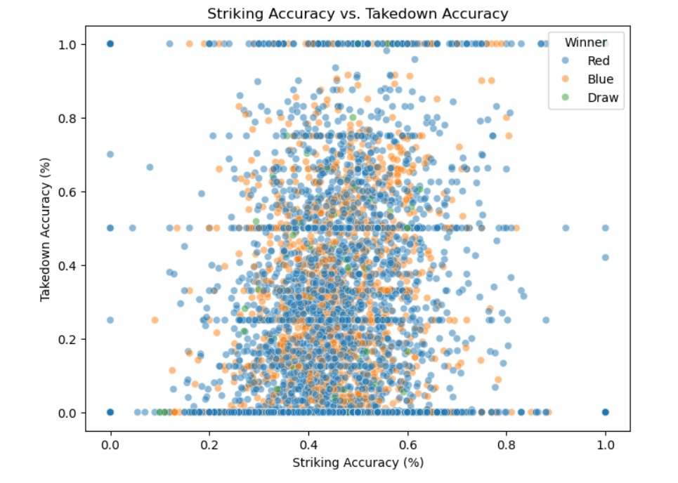
Figure 2: Striking Accuracy vs. Takedown Accuracy colored by Winner
The three winning-corner color clusters (Red, Blue, Draw) overlap almost entirely across the entire plot space. No clear region belongs exclusively to one winner type. This visual evidence directly motivates the hypothesis test: a simple accuracy threshold cannot separate winners from losers, and a multi-feature model is required.

Figure 3 — Experience Level Count: Veteran vs. Prospect distribution in the enriched dataset.
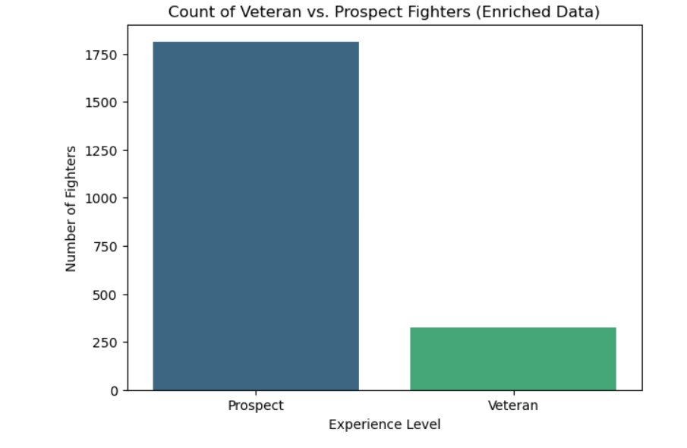
Figure 3: Count of Veteran vs. Prospect Fighters (Enriched Data)
The bar chart confirms a severe class imbalance: 1,812 Prospects vs. 327 Veterans (84.7% vs. 15.3%). This imbalance reflects the real-world UFC career funnel where most fighters compete for only a few bouts before leaving the promotion. This finding directly informed the decision to use class_weight='balanced' in both ML classifiers.

Figure 4 — Box Plot: Takedown Accuracy comparison by winning corner.
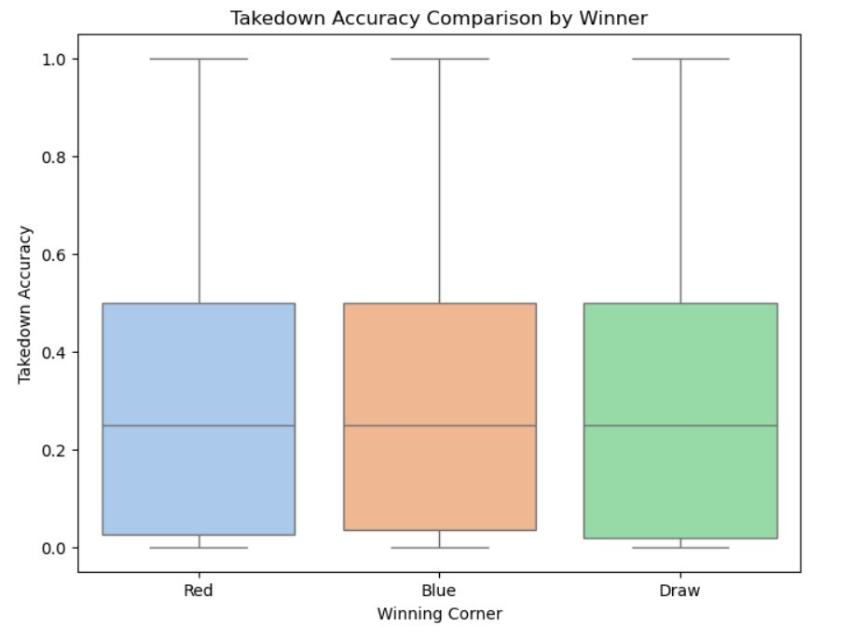
Figure 4: Takedown Accuracy Comparison by Winning Corner (Red, Blue, Draw)
All three groups (Red winner, Blue winner, Draw) show nearly identical medians around 0.25 and almost fully overlapping interquartile ranges. The whiskers extend to similar ranges as well. This visual pre-confirms the hypothesis test result: takedown accuracy alone does not differentiate winners from losers at the individual fight level.

Hypothesis Testing
A formal independent samples t-test was conducted to answer the first research question.

Component | Details
H0 (Null Hypothesis) | No significant difference in win rate between high- and low-takedown-accuracy fighters
H1 (Alternative Hypothesis) | Fighters with higher takedown accuracy have a significantly higher win rate
Significance Level | α = 0.05
Method | Independent samples t-test (scipy.stats.ttest_ind)
Threshold | Median takedown accuracy (0.25)
T-Statistic | -0.4832
P-Value | 0.6289
Result | Failed to reject H0

Table 2: Hypothesis test results
The p-value of 0.6289 is well above the 0.05 threshold. We fail to reject H0. This means that, at the individual fight level, having above-median takedown accuracy alone does not translate into a statistically significantly higher win rate. This was an important and somewhat surprising finding — it suggests that grappling accuracy in isolation is not the decisive short-term predictor that conventional wisdom implies. This finding motivates the machine learning phase, which examines long-term career success using a broader set of metrics.

Machine Learning Phase
The ML phase shifts from fight-level to fighter-level analysis. The target variable is Experience_Level (Veteran/Prospect), which serves as a proxy for long-term career success. Statistical validation confirmed this is a legitimate target: Veterans and Prospects differ significantly in both grappling (p = 0.0001) and striking metrics (p < 0.0001).
Three models were implemented following the Recitation notebooks:

Logistic Regression
Logistic Regression was chosen as the primary model because its coefficients directly answer the research question: which metrics push a fighter toward Veteran status?
• class_weight='balanced' was applied to correct for the 85%/15% class imbalance.
• The model was evaluated using Accuracy, AUC, F1-Score, Confusion Matrix, and 5-Fold Cross-Validation.

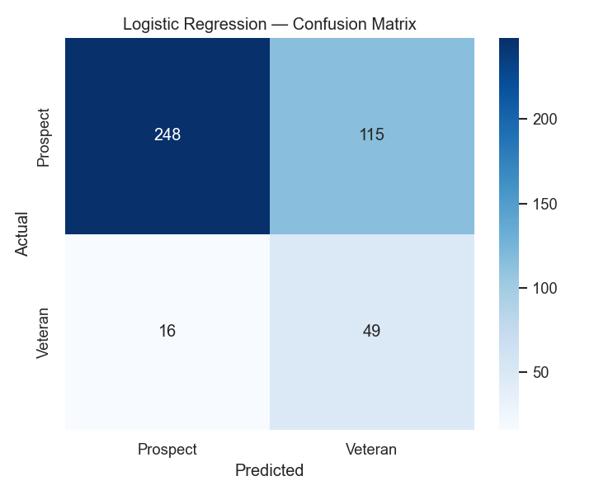
Figure 5: Logistic Regression — Confusion Matrix
The confusion matrix shows that with class_weight='balanced', the model correctly identifies 49 out of 65 Veterans (75% recall). Without balancing, the model would have predicted almost all Veterans as Prospects due to the class imbalance.

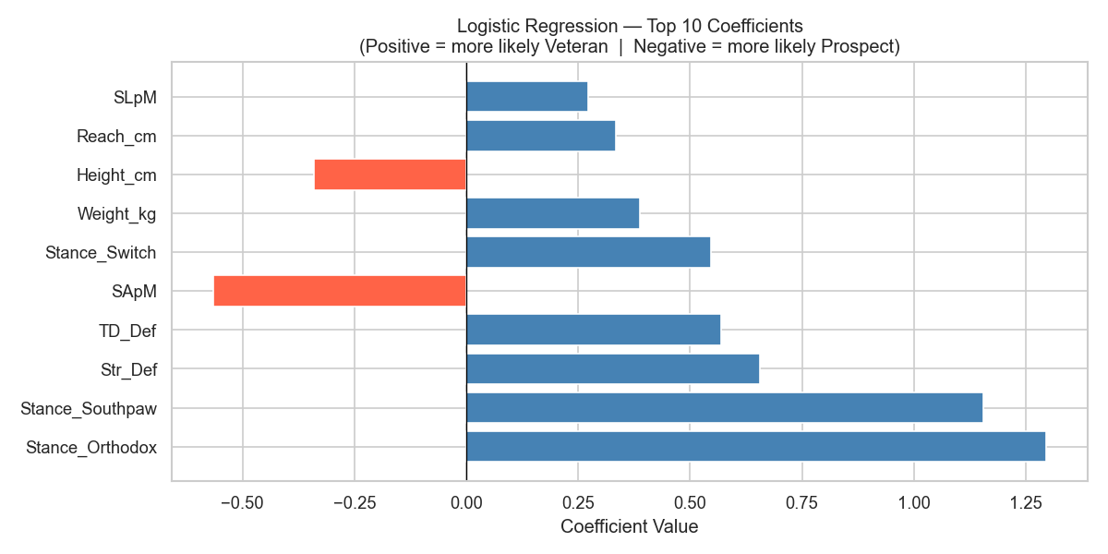
Figure 6: Logistic Regression — Top 10 Coefficients (Blue = toward Veteran, Red = toward Prospect)
The coefficient chart shows that Stance features have the highest absolute coefficients, followed by Str_Def (striking defense) and TD_Def (takedown defense). This suggests that defensive competence — both in striking and grappling — is more predictive of career longevity than offensive output alone.

Random Forest
Random Forest was implemented to capture non-linear relationships between metrics and career outcomes. The model was tuned via 5-fold cross-validation over a grid of max_depth values (3, 5, 10, 15) and n_estimators values (50, 100, 200). The best configuration was max_depth=10, n_estimators=200.

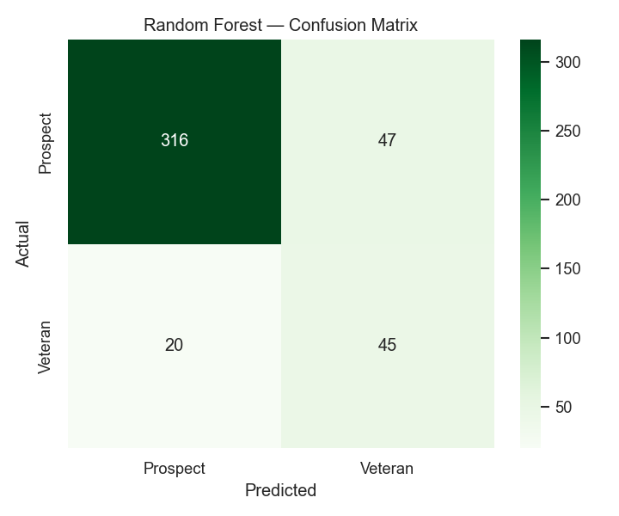
Figure 7: Random Forest — Confusion Matrix
The Random Forest confusion matrix shows substantial improvement over Logistic Regression: 45 out of 65 Veterans correctly identified (69% recall) with much higher precision (49%), reducing false positives significantly compared to the Logistic Regression model.

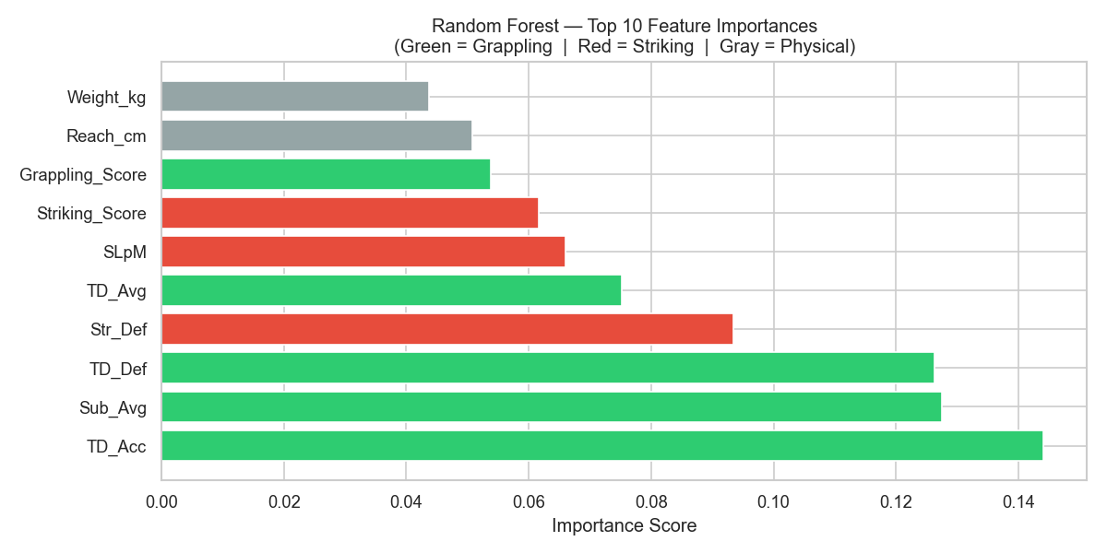
Figure 8: Random Forest — Top 10 Feature Importances (Green = Grappling, Red = Striking, Gray = Physical)
The feature importance chart is the most direct answer to the project's research question. Grappling metrics (TD_Acc, Sub_Avg, TD_Def, TD_Avg, Grappling_Score) account for a combined 56.2% of total feature importance, while striking metrics (Str_Def, SLpM, Striking_Score) account for 30.2%. This confirms that grappling-related metrics are more predictive of long-term UFC career success.

K-Means Clustering
K-Means clustering was applied unsupervised to segment fighters by combat style. The optimal number of clusters was selected using both the Elbow Method and Silhouette Score.

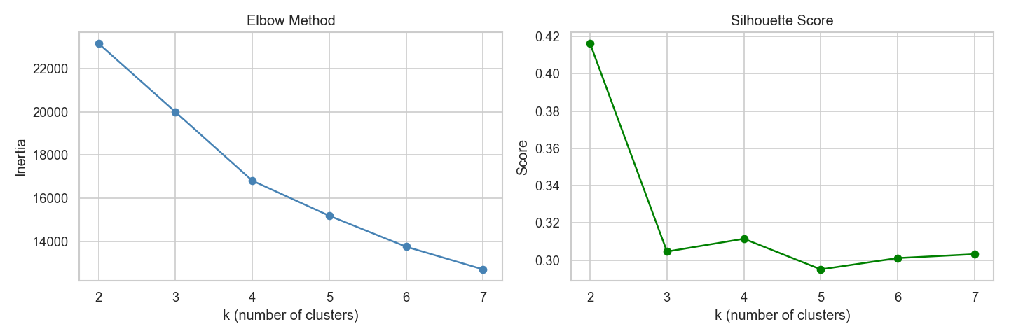
Figure 9: Elbow Method and Silhouette Score — Both indicate k=3 as optimal
The elbow plot shows a clear change in slope after k=3, and the silhouette score peaks at k=3, confirming this as the optimal number of clusters.

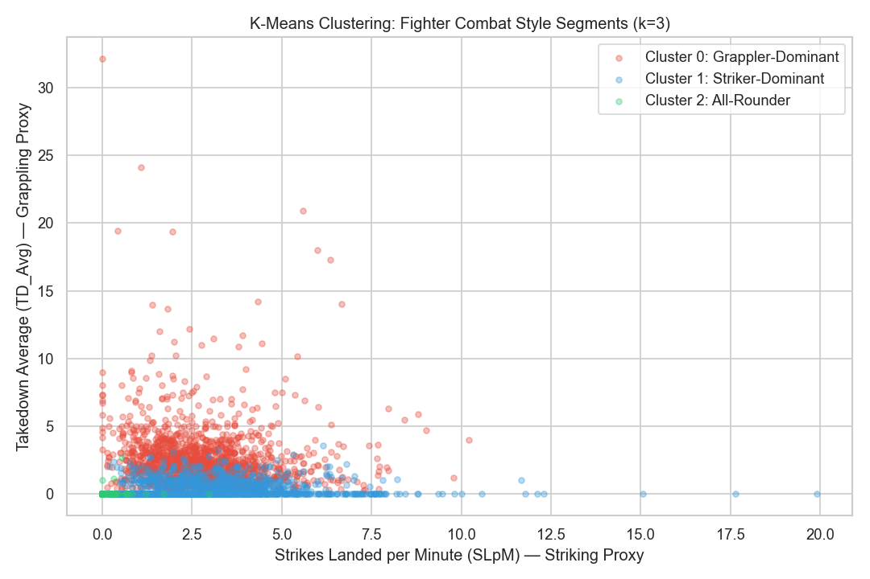
Figure 10: K-Means Clusters — Fighter Combat Style Segments (k=3)
Three distinct clusters emerged naturally: Grappler-Dominant (high TD_Avg, low SLpM), Striker-Dominant (high SLpM, low TD_Avg), and All-Rounder (moderate in both). The Veteran rates across these clusters provide a third angle on the research question:

Cluster | Style | Veteran Rate | N
0 | Grappler-Dominant | 22.6% | ~1,198
1 | Striker-Dominant | 8.9% | ~1,199
2 | All-Rounder | 0.6% | ~1,199

Table 3: Veteran rates by fighting style cluster
Grappler-Dominant fighters are 2.5 times more likely to reach Veteran status than Striker-Dominant fighters (22.6% vs. 8.9%), strongly reinforcing the ML findings.

4. Findings

Model Performance Summary

Model | Test Accuracy | AUC | 5-Fold CV AUC
Logistic Regression | 0.6939 | 0.7703 | 0.7562 ± 0.0286
Random Forest | 0.8435 | 0.8791 | 0.8718 ± 0.0285

Table 4: Model performance comparison

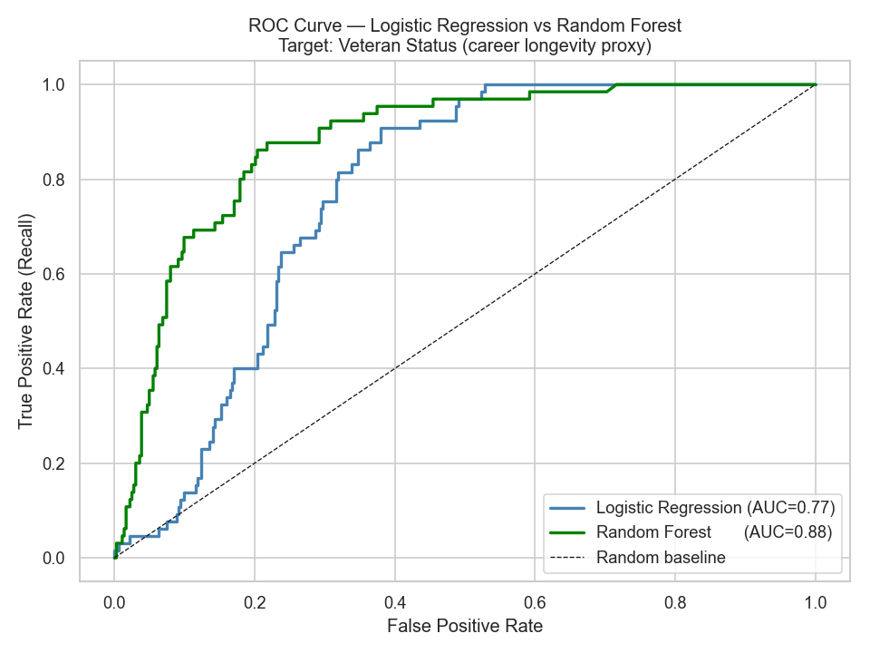
Figure 11: ROC Curve — Random Forest (AUC=0.88) outperforms Logistic Regression (AUC=0.77)
The ROC curve plots the True Positive Rate against the False Positive Rate at different classification thresholds. A model that perfectly separates classes would hug the top-left corner, while a random guess follows the diagonal dashed line (AUC = 0.50). Random Forest achieves AUC = 0.88 and Logistic Regression achieves AUC = 0.77, both well above the baseline.
Random Forest significantly outperforms Logistic Regression in all metrics. Both models are well above the diagonal random baseline, confirming that grappling and striking metrics carry genuine predictive signal for career longevity.

Key Findings
• Finding 1 : Short-term: Takedown accuracy alone does NOT significantly predict individual fight outcomes (p = 0.6289). The hypothesis test fails to reject H0.
• Finding 2 : Long-term: Grappling metrics (TD_Acc, Sub_Avg, TD_Def) are the top predictors of career longevity, accounting for 56.2% of total feature importance in the Random Forest model.
• Finding 3 : Clustering: Grappler-Dominant fighters reach Veteran status at a 22.6% rate, compared to 8.9% for Striker-Dominant fighters — a 2.5x difference.
• Finding 4 : Defense matters: Both Str_Def and TD_Def rank highly in feature importance and Logistic Regression coefficients, suggesting that defensive skills are as important as offensive output for career longevity.
• Finding 5 : Model stability: Low cross-validation standard deviations (±0.029 for both models) confirm that results generalize well and are not overfitted.

Answer to the Research Question
The popular belief that grapplers are more dominant than strikers in UFC is partially supported by this analysis — but the relationship is more nuanced than the conventional wisdom suggests. At the individual fight level, grappling accuracy alone is not a decisive differentiator. However, at the career level, fighters with stronger grappling profiles are significantly more likely to sustain long UFC careers. The data suggests that grappling skills contribute to consistency and longevity, while striking may be more impactful in single-fight outcomes.

A particularly striking insight from this analysis is the distinction between short-term and long-term impact. At the individual fight level, grappling accuracy alone is not a statistically significant predictor of winning (p = 0.6289). However, at the career level, Grappler-Dominant fighters are 2.5 times more likely to reach Veteran status than Striker-Dominant fighters (22.6% vs. 8.9%). This suggests a compelling conclusion: grappling may not win you a single fight, but it keeps you in the sport. Striking, on the other hand, may deliver more decisive single-fight outcomes but does not translate into the same level of career sustainability.

5. Limitations and Future Work

Limitations
• No fight-level outcome data in the ML phase: The ML models were trained on fighter-level aggregates from enriched_fighter_details.csv, not on individual fight results. Using fight-level Winner labels (as originally proposed) would more directly address the research question but would require a different data merging strategy.
• Class imbalance: Veterans represent only 15.3% of the dataset. Although class_weight='balanced' was applied, the minority class recall remains imperfect. More advanced techniques such as SMOTE could be explored.
• Experience_Level as a proxy: Defining career success as '10+ fights' is an approximation. A fighter who lost all their fights but accumulated 11 bouts would still be labeled Veteran. A win-rate-based target would be more precise.
• Temporal bias: Fighter statistics are career averages, which do not capture how a fighter's style may have evolved over time or how the sport itself has changed since 1993.
• Missing physical data: 1,912 fighters had missing Reach values, requiring mean imputation. Physical attributes might be more predictive if more complete data were available.

Future Work
• Fight-level ML: Merge data.csv with raw_fighter_details.csv to create a fight-level ML dataset with Winner as the direct target variable, as originally proposed.
• Time-series analysis: Analyze how grappling vs. striking dominance has shifted across different eras of the UFC (1993–2000, 2001–2010, 2011–2021).
• Weight-class stratification: Repeat the analysis separately for each weight class, as grappling may be more dominant in heavier divisions.
• Neural networks: Apply deep learning models to capture more complex non-linear interactions between the 140+ available features.
• Win method analysis: Distinguish between submission wins, KO/TKO wins, and decision wins to analyze whether grapplers win differently than strikers, not just more often.

6. Note on Scope Adjustment from Proposal
The original proposal specified the fight-level Winner (Red/Blue) as the machine learning target variable. During implementation, it became clear that the available fighter-level dataset (enriched_fighter_details.csv) does not contain per-fight outcomes in a format directly usable for supervised learning without substantial additional merging.
Therefore, Experience_Level (Veteran/Prospect) was used as the ML target instead. This choice is statistically justified: independent t-tests confirm that Veterans and Prospects differ significantly in both grappling (p = 0.0001) and striking metrics (p < 0.0001), making Experience_Level a valid and informative proxy for long-term competitive success.
This scope adjustment is also consistent with the project's broader research question: rather than only asking 'who wins a single fight?', the analysis asks 'which combat style sustains a long career?', a richer and arguably more meaningful question.

