Design Report
CS224
Section - 03
Lab - 06
Mert Fidan
22101734
- Matrix Size = 10.000 (N = 100)
- Direct mapped cache row-wise summation

Block Size (words) | 2 | 4 | 8 | 16 | 32
Cache Size (bytes)
256 (0.26 KB) | Miss Rate: 7%  Number of Misses: 17.832 | Miss Rate: 6%  Number of Misses: 15.945 | Miss Rate: 6%  Number of Misses: 14.845 | Miss Rate: 7%  Number of Misses: 17.960 | Miss Rate: 10%  Number of Misses: 25.136
512 (0.5 KB) | Miss Rate: 6%  Number of Misses: 16.428 | Miss Rate: 5%  Number of Misses: 14.228 | Miss Rate: 5%  Number of Misses: 13.050 | Miss Rate: 5%  Number of Misses: 14.293 | Miss Rate: 7%  Number of Misses: 17.725
1024 (1 KB) | Miss Rate: 6%  Number of Misses: 14.359 | Miss Rate: 4%  Number of Misses: 11.336 | Miss Rate: 5%  Number of Misses: 12.153 | Miss Rate: 5%  Number of Misses: 12.460 | Miss Rate: 5%  Number of Misses: 14.020
2048 (2 KB) | Miss Rate: 4%  Number of Misses: 10.413 | Miss Rate: 2%  Number of Misses: 5539 | Miss Rate: 4%  Number of Misses: 9629 | Miss Rate: 4%  Number of Misses: 11.520 | Miss Rate: 5%  Number of Misses: 12.120
4096 (4 KB) | Miss Rate: 4%  Number of Misses: 10.137 | Miss Rate: 2%  Number of Misses: 5226 | Miss Rate: 3%  Number of Misses: 8401 | Miss Rate: 4%  Number of Misses: 9536 | Miss Rate: 4%  Number of Misses: 11.170

- Direct mapped cache column-wise summation

Block Size (words) | 2 | 4 | 8 | 16 | 32
Cache Size (bytes)
256 (0.26 KB) | Miss Rate: 8%  Number of Misses: 11.896 | Miss Rate: 5%  Number of Misses: 7197 | Miss Rate: 3%  Number of Misses: 4847 | Miss Rate: 4%  Number of Misses: 6090 | Miss Rate: 7%  Number of Misses: 10.457
512 (0.5 KB) | Miss Rate: 8%  Number of Misses: 10.960 | Miss Rate: 4%  Number of Misses: 6105 | Miss Rate: 3%  Number of Misses: 3677 | Miss Rate: 3%  Number of Misses: 3672 | Miss Rate: 4%  Number of Misses: 5543
1024 (1 KB) | Miss Rate: 7%  Number of Misses: 10.492 | Miss Rate: 4%  Number of Misses: 5559 | Miss Rate: 2%  Number of Misses: 3092 | Miss Rate: 2%  Number of Misses: 2463 | Miss Rate: 2%  Number of Misses: 3086
2048 (2 KB) | Miss Rate: 7%  Number of Misses: 10.252 | Miss Rate: 4%  Number of Misses: 5279 | Miss Rate: 2%  Number of Misses: 2792 | Miss Rate: 1%  Number of Misses: 1843 | Miss Rate: 1%  Number of Misses: 1826
4096 (4 KB) | Miss Rate: 7%  Number of Misses: 10.132 | Miss Rate: 4%  Number of Misses: 5139 | Miss Rate: 2%  Number of Misses: 2642 | Miss Rate: 1%  Number of Misses: 1533 | Miss Rate: 1%  Number of Misses: 1196

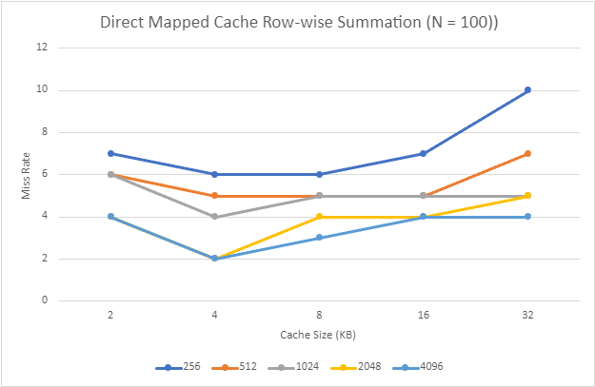

- Hit rate performances for various caches

 | Good Hit Rate Cache Size: 2048 bytes  Block Size: 4 words | Medium Hit Rate Cache Size: 1024 bytes  Block Size: 8 words | Poor Hit Rate Cache Size: 256 bytes  Block Size: 2 words
Fully Associative (LRU) | Miss Rate: 2%  Number of Misses: 1278 | Miss Rate: 4%  Number of Misses: 2819 | Miss Rate: 6%  Number of Misses: 3774
Fully Associative (Random) | Miss Rate: 2%  Number of Misses: 1506 | Miss Rate: 3%  Number of Misses: 2175 | Miss Rate: 6%  Number of Misses: 3916
Direct Mapped | Miss Rate: 2%  Number of Misses: 5539 | Miss Rate: 5%  Number of Misses: 12.153 | Miss Rate: 7%  Number of Misses: 17.832

- Hit rate performances for N-way caches

N-way Set Associative Cache Set Size | Good Hit Rate Cache Size: 2048 bytes  Block Size: 4 words | Medium Hit Rate Cache Size: 1024 bytes  Block Size: 8 words | Poor Hit Rate Cache Size: 256 bytes  Block Size: 2 words
2 | Miss Rate: 2%  Number of Misses: 1281 | Miss Rate: 4%  Number of Misses: 2458 | Miss Rate: 6%  Number of Misses: 3774
4 | Miss Rate: 2%  Number of Misses: 1275 | Miss Rate: 4%  Number of Misses: 2819 | Miss Rate: 6%  Number of Misses: 3774
8 | Miss Rate: 2%  Number of Misses: 1276 | Miss Rate: 4%  Number of Misses: 2819 | Miss Rate: 6%  Number of Misses: 3774
16 | Miss Rate: 2%  Number of Misses: 1276 | Miss Rate: 4%  Number of Misses: 2819 | Miss Rate: 6%  Number of Misses: 3774

- Matrix Size = 2500 (N = 50)
- Direct mapped cache row-wise summation

Block Size (words) | 2 | 4 | 8 | 16 | 32
Cache Size (bytes)
256 (0.26 KB) | Miss Rate: 6%  Number of Misses: 4159 | Miss Rate: 6%  Number of Misses: 3996 | Miss Rate: 6%  Number of Misses: 3717 | Miss Rate: 7%  Number of Misses: 4493 | Miss Rate: 10%  Number of Misses: 6287
512 (0.5 KB) | Miss Rate: 4%  Number of Misses: 2921 | Miss Rate: 4%  Number of Misses: 2870 | Miss Rate: 5%  Number of Misses: 3256 | Miss Rate: 5%  Number of Misses: 3552 | Miss Rate: 7%  Number of Misses: 4386
1024 (1 KB) | Miss Rate: 4%  Number of Misses: 2704 | Miss Rate: 3%  Number of Misses: 1971 | Miss Rate: 3%  Number of Misses: 2084 | Miss Rate: 5%  Number of Misses: 3082 | Miss Rate: 5%  Number of Misses: 3436
2048 (2 KB) | Miss Rate: 4%  Number of Misses: 2548 | Miss Rate: 3%  Number of Misses: 1816 | Miss Rate: 2%  Number of Misses: 1443 | Miss Rate: 3%  Number of Misses: 1997 | Miss Rate: 5%  Number of Misses: 2961
4096 (4 KB) | Miss Rate: 4%  Number of Misses: 2326 | Miss Rate: 3%  Number of Misses: 1670 | Miss Rate: 2%  Number of Misses: 1338 | Miss Rate: 2%  Number of Misses: 1233 | Miss Rate: 3%  Number of Misses: 1933

- Direct mapped cache column-wise summation

Block Size (words) | 2 | 4 | 8 | 16 | 32
Cache Size (bytes)
256 (0.26 KB) | Miss Rate: 9%  Number of Misses: 2992 | Miss Rate: 5%  Number of Misses: 1809 | Miss Rate: 3%  Number of Misses: 1218 | Miss Rate: 4%  Number of Misses: 1527 | Miss Rate: 7%  Number of Misses: 2618
512 (0.5 KB) | Miss Rate: 8%  Number of Misses: 2752 | Miss Rate: 4%  Number of Misses: 1529 | Miss Rate: 3%  Number of Misses: 918 | Miss Rate: 3%  Number of Misses: 907 | Miss Rate: 4%  Number of Misses: 1358
1024 (1 KB) | Miss Rate: 8%  Number of Misses: 2632 | Miss Rate: 4%  Number of Misses: 1389 | Miss Rate: 2%  Number of Misses: 768 | Miss Rate: 2%  Number of Misses: 597 | Miss Rate: 2%  Number of Misses: 728
2048 (2 KB) | Miss Rate: 7%  Number of Misses: 2572 | Miss Rate: 4%  Number of Misses: 1319 | Miss Rate: 2%  Number of Misses: 693 | Miss Rate: 1%  Number of Misses: 442 | Miss Rate: 1%  Number of Misses: 413
4096 (4 KB) | Miss Rate: 7%  Number of Misses: 2548 | Miss Rate: 4%  Number of Misses: 1291 | Miss Rate: 2%  Number of Misses: 663 | Miss Rate: 1%  Number of Misses: 380 | Miss Rate: 1%  Number of Misses: 287

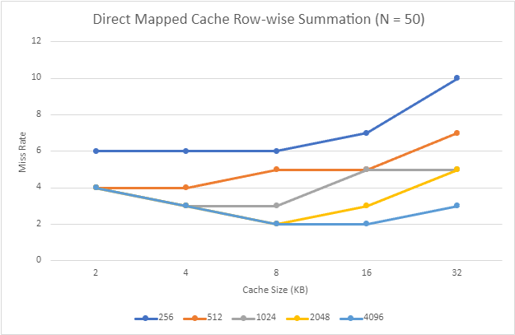

- Hit rate performances for various caches

 | Good Hit Rate Cache Size: 2048 bytes  Block Size: 8 words | Medium Hit Rate Cache Size: 1024 bytes  Block Size: 16 words | Poor Hit Rate Cache Size: 256 bytes  Block Size: 2 words
Fully Associative (LRU) | Miss Rate: 1%  Number of Misses: 667 | Miss Rate: 4%  Number of Misses: 2659 | Miss Rate: 6%  Number of Misses: 3774
Fully Associative (Random) | Miss Rate: 2%  Number of Misses: 1198 | Miss Rate: 4%  Number of Misses: 2706 | Miss Rate: 6%  Number of Misses: 3874
Direct Mapped | Miss Rate: 2%  Number of Misses: 1443 | Miss Rate: 5%  Number of Misses: 3082 | Miss Rate: 6%  Number of Misses: 4159

- Hit rate performances for N-way caches

N-way Set Associative Cache Set Size | Good Hit Rate Cache Size: 2048 bytes  Block Size: 8 words | Medium Hit Rate Cache Size: 1024 bytes  Block Size: 16 words | Poor Hit Rate Cache Size: 256 bytes  Block Size: 2 words
2 | Miss Rate: 1%  Number of Misses: 893 | Miss Rate: 4%  Number of Misses: 2659 | Miss Rate: 6%  Number of Misses: 3774
4 | Miss Rate: 1%  Number of Misses: 721 | Miss Rate: 4%  Number of Misses: 2659 | Miss Rate: 6%  Number of Misses: 3774
8 | Miss Rate: 1%  Number of Misses: 666 | Miss Rate: 4%  Number of Misses: 2659 | Miss Rate: 6%  Number of Misses: 3774
16 | Miss Rate: 1%  Number of Misses: 666 | Miss Rate: 4%  Number of Misses: 2659 | Miss Rate: 6%  Number of Misses: 3774

