**Name and Surname: No:**

**Name and Surname: No:**

**IE4058 Econometrics and Forecasting (2021-2022 Fall)**

**Project Part 1 Report**

1. Time series and ACF plots of the training data set:

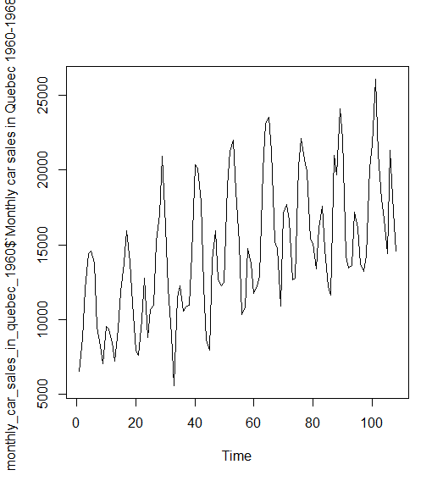

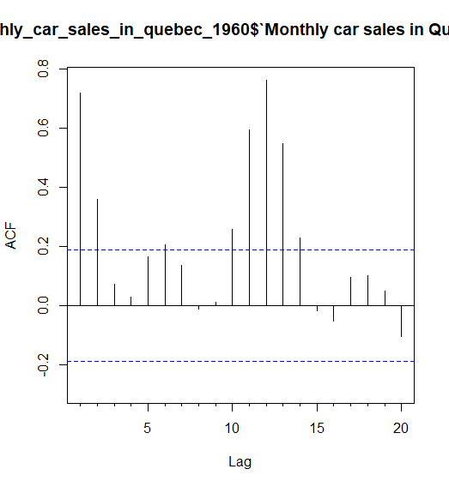

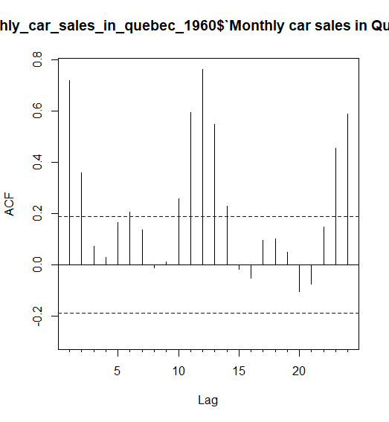

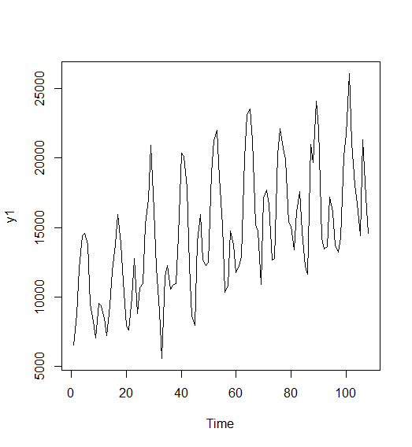

1. Smoothing parameters and initial states for Holt-Winters’ Additive Method:

Smoothing parameters:

alpha = 0.1465

beta = 2e-04

gamma = 0.0033

Initial states:

l = 9652.313

b = 91.8808

s = -2442.469 -37.0141 -562.6003 -4690.061 -3306.195 -1048.663

3780.367 6688.623 5003.571 2880.066 -2854.893 -3410.732

sigma: 1458.874

1. Smoothing parameters and initial states for Holt-Winters’ Multiplicative Method:

Smoothing parameters:

alpha = 0.1343

beta = 0.0034

gamma = 3e-04

Initial states:

l = 9834.6362

b = 134.7544

s = 0.8005 0.974 0.9896 0.6714 0.791 0.9369

1.2586 1.4442 1.3563 1.222 0.811 0.7445

sigma: 0.1087

1. Plot of Additive Decomposition:

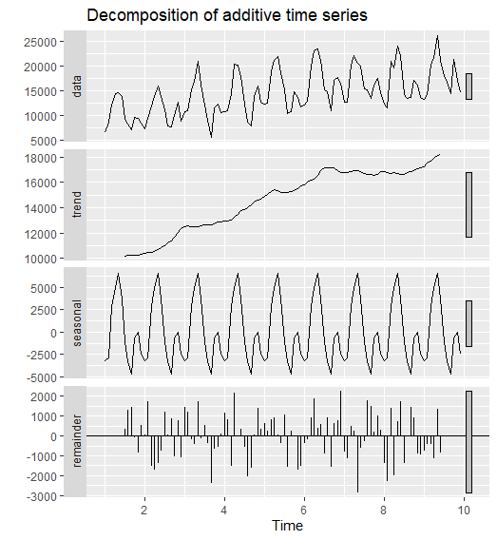

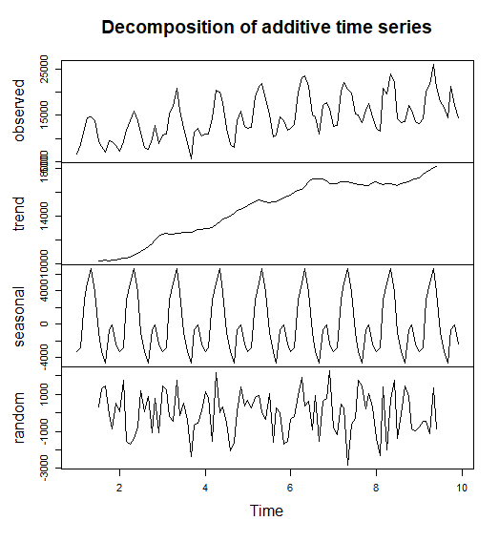

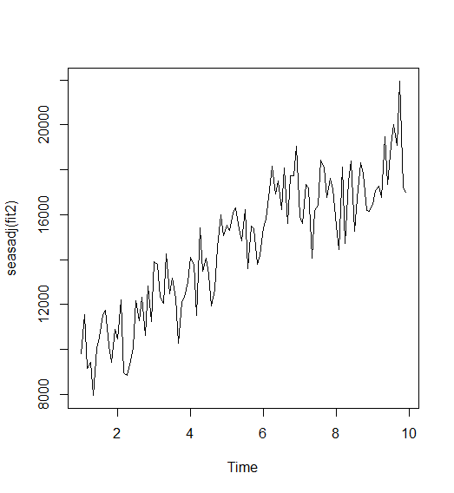

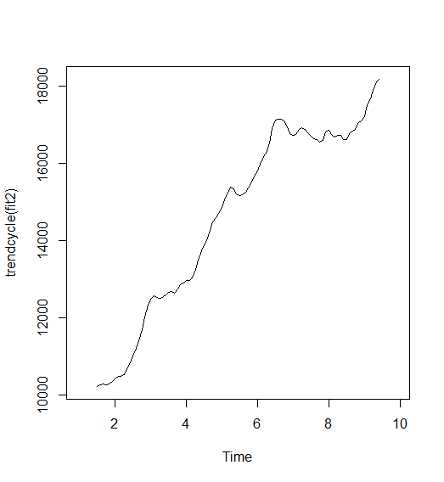

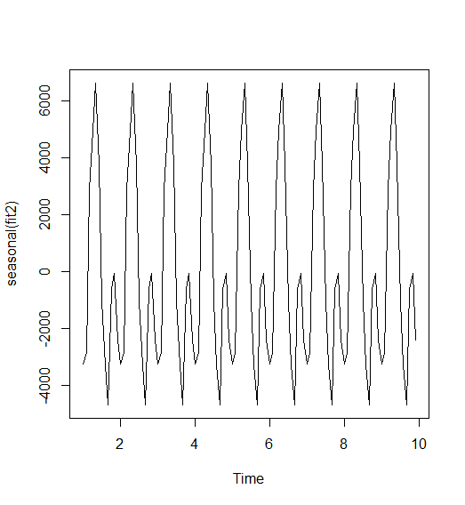

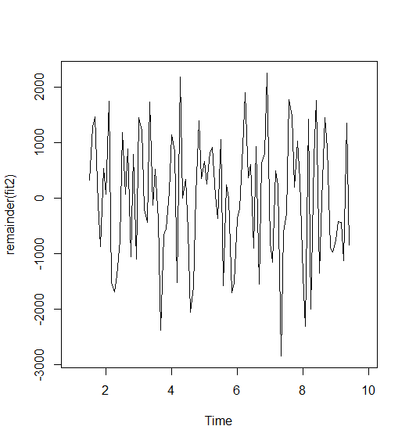

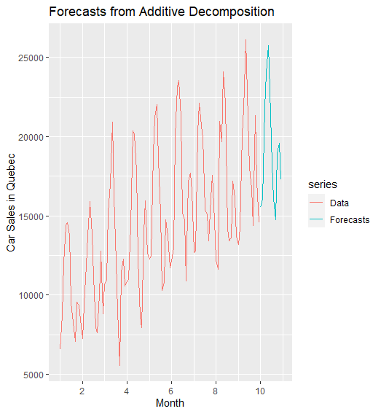

1. Plot of Multiplicative Decomposition:

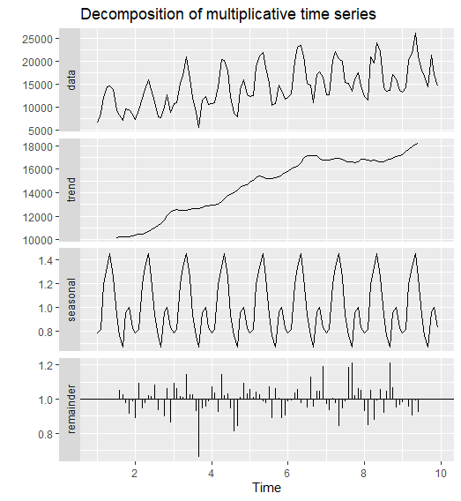

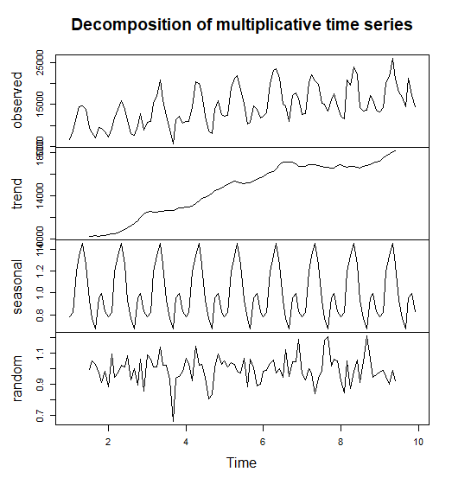

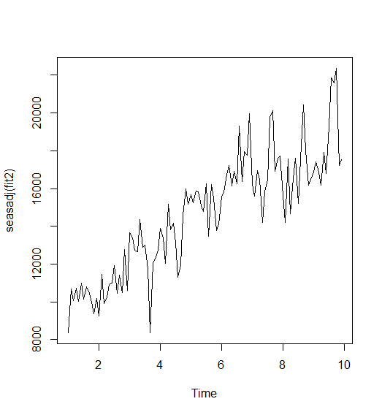



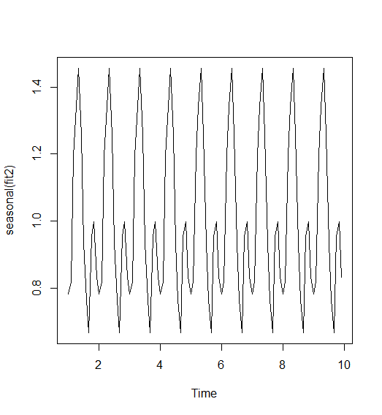

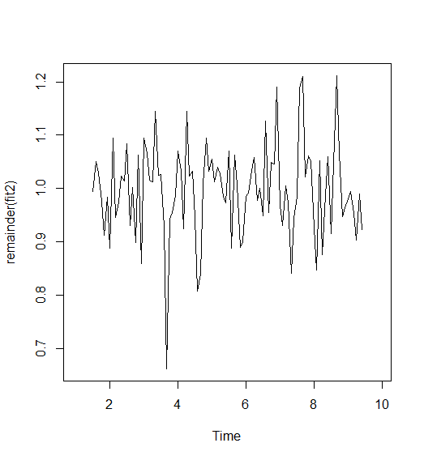

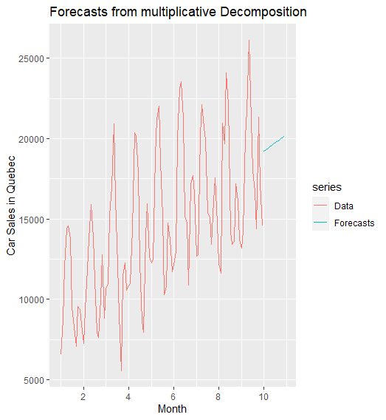

**6.**

|  |  |  |  |
| --- | --- | --- | --- |
|  | **Error measures calculated on the test set** | | |
| **Method** | **MSE** | **MAE** | **MAPE** |
| Holt-Winters’ Additive | 1813008.3904 | 1102.118 | 8.383906 |
| Holt-Winters’ Multiplicative | 2004495.3032 | 1090.571 | 8.124335 |
| Additive Decomposition | 1801224.35741 | 1096.592 | 7.847404 |
| Multiplicative Decomposition | 2261327.22044 | 1156.086 | 7.972965 |

1. Suggested method based on the comparison by error measures:

**8.** A single time series plot including forecasts for all methods:



