**Name and Surname: Tunahan Dikenova No: 150319560**

**Name and Surname: Mert Hırka No: 150319573**

**IE4058 Econometrics and Forecasting (2021-2022 Fall)**

**Project Part 2 Report**

**1.** The regression coefficients table, residual standard error, multiple R-squared, adjusted R-squared, F-statistic, and p-value:

Coefficients:

(Intercept) t tsq D1 D2 D3 D4

6367.6359 139.2420 -0.5033 -622.8521 -25.0404 5409.5557 7514.2697

D5 D6 D7 D8 D9 D10 D11

9033.4347 6352.2732 1651.8961 -524.9187 -2045.8380 2345.2495 2388.7881

Residual standard error: 1393 on 94 degrees of freedom

Multiple R-squared: 0.9167, Adjusted R-squared: 0.9052

F-statistic: 79.6 on 13 and 94 DF, p-value: < 2.2e-16

**2.** The time plot, ACF plot, and histogram of the residuals:

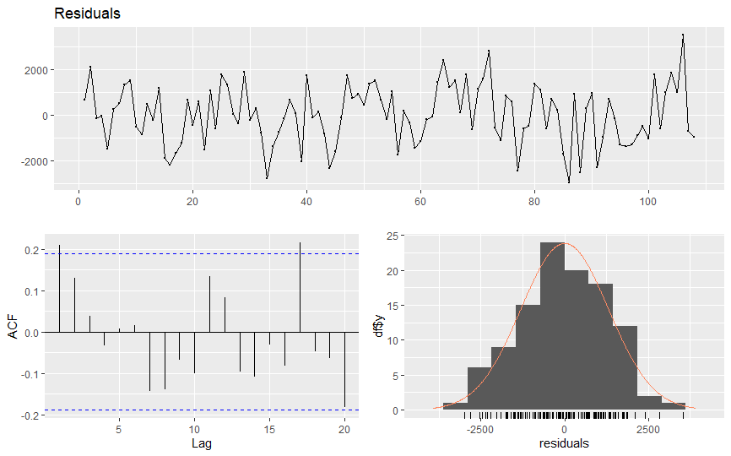

**3.** ARIMA(p, d, q)(P, D, Q)[s]:

data: Residuals from ARIMA(1,0,1)(0,1,1)[12] with drift

Q* = 29.996, df = 18, p-value = 0.03749

Model df: 4. Total lags used: 22

**4.** ARIMA model in terms of backshift operator:

ARIMA $(1,0,1){(0,1,1)}_{12}$ model:

$$\left(1-∅_{1}B\right){\left(1-∅_{1}B\right)}^{12}\left(1-B\right)\left(1-B^{12}\right)Y_{t}=(1-∅_{1}B)(1-∅_{1}B^{12})$$

**5.** ARIMA model coefficients table:

Coefficients:

ar1 ma1 sma1 drift

0.7794 -0.5317 -0.5863 0.4532

s.e. 0.1603 0.2193 0.1389 0.0699

sigma^2 estimated as 64.17: log likelihood=-336.53

AIC=683.05 AICc=683.72 BIC=695.87

**6.** The time plot, ACF plot, and histogram of the residuals:

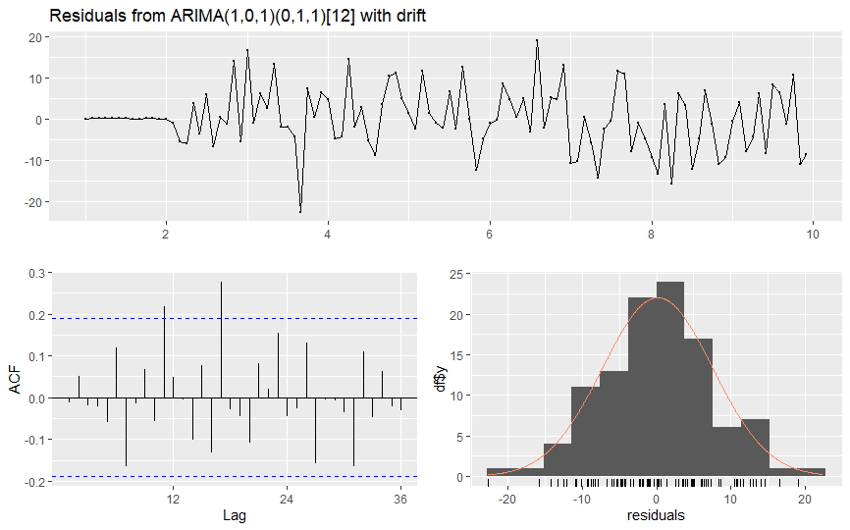

**7.** ARIMA(p, d, q)(P, D, Q)[s] (on Box-Cox transformed data):

Ljung-Box test

data: Residuals from ARIMA(1,0,1)(0,1,1)[12] with drift

Q* = 29.996, df = 18, p-value = 0.03749

Model df: 4. Total lags used: 22

**8.** Box-Cox Lambda = 0.4520921

**9.** ARIMA model in terms of backshift operator (on Box-Cox transformed data):

$$\left(1-∅_{1}B\right){\left(1-∅_{1}B\right)}^{12}\left(1-B\right)\left(1-B^{12}\right)Y_{t}=(1-∅_{1}B)(1-∅_{1}B^{12})$$

**10.** ARIMA model coefficients table (on Box-Cox transformed data):

Series: transy

ARIMA(1,0,1)(0,1,1)[12] with drift

Box Cox transformation: lambda= 0.4520921

Coefficients:

ar1 ma1 sma1 drift

0.7678 -0.5131 -0.5556 0.0282

s.e. 0.1641 0.2238 0.1360 0.0046

sigma^2 estimated as 0.2549: log likelihood=-70.84

AIC=151.69 AICc=152.36 BIC=164.51

**11.** The time plot, ACF plot, and histogram of the residuals:

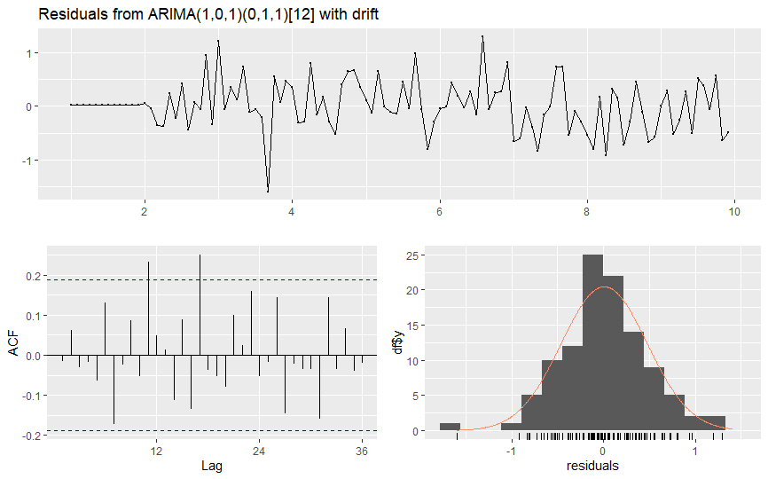

**12.**

|  |  |  |  |
| --- | --- | --- | --- |
|  | **Error measures calculated on the test set** | | |
| **Method** | **MSE** | **MAE** | **MAPE** |
| Regression | 3.4711964e-27 | 1065.625 | 8.080279 |
| ARIMA | 791.551778321 | 1066.076 | 7.410655 |
| ARIMA on Box-Cox transformed data | 0.01103138492 | 5.631724 | 3.439493 |

**13.** Suggested method based on the comparison by error measures: ARIMA on Box-Cox transformed data because errors are lower than other.

**14.** A single time series plot including forecasts for all methods:

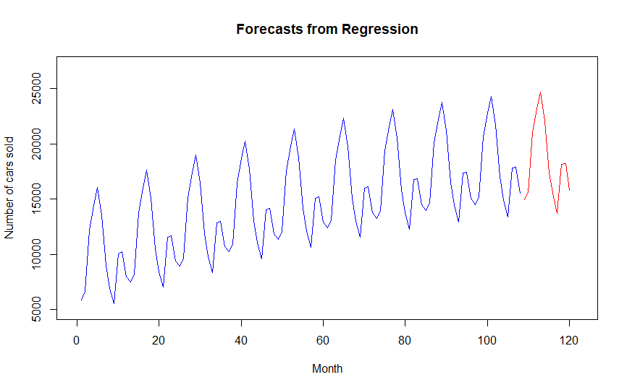

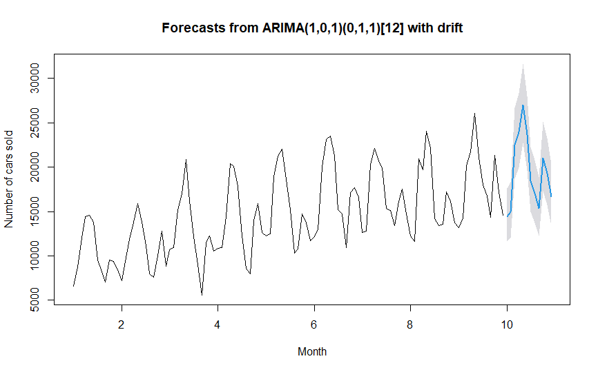

Figure 1: ARIMA ON BOX COX

