**Marmara University**

**IE2052/2152 - Statistics for Industrial Engineers Final Project**

Instructor: Assoc. Prof. Özlem ŞENVAR / Res. Asst. M. Umut İZER

**Group 25 – Balance of State Budget**

150818822 – Hatice Sena Temiz

150818821 – İremnur Boyacı

150319573 – Mert Hırka

150816043 – Selcan Akbulut

Due Date: 13.06.2021

**FALL 2011-2012**

**TABLE OF CONTENTS**

ABSTRACT 3

1. INTRODUCTION 4

2. LITERATURE REVIEW 5

3. METHODOGOLOGY AND APPLICATION 9

3.1. Descriptive Statistics 9

3.1.1. Summary Statistics 9

3.1.2. Frequency Distribution 13

3.1.3. Descriptive Plots 14

3.2. Inferential Statistics 27

3.2.1. Confidence Intervals 27

3.2.2. Hypothesis Tests 46

3.2.3. Goodness of Fit Tests and Contingency Analyses 76

3.2.4. Nonparametric Test Procedures 88

3.3. Exploratory Data Analyses 98

3.3.1. Correlation Analyses 98

3.3.2. Regression Analyses 104

3.4. Trend Based Forecasting 126

4. DISCUSSION AND CONCLUSION 137

REFERENCES 139

# ABSTRACT

In this project, our aim is to examine the budget expenditures of the Turkish Republic of Northern Cyprus between 1977 and 2018 by using Current Expenditure, Personnel Expenditure, Other Current Expenditure, Defence and GNP data. It is also to examine its connection with the country's economy. For this, some methods have been applied. Method solutions are obtained by using the R program. With the first method, descriptive statistics, the basic features of the Budget Expenditure data of the Turkish Republic of Northern Cyprus are explained. Various graphs are drawn in this section. These are team-leaf diagram, dot diagram, Time series diagram and Box-plot diagram and histogram. Together with the Inferential Statistics, With the Confidence interval, Current Expenditure, Personnel Expenditure, Other Current Expenditure, Defence and GNP data between 1977 and 2018 were accepted as samples and interval estimation of the population mean and variance at 95% confidence interval was provided. The assumptions of the population parameters were tested by using the Turkish Republic of Northern Cyprus data obtained as sample statistical data using the hypothesis test.

The latest method is Exploratory Data Analysis. This part includes correlation, regression and trend forecasting. In addition, two different regression models were used in the regression analysis part. The relationship between GNP value of the Turkish Republic of Northern Cyprus and Current Expenditure, Personnel Expenditure, Other Current Expenditure and Defence by Simple Linear Regression method was investigated seperately. The relationship between GNP and Current Expenditure and Defence with Multiple Linear Regression method was examined. With Trend Forecast, quantitative forecasts for the future were made using the historical data of the Turkish Republic of Northern Cyprus between 1977 and 2018. 2030 was chosen as the parameter to make the trend forecast. Quadratic Trend and Linear Trend were drawn. Among these methods, the R2 value of the Quadratic Trend model was found to be 0.97. On the other hand, R2 was calculated as 0.60 from the Linear Trend Model. According to these findings, it was decided to choose the Quadratic Trend model since the R2 value was higher in Quadratic Trend model.

**Keywords:** Turkish Republic of Northern Cyprus, Current Expenditure, Personnel Expenditure, Other Current Expenditure, Defence, GNP, Inferantial Statistics, Descriptive Statistics, Exploratory Data Analysis, Trend Forecasting, Time Series Plot

# 1. INTRODUCTION

The economic activities, which are one of the building blocks of development, and the phenomena that provide growth are expressed by the increase in the production capacity of the economy of a national place studied. The national economy includes the private sector, non-governmental organizations, households and the public sector. Therefore, these factors can be considered as the determinants of economic growth. The public sector has a substantial dimension in the national economy. With a decision taken and the policy implemented, it can directly affect the national income. In the empirical analysis that has been going on for years, the effect of the public sector on the economy has been made by the amount of public expenditures. However, public expenditures are divided into various branches within themselves, and each type of expenditure affects the contribution of economic growth in different ways.

In this project, a method was applied under 4 main headings: Descriptive statistics, Infereantial statistics, Exploratory Data Analysis and finally Trend Based forecasting, based on a number of subjects under the main heading of Budget expenditure of Northern Cyprus between 1977 and 2018. The titles examined under Budget Expenditure are as follows. Current Expenditure, Personnel Expenditure, Other Current Expenditure, Defence and Gnp.First of all, current expenditure is defined as expenditures for goods and services that do not contribute to the increase in production and whose effects are not long-lasting. These types of expenditures are also known as expenditures associated with public consumption. These expenses include expenses such as personnel, pensions and social security benefits (Yılmaz and Kaya,2005).Then other term in budget expenditures is Defence .Defence(Military) expenditures are one of the most important expenditure types in the state budget. It is the expenditure that a country must pay for its armed forces, soldiers, military munitions-equipment. These expenses also correlate with the economic metrics such as GNP and GDP (Brzoska, 1995). Our last title of budget expenditure, Gross National Product (GNP), refers to the contribution of a country's citizens to that country's economy. It refers to the sum of the market prices of the goods and services produced by the citizens in a certain time period (Kun,2019).

The aim of this project is to examine the budget expenditures of the Turkish Republic of Northern Cyprus and to analyze its relationship with the country's economy.

**Table1**. Indicates the State Budget Expenditures

tablo içeren bir resim

Açıklama otomatik olarak oluşturuldu

# 2. LITERATURE REVIEW

Studies examined in literature have been carried out by different countries, applying different methods with different data. In this study, statistical methods were used together with Current Expenditure, Other Current Expenditure, Personnel Expenditure, Defence and GNP data for Northern Cyprus from 1977 to 2018.

Biswal *et al.* (1999) try to test the relationship between national income and total public expenditure for Canada between 1950-1995 using Wagnerian and Keynesian hypotheses. Two-stage cointegration and error correction techniques based on previous similar research are used to test hypotheses. Various components of government expenditure and GDP percentages were obtained from Statistics Canada's CANSIM database. According to the results of this study, when testing broader aggregate government current expenditure (CE) and total current expenditure on goods and services (CEGS) supports both hypotheses. Besides, this study does not show any long-term relationship between GDP, but instead shows that it can be supported short-term by components of aggregate current expenditure.

Yıldırım *et al.* (2005) using the cross-section method and dynamic panel estimation techniques, they examined how military spending influenced economic growth between the years 1989 and 1999 for Middle Eastern countries and Turkey. While doing the research, a time series data panel was drawn for each country for the period 1989-1999. While data on military expenditures were obtained from SIPRI Annuals, World Bank Economic Indicators and Annuals were used for GNP, employment and investment data. The externality model was used to model the relationship between defense spending and growth. Empirical evidence suggests that military spending contributed and increased growth for Middle Eastern countries and Turkey between 1989 and 1999.

Feridun *et.al.* (2011) investigated the effects of defence expenditure and its effect on economic growth (GNP) for Northern Cyprus. This study also provided to make empirical study on North Cyprus. Defence data received which from TRNC State Planning Organization between 1977 and 2007 were used in data analysis. In this study, the Autoregressive Distributed Lag (ARDL) boundary test for cointegration and also Granger causality test were used. The findings show a one-way positive causality relationship, which indicates that defense expenditure contributes to the growth of the Northern Cyprus economy, but economic growth has no effect on defence expenditure.

Gangal and Gupta (2013) investigated the effects of public expenditure on economic growth for India. Data analysis was conducted between 1998 and 2012, and the data set included two variables as Total Public Expenditure (TPE) and Gross Domestic Product (GDP) which obtained from World Economic Outlook, IMF. Augmented Dickey-Fuller (ADF), Cointegration, Impulse Response Function and Granger Causality test methods were used as data analysis techniques. Granger causality test confirmed the result of the IRF which indicated the unilateral relationship between TPE and GDP and also results rejected the null hypothesis of TPE and GDP independence in Indian case. In addition, all analysis technique findings have proven that public expenditure has a positive effect on economic growth. At the end of the study, it was recommended that because of the increase in public expenditures benefited on economic growth, so the state can rise public expenditures in order to continue this growth.

Mosikari and Matlwa (2014) explored the relationship between defence expenditure and economic growth using the South African case. Pure economic factors were used in the research and with these factors, an econometric model of South African military spending has been estimated. Data from the International Monetary Fund (IMF) and Stolkhom International Peace Research Institute (SIPRI) between 1988 and 2012 were used to analyze the data. Military, health, education, population growth and gross domestic product were selected as variables on government spending. In this study, Augmented Dickey-Fuller test, Johansen cointegration, Engel-Granger cointegration test and Granger causality technique were used for data analysis. As a result of the research, it was determined that the relationship between defense expenditures and economic growth was long-term. According to the causality test, it was observed that a causality did not exist between gross domestic product per capita and defence expenditure.

Ambler and Neubauer (2017) examined defense expenditures in various aspects in their study. In addition, the factors affecting the GDP of the military spending in the Czech Republic, Slovak Republic, Hungary and Poland are also examined. For the data analysis of the military expenditures of Slovakia, Czech Republic, Poland and Hungary, which are the Visegrad group countries, the SIPRI database, the World Bank, was used. In addition, data analysis of military expenditures in the years 1955-2015 depends on these time series. On the other hand, Empirical model, statistical regression and panel regression method were used.

Gregoriou and Ghosh (2019) examine in a heterogeneous panel in the study. This includes the impact of government spending on growth. In this study, annual data on government expenditures for the years 1972-1999 for 15 developing countries are used. These data are taken from the Global Development Network Growth Database. As a result, current expenditures play an important role in long-term growth in Brazil and similar countries. On the other hand, current expenditures provide little benefit in countries like Sudan.

Polat (2020) has examined the relationship between defense expenditure and economic growth in his research by using data of top 15 countries which shares highest defense expenditure in 2017. The data of 1992-2017 is used as a time period and there are various tests conducted such as LLC and IPS panel unit root tests, long and short term analyzes and PDOLS method to analyze panel data. As a result of this analyzes it has been concluded that the series are cointegrated and 1% increase in defense expenditures increases average national income 1.05%. Similarly; 1% increase in National revenues also increases defense expenditures by 0.89% on average, and this effect was determined to be lower in the short period. This research consists of 15 countries’ data but mostly puts Turkish economy and Defense expenditures under the scope. Via using several tables giving information about Turkey’s defense spendings, GNP values, Defense Export and Number of Defense Projects, research has been made. These datas are retrieved from different sources such as SIPRI which claims itself to be independent international institute and SASAD.

Ehıkıoya and Omankhanlen (2021), has examined relationship between public debts and economic growth in Nigeria. The data retrieved from the Central Bank of Nigeria, Debt Management Office, International Monetary Fund and the World Bank for the time period 1981-2019. This study consists miscellaneous data analyzing methods such as Unit root, Johansen cointegration test, Ordinary Least Square technique and Vector Error Correction Model. The research shows that in Nigeria, there is a long-run equilibrium relationship between public debt and economic development. For the study period in Nigeria, the research shows evidence of a negative effect of public debt on economic growth. Although, only the lag variable has a major effect on the relationship. Inflation, interest rates, oil prices, and investment all have an effect on Nigeria's economic development, according to the study. According to these results, government budget policies has been determined to increase economic growth. The government should continue the debt control policy by the DMO in order to keep public spending well below the IMF prescription. Furthermore, rather than acquiring public debt solely for the sake of executing long-term infrastructure programs, the government should concentrate on implementing sound economic policies that would create an encouraging atmosphere for macroeconomic variables to stabilize and boost economic development.

Linhartova (2021), claims the goal of this study is to see if public spending in areas that produce goods and services that improve human capital actually helps to develop it in EU-28 member countries. The variables used in this study were COFOG government spending and the Human Development Index. The hypotheses were tested using panel data analysis for a sample of 28 EU countries from 1995 to 2018. Via using Hausman test, it has been determined that model with fixed effects should be used to conduct analysis using the sample data. As a result, it has been concluded that public spending has both positive and negative effect on human development in EU countries. According to data this study discovered that public spending on leisure, culture, and religion has the greatest impact on human development, preceded in descending order by health, social security, accommodation, and neighborhood amenities. To demonstrate, the panel data review revealed that government expenditure on environmental conservation has a negative effect. In reality, this means that rising investment in this sector stifles human capital growth.

# 3. METHODOGOLOGY AND APPLICATION

## 3.1. Descriptive Statistics

Descriptive statistics allow summarizing the characteristics of a data set. While making this summary, values such as mean and median are used. Thus, data set features can be better understood and comments about the data set can be made through them.

### 3.1.1. Summary Statistics

*3.1.1.1. Mean*

Average of the numbers is called as mean. To determine the mean, the numbers are sum up and then the total value is divided by the number of values as a shown in below formula.

(Equation 1)

*3.1.1.2. Median*

The middle value in a sorted data is known as the median. It is a preferred measure to summarize data, especially as a measure of central tendency. In addition, if the numbers of values in a data sets are even or odd, they are calculated differently.

*3.1.1.3. Mode*

The most repeated value in a data set is called as mode. More than one value can be found as mode in some data set. On the other hand, some data set may not contain a mod.

*3.1.1.4. Sample Standard Deviation*

The measure of the number distribution is standard deviation. Sample standard deviation is statistic. It is more variable. Because the sample standard deviation depends on the sample.

The formula for the sample standard deviation is as follows.

(Equation 2)

*3.1.1.5. Sample Variance*

One of the summary statistic subheadings, sample variance, is used to calculate how diverse a sample is. Defines the distribution of numbers in the data set. However, it also measures the distance from the average for each number in this set.

(Equation 3)

*3.1.1.6. Range*

It is found by subtracting the two extreme data, that is, the largest and the smallest value, from each other in a data set.

Summary statistics were calculated using the R program for Current Expenditure(CE), Personnel Expenditure (PE), Other Current Expenditure (OCE), Defence (D) and also GNP data. As a result, the values in the tables were obtained for each category.

**Table 2. S**ummary statistics of Current Expenditures(YTL) data from 1977 to 2018

|  |  |  |  |  |  |
| --- | --- | --- | --- | --- | --- |
|  | ***Mean*** | ***Median*** | ***Sample standard deviation*** | ***Sample Variance*** | ***IQR*** |
| ***Current Expenditures***  ***(CE)*** | 467141360 | 29873956 | 657878573.05 | 432804216879521536.0 | 1044530311.1 |

When Table 1 is examined, summary statistical values of the data provided for Current Expenditure (CE) between 1977 and 2018 for North Cyprus were found using R-Studio. When the mean and median values in Table 1 are compared, the mean value is greater than the median value. In this case, the data set is right skewed. Also, if we look at the minimum and maximum values of this data set, its minimum value is 668 YTL, while its maximum value is 2340681611 YTL.

**Table 3.** Summary statistics of Personal Expenditures((YTL) data from 1977 to 2018

|  |  |  |  |  |  |
| --- | --- | --- | --- | --- | --- |
|  | ***Mean*** | ***Median*** | ***Sample standard deviation*** | ***Sample Variance*** | ***IQR*** |
| ***Personnel Expenditures***  ***(PE)*** | 394109262.6 | 25915654.8 | 554389980.65 | 307348250641565056.0 | 883721552.2 |

As shown in Table 2, the mean and median values for Personnel Expenditure(PE) in Northern Cyprus between 1977 and 2018 were calculated with R program. When these values are compared, the mean value was greater than the median value. So, this situation indicates that the data set is skewed to the right. In addition, the minimum value and the maximum value of data set were found as 553.3 YTL and 1965616053.4 YTL, respectively.

**Table 4.**Summary statistics of Other Current Expenditures (YTL) data from 1977 to 2018

|  |  |  |  |  |  |
| --- | --- | --- | --- | --- | --- |
|  | ***Mean*** | ***Median*** | ***Sample standard deviation*** | ***Sample Variance*** | ***IQR*** |
| ***Other Current Expenditures(OCE)*** | 73032097.7 | 3958301.3 | 103715307.56 | 10756865022613600.0 | 167768669.7 |

Summary statistics of Other Current Expenditures (OCE) data sets for Northern Cyprus 1977-2018 are calculated with R. These values are given in Table 3. Looking at the mean and median values, the mean value is larger. In this case, the data set is right skewed. However, the minimum value is 114.7 YTL and the maximum value is 375065558.1 YTL.

**Table 5.** Summary statistics of Defence Expenditures (YTL) data from 1977 to 2018

|  |  |  |  |  |  |
| --- | --- | --- | --- | --- | --- |
|  | ***Mean*** | ***Median*** | ***Sample standard deviation*** | ***Sample Variance*** | ***IQR*** |
| ***Defence(D)*** | 68808754.1 | 7662500 | 91449014.17 | 8362922193236486.0 | 150936125.7 |

As shown in Table 4, the mean and median values for Defence(D) in Northern Cyprus between 1977 and 2018 were determined with R program. When mean and median values are compared, the mean value was found as greater than the median value. So, this shows that the data set is skewed to the right. In addition, the minimum value and the maximum value of data set were found as 124.9YTL and 305176267.8 YTL, respectively.

**Table 6.**Summary statistics of GNP (YTL) data from 1977 to 2018

|  |  |  |  |  |  |
| --- | --- | --- | --- | --- | --- |
|  | ***Mean*** | ***Median*** | ***Sample standard deviation*** | ***Sample Variance*** | ***IQR*** |
| ***GNP*** | 2884909571 | 175672105 | 4454768143.97 | 19844959216553959424.0 | 5199805160.0 |

Summary statistics of GNP data sets for Northern Cyprus 1977-2018 were calculated with R. When Table 5 is examined, these values can be observed. When looking at the mean and median values, the average value is greater. In this case, the data set is skewed to the right.

On the other hand, when the maximum and minimum values we obtained from the R output are examined, the minimum value is 3810 YTL, and the maximum value is 18334799699 YTL.

### 3.1.2. Frequency Distribution

Frequency distribution of Current Expenditure (CE), Personnel Expenditure (PE), Other Current Expenditure (OCE), Defence (D) and also GNP data between the years 1977-2018 in North Cyprus, using the R program, the values in Table 6, 7, 8, 9 and 10 has been obtained.

**Table 7.** Frequency table for Current Expenditures

|  |  |  |  |  |
| --- | --- | --- | --- | --- |
|  | **x.freq** | **x.relfreq** | **x.cumfreq** | **x.cumrelfreq** |
| [0,3.9e+08) | 27 | 0.64286 | 27 | 0.6429 |
| [3.9e+08,7.8e+08) | 3 | 0.07143 | 30 | 0.7143 |
| [7.8e+08,1.17e+09) | 5 | 0.11905 | 35 | 0.8333 |
| [1.17e+09,1.56e+09) | 3 | 0.07143 | 38 | 0.9048 |
| [1.56e+09,1.95e+09) | 2 | 0.04762 | 40 | 0.9524 |
| [1.95e+09,2.34e+09) | 1 | 0.02381 | 41 | 0.9762 |
| [2.34e+09,2.73e+09) | 1 | 0.02381 | 42 | 1.0000 |

**Table 8.** Frequency table for Personnel Expenditures

|  |  |  |  |  |
| --- | --- | --- | --- | --- |
|  | **x.freq** | **x.relfreq** | **x.cumfreq** | **x.cumrelfreq** |
| [0,3.28e+08) | 27 | 0.64286 | 27 | 0.6429 |
| [3.28e+08,6.55e+08) | 3 | 0.07143 | 30 | 0.7143 |
| [6.55e+08,9.83e+08) | 4 | 0.09524 | 34 | 0.8095 |
| [9.83e+08,1.31e+09) | 4 | 0.09524 | 38 | 0.9048 |
| [1.31e+09,1.64e+09) | 2 | 0.04762 | 40 | 0.9524 |
| [1.64e+09,1.97e+09) | 1 | 0.02381 | 41 | 0.9762 |
| [1.97e+09,2.29e+09) | 1 | 0.02381 | 42 | 1.0000 |

**Table 9.**Frequency table for Other Current Expenditures

|  |  |  |  |  |
| --- | --- | --- | --- | --- |
|  | **x.freq** | **x.relfreq** | **x.cumfreq** | **x.cumrelfreq** |
| [0,6.25e+07) | 28 | 0.66667 | 28 | 0.6667 |
| [6.25e+07,1.25e+08) | 2 | 0.04762 | 30 | 0.7143 |
| [1.25e+08,1.88e+08) | 5 | 0.11905 | 35 | 0.8333 |
| [1.88e+08,2.5e+08) | 4 | 0.09524 | 39 | 0.9286 |
| [2.5e+08,3.13e+08) | 2 | 0.04762 | 41 | 0.9762 |
| [3.13e+08,3.75e+08) | 0 | 0.00000 | 41 | 0.9762 |
| [3.75e+08,4.38e+08) | 1 | 0.02381 | 42 | 1.0000 |

**Table10.** Frequency table for Defence

|  |  |  |  |  |
| --- | --- | --- | --- | --- |
|  | **x.freq** | **x.relfreq** | **x.cumfreq** | **x.cumrelfreq** |
| [0,5.09e+07) | 25 | 0.59524 | 25 | 0.5952 |
| [5.09e+07,1.02e+08) | 4 | 0.09524 | 29 | 0.6905 |
| [1.02e+08,1.53e+08) | 3 | 0.07143 | 32 | 0.7619 |
| [1.53e+08,2.03e+08) | 6 | 0.14286 | 38 | 0.9048 |
| [2.03e+08,2.54e+08) | 3 | 0.07143 | 41 | 0.9762 |
| [2.54e+08,3.05e+08) | 0 | 0.00000 | 41 | 0.9762 |
| [3.05e+08,3.56e+08) | 1 | 0.02381 | 42 | 1.0000 |

**Table11.** Frequency table for GNP

|  |  |  |  |  |
| --- | --- | --- | --- | --- |
|  | **x.freq** | **x.relfreq** | **x.cumfreq** | **x.cumrelfreq** |
| [0,3.06e+09) | 28 | 0.66667 | 28 | 0.6667 |
| [3.06e+09,6.11e+09) | 6 | 0.14286 | 34 | 0.8095 |
| [6.11e+09,9.17e+09) | 4 | 0.09524 | 38 | 0.9048 |
| [9.17e+09,1.22e+10) | 2 | 0.04762 | 40 | 0.9524 |
| [1.22e+10,1.53e+10) | 1 | 0.02381 | 41 | 0.9762 |
| [1.53e+10,1.83e+10) | 0 | 0.00000 | 41 | 0.9762 |
| [1.83e+10,2.14e+10) | 1 | 0.02381 | 42 | 1.0000 |

### 3.1.3. Descriptive Plots

Descriptive statistics can be examined graphically. The shape or distribution of a sample or population can be predicted with these statistical graphs. Dot plot, the bar graph, frequency graph, histogram, the stem-and-leaf plot, pie chart, the box plot and also time-series plot can be used to examine the distributions in the data set. Budget Expenditure data set such as Current Expenditure, Personnel Expenditure etc. is a continuous data type. Steam and leaf, dot plot, frequency graph, histogram, time-series plots were used for the data set.

*3.1.3.1 Stem and leaf diagram:*

It is an easy method to draw data distributions manually with stem leaf plot. Using this chart, we can observe the structure and pattern of the data. In this section, a separate root leaf graph was created using the R program for Current Expenditure (CE), Personnel Expenditure (PE), Other Current Expenditures (OCE), Defense (D) and GNP data in Northern Cyprus for 1977-2018.

**"Stem and leaf diagram of Current Expenditures"**

The decimal point is 8 digit(s) to the right of the |

0 | 0000000000000000001124836

2 | 23

4 | 47

6 | 4

8 | 3

10 | 2046

12 | 00

14 | 77

16 | 8

18 | 6

20 |

22 | 4

**"Stem and leaf diagram of Personnel Expenditures"**

The decimal point is 8 digit(s) to the right of the |

0 | 00000000000000000011237149

2 | 97

4 | 8

6 | 26

8 | 7459

10 | 20

12 | 42

14 | 3

16 | 5

18 | 7

**"Stem and leaf diagram of Other Current Expenditures"**

The decimal point is 8 digit(s) to the right of the |

0 | 00000000000000000000011223

0 | 569

1 | 2

1 | 677889

2 | 034

2 | 5

3 | 1

3 | 8

**"Stem and leaf diagram of Defence"**

The decimal point is 8 digit(s) to the right of the |

0 | 0000000000000000000001223

0 | 5788

1 | 22

1 | 56779

2 | 0034

2 | 5

3 | 1

**"Stem and leaf diagram of GNP"**

The decimal point is 9 digit(s) to the right of the |

0 | 000000000000000000011247149

2 | 51

4 | 17146

6 | 696

8 | 8

10 | 26

12 |

14 | 6

16 |

18 | 3

*3.1.3.2.Dot Diagram:*

The data given for the North Cyprus 1977-2018 Other Current Expenditures(OCE) was used in the R program and a dot chart was drawn. When the dot diagram is examined, the sample mean value of the data belonging to current expenditure is observed. This value is 73032098 YTL.

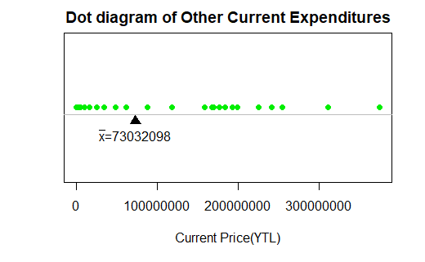

**Figure 1**. Indicates the Dot Diagram of Other Current Expenditures from 1977 to 2018

When the dot diagram was drawn for Defence(D) in the R program, Defence of mean (D) was observed. This value is 68808754 YTL as a shown in Figure 2.

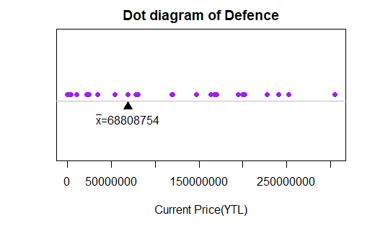

**Figure 2.** Indicates the Dot Diagram of Defence from 1977 to 2018

As a shown Figure 3, the dot plot was drawn for Current Expenditure (CE) for North Cyprus between 1977-2018. So, according to dot plot mean of Current Expenditure (CE) was observed easily as 467141360 YTL.

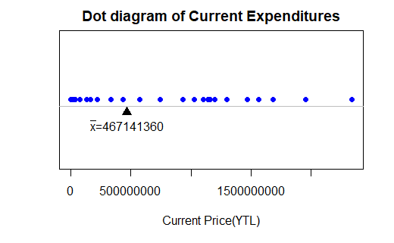

**Figure 3.** Indicates the Dot Diagram of Current Expenditures from 1977 to 2018

The data given for Northern Cyprus 1977-2018 Personnel Expenditures (PE) were used in the R program and a dot chart was drawn. This graph is given in Figure 4. When the point diagram is examined, the sample average value of the data on personnel expenditures can be seen. This value is 394109263 YTL.

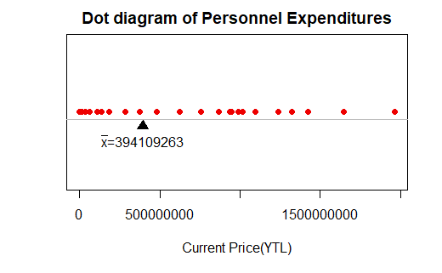

**Figure 4.** Indicates the Dot Diagram of Personnel Expenditures from 1977 to 2018

1977-2018 GNP values were used in the R program and a dot graph was drawn. This graph is given in Figure 5. When the point diagram is examined, the sample average value of the data on personnel expenditures is observed. This value is 2884909571 YTL.

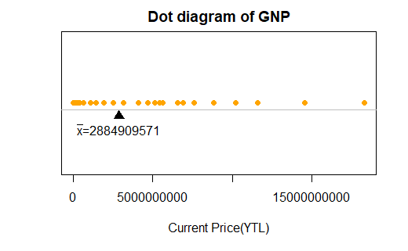

**Figure 5.** Indicates the Dot Diagram of GNP from 1977 to 2018

*3.1.3.3. Time Series Diagram:*

By using the time series chart, the relationship of changes in our data with time can be observed. Also, the x-axis in the chart shows the time. It is not divided into categories. In the time series graphs given below, the graphs containing the Current Expenditure (CE), Personnel Expenditure (PE), Other Current Expenditures (OCE), Defense (D) and GNP values for North Cyprus between 1977 and 2018 were drawn using the R program.

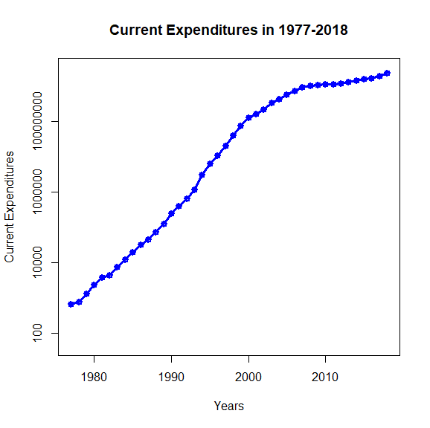

**Figure 6.** Plot Diagram of Current Expenditures in North Cyprus from 1977 to 2018

According to Figure 6 Current Expenditures increased every year including 2018.

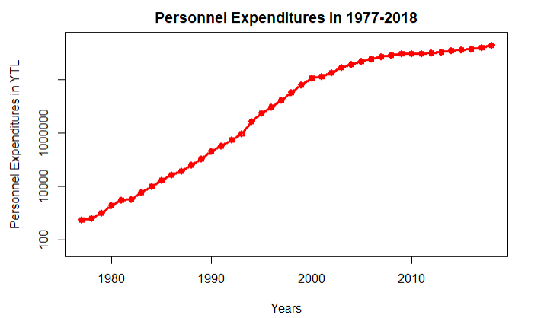

**Figure 7.** Plot Diagram of Personnel Expenditures in North Cyprus from 1977 to 2018

According to Figure 7 Personnel Expenditures increased every year including 2018.

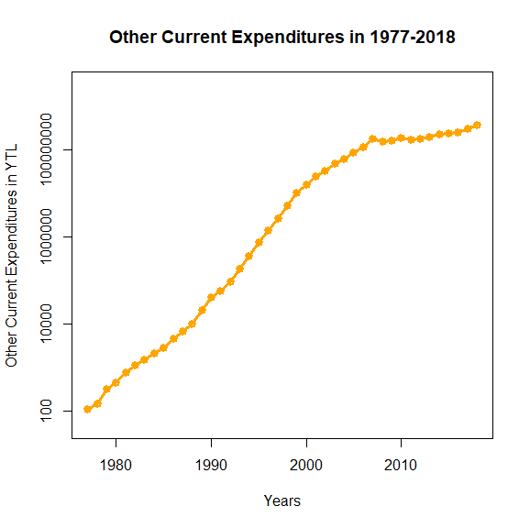

**Figure 8.** Plot Diagram of Other Current Expenditures in North Cyprus from 1977 to 2018

According to Figure 8 Other Current Expenditures has decreased in 2011 comparing to 2010. Current Expenditures for 2011 is 169567264.24 YTL and 192648480.18 YTL for 2010.

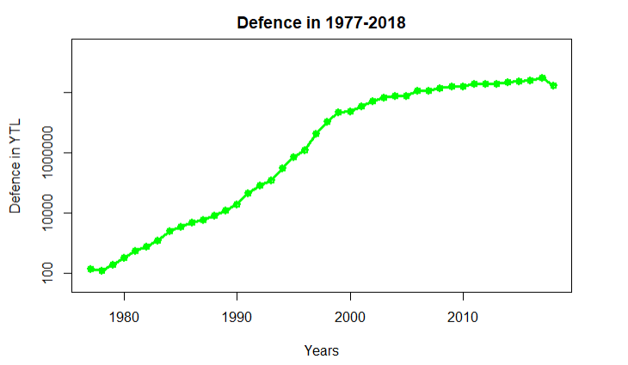

**Figure 9.** Plot Diagram of Defence in North Cyprus from 1977 to 2018

According to Figure 9 Defence Expenditures has decreased in 1978 comparing to 1977. Defence Expendiutres are 143,6 YTL for 1977 and 124,9 YTL for 1978. Also, Defence Expenditures has decreased in 2012 comparing to 2011. Defence Expendiutres are 199979873.17 YTL for 2011 and 194687299.57 YTL for 2012. In addition to this, Defence Expenditures has decreased in 2018 comparing to 2017. Defence Expendiutres are 305176267.81 YTL for 2017 and 170498906.17 YTL for 2018.

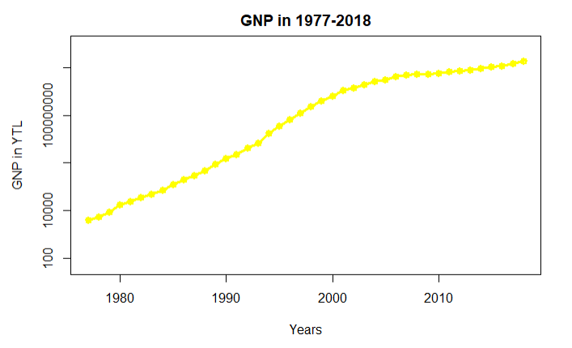

**Figure 10**. Plot Diagram of GNP in North Cyprus from 1977 to 2018

According to Figure 10 GNP has increased every year including 2018.

*3.1.3.4 Histogram Graph*

The histogram is used for continuous data. Data groups are observed as rectangular columns. These panes also represent data ranges. When the histogram graphs drawn using North Cyprus current Expenditure (CE), Personnel Expenditure (PE), Other Current Expenditures (OCE), Defense (D) and GNP values and frequency values are examined, the distribution is mostly in the first column. When Figure 11 and Figure 12 are examined, 27 frequencies are observed in the first column for Current Expenditure (CE) and Personnel Expenditure (PE). If Figure 13 is examined, 28 frequencies are observed in the first column for Other Current Expenses (OCE). For Defence (D), as seen in Figure 14, the highest frequency is 25. In the histogram graph for GNP in Figure 15, the highest frequency is 28. In addition, there are no columns at some intervals in Figure 13, 14 and 15. This is an indication that a frequency is not occurring.

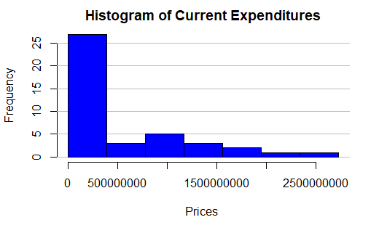

**Figure 11.** Indicates the Histogram of Current Expenditures

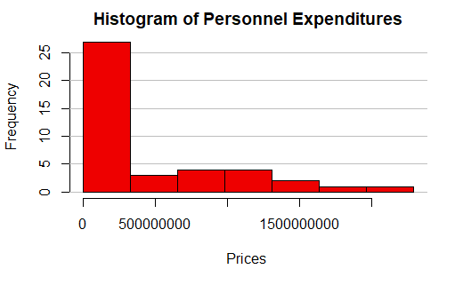

**Figure 12.** Indicates the Histogram of Personnel Expenditures

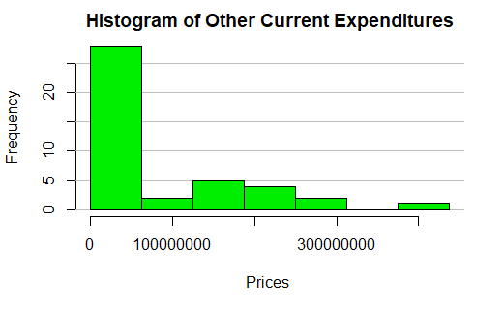

**Figure 13.** Indicates the Histogram of Other Current Expenditures

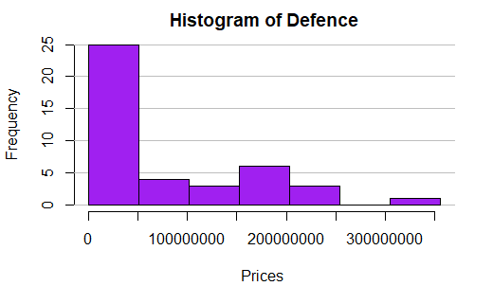

**Figure 14.** Indicates the Histogram of Defence

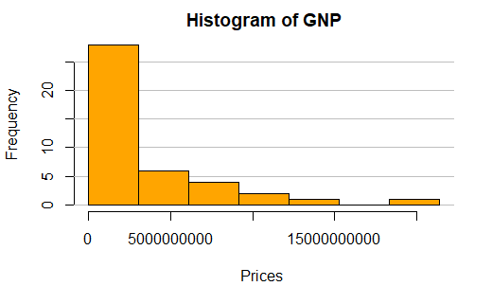

**Figure 15.** Indicates the Histogram of GNP

*3.1.3.4 Boxplot Graph*

The Boxplot is used for representing groups of numerical data according to their quartiles. Data groups are observed as quartiles and outliers in boxplot graph. as These panes also represent data ranges. According to data given as Northern Cyprus’s, Current Expenditure (CE), Personnel Expenditure (PE), Other Current Expenditures (OCE), Defense (DE) and GNP values, Boxplot graphs are plotted and distribution shapes are examined by using RStudio. When we analyze these graphs, we can easily see that all five graphs (Figure 16, Figure 17, Figure 18, Figure 19 and Figure 20) are right-skewed, which means mode is bigger than median and median is bigger than the mean. In addition to this, skewness of all five graphs emphasize that lower bounds of data are extremely low comparing to the rest of the data. When Figure 16, Figure 17, Figure 18 and Figure 19 are inspected, it has been seen that there are no quartiles for these data. However, In the boxplot graph for GNP in Figure 20, there are two outliers which are 14551761179.1 and 18334799699.2.

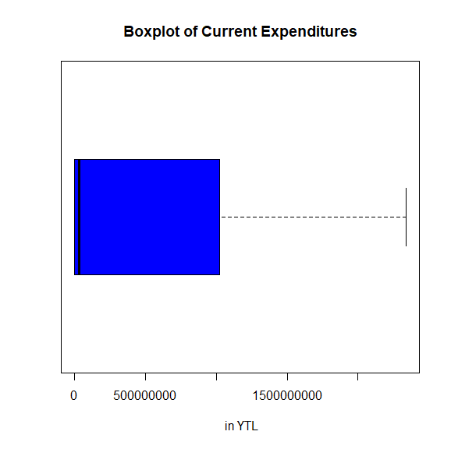

**Figure 16.** Indicates the Boxplot of Current Expenditures

Figure 16 shows that values of Current Expenditures between 1977 and 2018 are right-skewed.

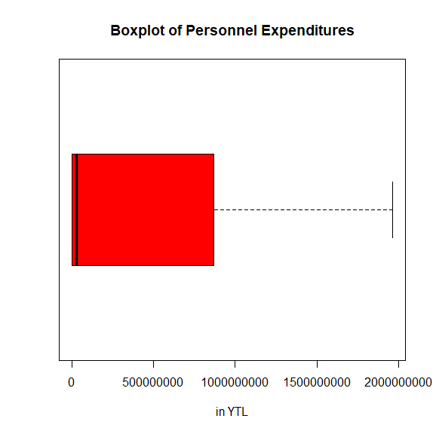

**Figure 17.** Indicates the Boxplot of Personnel Expenditures

Figure 17 shows that values of Personnel Expenditures between 1977 and 2018 are right-skewed.

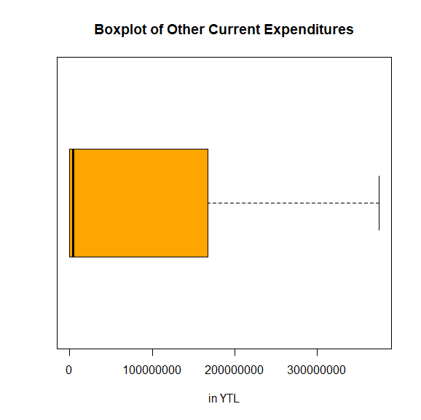

**Figure 18.** Indicates the Boxplot of Other Current Expenditures

Figure 18 shows that values of Other Current Expenditures between 1977 and 2018 are right-skewed.

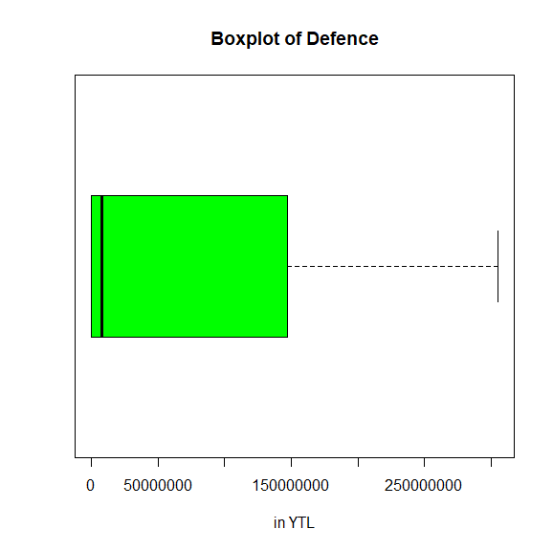

**Figure 19.** Indicates the Boxplot of Defence

Figure 19 shows that values of Defence between 1977 and 2018 are right-skewed.

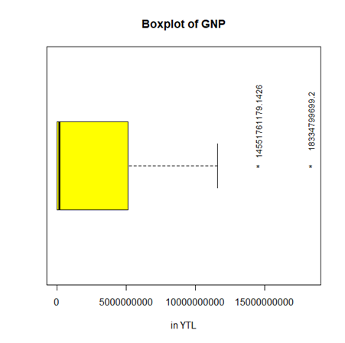

**Figure 20.** Indicates the Boxplot of GNP

Figure 20 shows that values of GNP between 1977 and 2018 are right-skewed and contains two outliers which are 14551761179.1 and 18334799699.2.

## 3.2. Inferential Statistics

### 3.2.1. Confidence Intervals

Confidence interval estimation (CI) is the range of possible values ​​for the population parameter depends on point estimates such as, sample mean and level of confidence and standard deviation.

*3.2.1.1. Confidence Intervals for the Population Mean of a Single Sample*

To calculate a mean value within a population, the confidence interval is calculated based on sample size, mean, and standard deviation of the sample data. The confidence interval gives us information within which range the mean can fall. If the number of samples is more than 30, the z test value is used

(Equation 4)

*3.2.1.1.1. Calculation for Current Expenditure*

For the Current expenditure values of North Cyprus 1977- 2018, the confidence intervals for the population mean of a single sample were calculated using the R program and the relevant graph was drawn. The sample mean value is 467141360, the sample standard deviation value is 657878573 and the sample size is 42. These values are used. In addition, while the significance level is 0.05, the confidence interval is 95%. The Margin error value is 198961565 as a result of the calculation with R programming. Since the number of sample values ​​is greater than 30 (42 30) z test was applied. Alternatively, the t test was used in the Prediction Interval comparison.

As seen in the Figure 21, it has been drawn in two intervals to be lower and higher. The start and end values ​​of the two are different. Confidence interval for Current expenditures according to the range specified in the Figure 22 is 268179796 £ m £ 666102925 with 95%. For the Prediction Interval, it is -8771951046 £ m £ 1811477867. The reason for the longer Prediction Interval is due to the single future observation calculation.

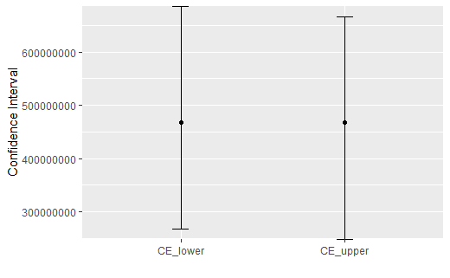

**Figure 21.** Indicates the both Lower and Upper Confidence Intervals for Current Expenditures

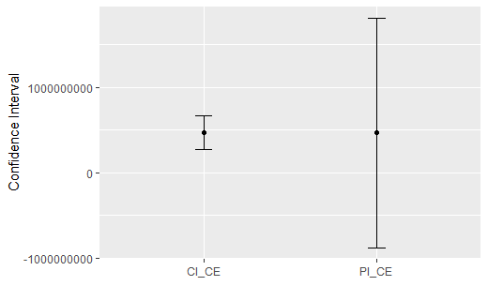

**Figure 22.** Indicates the Confidence Intervals and Prediction Intervals for Current Expenditures

*3.2.1.1.2. Calculation for Personnel Expenditure*

Confidence intervals for the mean population of a single sample for North Cyprus 1977- 2018 Personnel Expenditure values were calculated using the R program and the relevant graphs were drawn as follows. The sample mean value is 394109263, the sample standard deviation value is 554389981, and the sample size is 42. These values are used for calculation. In addition, while the significance level is 0.05, the confidence interval is 95%. As a result of the calculation made with R programming, the Margin error value is 167663612. Since the number of sample values ​​is greater than 30 (42> 30) z test was applied. Alternatively, the t test was used in the Prediction Interval comparison.

As seen in the Figure 23, it has been drawn in two intervals to be lower and upper. The start and end values ​​of the two are different. Confidence interval for Personnel Expenditures according to the range specified in the Figure 24 is 226445650 £ m £ 561772875 with 95%. For the Prediction Interval, it is -738754339 £ m £ 1526972865. The reason for the longer Prediction Interval is due to the single future observation calculation.

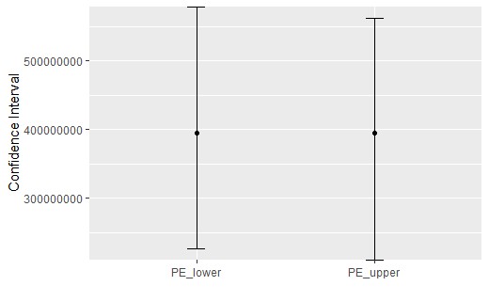

**Figure 23.** Indicates the both Lower and Upper Confidence Intervals for Personnel Expenditures

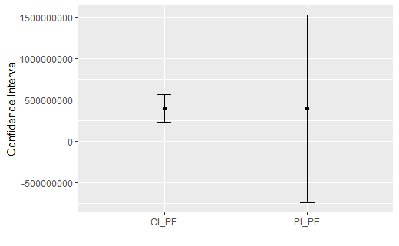

**Figure 24.** Indicates the Confidence Intervals and Prediction Intervals for Personnel Expenditures

*3.2.1.1.3. Calculation for Other Current Expenditure*

Confidence intervals for the mean population of a single sample for North Cyprus 1977-2018 Other Current Expenditure values were calculated using the R program and the relevant graphics were drawn as follows. The sample size is 42, the sample mean value is 73032098, and the sample standard deviation value is 103715308. Also, while the significance level is 0.05, the confidence interval is 95%. As a result of the calculation made with R programming, the Margin error value is 31366518. Since the number of sample values ​​is greater than 30 (42 > 30) z test was applied. Alternatively, the t test was used in the Prediction Interval comparison.

As seen in the Figure 25, it has been drawn in two intervals to be lower and upper. The start and end values ​​of the two are different. Confidence interval for Other current expenditures according to the range specified in the Figure 26 is 41665580 £ m £ 104398615 with 95%. For the Prediction Interval, it is -138904086 £ m £ 284968282. The reason for the longer Prediction Interval is due to the single future observation calculation.

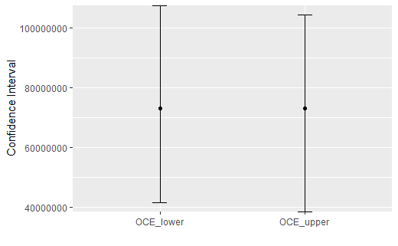

**Figure 25.** Indicates the both Lower and Upper Confidence Intervals for Other Current Expenditures

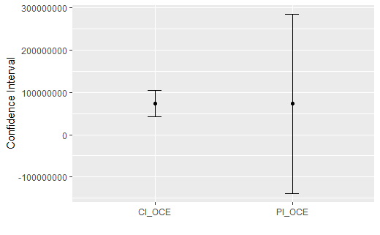

**Figure 26.** Indicates the Confidence Intervals and Prediction Intervals for Other Current Expenditures

*3.2.1.1.4. Calculation for Defence*

Defence values for Northern Cyprus between 1977 and 2018 were calculated using the R program for the population mean of a single sample and the relevant graphics were drawn as follows. The sample size is 42, the sample mean value is 68808754 and the sample standard deviation value is 91449014. In addition, while the significance level is 0.05, the confidence interval is 95%. As a result of the calculation made with R programming, the Margin error value is 27656835. Since the number of sample values ​​is greater than 30 (42> 30) z test was applied. Alternatively, the t test was used in the Prediction Interval comparison.

As seen in the Figure 27, it has been drawn in two intervals to be lower and upper. The start and end values ​​of the two are different. Confidence interval for Defence according to the range specified in the Figure 28 is 41151919 £ m £ 96455589 with 95%. For the Prediction Interval, it is -118061974 £ m £ 255679483. The reason for the longer Prediction Interval is due to the single future observation calculation.

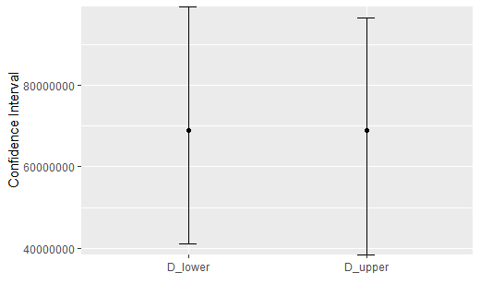

**Figure 27.** Indicates the both Lower and Upper Confidence Intervals for Defence

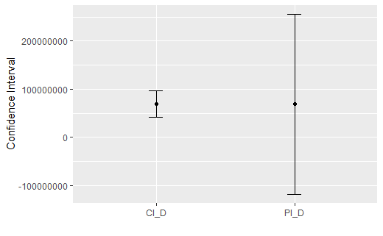

**Figure 28.** Indicates the Confidence Intervals and Prediction Intervals for Defence

*3.2.1.1.5. Calculation for GNP*

Confidence intervals of 1977-2018 GNP values for the population mean of a single sample for Northern Cyprus were calculated using the R program and the relevant graphics were drawn as follows. The sample size is 42, the sample mean value is 2884909571, and the sample standard deviation value is 4454768144. In addition, while the significance level is 0.05, the confidence interval is 95%. As a result of the calculation made with R programming, the Margin error value is 1347251113. Since the number of sample values ​​is greater than 30 (42> 30) z test was applied. Alternatively, the t test was used in the Prediction Interval comparison.

As seen in the Figure 29, it has been drawn in two intervals to be lower and upper. The start and end values ​​of the two are different. Confidence interval for GNP according to the range specified in the Figure 30 is 1537658458 £ m £ 4232160685 with 95%. For the Prediction Interval, it is -6218149398£ m £ 11987968540. The reason for the longer Prediction Interval is due to the single future observation calculation.

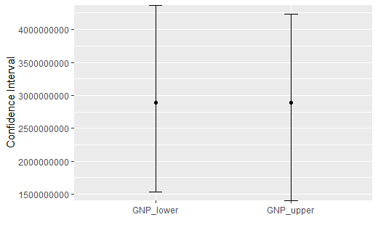

**Figure 29.** Indicates the both Lower and Upper Confidence Intervals for GNP

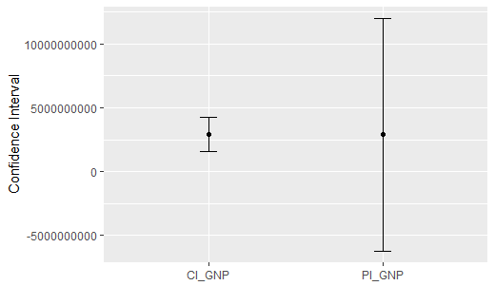

**Figure 30.** Indicates the Confidence Intervals and Prediction Intervals for GNP

*3.2.1.2. Confidence Intervals for the Population Variance of a Single Sample*

Sample within each population has mean variance and standard deviation values. Confidence interval calculation is necessary to be able to define it better. In the variance calculation, instead of the normally distributed sample calculation, the calculation is made according to the chi- square distribution, which makes it easy to find variance.

(Equation 5)

*3.2.1.2.1. Calculation for Current Expenditure*

Figure 31 shows the confidence interval for the Population Variance of a Single Sample for North Cyprus Current Expenditure data from 1977 to 2018. Figure 31 and the result of the operation were made using R. The variance value of Current Expenditure data is 432804216879521536. The mean value of Current Expenditure data is 467141360. Chi-square distribution is used. There is LCL and UCL. The LCL value is 293011977656920768. UCL value is 703760129104281856. On the other hand, with 95% confidence, the population variance confidence interval of Current Expenditure is 293011977656920768 ≤ σ2 ≤ 703760129104281856.

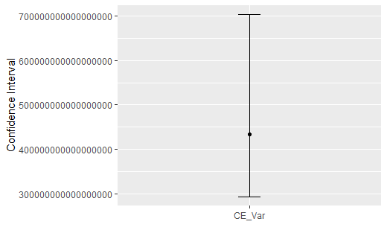

**Figure 31.** Indicates Confidence Intervals for the Population Variance of Current Expenditures

*3.2.1.2.2. Calculation for Personnel Expenditure*

Figure 32 shows the confidence interval for the Population Variance of a Single Sample for North Cyprus Personnel Expenditure data from 1977 to 2018. Figure 32 and the result of the operation were made using R. The variance value of Personnel Expenditure data is 307348250641565056. The mean value of Personnel Expenditure data is 394109263. Chi-square distribution is used. There is LCL and UCL. The LCL value is 208077267359316768. UCL value is 499762793696840512. On the other hand, with 95% confidence, the population variance confidence interval of Current Expenditure is 208077267359316768 ≤ σ2 ≤ 499762793696840512.

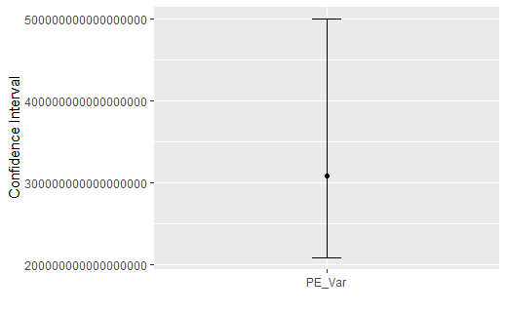

**Figure 32.** Indicates Confidence Intervals for the Population Variance of Personnel Expenditures

*3.2.1.2.3. Calculation for Other Current Expenditure*

Figure 33 below shows the confidence interval for the Population Variance of a Single Sample for North Cyprus Other Current Expenditure data from 1977 to 2018. Figure 33 and the result of the operation were made using R. The variance value of Other Current Expenditure data is 10756865022613600. The mean value of Other Current Expenditure data is 73032098. Chi-square distribution is used. There is LCL and UCL. The LCL value is 7282485176298436. UCL value is 17491171346833688. On the other hand, with 95% confidence, the population variance confidence interval of Current Expenditure is 7282485176298436 ≤ σ2 ≤ 17491171346833688.

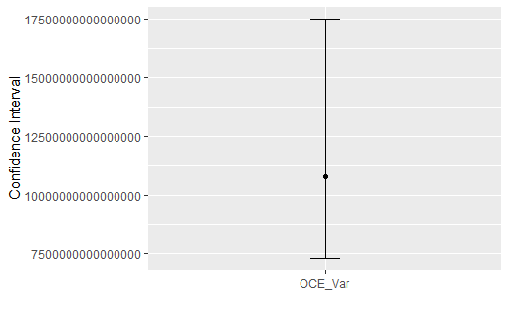

**Figure 33.** Indicates Confidence Intervals for the Population Variance of Other Current Expenditures

*3.2.1.2.4. Calculation for Defence*

Figure 34 shows the confidence interval for the Population Variance of a Single Sample for North Cyprus Current Expenditure data from 1977 to 2018. Figure 34 and the result of the operation were made using R. The variance value of Defence is 8362922193236486. The mean value of Defence data is 68808754. Chi-square distribution is used. There is LCL and UCL. The LCL value is 5661766395204270. UCL value is 13598507068242126. On the other hand, with 95% confidence, the population variance confidence interval of Current Expenditure is 5661766395204270 ≤ σ2 ≤ 13598507068242126.

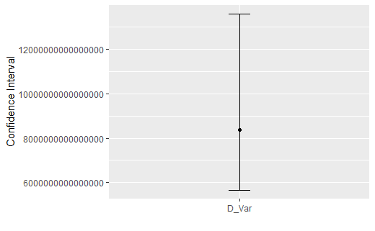

**Figure 34.** Indicates Confidence Intervals for the Population Variance of Defence

*3.2.1.2.5. Calculation for GNP:*

Figure 35 shows the confidence interval for the Population Variance of a Single Sample for North Cyprus Current Expenditure data from 1977 to 2018. Figure 35 and the result of the operation were made using R. The variance value of GNP data is 19844959216553959424. The mean value of GNP data is 2884909571. Chi-square distribution is used. There is LCL and UCL. The LCL value is 13435198918549504000. UCL value is 32268842390227734528. On the other hand, with 95% confidence, the population variance confidence interval of Current Expenditure is 13435198918549504000 ≤ σ2 ≤.32268842390227734528

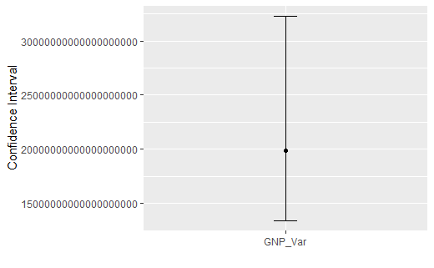

**Figure 35.** Indicates Confidence Intervals for the Population Variance of GNP

*3.2.1.3. Confidence Intervals for the Difference of Population Means/Proportions of Two Samples*

While conducting confidence interval of two samples regarding the difference of population means, the first control point is whether the population standard deviation is known or not. In our data, population standard deviation is not known but samples standard deviation is known. Second control point is that whether the both sample sizes greater or less than 30. Our samples size is 42. So, z test was applied for confidence interval of two samples.

(Equation6)

*3.2.1.3.1. Calculation for Personnel Expenditures and Other Current Expenditures*

For the Personnel Expenditures and Other Current Expenditures of North Cyprus 1977- 2018, the confidence intervals for the population mean of two sample were calculated using the R program and the relevant confidence interval plot was drawn. The sample mean value for Personnel Expenditures is 394109263, the sample standard deviation value for Personnel Expenditures is 554389981 and the sample size is 42. In addition, the sample mean value for Other Current Expenditures is 73032098, the sample standard deviation value for Other Current Expenditures is 103715308 and the sample size for Other Current Expenditures is also 42. Since the number of samples size are greater than 30 (42> 30), z test was applied rather than t test. In this test, the significance level is 0.05, the confidence level is 95%. As a result of these, the Margin error value was found as a 143148875. As a shown in Figure 36, the confidence interval for Personnel Expenditures and Other Current Expenditures are 177928290 ≤ 𝜇1−𝜇2 ≤ 464226040 at 95%. The margin of error could be found as a large due to the small sample size.

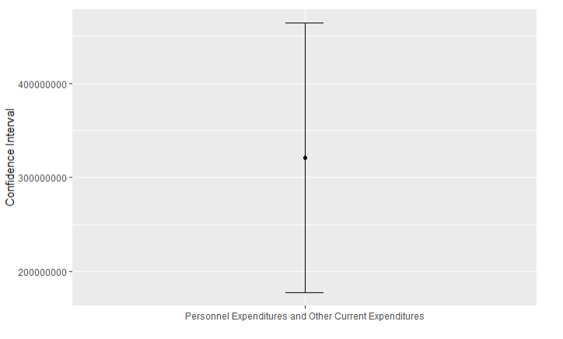

**Figure 36.** Indicates Confidence Intervals for Difference Means of Personnel Expenditures and Other Current Expenditures

*3.2.1.3.2. Calculation for Personnel Expenditures and Defence*

For the Personnel Expenditures and Defence of North Cyprus 1977- 2018, the confidence intervals for the population mean of two sample were calculated using the R program and the relevant confidence interval plot was drawn. The sample mean value for Personnel Expenditures is 394109263, the sample standard deviation value for Personnel Expenditures is 554389981 and the sample size is 42. In addition, the sample mean value for Defence is 68808754, the sample standard deviation value for Defence is 91449014 and the sample size for Defence is also 42. Since the number of samples size are greater than 30 (42> 30) , z test was applied rather than t test. In this test, the significance level is 0.05, the confidence level is 95%. As a result of these, the Margin error value was found as a 142609214. As a shown in Figure 37, the confidence interval for Personnel Expenditures and Other Current Expenditures are 182691294 ≤ 𝜇1−𝜇2 ≤ 467909723 at 95%. This large range may be due to the difference mean between Personnel Expenditures and Defence and the margin of error could be found as a large due to the small sample size.

Moreover, when Figure 36 and Figure 37 were compared, confidence interval and margin of error for Personnel Expenditures and Other Expenditures and also Personnel Expenditures and Defence was found as similar.

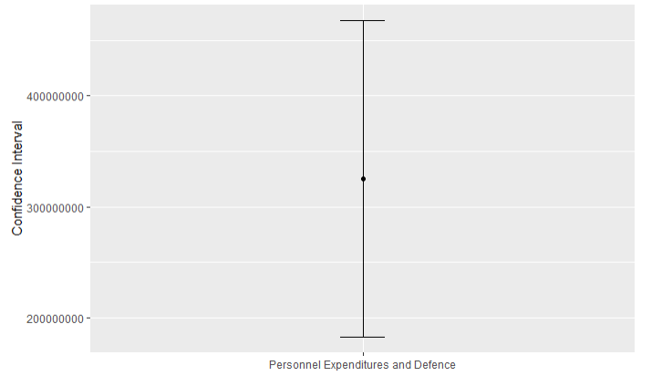

**Figure 37.** Indicates Confidence Intervals for Difference Means of Personnel Expenditures and Defence

*3.2.1.3.3. Calculation for Other Current Expenditures and Defence*

For the Other Current Expenditures and Defence of North Cyprus 1977- 2018, the confidence intervals for the population mean of two sample were calculated using the R program and the relevant confidence interval plot was drawn. The sample mean value for Other Current Expenditures is 73032098, the sample standard deviation value for Other Current Expenditures is 103715308 and the sample size for Other Current Expenditures is 42. In addition, the sample mean value for Defence is 68808754, the sample standard deviation value for Defence is 91449014 and the sample size for Defence is also 42. Since the number of samples size are greater than 30 (42> 30) , z test was applied rather than t test. In this test, the significance level is 0.05, the confidence level is 95%. As a result of these, the Margin error value was found as a 35094910. As a shown in Figure 38, the confidence interval for Personnel Expenditures and Other Current Expenditures are -30871567 ≤ 𝜇1−𝜇2 ≤ 39318254 at 95% confidence level. When the confidence interval is examined on the means at 95% confidence level, this range includes zero. This is an inconsistent result for the observed data set.

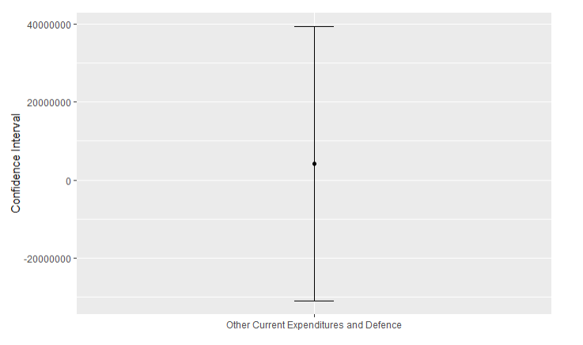

**Figure 38.** Indicates Confidence Intervals for Difference Means of Other Current Expenditures and Defence

*3.2.1.3.4. Calculation for Current Expenditures and Defence*

For the Current Expenditures and Defence of North Cyprus 1977- 2018, the confidence intervals for the population mean of two sample were calculated using the R program and the relevant confidence interval plot was drawn. The sample mean value for Current Expenditures is 467141360, the sample standard deviation value for Current Expenditures is 657878573 and the sample size for Current Expenditures is 42. In addition, the sample mean value for Defence is 68808754, the sample standard deviation value for Defence is 91449014 and the sample size for Defence is also 42. Since the number of samples size are greater than 30 (42> 30), z test was applied rather than t test. In this test, the significance level is 0.05, the confidence level is 95%. As a result of these, the Margin error value was found as a 168579278. As a shown in Figure 39, the confidence interval for Personnel Expenditures and Other Current Expenditures are 229753328 ≤ 𝜇1−𝜇2 ≤ 566911884 at 95%. This large range may be due to the difference mean between Current expenditures and Defence. In addition, larger sample size can give a shorter confidence interval.

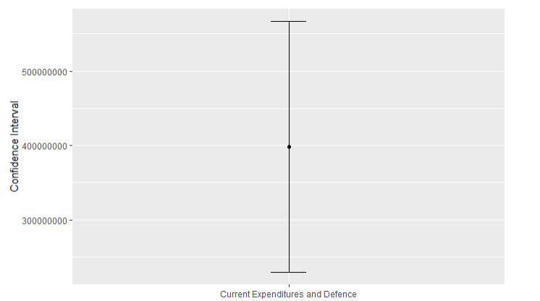

**Figure 39.** Indicates Confidence Intervals for Difference Means of Current Expenditures and Defence

*3.2.1.4. Confidence Intervals for the Ratio of Population Variances of Two Samples*

F test is used when determining the confidence intervals about the ratio of population variances for two samples with variances of samples. In this test, degrees of freedom is so important as a shown in below formula.

(Equation 7)

*3.2.1.4.1. Calculation for Personnel Expenditures and Other Current Expenditures*

Figure 40 shows the confidence interval for the population variance of two sample of Personnel Expenditures and Other Current Expenditures from 1977 to 2018. The standard deviation value of Personnel Expenditures is 554389981 and the standard deviation value of Other Current Expenditures is 103715308. The results were made using R. In this part, F test was used because there are two population variances. As a result, the population variance confidence interval for Personnel Expenditures and Other Current Expenditures is at 95% confidence level. The wide confidence interval shows the variability between samples.

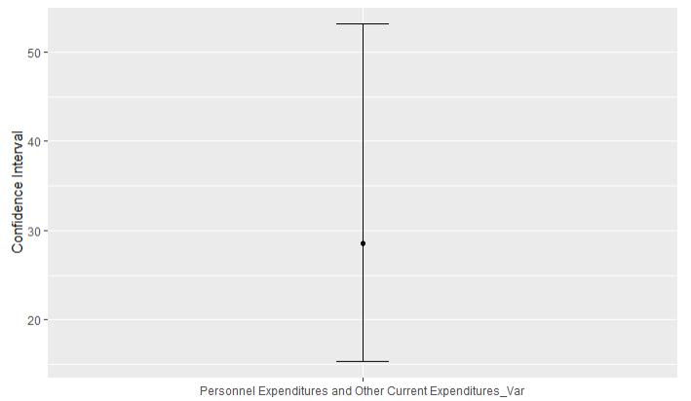

**Figure 40.** Indicates Confidence Intervals for Variances of Personnel Expenditures and Other Current Expenditures

*3.2.1.4.2. Calculation for Personnel Expenditures and Defence*

Figure 41 shows the confidence interval for the population variance of two sample of Personnel Expenditures and Defence from 1977 to 2018. The standard deviation value of Personnel Expenditures is 554389981 and the standard deviation value of Defence is 91449014. The results were made using R. In this part, F test was used because there are two population variances. As a result, the population variance confidence interval for Personnel Expenditures and Defence is at 95% confidence level. The wide confidence interval shows the variability between samples.

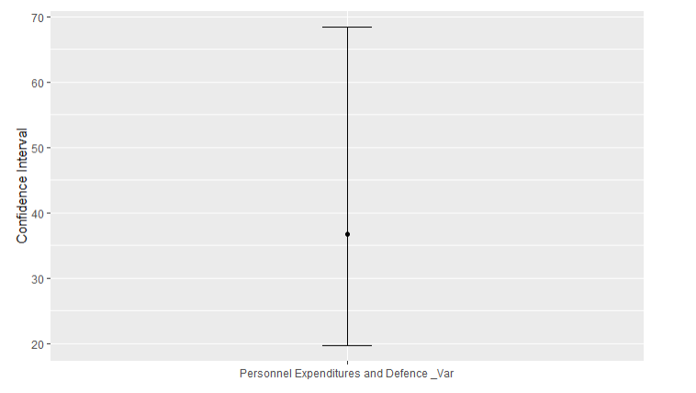

**Figure 41.** Indicates Confidence Intervals for Variances of Personnel Expenditures and Defence

*3.2.1.4.3. Calculation for Other Current Expenditures and Defence*

Figure 42 shows the confidence interval for the population variance of two sample of the Other Current Expenditures and Defence from 1977 to 2018. The standard deviation value of Other Current Expenditures is 103715308 and the standard deviation value of Defence is 91449014. The results were made using R. In this part, F test was used because there are two population variances. As a result, the population variance confidence interval for the Other Current Expenditures and Defence is at 95% confidence level. The wide confidence interval shows the variability between samples.

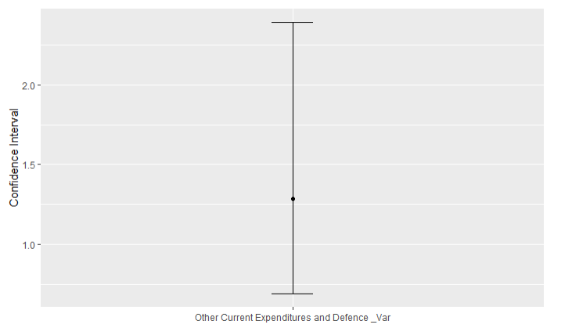

**Figure 42.** Indicates Confidence Intervals for Variances of Other Current Expenditures and Defence

*3.2.1.4.4. Calculation for Current Expenditures and Defence*

Figure 43 shows the confidence interval for the population variance of two sample of the Current Expenditures and Defence from 1977 to 2018. The standard deviation value of Current Expenditures is 657878573 and the standard deviation value of Defence is 91449014. The results were made using R. In this part, F test was used because there are two population variances. As a result, the population variance confidence interval for the Current Expenditures and Defence is 27.8296.28 at 95% confidence level. The wide confidence interval shows the variability between samples.

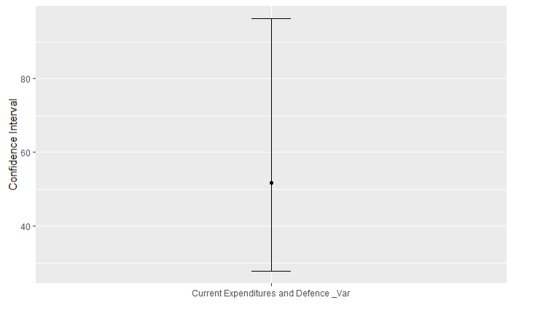

**Figure 43.** Indicates Confidence Intervals for Variances of Current Expenditures and Defence

### 3.2.2. Hypothesis Tests

The meaningful of the results obtained using the hypothesis test is tested. In addition, it is to test the assumptions made about population parameters by using the sample statistic.

*3.2.2.1. Hypothesis Tests on the Population Mean/Proportion of a Single Sample*

While conducting the Hypothesis Tests for the Population Mean of a Single Sample, it is first checked whether the standard deviation of the population is known or not. The standard deviation (s) of current expenditure (CE), Personnel Expenditure (PE), Other Current Expenditures (OCE), Defense (D) and GNP data between the years 1977-2018 in Northern Cyprus is known. Our sample size value is 42. In cases where , the test statistic is done using z. Equation 8 is the formula for this.

(Equation 8)

*3.2.2.1.1. Calculation for Current Expenditures*

Figure 44 is the hypothesis test chart on the population average on the Current expenditure data of Northern Cyprus between 1977 and 2018. This graphic was created using the R program. First of all, our relevant parameter is Current expenditure µ. Our null hypothesis (H0): µ = 500000000. Alternative hypothesis is H1: It is µ < 500000000. In this case, it is determined as lower tail test. Here, while our significance level was accepted as 0.05, the equation given for the test statistics was used. While the value was -1.645, the value was calculated as -0.32. In this case, since > , H0: µ = 50000000 do not rejected at the 0.05 significance level. Also, the correct mean, 95% confidence level is less than 500000000.

Interpretation: There is not sufficient evidence that the mean of Current expenditure.

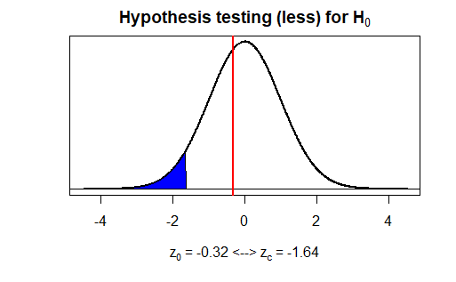

**Figure 44.** Indicates the Hypothesis Testing Plot on the Population Mean of Current Expenditures

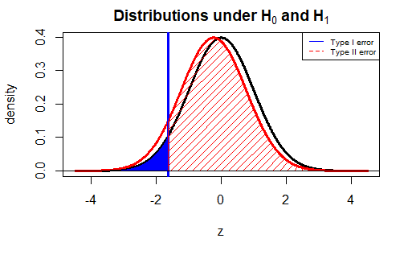

**Figure 45.** Indicates the Hypothesis Testing Plot for Type II Error on the Mean of Current Expenditures

Hypothesis test plot for the average price of Current Expenditures in Northern Cyprus. It was given from 1977 to 2018 and these results are calculated with R. Type II error and test power, values ​​calculated according to Actual parameter, the standard error of the mean and delta. To plot the Type-II error, the plotmeanbeta() function has been defined. Standard deviation, critical value, delta, number of samples and drawing type were entered as data. The population average was accepted as 480000000. For a one-sided test with alpha = 0.05, the delta value is -20000000 as a result of β calculations obtained as power = 0.07383.

Considering this, the reason why the power test is high is related to the wrong decision of H0 we reject. For this reason, the reason why our power test result is low is that due to the H0 being wrong according to the initial decision not to reject H0. We can get a high power number by increasing the sample size.

*3.2.2.1.2. Calculation for Personnel Expenditures*

Figure 46 shows the hypothesis test chart for the population mean included in North Cyprus' 1977-2018 Personnel Expenditure data. This graphic and the values used were created using the R program. First of all, our relevant parameter is Personnel Expenditure µ. Our null hypothesis (H0): µ = 400000000. Alternative hypothesis is H1: µ < 400000000. In this case, it is designated as the lower tail test. Here, while our significance level was accepted as 0.05, the equation given for test statistics was used. While the value was -1.645, the value was calculated as -0.07. In this case > is not rejected at the H0: µ = 400000000 at 0.05 significance level. Also, the correct mean, 95% confidence level is less than 400000000.

Interpretation: There is not sufficient evidence that the mean of Personnel Expenditure.

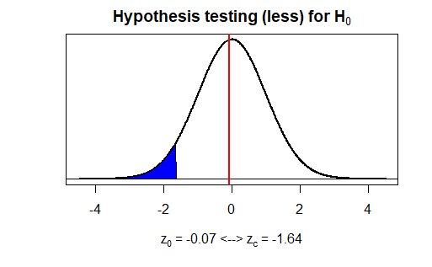

**Figure 46.** Indicates the Hypothesis Testing Plot on the Population Mean of Personnel Expenditures



**Figure 47.** Indicates the Hypothesis Testing Plot for Type II Error on the Mean of Personnel Expenditures

Hypothesis test plot for the average price of Personnel expenditures in Northern Cyprus. It was given from 1977 to 2018 and these results are calculated with R. Type II error and test power, values ​​calculated according to Actual parameter, the standard error of the mean and delta. To plot the Type II error, the plotmeanbeta () function has been defined. Standard deviation, critical value, delta, number of samples and drawing type were entered as data. The population average was accepted as 380000000.0. For a one-sided test with = 0.05, the delta value is -20000000 as a result of β calculations obtained as power = 0.07911.

Considering this, the reason why the power test is high is related to the wrong decision of H0 we reject. For this reason, the reason why our power test result is low is that due to the H0 being wrong according to the initial decision not to reject H0. We can get a high power number by increasing the sample size.

*3.2.2.1.3. Calculation for Other Current Expenditures*

Figure 48 shows the hypothesis test chart for the Population mean included in North Cyprus' 1977-2018 Other Current Expenditure data. First of all, our relevant parameter is Other Current Expenditure µ. Our null hypothesis (H0); µ = 80000000. Alternative hypothesis is H1: µ < 80000000. In this case, it is designated as the lower tail test. Here, while our significance level was accepted as 0.05, the equation given for test statistics was used. While the value was -1.645, the value was calculated as -0.4354. In this case > is not rejected at the H0: µ = 80000000 at 0.05 significance level. Also, the correct mean is less than 80000000 with 95% confidence level.

Interpretation: There is not sufficient evidence that the mean of Other Current Expenditure.

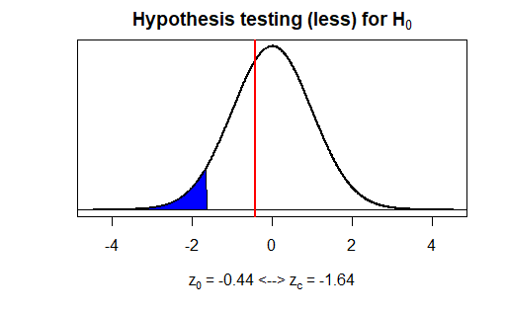

**Figure 48.** Indicates the Hypothesis Testing Plot on the Population Mean of Other Current Expenditures

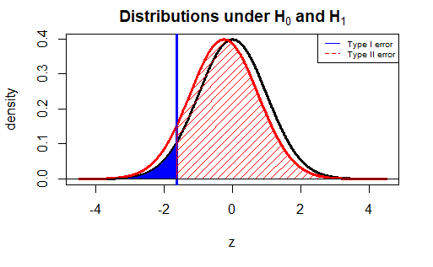

**Figure 49.** Indicates the Hypothesis Testing Plot for Type II Error on the Mean of Other Current Expenditures

Hypothesis test plot for the average price of Other Current Expenditures in Northern Cyprus. It was given from 1977 to 2018 and these results are calculated with R. Type II error and test power, values ​​calculated according to actual parameter, the standard error of the mean and delta. To plot the Type II error, the plotmeanbeta () function has been defined. Standard deviation, critical value, delta, number of samples and drawing type were entered as data. The population average was accepted as 76000000.0. For a one-sided test with = 0.05, the delta value is -4000000 as a result of β calculations obtained as power = 0.08152.

Considering this, the reason why the power test is high is related to the wrong decision of H0 we reject. For this reason, the reason why our power test result is low is that due to the H0 being wrong according to the initial decision not to reject H0. We can get a high power number by increasing the sample size.

*3.2.2.1.4. Calculation for Defence*

Figure 50 shows the hypothesis test chart for the Population mean included in North Cyprus 1977-2018 Defence data. First of all, our relevant parameter is Defence µ. Our null hypothesis (H0): . Alternative hypothesis is H1: . In this case, it is designated as the lower tail test. Here, while our significance level was accepted as 0.05, the equation given for test statistics was used. While the value was -1.645, the value was calculated as -0.084. In this case > is not rejected at the H0: µ = 70000000 at 0.05 significance level. Also, the correct mean is less than 70000000 with 95% confidence level.

Interpretation: There is not sufficient evidence that the mean of Defence.

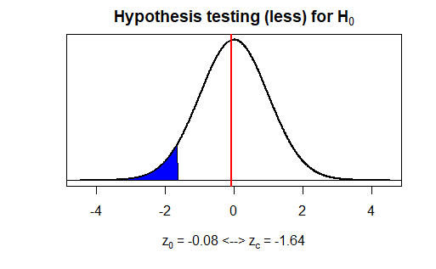

**Figure 50.** Indicates the Hypothesis Testing Plot on the Population Mean of Defence

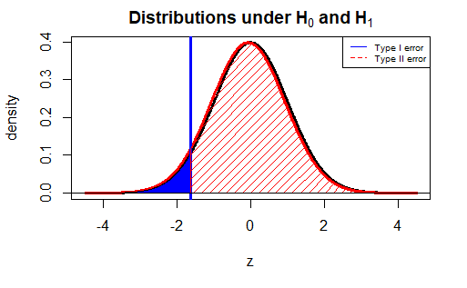

**Figure 51.** Indicates the Hypothesis Testing Plot for Type II Error on the Mean of Defence

Hypothesis test plot for the average price of Defence in Northern Cyprus. It was given from 1977 to 2018 and these results are calculated with R. Type II error and test power, values ​​calculated according to actual parameter, the standard error of the mean and delta. To plot the Type II error, the plotmeanbeta () function has been defined. Standard deviation, critical value, delta, number of samples and drawing type were entered as data. The population average was accepted as 69000000.0. For a one-sided test with = 0.05, the delta value is -1000000

as a result of β calculations obtained as power = 0.05775.

Considering this, the reason why the power test is high is related to the wrong decision of H0 we reject. For this reason, the reason why our power test result is low is that due to the H0 being wrong according to the initial decision not to reject H0. We can get a high power number by increasing the sample size.

*3.2.2.1.5. Calculation for GNP*

Figure 52 shows the Hypothesis Test chart for the Population mean included in North Cyprus' 1977-2018 GNP data. First of all, our relevant parameter is GNP µ. Our null hypothesis (H0); . Alternative hypothesis is H1; . In this case, it is designated as the lower tail test. Here, while our significance level was accepted as 0.05, the equation given for test statistics was used. While the value was -1.645, the value was calculated as -0.17. In this case > is not rejected at the H0: µ = 3000000000 with 0.05 significance level. Also, the correct mean is less than 3000000000 with 95% confidence level.

Interpretation: There is not sufficient evidence that the mean of GNP.

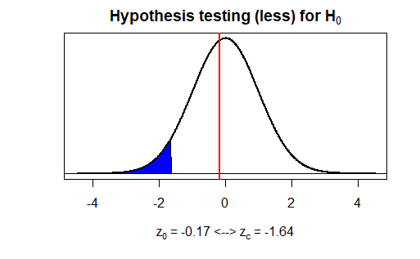

**Figure 52.** Indicates the Hypothesis Testing Plot on the Population Mean of GNP

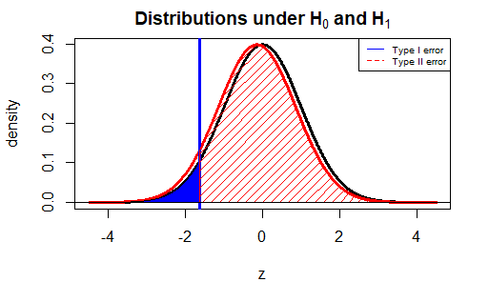

**Figure 53.** Indicates the Hypothesis Testing Plot for Type II Error on the Mean of GNP

Hypothesis test plot for the average price of GNP in Northern Cyprus. It was given from 1977 to 2018 and these results are calculated with R. Type II error and test power, values ​​calculated according to actual parameter, the standard error of the mean and delta. To plot the Type II error, the plotmeanbeta () function has been defined. Standard deviation, critical value, delta, number of samples and drawing type were entered as data. The population average was accepted as 2900000000. For a one-sided test with = 0.05, the delta value is -100000000

as a result of β calculations obtained as power = 0.06689.

Considering this, the reason why the power test is high is related to the wrong decision of H0 we reject. For this reason, the reason why our power test result is low is that due to the H0 being wrong according to the initial decision not to reject H0. We can get a high power number by increasing the sample size.

*3.2.2.2. Hypothesis Tests on the Population Variance of a Single Sample*

For conducting the Hypothesis tests for the population variance of a single sample, Chi-squared test is used. It is a method used to test whether the expected frequencies are actually the same as the expected frequency. The formula is given below.

(Equation 9)

*3.2.2.2.1. Calculation for Current Expenditures*

Figure 54 shows the hypothesis test for the population variance in the Current Expenditure of Northern Cyprus between 1977 and 2018. This graphic was drawn with the R program. Firstly, relevant parameter is Current Expenditure variance ( ). Null hypothesis (H0) was determined as and Alternative hypothesis (H1) was determined as. So, the upper tail test was performed. Significance level was accepted as 0.05. The critical value and test value were calculated with the R program. According to these calculations, while the value of  was 56.94, the value of  was calculated as 39.43.

In this case, since , H0: is not rejected at the 0.05 significance level. This means that there is not enough evidence that Current Expenditure variance is greater than.

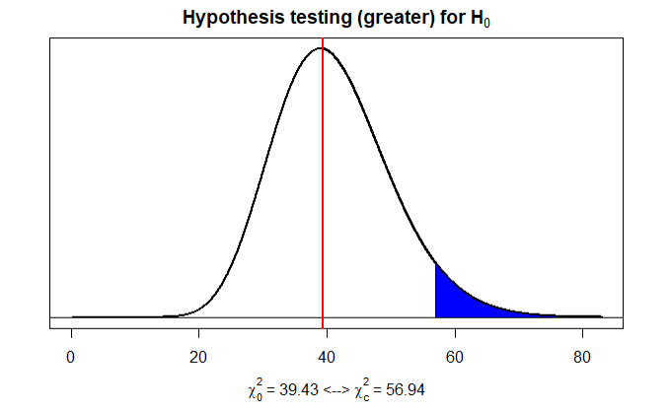

**Figure 54.** Indicates the Hypothesis Testing Plot on the Population Variance of Current Expenditures

*3.2.2.2.2. Calculation for Personnel Expenditures*

Figure 55 shows the hypothesis test for the population variance in the Personnel Expenditure of Northern Cyprus between 1977 and 2018. This graphic was drawn with the R program. The relevant parameter is Personnel Expenditure variance ( ). Null hypothesis (H0) was determined as and Alternative hypothesis (H1) was determined as. So, the upper tail test was performed. Significance level was accepted as 0.05. The critical value and test value were calculated with the R program. According to these calculations, while the value of  was 56.94, the value of  was calculated as 36. In this case, since , H0: is not rejected at the 0.05 significance level. This means that there is not enough evidence that Personnel Expenditure variance is greater than.

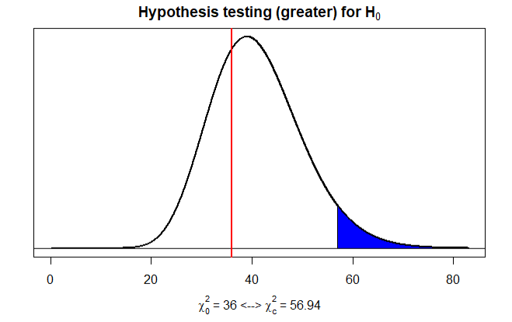

**Figure 55.** Indicates the Hypothesis Testing Plot on the Population Variance of Personnel Expenditures

*3.2.2.2.3. Calculation for Other Current Expenditures*

Figure 56 shows the hypothesis test for the population variance in the Other Current Expenditure of Northern Cyprus between 1977 and 2018. This graphic was drawn with the R program. The relevant parameter is Other Current Expenditure variance(). Null hypothesis (H0) was determined as and Alternative hypothesis (H1) was determined as. So, the upper tail test was performed. Significance level was accepted as 0.05. The critical value and test value were calculated with the R program. According to these calculations, while the value of  was 56.94, the value of  was calculated as 36.75.

In this case, since , H0: is not rejected at the 0.05 significance level. This means that there is not enough evidence that Other Current Expenditure variance is greater than.

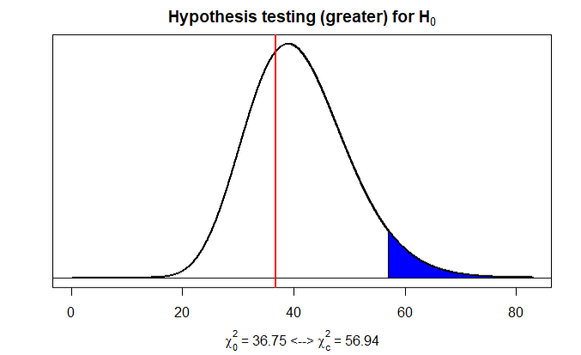

**Figure 56.** Indicates the Hypothesis Testing Plot on the Population Variance of Other Current Expenditures

*3.2.2.2.4. Calculation for Defence*

Figure 57 shows the hypothesis test for the population variance in the Defence of Northern Cyprus between 1977 and 2018. This graphic was drawn with the R program. The relevant parameter is Defence variance(). Null hypothesis (H0) was determined as and Alternative hypothesis(H1) was determined as. So, the upper tail test was performed. Significance level was accepted as 0.05. The critical value and test value were calculated with the R program. According to these calculations, while the value of  was 56.94, the value of  was calculated as 40.34.

In this case, since , H0:is not rejected at the 0.05 significance level. This means that there is not enough evidence that Defence variance is greater than.

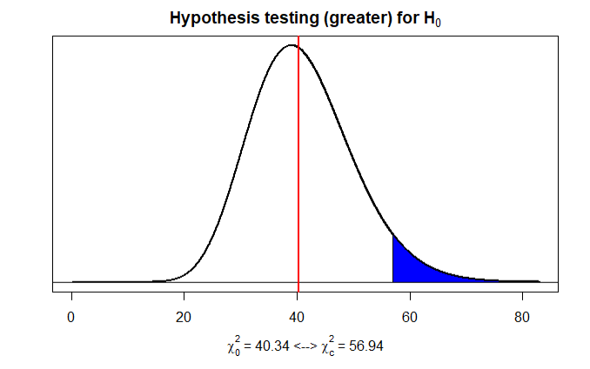

**Figure 57.** Indicates the Hypothesis Testing Plot on the Population Variance of Defence

*3.2.2.2.5. Calculation for GNP*

Figure 58 shows the hypothesis test for the population variance in the GNP of Northern Cyprus between 1977 and 2018. This graphic was drawn with the R program. The relevant parameter is GNP variance ().

So, Null hypothesis (H0) was determined as and Alternative hypothesis (H1) was determined as. In this case, the upper tail test was performed. Significance level was accepted as 0.05. The critical value and test value were calculated with the R program. According to these calculations, while the value of  was 56.94, the value of  was calculated as 38.74.

In this case, since , H0:is not rejected at the 0.05 significance level. This means that there is not enough evidence that GNP variance is greater than.

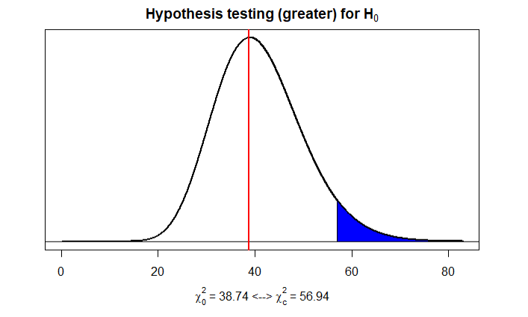

**Figure 58.** Indicates the Hypothesis Testing Plot on the Population Variance of GNP

*3.2.2.3. Hypothesis Tests on the Difference of Population Means/Proportions of Two Samples*

While conducting the hypothesis tests of two samples regarding the difference of population means, our first goal is to determine the difference, that is, the difference of the population means, with the information in the samples. Here the population standard deviation is unknown and since , the test is performed with the statistic "z". In addition, this process was done with the data of Personnel Expenditure-Current Expenditure, Personnel Expenditure - Defence, Other Current Expenditure - Defence, Defence- Current Expenditure.

(Equation 10)

*3.2.2.3.1. Calculation for Personnel Expenditures and Other Current Expenditures*

The hypothesis test chart for the population means of Personnel Expenditures and Other Current Expenditures data between the years 1977 and 2018 in Northern Cyprus is drawn in Figure 59. Tested the null hypothesis H0: μ1 = μ2 against μ1 > μ2 alternative. Our parameter in this section is Personnel Expenditures mean is μ1 and Other Current Expenditures mean is μ2.

H0: μ1- μ2 = 0

H1: μ1 - μ2 > 0

Here, while our significance level was accepted as 0.05, the z test statistic was applied. While critical value is 1.645, test statistic is 3.689 and p-value is 0.0001124. Since 0.05> 0.0001124, null hypothesis is rejected.

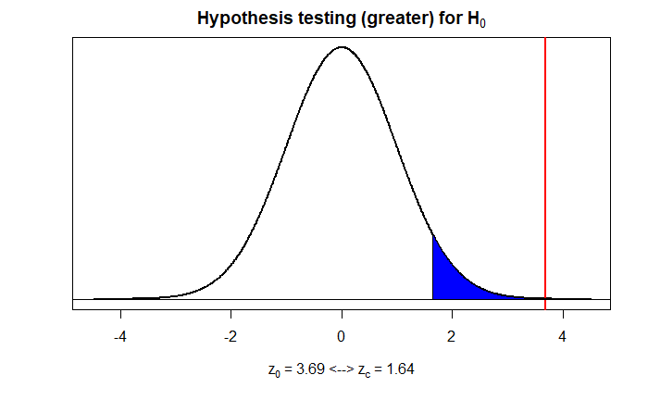

**Figure 59.** Indicates the Hypothesis Testing Plot on Means of Personnel Expenditures and Other Current Expenditures

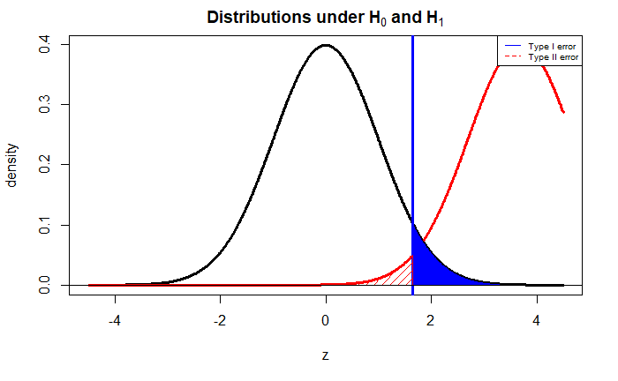

**Figure 60.** Indicates the Hypothesis Testing Plot for Type II Error on Means of Personnel Expenditures and Other Current Expenditure

The hypothesis test for the mean budget of Personnel Expenditures and Other Current Expenditures in Northern Cyprus was given from 1977 to 2018, and these results were calculated in R. Type II error and test power, values ​​calculated according to the actual parameter and calculated with delta (difference between means). The function plotmean.beta () has been defined to plot the Type II error. Standard deviation, sample size and drawing type were entered as data. Difference between means is 321077165. As a result of calculations β obtained for a greater test with = 0.05, power = 0.9795.

Accordingly, the reason for the high power test is related to the wrong decision of H0, which we rejected. In other words, If the rejected H0 decision is actually wrong, the power test is high. Therefore, the reason for our high power test result is that H0 was actually wrong compared to the initial decision to reject H0.

*3.2.2.3.2. Calculation for Personnel Expenditures and Defence*

The hypothesis test chart for the population means of Personnel Expenditures and Defence data between the years 1977 and 2018 in Northern Cyprus is drawn in Figure 61. Tested the null hypothesis H0: μ1 = μ2 against μ1 > μ2 alternative. Our parameter in this section is Personnel Expenditures mean is μ1 and Defence mean is μ2.

H0: μ1- μ2 = 0

H1: μ1 - μ2 > 0

Here, while our significance level was accepted as 0.05, the z test statistic was applied. While critical value is 1.645, test statistic is 3.752 and p-value is 0.00008771. Since 0.05> 0.00008771, null hypothesis is rejected.

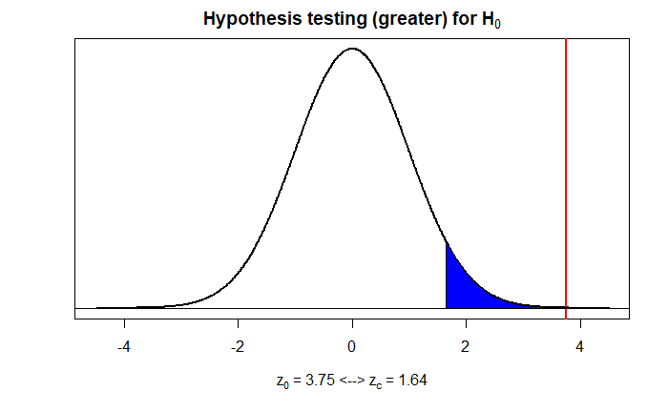

**Figure 61.** Indicates the Hypothesis Testing Plot on Means of Personnel Expenditures and Defence

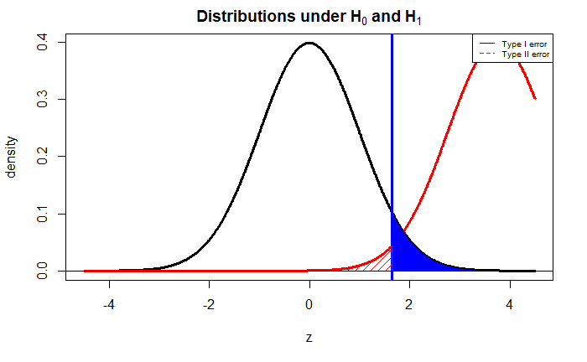**Figure 62.** Indicates the Hypothesis Testing Plot for Type II Error on Means of Personnel Expenditures and Defence

The hypothesis test for the mean budget of Personnel Expenditures and Defence in Northern Cyprus was given from 1977 to 2018, and these results were calculated in R. Type II error and test power, values ​​calculated according to the actual parameter and calculated with delta (difference between means). The function plotmean.beta () has been defined to plot the type-II error. Standard deviation, sample size and drawing type were entered as data. Difference between means is 325300508. As a result of calculations β obtained for a greater test with = 0.05, power = 0.9824.

According to power test, H0 hypothesis should be rejected and we made the right decision to reject h0 due to our high power rating which is 0.9824.

*3.2.2.3.3. Calculation for Other Current Expenditures and Defence*

The hypothesis test chart for the population means of Other Current Expenditures and Defence data between the years 1977 and 2018 in Northern Cyprus is drawn in Figure 63. Tested the null hypothesis H0: μ1 = μ2 against μ1 > μ2 alternative. Our parameter in this section is Other Current Expenditures mean is μ1 and Defence mean is μ2.

H0: μ1- μ2 = 0

H1: μ1 - μ2 > 0

Here, while our significance level was accepted as 0.05, the z test statistic was applied. While critical value is 1.645, test statistic is 0.1979 and p-value is 0.4215. Since 0.4215 > 0.05, null hypothesis is not rejected.

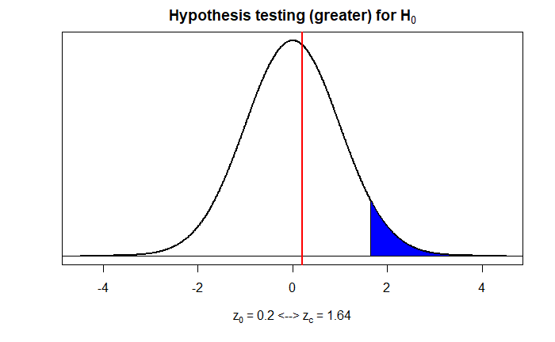

**Figure 63.** Indicates the Hypothesis Testing Plot on Means of Other Current Expenditures and Defence

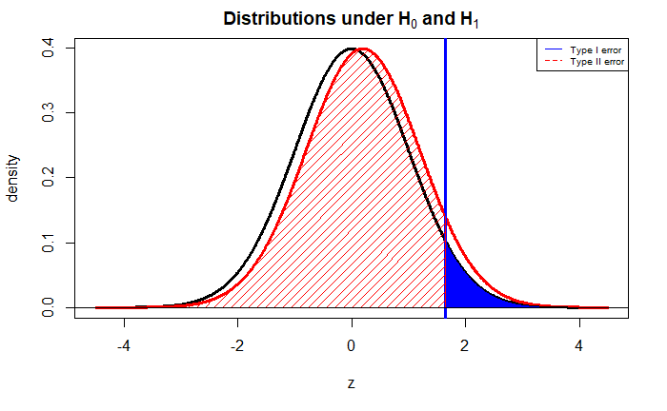

**Figure 64.** Indicates the Hypothesis Testing Plot for Type II Error on Means of Other Current Expenditures and Defence

The hypothesis test for the mean budget of Other Current Expenditures and Defense in Northern Cyprus was given from 1977 to 2018, and these results were calculated in R. Type II error and test power, values ​​calculated according to the actual parameter and calculated with delta (difference between means). The function plotmean.beta () has been defined to plot the type-II error. Standard deviation, sample size and drawing type were entered as data. Difference between means is 4223344. As a result of calculations β obtained for a greater test with = 0.05, power = 0.07396

According to power test, our power rating is 0.0739 which is pretty low, so we made right decision to not reject null hypothesis.

*3.2.2.3.4. Calculation for Current Expenditures and Defence*

The hypothesis test chart for the population means of Current Expenditures and Defence data between the years 1977 and 2018 in Northern Cyprus is drawn in Figure 65. Tested the null hypothesis H0: μ1 = μ2 against μ1 > μ2 alternative. Our parameter in this section is Current Expenditures mean is μ1 and Defence mean is μ2.

H0: μ1- μ2 = 0

H1: μ1 - μ2 > 0

Here, while our significance level was accepted as 0.05, the z test statistic was applied. While critical value is 1.645, test statistic is 3.887 and p-value is 0.00005083 Since 0.05> 0.00005083, null hypothesis is rejected.

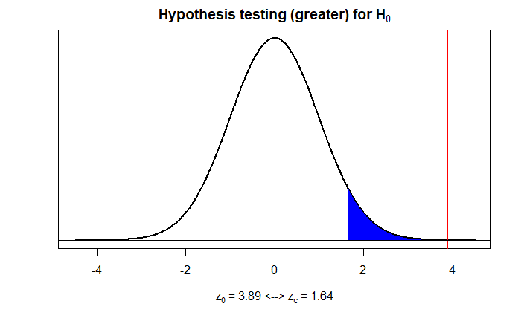

**Figure 65.** Indicates the Hypothesis Testing Plot on Means of Current Expenditures and Defence

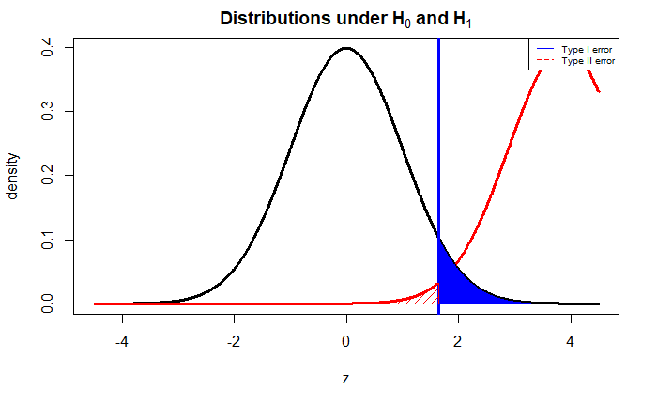

**Figure 66.** Indicates the Hypothesis Testing Plot for Type II Error on Means of Current Expenditures and Defence

The hypothesis test for the mean budget of Current Expenditures and Defence in Northern Cyprus was given from 1977 to 2018, and these results were calculated in R. Type II error and test power, values ​​calculated according to the actual parameter and calculated with delta (difference between means). The function plotmean.beta () has been defined to plot the Type II error. Standard deviation, sample size and drawing type were entered as data. Difference between means is 398332606. As a result of calculations β obtained for a greater test with = 0.05, power = 0.9875.

According to power test, H0 hypothesis should be rejected and we made the right decision to reject H0 due to our high power rating which is 0.9875.

*3.2.2.4. Hypothesis Tests on the Ratio of Population Variances of Two Samples*

There are two important items. These items are important for performing the two variance F test. The two populations should be independent and also the populations from which the samples were taken should show a normal distribution. The F test statistic is calculated by the following formula;

(Equations 11)

*3.2.2.4.1. Calculation for Personnel Expenditures and Other Current Expenditures*

The hypothesis test chart for the population variances of Personnel Expenditures and Other Current Expenditures data between the years 1977 and 2018 in Northern Cyprus is drawn in Figure 67. Tested the null hypothesis H0: = against one side alternative. Our parameter in this section is Personnel Expenditures variance and Other Current Expenditures variance .

H0: =

H1: >

Here, while our significance level was accepted as 0.05, the F test statistic was applied. While value is 1.68, value is 28.57. Since , null hypothesis is rejected.

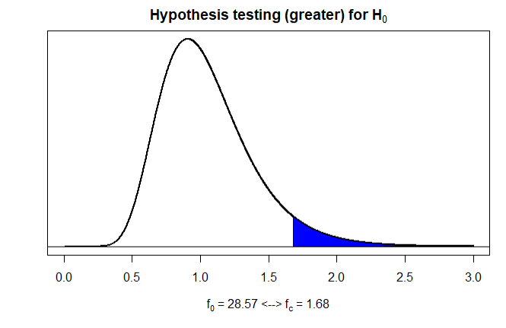

**Figure 67.** Indicates the Hypothesis Testing Plot on Variances of Personnel Expenditures and Other Current Expenditures

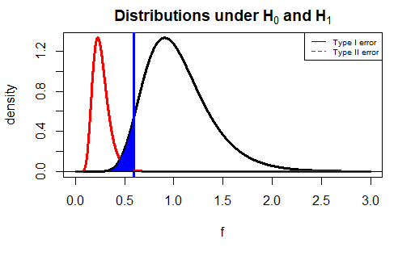

**Figure 68.** Indicates the Hypothesis Testing Plot for Type II Error on the Variances of Personnel Expenditures and Other Current Expenditures

The hypothesis test for the variance price of personnel expenditures and Other Current Expenditures in Northern Cyprus was given from 1977 to 2018, and these results were calculated in R. Type II error and test power, values ​​calculated according to the actual parameter and calculated with lambda (). The function plotvar.beta () has been defined to plot the Type II error. Variance, critical value, lambda, number of samples and drawing type were entered as data. Variance ratio was accepted as 0.5. As a result of calculations β obtained for a one-sided test with = 0.05, power = 0.9967.

Accordingly, the reason for the high power test is related to the wrong decision of H0, which we rejected. In other words, If the rejected H0 decision is actually wrong, the power test is high. Therefore, the reason for our high power test result is that H0 was actually wrong compared to the initial decision to reject H0.

*3.2.2.4.2. Calculation for Personnel Expenditures and Defence*

The hypothesis test chart for the population variances of Personnel Expenditures and Defence data between the years 1977 and 2018 in Northern Cyprus is drawn in Figure 69. Tested the null hypothesis H0: : = against one side alternative. Our parameter in this section is Personnel Expenditures variance : and Defence variance : .

H0: =

H1: >

Here, while our significance level was accepted as 0.05, the F test statistic was applied. While fc value is 1.68, f0 value is 36.75. Since f0 > fc, null hypothesis is rejected.

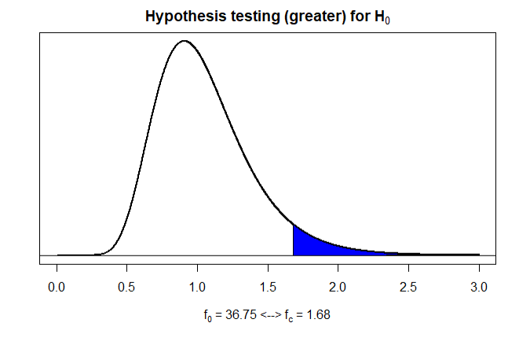

**Figure 69.** Indicates the Hypothesis Testing Plot on Variances of Personnel Expenditures and Defence

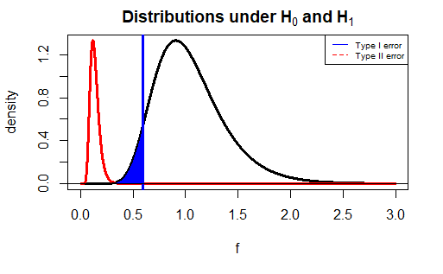

**Figure 70.** Indicates the Hypothesis Testing Plot for Type II Error on the Variances of Personnel Expenditures and Defence

The hypothesis test for the variance price of Personnel Expenditures and Defence in Northern Cyprus was given from 1977 to 2018, and these results were calculated in R. Type II error and test power, values ​​calculated according to the actual parameter and calculated with lambda (). The function plotvar.beta () has been defined to plot the Type II error. Variance, critical value, lambda, number of samples and drawing type were entered as data. Variance ratio was accepted as 0.36. As a result of calculations β obtained for a one-sided test with = 0.05, power = 1.

Accordingly, the reason for the high power test is related to the wrong decision of H0, which we rejected. In other words If the rejected H0 decision is actually wrong, the power test is high. Therefore, the reason for our high power test result is that H0 was actually wrong compared to the initial decision to reject H0.

*3.2.2.4.3. Calculation for Other Current Expenditures and Defence*

The hypothesis test chart for the population variances of Other Current Expenditures and Defence data between the years 1977 and 2018 in Northern Cyprus is drawn in Figure 71. Tested the null hypothesis H0: : = against one side alternative. Our parameter in this section is Other Current Expenditures variance : and Defence variance : .

H0: : =

H1: : >

Here, while our significance level was accepted as 0.05, the F test statistic was applied.While fc value is 1.68, f0 value is 1.29. Since f0 < fc, null hypothesis is not rejected.

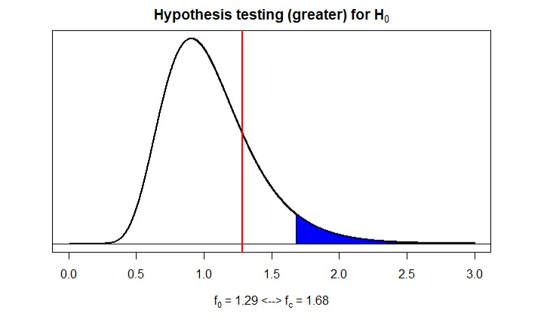

**Figure 71.** Indicates the Hypothesis Testing Plot on Variances of Other Current Expenditures and Defence

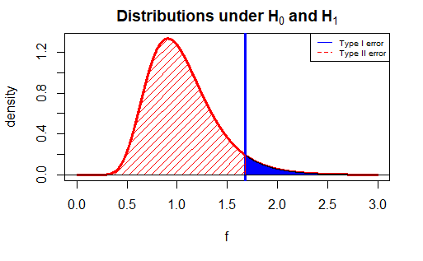

**Figure 72.** Indicates the Hypothesis Testing Plot on for Type II Error on the Variances of Other Current Expenditures and Defence

The hypothesis test for the variance price of personnel expenditures and Defence in Northern Cyprus was given from 1977 to 2018, and these results were calculated in R. Type II error and test power, values ​​calculated according to the actual parameter and calculated with lambda (). The function plotvar.beta () has been defined to plot the Type II error. Variance, critical value, lambda, number of samples and drawing type were entered as data. Variance ratio was accepted as 1. As a result of calculations β obtained for a one-sided test with = 0.05, power = 0.05.

Accordingly, the reason for the high power test is related to the wrong decision of H0, which we rejected. In other words, If the rejected H0 decision is actually wrong, the power test is high. But here, H0 was calculated as unrejected, so results that are not reject but are actually rejected are called Type II errors and therefore the test is less powerful. For this, it can be tried again by increasing the sample size.

*3.2.2.4.4. Calculation for Defence and Current Expenditures*

The hypothesis test chart for the population variances of Defence and Current Expenditures data between the years 1977 and 2018 in Northern Cyprus is drawn in Figure 73. Tested the null hypothesis H0: = against one side alternative. Our parameter in this section is Defence variance : and Current Expenditure variance : .

H0: : =

H1: : <

Here, while our significance level was accepted as 0.05, the F test statistic was applied. While fc value is 0.59, f0 value is 0.02. Since f0 < fc, null hypothesis is rejected.

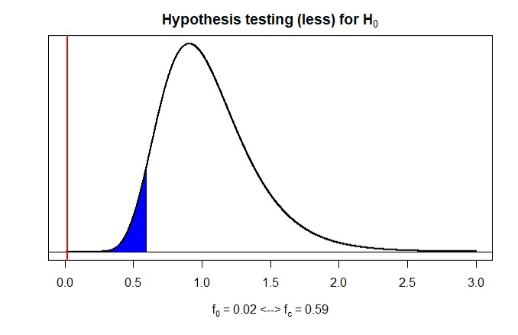

**Figure 73.** Indicates the Hypothesis Testing Plot on Variances of Defence and Current Expenditures

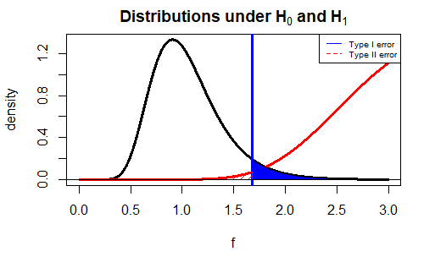

**Figure 74.** Indicates the Hypothesis Testing Plot for Type II Error on the Variances of Defence and Current Expenditures

The hypothesis test for the variance price of personnel expenditures and Defence in Northern Cyprus was given from 1977 to 2018, and these results were calculated in R. Type II error and test power, values ​​calculated according to the actual parameter and calculated with lambda (). The function plotvar.beta () has been defined to plot the Type II error. Variance, critical value, lambda, number of samples and drawing type were entered as data. Variance ratio was accepted as 2. As a result of calculations β obtained for a one-sided test with = 0.05, power = 0.9967.

Accordingly, the reason for the high power test is related to the wrong decision of H0, which we rejected. In other words If the rejected H0 decision is actually wrong, the power test is high. Therefore, the reason for our high power test result is that H0 was actually wrong compared to the initial decision to reject H0.

### 3.2.3. Goodness of Fit Tests and Contingency Analyses

*k=1+3.322 log n* (Equation 12)

(Equation 13)

(Equation 14)

Goodness of Fit Test is used to check whether our data suits to wanted distribution or not. This test uses Chi square distribution to test sample data. We conduct a hypothesis test to check our data. First of all, we define our bin which is = k. We used k = 1+3.322* log *10* (*42*) equation since we have examined expected frequencies (< 3). Our sample size is 42 and for all datasets we have same sample size. K value is calculated using the equation k = 1+3.322* log *10* (*42*) = 6.39, so we have to round it up to 7. Degrees of freedom calculated as 7-2-1=4. We calculated expected and observed frequencies using normal distribution and frequency distribution.

H0: Our null hypothesis is the form of the distribution is normal.

H1: Our alternative hypothesis is the form of the distribution is not normal.

*3.2.3.1 For Current Expenditures*

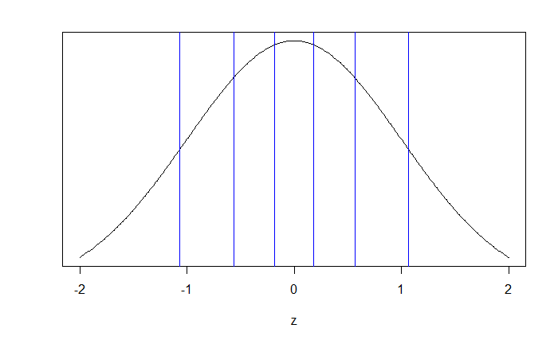

**Figure 75.** Probabilities for k=7

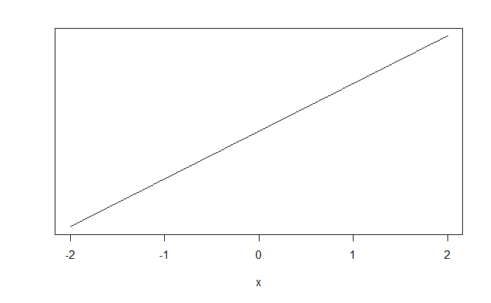

**Figure 76.** Probabilities for each data

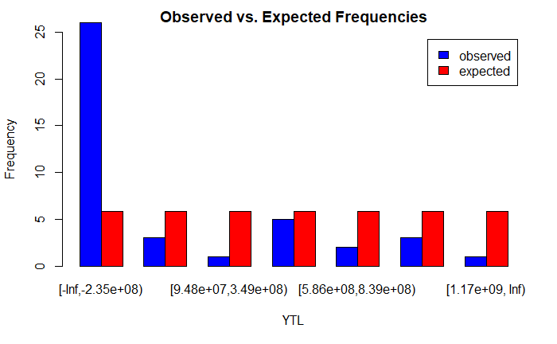

**Figure 77.** Observed vs Expected Frequencies for Current Expenditures

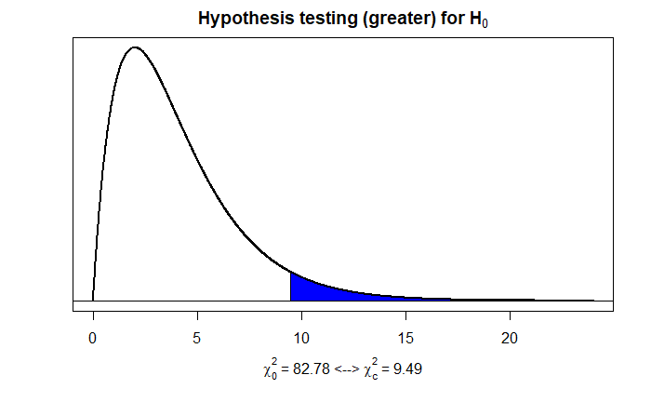

**Figure 78**. Hypothesis Testing for Goodness of Fit

H0 is rejected since X0^2 > XC^2, which means the form of this distribution is not normal distribution

*3.2.3.2 For Personnel Expenditures*



**Figure 79.** Probabilities for k=7

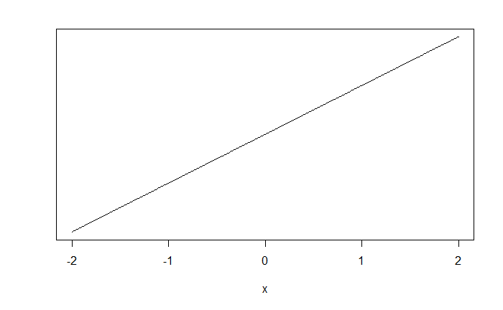

**Figure 80.** Probabilities for each data

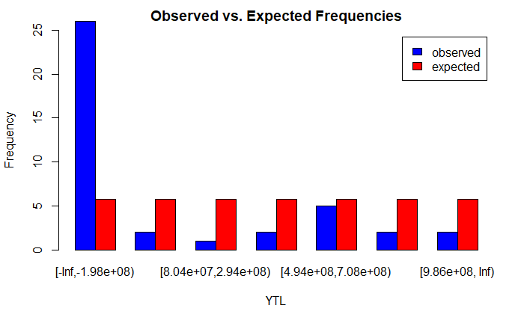

**Figure 81.** Observed vs Expected Frequencies for Personnel Expenditures

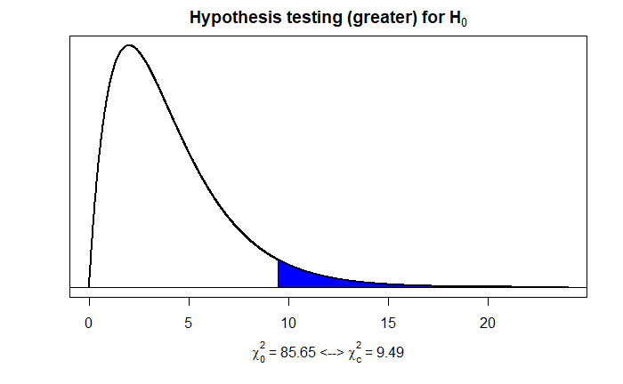

**Figure 82.** Hypothesis Testing for Goodness of Fit

H0 is rejected since X0^2 > XC^2, which means the form of this distribution is not normal distribution

*3.2.3.3 For Other Current expenditures*



**Figure 83.** Probabilities for k=7

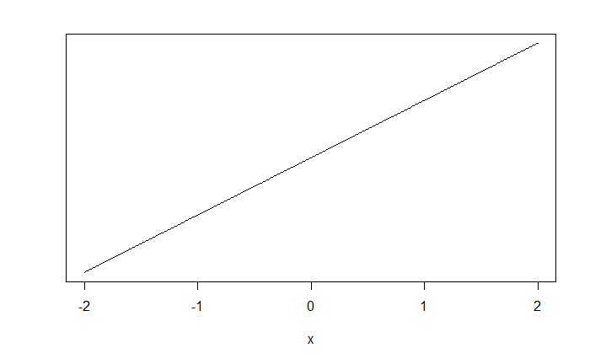

**Figure 84.** Probabilities for each data

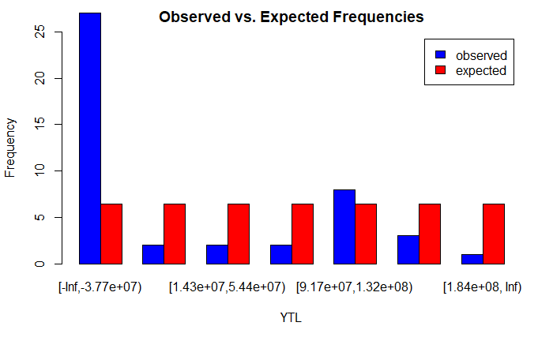

**Figure 85.** Observed vs Expected Frequencies for Other Current Expenditures

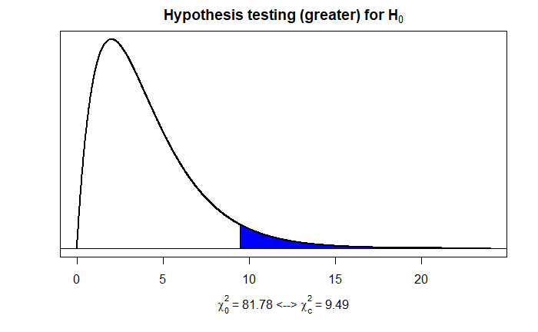

**Figure 86.** Hypothesis Testing for Goodness of Fit

H0 is rejected since X0^2 > XC^2, which means the form of this distribution is not normal distribution

*3.2.3.4 For Defence*



**Figure 87.** Probabilities for k=7



**Figure 88.** Probabilities for each cell

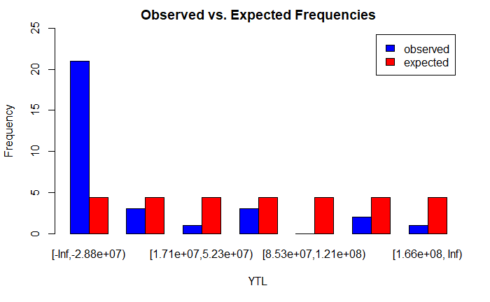

**Figure 89.** Observed vs Expected Frequencies for Defence

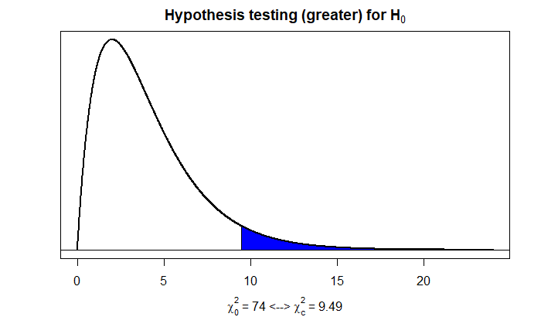

**Figure 90.** Hypothesis Testing for Goodness of Fit

H0 is rejected since X0^2 > XC^2, which means the form of this distribution is not normal distribution

*3.2.3.5 For GNP*



**Figure 91.** Probabilities for k=7

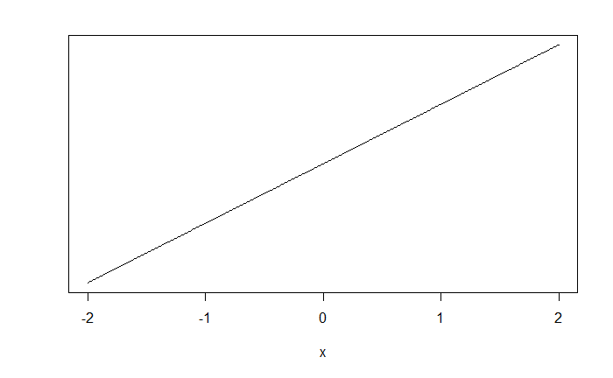

**Figure 92.** Probabilities for each cell

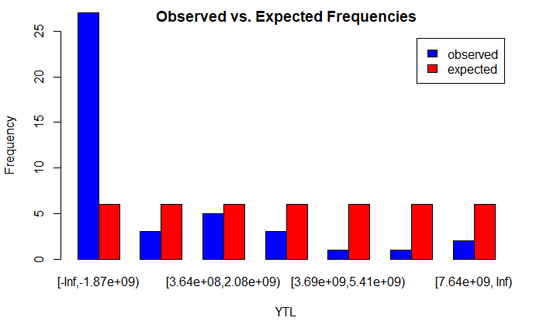

**Figure 93.** Observed vs Expected Frequencies for GNP

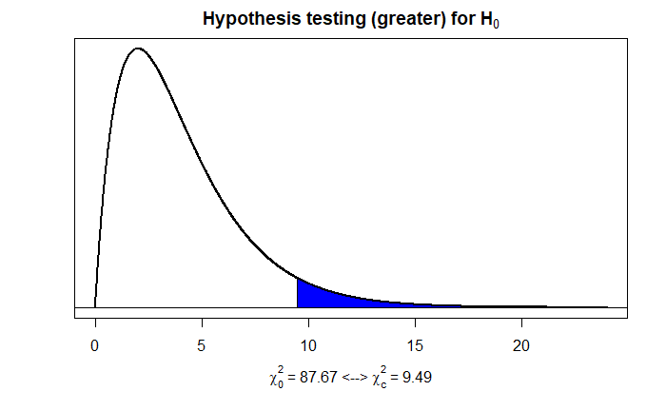

**Figure 94.** Hypothesis Testing for Goodness of Fit

H0 is rejected since X0^2 > XC^2, which means the form of this distribution is not normal distribution

*3.2.3.6 Contingency Analyses for all datasets*

(Equation 15)

Contingency Test is used to determine classification of methods are whether dependent or independent.Our null hypothesis is the row and column classification are independent. Our alternative hypothesis is the row and column classification are not independent.

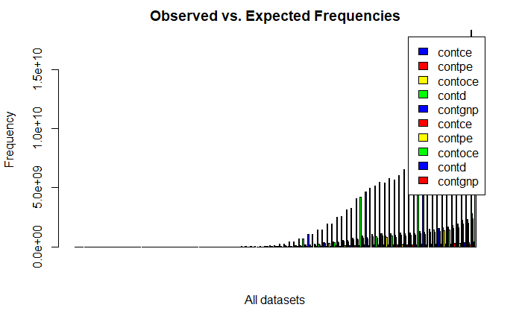

**Figure 95.** Observed vs. Expected Frequencies including All datasets

Degrees of freedom has been set 164, since for large samples we use d.f.= (r-1)*(c-1)

Calculation: d.f. = (42-1) *(5-1) = 164

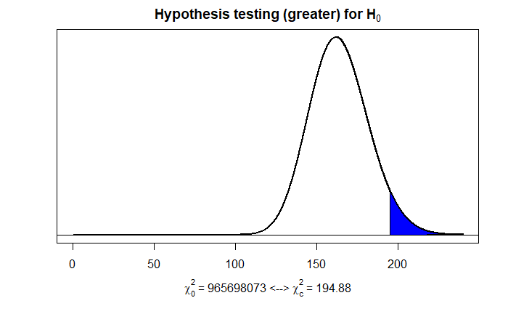

**Figure 96.** Hypothesis Testing for Goodness of Fit

H0 is rejected since X0^2 > XC^2, The row and column method are not independent.

### 3.2.4. Nonparametric Test Procedures

Nonparametric Test Procedures does not require a proper distribution to make assumptions. It is less efficient method to prove that our data is normally distributed compared Parametric test procedures.

*3.2.4.1. Sign Test*

(Equation 16)

We used built-in SIGN.test function to analyze our data in R studio. We set our significance level a equal to 0.05. Sign test analyzes our values’ distance from hypothesized median and sign. One-sample Sing-Test is conducted for all datasets.

Our null hypothesis is median is equal to mean.

Our alternative hypothesis is median is not equal to mean.

*3.2.4.1.1. For Current Expenditures*

Here, it is tested whether the median value was equal to the mean using the sign test with significance value = 0.05

• H0: median is equal to 467141360 and H1: median is not equal to 467141360

p value 0.04356 < 0.05 it is rejected and it can be said that there is sufficient evidence that with 95% of confidence interval median is not equal to mean and therefore null hypothesis rejected.

it was also shown that the median, which means that the shape of the box in the box-plot in Figure16 is positively skewed, it indicated median is different from the mean.

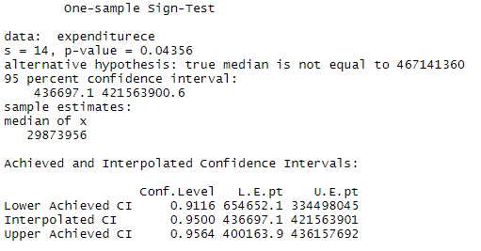

**Figure 97.** R Studio output for Sign Test

*3.2.4.1.2. For Personnel Expenditures*

Here, it is tested whether the median value was equal to the mean using the sign test with significance value = 0.05

• H0: median is equal to 394109263 and H1: median is not equal to 394109263

p value 0.04356 < 0.05 it is rejected and it can be said that there is sufficient evidence that with 95% of confidence interval median is not equal to mean and therefore null hypothesis rejected.

it was also shown that the median, which means that the shape of the box in the box-plot in Figure17 is positively skewed, it indicated median is different from the mean.

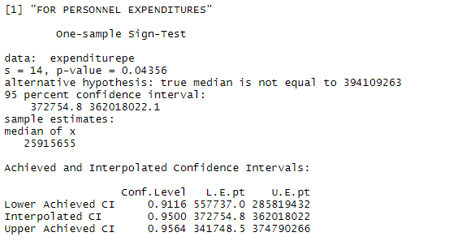

**Figure 98.** R Studio output for Sign Test

*3.2.4.1.3. For Other Current Expenditures*

Here, it is tested whether the median value was equal to the mean using the sign test with significance value = 0.05

• H0: median is not equal to 73032098 and H1: median is not equal to median is not equal to 73032098

p value 0.04356 < 0.05 it is rejected and it can be said that there is sufficient evidence that with 95% of confidence interval median is not equal to mean and therefore null hypothesis rejected.

it was also shown that the median, which means that the shape of the box in the box-plot in Figure19 is positively skewed, it indicated median is different from the mean.

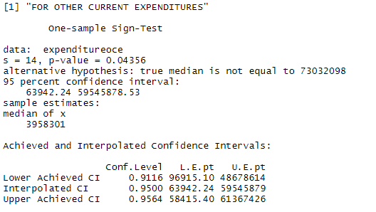

**Figure 99.** R Studio output for Sign Test

*3.2.4.1.4. For Defence*

Here, it is tested whether the median value was equal to the mean using the sign test with significance value = 0.05

• H0: median is not equal to 68808754 and H1: median is not equal to median is not equal to 68808754

p value 0. 0.1641 > 0.05 it is not rejected and it can be said that there is sufficient evidence that with 95% of confidence interval median is equal to mean and therefore null hypothesis is not rejected.

it was also shown that the median, which means that the shape of the box in the box-plot in Figure19 is close to symmetrical, it indicates median is not different from the mean.

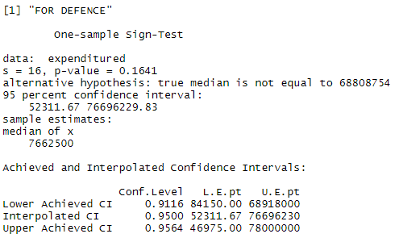

**Figure 100.** R Studio output for Sign Test

*3.2.4.1.4. For GNP*

Here, it is tested whether the median value was equal to the mean using the sign test with significance value = 0.05

• H0: median is not equal to 2884909571 and H1: median is not equal to median is not equal to 2884909571

p value 0.04356 < 0.05 it is rejected and it can be said that there is sufficient evidence that with 95% of confidence interval median is not equal to mean and therefore null hypothesis rejected.

it was also shown that the median, which means that the shape of the box in the box-plot in Figure20 is positively skewed, it indicated median is different from the mean.

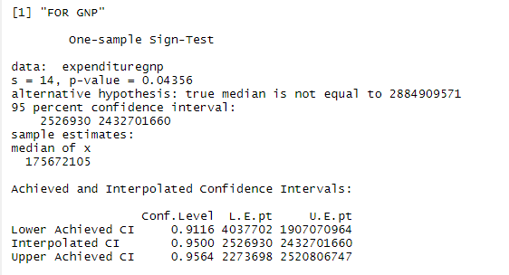

**Figure 101.** R Studio output for Sign Test

*3.2.4.2 Wilcoxon Signed-Rank Test*

metin içeren bir resim

Açıklama otomatik olarak oluşturuldu (Equation 17)

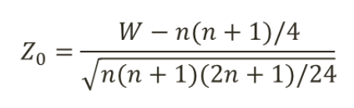 (Equation 18)

Wilcox test built-in function has been used to examine data.

H0: True location is equal to 467141360

H1: True location is not equal to 467141360

Null hypothesis is not rejected because 0.7759>0.05, True location is equal to 467141360

*3.2.4.2.1. For Current Expenditures*

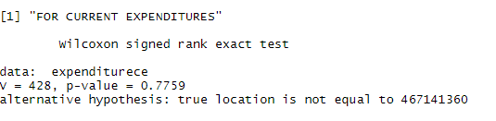

**Figure 102.** R Studio output for Signed-Rank Test

*3.2.4.2.2. For Personnel Expenditures*

H0: True location is equal to 394109263

H1: True location is not equal to 394109263

Null hypothesis is not rejected because 0.7383>0.05, True location is equal to 394109263

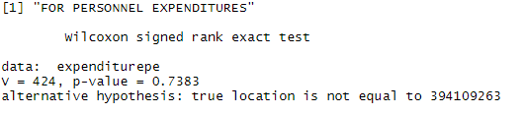

**Figure 103.** R Studio output for Signed-Rank Test

*3.2.4.2.3. For Other Current Expenditures*

H0: True location is equal to 73032098

H1: True location is not equal to 73032098

Null hypothesis is not rejected because 0.9408>0.05, True location is equal to 73032098

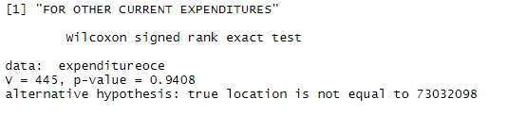

**Figure 104.** R Studio output for Signed-Rank Test

*3.2.4.2.4. For Defence*

H0: True location is equal to 68808754

H1: True location is not equal to 68808754

Null hypothesis is not rejected because 0.795>0.05, True location is equal to 68808754

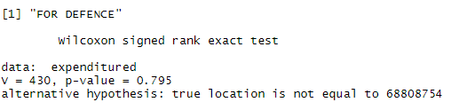

**Figure 105.** R Studio output for Signed-Rank Test

*3.2.4.2.5. For GNP*

H0: True location is equal to 2884909571

H1: True location is not equal to 2884909571

Null hypothesis is not rejected because 0.2182>0.05, True location is equal to 2884909571

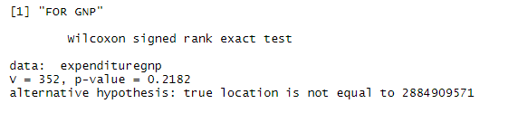

**Figure 106.** R Studio output for Signed-Rank Test

*3.2.4.3 Wilcoxon Rank-Sum Test*

metin içeren bir resim

Açıklama otomatik olarak oluşturuldu (Equation 19)

metin içeren bir resim

Açıklama otomatik olarak oluşturuldu (Equation 20)

This test is used to determine whether our data is symetrical or not. It binds different datasets and compares their medians. Wilcox.test built-in function has been used to examine data. Boxplot figures are plotted.

*3.2.4.3.1.For Personnel Expenditures and Other Current Expenditures*

H0: True location shift is equal to 0

H1: True location shift is not equal to 0

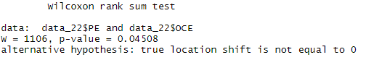

**Figure 107.** R Studio output for Wilcoxon Rank-Sum Test

Null hypthesis is rejected because 0.04508<0.05, True shift is not equal to 0

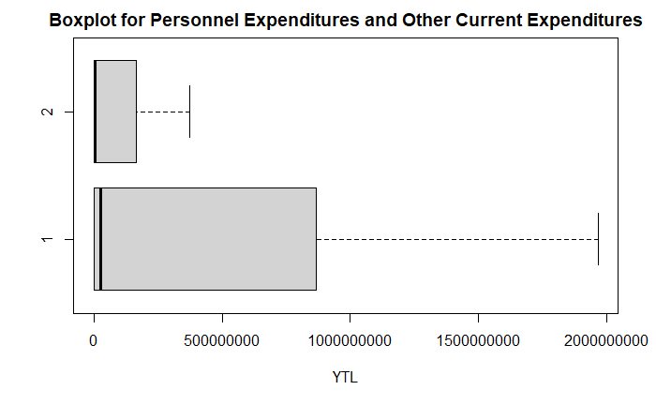

**Figure 108.** Boxplot for Personnel Expenditures and Other Current Expenditures

*3.2.4.3.2. For Personnel Expenditures and Defence*

H0: True location shift is equal to 0

H1: True location shift is not equal to 0

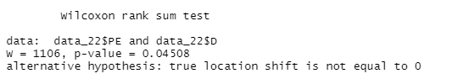

**Figure 109.** R Studio output for Wilcoxon Rank-Sum Test

Null hypothesis is rejected because 0.04508<0.05, True shift is not equal to 0

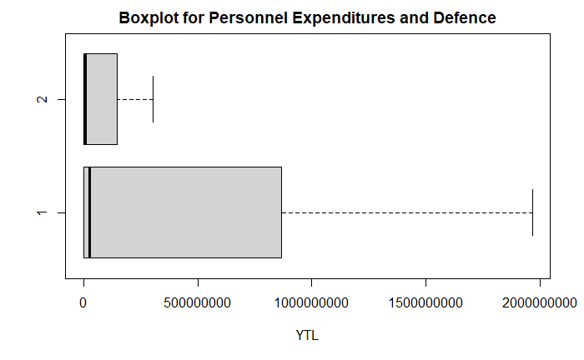

**Figure 110.** Boxplot for Personnel Expenditures and Defence

*3.2.4.3.3. For Other Current Expenditures and Defence*

H0: True location shift is equal to 0

H1: True location shift is not equal to 0

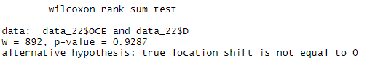

**Figure 111.** R Studio output for Wilcoxon Rank-Sum Test

Null hypothesis is not rejected because 0.9287>0.05, True shift is equal to 0

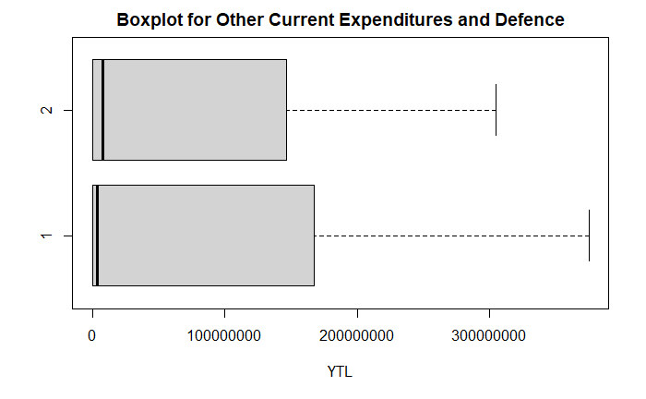

**Figure 112.** Boxplot for Other Current Expenditures and Defence

*3.2.4.3.4. For Current Expenditures and Defence*

H0: True location shift is equal to 0

H1: True location shift is not equal to 0

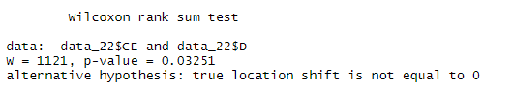

**Figure 113.** R Studio output for Wilcoxon Rank-Sum Test

Null hyothesis is rejected because 0.03251<0.05, True shift is not equal to 0

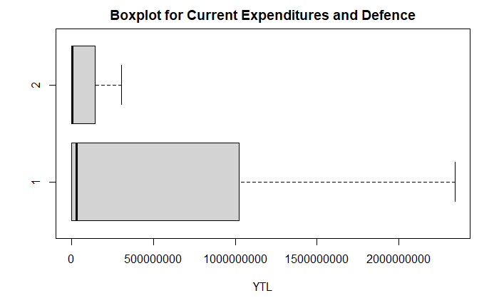

**Figure 114.** Boxplot for Other Current Expenditures and Defence

## 3.3. Exploratory Data Analyses

### 3.3.1. Correlation Analyses

(Equation 21)

(Equation 22)

(Equation 23)

*3.3.1.1. Hypothesis Tests on the Correlation Coefficient*

(Equation 24)

(Equation 25)

*3.3.1.1.1. For Current Expenditure and GNP*

A hypothesis test was conducted regarding the correlation coefficient of the current expenditure given for Northern Cyprus according to the GNP data. R program was used for this calculation. Below are the outputs obtained from R.

Pearson's product-moment correlation

data: data_22$CE and GNP

t = 34, df = 40, p-value <0.0000000000000002

alternative hypothesis: true correlation is not equal to 0

95% confidence interval:

0.9693 0.9912

sample estimates:

cor 0.9835

When the result is examined, the r value is 0.9835. This means that there is a strong positive correlation. The t-test was applied for the two-sided alternative hypothesis.

H0: ρ = 0

H1: ρ ≠ 0

The null hypothesis was rejected. The ρ value is less than 2e-16, very close to 0. On the other hand, the value of t0.025.40 is 2.021. There is strong evidence that the true correlation does not equal 0.

*3.3.1.1.2. For Personnel Expenditure and GNP*

A hypothesis test was conducted regarding the correlation coefficient of the personnel expenditure given for Northern Cyprus according to the GNP data. R program was used for this calculation. Below are the outputs obtained from R.

data: data_22$PE and GNP

t = 34, df = 40, p-value <0.0000000000000002

alternative hypothesis: true correlation is not equal to 0

95% confidence interval:

0.9693 0.9911

sample estimates:

cor 0.9835

When the result is examined, the r value is 0.9835. This means that there is a strong positive correlation. The t-test was applied for the two-way hypothesis.

H0 : ρ = 0

H1 : ρ ≠ 0

The null hypothesis was rejected. The ρ value is less than 2e-16, very close to 0. On the other hand, the value of t0.025.40 is 2.021. There is strong evidence that the true correlation does not equal 0.

*3.3.1.1.3. For Other Current Expenditure and GNP*

A hypothesis test was conducted regarding the correlation coefficient of the other current expenditure given for Northern Cyprus according to the GNP data. R program was used for this calculation. Below are the outputs obtained from R.

Pearson's product-moment correlation

data: data_22$OCE and GNP

t = 32, df = 40, p-value <0.0000000000000002

alternative hypothesis: true correlation is not equal to 0

95% confidence interval:

0.9657 0.9901

sample estimates:

cor 0.9816

When the result is examined, the r value is 0.9816. This means that there is a strong positive correlation. The t-test was applied for the two-sided alternative hypothesis.

H0 : ρ = 0

H1 : ρ ≠ 0

The null hypothesis was rejected. The ρ value is less than 2e-16, very close to 0. On the other hand, the value of t0.025.40 is 2.021. There is strong evidence that the true correlation does not equal 0.

*3.3.1.1.4. For Defence and GNP*

A hypothesis test was conducted regarding the correlation coefficient of the defencegiven for Northern Cyprus according to GNP data R program was used for this calculation. Below are the outputs obtained from R.

Pearson's product-moment correlation

data: data_22$D and data_22$GNP

t = 14, df = 40, p-value <0.0000000000000002

alternative hypothesis: true correlation is not equal to 0

95 percent confidence interval:

0.8347 0.9499

sample estimates:

cor 0.9082

When the result is examined, the r value is 0.9082. This means that there is a strong positive correlation. The t-test was applied for the two-sided alternative hypothesis.

H0 : ρ = 0

H1 : ρ ≠ 0

The null hypothesis was rejected. The ρ value is less than 2e-16, very close to 0. On the other hand, the value of t0.025.39 is 2.021. There is strong evidence that the true correlation does not equal 0.

*3.3.1.2. Confidence Intervals for the Correlation Coefficient*

(Equation26)

(Equation27)

*3.3.1.2.1. For Current Expenditure and GNP*

A Confidence interval was conducted regarding the correlation coefficient of the Current expenditure given for Northern Cyprus according to the GNP. R program was used for this calculation. Below are the outputs obtained from R. The 95% confidence interval for ρ is between 0.9693 and 0.9912.

95% confidence interval:

0.9693 0.9912

sample estimates:

cor

0.9835

*3.3.1.2.2. For Personnel Expenditure and GNP*

A Confidence interval was conducted regarding the correlation coefficient of the Personnel expenditure given for Northern Cyprus according to the GNP. R program was used for this calculation. Below are the outputs obtained from R. The 95% confidence interval for ρ is between 0.9693 and 0.9911

95 % confidence interval:

0.9693 0.9911

sample estimates:

cor

0.9835

*3.3.1.2.3. For Other Current Expenditure and GNP*

A Confidence interval was conducted regarding the correlation coefficient of the Other Current expenditure given for Northern Cyprus according to the GNP. R program was used for this calculation. Below are the outputs obtained from R. The 95% confidence interval for ρ is between 0.9657 and 0.9901.

95 percent confidence interval:

0.9657 0.9901

sample estimates:

cor 0.9816

*3.3.1.2.4. For Defence and GNP*

A Confidence interval was conducted regarding the correlation coefficient of the Defence given for Northern Cyprus according to the years from 1977 to 2018. R program was used for this calculation. Below are the outputs obtained from R. The 95% confidence interval for ρ is between 0.8347 and 0.9499.

95 percent confidence interval:

0.8347 0.9499

sample estimates:

cor

0.9082

### 3.3.2. Regression Analyses

Simple Linear Regression was used with single regressor variable like Current Expenditures, Personnel, Other Current Expenditures and Defence and dependent variable which GNP.

(Equation 28)

(Equation 29)

*Y* = b0 + b1X+ ε (Equation 30)

(Equation 31)

For Intercept: (Equation 32)

(Equation 33)

A model containing more than one regressor value, called Multiple Linear Regression, was established. In this model, the dependent variable (y) was chosen as GNP and the independent variables (x1,x4) were selected. The independent variables are Current Expenditures and Defence, respectively.

(Equation 34)

*metin içeren bir resim

Açıklama otomatik olarak oluşturuldu*  (Equation 35)

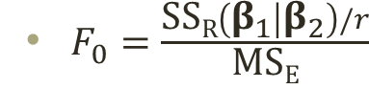 (Equation 36)

 (Equation 37)

 (Equation 38)

(Equation 39)

metin içeren bir resim

Açıklama otomatik olarak oluşturuldu (Equation 40)

*3.3.2.1. Regression Modeling*

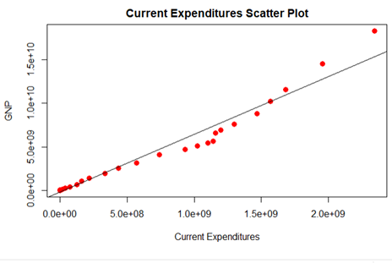

**Figure 115.** Indicates the Scatter Plot of Current Expenditures vs GNP

In the figure 115 above, the regression graph of Current Expenditure by GNP is given. Graphs and results are performed using R. The lm() function was used for simple linear regression analysis. The estimated slope of the regression line you see in the figure above is 6.66 and The estimated intersection of the regression line is -226165667.00 Therefore, the regression equation, It was found that ŷ = 6.66x - 226165667.00.

Using the Regression model, if the Current Expenditure is 10,000,000,000 YTL GNP will be equal to 66,373,834,333 YTL

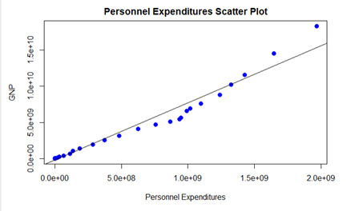

**Figure 116.** Indicates the Scatter Plot of Personnel Expenditures vs GNP

In the figure above, the regression graph of Personnel Expenditure by GNP is given. Graphs and results are performed using R. The lm() function was used for simple linear regression analysis. The estimated slope of the regression line you see in the figure above is 7.9 and The estimated intersection of the regression line is –229627474.9 Therefore, the regression equation, It was found that ŷ = 7.9x –229627474.9

Using the Regression model, if the Personnel Expenditure is 10,000,000,000 YTL GNP will be equal to 78,770,372,525 YTL

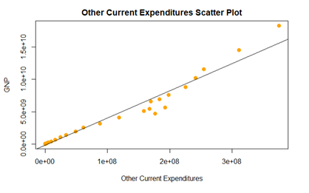

**Figure 117.** Indicates the Scatter Plot of Other Current Expenditures vs GNP

In the figure above, the regression graph of Other Current Expenditure by GNP is given. Graphs and results are performed using R. The lm() function was used for simple linear regression analysis. The estimated slope of the regression line you see in the figure above is 42.2 and The estimated intersection of the regression line is -194110949.5. Therefore, the regression equation, It was found that ŷ =42.2x - 194110949.5.

Using the Regression model, if the Other Current Expenditure is 10,000,000,000 YTL GNP will be equal to 4.21806E+11 YTL

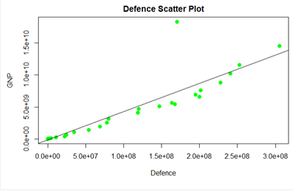

**Figure 118.** Indicates the Scatter Plot of Defence vs GNP

In the figure above, the regression graph of Defence by GNP is given. Graphs and results are performed using R. The lm() function was used for simple linear regression analysis. The estimated slope of the regression line you see in the figure above is 44.2 and The estimated intersection of the regression line is -159406019.1. Therefore, the regression equation, It was found that ŷ =44.2x -159406019.1.

Using the Regression model, if the Defence is 10,000,000,000 YTL GNP will be equal to 4.41841E+11 YTL

*3.2.2.1.1 Multiple Regression Model for GNP, CE and D.*

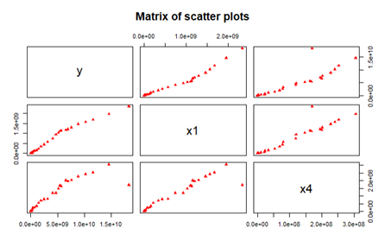

**Figure 119.** Indicates the Scatter Plot of Multiple Regression Model

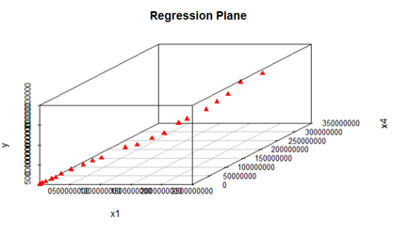

**Figure 120.** Indicates the 3D Scatter Plot of Regression Plane

In the figure above, the regression graph of Multiple Regression Model is given. Graphs and results are performed using R. The lm() function was used for simple linear regression analysis. The estimated slope of the regression line you see in the figure above is 8.92 and -17.04 . The estimated intersection of the regression line is -110211313.75. Therefore, the regression equation, It was found that ŷ = 8.92 X1-17.04X4-110211313.75.

X1: Curren Expenditures, X4: Defence Y: GNP

Using the Regression model, if the Current Expenditures and Defence are 10,000,000,000 YTL and 100,000,000 YTL respectively. GNP will be equal to 87,385,788,686 YTL

*3.3.2.2. Hypothesis Tests on the Slope and Intercept*

(Equation 41)

*3.3.2.2.1. For Current Expenditures*

Critical value of *t*0.005,41 : 2.704

Coefficients:

**Table 12.** Hypothesis Tests on the Slope and Intercept with Current Expenditures

|  |  |  |  |  |
| --- | --- | --- | --- | --- |
|  | **Estimate** | **Std. Error** | **t value** | **Pr(>|t|)** |
| **(Intercept)** | -226165666.996 | 154949927.732 | -1.46 | 0.15 |
| **x** | 6.660 | 0.194 | 34.40 | <0.0000000000000002 |

* H0 : b1 = 0 H1: b1 ¹ 0

Y was dependent variable which GNP. These are tested with a= 0.01 and it would be rejected the null hypothesis if |*t*0| > *t*a/2,*n* – 2.  Since *t*0.005,41 : 2.704 the value of the test statistic for b1 is 34.40 and 34.40 > 2.704 so it is very far into the critical, implying that null hypothesis of slope is 0 should be rejected. *P*-value of 0 for this test indicates the rejection decision is right

*3.3.2.2.2. For Personnel Expenditures*

Critical value of *t*0.005,41 : 2.704

Coefficients:

**Table 13.** Hypothesis Tests on the Slope and Intercept with Personnel Expenditures

|  |  |  |  |  |
| --- | --- | --- | --- | --- |
|  | **Estimate** | **Std. Error** | **t value** | **Pr(>|t|)** |
| **(Intercept)** | -229627474.88 | 155176339.81 | -1.48 | 0.15 |
| **x** | 7.90 | 0.23 | 34.37 | <0.0000000000000002 |

* H0 : b1 = 0 H1: b1 ¹ 0

Y was dependent variable which GNP. These are tested with a= 0.01 and it would be rejected the null hypothesis if |*t*0| > *t*a/2,*n* – 2.  Since *t*0.005,41 : 2.704 the value of the test statistic for b1 is 34.37 and 34.37 > 2.704 so it is very far into the critical, implying that null hypothesis of slope is 0 should be rejected. *P*-value of 0 for this test indicates the rejection decision is right

*3.3.2.2.3. For Other Current Expenditures*

Critical value of *t*0.005,41 : 2.704

**Table 14.** Hypothesis Tests on the Slope and Intercept with Other Current Expenditures

|  |  |  |  |  |
| --- | --- | --- | --- | --- |
|  | **Estimate** | **Std. Error** | **t value** | **Pr(>|t|)** |
| **(Intercept)** | -194110949.5 | 163359824.9 | -1.19 | 0.24 |
| **x** | 42.2 | 1.3 | 32.48 | <0.0000000000000002 |

* H0 : b1 = 0 H1: b1 ¹ 0

Y was dependent variable which GNP. These are tested with a= 0.01 and it would be rejected the null hypothesis if |*t*0| > *t*a/2,*n* – 2.  Since *t*0.005,41 : 2.704 the value of the test statistic for b1 is 32.48 and 32.48 > 2.704 so it is very far into the critical, implying that null hypothesis of slope is 0 should be rejected. *P*-value of 0 for this test indicates the rejection decision is right

*3.3.2.2.4. For Defence*

Critical value of *t*0.005,41 : 2.704

Coefficients:

**Table 15.** Hypothesis Tests on the Slope and Intercept with Defence

|  |  |  |  |  |
| --- | --- | --- | --- | --- |
|  | **Estimate** | **Std. Error** | **t value** | **Pr(>|t|)** |
| **(Intercept)** | -159406019.08 | 366042448.64 | -0.44 | 0.67 |
| **x** | 44.24 | 3.22 | 13.73 | <0.0000000000000002 |

* H0 : b1 = 0 H1: b1 ¹ 0

Y was dependent variable which GNP. These are tested with a= 0.01 and it would be rejected the null hypothesis if |*t*0| > *t*a/2,*n* – 2.  Since *t*0.005,41 : 2.704 the value of the test statistic for b1 is 13.73 and 13.73 > 2.704 so it is very far into the critical, implying that null hypothesis of slope is 0 should be rejected. *P*-value of 0 for this test indicates the rejection decision is right.

*3.3.2.2.5. Multiple Linear Regression*

*y ~ x1 + x4*

Y= GNP

X1 = Current Expenditures , X4=  Defence

Critical value of *t*0.005,41 : 2.704

Coefficients:

**Table 16.** Hypothesis Tests on the Slope and Intercept with Current Expenditures and Defence

|  |  |  |  |  |
| --- | --- | --- | --- | --- |
|  | **Estimate** | **Std. Error** | **t value** | **Pr(>|t|)** |
| **(Intercept)** | -110211313.75 | 131108104.95 | -0.84 | 0.41 |
| **x1** | 8.92 | 0.54 | 16.52 | < 0.0000000000000002 |
| **x4** | -17.04 | 3.88 | -4.39 | 0.000085 |

H0 : b1 = 0 H1: b1 ¹ 0

Y was dependent variable which GNP. It is tested with a= 0.01 and it would be rejected the null hypothesis because p-value of b1 which 0.0000000000000002 and it is less than 0.01. So, b1 can be significant and also present in model.

H0 : b4 = 0 H1: b4 ¹ 0

Y was dependent variable which GNP. It is tested with a= 0.01 and it would be rejected the null hypothesis and it would be rejected the null hypothesis because p-value of b4 which 0.000085 and it is less than 0.01. So, b4 can be significant and also present in model.

*3.3.2.3. Confidence Intervals for the Slope and Intercept*

(Equation 42)

(Equation 43)

*3.3.2.3.1 For Current Expenditures*

Below are the confidence intervals on the slope and intercept for Current Expenditures by GNP and were calculated using R.

**Table 17.** Confidence Interval for the Slope and Intercept with Current Expenditures

|  |  |  |
| --- | --- | --- |
|  | **2.5 %** | **97.5 %** |
| **(Intercept)** | -539331152.664 | 86999818.672 |
| **x** | 6.269 | 7.051 |

95% confidence interval was taken to perform This is the CI range for intercept between -539331152.664 < b0 < 86999818.672. When it is looked at the range the CI contain zero, so there is not sufficient evidence is found for intercept is not zero. Also in slope is 6.29 < b1 < 7.051. This Confidence interval did not include zero, so there was strong evidence that the slope was not zero.

*3.3.2.3.2 For Personnel Expenditures*

Below are the confidence intervals on the slope and intercept for Personnel expeditures by GNP and were calculated using R.

**Table 18.** Confidence Interval for the Slope and Intercept with Personnel Expenditures

|  |  |  |
| --- | --- | --- |
|  | **2.5 %** | **97.5 %** |
| **(Intercept)** | -543250556.415 | 83995606.660 |
| **x** | 7.438 | 8.367 |

95% confidence interval was taken to perform This is the CI range for intercept -543250556.415 < b0 < 83995606.660. When it is looked at the range the CI contain zero, so there is not sufficient evidence is found for intercept is not zero.

Also in slope is 7.438 < b1 < 8.367. This Confidence interval did not include zero, so there was strong evidence that the slope was not zero.

*3.3.2.3.3 For Other Current Expenditures*

Below are the confidence intervals on the slope and intercept for OtherCurrent expneditures by GNP and were calculated using R.

**Table19.** Confidence Interval for the Slope and Intercept with Other Current Expenditures

|  |  |  |
| --- | --- | --- |
|  | **2.5 %** | **97.5 %** |
| **(Intercept)** | -524273471.43 | 136051572.50 |
| **x** | 39.54 | 44.78 |

95% confidence interval was taken to perform This is the CI range for intercept -524273471.43 < b0 < 136051572.50. When it is looked at the range the CI contain zero, so there s not sufficient evidence is found for intercept is not zero.

Also in slope is 39.54 < b1 < 44.78. This Confidence interval did not include zero, so there was strong evidence that the slope was not zero.

*3.3.2.3.4 For Defence*

Below are the confidence intervals on the slope and intercept for Current expneditures by GNP and were calculated using R.

**Table 20.** Confidence Interval for the Slope and Intercept with Defence

|  |  |  |
| --- | --- | --- |
|  | **2.5 %** | **97.5 %** |
| **(Intercept)** | -899205403.83 | 580393365.66 |
| **x** | 37.73 | 50.76 |

95% confidence interval was taken to perform This is the CI range for intercept -899205403.83 < b0 < 580393365.66. When it is looked at the range the CI contain zero, so there is not sufficient evidence is found for intercept is not zero. Also in slope is 37.73 < b1 < 50.76. This Confidence interval did not include zero, so there was strong evidence that the slope was not zero.

*3.3.2.3.5 Multiple linear Regression*

Below are the confidence intervals on the slope and intercept for Current Expenditures and Defence and were calculated using R.

Y= GNP

X1= Current Expenditures

X4=Defence

**Table 21.** Confidence Interval for the Slope and Intercept with Current Expenditures and Defence

|  |  |  |
| --- | --- | --- |
|  | **2.5 %** | **97.5 %** |
| **(Intercept)** | -375402487.186 | 154979859.683 |
| **x1** | 7.829 | 10.014 |
| **x4** | -24.896 | -9.181 |

95% confidence interval was taken to perform This is the CI range for intercept -375402487.186 < b0 < 154979859.683. When it is looked at the range the CI contain zero, so there is not sufficient evidence is found for intercept is not zero. Also in slope is 7.829 < b1 < 10.014. This Confidence interval did not include zero, so there was strong evidence that the slope was not zero. -24.896 < b2 < -9.181 This Confidence interval did not include zero, so there was strong evidence that the slope was not zero.

*3.3.2.4. Analysis of Sum of Squares and Mean Squares*

*3.3.2.4.1. For Current Expenditures*

**Table 22.** Analysis of Sum of Square with Current Expenditures

|  |  |  |
| --- | --- | --- |
| SSR | SSE | SST |
| 787045294150890029046 | 26598033727822225408 | 81364332787871226264 |

Table indicates the Sum of Squares metrics. Sum Square of Total equals to 813643327878712262646, on the other hand, Sum Square of Residual equals to 787045294150890029046 and finally Sum Square of Error equals to 26598033727822225408.

**Table 23.** Analysis of Mean Square with Current Expenditures

|  |  |
| --- | --- |
| MSR | MSE |
| 787045294150890029046 | 664950843195555584 |

Table indicates the Mean Squares metrics. Mean Square of Residual equals to 787045294150890029046, on the other hand, Mean Square of Error equals to 664950843195555584

Meanwhile, R squared value is calculated in R as rsq.ce and result is 0.9673. Data was shown to be close to the fitted regression line as 96.73%.

*3.3.2.4.2. For Personnel Expenditures*

**Table 24.** Analysis of Sum of Squares with Current Expenditures

|  |  |  |
| --- | --- | --- |
| SSR | SSE | SST |
| 786988380344162975764 | 26654947534549295104 | 813643327878712262646 |

Table indicates the Sum of Squares metrics. Sum Square of Total equals to 813643327878712262646, on the other hand, Sum Square of Residual equals to 786988380344162975764 and finally, Sum Square of Error equals to 26654947534549295104

**Table 25.** Analysis of Mean Square with Personnel Expenditures

|  |  |
| --- | --- |
| MSR | MSE |
| 786988380344163106806 | 666373688363732352 |

Table indicates the Mean Squares metrics. Mean Square of Residual equals to 786988380344163106806, on the other hand, Mean Square of Error equals to 666373688363732352. Meanwhile, R squared value is calculated in R as rsq.ce and result is 0.9672. Data was shown to be close to the fitted regression line as 96.72%.

*3.3.2.4.3. For Other Current Expenditures*

**Table 26.** Analysis of Sum of Squares with Other Current Expenditures

|  |  |  |
| --- | --- | --- |
| SSR | SSE | SST |
| 783911783171597008986 | 29731544707115229184 | 813643327878712262646 |

Table indicates the Sum of Squares metrics. Sum Square of Total equals to 813643327878712262646, on the other hand, Sum Square of Residual equals to 783911783171597008986 and finally Sum Square of Error equals to 29731544707115229184

**Table 27.** Analysis of Mean Squares with Other Current Expenditures

|  |  |
| --- | --- |
| MSR | MSE |
| 783911783171596746722 | 743288617677880704 |

Table indicates the Mean Squares metrics. Mean Square of Residual equals to 783911783171596746722, on the other hand, Mean Square of Error equals to 743288617677880704. Meanwhile, R squared value is calculated in R as rsq.ce and result is 0.9635. Data was shown to be close to the fitted regression line as 96.35%.

*3.3.2.4.4. For Defence*

**Table 28.** Analysis of Sum of Squares with Defence

|  |  |  |
| --- | --- | --- |
| SSR | SSE | SST |
| 671172057876774387722 | 142471270001937809418 | 813643327878712262646 |

Table indicates the Sum of Squares metrics. Sum Square of Total equals to 813643327878712262646, on the other hand, Sum Square of Residual equals to 671172057876774387722 and finally Sum Square of Error equals to 142471270001937809418

**Table 29.** Analysis of Mean Squares with Defence

|  |  |
| --- | --- |
| MSR | MSE |
| 671172057876774387722 | 3561781750048445440 |

Table indicates the Mean Squares metrics. Mean Square of Residual equals to 671172057876774387722, on the other hand, Mean Square of Error equals to 3561781750048445440

Meanwhile, R squared value is calculated in R as rsq.ce and result is 0.8249. Data was shown to be close to the fitted regression line as 82.49%.

*3.3.2.4.5. Multiple Linear Regreesion*

Y= GNP

X1= Current Expenditures

X4=Defence

**Table 30.** Analysis of Sum of Squares with Current Expenditures and Defence

|  |  |  |
| --- | --- | --- |
| SSR | SSE | SST |
| 795831683490574893046 | 17811644388137398272 | 813643327878712262646 |

Multiple Regression is established with Current Expenditures and Defence. Table indicates the Sum of Squares metrics. Sum Square of Total equals to 813643327878712262646, on the other hand, Sum Square of Residual equals to 795831683490574893046 and finally Sum Square of Error equals to 813643327878712262646.

**Table 31.** Analysis of Mean Squares with Current Expenditures and Defence

|  |  |
| --- | --- |
| MSR | MSE |
| 397915841745287446528 | 456708830465061504 |

Table indicates the Mean Squares metrics. Mean Square of Residual equals to 397915841745287446528, on the other hand, Mean Square of Error equals to 456708830465061504

Meanwhile, R squared value is calculated in R as rsq and result is 0.9781. Data was shown to be close to the fitted regression line as 97.81%.

*3.2.5. Confidence Interval for the Mean Response*

*3.3.2.5.1. For Current Expenditures*

Below, these results were generated using R, with a 95% confidence interval on average response GNP with Current Expenditures

**Table 32.** The fit, lower and upper values for confidence interval with Current Expenditures

|  |  |  |  |
| --- | --- | --- | --- |
|  | Fit | lower | upper |
| 1 | -226161218 | -539326551 | 87004115 |

Appropriate value of mean with 95% CI is -539326551 £ m*Y*|1.00 £ 87004115 when x = Current Expenditure equals 1. The fit value is -226161218. It can be said that wide range between the intervals.

*3.3.2.5.2. For Personnel Expenditures*

Below, these results were generated using R, with a 95% confidence interval on average response GNP with Personnel Expenditures.

**Table 33.** The fit, lower and upper values for confidence interval with Personnel Expenditures

|  |  |  |  |
| --- | --- | --- | --- |
|  | Fit | lower | upper |
| 1 | -229623102 | -543246034 | 83999829 |

Appropriate value of mean with 95% CI is -543246034 £ m*Y*|1.00 £83999829 when x =personnel expenditure equals 1. The fit value is -229623102 . It can be said that wide range between the intervals

*3.3.2.5.3. For Other Current Expenditures*

Below, these results were generated using R, with a 95% confidence interval on average response GNP with Other Current Expenditures.

**Table 34.** The fit, lower and upper values for conficence interval with Other Current Expenditures

|  |  |  |  |
| --- | --- | --- | --- |
|  | Fit | lower | upper |
| 1 | -194106114 | -524268461 | 136056234 |

Appropriate value of mean with 95% CI is -524268461£ m*Y*|1.00 £ 136056234 when x = Other Current Expenditure equals 1. The fit value is -194106114. It can be said that wide range between the intervals

*3.3.2.5.4. For Defence*

Below, these results were generated using R, with a 95% confidence interval on average response GNP with Defence.

**Table 35.** The fit, lower and upper values for confidence interval with Defence

|  |  |  |  |
| --- | --- | --- | --- |
|  | Fit | lower | upper |
| 1 | -159399666 | -899198484 | 580399152 |

Appropriate value of mean with 95% CI is -899198484£ m*Y*|1.00 £ 580399152 when x = defence equals 1. The fit value is -159399666 It can be said that wide range between the intervals

*3.3.2.5.5. Multiple Linear Regression*

Below, these results were generated using R, with a 95% confidence interval on average response GNP with Current Expenditures and Defence.

Y= GNP

X1= Current Expenditures

X4=Defence

**Table 36.** The fit, lower and upper values for confidence interval with Current Expenditures and Defence

|  |  |  |  |
| --- | --- | --- | --- |
|  | Fit | lower | upper |
| 1 | -110211583 | -375402725 | 154979559 |

Appropriate value of mean with 95% CI is -375402725£ m*Y*|1.00 £154979559 when x = Current Expenditures and Defence equals 1. The fit value is -110211583 It can be said that wide range between the intervals.

*3.3.2.6. Prediction Interval for a New Observation*

(Equation 45)

*3.3.2.6.1. Prediction Interval for Current Expenditure*

The results given below were found using R. These results show us that for GNP, an estimate range is given for a new observation with Current Expenditure.

**Table 37.** The fit, lower and upper values for prediction interval with Current Expenditures

|  |  |  |  |
| --- | --- | --- | --- |
|  | Fit | lower | upper |
| 1 | -226161218 | -1903727207 | 1451404770 |

When the result was examined, a 95% prediction interval was found for the data between - -1903727207 and 1451404770 for a new observation when X= Current Expenditure equal to 1. Also the fit value is -226161218

*3.3.2.6.2. Prediction Interval for Personnel Expenditure*

The results given below were found using R. These results show us that for GNP, an estimate range is given for a new observation with Personnel Expenditure.

**Table 38.** The fit, lower and upper values for prediction interval with Personnel Expenditures

|  |  |  |  |
| --- | --- | --- | --- |
|  | Fit | lower | upper |
| 1 | -229623102 | -1909005853 | 1449759648 |

When the result was examined, a 95% prediction interval was found for the data between -1909005853 and 1449759648 for a new observation when X= Personnel Expenditures equal to 1.Also the fit value is -229623102.

*3.3.2.6.3. Prediction Interval for Other Current Expenditure*

The results given below were found using R. These results show us that for GNP, an estimate range is given for a new observation with Other Current Expenditures.

**Table 39**. The fit, lower and upper values for prediction interval with Other Current Expenditures

|  |  |  |  |
| --- | --- | --- | --- |
|  | Fit | lower | upper |
| 1 | -194106114 | -1967563806 | 1579351578 |

When the result was examined, a 95% prediction interval was found for the data between -1967563806 and 1579351578 for a new observation when X= Other Current Expenditures equal to 1. Also the fit value is -194106114.

*3.3.2.6.4. Prediction Interval for Defence*

The results given below were found using R. These results show us that for GNP,

an estimate range is given for a new observation with Defence.

**Table 40.** The fit, lower and upper values for prediction interval with Defence

|  |  |  |  |
| --- | --- | --- | --- |
|  | Fit | lower | upper |
| 1 | -159399666 | -4044792194 | 3725992862 |

When the result was examined, a 95% prediction interval was found for the data between -4044792194 and 3725992862 for a new observation when X= Defence equal to 1. Also the fit value is -159399666.

*3.3.2.6.5. Multiple Linear Regression on Prediction Interval*

The results given below were found using R. These results show us that for the GNP, an estimate range is given for a new observation with Current Expenditures and Defence between 1977 and 2018.

Y= GNP

X1= Current Expenditures

X4= Defence

**Table 41.** The fit, lower and upper values for prediction interval with Multiple

|  |  |  |  |
| --- | --- | --- | --- |
|  | Fit | lower | upper |
| 1 | -110207801 | - 1502633487 | 1282217885 |

When the result was examined, a 95% prediction interval on GNP(Y0) was found between -1502633487 and 1282217885 for a new observation when x1=8, x4=20. Also the fit value is –110207801.

*3.3.2.7. Analysis of Variance*

(Equation 46)

Y was dependent variable which GNP and x1 regressor which Current Expenditures. ANOVA model was created and F-statistic was used. F value was found as 1184. In addition, p-value was examined for Current expenditures. It is calculated as 0.0000000000000002 and so, p-value is less than αlpha value . It is understood that there is strong evidence to realize that H0 is not true and it is rejected.

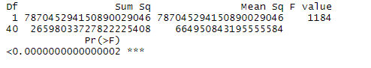

**Figure 121.** Analysis of Variance Table for Current Expenditures

Y was dependent variable which GNP and x2 regressor which Personnel Expenditures. ANOVA model was created and F-statistic was used. F value was found as 1181. In addition, p-value was examined for Personnel Expenditures. It is calculated as 0.0000000000000002 and so, p-value is less than αlpha value. It is understood that there is strong evidence to realize that H0 is not true and it is rejected.

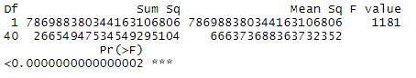  **Figure 122.** Analysis of Variance Table for Personnel Expenditures

Y was dependent variable which GNP and x3 regressor which Other Current Expenditures. ANOVA model was created and F-statistic was used. F value was found as 1055. In addition, p-value was examined for Other Current Expenditures. It is calculated as 0.0000000000000002 and so, p-value is less than αlpha value . It is understood that there is strong evidence to realize that H0 is not true and it is rejected.

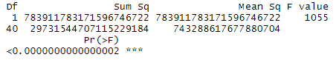

**Figure 123.** Analysis of Variance Table for Other Current Expenditures

Y was dependent variable which GNP and x4 regressor which Defence. ANOVA model was created and F-statistic was used. F value was found as 188. In addition, p-value was examined for defence. It is calculated as 0.0000000000000002 and so, p-value is less than αlpha value . It is understood that there is strong evidence to realize that H0 is not true and it is rejected.

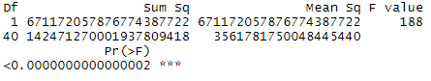

**Figure 124.** Analysis of Variance Table for Defence

*3.3.2.2.5. Multiple Linear Regression*

Y was dependent variable which GNP and x1. x4 regressor which Current Expenditures, Defence, respectively. ANOVA model was created and F-statistic was used for analysis of variance. F-statistic was found as 871. In addition, p-values were examined for Current Expenditures and Defence. It was calculated as 0.0000000000000002, 0.000085, respectively and so, p-values are less than αlpha value. It was understood that H0 is rejected. It was also conclude that GNP is linearly related to Current Expenditures and also Defence. On the other hand, more model adeqyacy tests may be needed to use this model

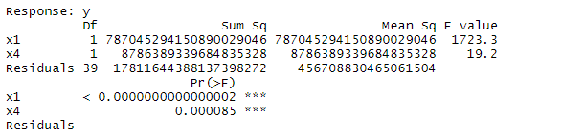

**Figure 125.** Analysis of Variance Table for Current Expenditures and Defence Regressor

*3.3.2.8. Adequacy of the Regression Model*

*3.3.2.8.1. For Current Expenditure*

Moreover, Residuals versus x1 (Current Expenditure) plot and Residuals versus x4 (Defence) plot was shown in Figure 126 and Figure 127, respectively.

When, Residuals versus x1 (Current Expenditure) plot was examined, it is understood that less variability presents in left side compared to right side of the graphs.

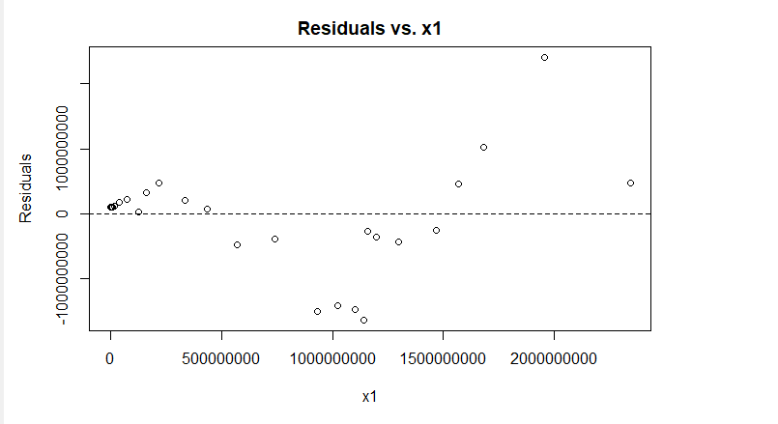

**Figure 126.** Residuals versus Current Expenditures for Adequacy of the Regression Model

*3.3.2.8.2. For Defence*

When, Residuals versus x4 (Defence) plot was examined, it is understood that less variability presents in left side compared to right side of the graphs.

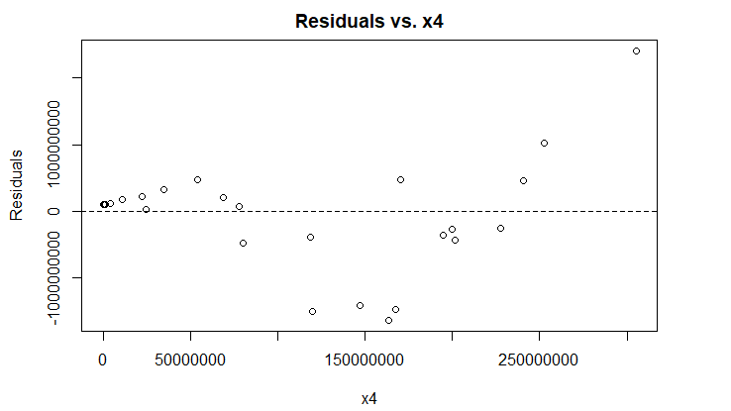

**Figure 127.** Residuals versus Defence for Adequacy of the Regression Model

*3.3.2.8.3. Multiple Linear Regression*

lm(y ~ x1 + x4)

Y= GNP

x1= Current Expenditure

x4= Defence

Residuals versus Fitted plot and the Normal Q-Q plot was shown in Figures 128 and 129. When look at Residuals versus Fitted, it is understood that model is inadequacy and linear relationship could not cover the information in the GNP variable. In addition, it is observed that normality cannot be achieved from the Normal Q-Q plot and there are also some outliers.

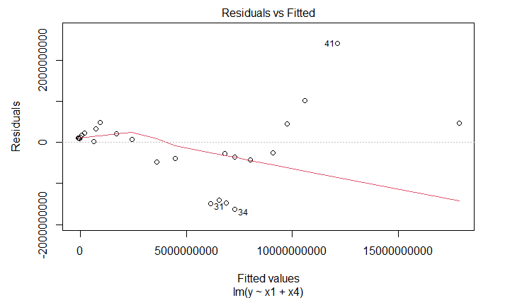

**Figure 128.** Residuals versus Fitted Plot for Adequacy of the Multiple Regression Model

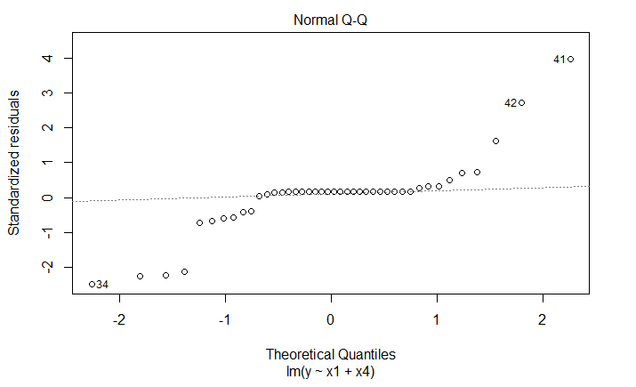

**Figure 129.** Normal Q-Q Plot for Adequacy of the Multiple Regression Model

*3.3.2.9. Residuals Analysis*

Residuals analysis was done in the Adequacy of the Regression Model part. Residual analysis graphs such as Residual versus x1(Current Expenditures), Residuals versus x4(Defence) and also interpretation about the Residuals analysis can be seen in the Adequacy of the Regression Model part.

## 3.4. Trend Based Forecasting

For Linear Trend: (Equation 47)

For Quadratic Trend: (Equation 48)

*3.4.1. For Current Expenditures*

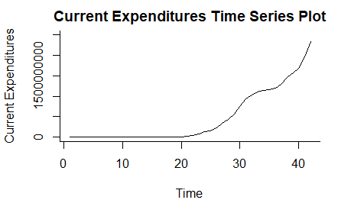

**Figure 130.** Indicates Time Series Plot for Current Expenditures

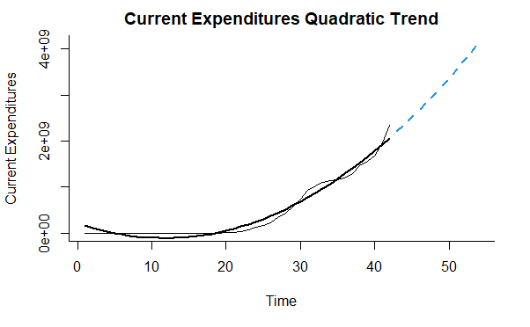

**Figure 131.** Indicates the Quadratic Trend Forecasting Analysis for Current Expenditures

Forecast analysis for Budget Expenditures has been made. Since the data is annual, it cannot be observed any seasonality. Only trend-based forecasting can be applied. Quadratic Trend Analysis is performed with the R program based on all data. For this, tslm and forecast functions are used. The year 2030 was chosen as the parameter of the Forecast analysis. Instead of using the year for this, each year is named with a number. For example, 1 reflects 1977, while 42 reflects 2018. Quadratic Trend Analysis gives an yt = b0 + b1t + b2t2

**Table 42.** Summary of Quadratic Trends for Current Expenditures

|  |  |  |  |  |
| --- | --- | --- | --- | --- |
|  | Estimate | Std. Error | t value | Pr(>|t|) |
| (Intercept) | 219385166 | 51784597 | 4.24 | 0.00013 |
| trend | -55667315 | 5554495 | -10.02 | 0.0000000000024 |
| I(trend^2) | 2371442 | 125261 | 18.93 | 0.0000000000000002 |

Residual standard error: 107000000 on 39 degrees of freedom

Multiple R-squared: 0.975, Adjusted R-squared: 0.974

F-statistic: 762 on 2 and 39 DF, p-value: <0.0000000000000002

In the light of all these, as a result of the Quadratic Trend analysis for Current Expenditures gives an equation yt = 219385166 -55667315t + 2371442t2 with adjusted R2 equals to 0.974.

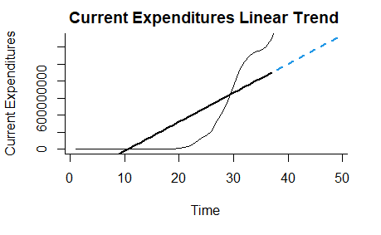

**Figure 132.** Indicates the Linear Trend Forecasting Analysis for Current Expenditures

Linear Trend Analysis is performed with the R program based on training and validation. Training range is between 1-37 and validation range is between 38-42. Again for this, tslm and forecast functions are used. The year 2030 was chosen as the parameter of the Forecast analysis. Linear Trend Analysis gives an yt = b0 + b1t

**Table 43.** Summary of Linear Trends for Current Expenditures

|  |  |  |  |  |
| --- | --- | --- | --- | --- |
|  | Estimate | Std. Error | t value | Pr(>|t|) |
| (Intercept) | -359333293 | 85243321 | -4.22 | 0.00017 |
| trend | 34005534 | 3911232 | 8.69 | 0.00000000029 |

Residual standard error: 254000000 on 35 degrees of freedom

Multiple R-squared: 0.684, Adjusted R-squared: 0.674

F-statistic: 75.6 on 1 and 35 DF, p-value: 0.000000000289

In the light of all these, as a result of the Linear trend analysis for Current Expenditures gives an equation yt = -359333293 + 34005534t with adjusted R2 equals to 0.674.

*3.4.2. For Personnel Expenditures*

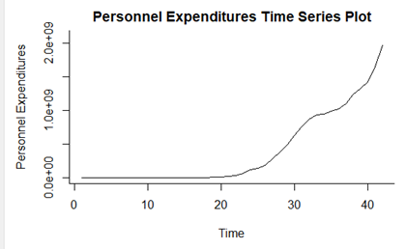

**Figure 133.** Indicates Time Series Plot for Personnel Expenditures

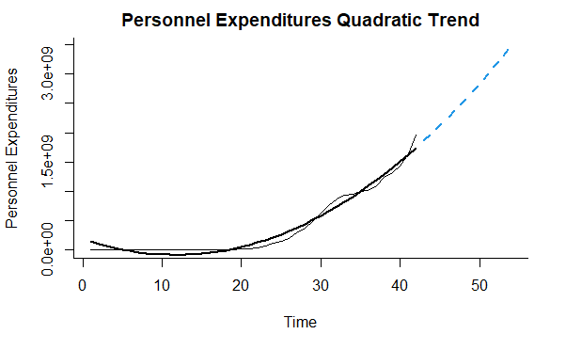

**Figure 134.** Indicates the Quadratic Trend Forecasting Analysis for Personnel Expenditures

**Table44.** Summary of Quadratic Trends for Personnel Expenditures

|  |  |  |  |  |
| --- | --- | --- | --- | --- |
|  | Estimate | Std. Error | t value | Pr(>|t|) |
| (Intercept) | 184900043 | 42354437 | 4.37 | 0.000090450713 |
| trend | -46915335 | 4543002 | -10.33 | 0.000000000001 |
| I(trend^2) | 1999271 | 102451 | 19.51 < | 0.0000000000000002 |

Residual standard error: 87200000 on 39 degrees of freedom

Multiple R-squared: 0.976, Adjusted R-squared: 0.975

F-statistic: 810 on 2 and 39 DF, p-value: <0.0000000000000002

In the light of all these, as a result of the Quadratic Trend analysis for Personnel Expenditures gives an equation yt = 184900043 -46915335 t + 1999271 t2 with adjusted R2 equals to 0.975.

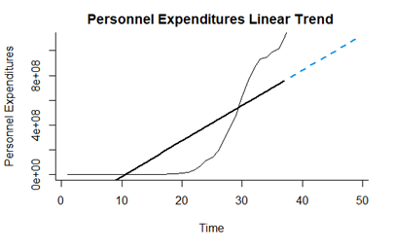

**Figure 135.** Indicates the Linear Trend Forecasting Analysis for Personnel Expenditures

Linear Trend Analysis is performed with the R program based on training and validation.Training range is between 1-37 and validation range is between 38-42.

**Table 45.** Summary of Linear Trends for Personnel Expenditures

|  |  |  |  |  |
| --- | --- | --- | --- | --- |
|  | Estimate | Std. Error | t value | Pr(>|t|) |
| (Intercept) | -302935713 | 71630623 | -4.23 | 0.00016 |
| trend | 28676827 | 3286638 | 8.73 | 0.00000000026 |

Residual standard error: 213000000 on 35 degrees of freedom

Multiple R-squared: 0.685, Adjusted R-squared: 0.676

F-statistic: 76.1 on 1 and 35 DF, p-value: 0.000000000265

In the light of all these, as a result of the Linear trend analysis for Personnel Expenditures gives an equation yt = -302935713 + 28676827t with adjusted R2 equals to 0.676.

*3.4.3. For Other Current Expenditures*

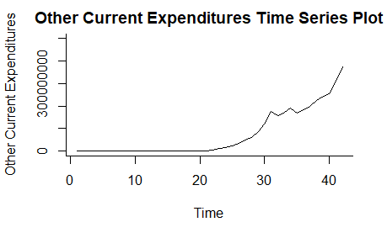

**Figure 136.** Indicates Time Series Plot for Other Current Expenditures

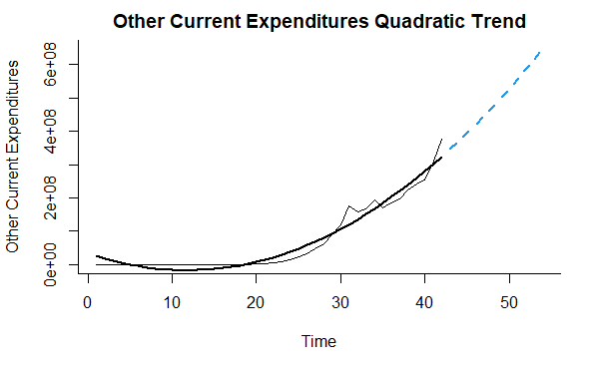

**Figure 137.** Indicates the Quadratic Trend Forecasting Analysis for Other Current Expenditures

**Table 46.** Summary of Quadratic Trends for Other Current Expenditures

|  |  |  |  |  |
| --- | --- | --- | --- | --- |
|  | Estimate | Std. Error | t value | Pr(>|t|) |
| (Intercept) | 34485123 | 9928649 | 3.47 | 0.0013 |
| trend | -8751980 | 1064962 | -8.22 | 0.00000000049 |
| I(trend^2) | 372172 | 24016 | 15.50 | 0.0000000000000002 |

Residual standard error: 20400000 on 39 degrees of freedom

Multiple R-squared: 0.963, Adjusted R-squared: 0.961

F-statistic: 509 on 2 and 39 DF, p-value: <0.0000000000000002

In the light of all these, as a result of the Quadratic Trend analysis for Other Current Expenditures gives an equation yt = 34485123 -8751980t + 372172t2 with adjusted R2 equals to 0.961.

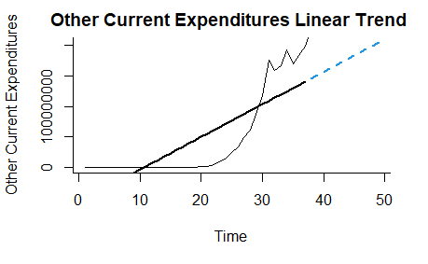

**Figure 138.** Indicates the Linear Trend Forecasting Analysis for Other Current Expenditures

Linear Trend Analysis is performed with the R program based on training and validation. Training range is between 1-37 and validation range is between 38-42.

**Table 47.** Summary of Linear Trends for Other Current Expenditures

|  |  |  |  |  |
| --- | --- | --- | --- | --- |
|  | Estimate | Std. Error | t value | Pr(>|t|) |
| (Intercept) | -56397580 | 13809229 | -4.08 | 0.00024 |
| trend | 5328706 | 633611 | 8.41 | 0.00000000064 |

Residual standard error: 41200000 on 35 degrees of freedom

Multiple R-squared: 0.669, Adjusted R-squared: 0.66

F-statistic: 70.7 on 1 and 35 DF, p-value: 0.00000000064

In the light of all these, as a result of the Linear trend analysis for Other Current Expenditures gives an equation yt = -56397580 + 5328706t with adjusted R2 equals to 0.66.

*3.4.4. For Defence*

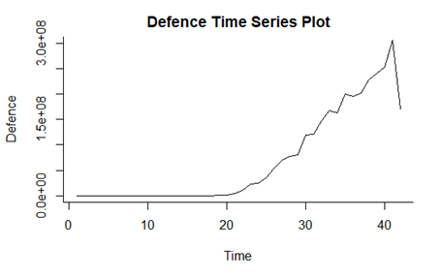

**Figure 139.** Indicates Time Series Plot for Defence

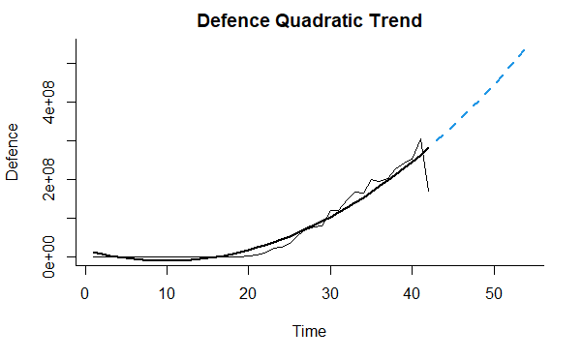

**Figure 140.** Indicates the Quadratic Trend Forecasting Analysis for Defence

**Table 48.** Summary of Quadratic Trends for Other Current Expenditures

|  |  |  |  |  |
| --- | --- | --- | --- | --- |
|  | Estimate | Std. Error | t value | Pr(>|t|) |
| (Intercept) | 17971342 | 11161067 | 1.61 | 0.12 |
| trend | -5696346 | 1197153 | -4.76 | 0.00002677447220 |
| I(trend^2) | 284502 | 26997 | 10.54 | 0.00000000000057 |

Residual standard error: 23000000 on 39 degrees of freedom

Multiple R-squared: 0.94, Adjusted R-squared: 0.937

F-statistic: 305 on 2 and 39 DF, p-value: <0.0000000000000002

In the light of all these, as a result of the Quadratic Trend analysis for Defence gives an equation yt = 17971342 -5696346 t + 284502 t2 with adjusted R2 equals to 0.937

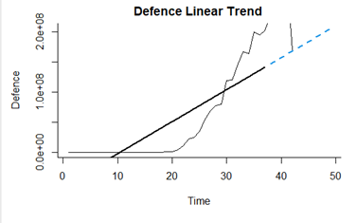

**Figure 141.** Indicates the Linear Trend Forecasting Analysis for Defence

Linear Trend Analysis is performed with the R program based on training and validation. Training range is between 1-37 and validation range is between 38-42.

**Table 49.** Summary of Linear Trends for Defence

|  |  |  |  |  |
| --- | --- | --- | --- | --- |
|  | Estimate | Std. Error | t value | Pr(>|t|) |
| (Intercept) | -55519287 | 12510460 | -4.44 | 0.000086478335 |
| trend | 5330986 | 574019 | 9.29 | 0.000000000057 |

Residual standard error: 37300000 on 35 degrees of freedom

Multiple R-squared: 0.711, Adjusted R-squared: 0.703

F-statistic: 86.3 on 1 and 35 DF, p-value: 0.0000000000566

In the light of all these, as a result of the Linear trend analysis for Defence gives an equation yt = -55519287 + 5330986 t with adjusted R2 equals to 0.703.

*3.4.5. For GNP*

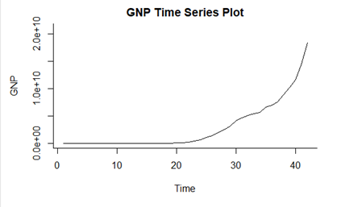

**Figure 142.** Indicates Time Series Plot for Defence

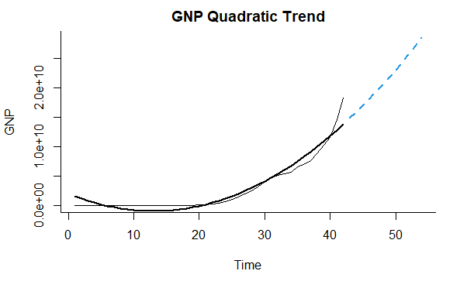

**Figure 143.** Indicates the Quadratic Trend Forecasting Analysis for GNP

**Table 50.** Summary of Quadratic Trends for GNP.

|  |  |  |  |  |
| --- | --- | --- | --- | --- |
|  | Estimate | Std. Error | t value | Pr(>|t|) |
| (Intercept) | 2020432936 | 530384790 | 3.81 | 0.00048 |
| trend | -456200462 | 56889884 | -8.02 | 0.00000000089 |
| I(trend^2) | 17520306 | 1282940 | 13.66 < | 0.0000000000000002 |

Residual standard error: 1090000000 on 39 degrees of freedom

Multiple R-squared: 0.943, Adjusted R-squared: 0.94

F-statistic: 322 on 2 and 39 DF, p-value: <0.0000000000000002

In the light of all these, as a result of the Quadratic Trend analysis for GNP gives an equation yt = 2020432936 -456200462 t + 17520306 t2 with adjusted R2 equals to 0.94.

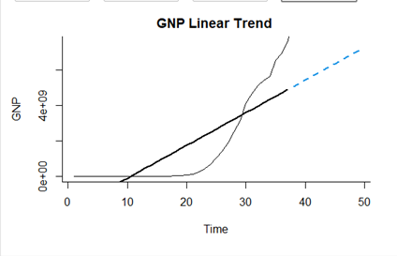

**Figure 144.** Indicates the Linear Trend Forecasting Analysis for GNP

Linear Trend Analysis is performed with the R program based on training and validation. Training range is between 1-37 and validation range is between 38-42.

**Table 51.** Summary of Linear Trends for GNP

|  |  |  |  |  |
| --- | --- | --- | --- | --- |
|  | Estimate | Std. Error | t value | Pr(>|t|) |
| (Intercept) | -1951105935 | 455950685 | -4.28 | 0.00014 |
| trend | 184657156 | 20920452 | 8.83 | 0.0000000002 |

Residual standard error: 1360000000 on 35 degrees of freedom

Multiple R-squared: 0.69, Adjusted R-squared: 0.681

F-statistic: 77.9 on 1 and 35 DF, p-value: 0.0000000002

In the light of all these, as a result of the Linear trend analysis for GNP gives an equation yt = -1951105935 + 184657156 t with adjusted R2 equals to 0.681.

# 4. DISCUSSION AND CONCLUSION

In this project, important statistical methods were applied using the Budget Expenditure data set belonging to the Turkish Republic of Northern Cyprus. This data set is shown in Table 1. In the literature review conducted in the first part of the project, different statistical analyzes were made using data from different countries at different time intervals. For example, Feridun et.al. (2011) study examined the effect of defense expenditures of Northern Cyprus on economic growth between 1977-2007. As a method, Autoregressive Distributed Latency (ARDL) bounds test and also Granger causality test were used.

In our project, using the Budget expenditure data set between 1977 and 2018, the economic contribution of these expenditures to the country was calculated using the statistical methods R program. The Method section begins with Descriptive statistics. In this section, the basic information of the data set is explained. The first step in descriptive statistics Summary statistics and frequency statistics values ​​were calculated with the help of the R program and the results are given in an understandable way in the tables. For example, when table 2 is examined, the average value of the Current Expenditure data is 467141360, the median 29873956 and the sample standard deviation value is 657878573.05. Then, Steam-leaf diagram, dot diagram, Time series diagram and Box-plot for each topic of the data set were drawn and interpreted. In addition, since our data set is continuous, histogram has been drawn.

Inferantial statistical calculations, which is the second part of the Method part, are made. The first part of this part is the Confidence interval application. Inferantial statistical calculations, which is the second part of the Method part, are made. The first part of this section is the Confidence interval application. First, the Confidence Interval was calculated for the Population Mean of a Single Sample. If we compare the results for Current Expenditure and Personnel Expenditure as an example. According to the result from the R program, we are sure that the population average is between 268179796 and 666102925 for Current Expenditure with 95% confident. Also, this range for Personnel Expenditure is 226445650 and 561772875. When these results are examined, the Current Expenditure confidence interval range is higher. In the calculation of the Confidence Interval for the Difference of Population Means/Two Sample Ratios, when we look at our Personnel Expenditures and Other Current Expenditures as an example, the confidence interval is 177928290 ≤ 𝜇1−𝜇2 ≤ 464226040 with 95% confidence. Apart from these calculations, the confidence interval was found by making calculations within the population variance. The assumptions made about population parameters by hypothesis testing were tested using sample statistics. Various assumptions were made in hypothesis testing and graphs were drawn. It was decided whether the null hypothesis or the alternative hypothesis was rejected. In addition, the graphics for Type 1 error and Type 2 error were drawn with the R program. Another method applied for the data set is correlation analysis. While GNP was used as the y value, each category was used separately for the x value. The correlation coefficient r in each sample was high and showed strong positive correlation. We examined the regression in two directions, as single and multiple. While the y value is GNP, the x1 value for multiple includes Current Expenditure, while the X4 value includes defense. For sample regression, the x value varies according to the individual topic. In this section, the relevant scatter plots are drawn.

For example, when our GNP values depend on the x value, that is, the Current Expenditure value, the equation found according to the result is ŷ = 6.66x - 226165667.00. According to this result, we calculated our GNP value when the current expenditure value is 10.000.000.000 YTL. This value is 66,373,834,333 YTL. Likewise, in the example where x is personnel expenditure, the equation is ŷ = 7.9x –229627474.9. When the same x value is given, the GNP value is 78,770,372,525 YTL. When the Sum of Squares and Mean Squares Analysis were performed, it was observed in the study that the best R2 value among the R2 values was that we applied multiple linear regression, X1 value was Current Expenditures X4 value was Defence and y was GNP. The R2 value is 0.9781

Trend analysis methods are used to predict the future. Two methods, Linear and Nonlinear, are tried and the results are compared with each metric drawn as a time series. Since data is annual, seasonal reviews are not made. In the analysis made for the year 2030, it is seen that each data does not have a linear distribution. Therefore, when linear trend analysis is performed, the adjusted R squared of the result is around 0.60 for all data, and therefore the closeness and suitability of a linear method to the regression line is low. In addition, when looking at the Quadratic model, it can be said that the values ​​are around 0.97 and for this reason, it is closer to the regression line and is more appropriate. The reason for looking at the adjusted R squared value instead of the R square value here is that it will give better results in multiple analysis comparisons, since it provides a decrease in the independent variables.

As a result, the statistical methods applied contributed to our understanding of the Budget Expenditure(Current Expenditure, Personnel Expenditures, Other Current Expenditure, Defence) of the Turkish Republic of Northern Cyprus between 1977-2018 and also until 2030.

# REFERENCES

Ambler, T. and Neubauer, J. (2017), “Defense expenditure and economic growth in Visegrad group countries: a panel data analysis”, in 35th International Conference Mathematical Methods in Economics, Hradec Králové, pp. 6-11.

( <https://k101.unob.cz/~neubauer/pdf/Defence_expenditure_in_V4_Ambler_Neubauer.pdf> )

Biswal, B., Dhawan, U. and Lee, H. Y. (1999), “Testing Wagner versus Keynes using disaggregated public expenditure data for Canada”, Applied Economics,Vol.31No.10, pp. 1283–1291. (<https://doi.org/10.1080/000368499323490>)

Brzoska, M. (1995). “Chapter 3 World military expenditures”. Handbook of Defense Economics, Vol 1, pp.45–67. (doi:10.1016/s1574-0013(05)80005-5)

Ehikioya, B. I., and Omankhanlen, A. E. (2021), “Impact of Public Debt on Economic Growth: Evidence from Nigeria”. Montenegrin Journal of Economics, Vol 17 No.1, pp. 97-109. ( doi: 10.14254/1800-5845/2021.17-1.7)

Feridun, M., Sawhney, B. and Shahbaz, M. (2011). “The impact of military spending on economic growth: the case of North Cyprus”. Defence and Peace Economics*,*Vol.22 No.5,pp.555–562. (<https://doi.org/10.1080/10242694.2011.562370>)

Gangal, V. L. and Gupta, H. (2013), “Public expenditure and economic growth: a case study of India”, Global Journal of Management and Business Studies,Vol. 3 No. 2, pp.191-196. (https://www.ripublication.com/gjmbs_spl/gjmbsv3n2spl_17.pdf)

Gregoriou, A. and Ghosh, S. (2009),” The impact of government expenditure on growth: empirical evidence from a Heterogeneous Panel”, Bulletin of Economic Research,Vol 61 No.1 , pp.95–102. (https://doi.org/ 10.1111/j.1467-8586.2008.00297.x)

Kun, S. H. I. (2019),”Research on the Application of Gross National Product Based on Indexed Principal Component Analysis”, DEStech Transactions on Social Science, Education and Human Science,

Linhartova, V. (2021), “Analyzing the role of public expenditures in human development: panel data analysis of EU-28 countries”, Montenegrin Journal of Economics, Vol. 17 No 1, pp.85-96.(doi: 10.14254/1800-5845/2021.17-1.6)

Mosikari, T. J. and Matlwa, K. (2014), “An analysis of defence expenditure and economic growth in South Africa”, Mediterranean Journal of Social Sciences,Vol.5 No. 20, p. 2769. (doi: 10.5901/mjss.2014.v5n20p2769)

Polat, M. A. (2020), “The relationship between defense expenditure and economic growth: a panel data analysis for Turkey and selected countries”, Akademik Araştırmalar Ve Çalışmalar Dergisi(Akad), Vol. 12 No.22, pp. 86-102.(<https://doi.org/10.20990/kilisiibfakademik.603555>)

Yılmaz, Ö., and Kaya,V. (2005), “Kamu harcama çeşitleri ve ekonomik büyüme ilişkisi”, Sosyal Ekonomik Araştırmalar Dergisi, Vol.5 No.9, pp.257-271.

Yildirim, J., Sezgin, S. and Öcal, N. (2005), “Military expenditure and economic growth in Middle Eastern countries: A dynamic panel data analysis”, Defence and Peace Economics, Vol.16 No.4, pp.283-295. (<https://doi.org/10.1080/10242690500114751>)