Deniz Toprak – 36235

Mert Kıray - 29202

COMP416 – Computer Networks Project #3 Report

In this project we were asked to implement a Distance Vector Routing Simulator.

We changed Node.java class in order to implement a functional Distance Vector Routing Simulator. These are the methods we changed:

1. public Node()
2. public void notifyNeighbors()
3. public void updateDV(Packet p)

public Node():

We first initialized an array named “cost” which is cost of this node between other nodes. Non-neighbor nodes have a cost of 999. Then we initialized myDV variable, which contains Distance Vectors to the other nodes sourcing from the specific node. In the public Node() constructor myDV is initially set to the costs we initialized earlier. We initialized a neighbor array that shows which nodes are neighboring.

Then for the part 2 we initialized bestPath array that will store the optimal nodes, the node should visit in order to reach the destination node with the optimal route. Index = destination node, value = next node. If the destination is the node itself or neighboring node then bestPath is its id initially, else a randomly chosen neighbor node’s id is the bestPath, initially.

Public void notifyNeighbors():

This function briefly sends myDV array to all neighbor nodes, with the information of the source(the node itself) and destination. We are using the Packets.java class to send this information. We first create a new Packet object and send it to all neighbor nodes.

Structure of the packet object: Packet(int source, int destination, int[] dv)

public void updateDV(Packet p):

For each packet received from the neighbor, we check if the neighbor provides a cheaper path. If true, we update myDV and the bestPath accordingly.

The algorithm to check if the neighbor provides a cheaper path is: current DV of i is min { current DV of i, cost to neighbor + neighbor's DV to i } (given us in the project pdf)

Test 1:

We first test our project with the given DVRS topology below.(figure 1)

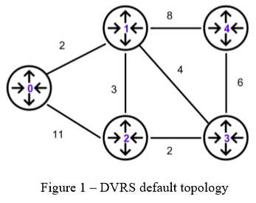

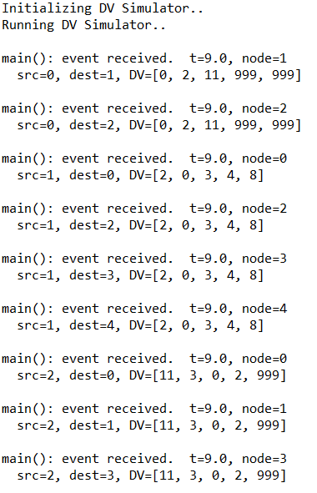Run results:

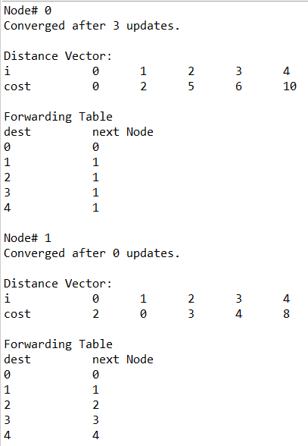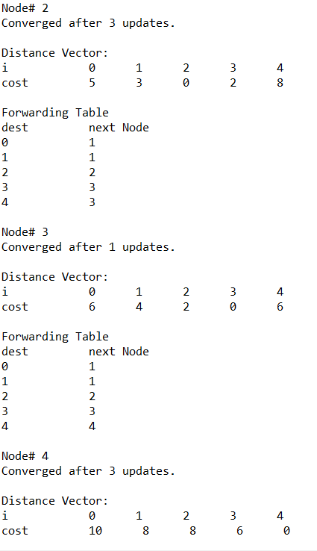

As can be seen our simulator is working perfectly. We observed expected results.

After testing other topology provided in the project description pdf. We tried on a different topology with different costs.

Test 2:

We used the topology:

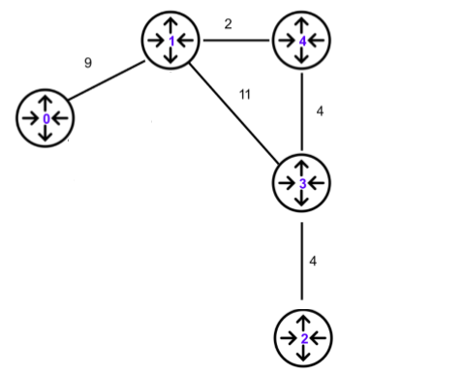

We changed DVSimulator.java class codes accordingly to implement our new topology.

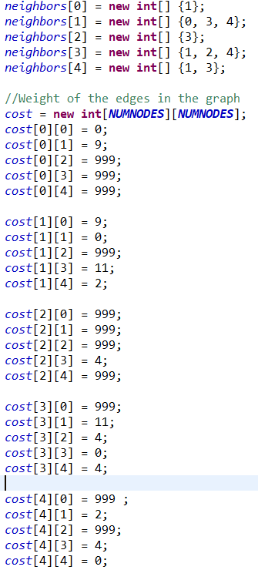

Run results are as following:

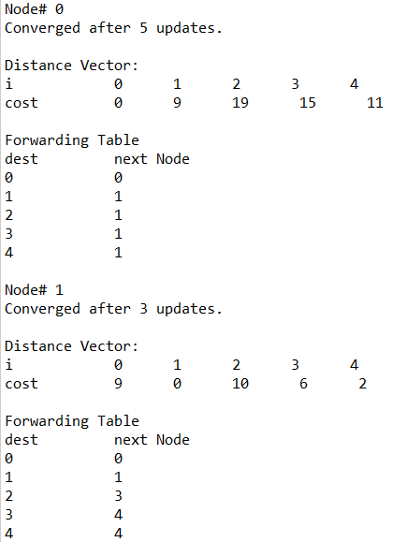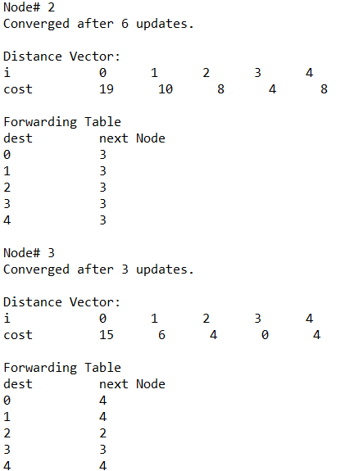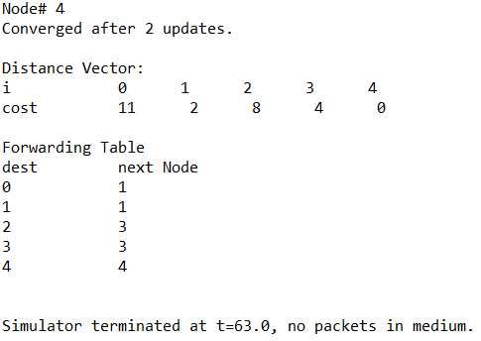

Our other test outputs correct result as expected.