**Neo4j Work:** Advanced-Level Cypher Queries in Neo4j

**Prepared by:** Mert OLÇAMAN

**Week:** 5-6

**patika.dev**

**NewMind AI Bootcamp**

**INTRODUCTION**

In this work, advanced-level cypher queries were performed to get detailed insights from the dataset. The dataset and the graph database design can be seen below respectively.

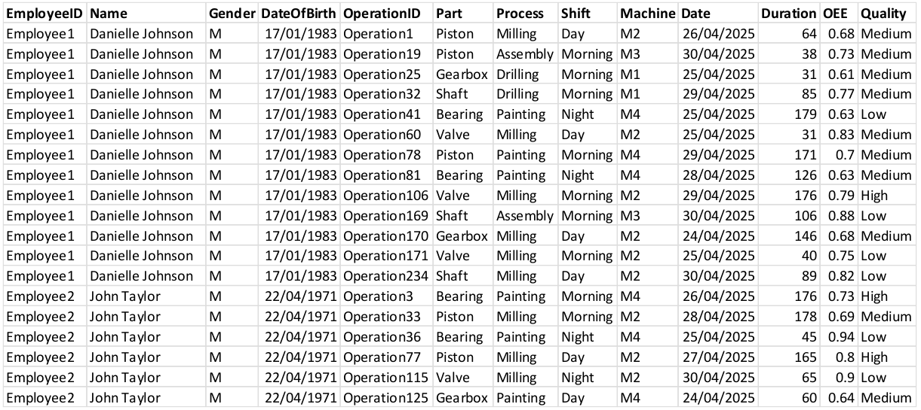

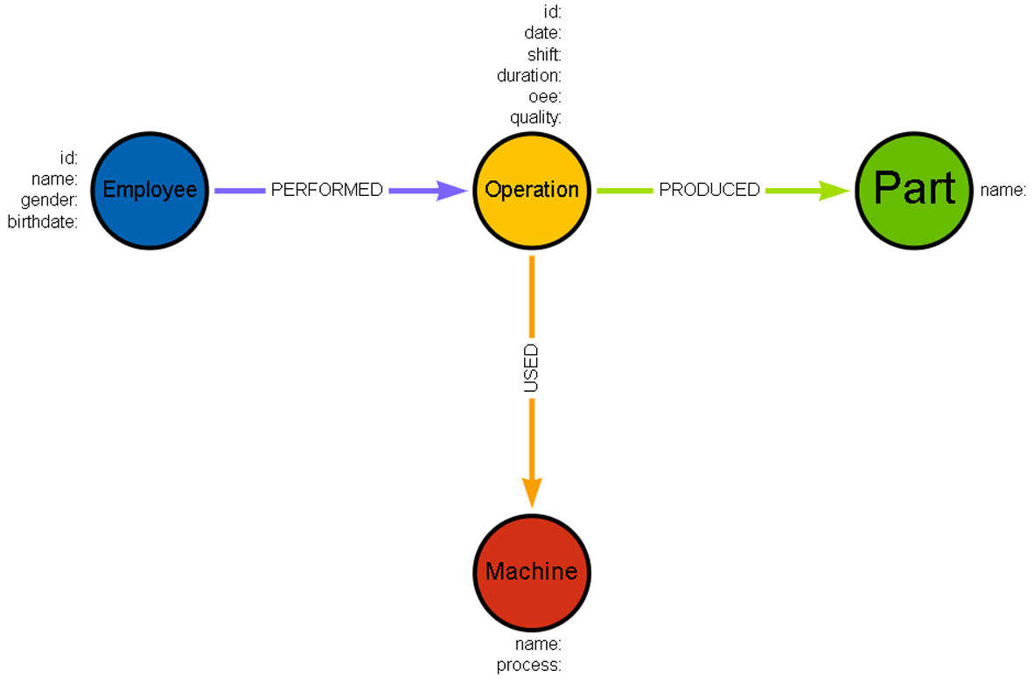

1. **Importing data into Neo4j**

At first, the generated csv file was uploaded to github directory. Secondly, it was directly imported by using function.

**Step1 - Adding Constraints:** Before starting everything, constraints should be specified. Otherwise, there might be some improper nodes, which causes wrong results.

**// --- ADDING CONSTRAINTS --- \\**

**// Employee constraint**

CREATE CONSTRAINT employee_id IF NOT EXISTS

FOR (e:Employee)

REQUIRE e.employee_id IS UNIQUE;

**// Operation constraint**

CREATE CONSTRAINT operation_id IF NOT EXISTS

FOR (o:Operation)

REQUIRE o.operation_id IS UNIQUE;

**// Part constraint**

CREATE CONSTRAINT part_name IF NOT EXISTS

FOR (p:Part)

REQUIRE p.part_name IS UNIQUE;

**// Machine constraint**

CREATE CONSTRAINT machine_name IF NOT EXISTS

FOR (m:Machine)

REQUIRE m.machine_name IS UNIQUE;

**Step2 – Loading CSV Files & Creating Nodes with Properties & Adding Relationships:** While loading data from the link, an alias should be specified to use in the other parts of the cypher query. It was specifed as **data** in this work.

For each node created, the unique property has to be specified in the merge line as a property. As for Employee node, only employee_id was set as unique property, so it was the only property which was provided in the merge, as it can be seen in the code cell below. If there had been multiple unique properties, they would have been specifed as well. Additionally, data alias was used to call the relevant data from the imported dataset by using the same column name as the imported dataset had. What it is meant here that EmployeeID was the name of the column in the dataset. It is valid for the other variables which start with the alias of data such as data.Name, data.Gender, and data.Shift.

On the other hand, the numerical values like duration must be converted into float by toFloat() function while calling the data from the csv file. The column of date was converted to date, as the format was only data (time not included).

**// --- LOADING CSV FILE --- \\**

LOAD CSV WITH HEADERS FROM 'https://media.githubusercontent.com/media/mertolcaman/patika_newmind_ai_bootcamp/refs/heads/main/4.week/mydata.csv' as **data**

**// --- CREATING NODES WITH PROPERTIES--- \\**

**// Creating Employee Node**

MERGE (e:Employee {employee_id: data.EmployeeID})

SET e.name = data.Name,

e.gender = data.Gender,

e.birthdate = data.DateOfBirth

**// Creating Operation Node**

MERGE (o:Operation {operation_id: data.OperationID})

SET o.date = date(data.Date),

o.shift = data.Shift,

o.duration = toFloat(data.Duration),

o.oee = toFloat(data.OEE),

o.quality = data.Quality

**// Creating Machine Node**

MERGE (m:Machine {machine_name: data.Machine})

SET m.process = data.Process

**// Creating Part Node**

MERGE (p:Part {part_name: data.Part})

**// --- CREATING RELATIONSHIPS --- \\**

**// Creating PERFORMED Relationship: Employee -> Operation**

MERGE (e)-[:PERFORMED]->(o)

**// Creating USED Relationship: Operation -> Machine**

MERGE (o)-[:USED]->(m)

**// Creating PRODUCED Relationship: Operation -> Person**

MERGE (o)-[:PRODUCED]->(p);

**GRAPH DESIGN**

**TEST**

**QUESTIONS**

***Before starting, each question related to the query was specified on top of the query.***

**TEST**

After loading a dataset, it should be checked if it has any errors. According to the query, there is no record found, which is related to not linked nodes.

MATCH (o:Operation)

WHERE NOT (o)<-[:PERFORMED]-(:Employee)

   OR NOT (o)-[:USED]->(:Machine)

   OR NOT (o)-[:PRODUCED]->(:Part)

RETURN o.operation_id;



The test query was run to see if there was any deficiency in the graph database model. However, no record was found, which is a good sign.

1. **Query performance comparison**

**Query comparison-1:**

//creating a detailed table for the best employees

PROFILE CALL {

  MATCH (e:Employee)-[:PERFORMED]->(o:Operation)

  WITH e.name AS employee, COUNT(CASE WHEN o.quality = "High" THEN 1 END) AS high

  ORDER BY high DESC

  LIMIT 5

  RETURN collect(employee) AS top_names

}

UNWIND top_names AS employee_name

MATCH (e:Employee)-[:PERFORMED]->(o:Operation)

WHERE e.name=employee_name

RETURN

  employee_name AS employee,

  o.shift AS shift,

  COUNT(*) AS op_count,

  COUNT(CASE WHEN o.quality = "High" THEN 1 END) AS high_quality,

  COUNT(CASE WHEN o.quality = "Low" THEN 1 END) AS low_quality,

  ROUND(AVG(o.oee), 2) AS avg_oee

ORDER BY employee, shift

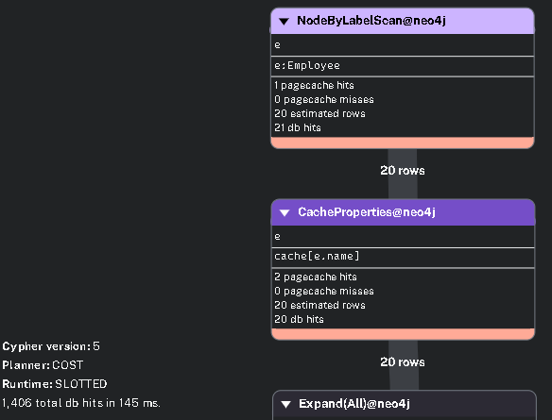

//creating a detailed table for the best employees

PROFILE  CALL {

  MATCH (e:Employee)-[:PERFORMED]->(o:Operation)

  WITH e.name AS employee, COUNT(CASE WHEN o.quality = "High" THEN 1 END) AS high

  ORDER BY high DESC

  LIMIT 5

  RETURN collect(employee) AS top_names

}

UNWIND top_names AS employee_name

MATCH (e:Employee {name: employee_name})-[:PERFORMED]->(o:Operation)

RETURN

  employee_name AS employee,

  o.shift AS shift,

  COUNT(*) AS op_count,

  COUNT(CASE WHEN o.quality = "High" THEN 1 END) AS high_quality,

  COUNT(CASE WHEN o.quality = "Low" THEN 1 END) AS low_quality,

  ROUND(AVG(o.oee), 2) AS avg_oee

ORDER BY employee, shift

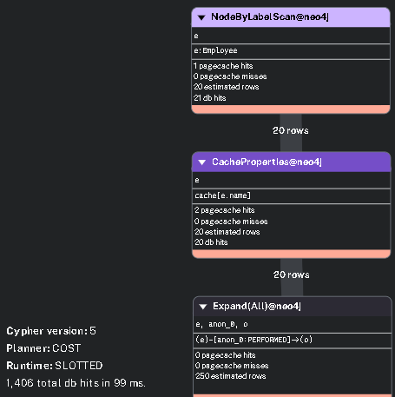

In the first query, employee name is filtered in WHERE part, which makes the query slower.

**Query comparison-2:**

PROFILE

MATCH (e:Employee)-[:PERFORMED]->(o:Operation)

MATCH (o)-[:USED]->(m:Machine)

RETURN e.name, COUNT(*) AS op_count

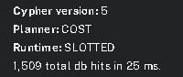

PROFILE

MATCH (e:Employee)-[:PERFORMED]->(o:Operation)-[:USED]->(m:Machine)

RETURN e.name, COUNT(*) AS op_count

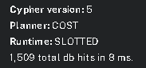

In the first query 2 different MATCH was used. Indicating all query in 1 MATCH makes the query faster.

**Query comparison-3:**

PROFILE MATCH (e:Employee)-[:PERFORMED]->(o:Operation)

WITH e.name AS employee, AVG(o.oee) AS avg_oee

ORDER BY avg_oee DESC

LIMIT 3

RETURN 'Best' AS category, employee, ROUND(avg_oee, 2) AS avg_oee

UNION

MATCH (e:Employee)-[:PERFORMED]->(o:Operation)

WITH e.name AS employee, AVG(o.oee) AS avg_oee

ORDER BY avg_oee ASC

LIMIT 3

RETURN 'Worst' AS category, employee, ROUND(avg_oee, 2) AS avg_oee

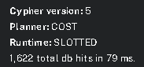

PROFILE

CALL {

  MATCH (e:Employee)-[:PERFORMED]->(o:Operation)

  WITH e.name AS employee, AVG(o.oee) AS avg_oee

  ORDER BY avg_oee DESC

  RETURN collect({

    employee: employee,

    avg_oee: ROUND(avg_oee, 2)

  }) AS employees

}

WITH employees

RETURN

  employees[..3] AS best_employees,   // Top 3

  employees[-3..] AS worst_employees  // Bottom 3

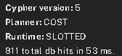

:param limit=>3;

PROFILE call{

MATCH (e:Employee)-[:PERFORMED]->(o:Operation)

WITH e.name AS employee, AVG(o.oee) AS avg_oee

ORDER BY avg_oee DESC

RETURN collect({

  employee: employee,

  avg_oee: ROUND(avg_oee, 2)

}) AS employees

}

RETURN employees[..$limit] as best_employees, employees[-$limit..] as worst_employees

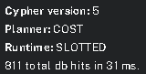

In the first query, two separate MATCH and aggregation operations are performed for best and worst results, which leads to redundant graph traversals and slower execution. The second and third queries improve performance by using a single MATCH with collect() and slicing, avoiding duplicate computations. The third query also adds flexibility by parameterizing the limit without affecting speed.

1. **Advanced-level cypher queries**

//Top 5 employees perform with high quality

MATCH (e:Employee)-[:PERFORMED]->(o:Operation)

RETURN e.name AS employee,

       COUNT(CASE WHEN o.quality = "High" THEN 1 END) AS High,

       COUNT(CASE WHEN o.quality = "Medium" THEN 1 END) AS Medium,

       COUNT(CASE WHEN o.quality = "Low" THEN 1 END) AS Low

ORDER BY High DESC

LIMIT 5

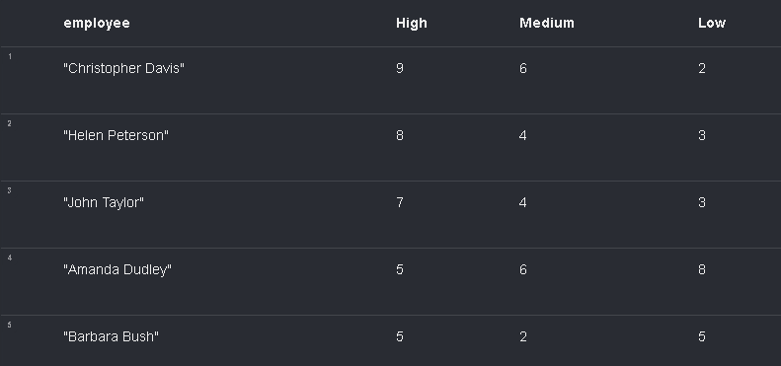

Christopher Davis shows the best performance with 9 high- and only 2 low-quality operations. In contrast, Amanda Dudley has 8 low-quality outputs, indicating inconsistency, while Barbara Bush shows a balanced but less remarkable result.

//Top 5 employees perform with low quality

MATCH (e:Employee)-[:PERFORMED]->(o:Operation)

RETURN e.name AS employee,

       COUNT(CASE WHEN o.quality = "High" THEN 1 END) AS High,

       COUNT(CASE WHEN o.quality = "Medium" THEN 1 END) AS Medium,

       COUNT(CASE WHEN o.quality = "Low" THEN 1 END) AS Low

ORDER BY Low DESC

LIMIT 5

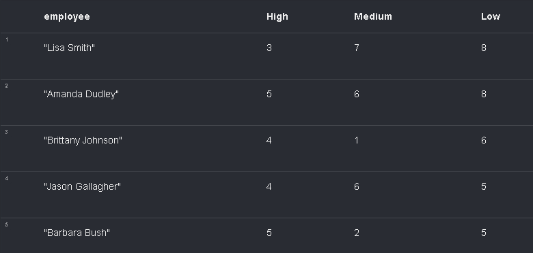

Lisa Smith and Amanda Dudley have the weakest performance, each with 8 low-quality operations, highlighting a consistent quality issue. Among the group, Barbara Bush stands out as the best, with 5 high- and only 5 low-quality results, showing a relatively balanced output.

//creating a detailed table for the best employees

CALL {

  MATCH (e:Employee)-[:PERFORMED]->(o:Operation)

  WITH e.name AS employee, COUNT(CASE WHEN o.quality = "High" THEN 1 END) AS high

  ORDER BY high DESC

  LIMIT 5

  RETURN collect(employee) AS top_names

}

UNWIND top_names AS employee_name

MATCH (e:Employee {name: employee_name})-[:PERFORMED]->(o:Operation)

RETURN

  employee_name AS employee,

  o.shift AS shift,

  COUNT(*) AS op_count,

  COUNT(CASE WHEN o.quality = "High" THEN 1 END) AS high_quality,

  COUNT(CASE WHEN o.quality = "Low" THEN 1 END) AS low_quality,

  ROUND(AVG(o.oee), 2) AS avg_oee

ORDER BY employee, shift



According to the table above, which shows the information about the best 5 employees by the high quality, Christopher Davis worked hard during the day shift with the average oee rate of 0.76. Barbara Bush was the least hardworking among these, worked 12 times with the lowest oee ratio.

//Rank Shifts by Total Production Time and Average Quality

MATCH (:Employee)-[:PERFORMED]->(o:Operation)

WITH o.shift AS shift,

     SUM(o.duration) AS total_time,

     AVG(CASE

            WHEN o.quality = "High" THEN 1

            WHEN o.quality = "Medium" THEN 0.5

            ELSE 0

         END) AS quality_score

RETURN shift, total_time, ROUND(quality_score, 2) AS avg_quality_score

ORDER BY total_time DESC

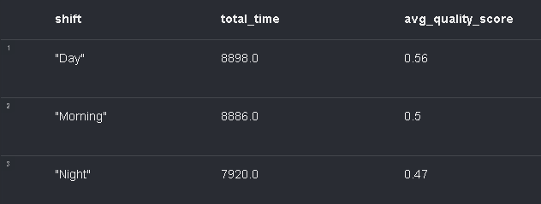

In the table above, day and morning was really close to each other in terms of total minutes of working, but the average quality score was lower for the night inspite of the least working duration.

//3 best and 3 worst employees in terms of average oee

call{

MATCH (e:Employee)-[:PERFORMED]->(o:Operation)

WITH e.name AS employee, AVG(o.oee) AS avg_oee

ORDER BY avg_oee DESC

RETURN collect({

  employee: employee,

  avg_oee: ROUND(avg_oee, 2)

}) AS employees

}

RETURN employees[..$limit] as best_employees, employees[-$limit..] as worst_employees

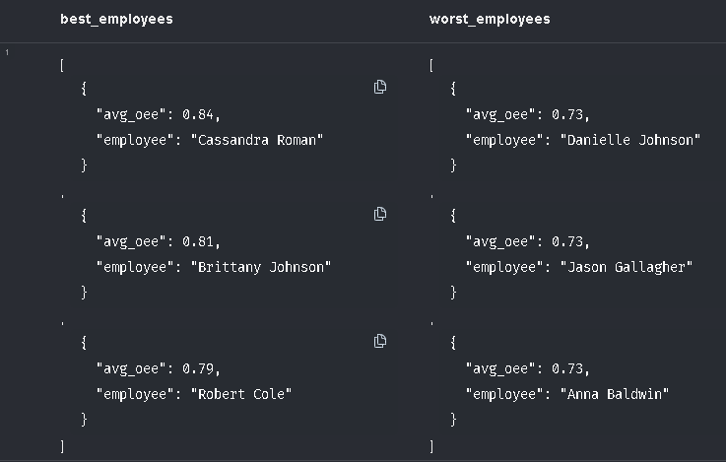

3 the best and the worst (left and right respectivelty) can be seen with json formats. The lowest OEE score was 0.73, while that of the highest was found as 0.84 (Cassandra Roman) – who might be the most experienced operator.

//Sort parts from low quality to high with the ratio

MATCH (o:Operation)-[:PRODUCED]->(p:Part)

WITH p.part_name AS part,

     COUNT(*) AS total,

     COUNT(CASE WHEN o.quality = 'Low' THEN 1 END) AS low_count

RETURN part,

       low_count,

       ROUND((1.0 * low_count) / total, 2) AS low_quality_ratio

ORDER BY low_quality_ratio DESC

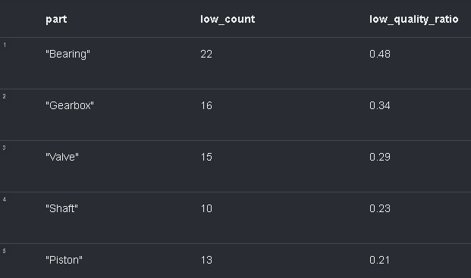

Bearing was found as the common part which was produced with the low quality among the all. Almost one in half of them was produced like that. On the other hand, piston held %0.79 with a good quality.

//Average quality score per process

MATCH (o:Operation)-[:USED]->(m:Machine)

WITH m.machine_name AS machine,

    m.process AS process,

     AVG(CASE o.quality

            WHEN 'High' THEN 3

            WHEN 'Medium' THEN 2

            ELSE 1 END) AS quality_score

RETURN

    machine,

    process,

    ROUND(quality_score, 2) AS avg_quality_score

ORDER BY avg_quality_score DESC

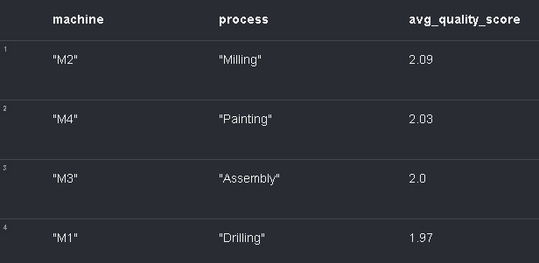

Since each process belongs to a unique machine, the average quality score can be seen seperately. 1 means the lowest, while 3 means the highest quality. All of them were cumulated around moderate quality.

//Finding the relation between oee-machine-quality

MATCH (o:Operation)-[:USED]->(m:Machine)

RETURN m.process AS process,

       m.machine_name AS machine,

       COUNT(CASE WHEN o.oee >= 0.9 THEN 1 END) AS high_oee_ops,

       COUNT(CASE WHEN o.oee >= 0.7 and o.oee < 0.9 THEN 1 END) AS medium_oee_ops,

       COUNT(CASE WHEN o.oee < 0.7 THEN 1 END) AS low_oee_ops,

       COUNT(CASE WHEN o.quality='High' THEN 1 END) AS high_quality,

       COUNT(CASE WHEN o.quality='Medium' THEN 1 END) AS medium_quality,

       COUNT(CASE WHEN o.quality='Low' THEN 1 END) AS low_quality

ORDER BY high_oee_ops DESC  
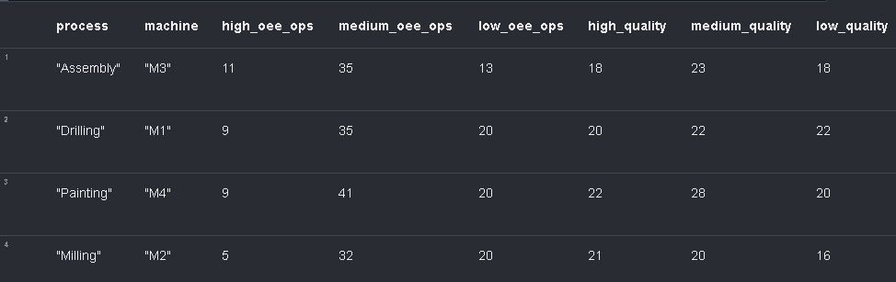

According to the result above, assembly (machine 3) had the highest amount of high OEE score (greater than 0.9), and lowest amount of low OEE score (less than 0.7). Machine 3, in other words assembly, can be the best performed process among all.

//finding the shift-part-oee-quality relation

MATCH (e:Employee)-[:PERFORMED]->(o:Operation)-[:PRODUCED]->(p:Part)

WITH o.shift as shift, p.part_name as part,  AVG(o.oee) as avg_oee,

AVG(CASE

    WHEN o.quality='High' THEN 1

    WHEN o.quality='Medium' THEN 0.5

    ELSE 0

END

) as quality_rate

WITH collect({

    shift: shift,

    part: part,

    avg_oee: ROUND(avg_oee,2),

    avg_quality: ROUND(quality_rate,2)

}) AS part_data

UNWIND part_data AS data

WITH data

RETURN data.shift as shift, data.part as part, data.avg_oee as avg_oee, data.avg_quality as avg_quality

ORDER BY part,shift



According to the shift-part-oee-quality table above, the part of shaft had the highest average OEE rate in the day shift with 59% average quality. The greatest average quality was observed for the piston in the day shift with average OEE score of 0.78.

//Which operations took significantly longer than the average for the same part - and who performed them, using which machine and in which shift?

:param threshold_factor => 1.5;

:param limit => 10;

MATCH (o:Operation)-[:PRODUCED]->(p:Part)

WITH p.part_name AS part, o

WITH part, AVG(o.duration) AS avg_duration

MATCH (e:Employee)-[:PERFORMED]->(o:Operation)-[:PRODUCED]->(p:Part {part_name: part}),

      (o)-[:USED]->(m:Machine)

WHERE o.duration > avg_duration * $threshold_factor

RETURN

  part,

  o.shift AS shift,

  o.quality AS quality,

  o.duration AS actual_duration,

  ROUND(avg_duration, 1) AS avg_duration,

  e.name AS employee,

  m.machine_name AS machine,

  m.process AS process

ORDER BY actual_duration DESC

LIMIT $limit



This table highlights operations that took significantly longer than the average duration for the same part. The longest delays occurred during Valve and Shaft productions, particularly in the Morning and Night shifts. Notably, Brittany Johnson and John Taylor are linked to multiple prolonged operations, often using Machine M2 (Milling), suggesting a potential performance or machine-related bottleneck. These patterns indicate that certain employee-machine combinations may require further investigation or support to reduce outliers and improve overall efficiency.

**SUMMARY**

In this assignment, advanced-level Cypher queries were used to extract detailed insights from a manufacturing dataset modeled in Neo4j. The analysis revealed standout performers like Christopher Davis, who consistently delivered high-quality outputs, and highlighted underperformers such as Amanda Dudley and Lisa Smith, suggesting the need for further evaluation or support. Among parts, bearings showed the highest defect rates, while pistons performed reliably with strong quality and OEE. Assembly (Machine M3) emerged as the most efficient process. Shift-wise, the Day shift proved optimal for producing parts like shafts and pistons, though overall productivity varied. Anomaly detection further identified operations that exceeded expected durations, particularly involving Valve and Shaft in Morning and Night shifts, often linked to Machine M2 and specific employees. Throughout the work, performance-optimized query structures-like single MATCH clauses and parameterized slicing-were effectively used to enhance both readability and execution speed.