

ANKARA YILDIRIM BEYAZIT UNIVERSITY

GRADUATE SCHOOL OF NATURAL AND APPLIED SCIENCES

Computer Engineering

**Healthcare and Running Application**

**by**

Mert Rıza Karadeniz (17050111054)

Aydın Başkara (19050151002)

**Supervised by**

Doç.Dr. SHAFQAT UR REHMAN

**Date**

**ABSTRACT**

*The modern urban lifestyle has many factors affecting people's health, such as insufficient physical activity, junk food, and high stress levels. This lifestyle can lead to diseases such as being overweight, obesity, stroke, cardiovascular etc. This shows that unhealthy behaviors increase the risk of disease. Therefore, they can be considered among the causes of many diseases.*

*The main purpose of this application is to guide people on how to live healthier. We want to develop an application where people can both track their pace, distance, calories burned time. Our motivation in this project is to create a super application by combining the features found in 3 different applications in one application. These applications are :*

* *Running app*
* *Time management app*
* *Calories burned app*

**Table of Contents**

LIST OF TABLES iv

LIST OF FIGURES v

1. INTRODUCTION 1

2. METHODOLOGY / SYSTEM DESIGN 1

3. RESULTS 2

References 3

# LIST OF TABLES

# LIST OF FIGURES

Figure 1 Context level diagram of the project 4

Figure 2 Example interface design of the project 5

Figure 3 Class diagram of the project 7

Figure 4 Use case diagram of the project 8

# INTRODUCTION

The modern urban lifestyle has many factors affecting people's health, such as insufficient physical activity, junk food, and high stress levels. This lifestyle can lead to diseases such as being overweight, obesity, stroke, cardiovascular etc. This shows that unhealthy behaviors increase the risk of disease. Therefore, they can be considered among the causes of many diseases.

## 1.1 Most Widely Used Apps

Many applications have been developed for people to live healthier. We reviewed 2 of the most widespread of these apps. These are Google Fit and Samsung Health.

### 1.1.1 Google Fit

Google Fit is a fitness tracking app available for Android and iOS devices. It's designed to act as a virtual coach to help you achieve a healthier and more active life.

The app also offers actionable tips to achieve daily activity and sleep goals, and you can use it to measure and track your progress. Google Fit can be used in tandem with other fitness apps and devices.

### 1.1.2 Samsung Health

Samsung Health is a health and fitness app that encourages users to set goals and stay active. Available on your Android or iOS phone, the app tracks activity data with significant health impacts helping you gain insight into your wellbeing. It is also the go-to fitness app for Samsung wearables and other devices.

It teams up plenty of tools to help you manage everything from stress and sleep to food and fitness, and organizes all of your data on an intuitive interface. It also offers a well of resources, including fitness coaches, mindfulness exercises, and a community of like-minded users.

Today, many people use smartphones and watches. People want to watch their body movements. They also want to manage time effectively. For these reasons, we want to develop such an application. In this project our aim is merging healthcare and management in one app since the user can track his healthcare, see his activities, and create new goals to achieve them.

## 1.2 What did we use in this project

Built by Google and Apple respectively, GoogleFit and HealthKit APIs are the easiest way to develop health care apps. These APIs contain all that is necessary to build. Here are we used in this project:

* MVVM Architecture
* Navigation Components
* Room Database with Coroutines
* Dependency Injection with Dagger

### 1.2.1 Application features

#### Movement tracking

The application will instantly calculate the user's steps, the speed and direction of the movement.

#### Calorie expenditure

The application will calculate how many calories the user has burned from the data entered by the user. All it takes is an algorithm and already existing data.

#### User profile

The user will store information about their age, gender and favorite activities in their profile.

#### Time Management

Success is a great incentive to work harder, and exercises have proven to be more effective when they're committed to a measurable goal. The application will help the user how to better manage his time.

# METHODOLOGY / SYSTEM DESIGN

## 2.1 Software Details

We will use Agile scrum software development method while developing this project. We are going to create a scrum team. This team will consist of one [Product Owner](https://www.scrum.org/resources/what-is-a-product-owner) and [Developers](https://www.scrum.org/resources/what-is-a-scrum-developer).

Healthcare and Running Application is a platform that brings a new perspective to today's running apps. It is an innovative and versatile production. Activity diagram of the project can be found in Figure 1.

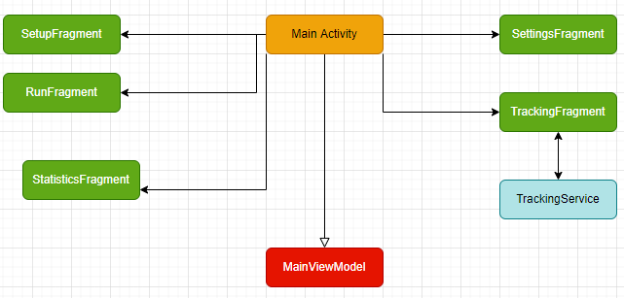

The following is example interface design of healthcare application:

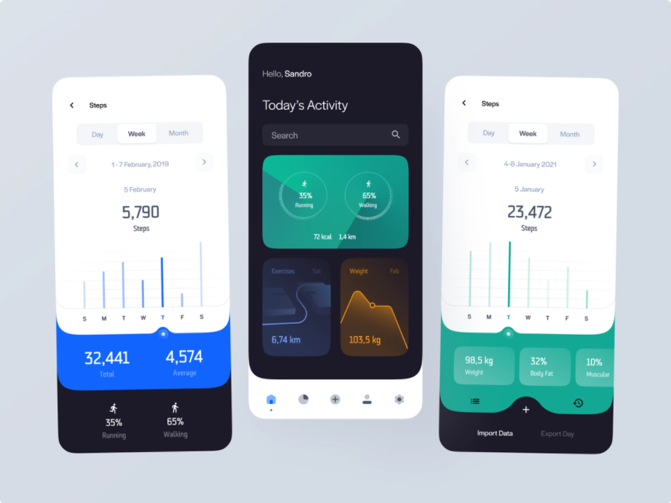

## 2.2 Implementation Details

This section includes a model of the system and the requirements that specify all the fundamental actions of the health care application.

The following list shows the high level requirements of the application:

* When the application starts for the first time, it should ask user gender, age etc. from the user.
* The application should list all the available data sources for live data capture using the Sensors API.
* After the application edits the information from the sensor and transfers it to data classes, the necessary data will be kept both in local and firebase.
* The data will be displayed in graphs in accordance with the design.
* After the user enters their information on the splash screen, they will be able to edit them on the profile side.
* The user will be able to learn the goals that she/he has to do on a daily basis according to the data she entered.
* The user will be informed with regular reminder notifications in line with the goals she/he has set.
* She/he will be able to calculate the nutritional values that she/he spends and needs to take on a daily basis.
* Necessary calculations can be made according to the body mass index.
* The user will be able to see the sleep intervals, efficiency and all the information about sleep in graphs.
* At the start of the application, there will be a splash screen that shows the application's logo and receives the necessary data from the sensor at that time.
* The user will be able to see the number of steps taken, the calories burned and the amount of water consumed daily.

The following is the class diagram of healthcare application, along with the high level functionality of classes:

The following is the use case diagram of healthcare application:

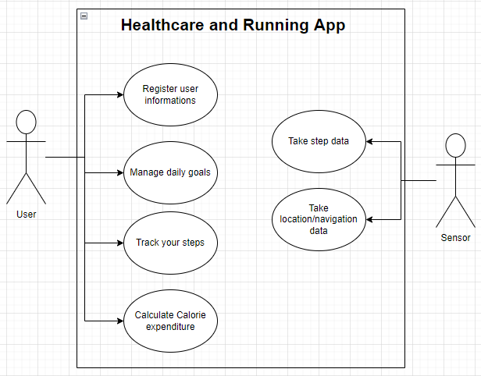

The structures we used in this project:

* MVVM Architecture
* Navigation Components
* Room Database with Coroutines
* Dependency Injection with Dagger

Libraries we used in this project:

* Navigation library
* Room library
* Retrofit
* Hilt
* Coroutines
* Timber
* GoogleFit API
* Google map location, maps, places,

# RESULTS

*The modern urban lifestyle has many factors affecting people's health, such as insufficient physical activity, junk food, and high stress levels. This lifestyle can lead to diseases such as being overweight, obesity, stroke, cardiovascular etc. This shows that unhealthy behaviors increase the risk of disease. Therefore, they can be considered among the causes of many diseases. In this project a mobile application for helping people live healthier is presented.*

*The main purpose of this application is to guide people on how to live healthier. We want to develop an application where people can both monitor their health information and manage their time, goals and movement. By Monitoring user data over time, this application gives feedback on the effectiveness of the activity and therefore can provide positive stimuli to motivate users.*

*A preliminary test phase has demonstrated the validity of the presented app, in terms of its usability and facility of use.*

**REFERENCES**

| [1] | Manolo Forastiere , Giuseppe De Pietro, Giovanna Sannino, An mHealth application for a personalized monitoring of one’s own wellness: design and development, 2016. |
| --- | --- |
| [2] | Chalimov, A. (2010, July 25)., from https://easternpeak.com |
|  |  |
|  |  |
|  |  |
|  |  |
|  |  |
|  |  |
|  |  |
|  |  |
|  |  |
|  |  |