Software Requirements Specification
(SRS)

Project Name | HEALTH AI Co-Creation & Innovation Platform
Course | SENG 384
Group No / Name | Massacrew
Group Members | Mert Tömekçe – 202328402, İlayda Gündüz – 2022228021
Submission Date | 07/05/2026
Version | 3.0
Revision History
Date | Version | Change Description | Author
16/04/2026 | 1.0 | Initial version | Mert Tömekçe, İlayda Gündüz
27/04/2026 | 2.0 | Updated version | İlayda Gündüz
07/05/2026 | 3.0 | Final Version | İlayda Gündüz

Table of Contents
Table of Contents 2
1. Introduction 3
1.1 Purpose 3
1.2 Scope 3
1.3 Definitions and Abbreviations 3
1.4 Intended Audience 3
2. Overall Description 3
2.1 Product Perspective 3
2.2 User Roles 3
2.3 Assumptions and Dependencies 4
2.4 Constraints 4
3. Functional Requirements 4
3.1 User Registration & Access Control 4
3.2 Post Management 4
3.3 Search & Matching 5
3.4 Meeting Request Workflow 5
3.5 Administrative Dashboard 5
3.6 Activity Logging & Audit Trail 6
4. Non-Functional Requirements 6
5. Use Cases 7
5.1 UC-01: User Registration & Verification 7
5.2 UC-02: Create an Announcement 7
5.3 UC-03: Request Meeting & Accept NDA 8
5.4 UC-04: Negotiate Time Slots 8
5.5 UC-05: User Marks Partner Found 8
5.6 UC-06: User Searches and Filters Posts 9
5.7 UC-07: Project Owner Reviews Expressions of Interest 9
5.8 UC-08: Applicant Tracks Request Status and Notifications 9
5.9 UC-09: Enforce Platform Integrity 10
5.10 UC-010: Monitor Audit Logs 10
6. Data Model 10
7. Interface Requirements 11
7.1 User Interface (UI) 11
7.2 External System Interfaces 12
8. Requirements Traceability Matrix 12
9. Appendices 14

1. Introduction

1.1 Purpose
The purpose of this document is to specify the software requirements for the HEALTH AI Co-Creation & Innovation Platform. This SRS defines the functional and non-functional requirements, use cases, and constraints for the development team, ensuring the delivery of a secure, GDPR-compliant web platform designed to facilitate interdisciplinary collaboration.

1.2 Scope
The HEALTH AI platform enables structured partner discovery between healthcare professionals and engineers. It provides a secure matchmaking infrastructure, a structured announcement board, and a meeting initiation facilitator. The system strictly does not function as a document repository, medical data system, project management suite, or file-sharing service. It does not support financial transactions, contract management, or the provision of medical advice.

1.3 Definitions and Abbreviations
- SRS: Software Requirements Specification.
- RBAC: Role-Based Access Control.
- GDPR: General Data Protection Regulation; European Union privacy law.
- NDA: Non-Disclosure Agreement; a confidentiality agreement required before requesting a meeting.
- WCAG 2.1: Web Content Accessibility Guidelines, ensuring the platform is usable by people with disabilities.
- IP: Intellectual Property.

1.4 Intended Audience
This document is intended for the software development team, the course instructor(s), and the evaluation committee for the Erasmus+ HEALTH-AI Project end-of-semester competition.

2. Overall Description

2.1 Product Perspective
Currently, multidisciplinary innovation in healthcare technology relies heavily on coincidence or personal networks, which is an inefficient model that slows down innovation. Engineers need clinical domain knowledge and validation pathways , while healthcare professionals generate compelling ideas but lack engineering competence. The HEALTH AI platform addresses this gap by eliminating randomness and providing rapid, structured access to complementary expertise.

2.2 User Roles
Role | Description | Key Permissions
Engineer | Technical professional seeking medical expertise. | Create posts, browse medical posts, suggest/accept meeting times, mark partner found.
Healthcare Professional | Medical domain expert seeking technical implementation. | Create posts, browse engineering posts, send meeting requests (with NDA), mark partner found.
Admin | System manager responsible for platform integrity. | Access dashboard, view/remove posts, view/suspend users, view tamper-resistant audit logs.

2.3 Assumptions and Dependencies
- It is assumed that legitimate users possess an institutional .edu email address for registration.
- The platform depends on external video conferencing tools (e.g., Zoom, Teams); meetings occur externally, and no meeting recordings are stored on the platform.
- The platform relies on a secure PostgreSQL database(Supabase) and SMTP services for transactional emails(e.g., email verification, notifications).

2.4 Constraints
- The system intentionally avoids storing confidential technical material, intellectual property files, or patient data.
- The platform facilitates first contact only; subsequent collaboration occurs off-platform.
- Registration using personal email providers (e.g., Gmail, Outlook) is strictly prohibited.

3. Functional Requirements

3.1 User Registration & Access Control
ID | Requirement Description | Priority | Source
FR-01 | The system shall only allow registration with institutional .edu email addresses. | High | Brief 4.1
FR-02 | The system shall implement an email verification mechanism. | High | Brief 4.1
FR-03 | The user shall be able to select a role during registration (Engineer / Healthcare Professional / Admin). | High | Brief 4.1
FR-04 | The platform shall enforce strict Role-Based Access Control (RBAC) across all modules. | High | Brief 4.1

3.2 Post Management
ID | Requirement Description | Priority | Source
FR-10 | Users shall be able to create a structured post including title, working domain, explanation, expertise needed, and project stage. | High | Brief 4.2
FR-11 | Users shall specify a confidentiality level for posts: "Public short pitch" or "Details discussed in meeting only". | High | Brief 4.2
FR-12 | The system shall support the following post lifecycle states: Draft, Active, Meeting Scheduled, Partner Found (Closed), and Expired . | High | Brief 4.2
FR-13 | The system shall strictly prevent the upload of technical documentation, patient data, and file repository functionality. | High | Brief 4.2
FR-14 | Posts must include location data (Country, City) and an expiry date with an auto-close option. | High | Brief 4.2
FR-15 | Users must be able to edit posts, mark them as "Partner Found", archive, or allow expiry. | High | Brief 4.2

3.3 Search & Matching
ID | Requirement Description | Priority | Source
FR-20 | The system shall allow users to filter posts by domain, required expertise, city, country, project stage, and status . | High | Brief 4.3
FR-21 | The system shall highlight city-based matches and provide a match explanation based on shared expertise tags. | Medium | Brief 4.3
FR-22 | The system shall provide match explanations based on shared expertise tags. | Medium | Brief 4.3

3.4 Meeting Request Workflow
ID | Requirement Description | Priority | Source
FR-30 | Users shall be able to send a meeting request that includes the mandatory acceptance of an NDA. | High | Brief 4.4
FR-31 | The workflow shall allow users to propose time slots, and accept, decline, or cancel requests. | High | Brief 4.4
FR-32 | The platform shall facilitate scheduling only; meetings occur externally and no meeting recordings shall be stored on the platform. | High | Brief 4.4

3.5 Administrative Dashboard
ID | Requirement Description | Priority | Source
FR-40 | The Admin Dashboard shall be accessible only via Role-Based Access Control. | High | Brief 4.5
FR-41 | Admins shall be able to view, filter (by city, domain, status), and remove inappropriate posts. | High | Brief 4.5
FR-42 | Admins shall be able to view all registered users, filter by role, and suspend/deactivate accounts. | High | Brief 4.5

3.6 Activity Logging & Audit Trail
ID | Requirement Description | Priority | Source
FR-50 | The system shall log login/logout events, failed login attempts, post changes, meeting requests, and security events . | High | Brief 4.6
FR-51 | Log data fields must include timestamp, user ID, role, action type, target entity, and result status, strictly excluding patient data . | High | Brief 4.6
FR-52 | Logs must be tamper-resistant, accessible only by admins, and retained for a defined period of 24 months. | High | Brief 4.6
FR-53 | The logging system must adhere to data minimization principles and guarantee that no patient data is present in logs. | High | Brief 4.6
FR-54 | The Admin Log Dashboard must support log filtering, CSV export, and anomaly pattern detection . | Medium | Brief 4.6

4. Non-Functional Requirements
ID | Requirement | Metric / Target | Category
NFR-01 | Search results shall be returned within a specified time. | < 1.5 seconds | Performance
NFR-02 | Page load time shall be limited. | < 3 seconds | Performance
NFR-03 | The platform shall reliably support concurrent traffic. | 1000 concurrent users | Performance
NFR-04 | Core workflows must be highly efficient: posting an announcement must take minimal time. | < 3 minutes | Usability
NFR-05 | Sending a meeting request must be a rapid process. | < 30 seconds | Usability
NFR-06 | The platform purpose must be immediately understandable to new users. | Within 20 seconds | Usability
NFR-07 | The system shall enforce secure communications and data storage. | HTTPS mandatory, Encrypted password storage | Security
NFR-08 | The system shall protect against automated attacks and unauthorized persistence. | Rate limiting, Anti-bot protection, Auto session timeout | Security
NFR-09 | The system shall adhere strictly to European privacy standards, including data minimization and the right to delete/export data. | GDPR Compliant | Privacy
NFR-10 | The user interface must be accessible to users with disabilities. | WCAG 2.1 compliance | Accessibility
NFR-11 | The UI shall feature plain language, clear status indicators, and tooltips for IP/NDA terms . | User Testing Validation | Usability

5. Use Cases

5.1 UC-01: User Registration & Verification
Name | UC-01: User Registration & Role Assignment
Actor(s) | Unregistered User (Engineer or Healthcare Professional)
Precondition | The user has access to a valid institutional .edu email address.
Main Flow | 1. The user navigates to the registration page. 2. The user enters their institutional .edu email and creates a password. 3. The user selects their role: Engineer or Healthcare Professional. 4. The system validates that the email does not belong to a personal provider (e.g., Gmail). 5. The system sends an automated verification link to the email. 6. The user clicks the link, and the system activates the account with the correct Role-Based Access Control (RBAC) privileges.
Postcondition | A verified account is created, and an audit log of the registration is generated .
Alternative Flow | 4a. If a personal email is detected, the system explicitly blocks the registration and displays an error message.

5.2 UC-02: Create an Announcement
Name | UC-02: Create an Announcement
Actor(s) | Platform User (Engineer & Healthcare Professional)
Precondition | The user is authenticated and active on the platform.
Main Flow | 1. The user clicks the “Post a New Need” or “Create Announcement” button. 2. The user fills in the structured form detailing the project, domain, and required expertise. 3. The user selects the desired confidentiality level (e.g., Public Pitch vs. Details in Meeting). 4. The user clicks "Publish". 5. The system saves the post and updates its status to ACTIVE.
Postcondition | The structured announcement is visible on the Co-Creation board to other matching users.
Alternative Flow | 2a. If required fields are omitted, the system prompts the user to complete them before publishing.

5.3 UC-03: Request Meeting & Accept NDA
Name | UC-03: Request Meeting & Accept NDA
Actor(s) | Platform User (Applicant)
Precondition | The user is logged in and viewing an ACTIVE announcement created by another user.
Main Flow | 1. The user clicks the button to express interest in the announcement. 2. The user drafts a short interest message explaining their expertise. 3. The system presents the mandatory Non-Disclosure Agreement (NDA) interface. 4. The user digitally accepts the NDA. 5. The system creates a pending Meeting Request and notifies the Announcement Owner.
Postcondition | A meeting request is sent, and the NDA acceptance is recorded with a timestamp.
Alternative Flow | 4a. If the user declines the NDA, the application is aborted, and no request is sent.

5.4 UC-04: Negotiate Time Slots
Name | UC-04: Negotiate Time Slots
Actor(s) | Platform User (Announcement Owner & Applicant)
Precondition | A Meeting Request has been accepted by the Announcement Owner.
Main Flow | 1. One party proposes a set of available calendar time slots for an external meeting. 2. The system notifies the other party of the proposed slots. 3. The receiving party reviews the proposed times. 4. The receiving party selects a mutually agreeable time slot. 5. The system confirms the meeting time, updates the slot status to SELECTED, and notifies both users.
Postcondition | Both parties have an agreed-upon time to meet via an external conferencing tool.
Alternative Flow | 4a. If none of the proposed slots work, the receiving party rejects them and proposes a new set of times (Counter-proposal round).

5.5 UC-05: User Marks Partner Found
Name | UC-05: User Marks Post as "Partner Found"
Actor(s) | Engineer, Healthcare Professional
Precondition | The user is logged in, has an "Active" or "Meeting Scheduled" post, and has successfully formed a collaboration.
Main Flow | 1. The user navigates to their "My Announcements" dashboard. 2. The user selects the relevant project. 3. The user clicks the "Mark Partner Found" button. 4. The system updates the announcement status to PARTNER_FOUND. 5. The system logs the successful match and removes the post from active public search.
Postcondition | The post is closed, removed from active search results, and the successful match is recorded.
Alternative Flow | 3a. If the collaboration failed or the project is cancelled, the user clicks "Archive/Allow Expiry" instead, changing the status to "Expired".

5.6 UC-06: User Searches and Filters Posts
Name | UC-06: User Searches and Filters Announcements
Actor(s) | Engineer, Healthcare Professional
Precondition | The user is logged in and actively looking for a project partner.
Main Flow | 1. The user navigates to the Search & Matching dashboard. 2. The user applies specific filters (Domain, Required expertise, City, Project stage). 3. The system processes the query and returns matching posts in under 1.5 seconds. 4. The system visually highlights city-based matches and displays match explanations based on shared tags.
Postcondition | The user is presented with a curated list of relevant posts to initiate contact.
Alternative Flow | 3a. If no active posts match the selected filters, the system displays a "No matches found" message and prompts the user to clear or broaden their filters.

5.7 UC-07: Project Owner Reviews Expressions of Interest
Name | UC-07: Project Owner Reviews Expressions of Interest
Actor(s) | Engineer, Healthcare Professional (Project Owner)
Precondition | The user has an "Active" post and has received at least one expression of interest from a potential collaborator.
Main Flow | 1. The user navigates to the "My Announcements" tab from the sidebar. 2. The user selects the active project (e.g., "AI-assisted ECG interpretation..."). 3. The system displays the list, showing the applicant's profile (name, role, skills) and message. 4. The user clicks the "Accept & Schedule" button for a suitable candidate. 5. The system transitions the request status and triggers a notification to the applicant.
Postcondition | The application is accepted, and the platform moves the users to the meeting scheduling and NDA acceptance workflow.
Alternative Flow | 4a. If the user finds the candidate unsuitable, they click "Decline". The request is rejected, and the applicant's status is updated accordingly.

5.8 UC-08: Applicant Tracks Request Status and Notifications
Name | UC-08: Applicant Tracks Request Status and Notifications
Actor(s) | Engineer, Healthcare Professional (Applicant)
Precondition | The user has successfully applied to an announcement.
Main Flow | 1. The user clicks the notification bell icon to view unread alerts. 2. The system displays an "Application Accepted" notification. 3. The user navigates to the "My Requests" tab via the sidebar. 4. The system displays the list of applied projects and their current lifecycle statuses (e.g., "Accepted - Negotiation Ready").
Postcondition | The user is informed of their application status and is ready to propose meeting times.
Alternative Flow | 2a. If there are no new updates, the notification panel displays "No new notifications".

5.9 UC-09: Enforce Platform Integrity
Name | UC-08: Enforce Platform Integrity
Actor(s) | Admin
Precondition | The user is authenticated with Admin privileges.
Main Flow | 1. The admin accesses the Admin Dashboard. 2. The admin reviews active announcements or flagged user profiles. 3. The admin identifies an announcement containing prohibited medical/patient data, or a malicious account. 4. The admin executes a removal or suspension action. 5. The system removes the inappropriate content or sets the user's account to suspended.
Postcondition | The violating content is removed, the platform's compliance is maintained, and the action is recorded.
Alternative Flow | N/A

5.10 UC-010: Monitor Audit Logs
Name | UC-08: Monitor Audit Logs
Actor(s) | Admin
Precondition | The user is authenticated with Admin privileges.
Main Flow | 1. The admin navigates to the Audit Logs section. 2. The system displays a chronological list of tamper-resistant system events. 3. The admin filters the logs to track specific actions (e.g., failed login attempts, status changes, admin actions). 4. The admin reviews the timestamped data and result statuses to ensure platform security.
Postcondition | The admin successfully audits system activity without accessing prohibited user communications or patient data.
Alternative Flow | N/A

6. Data Model
Entity | Key Fields | Relationships
User | id (PK), email (Unique), emailVerified, role (ENGINEER, HEALTHCARE_PROFESSIONAL, ADMIN), name, institution, city, country, bio, expertise (String Array), isActive, isSuspended, createdAt, updatedAt, deletedAt (Soft delete). | 1-to-Many with Announcement  1-to-Many with MeetingRequest (Sent/Received)  1-to-Many with Notification  1-to-Many with AuditLog
Announcement | id (PK), authorId (FK), title, domain, explanation, expertiseNeeded, projectStage, commitmentLevel, collaborationType, confidentiality, publicPitch, city, country, status (Draft to Archived), expiresAt, autoClose, createdAt, updatedAt, closedAt. | Many-to-1 with User (Author)  1-to-Many with MeetingRequest
MeetingRequest | id (PK), announcementId (FK), requesterId (FK), recipientId (FK), message, ndaAccepted, ndaAcceptedAt, status (Pending to Completed), agreedSlot, createdAt, updatedAt. | Many-to-1 with Announcement  Many-to-1 with User (Requester/Recipient)  1-to-Many with TimeSlot
TimeSlot | id (PK), meetingRequestId (FK), proposedBy (User ID), startTime, endTime, status (Pending, Selected, Rejected, Expired), round (Negotiation round). | Many-to-1 with MeetingRequest
Notification | id (PK), userId (FK), type (e.g., MEETING_REQUEST, SLOT_SELECTED), title, body, linkUrl, isRead (Boolean), createdAt. | Many-to-1 with User
AuditLog | id (PK), userId (FK - Nullable), role, actionType (e.g., LOGIN, POST_CREATED), targetEntity, result, ipAddress (Nullable), metadata (JSON), createdAt (Append-only). | Many-to-1 with User
PlatformSettings | id (PK), maintenanceMode, allowedDomains, sessionTimeout, postExpiry, requireNDA, emailNotifications, updatedAt. | None (Global Configuration)

7. Interface Requirements

7.1 User Interface (UI)
The platform features a modern, accessible interface with a persistent sidebar navigation system. The main screens include:
- Registration & Login Page: A clean entry point emphasizing the ".edu email" requirement for platform access, alongside the platform's value proposition.

- Main Dashboard: A personalized greeting screen (e.g., "Good morning") that provides a quick overview of user metrics (Active Applications, Pending Meetings, Unread Notifications), a feed of the "Newest Opportunities", and "Quick Actions" for rapid navigation.

- Co-Creation Board (Announcement Board): A searchable interface where users can browse posts. It includes filter pills (e.g., All Domains, Cardiology, Neurology) and displays project cards summarizing the domain, stage, and commitment level.

- My Announcements (Manage Projects): A dedicated interface for users to track their active posts. It displays "Expressions of Interest" from other users, showing their profile details and messages, with actionable buttons to "Accept & Schedule" or "Decline".

- My Requests: A tracking page for applicants to monitor the lifecycle status of their outgoing project applications (e.g., showing "Accepted - Negotiation Ready").

- Profile Settings: A form-based page for managing personal details, including Full Name, Institution/Company, and Country.

- Notifications Panel: A slide-out or dropdown interface displaying timestamped system alerts, such as application acceptances or meeting updates.

- Admin Panels: Groups of interfaces which admin can suspend users, audit logs, remove inappropriate content.

- Collaboration Chat: A dedicated communication interface for real time messaging between collaborators. It features a dual-pane layout with a list of active threads and a primary chat window that integrates conversation history, project context, and meeting scheduling status.

7.2 External System Interfaces
- SMTP/Email Service: Required to send automated email verification links to .edu addresses during registration.
- Database: Secure connection to a PostgreSQL instance (via Supabase).
- External Conferencing Platforms: The platform does not host meetings. Users rely on Zoom, MS Teams, or Google Meet links shared securely during the agreed meeting workflow.

8. Requirements Traceability Matrix
Req. ID | Requirement Summary | Source (Brief) | Related Use Case
FR-01 | .edu email restriction | Brief 4.1 | UC-01
FR-02 | Mandatory email verification | Brief 4.1 | UC-01
FR-03 | Role selection during registration | Brief 4.1 | UC-01
FR-04 | Enforced Role-Based Access Control (RBAC) | Brief 4.1 | UC-01, UC-09, UC-10
FR-10 | Creation of structured posts (Domain, stage, commitment, expertise) | Brief 4.2 | UC-02
FR-11 | Confidentiality level selection (Public vs. Meeting Only) | Brief 4.2 | UC-02
FR-12 | Management of specific Post Lifecycle States (Draft to Expired) | Brief 4.2 | UC-02, UC-05
FR-13 | Absolute block on patient data and technical document uploads | Brief 4.2 | UC-02, UC-09
FR-14 | Include location data and expiry date | Brief 4.2 | UC-02
FR-15 | Edit, mark "Partner Found", archive posts | Brief 4.2 | UC-05
FR-20 | Advanced filtering capabilities and city-based match highlighting | Brief 4.3 | UC-06
FR-21 | Highlight city-based matches | Brief 4.3 | UC-06
FR-22 | Provide match explanations (shared tags) | Brief 4.3 | UC-06
FR-30 | Mandatory NDA acceptance prior to finalizing meeting request | Brief 4.4 | UC-03
FR-31 | Propose time slots, accept/decline/cancel | Brief 4.4 | UC-04
FR-32 | Facilitate scheduling only (no external recordings stored) | Brief 4.4 | UC-04
FR-40 | Admin Dashboard restricted via RBAC | Brief 4.5 | UC-09, UC-10
FR-41 | Admin filter and remove inappropriate posts | Brief 4.5 | UC-09
FR-42 | Admin view, suspend/deactivate user accounts | Brief 4.5 | UC-09
FR-50 | Log logins, post changes, meetings, security events | Brief 4.6 | UC-01, UC-02, UC-03, UC-04, UC-05, UC-07, UC-09
FR-51 | Log fields explicitly exclude patient data | Brief 4.6 | UC-02, UC-09
FR-52 | Tamper-resistant logs retained for 24 months | Brief 4.6 | UC-10
FR-53 | Adhere to data minimization in logging | Brief 4.6 | UC-01, UC-02, UC-03, UC-09, UC-10
FR-54 | Admin Log Dashboard (filtering, CSV export) | Brief 4.6 | UC-10
NFR-01 | Search results < 1.5 seconds | Brief 5.3 | UC-06
NFR-02 | Page load time < 3 seconds | Brief 5.3 | All UCs
NFR-03 | Support 1000 concurrent users | Brief 5.3 | All UCs
NFR-04 | Post announcement < 3 minutes | Brief 5.4 | UC-02
NFR-05 | Sending meeting request < 30 seconds | Brief 5.4 | UC-03
NFR-06 | Platform purpose understandable within 20 seconds | Brief 5.4 | UC-01, UC-06
NFR-07 | HTTPS mandatory, Encrypted passwords | Brief 5.2 | All UCs
NFR-08 | Rate limiting, Anti-bot, Auto session timeout | Brief 5.2 | All UCs
NFR-09 | GDPR Compliant (data minimization, export) | Brief 5.1 | UC-01, UC-09, UC-10
NFR-10 | WCAG 2.1 compliance | Brief 5.4 | All UCs
NFR-11 | Plain language, tooltips for IP/NDA | Brief 5.4 | UC-02, UC-03

9. Appendices
• Use Case Diagram

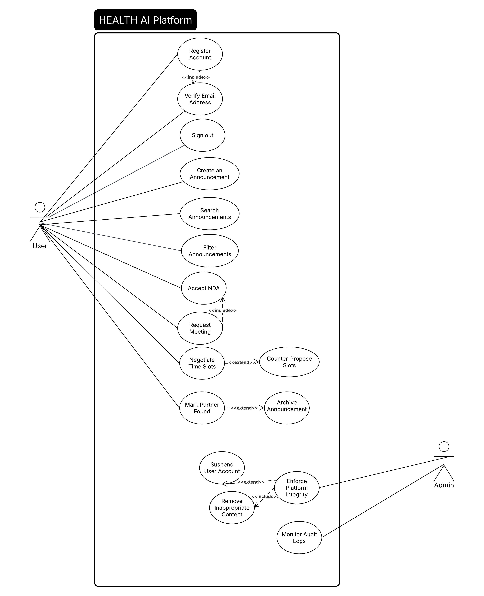

• Wireframe / Mockup images
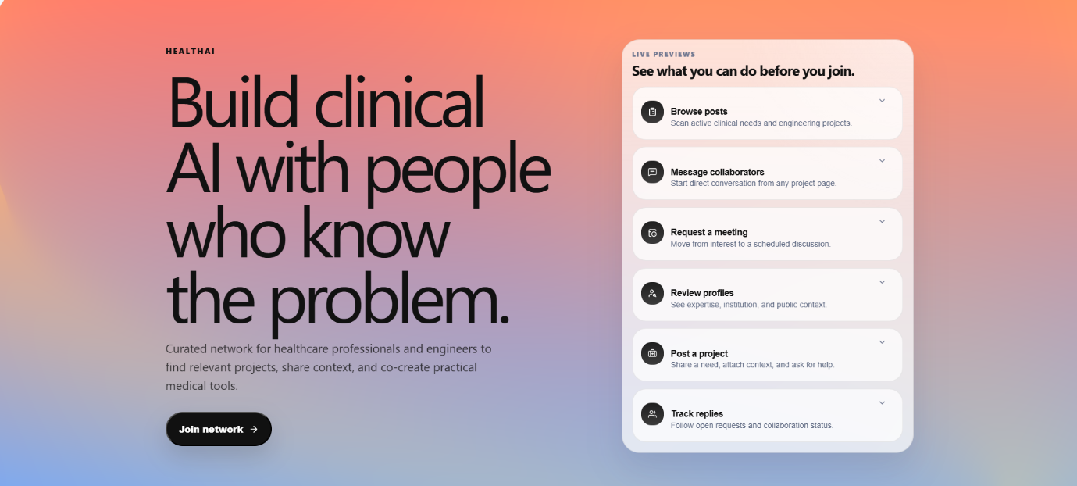
Figure 1

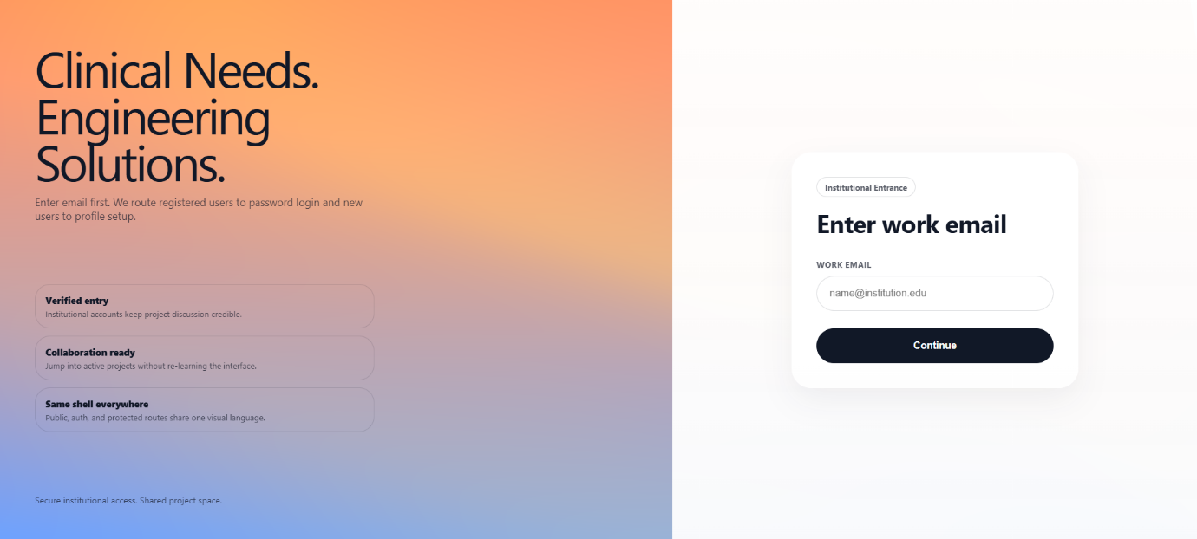
Figure 2

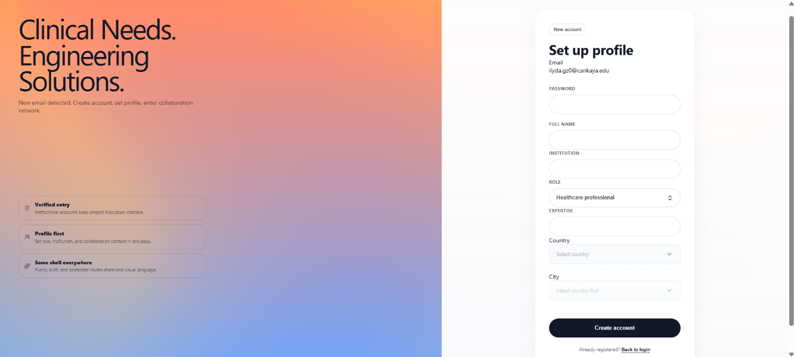
Figure 3

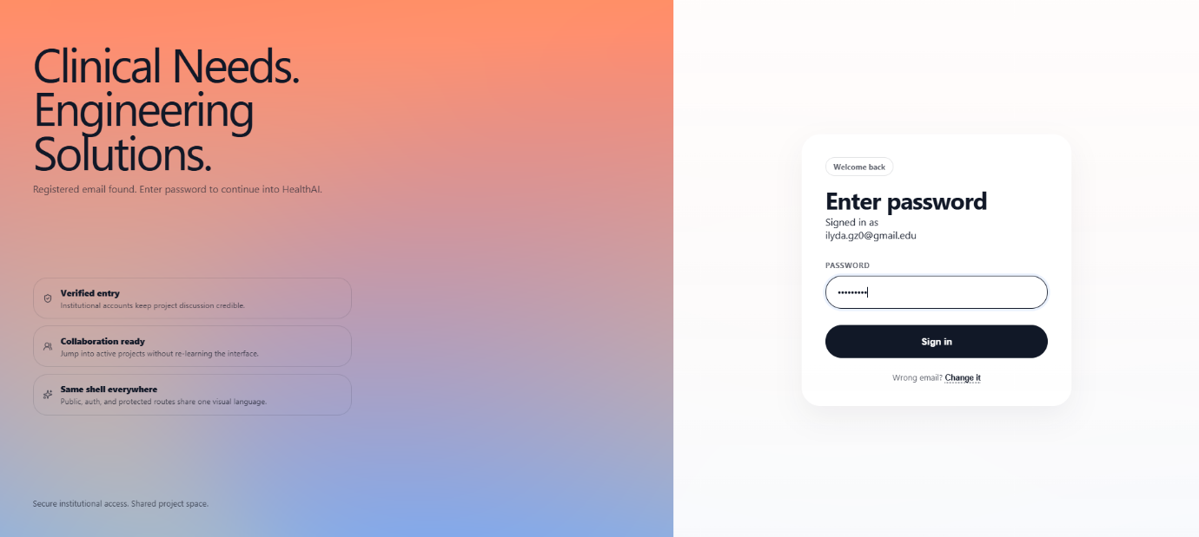
Figure 4

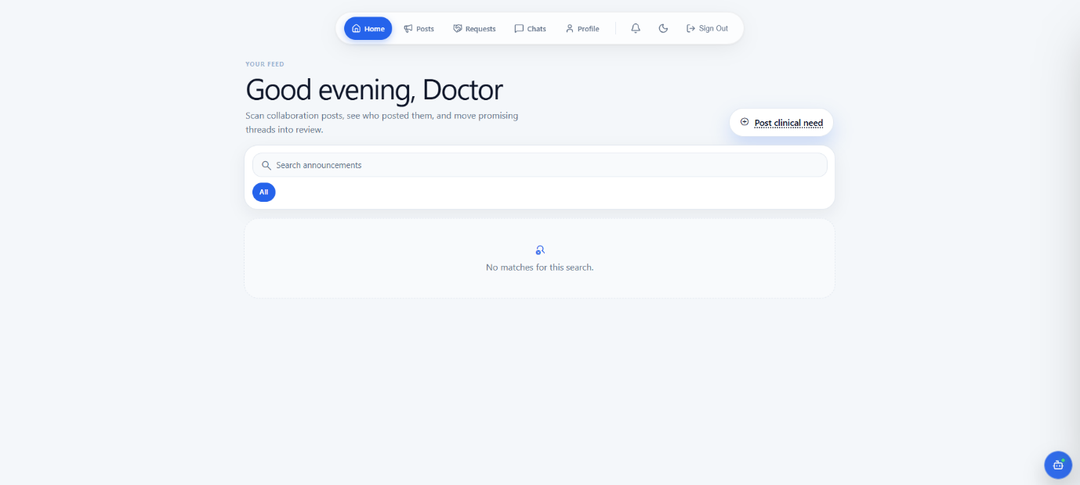
Figure 5

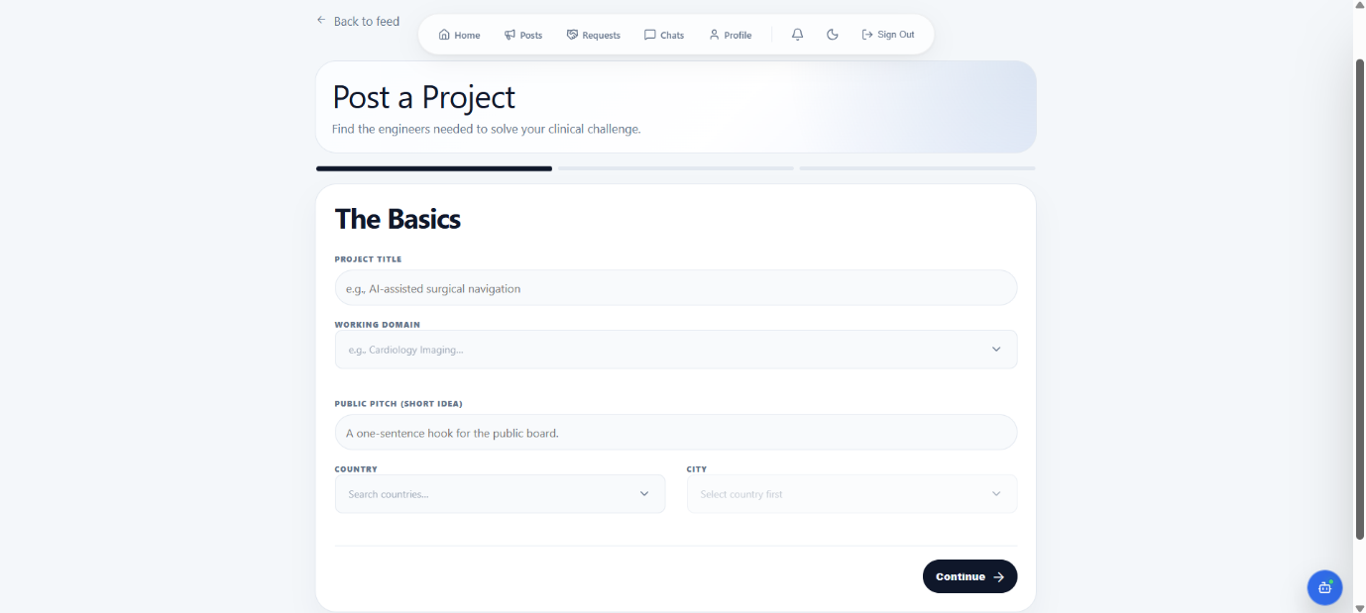
Figure 6

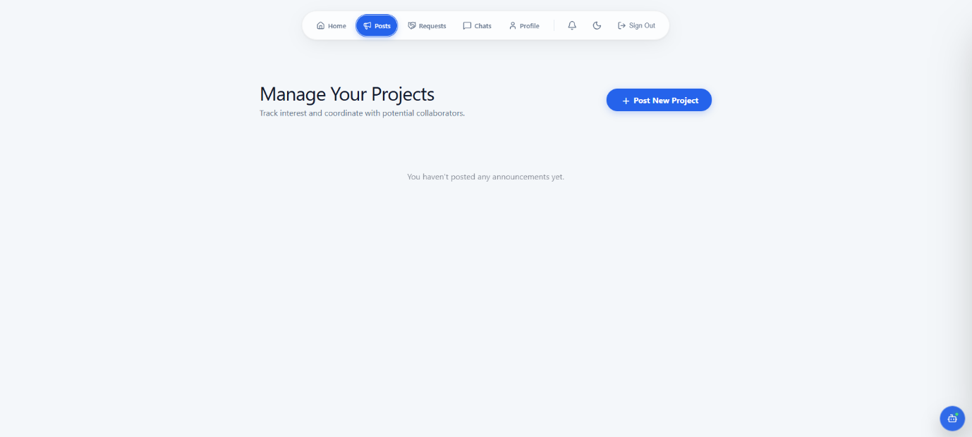
Figure 7

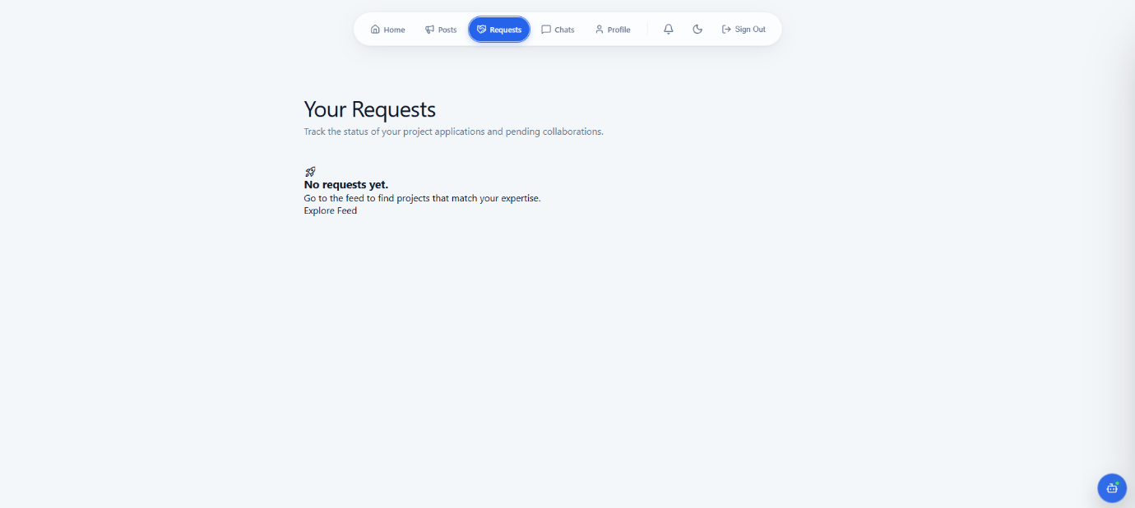
Figure 8

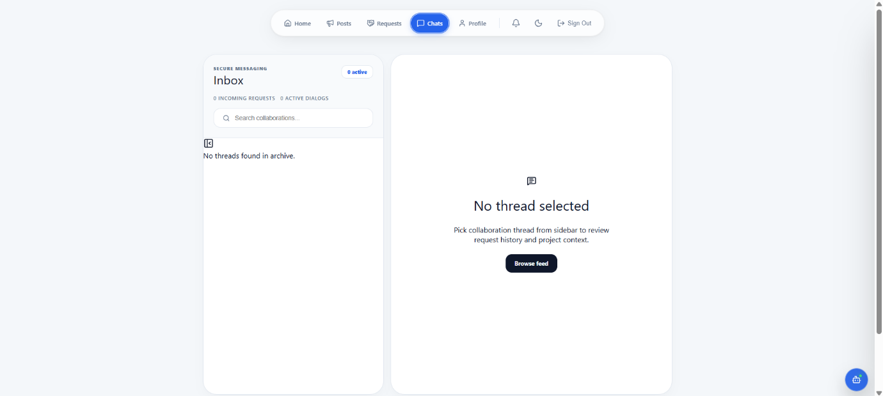
Figure 9

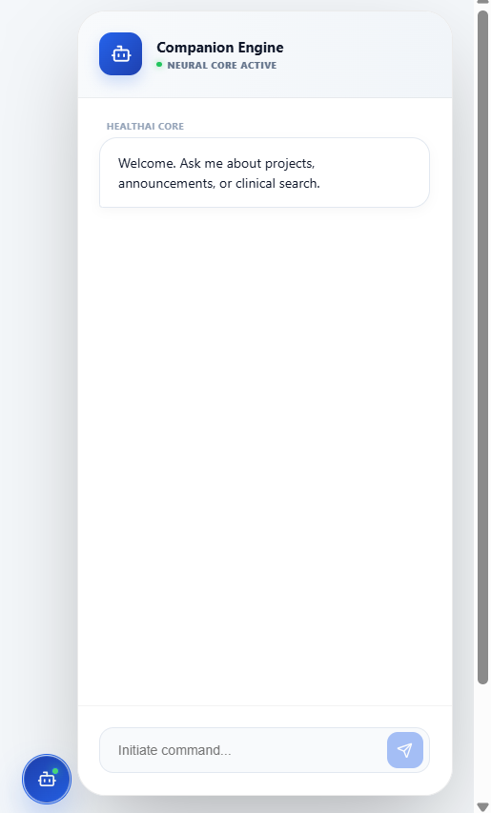
Figure 10

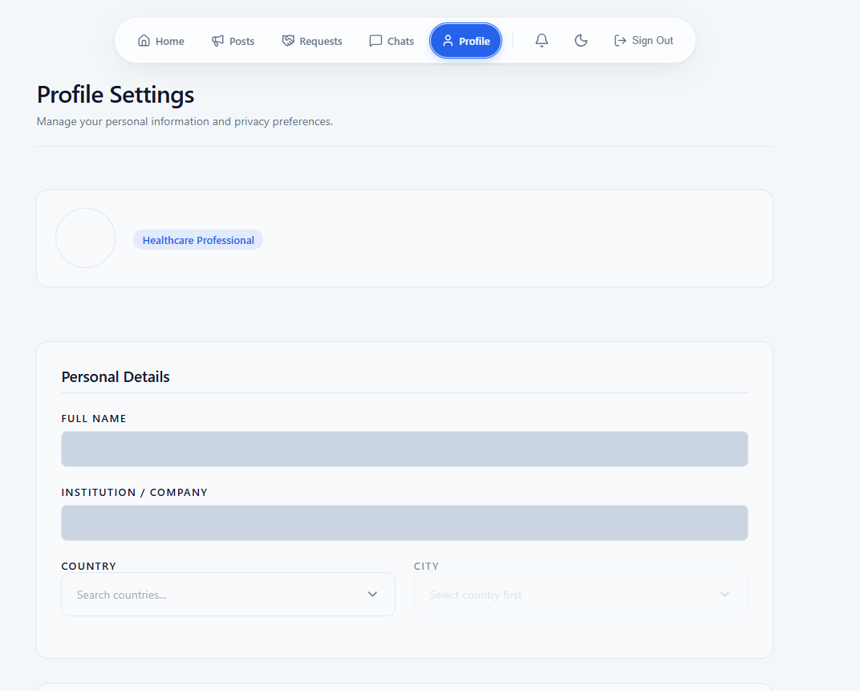
Figure 11

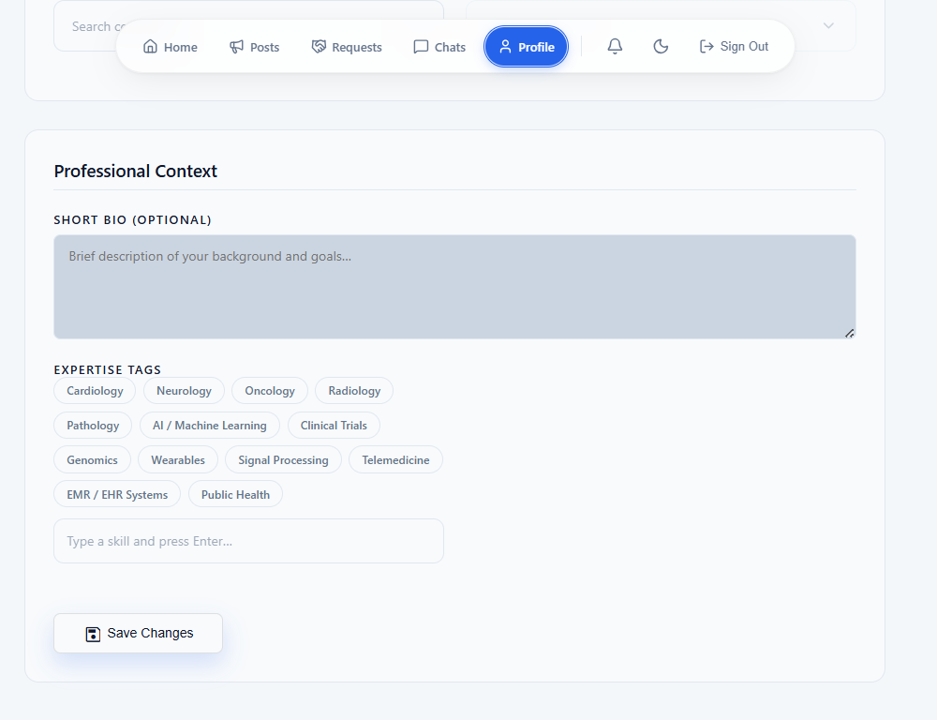
Figure 12
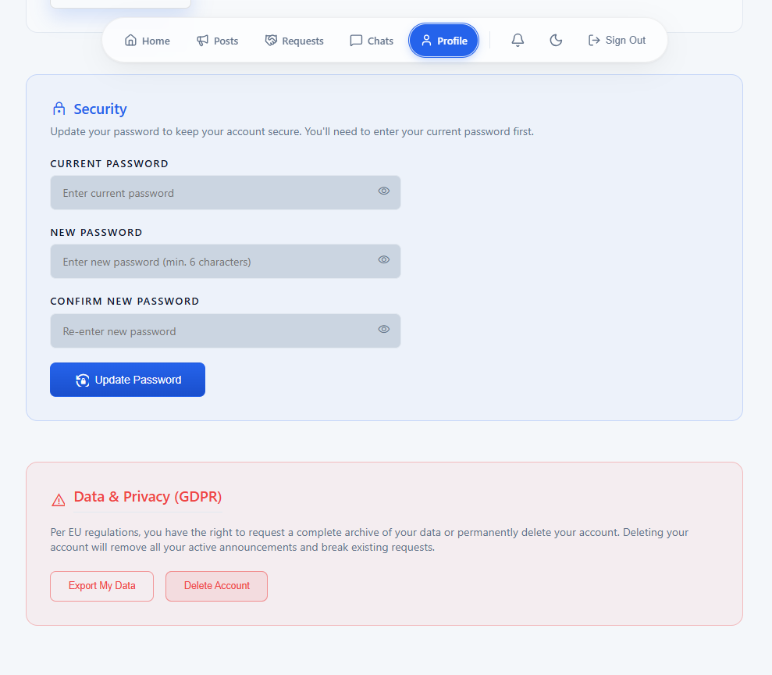
Figure 13

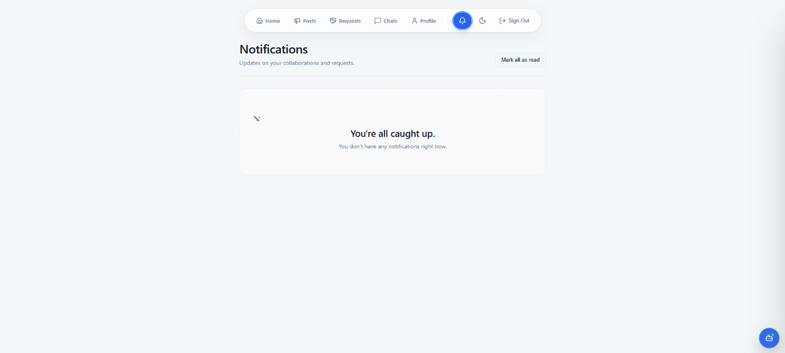
Figure 14

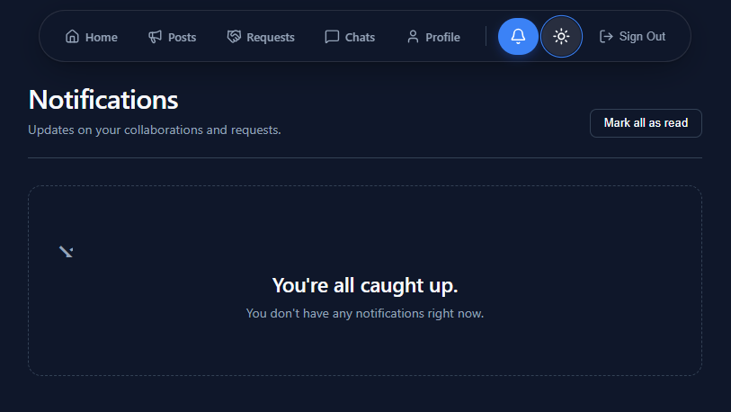
Figure 15

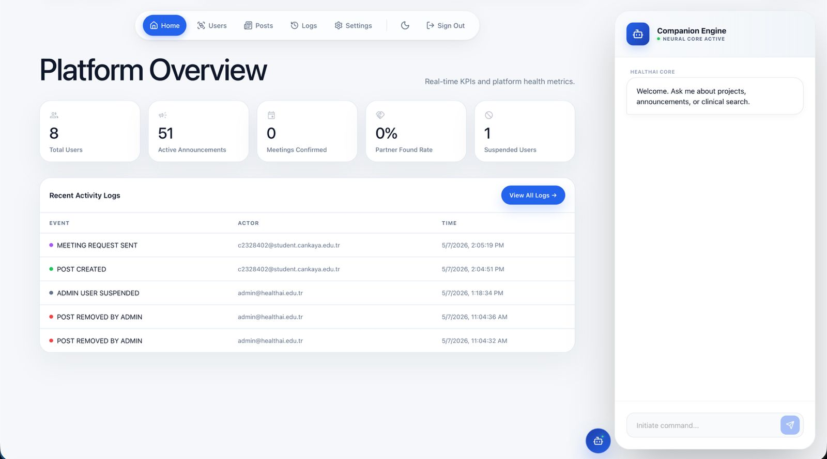
Figure 16

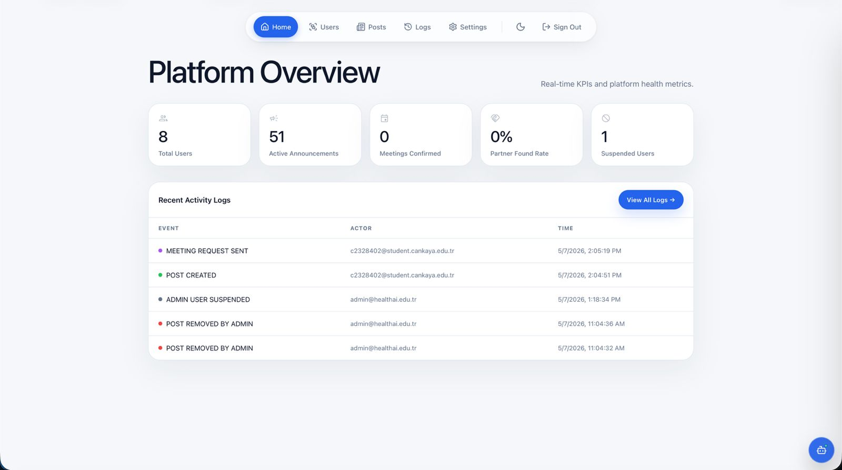
Figure 17

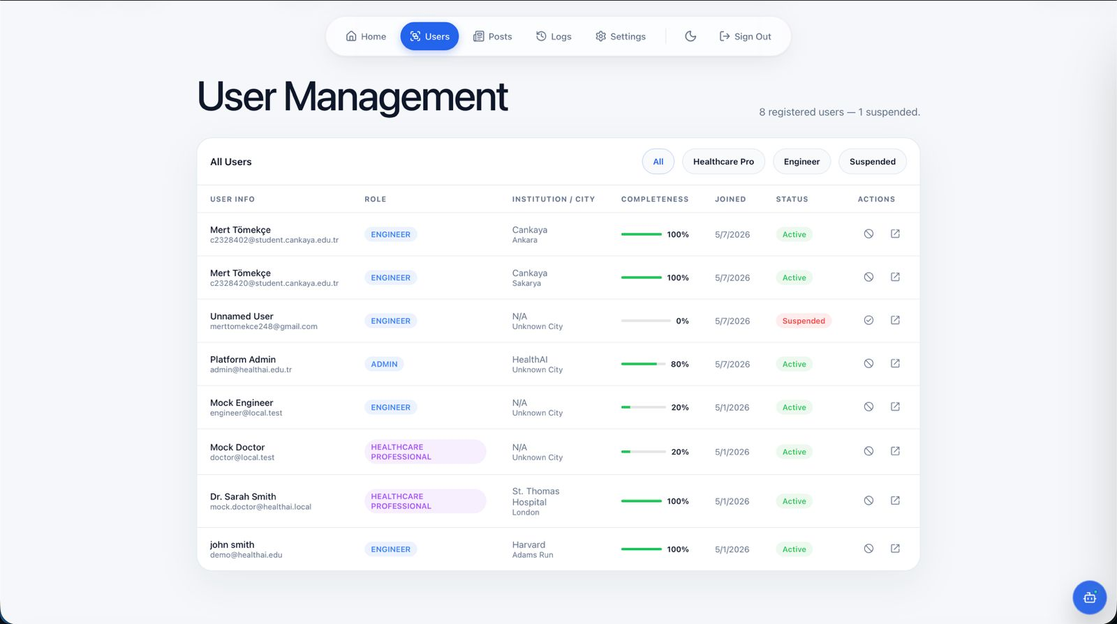
Figure 18
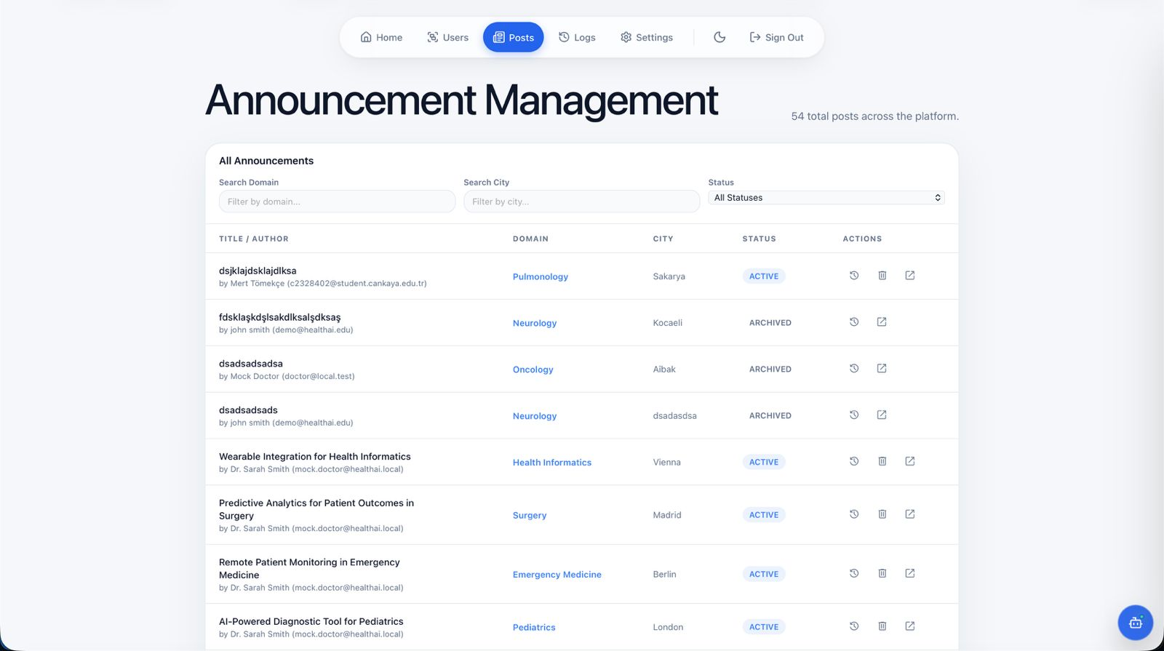
Figure 19

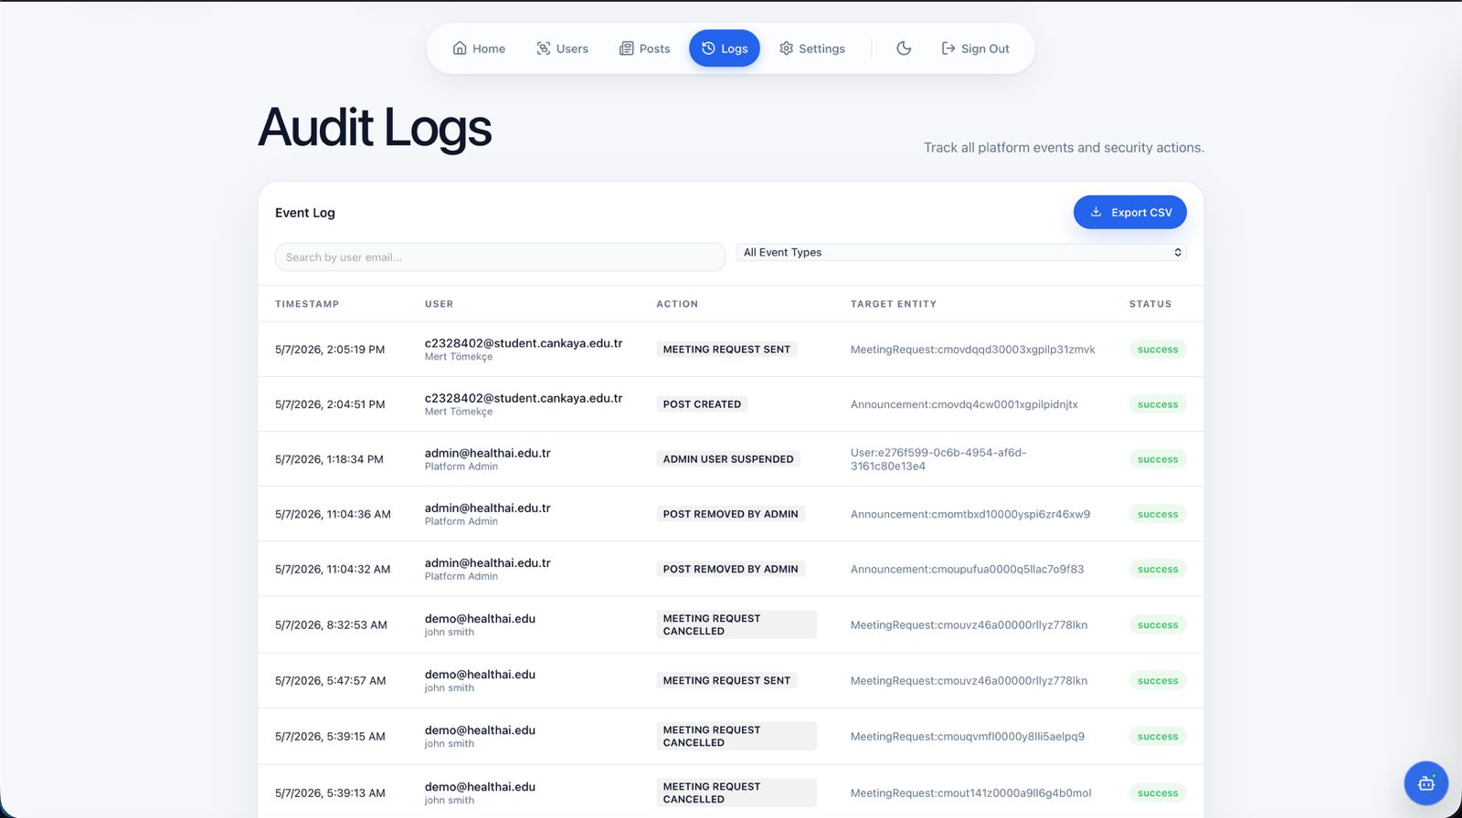
Figure 20
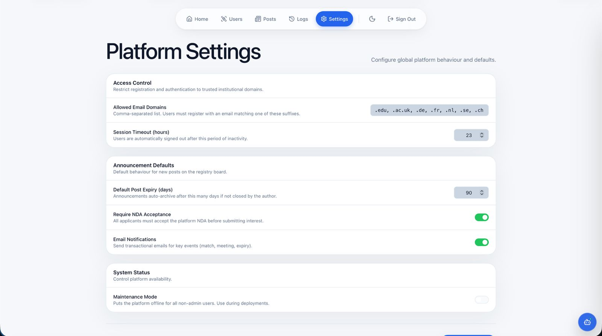
Figure 21
• ER Diagram
