**22:799:637/659 Supply Chain Solutions with ERP/SAP I**

**Midterm Exam**

Meru Bhatnagar

**Instructions**

* There are 5 sets of exercises/questions in the exam with a total of 40 points.
* For any works in our SAP system, please use your own data set only. For example, if your user ID is FSUSER-16, then please use data set 16. PLEASE DO NOT MODIFY ANY OTHER DATA SET DURING THE EXAM, which might bring trouble to your peers.
* Please finish this exam INDEPENDENTLY! CHEATing is not TOLERABLE according to University Policy.
* Please submit your answers to my questions in the exam to erpsapii@gmail.com by 6pm on Sunday, December 3rd.  All answers should be in one file, with name [Your Last Name], [Your First Name] SAPI Exam.doc, docx or pdf. LATE SUBMISSIONS WILL NOT BE ACCEPTED.

**Good luck!**

1. Please list and DESCRIBE the advantages of using Service Oriented Architecture (SOA) in the deployments of business management systems **(3 pts. Please answer this question using no more than 15 lines)**. ERP systems usually consist of three layers: presentation layer, application layer and database layer. Which layer does the middleware of an SOA architecture belong to? **(1 pt)**  
**Ans**. -Service Reusability  
Under Service Oriented Architecture, the services can be reused in multiple applications independent of their interactions with other services which can be used by on site managers and team leads.  
-Easy Maintainability  
Since a service is an independent entity, it can be easily updated or maintained thus helping to manage large, complex applications which eases the role of Business Analyst.  
-Greater Reliability  
SOA-based applications are more reliable as small, independent services are easier to test and debug as compared to large codes.  
-Location Independence  
The services are usually published to a database for easy access. The consumers are always able to locate their requested service through the directory look up which is a great feature for end users.  
-Improved Scalability and Availability  
Multiple instances of a single service can run on different servers at the same time for better scalability and availability purposes.

-Improved Software Quality  
Since services can be reused, there is no scope for redundant functionality. This helps reduce errors due to inconsistent data, and thereby improves the quality of code.  
-Platform Independence  
SOA facilitates the development of a complex product by integrating different products from different vendors independent of the platform and technology.  
-Increased Productivity  
Developers can reuse existing legacy applications and build additional functionality without having to develop the entire thing from scratch.

The middleware of SOA architecture belongs to application layer

2. Please read the case “University ERP: Big Mess on Campus” in file University ERP.pdf attached with the exam, and evaluate the ERP implementation risks at Northeastern University and Stanford University, respectively. In this file, their common implementation experiences are described at the beginning of the story, and their individual experiences are provided in the corresponding sections. Are these risks low or high? Why? (**5 pts. Please answer this question using no more than 30 lines.**

If you cannot evaluate some types of risks due to lack of evidences in the case, please just provide “N/A” for the corresponding risk type(s).)

**Ans.**

**ERP Implementation risks at Northeastern University:**

NEU was very casual to understand the complexity and resources necessary to implement an effective ERP system. Installing 22 modules in a very short span was very illogical and unrealistic. They initially failed to adequately plan for unpredictable contingencies that resulted in delay of schedules and deliverables. SAP has a lot of interdependencies which were not considered by the management. The compounding effect of not meeting deadlines is the reason why many other risks of ERP implementation are influence by scheduling and contingency risk. This is one of high risk areas that affect core strategic objectives. One workaround to reduce such risks is to establish milestones so that each project team can develop plans around. Other thing that can be done is to have quarters and divide the tasks on quarter basis. This way it would be possible for the managers to track the project and also plan ahead about the tasks that needs to be done.

**ERP Implementation Risks in Stanford University:**

Stanford University also faced the same problem as NEU by doing too much in too little time. Further, due to limited investment there was not proper functional testing and training was not given to end users as to how to handle the system. The purpose of testing in an ERP project is not only to see if the software works, but also to see if the system meets business needs and produces desired output. Reducing testing left defects undiscovered and increase the risk of ERP system failures when the end user were using. ERP implementation encouraged Stanford University to take a more business-like approach to education, resulting in cultural changes. ERP systems are integrated modules that have dynamic complexity and hence is difficult to implement for both the management and technical staff. The case with Stanford was that it lacked management and IT staff who were skillful enough to handle ERP applications. Standardization and integration both of which are key features of ERP systems were ignored which limited the flexibility of university system. This loss of flexibility led staff to create workarounds in which workers were attempting to carry on their previous process. This ultimately resulted in high risks, as it would increase staff workloads and create a data gap between the system further consuming time and increasing cost.

3. Please complete the following transactions mainly on Sales (This does not guarantee that referring to the SD handouts is sufficient to complete this question. Handouts on other modules may also be needed.) in our SAP system, client 515, and answer questions in a), b) and d) - g).

1. Find out the sales order you created against the sales quantity contract in Sales Exercise II and write down the sales order number **00000022** (no explanation or screenshot is needed); **(1 pt)**
2. Which of the following organization unit is not directly related to customer master data creation/change/display? **(1 pt, select only one choice)**
3. Client
4. Sales Organization
5. Sales Area
6. Company Code
7. **None of the above**
8. Complete the remaining sales transactions for this sales order, including to deliver **(1 pts)** , bill **(1 pt)**, and receive payment **(1 pt)**, in the system (we assume full delivery, full billing and full payment);
9. Please provide the types of ALL accounts (no need to provide the account numbers) in G/L that are influenced by goods issue at Step c) for this sales order. **(1 pt)**

**Ans:**

02: Account Recievable

600000: Sales Revenue

610000: Sales Discount

1. To demonstrate the integration feature of ERP, please briefly describe how the Sales and Distribution module is integrated with the Financial Accounting, Controlling and Materials Management modules at the goods issue step. **(1 pt)**

**Ans:**

ERP automatically determines the account and links it to the GL Account. This integration feature helps Sales and Distribution module to get connected with Financial Accounting module. So after the invoice gets generated ERP automatically debits or credit the account in General Ledger.

1. The completion of which step will change the status of outbound delivery to “completed”? **(1 pt, select only one choice)**
2. Create the Delivery
3. Picking
4. Packing
5. Posting Goods Issue
6. **Issue the Invoice to the Customer**
7. Please provide evidence with **ONE screenshot** to show that all your works at Step c) are completed (no explanation is needed). **(1 pt)** We also discussed a way to check the production status in class. Please describe this method. **(1 pt)**

**Ans:** 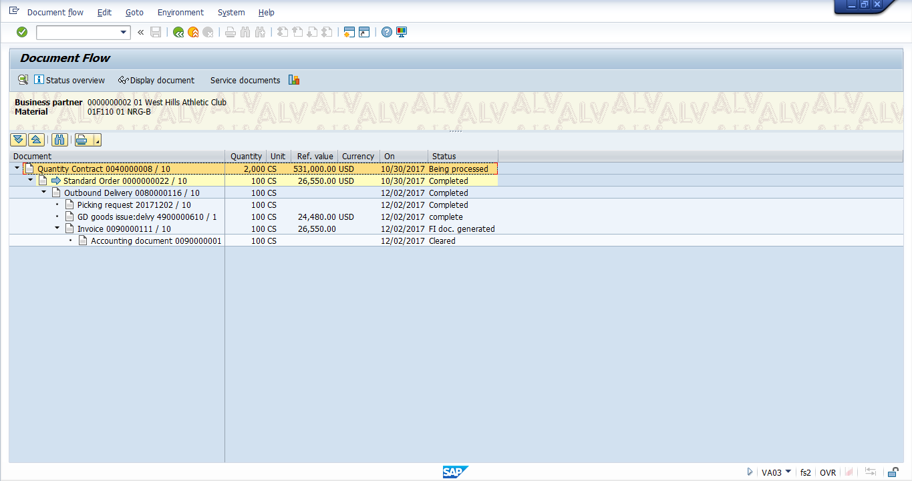

We run the MRP(Logistics-> productions-> MRP-> Evaluations -> Stock Requirement List) and check the stock requirement list 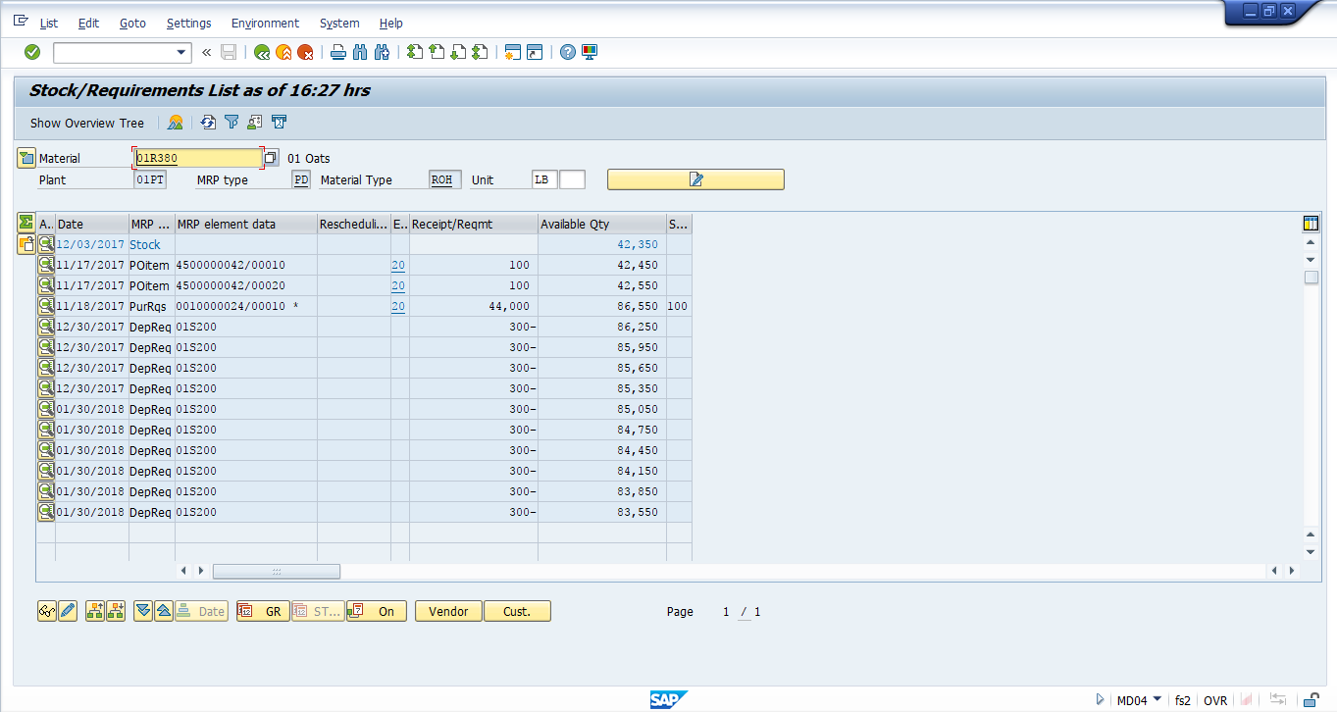

4. Please complete the following transactions mainly on Accounting (This does not guarantee that referring to the FICO handouts is sufficient to complete this question. Handouts on other modules may also be needed.) in our SAP system, client 515, and answer questions in b) - g).

1. Please issue 1000 units of ##R380 to cost center A010; **(1 pt)**
2. Please provide the types of ALL accounts (no need to provide the account numbers) in G/L that are influenced by the goods issue at Step a). **(1 pt)**

**Ans:**

**200000 Inventory Raw Material**

**720000 Raw Material Consumption**

1. Does this goods issue step generate controlling document? Why? **(1 pt)**

**Ans:** Controlling documents are for internal movement as the good are getting transferred from the warehouse to cost center (Movement type 201) which is internal hence answer is yes, we can generate controlling document.

1. Display actual line items for cost center A010 and please provide the **screenshot**. **(1 pt)**

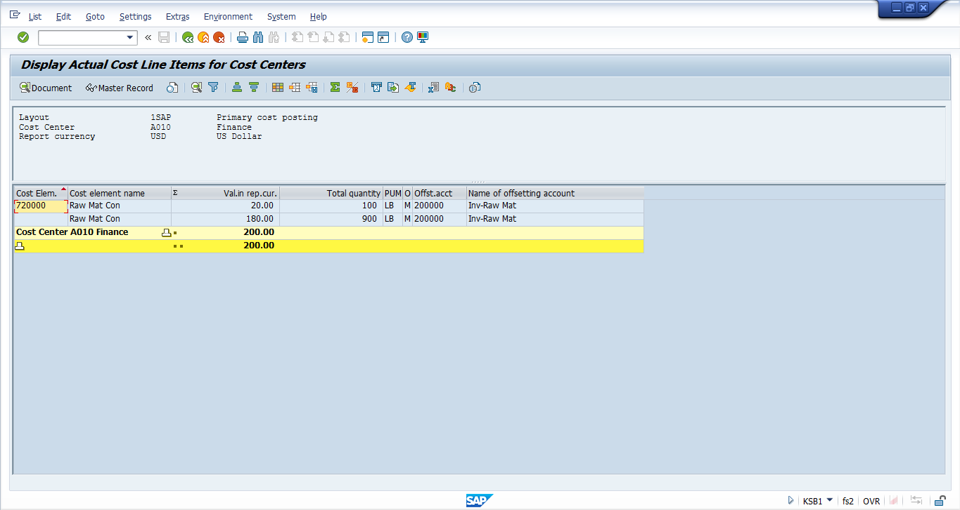

1. Which cost element **720000** (please provide the cost element number without explanation) in A010 is used to record the cost associated with the goods issue you do at Step a)? **(1 pt)**
2. Is the cost element you provide at Step e) a primary or secondary cost element? **(1 pt)**

**Ans:** Secondary

1. Which of the following will **NOT** be influenced/created by goods issue at Step a)? **(1 pt, select only one choice)**
2. Material Document only
3. Material ##R380’s Valuation only
4. Material Master of ##R380 only
5. Outbound Delivery Document only
6. Both 1) and 3)
7. **Both 2) and 4)**
8. Based on the statistical key figures you created in our accounting lab (These statistical key figures are based on the space of each cost center occupies, which may not be appropriate in practice for allocating costs of material consumptions. I ask you to directly use these key figures just to save your time in the exam), please perform cost allocation from cost center A010 to cost centers A010, A020, A030, A040, A050, A060 for the cost element you record at Step c). **(3 pts)**

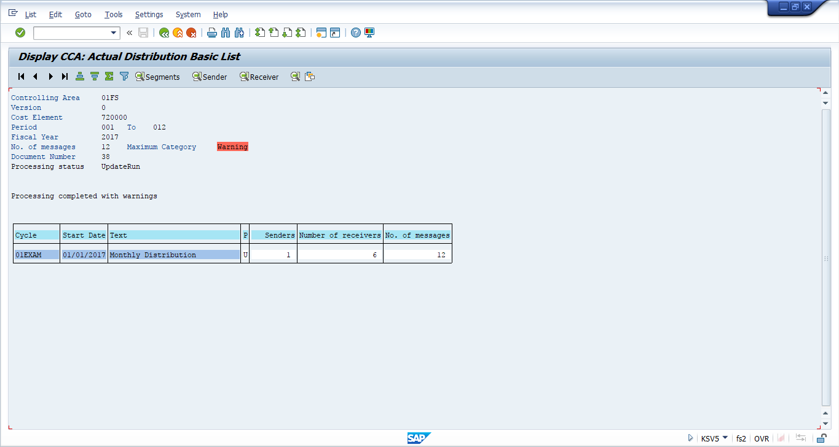

5. Please complete the following transactions mainly on MM (This does not guarantee that referring to the MM handouts is sufficient to complete this question. Handouts on other modules may also be needed.) in our SAP system, client 515, and answer questions in a), c) - e), h) and i).

1. Find out the purchase order you created against the quantity contract in MM Exercise II and write down the purchase order number**4500000111** (no explanation or screenshot is needed); **(1 pt)**
2. Complete goods receipt for the above purchase order and receive the goods into storage location 100 (Raw Materials location) as stock type **Quality Inspection**;

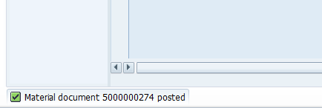

1. Check the raw material account (asset) in G/L and display the account balance. Please provide a **screenshot** for the account balance; **(1 pt)**

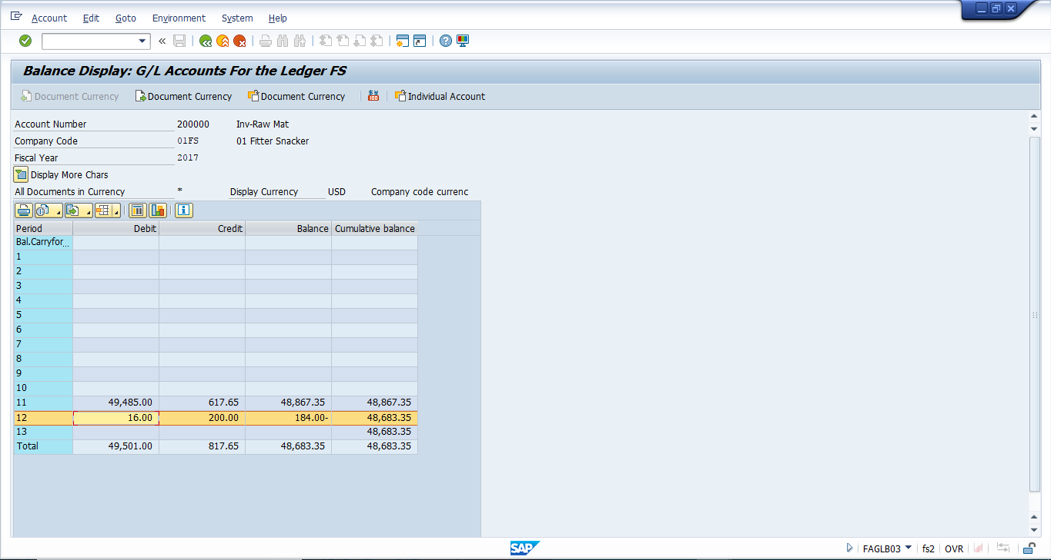

1. As you can see at Step c) that SAP system automatically maintains the associated G/L accounts when you are working on the MM part. Please discuss the advantages of the automatic account determination function (please list the advantages and provide your explanations); **(1 pt)**

**Ans:**Postings are made to G/L accounts automatically in the case of Invoice Verification or when good receipt needs to be posted. The R3 system will automatically define which accounts to post.

Stock account

Consumption account

SAP automatically maps these account to G/L account once Goods Receipts has been executed. The advantage of the account automatic determination is that we don’t have to remember and define every account number for every purchasing.

1. If the raw material processed at Step b) is a consumable material, please provide the types of all accounts that will be involved in the accounting transactions related to this goods receipt step. Please also specify which account will be debited and which will be credited. **(2 pt)**

Account type involved will be

Cost Center Account

Consumption Account

GL Account

CREDITED account will be Consumption and Cost Center Account.

1. Transfer 50% stock you receive at Step b) from Quality Inspection stock to Unrestricted Use stock; **(1 pt)**

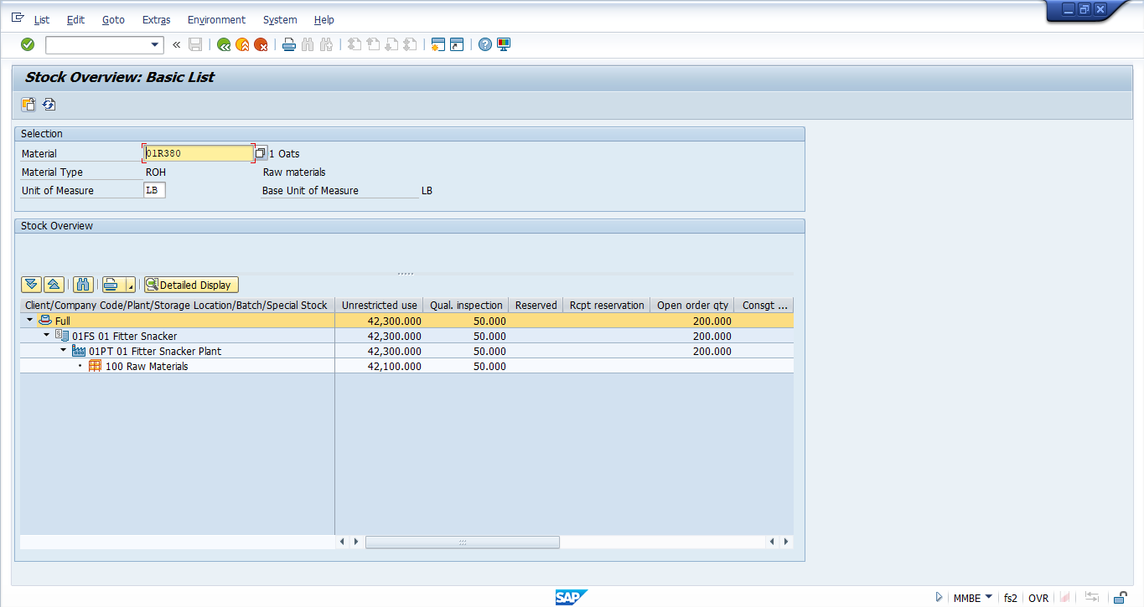

1. Create an invoice for the goods receipt you create at Step b); **(1 pt)**
2. Suppose the moving average pricing approach is used for the raw materials you receive in this question. If the vendor kindly sends you an invoice with an amount 25% less than the purchase order (the one you found at Step a) amount, what G/L accounts will be involved in this invoice posting transaction? **(1 pt)** For each of these accounts, do we debit or credit? How much? **(1 pt)** Please do not do anything in the SAP system for Step h, but just answer the questions.

**Ans.**

Account involved :

Stock Account (Credit$5 and $15)

GR/IR Account ( Debit 20$ and Credit 20$)

Vendor General Ledger ( Credit of 15$)

Price Difference ( Debit $5)

Consumption Raw Material ( Debit $15)

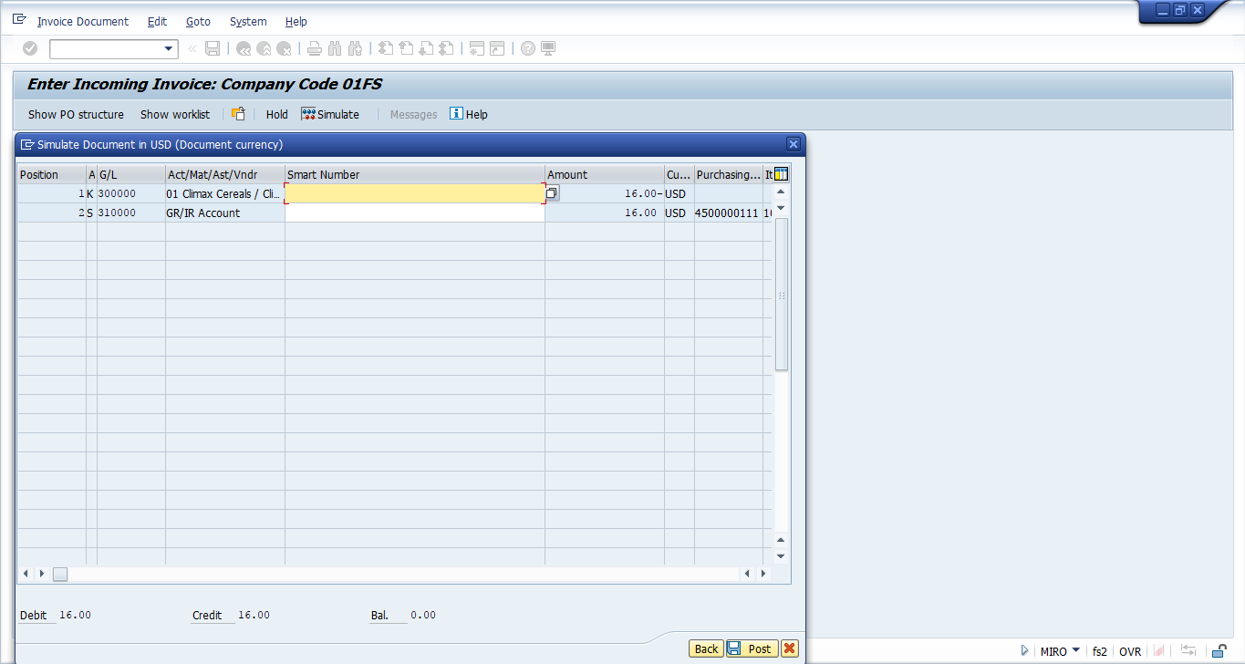

1. Display (and provide **screenshot**) the line item of the vendor account (from whom you receive goods at Step b) and demonstrate/explain that the invoice created at Step g) is still unpaid. **(1 pts)**

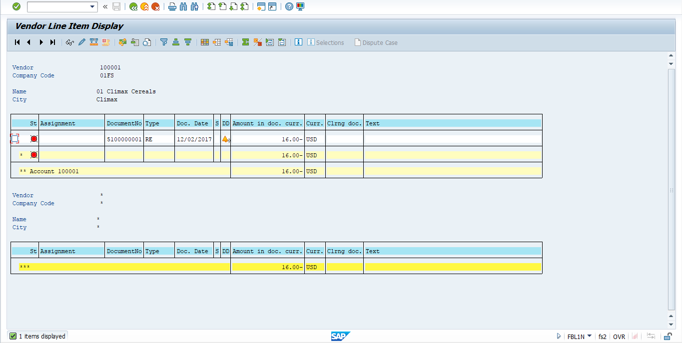

Invoice is unpaid as $16 is still unpaid to the vendor.