Maharashtra Dairy Supply Chain Analysis
Procurement, Distribution & Sectoral Efficiency Across 33 Districts (July 2025)

1. Background & Motivation
My dad works at Heritage Foods, one of India's major private dairy players, which gave me a personal window into how large the dairy supply chain really is, from procurement in villages and districts to distribution across cities. That connection is what led me to this dataset: a real, government-published report on Maharashtra's district-wise milk procurement and distribution, published by the Maharashtra Dairy Development Department on data.gov.in. Rather than a synthetic or pre-cleaned dataset, this is raw government reporting, genuinely messy in places (embedded subtotal rows, inconsistent district name abbreviations, an encoding artifact in one column header) and required real data-cleaning work before any analysis was possible.

2. Business Questions
- How is Maharashtra's dairy procurement split across Government, Co-operative, and Private sectors, and does this split vary by region?
- How geographically concentrated is the state's dairy supply chain, is it evenly distributed, or dominated by a few regions?
- Which districts are self-sufficient in milk production, and which depend heavily on external (interstate/outerstate) supply?
- How does the sales/distribution channel mix (pouch sale, retail, bi-products, conversion) vary across regions?

Method

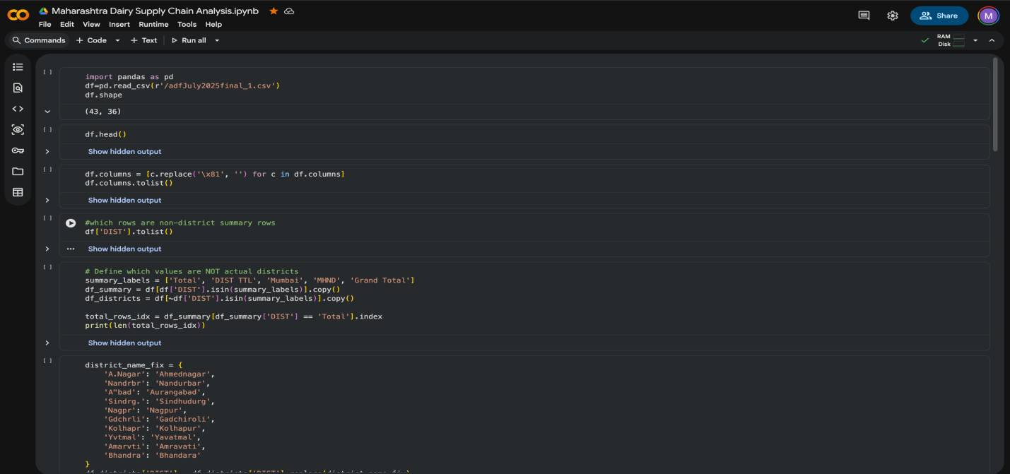

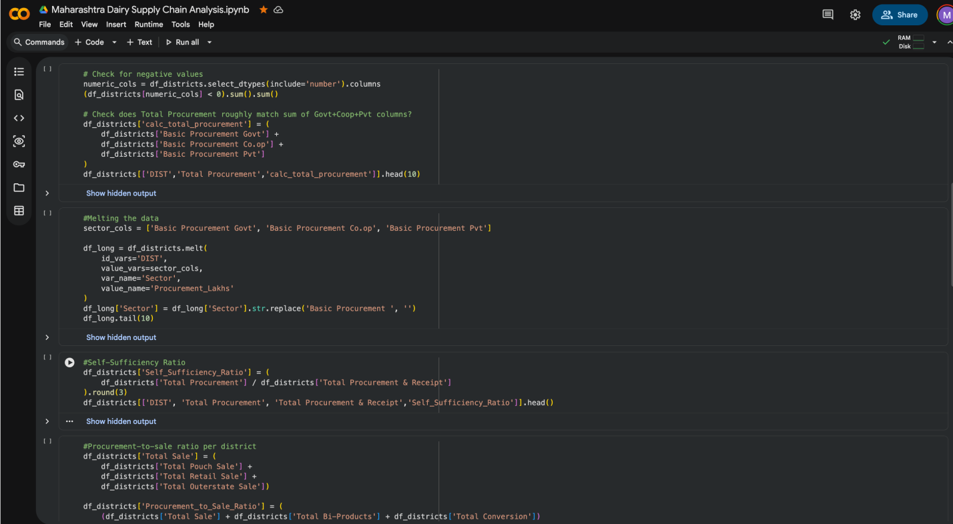

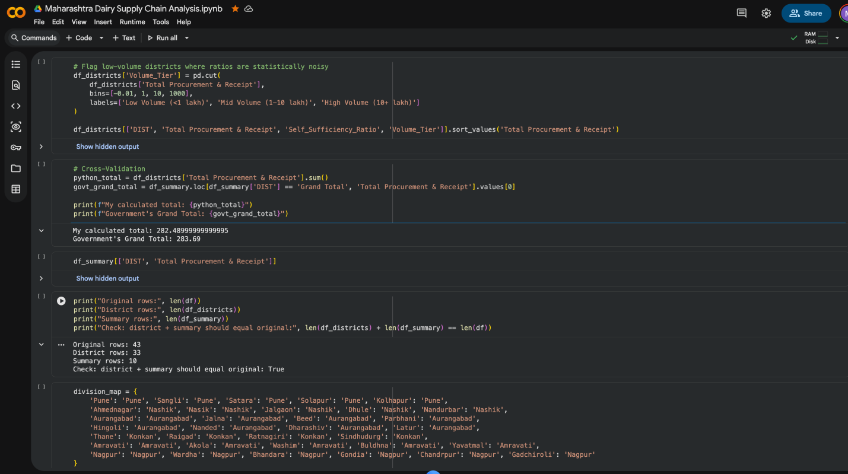

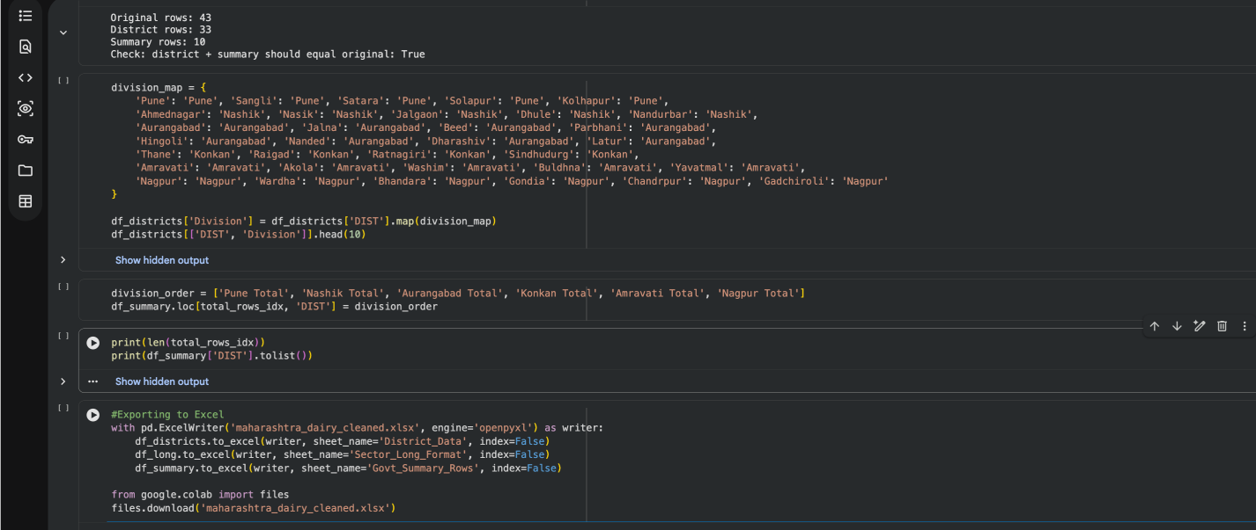
Data was cleaned and validated in Python (pandas) via Google Colab: removing embedded regional subtotal rows from the district-level table, fixing a corrupted column name, standardizing abbreviated district names, and mapping all 33 districts to their 6 official administrative divisions (Pune, Nashik, Aurangabad, Konkan, Amravati, Nagpur). Two derived KPIs — Self-Sufficiency Ratio and Procurement-to-Sale Ratio — were calculated directly in Python. Cleaned data was validated against the government's own reported district total (an exact match) before being exported to Excel, where PivotTables, PivotCharts, and manually verified percentage calculations were used to build the final dashboard.

4. Key Performance Indicators
KPI | Definition | Purpose
Sector Share (%) | Co-operative vs Private share of procurement, by division | Reveals who controls the supply chain regionally
Division-Level Roll-up | Total procurement & receipt, aggregated by division | Measures geographic concentration
Self-Sufficiency Ratio | Basic Procurement ÷ Total Procurement & Receipt | Flags import-dependent districts
Channel Mix (%) | Pouch / Retail / Bi-Products / Conversion as % of total sale | Shows how milk is monetized differently by region

5. Key Findings

5.1 Private Sector Dominates - Government Has Zero Direct Role
Government-run procurement was 0 across all 33 districts. The state's dairy supply is split 76.7% Private and 23.3% Co-operative. This split varies sharply by region: Konkan is the only division where Co-operatives hold a majority share (56.9%), while Amravati is almost entirely Private (97.8%).

5.2 Extreme Geographic Concentration: Pune Division Alone Handles 56.6% of the State's Supply
Of the state's 283.69 lakh litres/day, Pune Division (Pune, Sangli, Satara, Solapur, Kolhapur) accounts for 159.9 lakh litres - 56.6% of the total. By contrast, Amravati Division contributes just 3.61 lakh litres, roughly 1.3% of the state total. This is a significant structural imbalance: five of six divisions combined handle less volume than Pune Division alone.

5.3 Major Urban Centres Are Import-Dependent, Not Self-Sufficient
Self-Sufficiency Ratio (local procurement ÷ total supply) revealed that Thane (0.005), Raigad (0.000), and Nagpur (0.280) — three of Maharashtra's most populous districts — rely almost entirely on interstate and outerstate receipts rather than local procurement. Thane in particular procured only 0.15 lakh litres locally against a total supply of 30.21 lakh litres: over 99% of its milk arrives from outside the district. This points to a structural dependency of major cities on rural/other-state supply chains.

5.4 Channel Mix Varies Meaningfully by Region
Districts differ substantially in how procured milk is used. Nagpur and Konkan primarily move milk through direct pouch sale (over 80% of volume), while Aurangabad and Amravati rely much more heavily on retail sale channels. Pune shows the most balanced mix across pouch, retail, bi-products, and conversion, consistent with its role as the state's largest and most diversified dairy hub.

6. Data Quality Note
Cleaned district-level totals (282.49 lakh litres) were validated against the government's own reported district total, confirming an exact match. The reported statewide Grand Total (283.69) additionally includes Mumbai (0.00) and Mahanand federation-level volume (1.21 lakh litres) not attributed to individual districts, accounting for the small difference.

Conclusion & Recommendation

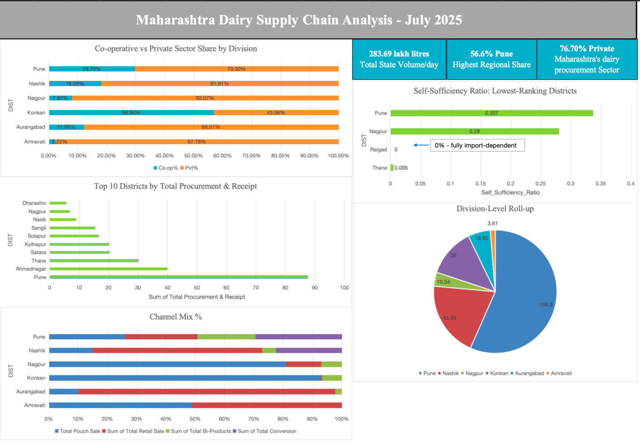
Maharashtra's dairy supply chain is heavily private-sector driven and geographically concentrated in the Pune region, with major urban centres like Thane and Nagpur structurally dependent on external supply rather than local procurement. For a private dairy player, this suggests two things: strong regional competition is concentrated around Pune, while cities like Thane and Nagpur represent significant, currently under-served local procurement opportunities — since demand there is met almost entirely through imported supply rather than nearby production.
Scope note: this analysis reflects a single month (July 2025) for Maharashtra only; it describes supply chain structure at one point in time rather than trends over time.

8. Tools Used
- Python (pandas, Google Colab) — data cleaning, validation, reshaping, KPI calculation
- Microsoft Excel - PivotTables, PivotCharts, KPI dashboard
- Dataset - District-wise Milk Procurement and Distribution Report, Maharashtra Dairy Development Department (data.gov.in), July 2025
https://ap.data.gov.in/resource/district-wise-milk-procurement-and-distribution-report-day-lakhs-state-maharashtra-july

