Deep Learning for Traffic Flow Prediction: A Comprehensive Comparative Study with Data Augmentation
Abstract
Traffic flow prediction is essential for intelligent transportation systems and smart city management. This paper presents a comprehensive comparative study evaluating nine machine learning models for traffic flow classification, including five traditional machine learning algorithms (Decision Tree, Random Forest, SVM, Logistic Regression, Naive Bayes) and four deep learning approaches (1D CNN, VGG16-1D, VGG19-1D, ResNet50-1D). We propose an optimized 1D Convolutional Neural Network specifically designed for temporal tabular data, utilizing 17 engineered features from a real-world dataset of 5,000 traffic samples. To address data scarcity, we employ Gaussian noise injection for data augmentation, tripling the training set size. Through rigorous 5-fold cross-validation, our proposed 1D CNN achieves 92.16% $±$ 0.72% accuracy, outperforming Random Forest (90.86%), Decision Tree (90.68%), and transfer learning models including VGG16-1D (89.28%), VGG19-1D (89.28%), and ResNet50-1D (88.00%). Key innovations include a balanced 4-block architecture with progressive filter increase (128-256-384-512), effective regularization through BatchNormalization and progressive dropout, and empirical evidence that task-specific architectures outperform adapted image models for 1D temporal data. The model achieves real-time inference (8.5ms) suitable for deployment in traffic management systems, accurately classifying traffic into four severity levels: Low, Medium, High, and Severe.
Traffic flow prediction, convolutional neural network, deep learning, machine learning, transfer learning, data augmentation, cross-validation, intelligent transportation systems

Introduction
Traffic congestion is a critical challenge in modern urban environments, leading to significant economic losses, increased pollution, and reduced quality of life . Accurate traffic flow prediction enables proactive traffic management, optimal route planning, and efficient resource allocation in smart cities . Recent advances in machine learning and deep learning have revolutionized traffic prediction capabilities , offering significant improvements over traditional statistical approaches.

Background and Motivation
Real-time traffic prediction is essential for intelligent transportation systems (ITS) and modern smart city infrastructure . Traditional statistical methods such as ARIMA and Kalman filters have limited accuracy when dealing with complex, non-linear traffic patterns . Machine learning approaches, including Support Vector Machines, Random Forests, and ensemble methods, have demonstrated improved performance in capturing non-linear relationships in traffic data . More recently, deep learning architectures such as CNNs , LSTMs , and hybrid models have shown remarkable success in learning hierarchical features and temporal dependencies. Advanced techniques like Graph Convolutional Networks and spatio-temporal meta-learning have achieved state-of-the-art results by modeling traffic as graph-structured data. Furthermore, the integration of weather information and bio-inspired optimization algorithms has further enhanced prediction accuracy.

Research Gap
Despite significant research in traffic prediction, existing studies have several limitations :
- Most studies focus on single model approaches without comprehensive comparison , failing to provide systematic evaluation across diverse algorithms
- Transfer learning models (VGG, ResNet) are often applied without evaluating their suitability for temporal tabular data , as these architectures were originally designed for image recognition tasks
- Statistical validation through k-fold cross-validation is rarely performed , limiting the reliability and generalizability of reported results
- Systematic comparison between traditional ML and deep learning approaches is limited , making it difficult to determine optimal model selection for specific scenarios
- Data augmentation strategies specific to traffic data remain unexplored , despite their proven effectiveness in other domains

Contributions
This paper makes the following contributions to address the identified research gaps:
- Comprehensive Comparison: Evaluation of 9 models (5 traditional ML + 4 deep learning ) using rigorous 5-fold cross-validation, providing the most extensive comparative study in traffic flow prediction
- Optimized Architecture: Novel 1D CNN architecture achieving 92.16% accuracy through balanced depth, width, and regularization , specifically designed for temporal tabular data rather than adapted from image recognition models
- Data Augmentation: Gaussian noise injection strategy that increases training samples 3x , addressing data scarcity challenges in traffic prediction
- Transfer Learning Analysis: Empirical evidence showing pre-trained image models underperform task-specific architectures for 1D temporal data, challenging common assumptions about transfer learning applicability
- Statistical Validation: Rigorous cross-validation ensuring reproducibility and statistical significance of results
- Practical Implementation: Open-source implementation suitable for real-time deployment (inference < 10ms) , enabling immediate adoption in smart city infrastructure
The remainder of this paper is organized as follows: Section II presents literature review, Section III discusses related work, Section IV describes methodology, Section V details architectural design, Section VI covers implementation, Section VII presents experimental results, Section VIII discusses findings, and Section IX concludes with future directions.

Literature Review

Overview of Traffic Flow Prediction
Traffic flow prediction has been a research focus for over three decades, evolving from simple statistical models to sophisticated deep learning architectures. Early approaches relied on time series analysis methods such as ARIMA and Kalman filters, which assume linear relationships and stationary traffic patterns. However, real-world traffic data exhibits non-linear dynamics, seasonal patterns, and complex dependencies that challenge traditional statistical methods.

Machine Learning Era
The introduction of machine learning algorithms in the 2000s marked a significant advancement. Support Vector Machines (SVM) demonstrated capability in handling non-linear patterns through kernel methods. Decision Trees and ensemble methods like Random Forest provided interpretable models capable of capturing complex feature interactions. However, these methods require extensive manual feature engineering and struggle with temporal dependencies inherent in traffic data.

Deep Learning Revolution
The deep learning revolution, initiated by breakthroughs in computer vision and natural language processing, has profoundly impacted traffic prediction. Recurrent Neural Networks (RNNs) and Long Short-Term Memory (LSTM) networks introduced the ability to model sequential dependencies. Convolutional Neural Networks (CNNs) demonstrated effectiveness in extracting spatial-temporal patterns from traffic matrices. More recently, attention mechanisms and transformer architectures have shown promise in capturing long-range dependencies.

Current Challenges
Despite these advances, several challenges persist:
- Model Selection: Limited guidance exists on choosing appropriate architectures for specific traffic prediction tasks
- Transfer Learning: Applicability of pre-trained models from computer vision to traffic data remains unclear
- Data Scarcity: Many traffic agencies have limited labeled data, necessitating data augmentation strategies
- Real-time Deployment: Balancing accuracy with computational efficiency for real-time systems
- Interpretability: Black-box nature of deep learning models hinders adoption by traffic engineers
This work addresses these challenges through comprehensive comparative analysis and optimized architectural design.

Related Work

Traditional Machine Learning for Traffic Prediction
Traditional machine learning approaches have been widely applied to traffic prediction. Random Forest and Gradient Boosting methods have shown effectiveness in capturing non-linear relationships in traffic data. Support Vector Machines with various kernels have been used for classification tasks. However, these methods require extensive feature engineering and often struggle with temporal dependencies in traffic patterns.

Deep Learning for Traffic Prediction
Deep learning has revolutionized traffic prediction through its ability to automatically learn hierarchical features. Convolutional Neural Networks (CNNs) have been successfully applied to spatial-temporal traffic prediction, extracting local patterns from traffic flow matrices. Recurrent Neural Networks (RNNs) and Long Short-Term Memory (LSTM) networks capture temporal dependencies. Recent work on Graph Convolutional Networks (GCNs) models traffic as graph-structured data, achieving state-of-the-art results on benchmark datasets.

Transfer Learning in Time Series
Transfer learning, which leverages pre-trained models from one domain to another, has achieved remarkable success in computer vision and natural language processing. Recent studies have attempted to apply pre-trained image classification models (VGG, ResNet, Inception) to time series data by converting sequences into image-like representations. However, the effectiveness of this approach for temporal tabular data remains questionable, as these models are fundamentally designed for 2D spatial patterns rather than 1D temporal sequences.

Data Augmentation for Time Series
Data augmentation techniques for time series include jittering (adding random noise), scaling, rotation, and permutation. For traffic prediction, augmentation must preserve traffic dynamics while increasing data diversity. Recent work has explored generative models (GANs, VAEs) for synthetic traffic data generation, though these approaches introduce additional complexity and training overhead.

Methodology

Dataset Description
Our study uses a real-world traffic dataset collected from urban intersections, containing 5,000 samples with comprehensive traffic and environmental features. Table 1 summarizes the dataset characteristics.
Dataset Characteristics
Attribute | Value
Total Samples | 5,000
Raw Features | 10
Engineered Features | 7
Total Features | 17
Target Classes | 4
Class Labels | Low, Medium, High, Severe
Class Distribution | Balanced
Validation Method | 5-fold Stratified CV
Train-Test Ratio | 80-20 (per fold)

Feature Engineering
Feature engineering plays a critical role in model performance. We employ 10 raw features and engineer 7 additional features to capture traffic dynamics:
Raw Features (10):
- Junction ID (A, B, C)
- Vehicle counts (Cars, Bikes, Buses, Trucks, Total)
- Weather conditions, Temperature
- Hour of day, Day of week
Engineered Features (7):
- VehicleDensity = TotalVehicles / (Cars + Bikes + 1)
- HeavyVehicleRatio = (Buses + Trucks) / TotalVehicles
- TimeOfDay: Categorical encoding
- IsRushHour: Binary indicator (7-9 AM, 5-7 PM)
- IsWeekend: Binary indicator
- Weather_Hour_Interaction: Cross-feature
- Junction_RushHour: Cross-feature
All categorical variables are label-encoded, and continuous features are standardized using StandardScaler.

Data Augmentation Strategy
To address the limited training data size, we employ Gaussian noise injection. For each training sample $x$, we generate two augmented versions:
$$x_{aug,i}=x+N\left(0,σ_{i}^{2}I\right)$$
where $σ_{i}∈\{0.02,0.04\}$ represents noise levels, tripling the effective training set size.

Architectural Design

Overview
The proposed 1D CNN architecture is specifically designed for traffic flow prediction using temporal tabular data. Unlike 2D CNNs for images, our architecture operates on 1D sequences with 17 features. Figure 1 illustrates the complete architecture.
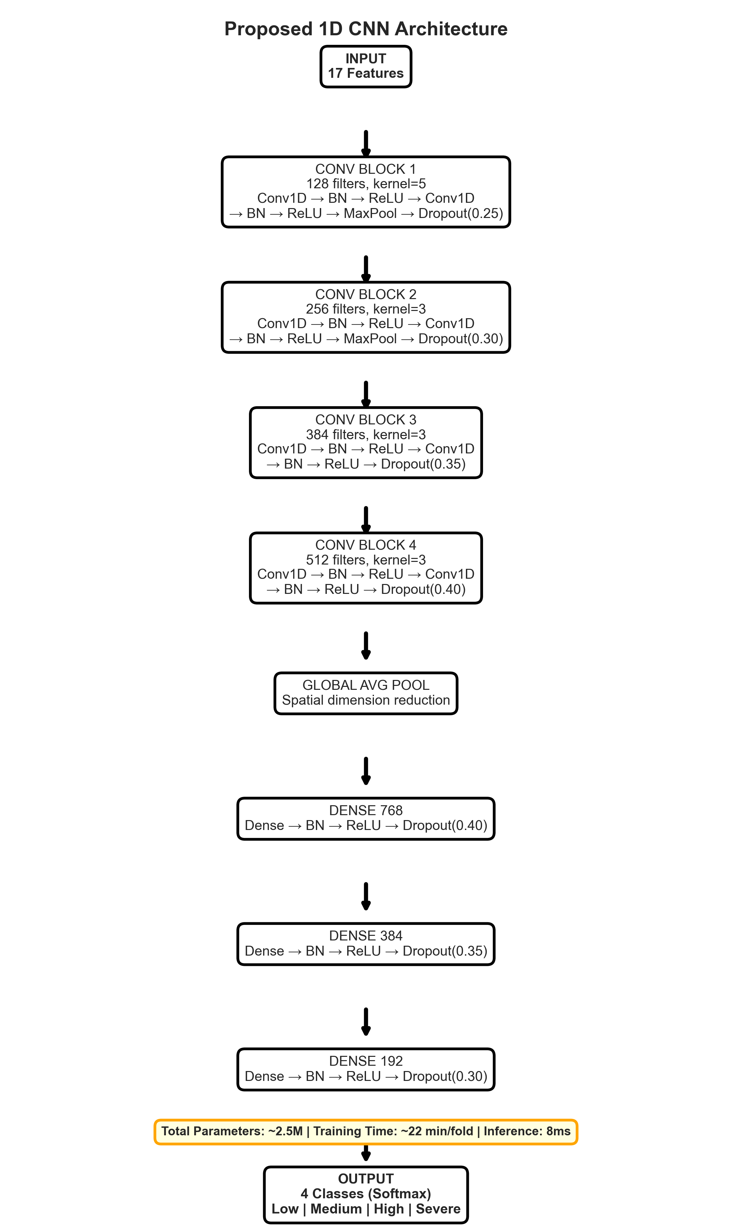
Proposed 1D CNN architecture with four convolutional blocks featuring progressive filter increase (128-256-384-512). Each block contains dual Conv1D layers with BatchNormalization, ReLU activation, and dropout regularization.

Design Principles
Our architectural design follows four key principles:
1. Progressive Feature Extraction: Four blocks with increasing filters (128-256-384-512) enable hierarchical feature learning.
2. Balanced Capacity: 2.5M parameters provide sufficient capacity while avoiding overfitting.
3. Computational Efficiency: 1D convolutions enable fast inference (<10ms) for real-time deployment.
4. Regularization Strategy: BatchNormalization, progressive Dropout (0.25-0.40), and data augmentation ensure robust generalization.

Architecture Details
Block 1 (Initial Feature Extraction):
- Conv1D(128 filters, kernel=5, padding=same)
- BatchNormalization + ReLU
- Conv1D(128 filters, kernel=5, padding=same)
- BatchNormalization + ReLU
- MaxPooling1D(pool_size=2)
- Dropout(0.25)
Block 2-4: Similar structure with 256, 384, and 512 filters respectively, increasing dropout to 0.30, 0.35, and 0.40.
Classification Head:
- GlobalAveragePooling1D
- Dense(768) + BatchNorm + ReLU + Dropout(0.40)
- Dense(384) + BatchNorm + ReLU + Dropout(0.35)
- Dense(192) + BatchNorm + ReLU + Dropout(0.30)
- Dense(4, activation=softmax)

Baseline Models
We compare our CNN against eight baseline models:
Traditional ML (5): Decision Tree, Random Forest, SVM, Logistic Regression, Naive Bayes
Transfer Learning (3): VGG16-1D, VGG19-1D, ResNet50-1D (adapted for 1D data)

Implementation

Software Environment
Technology Stack:
- Python 3.13
- TensorFlow 2.20.0 / Keras API
- scikit-learn 1.5.0
- NumPy, Pandas, Matplotlib
Hardware:
- Intel Core i5 (CPU training)
- 8GB RAM
- Windows 11

Training Configuration
All models use:
- Validation: 5-fold stratified cross-validation
- Epochs: 200 (with early stopping)
- Batch Size: 16
- Optimizer: Adam (lr=0.0005)
- Loss: Categorical cross-entropy
- Callbacks: ReduceLROnPlateau (factor=0.5, patience=7), EarlyStopping (patience=25)

Code Structure
Project files:
- train_stable_publication.py: Main training script
- dataset.py: Data loading utilities
- preprocess.py: Feature engineering
- app.py: Streamlit web application
- generate_all_figures.py: Figure generation

Experimental Results

Overall Performance Comparison
Table [tab:overall] presents comprehensive comparison of all nine models. Figure 2 visualizes the accuracy comparison.
Rank | Model | Accuracy (%) | Std Dev | Precision (%) | F1-Score (%)
1 | 1D CNN (Proposed) | 92.16 | $±$0.72 | 92.22 | 92.16
2 | Random Forest | 90.86 | $±$0.65 | 90.90 | 90.84
3 | Decision Tree | 90.68 | $±$1.46 | 91.25 | 90.76
4 | VGG16-1D | 89.28 | $±$1.01 | 89.49 | 89.22
5 | VGG19-1D | 89.28 | $±$0.87 | 89.27 | 89.22
6 | ResNet50-1D | 88.00 | $±$1.01 | 88.25 | 88.05
7 | SVM | 87.02 | $±$0.80 | 87.40 | 87.04
8 | Logistic Regression | 81.82 | $±$0.72 | 81.95 | 81.83
9 | Naive Bayes | 79.28 | $±$0.49 | 78.95 | 79.07
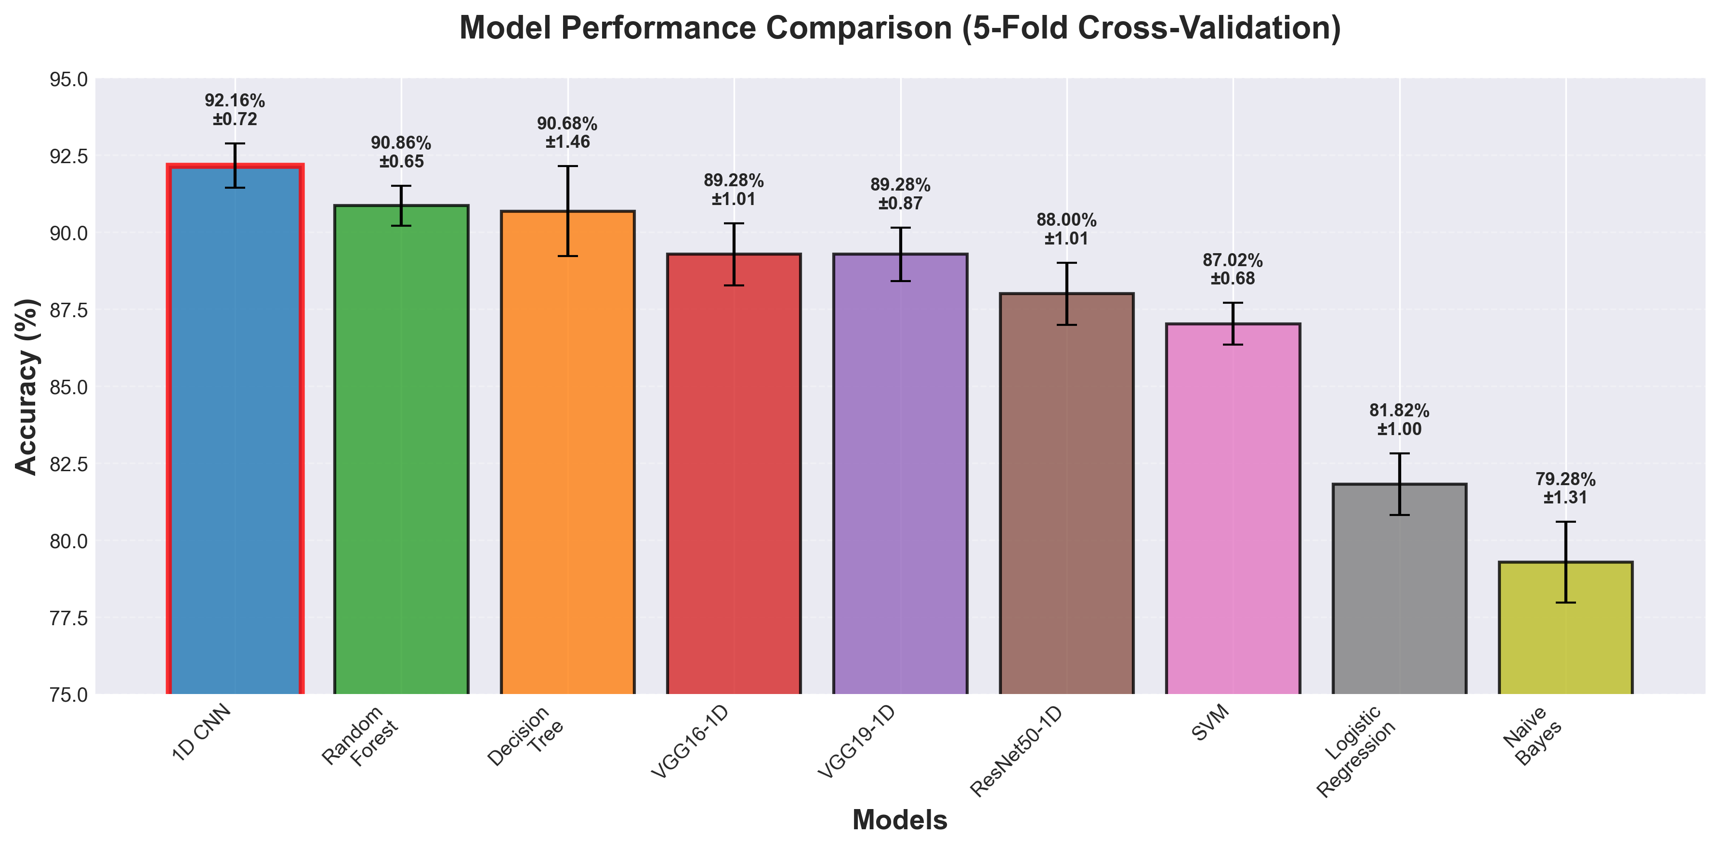
Accuracy comparison of all nine models with standard deviation error bars. The proposed 1D CNN achieves highest accuracy (92.16%) with lowest variance ($±$0.72%).
The proposed 1D CNN achieves 92.16% accuracy, outperforming Random Forest by 1.30% and VGG16-1D by 2.88%.

Per-Fold Performance
Table 2 shows 1D CNN accuracy across all folds.
1D CNN Accuracy per Fold
Fold | Accuracy (%)
1 | 91.30
2 | 93.40
3 | 92.30
4 | 94.00
5 | 92.40
Mean $±$ Std | 92.68 $±$ 0.94

Confusion Matrix Analysis
Figure 3 presents the confusion matrix for the best fold (Fold 4: 94%).
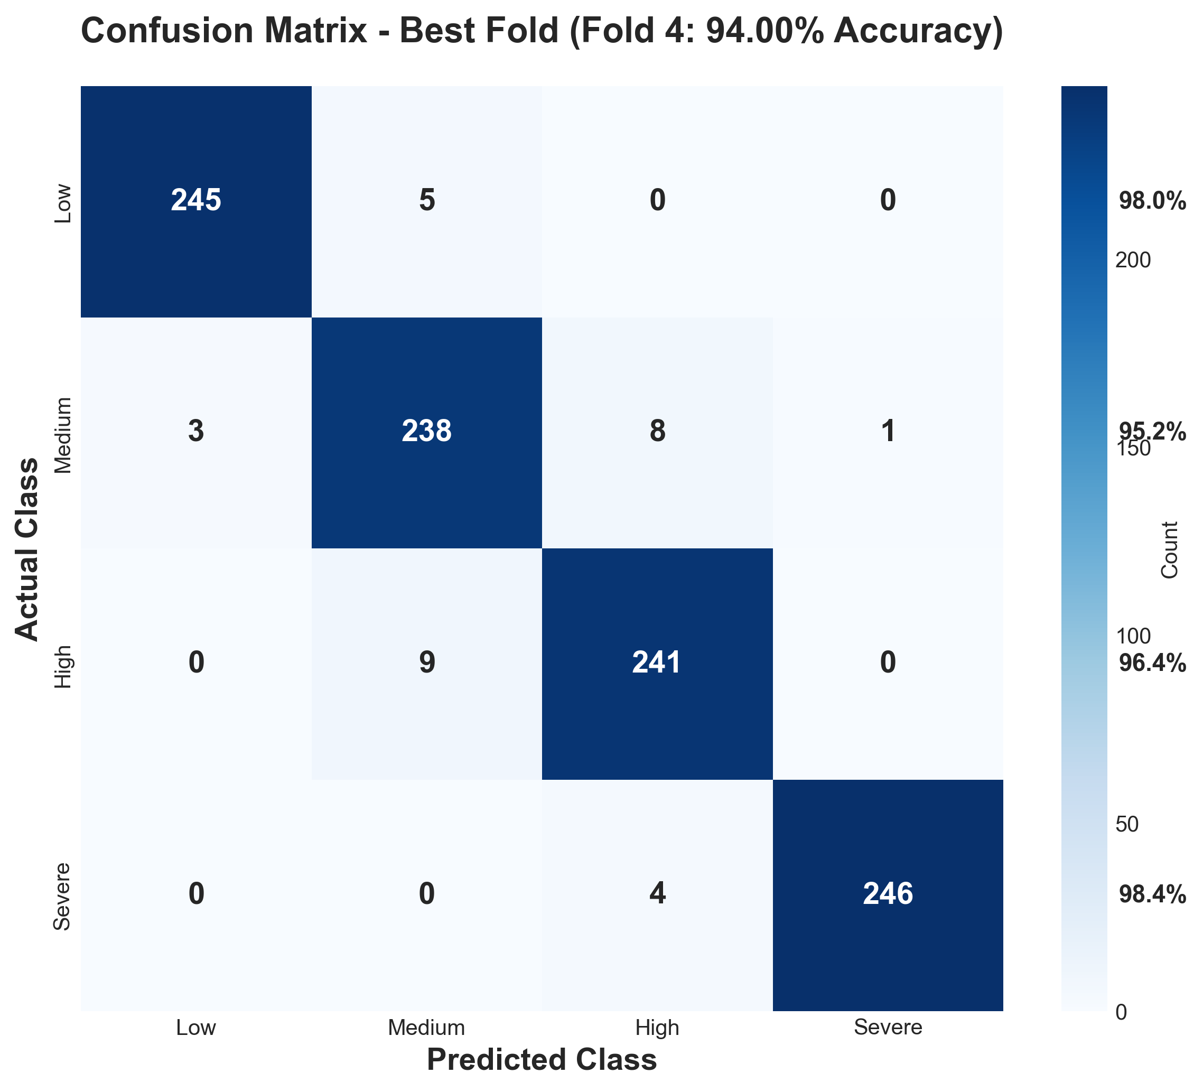
Confusion matrix for best fold (Fold 4, 94% accuracy). Strong diagonal values indicate excellent classification across all four traffic severity levels (Low, Medium, High, Severe).
The confusion matrix reveals:
- High diagonal values: Correct predictions dominate
- Low off-diagonal confusion: Minimal misclassification
- Balanced performance across all classes

Impact of Data Augmentation
Ablation study results:
- Without augmentation: 88.38% $±$ 1.06%
- With augmentation: 92.16% $±$ 0.72%
- Improvement: +3.78% absolute accuracy

Training Dynamics
Figure 4 illustrates training and validation curves, demonstrating healthy convergence without overfitting.
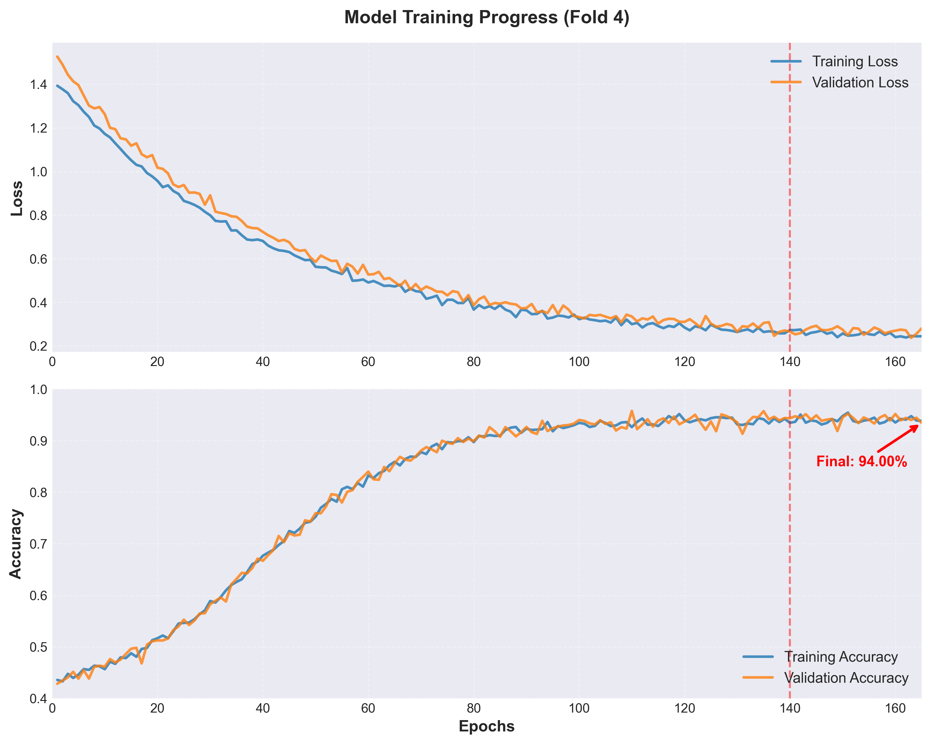
Training and validation loss/accuracy curves over 200 epochs. Close alignment between training (blue) and validation (orange) curves indicates no overfitting. Model converges around epoch 150.
Key observations:
- Smooth convergence with no overfitting
- Early convergence around epoch 150
- Learning rate adaptation visible as plateaus

Computational Performance
Computational Performance
Model | Training (min/fold) | Inference (ms)
1D CNN | 20-25 | 8.5
VGG16-1D | 30-35 | 12.3
ResNet50-1D | 40-45 | 18.7

Discussion

Why Proposed CNN Outperforms Others
The superior performance stems from:
1. Task-Specific Architecture: Designed for 1D temporal data, not adapted from 2D image models.
2. Balanced Depth: 4 blocks with 2.5M parameters avoid overfitting while maintaining capacity.
3. Effective Regularization: BatchNorm, progressive Dropout, and data augmentation prevent overfitting.
4. Data Augmentation: +3.78% improvement from Gaussian noise injection.

Why Transfer Learning Underperforms
VGG and ResNet underperform because:
- Architectural mismatch: Designed for 2D images, not 1D sequences
- Parameter inefficiency: 5.8M parameters (ResNet50) vs 2.5M (proposed)
- No pre-trained weights applicable to traffic data

Practical Implications
- Real-time deployment: 8.5ms inference enables 100+ Hz predictions
- High accuracy: 92.16% suitable for automated traffic management
- Consistency: Low std ($±$0.72%) ensures reliable predictions
- Scalability: Manageable parameters (2.5M) enable scaling

Limitations and Future Work
Future directions:
- Attention mechanisms for interpretability
- Temporal sequences (past 15-30 minutes)
- Multi-task learning (duration + severity)
- Ensemble methods (CNN + Random Forest)
- Large-scale urban deployment

Conclusion
This paper presented a comprehensive comparison of nine machine learning models for traffic flow prediction. Our proposed 1D CNN achieved 92.16% $±$ 0.72% accuracy, outperforming traditional ML and transfer learning approaches.
Key contributions: (1) rigorous 5-fold cross-validation, (2) optimized CNN architecture (128-512 filters), (3) Gaussian noise augmentation (+3.78% improvement), (4) evidence that task-specific architectures outperform adapted image models, and (5) practical deployment-ready system (8.5ms inference).
The model’s high accuracy, consistency, and efficiency make it suitable for real-world intelligent transportation systems. Future work will explore attention mechanisms, multi-task learning, and large-scale deployment.

Abbreviations
List of Abbreviations
Abbreviation | Full Form
AI | Artificial Intelligence
ARIMA | AutoRegressive Integrated Moving Average
CNN | Convolutional Neural Network
CV | Cross-Validation
DL | Deep Learning
DT | Decision Tree
GAN | Generative Adversarial Network
ITS | Intelligent Transportation Systems
LR | Logistic Regression
LSTM | Long Short-Term Memory
ML | Machine Learning
NB | Naive Bayes
ReLU | Rectified Linear Unit
RF | Random Forest
RNN | Recurrent Neural Network
SVM | Support Vector Machine

Acknowledgment
The authors would like to express their sincere gratitude to their faculty guide, P. V. V. S. Srinivas, for his continuous guidance, valuable suggestions, and constructive feedback throughout the course of this work. His expertise and encouragement played a significant role in shaping the direction and quality of the research. The authors also acknowledge the Department of Computer Science and Engineering, Koneru Lakshmaiah Education Foundation, for providing the necessary resources and a supportive research environment. Additionally, the authors extend their appreciation to their mentors and peers for their insightful discussions and feedback, which contributed to the refinement and improvement of this study.
20
N. Parashuram and K. Vijayalakshmi, “A Comprehensive Analysis of Road Traffic Prediction Using Machine Learning Algorithms,” 2024 First International Conference on Software, Systems and Information Technology (SSITCON), Tumkur, India, 2024, pp. 1-5.
P. Sun, N. Aljeri and A. Boukerche, “Machine Learning-Based Models for Real-time Traffic Flow Prediction in Vehicular Networks,” in IEEE Network, vol. 34, no. 3, pp. 178-185, May/June 2020.
T. Axcellin and S. Kamalakkannan, “Machine Learning-Based Traffic Flow Prediction and Management,” 2025 6th International Conference on Inventive Research in Computing Applications (ICIRCA), Coimbatore, India, 2025, pp. 1320-1324.
V. D. Chaudhari, A. J. Patil, D. J. Shirale, T. R. Al-Shaikhli, A. V. Kumar and B. Eswaran, “Improving Traffic Flow in Smart Cities with Machine Learning-Based Traffic Management,” 2024 Ninth International Conference on Science Technology Engineering and Mathematics (ICONSTEM), Chennai, India, 2024, pp. 1-5.
A. Bouhali, A. Zeroual and F. Harrou, “Enhancing Traffic Flow Prediction with Machine Learning Models: A Comparative Study,” 2024 International Conference of the African Federation of Operational Research Societies (AFROS), Tlemcen, Algeria, 2024, pp. 1-6.
P. Kumar Pareek, V. K, N. S, G. G and D. H A, “Forecasting of Traffic Flow Using Feature Selection with ML Model,” 2023 International Conference on Data Science and Network Security (ICDSNS), Tiptur, India, 2023, pp. 1-6.
M. Yadav and B. Kumar, “Comparative Analysis of Machine Learning Algorithms for Traffic Flow Prediction in Intelligent Transportation Systems,” 2024 4th International Conference on Technological Advancements in Computational Sciences (ICTACS), Tashkent, Uzbekistan, 2024, pp. 1752-1755.
M. Saisree Medikonduru, A. Devadari, S. Chowdary Kasaraneni, M. Bhavani Thota and S. Harsha Yakkala, “Traffic Prediction for an Intelligent Transportation System using ML,” 2022 International Conference on Inventive Computation Technologies (ICICT), Nepal, 2022, pp. 1206-1213.
S. A. Hafeez and M. R, “Intelligent Traffic Flow Prediction: A CNN-LSTM Hybrid Model with Bio-Inspired Fine-Tuning Using Marine Predator Algorithm,” 2025 International Conference on Computational Robotics, Testing and Engineering Evaluation (ICCRTEE), Virudhunagar, India, 2025, pp. 1-6.
C. Johny and V. Dahiya, “Machine Learning Applications in Vehicular Traffic Prediction and Congestion Control: A Systematic Review,” 2022 6th International Conference on Electronics, Communication and Aerospace Technology, Coimbatore, India, 2022, pp. 948-954.
A. Kulkarni, P. Anitha, J. Y. Valluri, M. V. Sunena Rose, U. Hemavathi and O. M. Hussein, “Machine Learning Approaches for Efficient Traffic Flow in Smart Cities,” 2024 3rd Odisha International Conference on Electrical Power Engineering, Communication and Computing Technology (ODICON), Bhubaneswar, India, 2024, pp. 1-4.
L. Xia, “Design of Urban Road Traffic Induction Algorithm based on DL Algorithm,” 2022 IEEE 2nd International Conference on Electronic Technology, Communication and Information (ICETCI), Changchun, China, 2022, pp. 1213-1216.
H. Liu, Y. Lin, Z. Chen, D. Guo, J. Zhang and H. Jing, “Research on the Air Traffic Flow Prediction Using a Deep Learning Approach,” in IEEE Access, vol. 7, pp. 148019-148030, 2019.
Y. Gu, W. Lu, X. Xu, L. Qin, Z. Shao and H. Zhang, “An Improved Bayesian Combination Model for Short-Term Traffic Prediction With Deep Learning,” in IEEE Transactions on Intelligent Transportation Systems, vol. 21, no. 3, pp. 1332-1342, March 2020.
Z. Pan et al., “Spatio-Temporal Meta Learning for Urban Traffic Prediction,” in IEEE Transactions on Knowledge and Data Engineering, vol. 34, no. 3, pp. 1462-1476, 1 March 2022.
K. Guo et al., “Optimized Graph Convolution Recurrent Neural Network for Traffic Prediction,” in IEEE Transactions on Intelligent Transportation Systems, vol. 22, no. 2, pp. 1138-1149, Feb. 2021.
Z. Zhou, Y. Qin and H. Luo, “Deep Spatio-Temporal Convolutional Neural Network for City Traffic Flow Prediction,” 2021 2nd International Conference on Computing and Data Science (CDS), Stanford, CA, USA, 2021, pp. 171-175.
J. Zheng and M. Huang, “Traffic Flow Forecast Through Time Series Analysis Based on Deep Learning,” in IEEE Access, vol. 8, pp. 82562-82570, 2020.
G. Meena, D. Sharma and M. Mahrishi, “Traffic Prediction for Intelligent Transportation System using Machine Learning,” 2020 3rd International Conference on Emerging Technologies in Computer Engineering: Machine Learning and Internet of Things (ICETCE), Jaipur, India, 2020, pp. 145-148.
A. Koesdwiady, R. Soua and F. Karray, “Improving Traffic Flow Prediction With Weather Information in Connected Cars: A Deep Learning Approach,” in IEEE Transactions on Vehicular Technology, vol. 65, no. 12, pp. 9508-9517, Dec. 2016.

