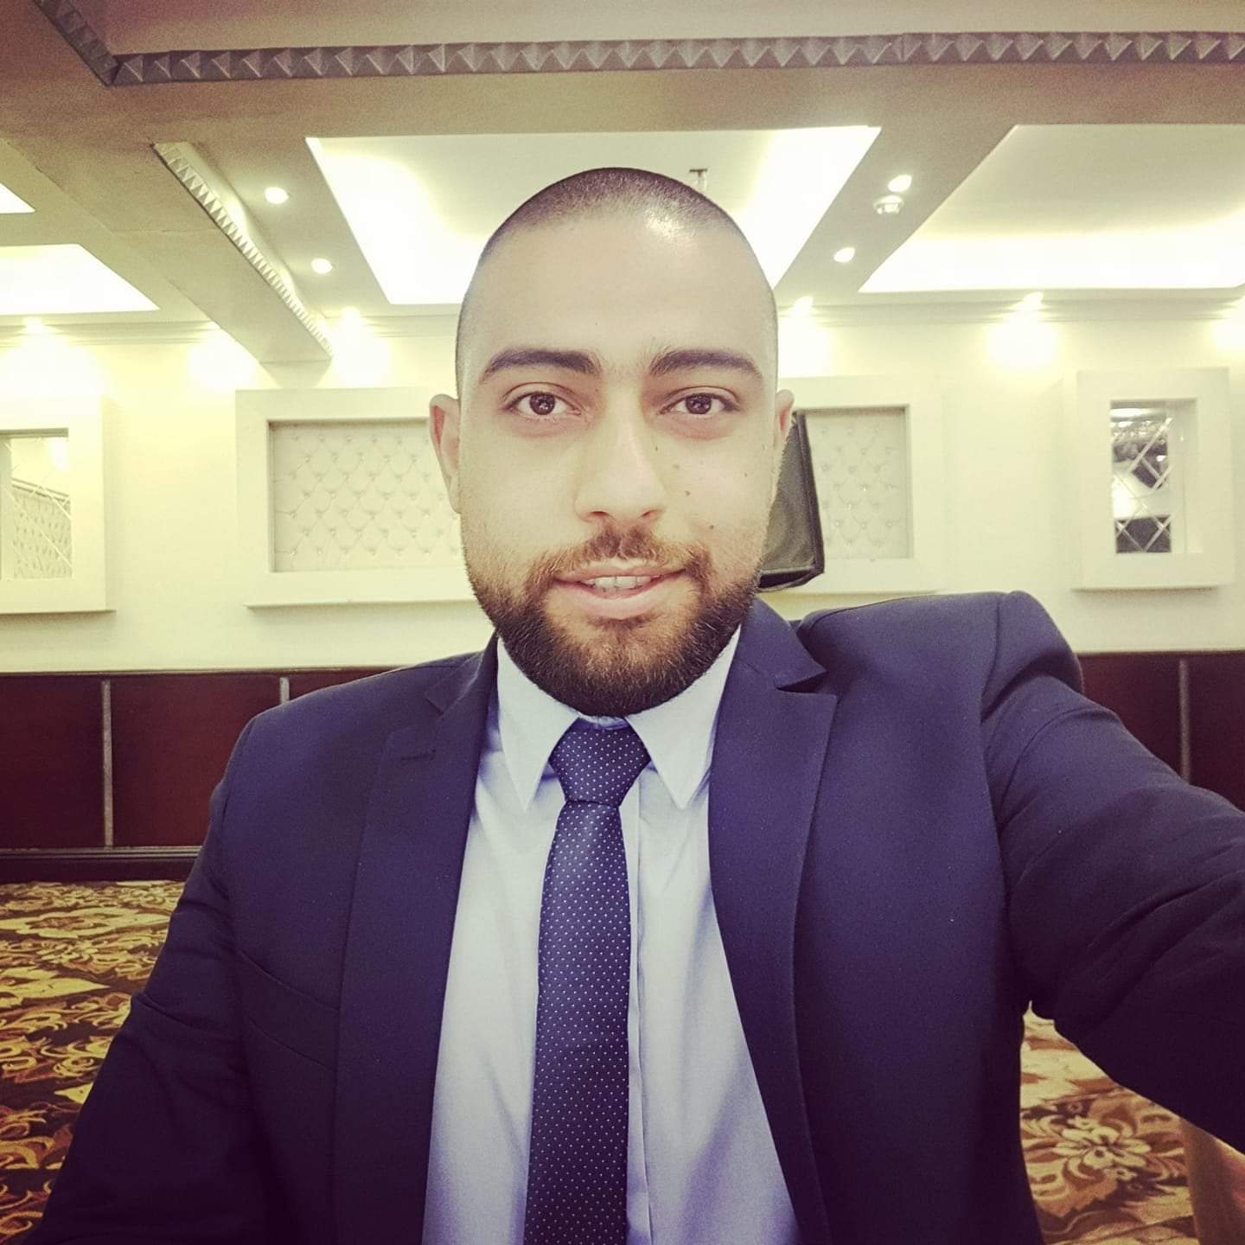

Contact

**Address:**

50 El Esawy Street, Sidi Bisher Alexandria

**Phone:**

**(+020) 755 434 104**

**Email:**

[SherifShickoo.m@gmail.com](mailto:SherifShickoo.m@gmail.com)

**LinkedIn:**

linkedin.com/Sherif.Shicko

Languages

Spanish – C2

Chinese – A1

German – A2

Hobbies

* Writing
* Sketching
* Photography
* Design

Summary

Senior Web Developer specializing in front end development. Experienced with all stages of the development cycle for dynamic web projects. Well-versed in numerous programming languages including HTML5, PHP OOP, JavaScript, CSS, MySQL. Strong background in project management and customer relations.

Skill Highlights

|  |  |
| --- | --- |
| * Project management * Strong decision maker * Complex problem solver | * Creative design * Innovative * Service-focused |

Experience

**Web Developer** - 09/2015 to 05/2019

**Luna Web Design**, Alexandria

* Cooperate with designers to create clean interfaces and simple, intuitive interactions and experiences.
* Develop project concepts and maintain optimal workflow.
* Work with senior developer to manage large, complex design projects for corporate clients.
* Complete detailed programming and development tasks for front end public and internal websites as well as challenging back-end server code.
* Carry out quality assurance tests to discover errors and optimize usability.

Education

Bachelor of Science: **Computer Information Systems** - 2014

**Alexandria University**

Certifications

PHP Framework (certificate): **Zend, Codeigniter, Symfony**.

Programming Languages: **JavaScript, HTML5, PHP OOP, CSS, SQL, MySQL**., React

Sherif Abd Elmoneim