ORCID ROLE ENRICHMENT
Where we are, and what to do next
Working document · updated 30 October 2026 · Analytics Engineering, Researcher 360
WHAT CHANGED SINCE THE LAST VERSION
Section 6 is new: every target audience now has its own heading, with Lecturer written out in full — how it is labelled, how accurate it has been shown to be in both directions, what was corrected and what is still open. The other eight are summarised and will be expanded in the same shape.

The validation was re-measured in both directions. The earlier 81.8% answered only "did we find them". Measuring the other way as well — do the people we put in an audience agree — gives 59.3% of 11,635 memberships confirmed, against a mechanical ceiling near 78%. Section 5 carries both numbers; neither alone is the answer.

Lecturer has been read end to end. 91.1% found, 78.2% agree, and 99.2% of the titles were read correctly — of 1,354 people who call themselves something else, only 50 have a title that is not a teaching title at all.

Fourteen corrections landed, covering 16,507 records, and the Lecturer audience moved by one person. The dictionary is cleaner and the audience is not, because the people holding a bad title almost always hold a good one too. That is the third time this project has measured it and it is section 6.1.3.

A third instance of the one-word failure was found and fixed. associate reaching teaching through associate professor, after member in October and fellow last week — 78,565 records between them. It needs a standing check, not a third discovery.

Head of Faculty is now university heads only. A medical director at a hospital was reaching it; rather than patch that one title the whole hospital path came out. 2,819 people leave, including 294 heads of department and 17 deans, and that cost was measured before the decision. A small, certain audience was preferred.

Head of Faculty grows for the first time, by 8.5%. The professor-plus-leadership compounds now reach it: 1,498 new confirmed people against 1,026 leaving Lecturer, which is 0.26% of that audience. It took a new mechanism — a pattern scoped to one group — because an unscoped one would have swept 14,500 records out of eight other groups, including 2.7% of the whole pharmacist group. head of X and dean are modifiers, not professions. Section 6.4 has the measurement and what is still open.

1. Where we are today
ORCID is where researchers write their own employment history: job title, organisation, department. All of it is free text. There is no field anywhere that says what profession someone is. We read that text and work it out.
 | Today | What it means
People with a profession | 673,851 | We can name a profession for them
Reachable | 501,508 | In the CDP and opted in. This is what a campaign can use
Audiences | 9 | Before this project there was one
Different job titles handled | 317,302 | The work runs once per title, not once per person
Different departments handled | 459,123 | Same again, for the subject area

The last two rows are the reason this is affordable. We do the thinking once, over the vocabulary, and store the answers. Giving 1.8 million people their profession after that is an ordinary database join.
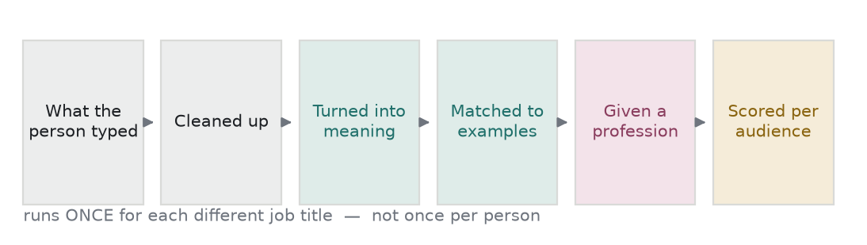
How one job title travels through the system.
2. One job title, followed all the way
This is the whole system in one example. Everything later in this document refers back to it.
EXAMPLE 1 — THE MACHINE DECIDES
A person typed Consultant Paediatrician as their job title.

what they typed Consultant Paediatrician
cleaned up consultant paediatrician
nearest example word consultant
how close 0.699 out of 1.00

So the title is given the profession Practitioner. That answer is stored once and reused for everyone who ever typed the same thing.

Now one actual person with that title. They work at a hospital, in a paediatrics department. Three things are scored and added up:

title 0.45 x 0.742 = 0.334
organisation 0.15 x 1.000 = 0.150
department 0.40 x 1.000 = 0.400
TOTAL = 0.884

The line for this audience is 0.70. They are in.

Now change one thing. Same job title, but the department says mechanical engineering. This audience needs the title and the subject to agree, so the person is not scored low — they simply do not appear at all. That second check is what stops a job title alone from putting someone in a healthcare audience.
EXAMPLE 2 — A PERSON OVERRULES THE MACHINE
The title junior researcher appears on 42,949 records.

The machine put it in the senior researcher group, and it was 0.870 confident. Very sure, and completely wrong. The reason is that the computer treats *junior* and *senior* as two ends of one idea, so they look similar to it.

Someone wrote one line in a file to say: this is early career. That line wins for ever and survives every rebuild.

But notice what it did not change. Both researcher groups feed the same audiences, so 42,949 records moved and not one person entered or left an audience. A correct dictionary and a correct audience are two different things.

3. Where each profession stands
"Read" below means a person has looked at job titles covering that share of the group's records. It does not mean the rest is wrong — it means nobody has checked it.
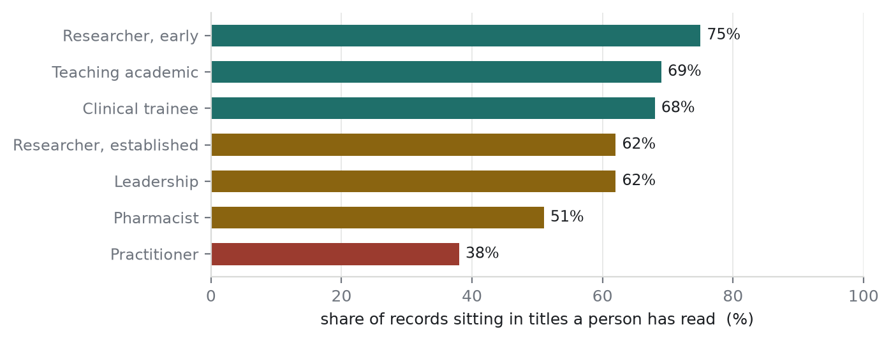
How much of each profession a person has actually read.
Profession | Records | Read | Condition | What it needs next
Practitioner | 1,650,456 | 38% | Weakest | A clinical expert. 52 of its example words are not in any taxonomy we have.
Clinical trainee | 751,548 | 68% | Good | Nothing urgent.
Teaching academic | 11,994,600 | 69% | Exposed | No subject check at all, so a wrong title goes straight through.
Researcher, early | 8,408,047 | 75% | Cleanest | Nothing. Zero corrections were needed on the first read.
Researcher, established | 1,945,519 | 62% | Good | Two naming clashes to settle. See section 7.
Leadership | 962,236 | 62% | Good | Watch one side effect after the next build.
Pharmacist | 74,951 | 51% | Fixed | Was the dirtiest group. 21% of its records were wrong and it cost the audience 91 people.
Librarian | 21,855 | n/a | Solid | Decided by the word itself, not by the machine. 0.4% known wrong.
Student | 1,970,615 | 0% | Not read | About to become an audience. Nobody has reviewed it.
Support / technical | 1,453,643 | n/a | Parked | Feeds nothing. Deliberately holds titles that belong nowhere.

WHY "PRACTITIONER" KEEPS COMING UP
It has the least review and it feeds the most audiences. Clinical job titles are also the most scattered vocabulary in the data.

Academic titles are nearly the same everywhere: Professor, Associate Professor, Lecturer. Clinical titles are not. Resident, Registrar, Facharzt, Interno and Jefe de Servicio can all mean a doctor in training, and they share no common word.

Real example: before October we had no example word for anaesthetists, so 2,765 of them were matched to neurosurgeon. And 2,684 veterinarians were matched to dentist, because dentist was the closest word we had given the machine.

4. The outside sources we now have
Until this month every number in this project came from our own pipeline. That is a closed loop. We now have three outside sources, and each one can check a different thing. None of them can check everything.
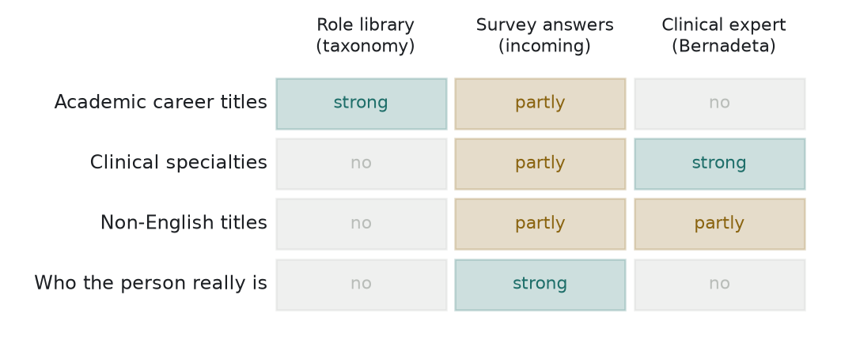
What each outside source can and cannot check for us.
4.1 The role library (the taxonomy)
Market Intelligence keeps a library of 315 job titles with a description, a sector and a role type for each. Chloe O'Donnell wrote it specifically because this project reads free text, so it is fuller than the short list they use in surveys.
What it confirms. 48 of our 151 example words appear in it. That is the first time anybody outside this project has checked our vocabulary.
What it cannot check. 103 of our example words are not in it, and they are not random:
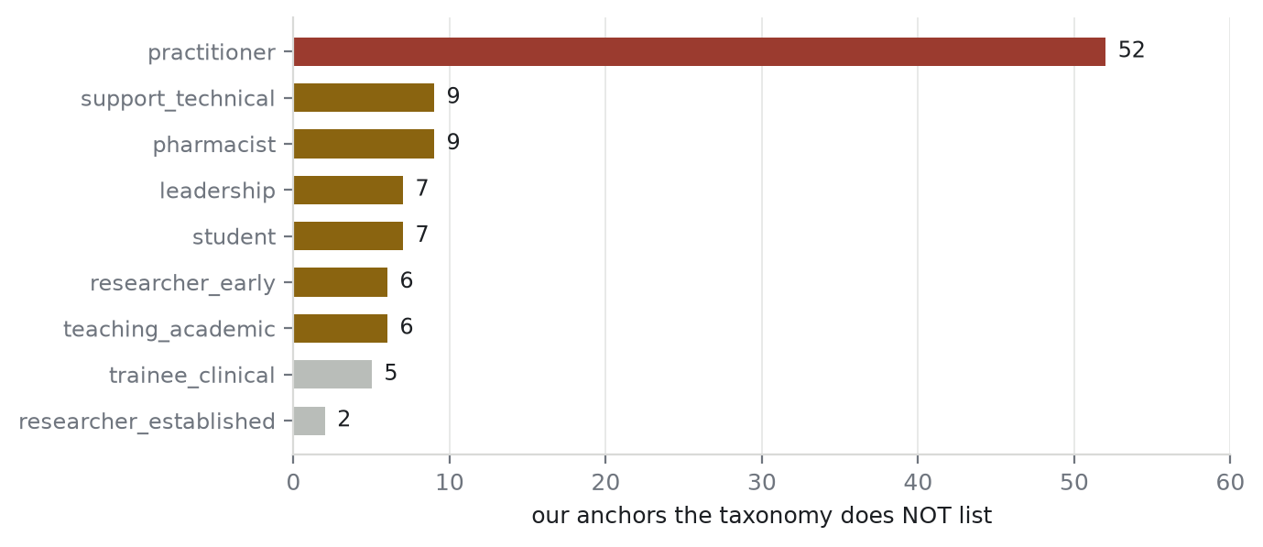
Our example words the taxonomy does not list, by profession.
WHAT THIS MEANS IN PLAIN TERMS
The role library is a research career taxonomy, not a medical one. Its healthcare section has Physician, Clinician, Surgeon and Healthcare Professional. It has no list of specialties at all — no cardiologist, no anaesthetist, no midwife, no veterinarian.

It is also written in English, so every foreign word we use is missing: dirigente medico, apotheker, pharmacien, eczaci, docente, dozent, wissenschaftlicher mitarbeiter.

Three conclusions. The 39 clinical example words we added in October were not redundant. We still need a clinical expert. And the taxonomy cannot check the multilingual half of our dictionary, which is exactly where our worst mistakes have been.

4.2 The survey answers — ARRIVED, and measured in section 5
Market Intelligence asks people their job title in most surveys. It is a closed question with 21 options, so the answers are clean. Crucially, some surveys also record the person's email address, which means we can match them to our own output.
Export | Rows | What it gives us
Journal Author Satisfaction | 109,396 | Email + the job title the person picked for themselves
Researcher Panel members | 232,648 | Opt-in email + self-selected job title

Both exports arrived on 30 October and have been used. 290,045 unique people after deduplication, 93.2% of whom could be mapped onto one of our ten professions. The full result is section 5. The headline: 81.8% of the people we classified were put in the audience they put themselves in, against a ceiling of 88.9%.
WHAT IT WILL AND WILL NOT TELL US
It will tell us where our profession disagrees with what the person says they do. That is a real external check and we have never had one.

It will not give us an accuracy percentage. The people in these surveys are a selected group: they publish, and they answer surveys. Librarians and students are barely in it. So it checks the research core well and the edges not at all.

And the 21 options do not line up with our 10 groups. The survey has Masters Student and PhD Student separately; we have one Student group. The survey has no pharmacist option and no librarian option at all, so those two audiences cannot be checked this way.

4.3 Clinical expertise
A call with Bernadeta is being arranged. Section 4.1 shows why this is still needed even though we now have a taxonomy: the taxonomy is silent on exactly the part where we are weakest. The three things worth asking for are any existing clinical title list, anything that explains how clinical titles differ between countries, and whether web-scraped data she worked on could help.
5. VALIDATION — our answer against what people said about themselves
Until the end of October every number in this project came from our own pipeline. Market Intelligence then exported two surveys in which people had picked their own job title from a fixed list and given an email address. That let us compare our answer to the person's own answer for the first time.
Source | Rows | Period
Researcher Panel | 232,648 | June 2022 – October 2026
Journal Author Satisfaction | 109,396 | April 2024 – October 2026
Combined, one answer per person | 290,045 | most recent answer kept

5.1 We measured the ceiling before measuring ourselves
34,372 people appear in both surveys, so they declared their own job twice. That gives something rare: a way to find out how reliable the yardstick is before using it.
PEOPLE DISAGREE WITH THEMSELVES 11% OF THE TIME
same person, two surveys, same profession 88.9%
same person, two surveys, same words 60.6%

So 88.9% is the ceiling. Nothing we do can score meaningfully above it, and 85% would be close to perfect rather than poor.

Their disagreements are real rather than careless:

627 professor in one, research scientist in the other
523 professor in one, editor in the other
288 head of department in one, professor in the other
180 student in one, academic in the other (time: people move on)

Measuring this first is the point. Without it we would have compared our own number against an implied 100% and called a good result a failure.

5.2 A cleaner yardstick: people who do not contradict themselves
Merve, 30 October: treat self-declaration as the truth, but only from people who are consistent about it. Of the 34,372 who answered both surveys, 3,613 contradicted themselves and were dropped. The remaining 28,866 are the ground truth used from here on.
5.3 Two questions, not one — and they give different answers
A single agreement figure hides which way the system is failing. There are two separate questions and they fail independently:
- Did we FIND the people who say they are this? A low score means we are missing people. (Recall)
- Do the people we PUT here say they are this? A low score means we are letting the wrong people in. (Precision)
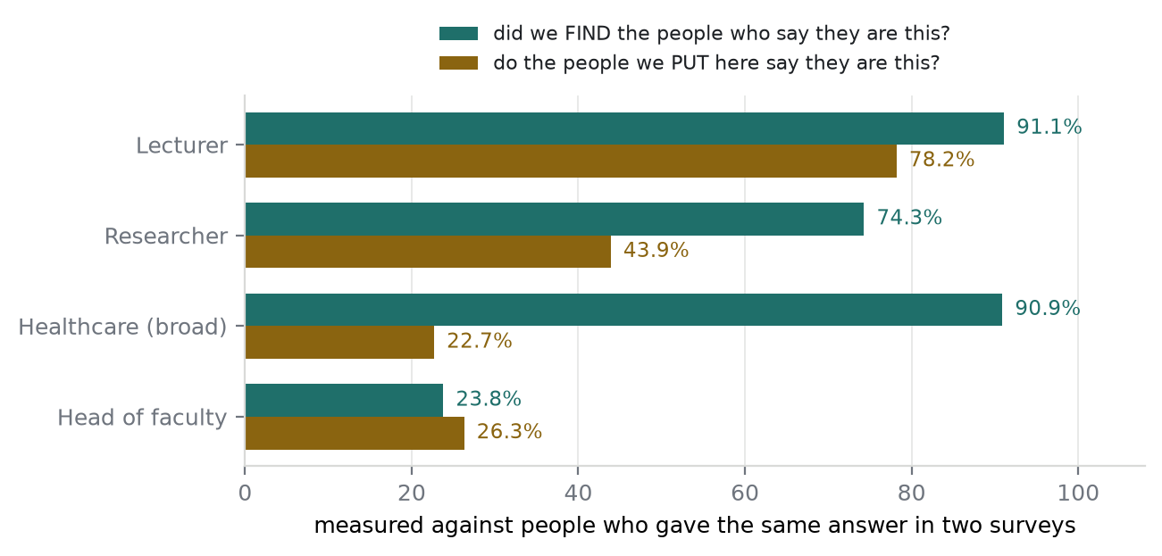
The same audiences, measured in both directions against the consistent ground truth.
Audience | People in it | Did we find them? | Do they agree? | Read
Lecturer | 6,206 | 91.1% | 78.2% | Strong both ways
Researcher | 2,967 | 74.3% | 43.9% | Precision depressed by multi-role people
Healthcare (broad) | 1,148 | 90.9% | 22.7% | A wide net by design — see below
Practitioner | 615 | — | 35.8% | Survey cannot split the healthcare sub-audiences
Clinical researcher | 396 | — | 48.2% | Same
Head of faculty | 232 | 23.8% | 26.3% | Weak both ways. Real.
Clinical administrator | 71 | — | 22.5% | 71 people — too few to conclude
Pharmacist | 20 | — | — | Cannot be measured — no survey option
Librarian | 4 | — | — | Cannot be measured

Overall, 6,902 of 11,635 audience memberships were confirmed by the person themselves — 59.3%.
WHY PRECISION IS LOWER THAN IT LOOKS
The truth set records one answer per person. Our system gives each person 1.53 audiences on average.

So a professor who is in both Lecturer and Researcher, and who wrote "Professor" on the survey, is counted right for Lecturer and wrong for Researcher — even though they may well do both.

That caps precision at roughly 78% before anybody makes a mistake. The measured 59.3% sits below it, so there is a real gap, but it is not the gap the raw numbers suggest.

5.4 Which of these are problems and which are the design working
Healthcare (broad) at 22.7% is mostly deliberate. That audience admits anybody in a clinical department even when their job title is academic — a Professor of Cardiology belongs in it. They write "Professor" on the survey and the measurement calls it a miss.
AND THAT NUMBER IS USEFUL: IT PRICES AN OPEN QUESTION
887 people in the Healthcare audience describe themselves as something other than a clinician — mostly professors and researchers in clinical departments.

Whether they belong there is open question 2 in the marketing document: is "healthcare professional" about the work or about the subject?

That has been an abstract argument about definitions. It now has a price: if marketing answers "the work", those 887 are wrong and the audience shrinks. If "the subject", they are right and nothing changes.

Researcher at 43.9% and Practitioner at 35.8% are mostly the same effect — a professor who runs a research group, a consultant who is also a professor. Both descriptions are true and the survey only takes one.
5.5 The real limit is coverage, not accuracy
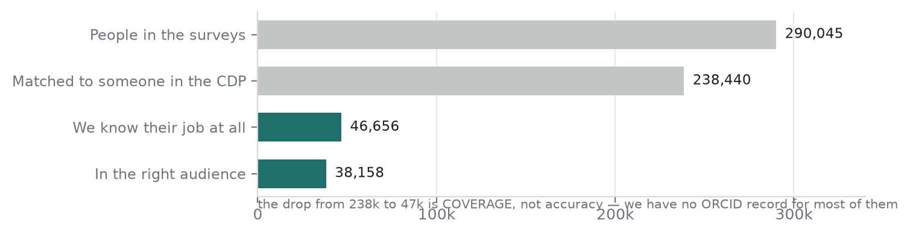
Where the 290,045 survey respondents go.
We matched 238,440 of them to somebody in the CDP, and then knew the job of only 46,656 — a quarter. The rest have no ORCID employment record we can read.
This confirms from outside what the project has been saying from inside: the ceiling on this work is how many people we can say anything about at all, not how often we are right about the ones we can.
5.6 What it found: the one-title-one-group rule
Head of Faculty scored 20%, and the Researcher audience 69.9%. The biggest single cause is the same in both, and it is a design choice rather than a bug.
A PROFESSOR CAN ONLY BE ONE THING
4,210 said "research scientist" we said teaching academic
654 said "head of department" we said teaching academic
2,602 said "PhD student" we said teaching academic

All of them have Professor recorded as their ORCID job title, and a title belongs to exactly one profession in our system. A professor who researches, runs a department or supervises doctoral students is only a lecturer to us.

This was already an open question — worth 463,603 records — and it was marked low priority because it is a design change rather than a setting. It now has outside evidence: more than ten thousand people describe themselves differently from us, and this rule is why.

Head of Faculty has two further causes, both of them decisions taken deliberately in the last week: it counts current posts only, and it was narrowed to universities only on 29 October.
5.7 What this is not
- It is not an accuracy rate. Self-declaration is a second opinion, not a fact. People pick one option from a list to describe a life that has several.
- The population is selected. These are people who publish and who answer surveys. Librarians appear seven times. Students and support staff are barely represented.
- Two audiences cannot be checked this way at all — the survey offers no pharmacist and no librarian option worth the name.
- Head of Faculty is the one genuine weakness. It is poor in both directions — we miss three quarters of the people who say they lead a faculty, and three quarters of the people we put there do not say it. The causes are all known and two of them were chosen on purpose: one title can only belong to one profession, the audience counts current posts only, and it was narrowed to universities on 29 October.
- It is repeatable. The comparison is a query, so it can be re-run after every change as a regression check. That is new, and it is worth more than the single number.
6. Every target audience, one by one
Nine audiences. This section gives each one its own heading: how big it is, how it is labelled, how accurate it has been shown to be, what we fixed and what is still open. Lecturer is written out in full because it is the one we have measured most; the others are summarised and will be expanded in turn.
Two numbers appear throughout and they are not the same thing. They fail in opposite directions and an audience can be good at one and poor at the other:
- Did we find them? Of the people who say they are this, how many did we put in the audience. A low score means we are missing people.
- Do they agree? Of the people we put in the audience, how many say they are this. A low score means we are letting the wrong people in.
Both are measured against 28,866 people who answered two separate surveys the same way. Those people agree with themselves 88.9% of the time, so 88.9% is the ceiling for either number.
Audience | People | Did we find them? | Do they agree? | State
Lecturer | 399,884 | 91.1% | 78.2% | Best measured. Detailed below
Researcher | 321,824 | 74.3% | 43.9% | Good. Precision depressed by multi-role people
Healthcare (broad) | 126,869 | 90.9% | 22.7% | A wide net on purpose
Practitioner | 60,937 | — | 35.8% | Survey cannot split the healthcare sub-audiences
Clinical researcher | 50,600 | — | 48.2% | Same
Head of faculty | 17,528 | 23.8% | 26.3% | The weak one. Known causes
Clinical administrator | 6,865 | — | 22.5% | 71 people checked — too few
Pharmacist | 2,245 | — | — | Cannot be measured — no survey option
Librarian | 668 | — | — | Cannot be measured — 4 people

6.1 LECTURER — teaching academics
The largest audience and the best understood. It is built from the teaching_academic title group and asks only one question of a person: does their job title name a teaching post.
6.1.1 How big it is, and who decided
 | Figure | Against what
Job titles in the group | 74,365 | out of 317,302 distinct titles in ORCID
Employment records | 11,994,600 | the largest group by a wide margin
People in the audience | 399,884 | 308,671 of them reachable
Example words behind it | 15 | professor, lecturer, docente, dozent, reader…
Decided by the machine | 99.705% | 74,339 titles
Decided by a person | 0.295% | 26 titles, 35,380 records
Decided by a literal pattern | none | patterns exist only for Librarian

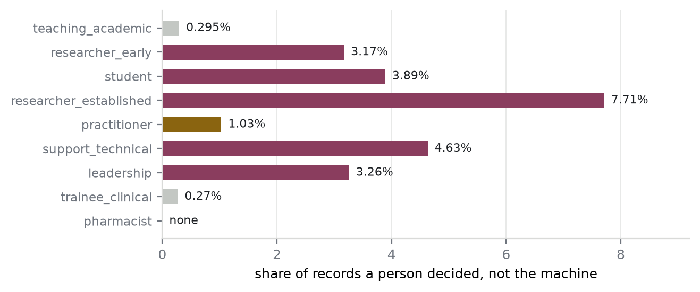
Share of a group's records whose title a person decided by hand. Teaching academics have the least human attention of any assigned group, and the most records.
Fifteen hand-written words classify twelve million records. That ratio is the whole design: we never classify people, only the vocabulary, and the vocabulary is small because job titles repeat.
Where the human decisions went
26 titles, and they are the ones the machine could not have got right — mostly because it does not speak the language:
THE FOUR LARGEST HUMAN CORRECTIONS IN THIS GROUP
dr öğr üyesi 4,246 Turkish assistant professor, matched 'wissenschaftlicher mitarbeiter'
doç dr 2,547 Turkish associate professor, matched 'medical doctor'
ayudante doctor 1,861 a Spanish teaching post, matched 'medical doctor'
אקדמי בכיר פרופסור 248 Hebrew for senior academic professor

The machine sent all four towards medicine, because the strings contain *dr* or *doctor*. A person who reads Turkish or Hebrew fixed them in one line each.

6.1.2 How accurate is it
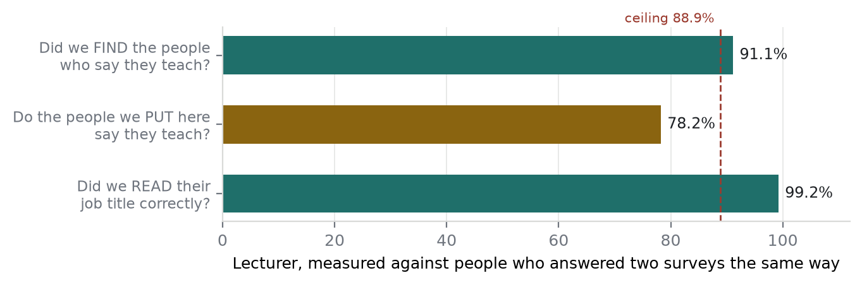
Three different questions about the same audience, measured 30 October.
91.1% — did we find them? Of the people who told a survey they are an academic and whom we classified at all, we put 91.1% in Lecturer. That is above the 88.9% ceiling, which does not mean we beat it: the ceiling compared one answer to one answer, while this asks whether Lecturer is among the roles we gave the person. The easier test.
78.2% — do they agree? Of 6,205 people we put in Lecturer and can check, 4,851 call themselves academics. The other 1,354 call themselves something else — mostly researchers, students or heads of department.
99.2% — did we read the title right? This is the one that measures *us* rather than how people describe themselves. Of those 1,354, only 50 have an ORCID job title that is not a teaching title at all. The rest wrote *Lecturer* or *Professor* in their employment record and then picked a different option on a survey form.
WHY 78.2% IS NOT AN ERROR RATE
103 people wrote 'lecturer' in ORCID, said 'PhD student' on the survey
93 people wrote 'professor', said 'Laboratory Director'
54 people wrote 'professor', said 'Head of Department'

None of these is a mistake. They hold a lectureship AND they are a doctoral student, or a lab head, or a department head. The survey takes one answer; a career has several.

And the first line is marketing's own rule: on 21 October the decision was that if somebody teaches they go in Lecturer, doctoral student or not.

6.1.3 What we fixed, and what it taught us
Fourteen corrections on 30 October, covering 16,507 records, found by reading the group four ways: by example word, by margin, by single-word titles, and by titles carrying another profession's vocabulary.
Title | Records | Was | Now
associate | 6,631 | teaching | rejected — names no profession
visiting ph d student | 2,036 | teaching | student
senior advisor | 1,754 | teaching | rejected
facultativo especialista | 1,222 | teaching | practitioner — Spanish hospital consultant
assistenzarzt | 1,133 | teaching | clinical trainee — German junior doctor
assistant editor | 1,133 | teaching | support
visiting | 585 | teaching | rejected — no occupation attached
assistenzärztin | 487 | teaching | clinical trainee
alumni | 433 | teaching | rejected — being a graduate is not a job
科主任 | 406 | teaching | leadership — Chinese department head
co-editor | 312 | teaching | support
universitätsassistent | 280 | teaching | early researcher — Austrian doctoral post
recenseador | 95 | teaching | rejected — Portuguese census enumerator

The pattern behind six of them has now cost us three times.
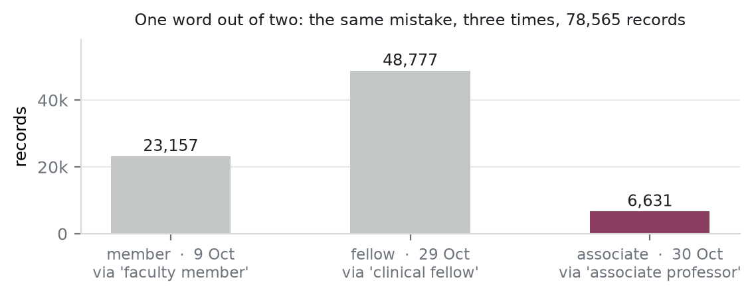
A title matching ONE word of a two-word example term.
member reached faculty member. fellow reached clinical fellow. associate reached associate professor. In each case the single word carries no occupation at all — an associate is a grade at a law firm as readily as a university — and in each case it took a human reading the list to notice. 78,565 records, and it will happen again. A check for it should run with every build.
AND A CORRECTION DOES NOT TRAVEL TO OTHER LANGUAGES
Three of the fourteen were fixes we had already made, escaping in another language or inflection:

university assistant corrected in October, universitätsassistent was not
visiting scientist moved 21 October, visiting ph d student was not
assistenzarzt fixed 30 October, assistenzärztin needed its own row

The dictionary keys on the exact string, so every correction should be followed by the question: what is this in the other languages we see?

THE FIXES BARELY MOVED THE AUDIENCE, AND THAT IS THE LESSON
16,507 records left the teaching group. The Lecturer audience went from 6,206 to 6,205 people in the checkable sample, and precision stayed at 78.2%.

Because somebody who wrote associate in one employment record almost always wrote associate professor in another. Removing the bad title does not remove the person — they are still a lecturer, through a better record.

A correct dictionary and a correct audience are different things. This is the third time the project has measured that, and it is the single most useful thing to remember when judging whether a fix was worth making. It was — the dictionary is what the next audience will be built on.

6.1.4 What is still open
Question | Records | Where it stands
Are visiting scholars and fellows teaching staff? | 81,749 | Open. visiting scholar 60,561, visiting fellow 15,832. May teach, may only research
Is an honorary professor active? | 6,651 | Open. We rejected emeritus professor and honorary researcher; this one survived
Compound titles split by word order | ~68,000 | Open. professor and director is leadership, professor & director is teaching
Does a title that names two jobs count as both? | 78,000 | Decided 30 Oct — no, they stay in Lecturer. Awaiting marketing's confirmation
Are teaching assistants lecturers? | 178,205 | Decided 21 Oct — yes, if they teach

THE STRUCTURAL RISK WORTH KNOWING
Lecturer asks only about the job title. Its department weight is zero, so there is no second signal to catch a wrong one.

weakest acceptable title 0.75 x 0.70 = 0.525, resolved organisation 0.25 = 0.775
the line is 0.60

Anything that lands in the teaching group reaches the audience as soon as the organisation resolves. Compare healthcare, where the department has to agree before anybody is confirmed.

That is why the group is read by hand more often than its 6.7% uncertainty figure would suggest it needs — nothing else is checking.

The other eight, in brief. Each will get the same treatment as Lecturer in turn. For now, where they stand.
6.2 RESEARCHER — 321,824 people
74.3% found, 43.9% agree. Built from two title groups, researcher_early (8.4M records) and researcher_established (1.9M), which both feed this one audience — the seniority split is computed and then never used.
The low precision is largely an artefact. A professor who runs a research group is in both Lecturer and Researcher; the survey records one answer, so one of the two memberships is counted wrong whatever we do.
Its cleanest half. researcher_early needed zero corrections on its first read — the only group in the project that did. Being generic did not make researcher dirty, because the space around it is densely packed with real research vocabulary.
Same structural risk as Lecturer: department weight zero, no second signal.
6.3 HEALTHCARE (BROAD) — 126,869 people
90.9% found, 22.7% agree. The widest net: it admits anybody whose job title is clinical or whose department is, so that nobody clinical is missed.
The 22.7% is mostly the design working. 887 of the people in it describe themselves as professors or researchers rather than clinicians — they are there because of their department. A Professor of Cardiology belongs in it and will write *Professor* on a survey.
And that number prices an open question. Whether those 887 belong is marketing question 2: is *healthcare professional* about the work or about the subject. The argument used to be abstract; it now has a figure attached.
6.4 HEAD OF FACULTY — 17,528 people, 19,026 after the next build
23.8% found, 26.3% agree. The weakest audience we have, and poor in both directions.
But most of the recall gap is not a defect. Of people who say they head a department, around 62% wrote only professor in ORCID — nothing in their record says they lead anything. We cannot know, and the standing rule is not to guess.
Three known causes, two of them chosen deliberately. One title belongs to one profession, so a dean who wrote *professor* is a lecturer to us. The audience counts current posts only. And it was narrowed to universities on 29 October at a measured cost of 2,819 people — a decision taken knowingly, preferring a small certain audience to a large arguable one.
And it is starved by the organisation, not the title. About 14,600 records carry a strong leadership title — average score 0.856 — and can never be confirmed because the organisation did not resolve and therefore scores zero.
MEASURED 30 OCTOBER: THE COMPOUND TITLES, AND WHAT THEY WOULD BUY
This is the one route that could materially grow the audience from data we already hold: titles naming both posts — professor and head of department, professor & dean. They sit in teaching today, so none of them reaches Head of Faculty. Sized for the first time on 30 October:

head or dean, no chair word 1,982 titles 78,005 records
chair word only 968 titles 44,611 records
both 49 titles 1,421 records

**chair is ruled out. 335 chair titles over 8,889 records are endowed professorships**, not leadership posts — Canada Research Chairs, a Dean's Chair, a European Lehrstuhl. Reading the visible rows had put that at ~1,600 records; measured, it is five times larger. And the exclusion cannot be written as a pattern: the pattern layer is a plain text match, and BigQuery's regular expressions have no way to say "not", so "contains professor and chair but not research chair" is not expressible in one row.

The head and dean family, measured both ways and then shipped. 1,706 titles over 48,995 records, held by 2,354 people:

Lecturer 399,884 -> 398,858 -0.26%
1,026 leave; 1,328 hold another teaching title and stay
Head of Faculty 17,528 -> 19,026 +8.5%
1,498 new and confirmed; 280 already in; 543 no ROR match

The organisation does not block it, which was the one thing that could have. 1,702 of the 2,354 are at an Education or Facility employer. What strands 14,600 strong leadership records elsewhere does not strand these, because a professor who also heads a department is at a university and the ROR resolves.

AND `head` ON ITS OWN CANNOT BE TRUSTED EITHER
Reading the list found that the word does not always mean a leadership post:

assistant professor director head and neck surgery 107 anatomy
professor - senior consultant - head of thrombosis unit 128 clinical unit
assistant professor head of spine center 151 clinical centre
associate professor - head of scientific committee 156 a committee
dean of the sport sciences faculty 2010-2020 professor 126 ENDED in 2020

head and neck surgery settles it: a bare head match would read an anatomical term as a faculty post. So the rule has to name the level — head of department, head of school, head of faculty, head of institute, head of division, dean. Those are positive and specific, so they need no "not".

The pattern layer was the obvious answer, and the measurement killed it
1,982 titles cannot be written out as individual overrides, so the plan was to extend the pattern layer beyond librarian for the first time — a pattern matches professor and head of department and head of department professor identically, which would have closed the word-order question too. Three queries were run first. The second one ended it.
WHAT THE PATTERN WOULD HAVE TAKEN WITH IT — 14,500 RECORDS, EIGHT GROUPS
A pattern matches every title containing the phrase, not only professor compounds:

researcher, early 5,217 records associate dean research
researcher, established 3,389 principal researcher - head of department
practitioner 2,353 head of department of cardiology
pharmacist 1,990 cluster pharmacy manager & head of department
support / technical 1,023
student 396 sub-dean graduate studies
clinical trainee 91 dean s clinical research fellow
librarian 14 associate dean of library services

Against a gain of about 49,100 records out of teaching. And the reason is structural, not a regex that needs tightening:

**head of X and dean are modifiers, not professions. They attach to any job, so a pattern matching them overrides the profession word standing next to it in the same string. A head of a cardiology department stops being a clinician. A pharmacy manager stops being a pharmacist — and 1,990 records is 2.7% of the entire pharmacist group**, in the audience that has no external check at all.

A pattern cannot reject and forces a score of 1.0, and it is undone one title at a time, so repairing that would take hundreds of exclusions — worse than the override list it was meant to replace.

This is the one-title-one-profession decision restated with numbers. Marketing's rule that a title names one profession is exactly what makes the profession word the one that has to win. Being a head of department is an attribute of a job; it is not the job.
WHAT SHIPPED — A PATTERN THAT APPLIES WITHIN ONE GROUP
A pattern row can now say only when the model already put this title in teaching. That removes the 14,500-record sweep by construction: practitioner, pharmacist and the researcher groups are never consulted. The three librarian collisions go the same way, the word-order split closes because a pattern matches every separator, and the profession word still wins.

10 patterns head of department / school / faculty / institute / division,
head of the department, head of dept, dean, decano, dekan
10 exclusions the possessives - dean s chair, college of science dean s
distinguished professor, dean s assistant full-time lecturer
1 correction ... vice dean/ acting dean/ dean s advisor IS a deanship.
The exclusion regex had flagged it on the possessive alone
3 decisions the collision titles, all to librarian

Why the trade is defensible, and it is not that Head of Faculty is small. Under the one-title-one-profession rule something has to be dropped from professor and head of department, and the two readings are not equal: heading a department at a university entails being an academic there, while being a professor entails nothing about leading anything. The leadership reading keeps both facts; the teaching reading throws one away. That is an argument about what the title says.

WHAT IS STILL NOT CERTAIN, AND IT IS SMALL
One flaw was found while writing it and fixed before it shipped. The scope has to mean the model *assigned* that group, not merely that teaching was its nearest guess. The nearest group is recorded even for a title the model rejected as too weak, so conditioning on it would have promoted those titles with a perfect score — rescuing precisely what the confidence floor exists to hold back.

Two things the build will settle. A title that is teaching by human decision rather than by the model will not be claimed, which would show up as slightly fewer than 1,706 titles moving; there are 26 human decisions in that group and none of them is a head or dean compound, so this should be nil. And the four smallest patterns — dekan with 2 titles, head of dept and decano with 4, head of faculty with 6 — would fail the test that every pattern must match something, if even one of those few turns out to be a human decision. That failure is the guard working, and the fix is one word in a note.

And one known residual: 26 titles, 604 records, 1.2% of the scope. They carry their own dates, and a date is not a rule — dean 2010-2018 has ended, dean 2014- and head of department 1997-pres have not, and one title carries both ranges with the headship on the open side. Query L lists all 26 to be read rather than regexed.

A FOURTH SIGHTING OF THE SAME FAILURE, IN THE POSSESSIVE
dean s chair, dean s clinical prize, dean s clinical research fellow, dean s research assistant — an award or a post named after the dean, which a dean match reads as a deanship.

It is the shape that gave us member (23,157), fellow (48,777) and associate (6,631): a word that means something only in company. Found this time before it shipped rather than after, which is the first time that has happened.

6.5 PRACTITIONER and CLINICAL RESEARCHER — 60,937 and 50,600 people
35.8% and 48.2% agree; neither has a recall figure, because the survey offers only *Physician/Clinician* and *Healthcare professional* with no sub-breakdown.
Practitioner is the least-read group in the project — titles covering 38% of its records, against 75% for early-career researchers. Clinical vocabulary is the most scattered in the data: 58 example words and still not enough, because *Resident*, *Registrar*, *Facharzt* and *Interno* share no common word.
It is also where the role library cannot help. 52 of our 58 clinical example words are absent from it — it has Physician, Clinician and Surgeon but no specialty list at all. That gap is what the clinical expert conversation exists to fill.
6.6 CLINICAL ADMINISTRATOR — 6,865 people
22.5% agree, on 71 people checked — too few to conclude anything.
Worth one note from 29 October: medical director was moved into leadership so it would reach this audience, and 198 people arrived. The same move put 145 people into Head of Faculty, where they do not belong, and that was accepted rather than fixed because removing them would have cost 294 heads of department and 17 deans.
6.7 PHARMACIST — 2,245 people
Cannot be measured. The survey has no pharmacist option, so this audience has no external check at all and will not get one from this source.
What we do know is internal. It was proportionally the dirtiest group in the project — 21% of its records were wrong, caused almost entirely by five foreign example words, with French praticien sitting three letters from pharmacien.
And fixing all of that moved the audience by 91 people. The weights make a pharmacy department effectively mandatory, so a chemist without one was never confirmed in the first place. The clearest demonstration in the project that a dictionary and an audience are different things.
6.8 LIBRARIAN — 668 people
Cannot be measured externally — four people in the ground truth set.
But it is the one audience whose error rate we actually know, because every assignment is exact. It is decided by eleven literal patterns rather than by the machine, so each of its 871 titles either contains the word or does not. We read the exceptions: 89 records of 21,855, or 0.4%, both of them genetic and chemical *libraries* rather than library staff.
That is a different kind of evidence from everything else here — not a sample, a complete reading. It is possible only because the group is small and the rule is literal.
7. How to use the taxonomy well — step by step
The taxonomy is built for a B2C research audience, so most of it is not about us. The aim is to take only the parts that improve our matching and leave the rest. Here is the order to do it in, cheapest and surest first.
Step 1 — Check the synonym groups. (DONE 30 October)
The taxonomy groups titles that mean the same job. There are 124 such groups and 254 pairs to check. The rule is simple: if two titles are the same job, they must land in the same profession in our system. Where they do not, one of them is wrong.
No judgement is needed and nobody has to read anything. It is a query.
WHY THIS IS THE BEST FIRST STEP
We already found one of these by hand, and it is the biggest open problem on the list:

assistant research professor 14,060 records -> Teaching academic
research assistant professor 71,785 records -> Researcher, early

The taxonomy lists those two as the same job. We put them in different professions, which means they feed different audiences. That is 85,845 records split by nothing more than word order.

The synonym check would have found this automatically, and it will find the others we have not noticed.

Step 2 — Finish the gap list we already measured.
We compared every taxonomy title against our dictionary and measured which gaps are real in ORCID. Four have been fixed, covering 80,417 records. Four are left and are listed in section 6.
The rule that matters here: a gap is not automatically a new example word. A title nobody types into ORCID is not worth adding, and a title already landing in the right place does not need anything.
A PREDICTION THE MEASUREMENT KILLED
Before running it, I expected allied health professional to be a real gap. It is a standard umbrella term in the UK health service, covering physiotherapists, radiographers and occupational therapists.

It appears 0 times in ORCID. Nobody writes it as their job title.

Had we added it as an example word without measuring, we would have gained nothing and taken on one more risk. This is why we measure before adding.

Step 3 — Use the descriptions to settle open questions.
The taxonomy has three columns we have not used at all: a description, typical responsibilities, and typical outputs. These are the richest part of it, and they are what settles an argument about where a job belongs.
EXAMPLE — A BOUNDARY CASE THE DESCRIPTION SETTLES
clinical scientist 1,671 records -> we put it in Clinical trainee

It got there through the example word clinical fellow, matching on one word.

The taxonomy says: *"A scientist applying laboratory or analytical expertise to diagnosis, monitoring and treatment in healthcare."*

That is a qualified healthcare scientist, not a doctor in training. The description answers the question without anybody needing to be an expert.

We have thirteen open questions waiting on marketing. For several of them the taxonomy's own words are the evidence to put in front of the meeting.
Step 4 — Use the role type, but only where it is clear.
The taxonomy sorts titles into about 23 role types. Most do not line up with our 10 professions, because theirs is about seniority and ours is about occupation. Comparing all of them would produce noise.
Four of them are unambiguous and worth checking:
Taxonomy role type | Must become | If it does not, it is a real finding
Clinical practitioner / researcher | practitioner | A doctor is in the wrong group
Clinical trainee | trainee_clinical | A trainee is in the wrong group
Student / trainee | student | A student is counted as staff
Former / inactive researcher | rejected | A retired person is in a live audience

Step 5 — Do not use it for two things.
- Clinical specialties. It does not have them. That is the clinical expert's job.
- Non-English titles. It has almost none. That is the survey data's job, and our own reading.
Trying to stretch the taxonomy over these would waste time and give false comfort.
Step 6 — Keep the useful part as a permanent test.
Once the synonym check is done, turn it into a test that runs with every build. Then a future change to our example words cannot quietly split a synonym group again. The one in step 1 went unnoticed for months.
8. Which matches need the most attention
Ranked by how many records are affected. The first two are the same problem seen twice: the same job written two ways, landing in two professions.
What is wrong | Records | Why it happened | What to do
research assistant professor is in Researcher, while assistant research professor is in Teaching | 85,845 | The machine matched one on *research assistant* and the other on *assistant professor* | Decide which is right, then one line each
research director is a researcher, but director of research was in a group that feeds nothing | 22,403 | Same job, different word order | Done on 29 Oct
fellow on its own was treated as a doctor in training | 48,777 | Matched on *clinical fellow*, one word out of two | Done on 29 Oct
pi was given no profession at all | 17,219 | Scored 0.537, below the line we accept, so it was dropped | Done on 29 Oct
statistician feeds nothing, but biostatistician and bioinformatician are researchers | 7,094 | Three similar jobs, one treated differently | Asked of marketing — see the questions document
medical director was treated as someone who treats patients | 7,715 | A medical director runs a unit; they do not see patients | Done on 29 Oct — watch one side effect
privatdozent and pd are given no profession | 2,046 | German academic rank. Scored 0.642, just under the line | Check what pd really is, then two lines
Retired and emeritus titles still in live audiences | 15,317 records / 1,065 people | 878 different spellings, no two alike | Recorded as a known limit. Not worth fixing

A RULE WE LEARNED THE HARD WAY THIS WEEK
We have always picked what to review by how many records a title carries. For finding people who are wrongly in an audience, that is the wrong order — by a factor of fourteen.

retired and emeritus titles 15,317 records
people they actually put in an audience 1,065

The reason is simple. A role looks at a person's whole career. Someone who typed *Professor Emeritus* usually also has *Professor, 1990-2020* behind it, and that older record keeps them in the audience anyway. Removing the first one changes nothing for them.

So: to fix the dictionary, sort by records. To fix the audience, sort by people. Using the first to answer the second nearly bought us a change we did not need.

9. What happens next
# | What | Why now | Who
1 | Run the synonym check | Written as analyses/28. Finds splits like the 85,845-record one automatically. No judgement needed. | Us
2 | Fold its findings into the next build | So Students, the consent basis and these corrections all land in one rebuild and one round of checking. | Us
3 | Add the Students audience | Agreed at the meeting. All decisions already made: internships count, trainees do not, current post only, one bucket for all levels. | Us
4 | Add the fourth consent basis | is_book_author_communications_opted_in. Agreed. Half an hour. | Us
5 | Match the survey answers | The first real outside check. Needs the files. | Us
6 | Clinical expert call | The one gap no data source covers. | Merve / Bernadeta
7 | Reach the survey data in BigQuery | Chloe pointed at Staging_Response. Would make the check repeatable instead of a one-off export. | Us / data eng

Items 3 and 4 should go in the same build, so there is one rebuild and one round of checking rather than two.
HOW THE 145 WERE RESOLVED — AND THE PATTERN TO REMEMBER
Moving medical director into Leadership was right for the Clinical Administrator audience. But Leadership feeds two audiences, and we only wanted one of them:

leadership -> hcp_administrator (what we wanted)
-> faculty_head (what we did not)

The arithmetic lets a hospital medical director straight through:

0.60 x 1.000 (the title, forced to full marks by our correction)
0.40 x 0.500 (a hospital)
TOTAL 0.800 the line for Head of Faculty is 0.65

Measured: 145 people. That is 0.7% of Head of Faculty. Small — except that this is the one audience built for precision rather than reach, so being right matters more here than anywhere else.

Why there is no easy fix. The system has no way to say 'this title must not feed that audience'. The only veto that exists works on the organisation name, not the job title. So the choices are all compromises:

Option | What it costs
Lower the hospital score for Head of faculty | Would have to drop from 0.50 to below 0.125, which removes every head of faculty whose record names a hospital — including real medical school deans
Move medical director back to Practitioner | Fixes this, but puts them back in an audience for people who treat patients, which they do not
Accept the 145 and record it | Honest, costs nothing, leaves a known error in the audience we most want to be right
Build a title-level exclusion | The proper fix. A model change plus a new test, for 145 people

Both measurements came back on 29 October. medical director added 198 people to Clinical Administrator, so the move itself was worth it. And the hospital path into Head of Faculty carried about 2,000 people — 826 director, 294 head of department, 17 dean — so lowering the score would have cost far more than the 95 medical directors it removed.
The decision went further than the measurement suggested. Rather than trade one group off against another, Merve took the whole hospital path out: Head of Faculty is university heads only. It is the one audience built for precision rather than reach, there is no second signal available in it, and coverage can come back later from a faculty-leadership source. The ~2,000 leave knowingly.
This is worth reading twice, because it is the shape of problem we will keep meeting: a correction that is right for one audience is wrong for another, because they share a group. Nothing in the current design separates them.

