SPRINGER NATURE · RESEARCHER 360
Role Enrichment from ORCID
Findings, method and model performance
1 October 2026 · Status: design validated on real data, not yet in production
PURPOSE OF THIS DOCUMENT
To record what we are building, what the data actually showed when we measured it, how well the model performs, and what is still open. Every figure here was produced by a query against the live ORCID, ROR and CDP tables. Nothing is estimated.

Executive summary
Marketing needs audiences by professional role — healthcare professionals, pharmacists, researchers, faculty leadership. Today each one is hand-built with regular expressions, which took weeks for the HCP audience alone and still misses every job title not written in English.
We built a pipeline that classifies the 355,803 distinct job titles in ORCID once, caches the result, and then labels people with a plain database join. The classification uses an embedding model that another team had already provisioned, so no new AI infrastructure was required.
Five rounds of measurement changed the design substantially. The most important finding was unexpected and is set out in Section 6.
Headline | Figure | Meaning
ORCID profiles available | 24,864,410 | The raw population
Carry a Springer Nature identity | 1,755,447 | 7.1% — the rest are unreachable
With a usable employment record | 823,427 | Public visibility and a job title present
Present in CDP | 1,684,121 | 95.9% — identity linkage is not a problem
Marketing consent | 423,904 | 24.1% — consent is the real constraint
Advertising consent | 328,406 | 18.7%
Classification accuracy | 100% | 64 of 64 on the labelled test set

The pipeline is designed so that adding a new role is a configuration change rather than a new engineering project. That is the point of the work, and it is what the measurement exercise was protecting.

1. What we are trying to do
Three things, in order of importance.

Deliver role-based audiences
Given a role, return the list of Springer Nature identities that hold it, together with the evidence for each one and whether the person can lawfully be contacted.

Make adding a role cheap
The HCP audience took weeks of hand-written rules. The sixth role should take a day. This is the difference between a one-off project and a capability.

Work across languages
ORCID is global. A German cardiologist writes “Oberärztin Kardiologie” and a Turkish one writes “kardiyolog”. Rule-based matching cannot cover this; the existing HCP document names it as a known limitation of the current approach.
WHAT THIS IS NOT
This is not a replacement for the existing HCP pipeline. It generalises it. The existing HCP output is the benchmark the new system has to reproduce before anything is built on top of it.

2. What we use
Layer | Component | Why
Data warehouse | BigQuery | The data is already there. Nothing leaves it.
Transformation | dbt | Versioned, testable, scheduled. Same tooling as our existing pipelines.
Semantic matching | Vertex AI embedding model | Already provisioned by another team. Verified multilingual.
Search | BigQuery VECTOR_SEARCH | Native function. No separate vector database.
Organisation identity | ROR registry | Open, free, and ORCID already references it.
Adjudication | Gemini | For ambiguous titles. Not yet available — see Section 10.

The only component we do not have is the Gemini connection. The pipeline runs without it; Section 10 explains what that costs.

Data sources
Source | What we take
ORCID — employment records | Job title, organisation, department, country, dates, organisation identifier
ORCID — education records | Degree and field of study (dropped — see Finding 5)
ROR registry | Organisation type: healthcare, education, company, government and so on
CDP — audience_builder_big | Identity, email address, marketing consent, advertising consent

3. Which ORCID fields we read
An ORCID profile is broad. We read a narrow slice of it.
Field | What it contributes | Populated
employment.role | The job title. The primary signal. Free text, every language. | 81.9%
employment.organisation_name | The employer. A title means different things in a hospital and a bank. | 100%
employment.department_name | The department. This turned out to be where the discipline lives. | 78.5%
employment.disambiguated_organisation_id | ORCID's own organisation identifier. Gives the organisation type for free. | 78.8%
employment.full_end_date | Empty means the post is current. Required for leadership roles. | —
employment.country_code | Country, recorded per post rather than per profile. | 100%
employment.visibility | Public, limited or private. We use public only. | 95.8% public

Fields we deliberately do not use
Field | Reason
publications | 1.24 billion records across 783,044 journals. A strong future signal, but a separate phase.
keywords, peer_reviews | Useful supplementary signals. Not needed to deliver the current roles.
emails | ORCID email addresses are mostly private. Email comes from CDP instead.
country_codes (profile level) | The per-post country is more accurate. Someone can hold a German profile and a UK post.
education | Dropped after measurement. See Finding 5.

4. The data, as measured
Before designing anything we measured what is actually in the tables. Three results shaped every decision that followed.

The working population is far smaller than the raw table
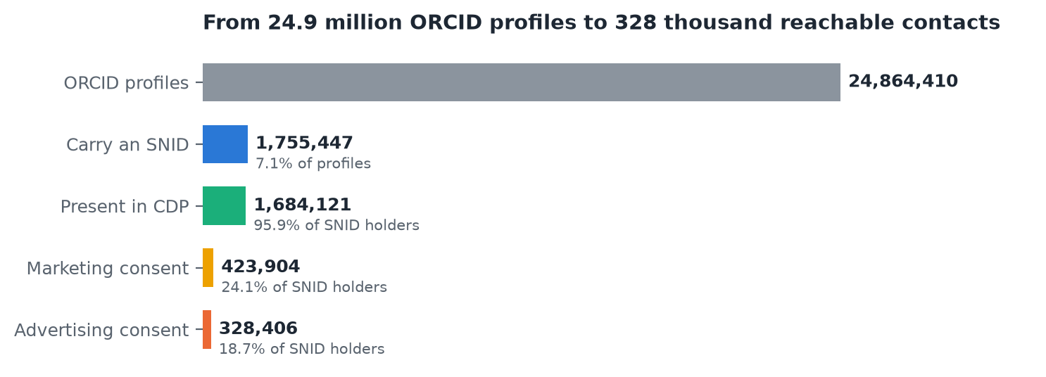
Figure 1 — Only 7.1% of ORCID profiles carry a Springer Nature identity. Identity linkage is then near-perfect, but consent removes three quarters of what remains.
Two conclusions. First, identification is not the bottleneck: 95.9% of identified people are already in CDP. Second, consent is. Every output of this pipeline therefore reports reachable counts, not matched counts — “we found 47,000 people” is a misleading number on its own.
A CORRECTION WORTH RECORDING
Of the 1,755,447 people carrying an identity, 823,427 have an employment record that is both public and has a job title filled in. That smaller figure is the true base for role assignment.

The fields we depend on are well populated
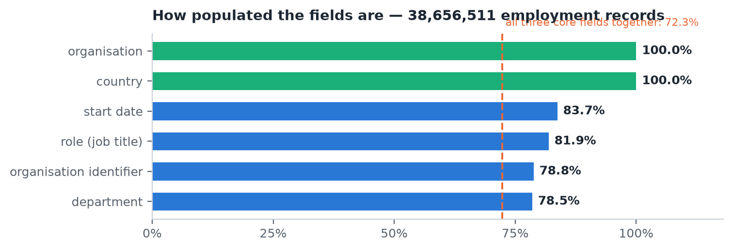
Figure 2 — Department being 78.5% populated is what justifies the weight it carries in scoring. 72.3% of records carry all three core fields.

Organisation identity needs more than one route
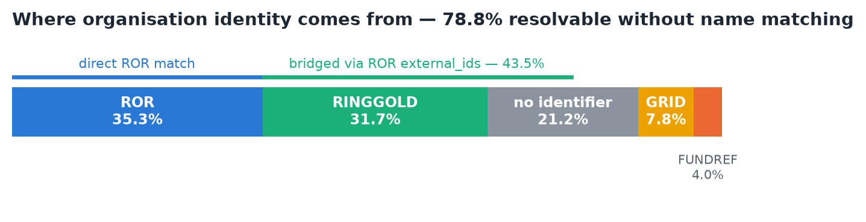
Figure 3 — Relying on ROR identifiers alone would leave us blind to the organisation type on 65% of records. The other identifier systems are stored inside the ROR record, so we bridge through them.

5. Method

Classify titles, not people
Thousands of people share one job title. Deciding “Professor” once labels all of them. So the AI runs over the 355,803 distinct title strings, not over the millions of employment records, and the result is cached permanently.
Approach | Cost | Repeatability
Send every record to a model | 38,656,511 calls per run | Different answer each run
Classify distinct titles once | 355,803 calls, once | Identical every run

After the dictionary is built, labelling people is a database join: instant, free, and deterministic. That last property matters — an audience list that changes when you rerun it is not usable.

The decision rule
Our first attempt compared a title against each role and accepted the closest match above a threshold. Calibration against 37 hand-labelled examples showed this does not work.
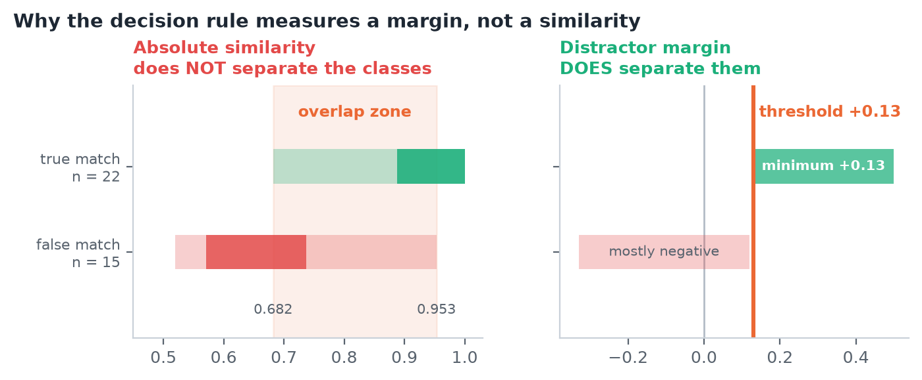
Figure 4 — True and false matches overlap heavily on absolute similarity. “Pharmacologist” scores 0.953 against pharmacist anchors but is not a pharmacist. The margin against unrelated occupations separates them cleanly.
The fix was to teach the system 72 common occupations that are none of our target roles — software engineer, lawyer, HR manager — and change the question from “how similar is this to the role?” to “how much more similar is it to the role than to unrelated work?” True matches clear +0.13; false matches are mostly negative.
Two further mechanisms sit alongside it. Role-specific exclusion terms caught 9 of the 15 false matches on their own. And a tie band accepts every role within 0.12 of the best, so a title that genuinely belongs to two roles keeps both.

6. Findings
Six results from the measurement rounds, in the order they changed the design.

Finding 1 — The embedding model is multilingual
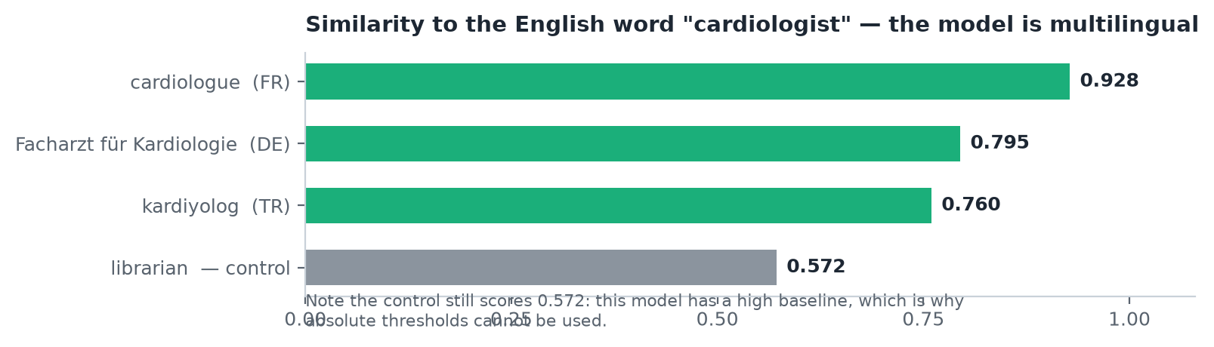
Figure 5 — French, German and Turkish equivalents all score high against the English term. No translation step is required.
This was not guaranteed: the model was provisioned for matching institution names, which are mostly English. Had it been English-only, every non-English title would have been dropped silently. It also revealed that the model has a high baseline similarity, which is why the decision rule had to be rebuilt around margins.

Finding 2 — The job title says POSITION, not DISCIPLINE
This is the most important result in the project and it reversed a design decision.
We tried to assign every title to a broad occupational field. It failed: 73.5% of records were unassignable or ambiguous, and the groups that did win, won on noise. “Lecturer” (903,050 records) was assigned to law. “Assistant professor” (2,513,601) to physical chemistry.
The reason is visible in the data. The most common ORCID job titles are:
Job title | Records
assistant professor | 2,513,601
associate professor | 1,715,550
professor | 1,480,748
lecturer | 903,050
researcher | 743,113
postdoctoral researcher | 604,970

None of them state a field. They state a rung on the academic ladder.
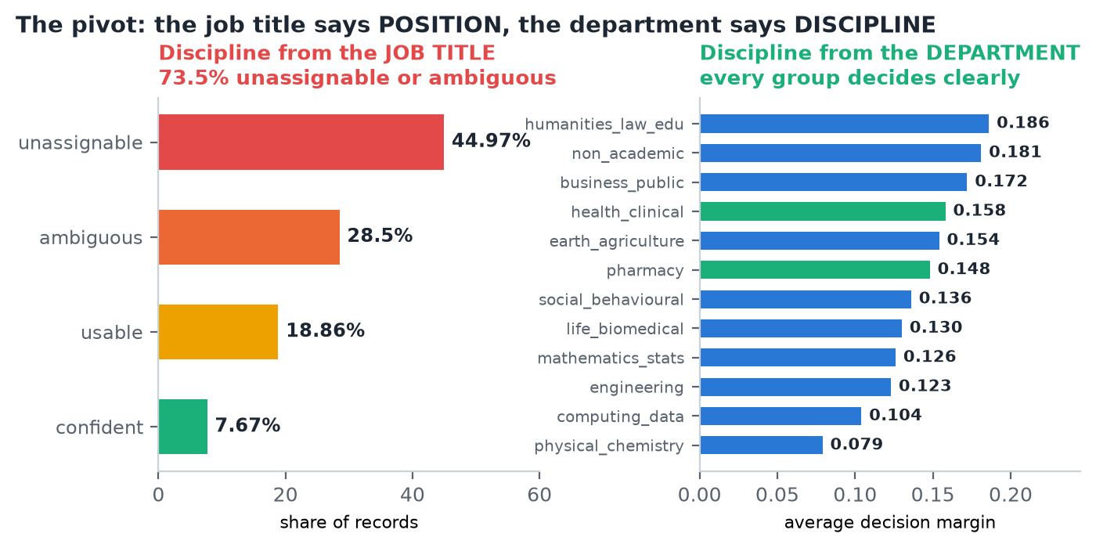
Figure 6 — The same classification run against the department field instead. Every group decides with a clear margin.
WHAT CHANGED BECAUSE OF THIS
The taxonomy was split into two independent axes. POSITION is read from the job title; DISCIPLINE is read from the department. Our roles are then combinations of the two — and “researcher in any field”, which never fitted a single flat list, becomes expressible.

Finding 3 — Both axes are usable together
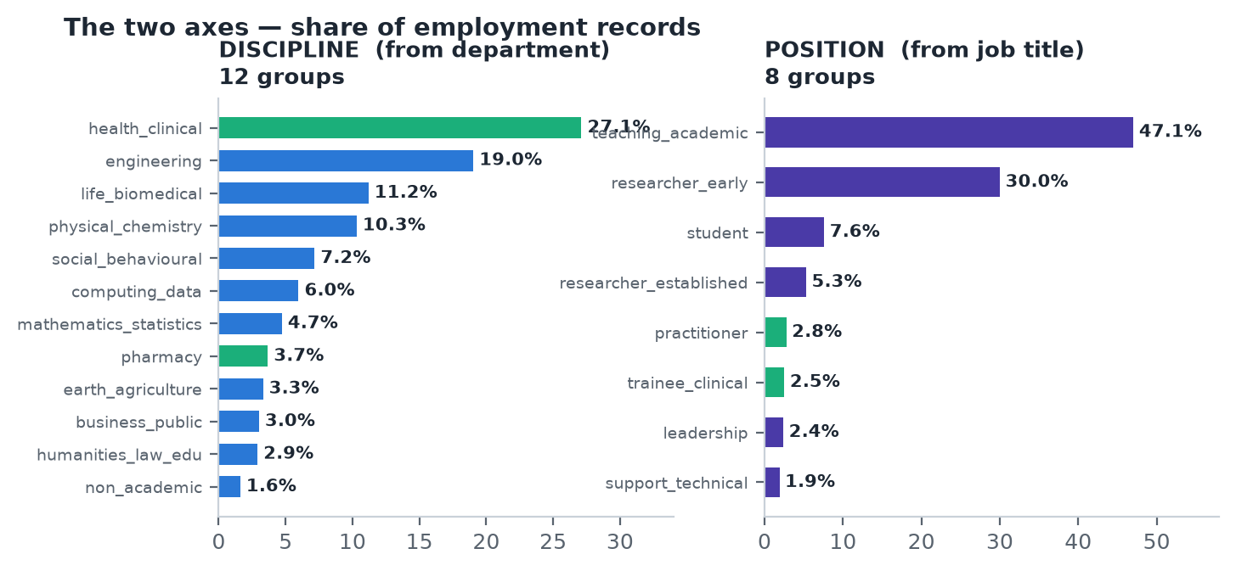
Figure 7 — The final taxonomy. Green marks the groups our current roles depend on.
Between 82.7% and 93.8% of records in every position group also carry a department, so the two axes are available together for the great majority of people.

Finding 4 — Errors cluster by word shape, and can be caught systematically
“Radiology” was being assigned to earth sciences because it rhymes with “geology” — 71,300 records in the wrong group. We found it by reading a sample, which neither scales nor proves anything.
So we built an audit that uses regular expressions as a checker rather than a classifier: any department containing “cardiolog” is clinical, and if the model disagrees, that is a defect. The audit found five more real errors covering roughly 58,000 records, including a systematic one — the pharmacy group was pulling in chemistry departments.

Finding 5 — The degree field records level, not subject
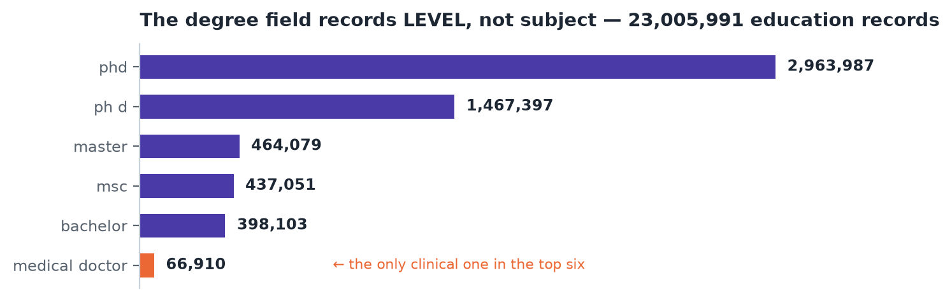
Figure 8 — The six most common degree values. Only one of them is clinical.
The education signal was meant to lift borderline cases. Measurement showed the degree field is dominated by academic level: 2,963,987 records say “phd”, which says nothing about whether someone practises medicine. Of 302,701 distinct degree strings, our rules matched 4.1%.
Because the employment department now supplies the discipline signal directly, education was dropped. The HCP regression test will confirm whether that costs anything.

Finding 6 — ORCID is the wrong source for librarians
Measure | Figure
Distinct librarian job titles | 969
Employment records | 26,047
People | 1,154
Present in CDP | 1,066
Marketable | 258

969 distinct titles for 1,154 people is almost one title per person — there is no frequency head to review and nothing for an embedding to amortise against. More fundamentally, ORCID is a researcher identifier and librarians are not researchers, so most never create one. 258 marketable contacts is not a pipeline failure; it is the true size of the overlap.
DECISION
The librarian role is dropped from this pipeline. If a librarian audience is needed commercially it requires a different source — CDP self-reported role, institutional contacts or conference registrations.

7. Model performance
Test | What it measures | Result
Labelled test set | 62 departments with hand-assigned correct answers, including every known trap | 100% (64/64)
Trap departments | 18 specifically confusable departments checked individually | 18/18 correct
Multilingual verification | Whether non-English titles reach their English equivalents | Passed
Decision margins — discipline | Average separation between first and second choice, 12 groups | 0.079 – 0.186
Decision margins — position | Same, 8 groups | 0.085 – 0.157
Exclusion terms | False matches caught by role-specific exclusions alone | 9 of 15
Unassignable records | Share of records the discipline axis cannot place | 1.6%

For context, the earlier design — assigning discipline from the job title — left 73.5% of records unassignable or ambiguous. Moving the discipline signal to the department reduced that to 1.6%.

How the roles are defined
Each role is a query over the two axes rather than a separately engineered classifier.
Role | Position (from title) | Discipline (from department)
researcher | researcher_early or researcher_established | any field
lecturer | teaching_academic | any field
faculty_head | leadership | academic organisation
hcp | any | health_clinical
pharmacist | any | pharmacy
librarian (dropped) | — | see Finding 6

A professor of cardiology receives both “lecturer” and “hcp”. That is correct, and the multi-label structure preserves it.
A SIDE EFFECT WORTH NOTING
“Lecturer” had been deferred because a UK Lecturer is roughly a US Assistant Professor and we could not reconcile them. On the position axis both are simply teaching_academic. The problem disappeared.

8. Strengths and limitations

What this approach does well
- Works across languages without translating. Verified on French, German and Turkish. The existing HCP pipeline cannot do this.
- Deterministic. AI runs once per distinct title and the answer is cached. The same question returns the same audience.
- Calibrated rather than guessed. Every threshold in the system came from a measurement, and the measurement is reproducible.
- Errors are caught by class, not by luck. The audit checks all 500 frequent departments against decisive word stems, so a whole family of mistakes is found at once.
- Adding a role is configuration. A role is a query over two axes. The seventh role costs a day, not a quarter.
- Every assignment carries its evidence. Each person in an audience is accompanied by the title, organisation and department that put them there.

What it does not do, or does not do yet
- Not yet run end to end. These results come from analysis queries. The dbt pipeline is written but has not produced a production table.
- Tested on the frequent values only. Validation covered the 500 most common titles and departments. The long tail is unmeasured.
- One label per department. “Electrical and computer engineering” is genuinely two disciplines; we currently assign one. It does not affect the current roles.
- 11.6% of records have no department. Those people get a position but no discipline, so they cannot qualify for HCP or pharmacist.
- Some titles cannot be resolved at all. “Dr” appears on 96,439 records and is a courtesy title, not a role. These rely entirely on the department.
- No second opinion on ambiguous cases. The LLM adjudication step has no Vertex AI connection yet. Ambiguous titles currently fall to human review.
- The benchmark test has not been run. Reproducing the existing HCP list is the real validation gate and it is still ahead of us.

9. What happens next
# | Step | Why it matters
1 | Run the remaining validation queries | Confirms the corrected anchors on the title axis
2 | Rebuild the dbt models around the two axes | Turns the validated design into production tables
3 | Reproduce the existing HCP list | The gate. Nothing is built on top until this passes
4 | Produce audiences for the four surviving roles | researcher, lecturer, faculty_head, hcp, pharmacist
5 | Review the most frequent ambiguous titles by hand | A few hundred titles cover a large share of people
6 | Deliver to the Braze contract | Final schema, with consent applied

Open decisions
Question | Owner | Consequence
Vertex AI connection for Gemini | Infrastructure | Without it, ambiguous titles need manual review on every new role
Marketing consent or legitimate interest | Data protection | 423,904 contacts versus 1,684,121
Whether a librarian audience is needed at all | Commercial | If yes, it needs a source other than ORCID

Appendix — every measurement
All figures were produced by queries against the live tables. The queries are version controlled alongside the pipeline.

Population and volume
Measure | Figure | What it decided
ORCID profiles | 24,864,410 | The starting point
Carrying an identity | 1,755,447 | The real population; filtered at source
With a usable employment record | 823,427 | The true base for role assignment
Present in CDP | 1,684,121 | 95.9% — linkage is not a problem
Marketing consent | 423,904 | The binding constraint
Advertising consent | 328,406 | Tighter still
Employment records | 38,656,511 | The volume to process
Distinct job titles | 355,803 | Dictionary size, and cost
Education records | 25,649,641 | Basis for the dropped bonus signal
Publication records | 1,237,919,689 | Future signal — 783,044 distinct journals

Data quality
Measure | Figure | What it decided
role populated | 81.9% | The primary signal is reliable
organisation_name populated | 100% | Name matching is always available as a fallback
department_name populated | 78.5% | Justified moving the discipline signal here
All three core fields | 72.3% | Share of fully scoreable records
Visibility public | 95.8% | The privacy filter costs only 4%
Organisation identity — ROR | 35.3% | Not sufficient alone
Organisation identity — all routes | 78.8% | After bridging RINGGOLD, GRID and FUNDREF
Non-Latin script titles | 0.5% | CJK, Cyrillic and Arabic are a small minority

Model calibration
Measure | Figure | What it decided
kardiyolog vs cardiologist | 0.760 | The model is multilingual
Unrelated control term | 0.572 | High baseline — absolute thresholds unusable
True match range | 0.682 – 1.000 | Tested on 37 labelled examples
False match range | 0.519 – 0.953 | Overlaps — a different measure was needed
Margin threshold | +0.13 | The measure that actually separates
Caught by exclusion terms | 9 of 15 | The exclusion mechanism is highly effective
Labelled test set accuracy | 100% | 64 of 64, including every known trap

Taxonomy outcome
Axis | Groups | Margin range | Unassignable
Discipline — from department | 12 | 0.079 – 0.186 | 1.6%
Position — from job title | 8 | 0.085 – 0.157 | —
Discipline — from job title (rejected) | 18 | 0.001 – 0.145 | 73.5%

Benchmark — the existing HCP pipeline
Measure | Figure
Phase-1 candidates | 204,130
Final HCP list | 94,139
Present in CDP | 93,177 (99.0%)
Marketable | 21,040 (22.4%)
Advertisable | 11,830 (12.6%)

Reproducing these labels on the same population is the validation gate for the new pipeline.

