Database

*JDBC Assignment:Movie Application*

**Merve Sayar**

**A00227206**

I made Movie Application for database assignment. You can add new movie, delete old movie also update the movie with this application. Movie Application let the users export the movie details. They can export the movie table, Number of Genre, Average IMDb Rating for Genre, List Movies after year they want, List all movies, and List all director. They can see cast of movies on another page and the same time they can export this data. In addition, users can sort the film by IMDb rating, release date and movie name.

* Firstly, I have 37 movies.
* 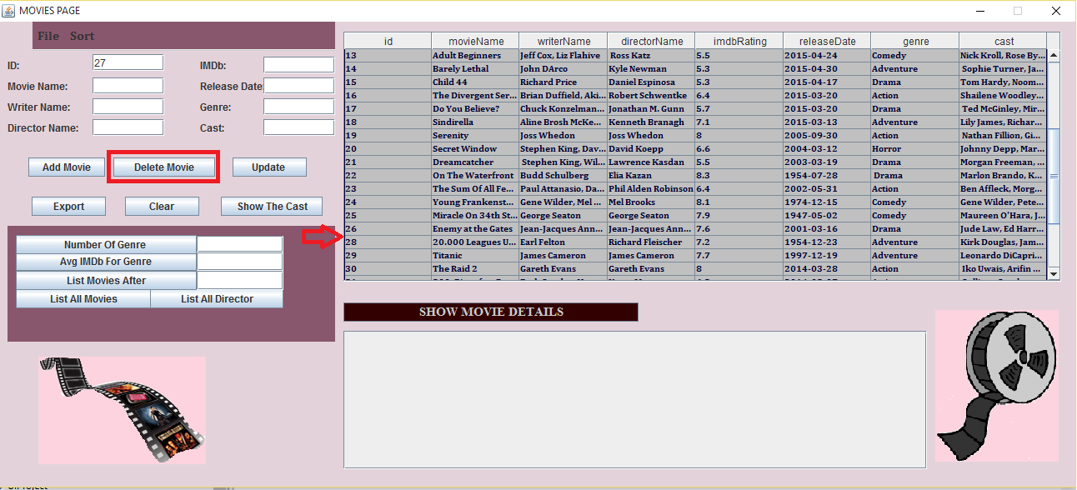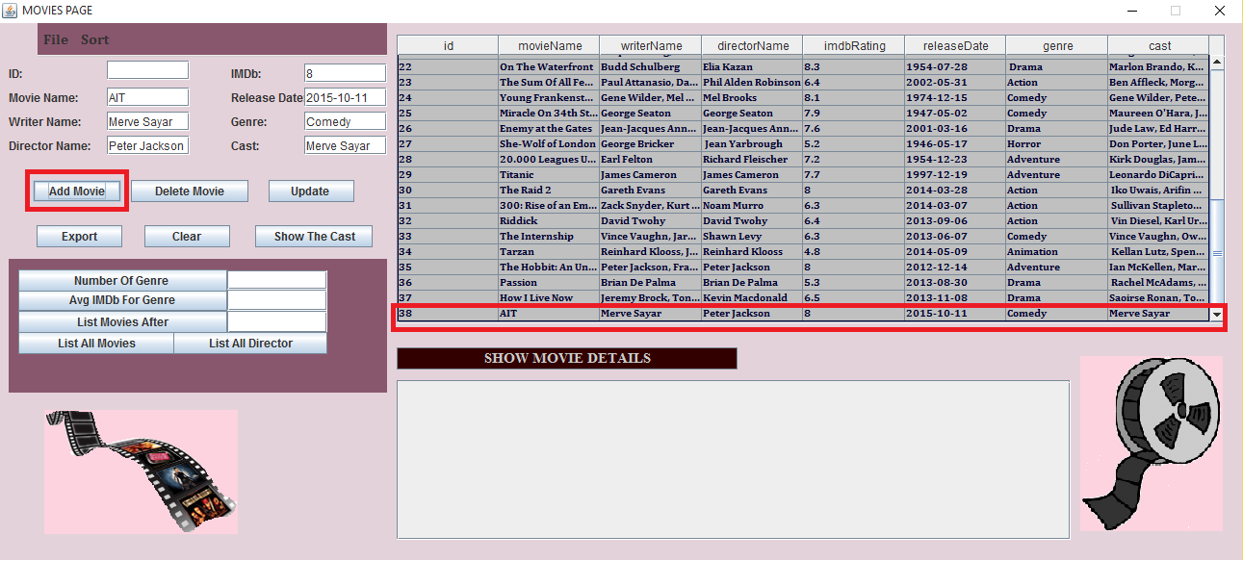When you click on the Add movie button, you can insert the new movie.
* When you click on the Delete movie button, you can delete the movie.

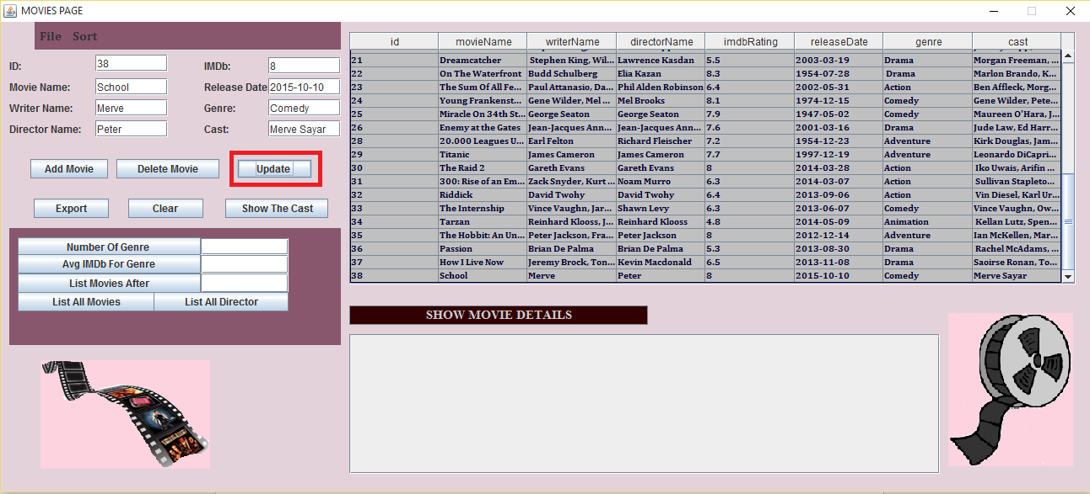

* 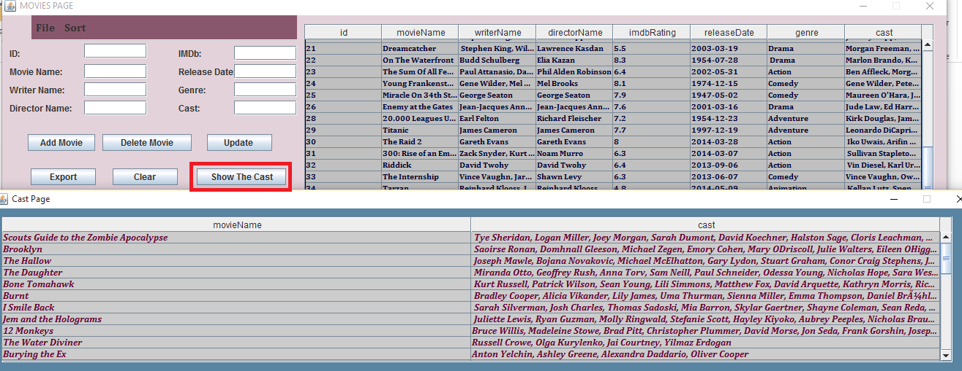If you hit on the update button, you can update the movie you want.
* When you click on the Show the Cast button, you will see cast of movies on another page also you can export this data.
* I made this table using the following view statement:

*create view cast_movies as*

*select id,movieName,cast from moviedetails;*

* 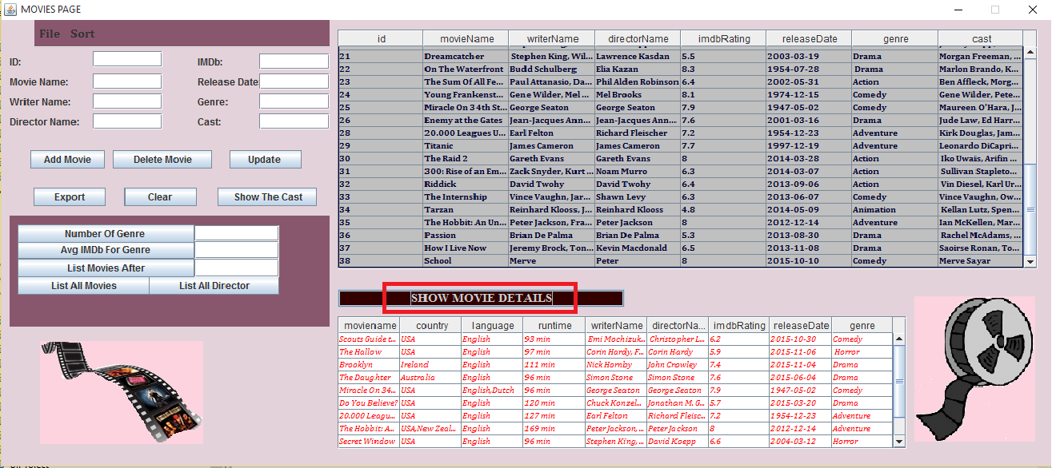When you click on the Show Movie Details, you will see the more details about movie like movies’ country, language and run time.
* I made this table using the following join statement:

*select moviedetails1.moviename,moviedetails1.country,moviedetails1.language,moviedetails1.runtime,moviedetails.writerName ,moviedetails.directorName,moviedetails.imdbRating,moviedetails.releaseDate,moviedetails.genre*

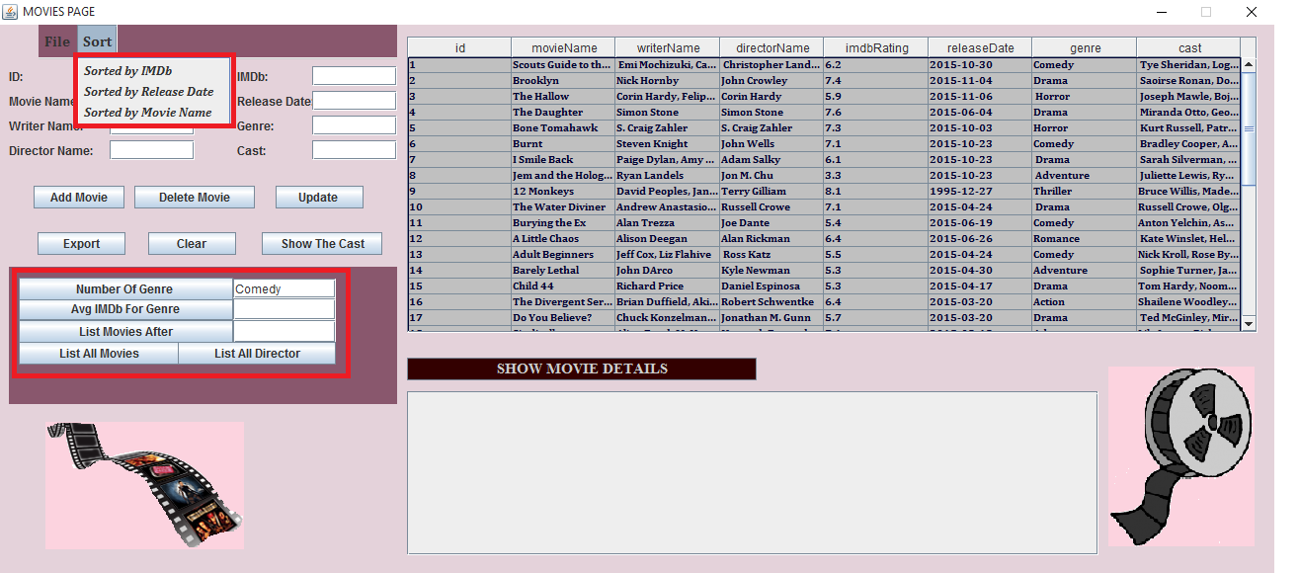 *from moviedetails1 inner join moviedetails on moviedetails1.m_id= moviedetails.id;*

* You can export the sorted movies and the other details clicking the button in figure.