Server-Side Web Development

Report

*Movie Web Site Application*

**

**Course:** BEng (Hons) Software Engineering

**Year:** 4

**Student:** Merve Sayar

**ID:** A00227206

**INTRODUCTION**

I made movie web site application for my assignment. Firstly, you can register my site and then you need to login. When you login as admin, you will see add movie and delete movie link. Only admin can add new movie and delete movie. Another users can see movie list and they can add movie in their watch list which movie they want. When they add movie into their watch list, they also can give their rating for movie. Users can see the best 10 movies according to movies imdb rating and coming soon movies. When users click the logout button they will exit my movie site.

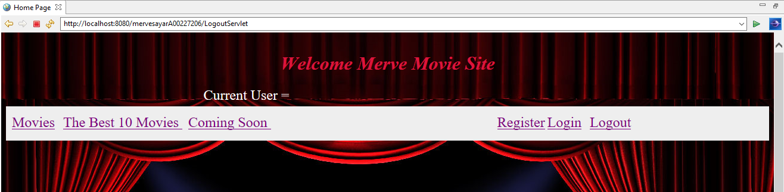

When you run my application, first you will see my home page.

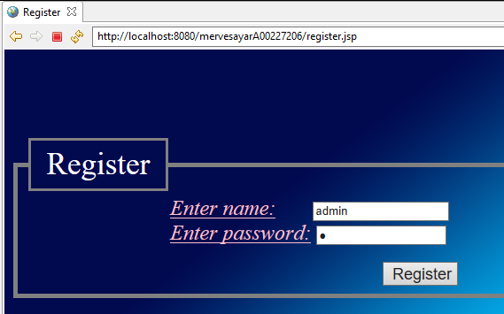

After you need to register, first you have to register for admin.

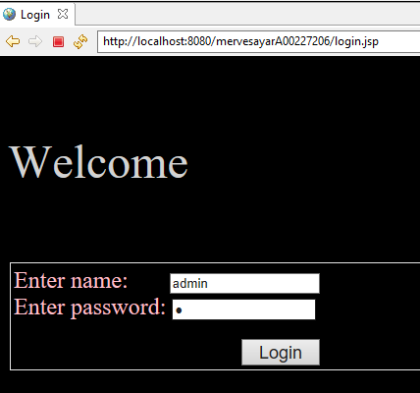

After register, you can do login as admin.

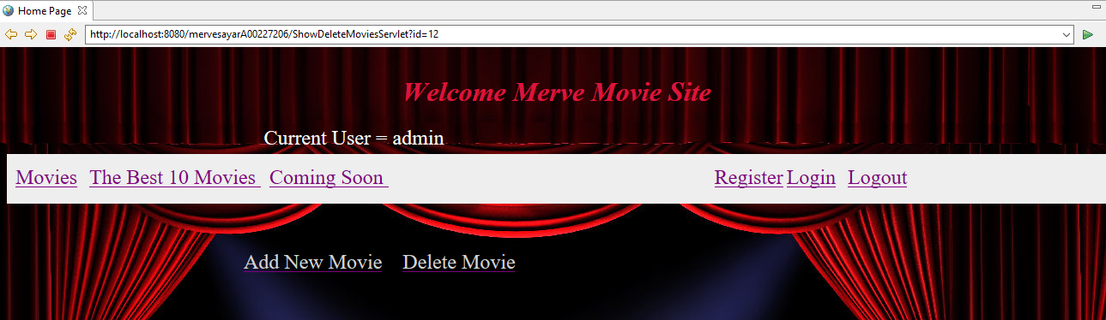

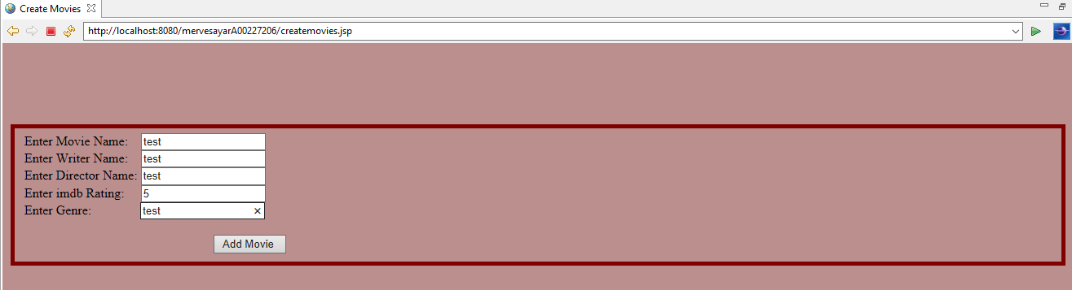When you login as admin, you will see add new movie and delete movie link.

Admin can add new movie, admin have to write movie name, writer name, director name, imdb rating and also movie’s genre .When admin click add movie button, he/she will see the new movie is added.

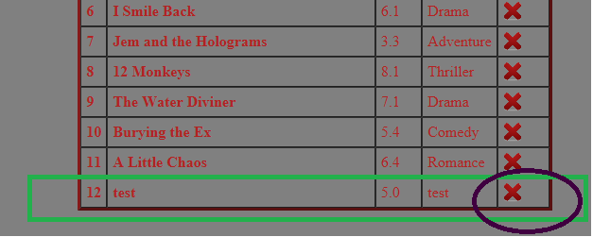

Admin can delete which movie he/she wants .When admin wants to delete any movie, he/she have to click delete image. When admin deletes movie, movie is also deleted somebody’s watch list if he/she has this movie in their watch list.

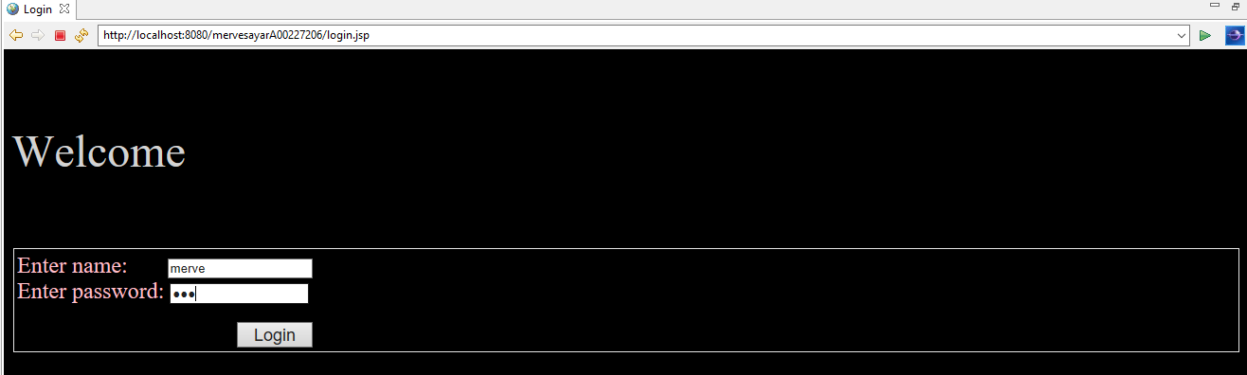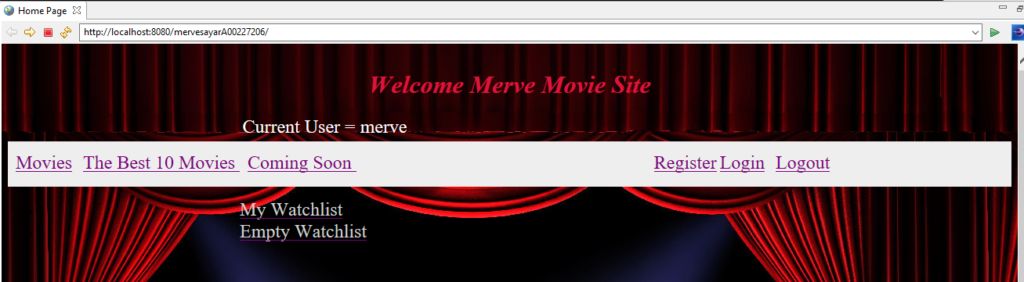

When you login as any user, you will see my watch list and empty watch list link.

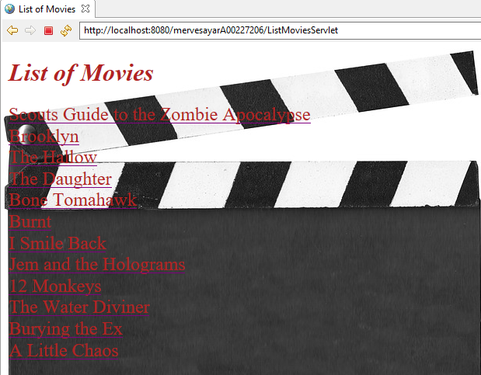

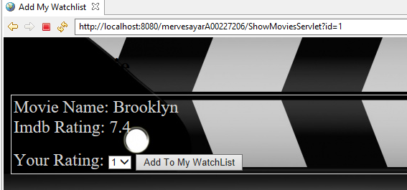

Movie area shows the all movie name list. When you click any movie name, you can add this movie in your watch list.

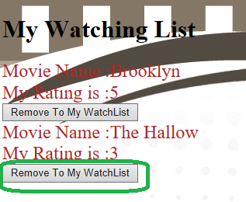

You can see your movies name and your rating in your watch list.

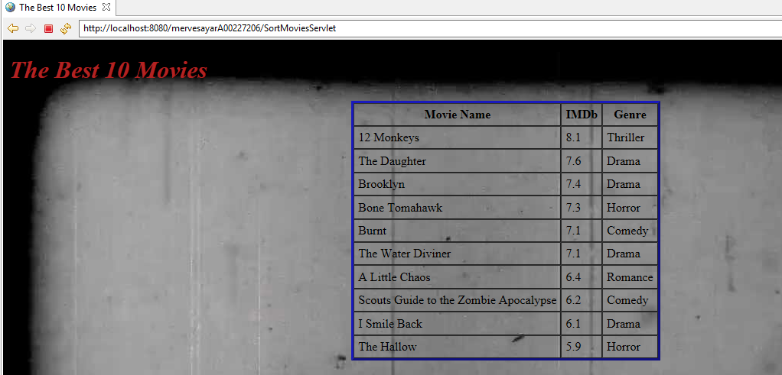When you click on the remove button, you will delete this movie in your watch list.

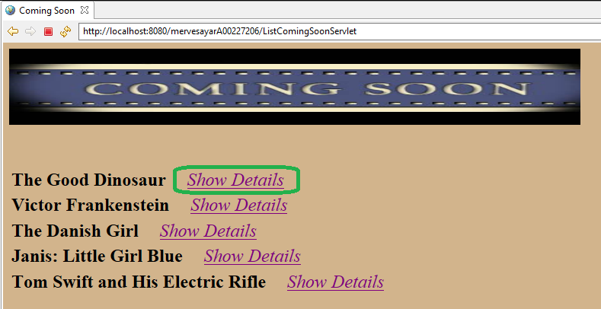The Best 10 Movies section shows to users the best 10 movies. It sorts the movies according to imdb rating, this movies are in movies list.

Coming Soon section shows to users, coming soon movies.

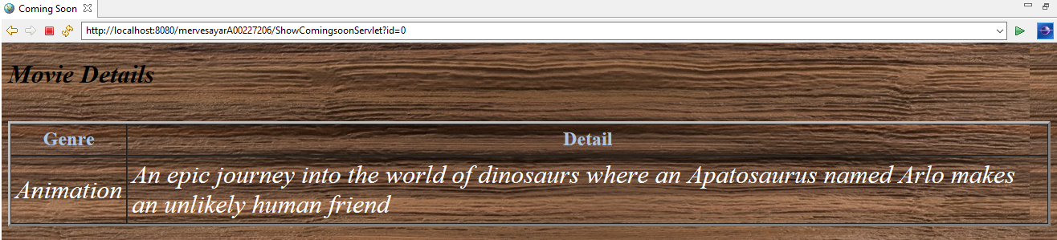 If you want to see coming soon movies’ details, you can click on the “Show Details” button and then you will see details about movie.

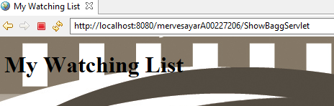

When clicking on the empty watch list, your all watch list are deleted.