**Appendix A**

Temperature and Humidity Sensor

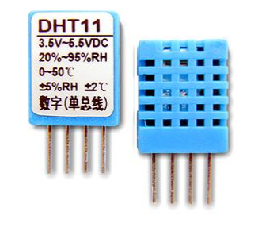

This DHT11 Temperature & Humidity Sensor features a temperature & humidity sensor complex with a calibrated digital signal output. By using the exclusive digital-signal-acquisition technique and temperature & humidity sensing technology, it ensures high reliability and excellent long-term stability. This sensor includes a resistive-type humidity measurement component and an NTC temperature measurement component, and connects to a high-performance 8-bit microcontroller, offering excellent quality, fast response, anti-interference ability and cost-effectiveness.

* Ultra low cost
* 3 to 5V power and I/O
* 2.5mA max current use during conversion (while requesting data)
* Good for 20-90% humidity readings with 5% accuracy
* Good for 0-50°C temperature readings ±2°C accuracy
* No more than 1 Hz sampling rate (once every second)
* Body size 15.5mm x 12mm x 5.5mm4 pins with 0.1" spacing

**Appendix B**

ATmega328

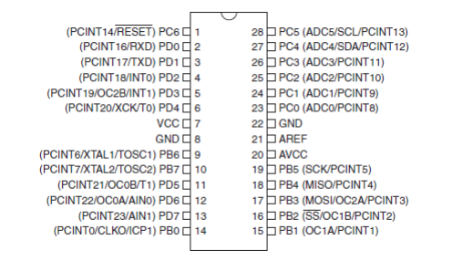

The high-performance Atmel 8-bit AVR RISC-based microcontroller combines 32KB ISP flash memory with read-while-write capabilities, 1KB EEPROM, 2KB SRAM, 23 general purpose I/O lines, 32 general purpose working registers, three flexible timer/counters with compare modes, internal and external interrupts, serial programmable USART, a byte-oriented 2-wire serial interface, SPI serial port, 6-channel 10-bit A/D converter (8-channels in TQFP and QFN/MLF packages), programmable watchdog timer with internal oscillator, and five software selectable power saving modes. The device operates between 1.8-5.5 volts.

* Operating Voltage: 1.8 - 5.5V for ATmega48PA/88PA/168PA/328P
* Temperature Range: 40°C to 85°C
* Speed Grade:0 - 20 MHz @ 1.8 - 5.5V
* Peripheral Features: Two 8-bit Timer/Counters with Separate Presales and Compare Mode, Real Time Counter with Separate Oscillator, Six PWM Channels, 8-channel 10-bit ADC in TQFP and QFN/MLF package Temperature Measurement, 6-channel 10-bit ADC in PDIP Package Temperature Measurement
* Special Microcontroller Features: Power-on Reset and Programmable Brown-out Detection, Internal Calibrated Oscillator, External and Internal Interrupt Sources, Six Sleep Modes: Idle, ADC Noise Reduction, Power-save, Power-down, Standby, and Extended Standby
* Speed Grade: 0 - 20 MHz @ 1.8 - 5.5V

**Appendix C**

PH Sensor

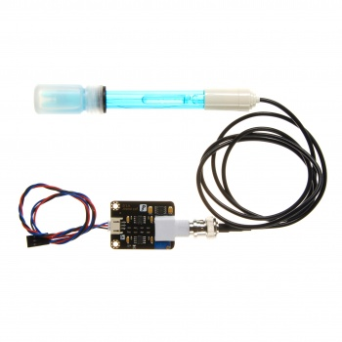

A pH sensor is a passive device that detects a current generated from hydrogen ion activity. This current (which can be positive or negative) is very weak and cannot be detected with a multimeter, or an analog to digital converter. This weak electrical signal can easily be disrupted and care should be taken to only use proper connectors and cables.

* Module Power : 5.00V
* Module Size : 43mm×32mm
* Measuring Range:0-14PH
* Measuring Temperature :0-60 ℃
* Accuracy : ± 0.1pH (25 ℃)
* Response Time : ≤ 1min
* pH Sensor with BNC Connector
* PH2.0 Interface ( 3 foot patch )
* Gain Adjustment Potentiometer
* Power Indicator LED
* Cable Length from sensor to BNC connector:660mm

**Appendix D**

Peltier Tile

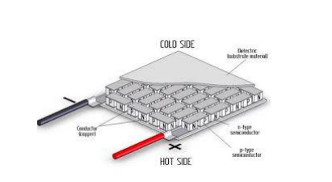

TE Technology’s Thermoelectric, or Peltier Cooling Modules (also known as a TEC or a TEM) come in a wide variety of types and sizes. While typically used for cooling, they can also be used for heating (by reversing the electric current flow) and even power generation. The TEC have two wires coming out of it, if a voltage is applied to those wires, then a temperature difference across the two sides is achieved, if the polarity is reversed on the wires - then the temperature difference is also reversed.

* TEC1-12706 Thermoelectric Cooler Peltier 12V 60W
* TEC1-12706
* Voltage(V): 12V Umax (V): 15.4V Imax (A): 6A
* QMax (W) : 92W
* Dimensions : 40mm x 40mm x 3.6mm