**CHAPTER 3: PROJECT/SYSTEM DESIGN**

**Input – Process – Output**

The framework used in design project is the Input-Output-Process Model. In the IPO mode, a process is viewed as a series of boxes (processing elements) connected by inputs and outputs. Information or material objects flow through series of tasks or activities based on a set of rules or decision points (Harris & Taylor, 1997).

**INPUT**

Knowledge Requirements

* Circuit Analysis and Design
* Data Acquisition
* Internet of Things
* Programming

Hardware Requirements:

* Raspberry Pi 3
* Raspberry Pi LCD
* Arduino Uno
* A/D Converter
* Amplifier
* Sensors
* Actuators

Software Requirements:

* Proteus Design Suite
* SketchUp
* Python Programming
* PHP and HTML/CSS
* MySQL

Multiple Constraints

Engineering Standards

**PROCESS**

Data Gathering

* Designing of the system that can determine and control level of different parameters necessary for the optimal growth of high value crops.
* Designing of data acquisition system for monitoring and data manipulation.
* Testing and evaluation of the controlled environment system and data acquisition system.

Design

* GUI Design (Desktop, Web, and Android Application)
* Database Design

Testing and evaluation of the system.

**OUTPUT**

**THE DESIGN OF A CONTROLLED ENVIRONMENT SYSTEM FOR HIGH VALUE CROPS**

Figure 3.1 Conceptual Framework

The inputs are made up of knowledge requirements, hardware requirements, software requirements, multiple constraints and engineering standards. The knowledge consist Circuit Analysis and Design, Data Acquisition, Internet of Things (IOT) and Programming. The said requirements are the essential parts in developing the system.

The hardware requirements are made up of different components that are used for making the system. Raspberry Pi 3 serves as the computer system – used as a bridge of the hardware components and software through Wi-Fi connection. Raspberry Pi LCD is used to provide interactive interface to the Raspberry Pi 3. Arduino Uno is used to connect, program and control the sensors and actuators. A/D converter for the electrical signals resulting from the sensors is converted to digital data. Amplifier is also use to increase the power supply. Actuators and Sensors are placed in the system to produce an electrical signal directly related to the different parameters that are to be measured.

The software requirements consist of Proteus Design Suite, SketchUp, Python Programming, PHP and HTML/CSS and MySQL. Proteus Design Suite was used for creating the circuit layout, placing of components and simulation of the circuit. SketchUp was used for the scale model and 3D model of the prototype. Python Programming which was used to write the code for the data acquisition system. PHP and HTML/CSS was used for the functionalities and design of the desktop, web, and mobile applications. It was also used to store and retrieve data from the MySQL database.

The process in the illustration refers to the engineering methods to be taken. The data gathering in which all the possible technologies that can be used in development are researched as well as methods are best to achieve the objectives of the project.

**System Flowchart**

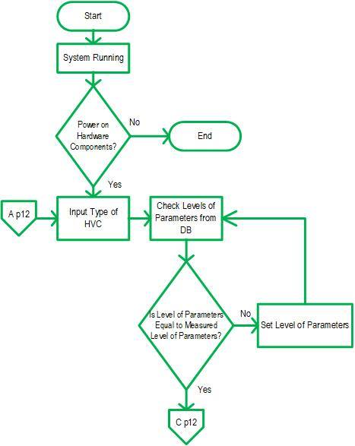The system flowchart shows the flow of data in the system from the key input of the user up to the output data generated in the desktop, web, and mobile applications. It also shows how decisions are made to control the events in the system.

Figure 3.2 System Flowchart

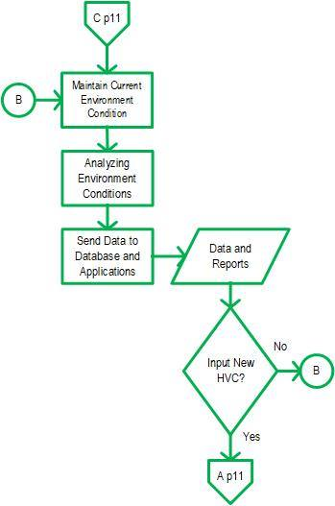

As Figure 3.2 shows, the system starts when it is turned on. Upon turning the device on, the user must input the type of high value crops to be planted in the controlled environment system. Once the user has already input the crops to be planted, the readings of level of different parameters from the database can then be monitored. If the level of parameters in the database matched the level of parameters measured by the sensors, the system will automatically maintain the current environment conditions; otherwise, the system will set another level of parameters from the database. If the system maintains the current environment conditions, the data will then be analyzed and be sent to the database and applications for real-time monitoring.

**Desktop Application**

Desktop Application shows the interface of the system for admin users by logging in. An admin is given a number of functions to handle the system.

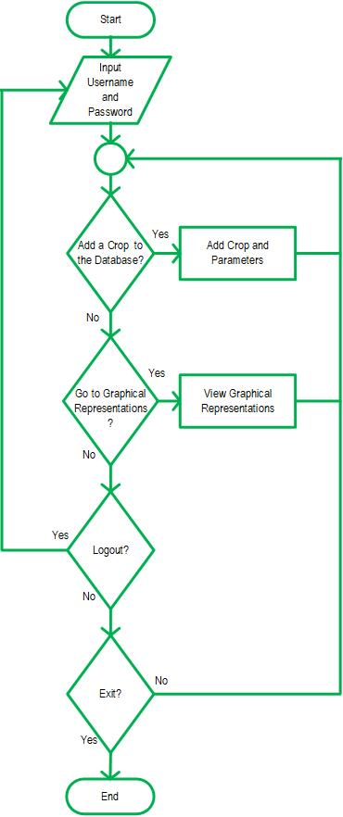

**Figure 3.3** Desktop Application Flowchart

The process starts by logging in the account of an admin. An admin can add a new crop and set its required parameters. The Admin can view the current graphical representations of the environment being sent from the sensors.

**Web Application**

Web Application is intended for basic users to provide updates and current reports in the system.

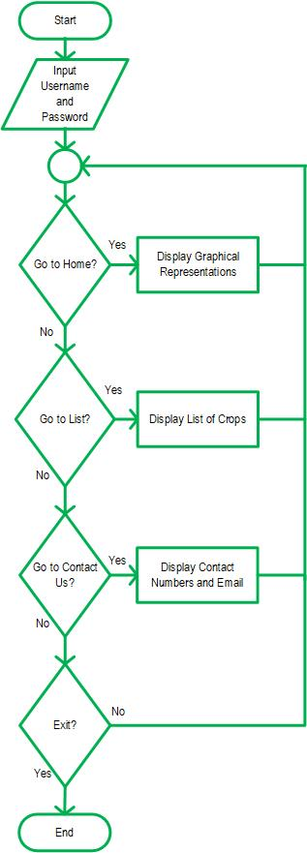

**Figure 3.4** Web Application Flowchart

The process starts by logging in the account of the user. The user can view the graphical representations of the environment, the list of current planted crops, and the contacts of the designers.

**Mobile Application**

Mobile Application is intended for basic users to view the current updates of the system.

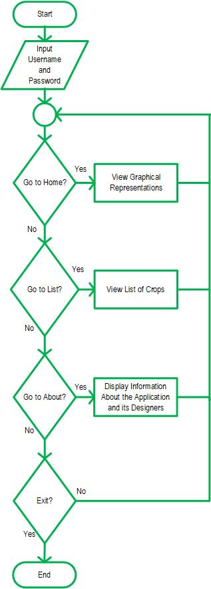

**Figure 3.5** Mobile Application Flowchart

The process starts by logging in the account of the user. The system provides a number of functions to the user such as viewing the graphical representations of the system, viewing the list of planted crops, and viewing the information about the application and its designers

**Illustrative Diagram**

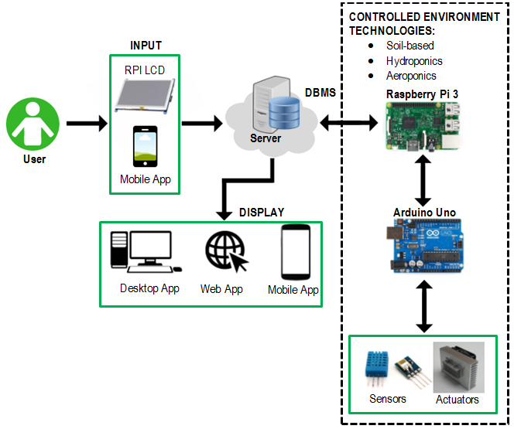

Figure 3.6. Illustrative Diagram

The illustrative diagram displayed in Figure 3.6 shows the different components used in system. The arrows show where a component is attached or where it gives feedback.

Description of each component:

* **Raspberry Pi LCD and Mobile Application**

These components serve as an interactive interface for the user’s input.

* **Server**

A server is a program that awaits and fulfils requests from client programs in the same or other computers. Databases are saved in the server. The desktop application communicates with the server to provide all necessary information for the end-users.

* **Database Management System (DBMS)**

Database Management System is a collection of programs that enables the users to store, modify, and extract information from a database.

* **Raspberry Pi 3**

Raspberry Pi 3 is a credit card-sized computer. It is used to process user input and generate output for the touch panel and mobile application. It also serves as the main component for the controlled environment system.

* **Arduino Uno**

Arduino Uno is a microcontroller board based on the ATmega328 microcontroller chip. It enables bidirectional data communication and serves as the physical connection of the sensors and actuators to Raspberry Pi 3.

* **Sensors**

These are devices that detects or measures physical property and record, indicate, or otherwise respond to it. Sensors are to be place in the system for it to produce an electrical signal directly related to the parameter that is needed to be measured.

* **Actuators**

Actuators serve as the changing mechanism in the system. These actuators react to the measured level of different parameters in the system and give the optimal growing environment condition of the crops.

**Hardware Design**

The functionality of the Controlled Environment System for High Value Crops ran by maintaining the required level of parameters that would support the growth of the crops.

Also, a microcontroller would be of great importance to control the input and output devices and will serve as the brain of the design. It is a small computer on a single integrated circuit containing a processor core, memory, and programmable input/output peripherals. Program memory in the form of NOR flash or OTP ROM is also often included on chip, as well as typically small amount of RAM.

The Raspberry Pi would act as the motherboard of the design and interface with the microcontroller and display panel.

### Design 1: Using Soil-based Controlled Environment System for High Value Crops

Design 1 uses soil to provide a medium for plant growth. Soil is essential for the plants such as high value crops. One of the main factors is that it supports the roots to keep them upright. Another one is that it stores and provides nutrients and mineral.

Considering the different parameters affecting the growth of the plants, the designers also put in consideration the constraints for the design. These constraints are performance, economic for the developmental cost, and manufacturability.

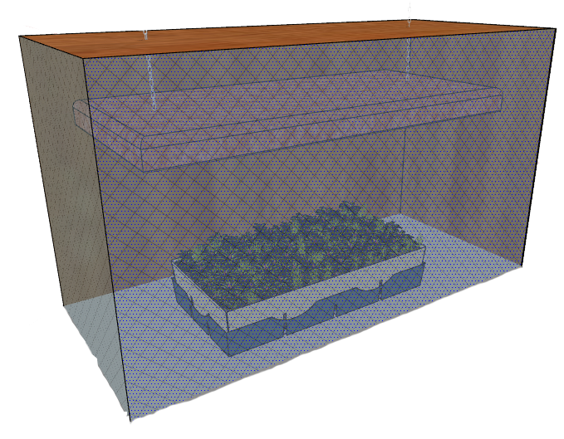**Prototype Design**

Figure 3.7 Soil-based Controlled Environment System for High Value Crops

**Functionality**

The functionality of the system always accounts the purpose of the project which is to produce high value crops of good quality. In farming systems, the functionality is always measured through its product. Thus, it makes the nutrients concentration of the crops directly proportional to its biomass productivity which is at (DW) 0.192%.

#### Performance

The controlled environment system for high value crops uses soil-based approach. The performance of the system depends on the percentage of irrigation water saving, fertilizing saving, and increase in production.

#### Economic

The soil moisture sensor is easy to use and reliable for this type of design. Moreover, compared to other designs, the sensor that is used in Design 1 is less expensive. This affects the economic constraint being considered in the project.

**Table 3-1.** Total Cost of Design 1

|  |  |  |  |  |
| --- | --- | --- | --- | --- |
| Components | Price | Quantity | Specification | Cost |
| Raspberry Pi | ₱2700.00 | 1 | * 700 MHz ARM1176JZF-S core CPU * 512 MB RAM * 4 x USB2.0 Ports with up to 1.2A output * Expanded 40-pin GPIO Header | ₱2700.00 |
| Arduino Uno | ₱500.00 | 1 | * ATmega328 microcontroller * Input voltage - 7-12V * 14 Digital I/O Pins (6 PWM outputs) * 6 Analog Inputs | ₱500.00 |
| Full Spectrum LED | ₱1972.00 | 1 | * Plug Type:SAA * Lumen: 260-312LM * Irradiation area:5-8 Square meters | ₱1972.00 |
| DHT11 | ₱105.00 | 1 | * Humidity measurement range: 20%~90%RH * Humidity measurement error: ±5%RH * Temperature measurement range: 0~60°C * Temperature measurement error: ±2°C | ₱105.00 |
| Peltier | ₱235.00 | 2 | * Operates from 0~15.2V DC and 0~6A * Operates Temperature: -30°C to 70°C * Max power consumption: 60 Watts | ₱470.00 |
| Fan and Heatsink | ₱700.00 | 4 | * 2.75 inch DC Brushless fan * Length: Approx. 225mm * Dimensions:50mm x 70mm x 70mm * Excellent cooling * Keep socket processor safe | ₱2800.00 |
| Humidifier | ₱490.00 | 1 | * Application:<10㎡ * Function: Ultrasonic Sterilize * Mist Output (gallon / day):30-40ml/h * Voltage (V):DC5V   Capacity:400ML | ₱490.00 |
| Soil Moisture Sensor | ₱310.00 | 1 | * pH Range: 0-14 (Na+ error at >12.3 pH) * Speed of Response: 95% in 1 second | ₱310.00 |
| PH sensor and PH solution | ₱7650.00 | 1 | * pH Range: 0-14 (Na+ error at >12.3 pH) * Speed of Response: 95% in 1 second | ₱7650.00 |
| Other Materials | ₱6000.00 |  |  | ₱6000.00 |
| Water Pump | ₱3598.00 | 2 | * 130 PSI * 6L/ Min Water High Pressure Diaphragm Self-Priming Pump * DC 12 V * 70W FL-3308 | ₱7196.00 |
| TOTAL |  |  |  | **₱30,193.00** |

**Circuit Diagram**

The figure 3-7 shows the circuit diagram used in design 1 using ATmega328P microcontroller which is connected to the actuators and sensors. Peltier, humidifier, and sprinkler are used as actuators in the system. DHT11 sensor and soil moisture sensor are used as sensors in the system.

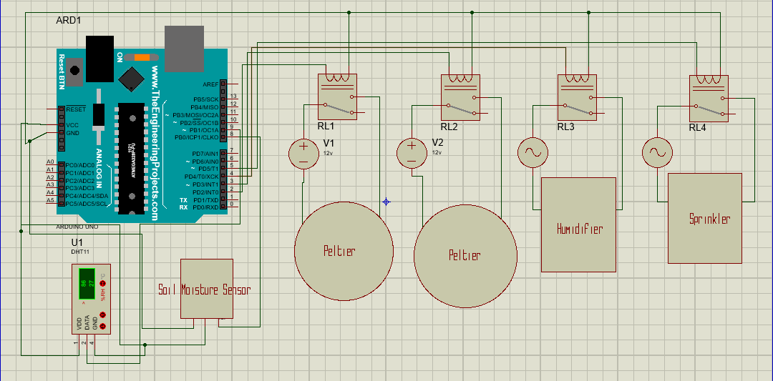

Figure 3-7. Circuit Diagram of Soil-based Controlled Environment System

**Power Consumption Computation for Design 1**

Considering the different actuators used, the designers estimate the power consumption that will be spent annually:

**Raspberry Pi**

**Peltier (2 pcs.)**

**Humidifier**

**Water Pump**

**Full Spectrum LED**

Summing all the computed power you will get:

With this you can get the annual electric consumption:

Therefore **if 1Kw/h is equal to ₱9.00** we can get the estimated electricity cost per year:

### Design 2: Using Hydroponics Controlled Environment System for High Value Crops

Design 2 is a system of agriculture that utilizes nutrient-laden water rather than soil for plant nourishment (Bridgewood, 2003). It uses sterile root zone media such as rockwool, coco coir or volcanic rock instead of soil. In this system, roots can more easily and efficiently uptake nutrients from sterile media, and because growers can totally control what ratios and types of nutrients enter the plants.

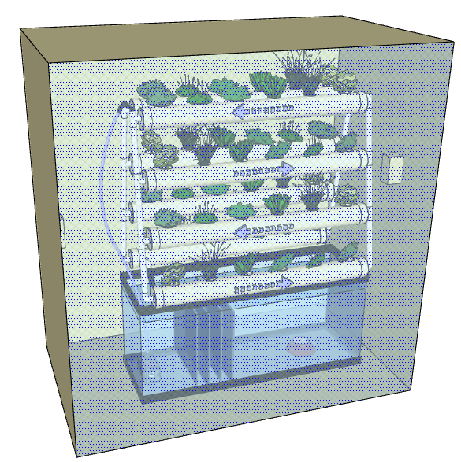The designers came up with design 2 by considering the constraints set on the previous chapter. These constraints are economic, manufacturability and performance.

**Prototype Design**

Figure 3.8 Hydroponics Controlled Environment System for High Value Crops

**Functionality**

The functionality of the system always accounts the purpose of the project which is to produce high value crops of good quality. In farming systems, the functionality is always measured through its product. Thus, it makes the nutrients concentration of the crops directly proportional to its biomass productivity which is at (DW) 0.78%.

**Performance**

The controlled environment system for high value crops uses hydroponics approach. The performance of the system depends on the percentage of irrigation water saving, fertilizing saving, increase in production, and water productivity.

In hydroponics approach, water consumption decreases which yields to 85% water saving during the irrigation process.

**Economic**

The PH Sensor and Salinity Sensor are easy to use and reliable for this type of design, yet making the total cost of the system more expensive. This affects the economic constraint being considered in the project.

**Table 3-3.** Total Cost of Design 2

|  |  |  |  |  |
| --- | --- | --- | --- | --- |
| Components | Price | Quantity | Specification | Cost |
| Raspberry Pi | ₱2700.00 | 1 | * 700 MHz ARM1176JZF-S core CPU * 512 MB RAM * 4 x USB2.0 Ports with up to 1.2A output * Expanded 40-pin GPIO Header | ₱2700.00 |
| Arduino Uno | ₱500.00 | 1 | * ATmega328 microcontroller * Input voltage - 7-12V * 14 Digital I/O Pins (6 PWM outputs) * 6 Analog Inputs | ₱500.00 |
| Full Spectrum LED | ₱1972.00 | 1 | * Plug Type:SAA * Lumen: 260-312LM * Irradiation area:5-8 Square meters | ₱1972.00 |
| DHT11 | ₱105.00 | 1 | * Humidity measurement range: 20%~90%RH * Humidity measurement error: ±5%RH * Temperature measurement range: 0~60°C * Temperature measurement error: ±2°C | ₱105.00 |
| Peltier | ₱235.00 | 2 | * Operates from 0~15.2V DC and 0~6A * Operates Temperature: -30°C to 70°C * Max power consumption: 60 Watts | ₱470.00 |
| Fan and Heat sink | ₱700.00 | 4 | * 2.75 inch DC Brushless fan * Length: Approx. 225mm * Dimensions:50mm x 70mm x 70mm * Excellent cooling * Keep socket processor safe | ₱2800.00 |
| Humidifier | ₱490.00 | 1 | * Application:<10㎡ * Function: Ultrasonic Sterilize * Mist Output (gallon / day):30-40ml/h * Voltage (V):DC5V   Capacity:400ML | ₱490.00 |
| PH sensor and PH solution | ₱7650.00 | 1 | * pH Range: 0-14 (Na+ error at >12.3 pH) * Speed of Response: 95% in 1 second | ₱7650.00 |
| Other Materials | ₱6000.00 | 1 |  | ₱6000.00 |
| Water pump | ₱1123.30 | 1 | * 1500L/Hr. Submersible Pump for Aquarium * 2 Nozzles * 25W AC 110V | ₱1123.30 |
| TOTAL |  |  |  | **₱16,925.30** |

**Circuit Diagram**

The figure 3-8 shows the circuit diagram used in design 2 using ATmega328P microcontroller which is connected to the actuators and sensors. Peltier, humidifier, water pump, salinity solution, and PH solution are used as actuators in the system. DHT11 sensor, PH sensor, and salinity sensor are used as sensors in the system.

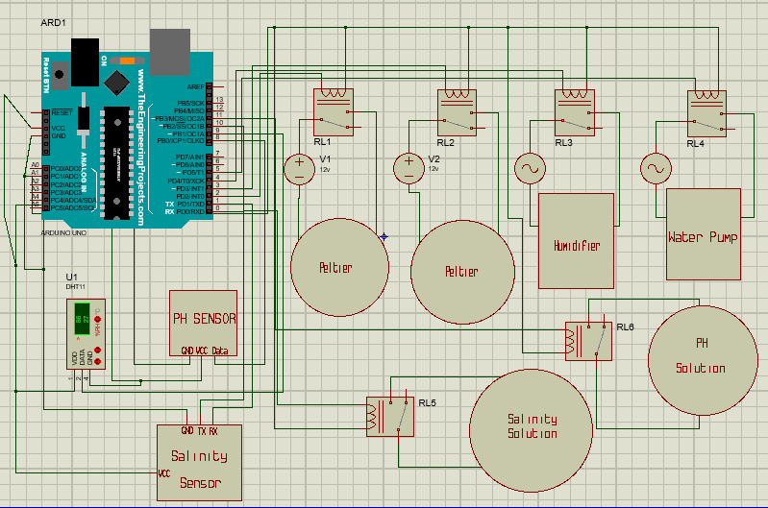

Figure 3-8. Circuit Diagram of Hydroponics Controlled Environment System

**Power Consumption Computation for Design 2**

Considering the different actuators used, the designers estimate the power consumption that will be spent annually:

**Raspberry Pi**

**Peltier (2 pcs.)**

**Humidifier**

**Water Pump**

**Full Spectrum LED**

Summing all the computed power you will get:

With this you can get the annual electric consumption:

Therefore **if 1Kw/h is equal to ₱9.00** we can get the estimated electricity cost per year:

**Design 3: Using Aeroponics Controlled Environment System for High Value Crops**

Design 3 do not require pesticides, require less water and space than traditional agricultural systems, and may be stacked in order to limit space use and uses no growing medium at all (Growing Power, 2011; Marginson, 2010). In this design, the plant is placed into something that can hold them up into the air. The water in this design will be the main factor for the plant’s growth. The nutrients that the plants will need are mixed into the water. The plants grow by misting rich nutrients water. Plant roots in this system are suspended in a dark enclosure, while a nutrient-dense solution is sprayed on the roots at certain intervals

With regards to the design, the designers also weighted the effects on the constraints set on the previous chapter. These constraints are economic, manufacturability and performance.

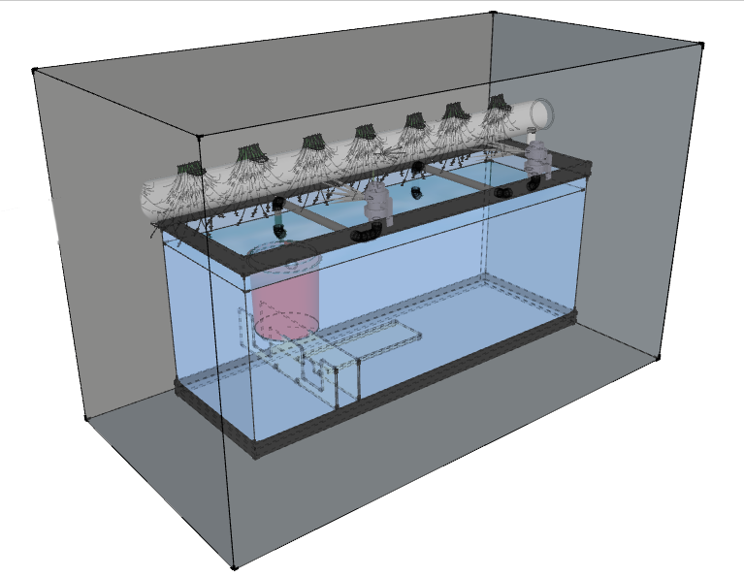**Prototype Design**

Figure 3.9 Aeroponics Controlled Environment System for High Value Crops

**Functionality**

The functionality of the system always accounts the purpose of the project which is to produce high value crops of good quality. In farming systems, the functionality is always measured through its product. Thus, it makes the nutrients concentration of the crops directly proportional to its biomass productivity which is at (DW) 0.59%.

**Performance**

The controlled environment system for high value crops uses aeroponics approach. The performance of the system depends on the percentage of irrigation water saving, fertilizing saving, increase in production, and water productivity.

In aeroponics approach, water consumption decreases which yields to 90% water saving during the irrigation process.

**Economic**

The PH Sensor and Salinity Sensor are easy to use and reliable for this type of design, yet making the total cost of the system more expensive. This affects the economic constraint being considered in the project.

**Table 3-5.** Total Cost of Design 3

|  |  |  |  |  |
| --- | --- | --- | --- | --- |
| Components | Price | Quantity | Specification | Cost |
| Raspberry Pi | ₱2700.00 | 1 | * 700 MHz ARM1176JZF-S core CPU * 512 MB RAM * 4 x USB2.0 Ports with up to 1.2A output * Expanded 40-pin GPIO Header | ₱2700.00 |
| Arduino Uno | ₱500.00 | 1 | * ATmega328 microcontroller * Input voltage - 7-12V * 14 Digital I/O Pins (6 PWM outputs) * 6 Analog Inputs | ₱500.00 |
| Full Spectrum LED | ₱1972.00 | 1 | * Plug Type:SAA * Lumen: 260-312LM * Irradiation area:5-8 Square meters | ₱1972.00 |
| DHT11 | ₱105.00 | 1 | * Humidity measurement range: 20%~90%RH * Humidity measurement error: ±5%RH * Temperature measurement range: 0~60°C * Temperature measurement error: ±2°C | ₱105.00 |
| Peltier | ₱235.00 | 2 | * Operates from 0~15.2V DC and 0~6A * Operates Temperature: -30°C to 70°C * Max power consumption: 60 Watts | ₱470.00 |
| Fan and Heatsink | ₱700.00 | 4 | * 2.75 inch DC Brushless fan * Length: Approx. 225mm * Dimensions:50mm x 70mm x 70mm * Excellent cooling * Keep socket processor safe | ₱2800.00 |
| Humidifier | ₱490.00 | 1 | * Application:<10㎡ * Function: Ultrasonic Sterilize * Mist Output (gallon / day):30-40ml/h * Voltage (V):DC5V   Capacity:400ML | ₱490.00 |
| PH sensor and PH solution | ₱7650.00 | 1 | * pH Range: 0-14 (Na+ error at >12.3 pH) * Speed of Response: 95% in 1 second | ₱7650.00 |
| Other Materials | ₱6000.00 | 1 |  | ₱6000.00 |
| Water Pump | ₱919.07 | 6 | * High Pressure Self-Priming Electric Car Portable Washer Water Pump * 12 V * 60W AC 220V | ₱5514.42 |
| TOTAL |  |  |  | **₱28, 201.42** |

**Circuit Diagram**

The figure 3-8 shows the circuit diagram used in design 2 using ATmega328P microcontroller which is connected to the actuators and sensors. Peltier, humidifier, mist nozzle, salinity solution, and PH solution are used as actuators in the system. DHT11 sensor, PH sensor, and salinity sensor are used as sensors in the system.

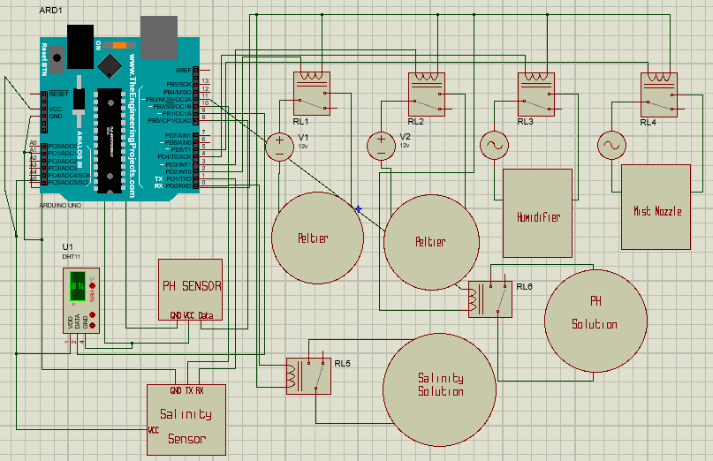

Figure 3-8. Circuit Diagram of Aeroponics Controlled Environment System

**Power Consumption Computation for Design 3**

Considering the different actuators used, the designers estimate the power consumption that will be spent annually:

**Raspberry Pi**

**Peltier (2 pcs.)**

**Humidifier**

**Water Pump**

**Full Spectrum LED**

Summing all the computed power you will get:

With this you can get the annual electric consumption:

Therefore **if 1Kw/h is equal to ₱9.00** we can get the estimated electricity cost per year:

**Data Flow Diagram**

A data flow diagram (DFD) is a graphical representation of the flow of data through an information system, modeling its process aspects. A DFD if often used as a preliminary step to create an overview of the system, which can be elaborated. The DFD of the system is shown in Figure 3.

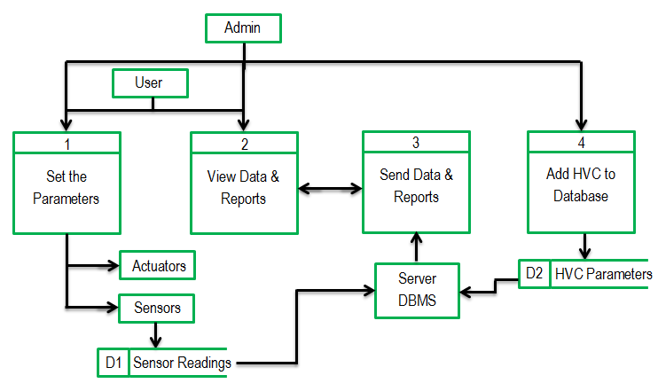

The data have to undergo multiple stages and procedures as is passes through the system. The starting values will depend on the user’s input. As the user already input a value, the actuators will automatically set the level of different parameters and the readings from the sensor will then be sent to the database. The data is sent to the devices including web and mobile applications for real-time monitoring.