DESIGN 1 SCHEME

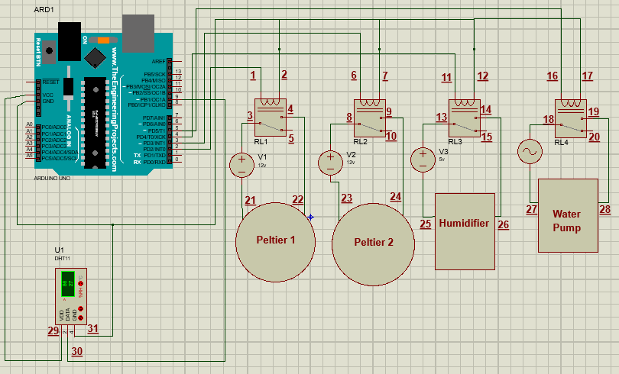

|  |  |  |
| --- | --- | --- |
| Relay Switch 1 | | |
| Pin Number | **Function** | **Attached to:** |
| 1 | VCC - Coil | Arduino pin 2 |
| 2 | GND - Coil | Arduino pin GND |
| 3 | Common Terminal | Power Supply’s VCC (12v) |
| 4 | Normally Open Terminal | Peltier 1’s VCC |
| 5 | Normally Close Terminal | N/A |

|  |  |  |
| --- | --- | --- |
| Relay Switch 2 | | |
| Pin Number | **Function** | **Attached to:** |
| 6 | VCC - Coil | Arduino pin 3 |
| 7 | GND - Coil | Arduino pin GND |
| 8 | Common Terminal | Power Supply’s VCC (12v) |
| 9 | Normally Open Terminal | Peltier 2’s VCC |
| 10 | Normally Close Terminal | N/A |

|  |  |  |
| --- | --- | --- |
| Relay Switch 3 | | |
| Pin Number | **Function** | **Attached to:** |
| 11 | VCC - Coil | Arduino pin 4 |
| 12 | GND - Coil | Arduino pin GND |
| 13 | Common Terminal | Power Supply’s VCC (5v) |
| 14 | Normally Open Terminal | Humidifier’s VCC |
| 15 | Normally Close Terminal | N/A |

|  |  |  |
| --- | --- | --- |
| Relay Switch 4 | | |
| Pin Number | **Function** | **Attached to:** |
| 16 | VCC - Coil | Arduino pin 5 |
| 17 | GND - Coil | Arduino pin GND |
| 18 | Common Terminal | Power Supply’s VCC (220v) |
| 19 | Normally Open Terminal | Water Pump’s VCC |
| 20 | Normally Close Terminal | N/A |

|  |  |  |
| --- | --- | --- |
| Peltier 1 | | |
| Pin Number | **Function** | **Attached to:** |
| 21 | GND | Power Supply’s GND (12v) |
| 22 | VCC | Relay 1 - Normally Open Terminal |

|  |  |  |
| --- | --- | --- |
| Peltier 2 | | |
| Pin Number | **Function** | **Attached to:** |
| 23 | GND | Power Supply’s GND (12v) |
| 24 | VCC | Relay 2 - Normally Open Terminal |

|  |  |  |
| --- | --- | --- |
| Humidifier | | |
| Pin Number | **Function** | **Attached to:** |
| 25 | GND | Power Supply’s GND (5v) |
| 26 | VCC | Relay 3 - Normally Open Terminal |

|  |  |  |
| --- | --- | --- |
| Water Pump | | |
| Pin Number | **Function** | **Attached to:** |
| 27 | GND | Power Supply’s GND (220v) |
| 28 | VCC | Relay 4 - Normally Open Terminal |

|  |  |  |
| --- | --- | --- |
| DHT 11 | | |
| Pin Number | **Function** | **Attached to:** |
| 29 | VCC | Arduino pin VCC |
| 30 | Data | Arduino pin 9 |
| 31 | Ground | Arduino pin GND |

DESIGN 2 SCHEME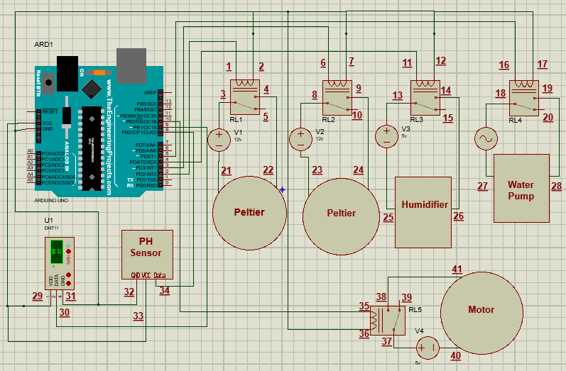

|  |  |  |
| --- | --- | --- |
| Relay Switch 1 | | |
| Pin Number | **Function** | **Attached to:** |
| 1 | VCC - Coil | Arduino pin 2 |
| 2 | GND - Coil | Arduino pin GND |
| 3 | Common Terminal | Power Supply’s VCC (12v) |
| 4 | Normally Open Terminal | Peltier 1’s VCC |
| 5 | Normally Close Terminal | N/A |

|  |  |  |
| --- | --- | --- |
| Relay Switch 2 | | |
| Pin Number | **Function** | **Attached to:** |
| 6 | VCC - Coil | Arduino pin 3 |
| 7 | GND - Coil | Arduino pin GND |
| 8 | Common Terminal | Power Supply’s VCC (12v) |
| 9 | Normally Open Terminal | Peltier 2’s VCC |
| 10 | Normally Close Terminal | N/A |

|  |  |  |
| --- | --- | --- |
| Relay Switch 3 | | |
| Pin Number | **Function** | **Attached to:** |
| 11 | VCC - Coil | Arduino pin 4 |
| 12 | GND - Coil | Arduino pin GND |
| 13 | Common Terminal | Power Supply’s VCC (5v) |
| 14 | Normally Open Terminal | Humidifier’s VCC |
| 15 | Normally Close Terminal | N/A |

|  |  |  |
| --- | --- | --- |
| Relay Switch 4 | | |
| Pin Number | **Function** | **Attached to:** |
| 16 | VCC - Coil | Arduino pin 5 |
| 17 | GND - Coil | Arduino pin GND |
| 18 | Common Terminal | Power Supply’s VCC (220v) |
| 19 | Normally Open Terminal | Water Pump’s VCC |
| 20 | Normally Close Terminal | N/A |

|  |  |  |
| --- | --- | --- |
| Relay Switch 5 | | |
| Pin Number | **Function** | **Attached to:** |
| 35 | VCC - Coil | Arduino pin 10 |
| 36 | GND - Coil | Arduino pin GND |
| 37 | Common Terminal | Power Supply’s VCC (5v) |
| 38 | Normally Open Terminal | Motor’s VCC |
| 39 | Normally Close Terminal | N/A |

|  |  |  |
| --- | --- | --- |
| Peltier 1 | | |
| Pin Number | **Function** | **Attached to:** |
| 21 | GND | Power Supply’s GND (12v) |
| 22 | VCC | Relay 1 - Normally Open Terminal |

|  |  |  |
| --- | --- | --- |
| Peltier 2 | | |
| Pin Number | **Function** | **Attached to:** |
| 23 | GND | Power Supply’s GND (12v) |
| 24 | VCC | Relay 2 - Normally Open Terminal |

|  |  |  |
| --- | --- | --- |
| Humidifier | | |
| Pin Number | **Function** | **Attached to:** |
| 25 | GND | Power Supply’s GND (5v) |
| 26 | VCC | Relay 3 - Normally Open Terminal |

|  |  |  |
| --- | --- | --- |
| Water Pump | | |
| Pin Number | **Function** | **Attached to:** |
| 27 | GND | Power Supply’s GND (220v) |
| 28 | VCC | Relay 4 - Normally Open Terminal |

|  |  |  |
| --- | --- | --- |
| Motor | | |
| Pin Number | **Function** | **Attached to:** |
| 40 | GND | Power Supply’s GND (5v) |
| 41 | VCC | Relay 5 - Normally Open Terminal |

|  |  |  |
| --- | --- | --- |
| DHT 11 | | |
| Pin Number | **Function** | **Attached to:** |
| 29 | VCC | Arduino pin VCC |
| 30 | Data | Arduino pin 9 |
| 31 | Ground | Arduino pin GND |

|  |  |  |
| --- | --- | --- |
| PH Sensor | | |
| Pin Number | **Function** | **Attached to:** |
| 32 | GND | Arduino pin GND |
| 33 | VCC | Arduino pin VCC |
| 34 | Data | Arduino pin 8 |

DESIGN 3 SCHEME

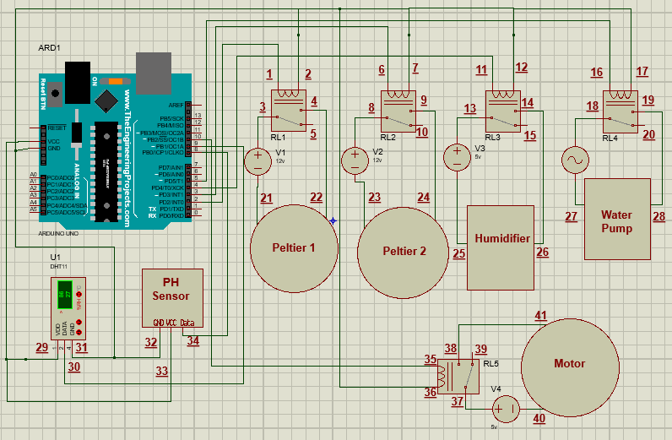

|  |  |  |
| --- | --- | --- |
| Relay Switch 1 | | |
| Pin Number | **Function** | **Attached to:** |
| 1 | VCC - Coil | Arduino pin 2 |
| 2 | GND - Coil | Arduino pin GND |
| 3 | Common Terminal | Power Supply’s VCC (12v) |
| 4 | Normally Open Terminal | Peltier 1’s VCC |
| 5 | Normally Close Terminal | N/A |

|  |  |  |
| --- | --- | --- |
| Relay Switch 2 | | |
| Pin Number | **Function** | **Attached to:** |
| 6 | VCC - Coil | Arduino pin 3 |
| 7 | GND - Coil | Arduino pin GND |
| 8 | Common Terminal | Power Supply’s VCC (12v) |
| 9 | Normally Open Terminal | Peltier 2’s VCC |
| 10 | Normally Close Terminal | N/A |

|  |  |  |
| --- | --- | --- |
| Relay Switch 3 | | |
| Pin Number | **Function** | **Attached to:** |
| 11 | VCC - Coil | Arduino pin 4 |
| 12 | GND - Coil | Arduino pin GND |
| 13 | Common Terminal | Power Supply’s VCC (5v) |
| 14 | Normally Open Terminal | Humidifier’s VCC |
| 15 | Normally Close Terminal | N/A |

|  |  |  |
| --- | --- | --- |
| Relay Switch 4 | | |
| Pin Number | **Function** | **Attached to:** |
| 16 | VCC - Coil | Arduino pin 5 |
| 17 | GND - Coil | Arduino pin GND |
| 18 | Common Terminal | Power Supply’s VCC (220v) |
| 19 | Normally Open Terminal | Water Pump’s VCC |
| 20 | Normally Close Terminal | N/A |

|  |  |  |
| --- | --- | --- |
| Relay Switch 5 | | |
| Pin Number | **Function** | **Attached to:** |
| 35 | VCC - Coil | Arduino pin 10 |
| 36 | GND - Coil | Arduino pin GND |
| 37 | Common Terminal | Power Supply’s VCC (5v) |
| 38 | Normally Open Terminal | Motor’s VCC |
| 39 | Normally Close Terminal | N/A |

|  |  |  |
| --- | --- | --- |
| Peltier 1 | | |
| Pin Number | **Function** | **Attached to:** |
| 21 | GND | Power Supply’s GND (12v) |
| 22 | VCC | Relay 1 - Normally Open Terminal |

|  |  |  |
| --- | --- | --- |
| Peltier 2 | | |
| Pin Number | **Function** | **Attached to:** |
| 23 | GND | Power Supply’s GND (12v) |
| 24 | VCC | Relay 2 - Normally Open Terminal |

|  |  |  |
| --- | --- | --- |
| Humidifier | | |
| Pin Number | **Function** | **Attached to:** |
| 25 | GND | Power Supply’s GND (5v) |
| 26 | VCC | Relay 3 - Normally Open Terminal |

|  |  |  |
| --- | --- | --- |
| Water Pump | | |
| Pin Number | **Function** | **Attached to:** |
| 27 | GND | Power Supply’s GND (220v) |
| 28 | VCC | Relay 4 - Normally Open Terminal |

|  |  |  |
| --- | --- | --- |
| Motor | | |
| Pin Number | **Function** | **Attached to:** |
| 40 | GND | Power Supply’s GND (5v) |
| 41 | VCC | Relay 5 - Normally Open Terminal |

|  |  |  |
| --- | --- | --- |
| DHT 11 | | |
| Pin Number | **Function** | **Attached to:** |
| 29 | VCC | Arduino pin VCC |
| 30 | Data | Arduino pin 9 |
| 31 | Ground | Arduino pin GND |

|  |  |  |
| --- | --- | --- |
| PH Sensor | | |
| Pin Number | **Function** | **Attached to:** |
| 32 | GND | Arduino pin GND |
| 33 | VCC | Arduino pin VCC |
| 34 | Data | Arduino pin 8 |