target: 192.168.56.114

host: 192.168.56.112

1. nmap -p- 192.168.56.114 --open scan the open port on the target, and then scan the server info on the special ports. nmap -p21,22,80 -sV 192.168.56.114

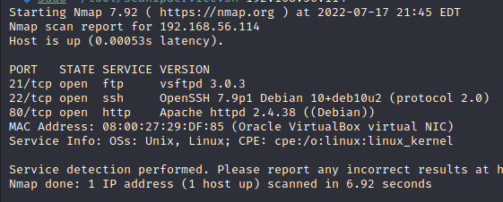

2.search the exploit info for vsftpd, no useful info.

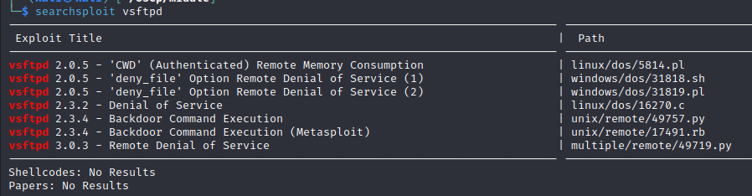

3.try to login ftp with anonymous, failed

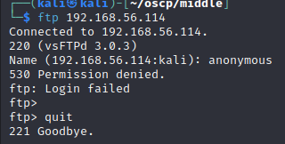

4.use dirsearch to scan the path of servers, found the hidden path /nothing and /hidden/text directory

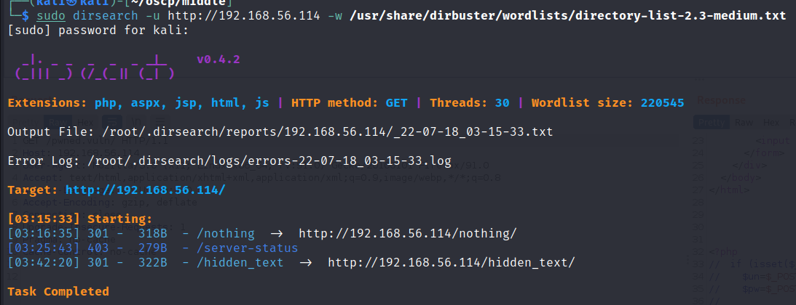

5.visit hidden page <http://192.168.56.114/hidden_text/>, found a secret.dic file, check the file’s content, it’s a directory list

