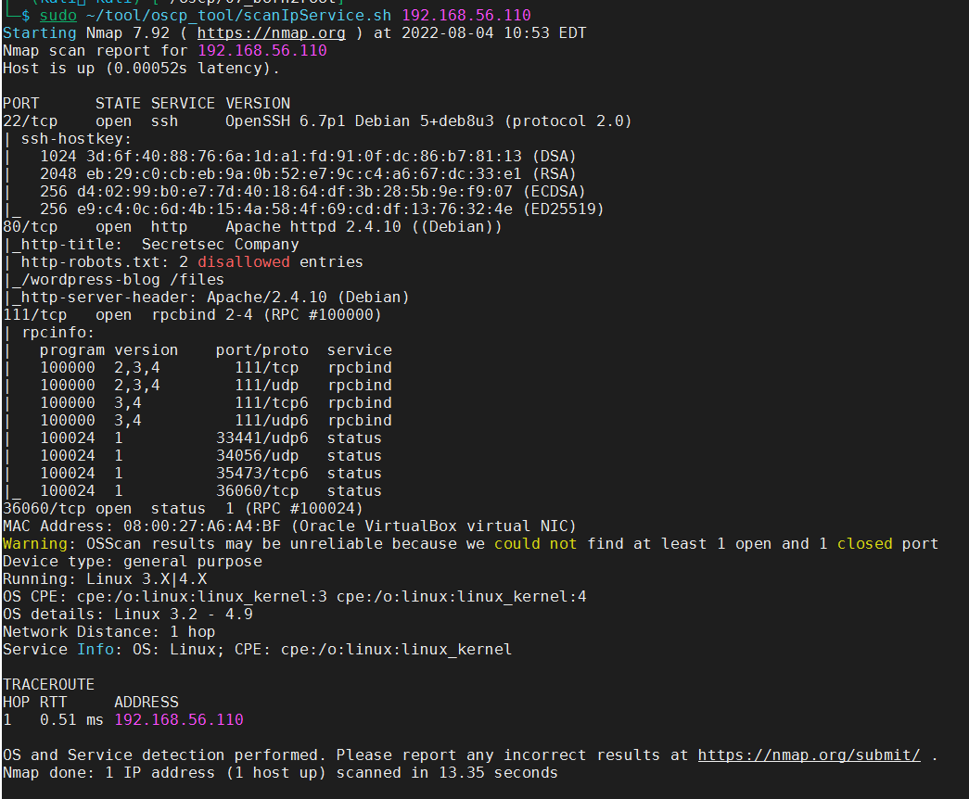

access the web <http://192.168.56.110>, found three user name(martin,hadi,jimmy)

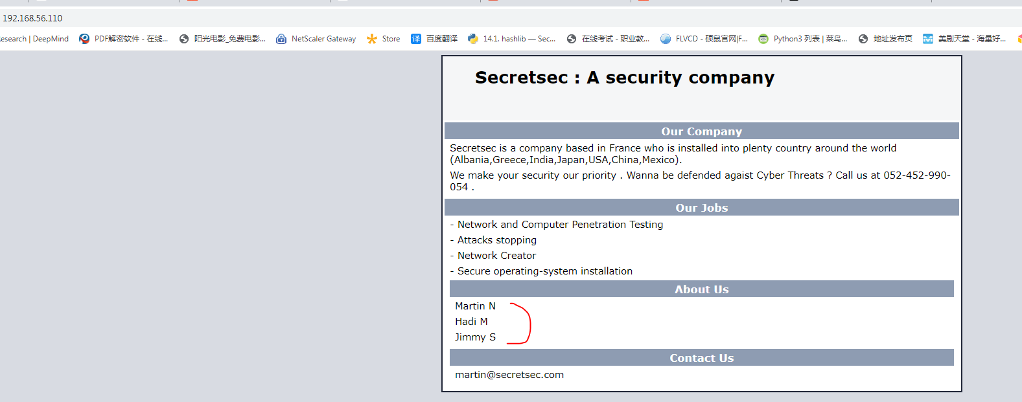

access the disallowed page <http://192.168.56.110/wordpress-blog> and <http://192.168.56.110/files,> nothing found in the two pages

use nikto to scan the webserver http://192.168.56.110,

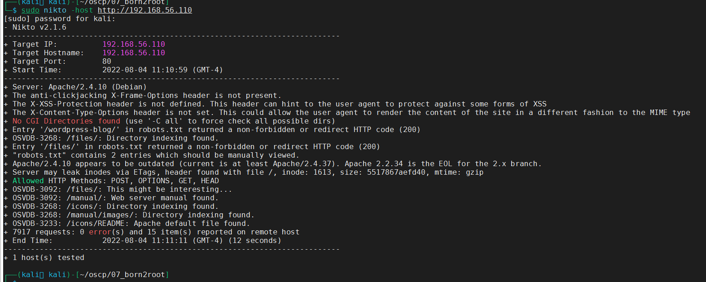

access page <http://192.168.56.110/icons/>, found a suspicious file which is named VdSoyuAXiO.txt

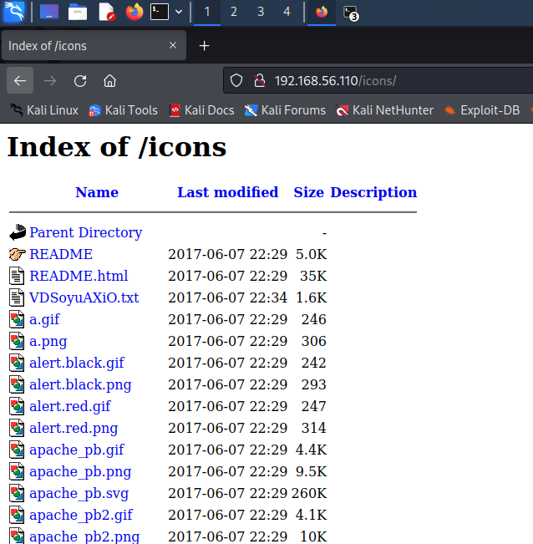

Its content looks like a private key file.

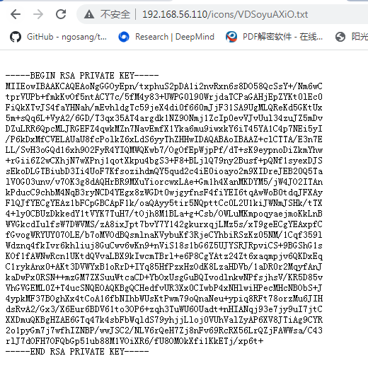

Save these contents to file and name it as id_rsa, change its mode to 600

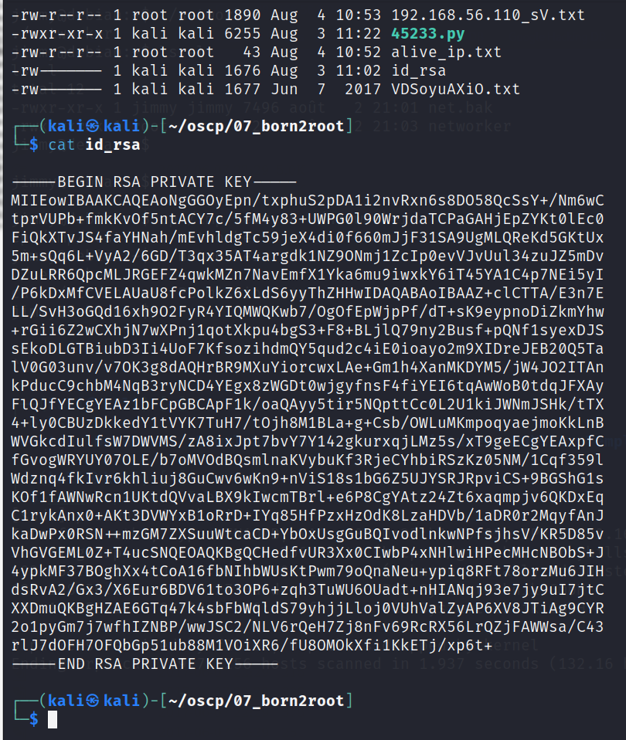

try to use the names found in home webpage with the private key file to login the target, it’s failed with the following err info.

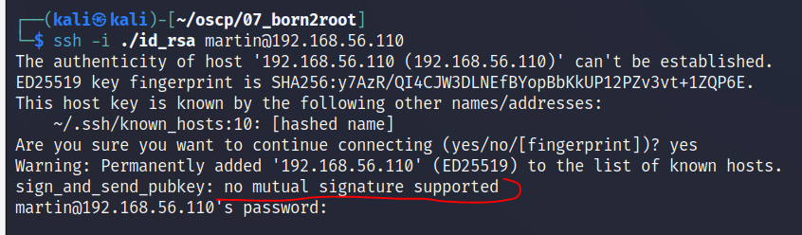

add

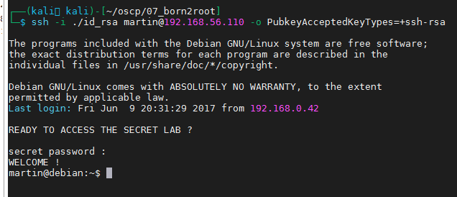

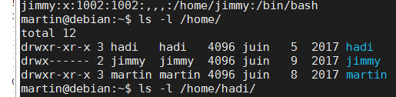

check the cron config file, there is task run by jimmy, it will execute a file in tmp directory,and the file is not exist now.

