Defect Report
Tichi Web Application — Login Module
Prepared by: [Anton Mervin Xavier M] | Date: 02-Jul-2026

BUG-001: Account Not Locked After Multiple Failed Login Attempts
Bug ID | BUG-001
Title | Account is not locked after multiple failed login attempts
Module | Login
Severity | High
Priority | High
Environment | Tichi Web Application (Stage) | Browser: Chrome | OS: Windows 11
Status | Open

Precondition
A registered user account exists.

Steps to Reproduce
1. Open the Login page.
2. Enter a valid registered email address.
3. Enter an incorrect password.
4. Click Login.
5. Repeat the incorrect login attempt 5 or more times.

Expected Result
The application should temporarily lock the account, show a warning message, require CAPTCHA, or otherwise prevent further login attempts.

Actual Result
The application continues to allow repeated login attempts without locking the account or displaying any warning.

Impact
Unlimited login attempts increase the risk of brute-force attacks against user accounts.

Evidence / Screenshot
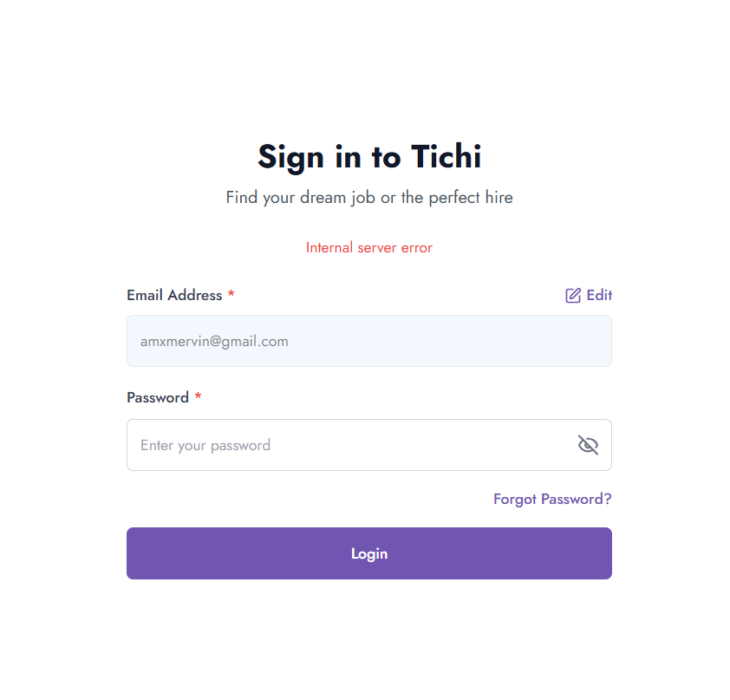
Figure 1: Login screen after repeated failed attempts — no lockout, warning, or CAPTCHA is triggered; only a generic "Internal server error" is shown.

BUG-002: Password Requirement Tooltip Overlaps Page Elements
Bug ID | BUG-002
Title | Password requirement tooltip overlaps the "Error Messages" and Login button
Module | Login
Severity | Medium
Priority | Medium
Environment | Tichi Web Application (Stage) | Browser: Chrome | OS: Windows 11
Status | Open

Precondition
Login page is open.

Steps to Reproduce
1. Open the Login page.
2. Click inside the Password field.
3. Observe the password requirement tooltip that appears.

Expected Result
The password requirement tooltip should display without overlapping or hiding other UI elements. Users should still be able to clearly see and access the "Error Messages" and Login button.

Actual Result
The password requirement tooltip overlaps the "Error Messages" and partially covers the Login button, affecting page layout and usability.

Impact
Reduces usability; users may struggle to access the Login button or Error Messages while the tooltip is visible.

Evidence / Screenshot
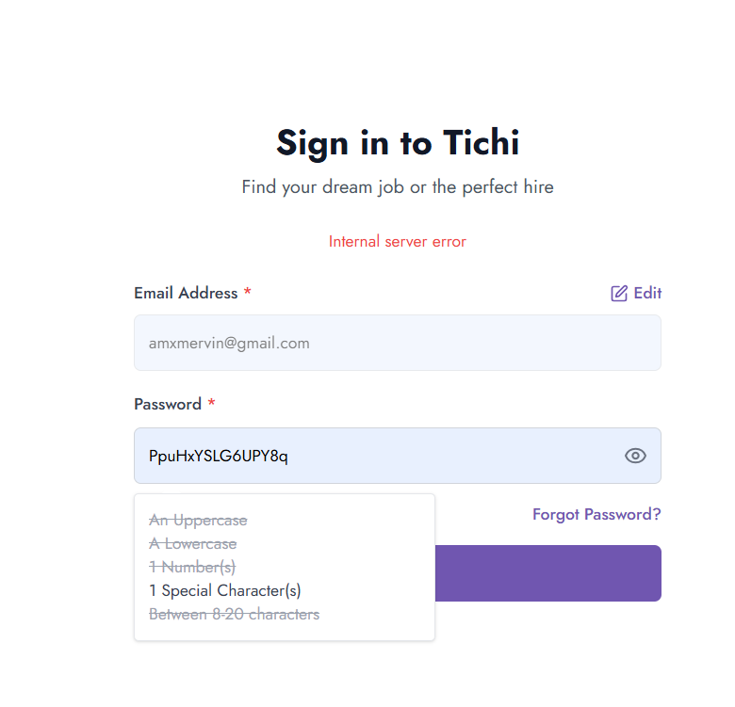
Figure 2: Password requirement tooltip overlapping the "Forgot Password?" link and Login button.

