**Methodologies and Methods**

The purpose of this chapter is to provide information about the research methodologies and methods used in this thesis. We are going to focus on research strategies, data collection, and quality assurance.

This chapter is has Sections that describes the research process underlying the thesis project, presents details about the methodologies, methods adopted in order to select the most suitable 2FA method and explaining how data was searched and collected and presents some ethical aspects linked to it. We also detail the techniques used to evaluate the reliability and validity of the data collected.

Research Process

Research involves a process which focus is on objectively gathering information that will be analyzed in order to come to a conclusion. This thesis project’s research process includes multiple steps that are interlinked with each other. These steps are:

* selection of the topic area,
* formulation of the problem,
* formulation of the goals of the thesis,
* review of the literature,
* selection of methods of data collection,
* analysis of data, and
* reaching conclusions.

Selection of a topic area was the first step. This project focuses on the weak security offered by passwords and on how to make authentication more secure. The topic area was selected by the authors of this thesis together with their supervisor at the company because it was of mutual interest. The authors have previously taken courses on cryptoraphy and computer security. They have understoon the need to to follow Confidentiality and Integrity of the information of our sources. Moreover, the topic of this thesis project was found to be interesting because it addresses an underrated but serious problem.

Identifying a problem related to the topic area is the goal of the second step. The problem is the weak security of Single Factor Authentication (i.e., passwords) in the field of digital assessment platforms. After the problem has been identified, the aims and objectives of the thesis had to be stated in order to determine the scope, the depth, and the direction of the work. In order to avoid setting unrealistic goals and aims, the research objectives were formulated according to specific, measurable, achievable, realistic and timely objectives . Therefore, the goal of the project was set to identify and implement a suitable 2FA method for TrustBank for securing users’ accounts. It is a goal that was regarded as achievable and realistic at the beginning of the project, and it is also considered to be timely.

Once the problem and the scope are identified, existing literature on the topic has to be searched and reviewed. This step allows the researcher to find previous work regarding the problem and data related to it. The first stage in the literature search was to identify search terms. The main search terms in this project were 2FA, authentication, data breaches, two-factor authentication with one time passwords, different 2FA methods, authentication factors, types of authentication, sending OTP, UX with 2FA, cost of 2FA, algorithms used in OTP and other. In the second stage, online literature was found using these search terms.

The different types of research methods can be divided into several categories depending on the nature, the scope, and the purpose of the research. The general classification of the different methods is quantitative and qualitative. The quantitative research method is based on numbers and calculations while the qualitative one is based on perceptions and feelings and aims to provide depth of understanding. This thesis will mainly follow the quantitative approach due to the topic area that is analyzed. Moreover, a research method could be descriptive or analytical. A descriptive method involves surveys and studies which goal is to identify facts and describe a situation as it is at present. An analytical research is different because it is based on already available information that is analyzed in order to provide an evaluation. This thesis project follows the analytical method as it relies on existing data and information and not on surveys carried out by the researcher.

Data Collection

Data collection is the process by which the researcher collects information from all the relevant sources chosen in the previous steps of the research process. The collected data can be divided into two categories: secondary data collection and primary data collection. Primary data are collected by the researcher conducting the research through methods like surveys, interviews or questionnaires. Often, when the research problem is unique, there is no available related work, then the

researcher has to collect the data him or herself.

**Ethical considerations**

There amain objective regarding ethics is to keep security and confidentiality of the data used.

The main issues with secondary data are related to potential harm to individuals as well as the issue of consent. Data could contain identifying information about participants, which means that the researcher re-using this data should describe how the privacy and confidentiality of the participant will be protected. If the data does not contain any identifying information, then the researcher should confirm that the data is anonymous and acknowledge the source of the data.

The data collected was also relevant as it was not outdated and it perfectly fits the problem of this thesis. Moreover, the data was assessed as being accurate. The data was detailed, exact, and comprehensive. The articles chosen presented a throughout discussion of the subject and all sides of the main issue were addressed.

**Data Protection Bill**

The Kenya Data Protection Bill, 2018 presented by chairperson of the Committee on Information, Communication and Technology contains provisions that will significantly change how public and private entities handle information entrusted to them.

According to the Bill, companies will now have to inform users of any personal data they are collecting, the purpose for collecting that data and how long the same will be stored. The law also gives users the right to decline to have their data collected or processed as well as demand to have false data corrected or deleted upon demand. A person found guilty of interfering with the personal data of others or infringes on their right to privacy will be liable, on conviction, to a fine not exceeding Sh500,000 or to imprisonment for a term not exceeding two years, or to both. The Bill is, however, mum on penalties or fines subject to corporates found guilty of the same and leaves it to the complaints commission to decide the course of action.

**Software used**

With regard to the design and implementation of the prototype, the software used has to be decided. The way in which the software will be decided reflects the abilities and skills the authors have acquired during their studies. The main line that will be followed is to use well-known programs/software. Implementation Chapter will provide information about the software used when implementing the solution.

4 **System Analysis**

4.1 **Introduction**

Lonnie D.(2007) explains system analysis as the process of dissecting a system with the sole objective to learn how the component pieces interact to achieve their functions. The aim of performing this activity is to find out how the current system operates (i.e. where one exists) and thus identify where the problems are incurred hence solutions to these problems can then be identified. This activity further enables the analyst to further identify some additional requirements which the user needs and thus incorporate the same in the construction of the new system. This is further realized in the data collection process where the additional information is gathered from the respective stakeholders. System analysis answers the questions of who will use the system, what the system will do and where and when it will be used. It is a process of collecting and interpreting facts, identifying the problems, and decomposition of a system into its components. System analysis is conducted for the purpose of studying a system or its parts in order to identify its objectives. It is a problem solving technique that improves the system and ensures that all the components of the system work efficiently to accomplish their purpose

4**.2 Problem Specification**

With the increasing number of web based Applications and users registering or opening many accounts online these applications, there is a high tendency of users choosing simple or easy passwords. Also users make a mistake of writing these passwords on paper or anywhere they would reach for them easily. In addition to social engineering, password phishing using spyware for passwords stored in electronic form causes a lot of risk to users information. designing One Time password, that is send to the mobile phone of the user and used once can help secure many user's web based accounts. The task is therefore to come up with an application that allows for this kind of online access control using OTP to personalize such online access, which is more secure than static passwords. Access control systems are responsible for authenticating and authorizing users to access content in the system.

4.2.**1 Feasibility Study**

The feasibility analysis examines the technical, economic, and pros and cons of developing the system, and it gives a slightly more detailed picture of the advantages of investing in the system as well as any obstacles that could arise. It also identifies the important risks associated with the project that must be addressed if the project is approved. The fact finding process that revealed the ability to successfully complete the proposed system thus providing the justification for the

efficiency and effectiveness of the system. It was aimed at establishing whether it is necessary to develop the proposed system Feasibility study includes three techniques namely:

**4.2.2 Technological Feasibility**

Most organizations are connected to network and it is technologically feasible The SMS based means of sending the OTP is compatible to most mobile phones and so the system is technological feasibility is viable.

**4.2.3 Technical Feasibility**

Familiarity with the application: The analyst of the application is familiar with the web based Applications area and OTP. Therefore, there is a lesser chance of misunderstanding the user needs or missing opportunities for improvement. Familiarity with the technology: The developer is familiar with web application development and thus there are lesser chances that problems will occur and delays be incurred because of the need to learn how to use the technology. This section looks to answers 3 questions:

1. Are the required resources available?
2. Is the required technology available or not?
3. Is the required knowhow available or not?

It also establishes the proposed system's interaction with other systems. Only designers, analysts and developers constitute the team foundation in terms of skilled labor. Users only ought to be computer literate. The system seeks to be resource friendly.

**4.2.4 Operational Feasibility**

This basically deals with how well the system will be accepted by its users and incorporated into the ongoing activities of the users. It was of great importance to include users in the analysis of the system in order to get feedback on acceptable ways of implementing the lock mechanisms on user access controls. From the users' feedback, the system was deemed to be operationally feasible as it improved on the security of user.

**4.2.5 Economical Feasibility**

This section is aimed at determining the positive economic benefits to an organization that the proposed system is to provide. It includes identification and quantification of all benefits projected. It answered the following question:

1. Will users derive an economic benefit from the proposed system?
2. Will the cost of implementation be justifiable?

The system will enable users derive an economic benefit as they can sell their research papers online. The added security layer that will be included will not be costly to incorporate and manage. From the findings, the added security layer will also increase cost of attacking the system hence ensuring income from using the system will be more secure hence increasing computational trust of the system.

**4.3 System Analysis**

**4.3.1 Requirement Analysis**

This is the process of studying and analyzing the customer or the user needs to arrive at a definition of software requirements. The software requirements were identified by analyzing existing systems and online. Three organizations were selected for case study as common application platforms sometimes uses OTP but not always.

***Explain how the companies use the otp here***

**4.4 Requirement Specification**

A requirement is simply a statement of what the system must do or what characteristic it must have. Requirements can be mainly divided into two: either functional or non-functional.

A functional requirement relates directly to a process the system has to perform or information it needs to contain. A non-functional requirement refer to behavioural properties that the system must have, such as performance and usability.

**4.5 Functional Requirements**

**Create an account:**

Anyone wishing to use this online service must register as a user by creating an account. The system should allow for creation of unique accounts for each user.

2. **Sign up a registered** user of the web based Application. Those wishing to sign up as users will submit their application through filling in an online form. The form will be relatively short but just enough to capture all the relevant details.

3. The system should be able to deny access to **Unauthenticated users**. Without correct username and password and the OTP, the system should not allow access to the secure user information in the web based application.

4. Generate and **send the One Time Password**.

5. **Search for user details**: The users of the system will be able to access the system to look for user record . The search can be done based on specific attributes such as specific username. Alternatively, the search may be done via the user name which case a detailed record the user will be provided.

4.6 **Non-functional Requirements**

1. **Accuracy and timeliness** in the process of producing and sending OTP. This is very important because the six digit OTP in only valid for a short period of Time.

2. **Performance** -this refers to the speed, capacity and reliability of the system. The requirements include:

1. The system should be available for use 24 hours a day, 365 days per year.
2. An interaction between the user and the system should not exceed 2 seconds.

3. **Usability:** Should allow ease of use. Documentation: Should be well documented to facilitate use of the system.

4. **Security** -this basically refers to how secure the system is in terms of allowing only specific people to access the system at specific times. The requirements include:

1. The users of the system can only access specific information in the web based application.
2. The users cannot be able to modify data related to other users, though they can modify data about them save for unique identifiers.

5. **Performance** -this refers to the speed, capacity and reliability of the system.

The requirements include:

1. The system should be available for use 24 hours a day, 365 days per year.
2. An interaction between the user and the system should not exceed 2 seconds.

6. **Operational** -this basically involves the physical and technical environments in which the system will operate. Thus, they include:

1. The system should be able to work on any web browser.
2. The system will be able to operate in Windows, Macintosh and Linux environments as it will be running in a web browser.

7. **Adaptability:** It should be easy for users to adapt to the application.

8. **Accessibility**: The user interface will be responsive to cater for the devices that users might have to access the system.

**4.7 Functional Modeling**

Functional models describe business processes and the interaction of an information system with its environment. In object-oriented systems development, two types of models are used to describe the functionality of an information system:

1. Activity diagrams support the logical modeling of business processes and work ows.
2. Use cases are used to describe the basic functions of the information system.

**4.7.1 Use case Descriptions**

The use case communicates at a high level what the system needs to do. Use cases capture the typical interaction of the system with the system's users (end users and other systems). The following use cases were developed after reviewing the requirements.

There are 3 actors in the system, namely user, admin and the public. The user can perform the following actions. First he/she has to log in to the system. The log in with user name and password utilizes the user private username and password and database function to create account to check whether the user has an account. The log in with OTP uses users information in the database to check or match. After logging in, the user can create a profile. This will show details about the

user that will be available for view by other users. This is where the user builds a profile that is trustworthy and that which will attract customers to download the users content. The create profile use case extends the edit profile use case. Finally user can upload research papers and journal, which he can set a price that will be available for download by other users. A user can also view research papers uploaded by other users click and purchase them. This is after he has deposited

money into his account for purchasing the documents. Admin actor has simple basic functions such as facilitating the users withdrawal. He also has the basic functions of deleting unnecessary posts and dealing with user inquiries. He can also withdraw income that the system accumulates.

figure : Use case diagram

**4.8 System requirements analysis**

Hardware constraints Minimum or actual hardware speciation required:

None- Software Constraints System interface will be implemented using HTML5, Vue.js (a JavaScript framework), and Tailwind CSS (A utility first CSS framework). Backend of the system will be implemented using Laravel 5.6, a PHP framework. Justinmind will be required too to create mock-ups and Katalon studio for Automation testing.

Database constraints. Database of the system will strictly be implemented using MySQL database.

**Non-functional requirements**

This section species the quality factors required by the system which are not related to the specific functional requirements:

**System Design**

**5.1 Introduction**

The design of the system will aim to identify the subsystems in the project, the interactions between the subsystems, system states and the logical ow of events within the system. During the system design we identify the data relationships and the database schema elements. The design also seeks to define how the user will interact with the system and the desired system user interfaces.

This chapter describes the process followed in defining the architecture, components, modules, interfaces, and data for the system to ensure that it satisfies the specified requirements. The system design was approached through the main sections as outlined below.

dentiﬁed Use Cases

A use case diagram in the Uniﬁed Modeling Language (UML) is a type of behavioral diagram deﬁned by and created from a Use-case analysis. Its purpose is to present a graphical overview of the functionality provided by a system in terms of actors, their goals (represented as use cases), and any dependencies between those use cases. The main purpose of a use case diagram is to show what system functions are performed for which actor. Roles of the actors in the system can be depicted. Interaction among actors is not shown on the use case diagram. If this interaction is essential to a coherent description of the desired behavior, perhaps the system or use case boundaries should be re-examined. Alternatively, interaction among actors can be part of the assumptions used in the use case.

Use case: A use case describes a sequence of actions that provide something of measurable value to an actor and is drawn as a horizontal ellipse.

**Actor:** An actor is a person, organization or external system that plays a role in one or more interaction with the system.

**System boundary boxes (optional**): A rectangle is drawn around the use cases, called the system boundary box, to indicate the scope of system. Anything within the box represents functionality that is in scope and anything outside the box is not.

**Include:** In one form of interaction, a given use case may include another. ”Include is a Directed Relationship between two use cases, implying that the behavior of the included use case is inserted into the behavior of the including use case.

**Extended use case**: In another form of interaction, a given use case (the extension) may extend another. This relationship indicates that the behavior of the extension use case may be inserted in the extended use case under some conditions. The notation is a dashed arrow from the extension to the extended use case, with the label ”extend”. Modelers use the ”extend” relationship to indicate use cases that are ”optional” to the base use case.

**Associations:** Association between actors and use cases are indicated in use case diagrams by solid lines. An association exists whenever an actor is involved with an interaction described by a use case. Associations are modeled as lines connecting use cases and actors to one another, with an optional arrowhead on one end of the line. The arrowhead is often used to indicating the direction of the initial invocation of the relationship or to indicate the primary actor within the use case.

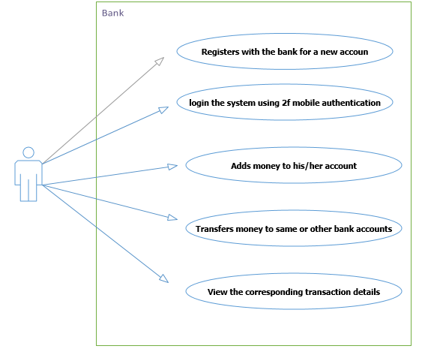

5.2 Behavioral Modelling

Behavioral models describe the internal dynamic aspects of the system that supports the business processes in an organization. It describes what the internal logic of the processes is. In this chapter, we describe three Unified Modeling Language (UML) diagrams that are used in behavioral modeling

(sequence diagrams and activity diagrams).

**5.2.1 Logical Sequence of Activities in the System**

Sequence Diagram: Login

USER

MOBILE

SYSTEM

DATABASE

OPENS APP

GETS OPTIONS

TO LOG IN

LOGS IN WITH

USERNAME AND PIN

GETS FEEDBACK FROM USER

AND SENDS IT TO THE SYSTEM

FOR VALIDATION

GETS THE VALIDATION REQUEST

RECIEVES VALD

QUERY AND CHECKS

GENERATES OTP

AND SENDS IT TO

THE USER

RECIEVES THE OPT AND

DISPLAYS IT VIA SMS FROM

AFRICAS TALKING

ENTERS THE RECEIVED OTP

GETS THE USERS INPUT AND

SENDS IT TO THE SYSTEM FOR

VERIFICATION

COUNTER CHECKS WITH THE

GENERATED OTP

GRANTED ACCESS TO THE

SYSTEM

.

DISPLAYS HOMEPAGE

.

VIEWS AND PROCEEDS WITH

THE INTENDED TRANSACTION

.

GETS THE OTP FROM THE

SYSTEM AND DISPLAYS IT

INPUTS THE OTP

NOT VALID

VALID

STORES THE

GENERATED OTP

NOT VALID

VALID

Figure: sequence Diagram

5.2.2 Logical Sequence of Activities in the System Data and Database Modeling

5.3 **Data and Database Modeling**

Figure 4: The User Table

5.3.1 Database design

This section describes the process of creating data models of the system database.

These models help to give clear relations of objects and their interactions in the database. Below are the models that were chosen to represent the system:

5.3.2 Logical model

_gure: Dtabase Table design

_gure: database design.

36

**Figure 5: The Logical design**

**Class diagram**

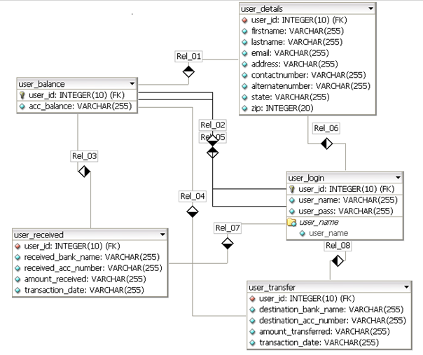

5.4 Human Computer Interaction Layer Design

The human computer interface layer defines the way in which the users will interact with the system and the nature of the inputs and outputs that the system accepts and produces. The user interface includes three fundamental parts which were reviewed in the construction of the system:

1. Navigation mechanism, the way in which the user gives instructions to the system and tells it what to do (e.g., buttons, menus). The system thus consisted of menus and button which acted as `guides' and when clicked resulted in the execution of various commands
2. Input mechanism, the way in which the system captures information (e.g., forms for creating new users). this application mainly deals with controlling access by generating OTPs to be used by users.
3. Output mechanism the way in which the system provides information to the user or to other systems (e.g., reports, Web pages). This application provides SMS based One Time password.

**Navigation Design**

The navigation component of the interface enables the user to enter commands to navigate through the system and perform actions to enter and review information it contains. A good navigation component is one the user never really notices. It simply functions the way the user expects, and thus the user

gives it little thought.

The following navigation controls will be used:

1. **Menus:** In the design of the navigation, menus and links will be heavily utilized in order to prevent the user from making mistakes e.g. during typing. Thus direct manipulation was exemplified.
2. **Messages:** they are the way in which the system responds to a user and informs him or her of the status of the interaction. There are many different types of messages, such as error messages, confirmation messages, acknowledgment messages, delay messages, and help messages. These will be included in this system as shown in the sample below.

Figure 6: The Logical design

User modules/pages Log in page: This form requires users to input the necessary details that are required to validate a user and create a session. Upon successful validation users are redirected to the intended page otherwise they are redirected back with error that the log in details are incorrect.

This page will be used to collect the main details of a user that will be sufficient

to provide quality service once the user successfully registers.

**System implementation**

Implementation is the fourth phase in the system development life cycle(SDLC). The purpose of system implementation is to build a properly working system and install it in an organization.

In **computer** science, an **implementation** is a realization of a technical specification or algorithm as a program, software component, or other **computer** system through **computer** programming and deployment. Many implementations may exist for a given specification or standard.

**Systems implementation** is the process of:

1. defining how the information system should be built (i.e., physical system design),
2. ensuring that the information system is operational and used,
3. ensuring that the information system meets quality standard (i.e., quality assurance).

**5 areas of expectations from the developers**

1. Goals: the reasons for developing the system
2. Importance: the importance of the problem being addressed
3. Patterns of use: the way the system will be used
4. Impacts: system impacts on the organization
5. Evaluation criteria

**Software implementation**

This section describes how the design was implemented and which tools were used during the development of this implementation. Some important parts of the code are shown as well as the database scheme.

**Software and tools used**

* **Laravel**
* **Tailwind Css**
* **Africas talking API**
* **fixer.io API**
* **Katalon studio**
* **composer**
* **Vue.js**

A detailed use of the software can be found on the appendix page.

**User Experience (UX) Design.**

To start, it has to be said that increased security comes with a loss of convenience and ease of use. Therefore, designing a user-friendly 2FA is a hard task due to the fact that authentication poses many contradictions to the principles of Human-Computer Interaction (HCI), as secure authentication often compromises the user’s experience. However, our study, concluded that the usability of different 2FA methods varied depending on the users’ demographic background.

**Algorithms used in 2FA**

An OTP value can be generated through two standards governed by the Initiative for Open Authentication (OATH): HOTP or TOTP. In this section details about these OTP schemes are given and the two algorithms are presented.

OTP

RFC 2289 describes a One-Time Password System. OTPs were mainly to counter a “replay attack”, in which information is eavesdropped and captured on a network connection in order to be used later to access a system. The system described in the RFC relies on a secret pass-phrase that is used to generate a series of OTPs. The strength of the system is that the user’s pass-phrase never has to traverse the network, therefore it is invulnerable to replay attacks; moreover, added security is given by the property that no secret information has to be stored on any system. However, OTP offers no protection against social engineering or active attacks. There are mainly two requirements for an OTP-system to work. First, the generator must generate the OTP from the user’s secret pass-phrase and from the information provided by the server. The server, on the other hand, must send a challenge to the generator, must verify the received OTP, must store the last valid OTP it received, and must store the OTP sequence number. The OTP generator passes the pass-phrase, along with a seed received from the server through a secure hash function to produce a one-time password.

**HOTP**

HOTP algorithm is used to generate one-time passwords based on the Hashed Message Authentication Code (HMAC). The algorithm relies on few factors such as:

* a shared secret key and a moving factor. The symbols introduced by the

RFC are:

* an 8-byte counter value C that is the moving factor. This counter has to be synchronized between the client (generator) and the server (validator),
* a shared secret K between client and server. Each generator has a unique and different K,

HOTP is based on using the HMAC-SHA-1 algorithm. Since the output of the algorithm is 160 bits, the value is truncated in order to easily be read by the user.

**TOTP**

HOTP algorithm, where the moving factor is based on a time value. This time-based OTP algorithm provides short-lived OTPs which strengthen security. The basic different between the TOTP algorithm and the HOTP algorithm is that a value T derived from a time reference replaces the counter C.

With regard to security RFC 4226 states that even if an adversary is able to observe numerous message exchanges of successful authentication attempts and knows how build a function in order to generate HOTP values, then the adversary will not have a significant advantage over a random guess.

**HOTP or TOTP**

The main difference between HOTP and TOTP is that the OTPs generated through the TOTP algorithm are short-lived (generally with a lifetime of less than 30 seconds), while the OTP generated through the HOTP algorithm is potentially longer-lived. This means that the security provided by a TOTP implementation is better than an HOTP implementation for two reasons. First, if an HOTP password is compromised, it can be valid for a “long time”, while a TOTP password is only valid for a number of seconds chosing otp TOTP implementation of the OTP is preferable due to its enhanced security. If the OTP scheme is based on a software solution, then the OTP is generated by an application on the phone.

**The main advantages of receiving a OTP via SMS is that the user does not have to own a smartphone, since all mobile phones are able to receive SMSs.**

Implementing a TOTP application solution means that not everyone is able to use it. Moreover, SMSs are convenient since there is no need to download an application or perform any setup. In terms of deployment, an SMS-based solution is simpler than an application-based solution since it does not require the company to write an application to generate TOTPs or to modify its servers in order to meet the requirements of the TOTP algorithm. Also, the client device generating the TOTP does not need to be connected to the Internet (as the protocol also works in offline mode).

On the other hand, there are some disadvantages in using SMS delivery of OTPs. The first disadvantage is due to limited network coverage as poor network coverage would imply the impossibility for the user to authenticate using 2FA.

Moreover, sending OTPs though SMS is no longer considered secure due to the vulnerabilities of the GSM network and due to malware & Trojans designated to intercept SMSs. Our assumption is that SIM exchange will not compromise the TOTP codes since the codes are independent of the SIM card.

**cost**

In terms of cost, the TOTP solution is more convenient since it is nearly free (once it has been implemented). The TOTP protocols are open source, which means that the only cost will be based upon the amount of time necessary for TrustBank to implement the protocol in its servers and to develop an app that generates TOTPs.

Implementing an SMS 2FA will have an on-going cost to TrustBank, changed at normal SMS rates by the service provider since the company will have to utilize a communication platform, and also perform HTTP request from third party SMS gateway provider.

**Account recovery**

The more secure the authentication process is the harder it is to regain control over the account, as more information has to be proven. This means that while 2FA strengthens the security of the account at login, it also makes it more difficult and troublesome for the account possessor to regain control over an account. This difficulty in account recovery should be kept in mind, as if not implemented thoughtfully it could enable an intruder to steal an account. An unavailable mobile device implies the inability of the user to use the second authentication factor. Depending on which 2FA method is used and whether the device is broken or lost there are different ways of dealing with account recovery.

|  |  |
| --- | --- |
| case | Recovery |
| Forgotten password | E-mail with reset link  (SMS if number stored |
| Broken device | SMS with code |
| Lost device | Backup code or peer  recovery. (SMS if number recovery stored) |
|  |  |

A forgotten password is one of the most common reasons for being unable to access an account. The most common method used in order to recover the account in this scenario is to send a recovery link or temporary password to the user’s email address, which was registered during account creation. Sometimes the password or the link is sent to an alternative mail address, still provided by the user during account creation. This method is the easiest and probably the most logical one to deal with forgotten passwords. Regardless of the 2FA method used, the account recovery mechanism should work in the same way as described in the previous section; hence 2FA would not be bypassed. Even if a potential intruder manages to reset the password, the second authentication factor would still be required in order to gain access and therefore the account is still secured with 2FA. Inability to provide the second factor of authentication The inability to provide the second factor of authentication could be due to either loss of the user’s mobile device or it being broken. By the term broken we mean a mobile device that is in possession of the user but is unusable. A lost mobile device means that the user has no physical access to the device. Storing the user’s phone number during the registration process makes it easier to deal with account recovery in case of a broken mobile device, regardless of the 2FA method chosen for login. This is true since the SIM card is still in possession of the user, hence the user could move this SIM card to another devices and an SMS could be sent with either a code to login or a restore code to reset the password. On the other hand, the process of recovering the account becomes complicated if 2FA relies on OTP and no phone number is linked to the account. This case is handled in the same way for both a lost and broken mobile device. The problem that arises, in this case, is that authentication is dependent upon the application.

**Afrikas talking API**

The most common API among developers is to use Africas’ talking Mobile services, ranging from USSD, SMS, Short code to mobile money check out. SMS service is used to send verification codes to users mobile phones, in combination with a username and password to strengthen the security of users’ logins. The main advantages offered by the OTP solution provided by Afrikas’ Talking are that there is no need for client software further easing its implementation and that they have the cheapest SMS service platform.

In order to verify the OTPs, two options can be followed by the company / developer:

* Use Afrikas own web server called Afrikas talking, which is available after getting an free API key or host a verification server. Implementations of such a server written in Go, Python, and PHP are available on the website.
* 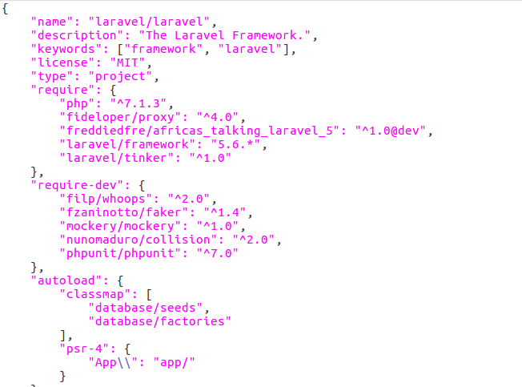Laravel developers can access Afrikas’ talking package from packagist.com. The developer can install via composer dependency manager.

diagram showing installation of afrikas’ talking via composer

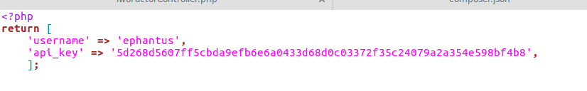

diagram showing Afikas’ talking API key and username

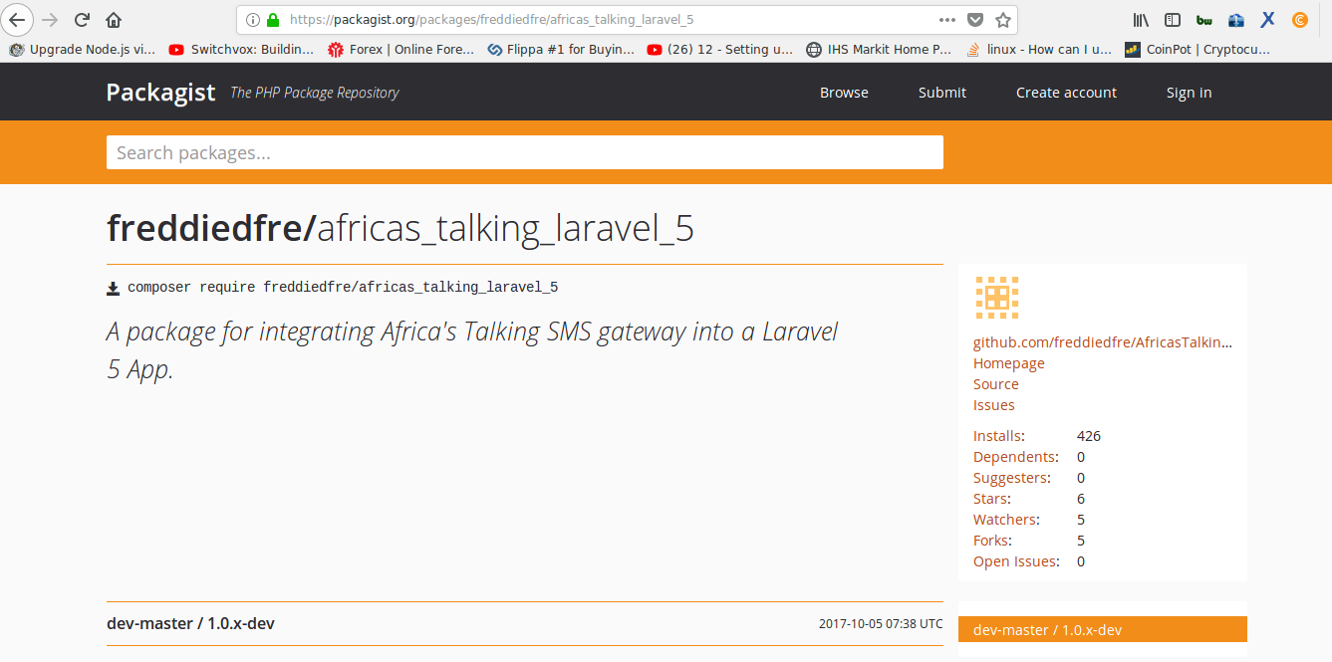

diagram showing laravel package for Afrika’s talking on [www.packagist.com](http://www.packagist.com)

**Programing language**

The first choice to made was to choose which programming language to use for implementing the server side of f the solution, the client side, and the database. The web page was written in HTML and Tailwind CSS — as these are the tandard languages for creating web pages rapidly. JavaScript and Vue.js framework were used to develop models that engaged calculations like loan interests, and to stream line some process more comfortable . The server side was implemented using Laravel for the same reasons. The database used was MySQL.

**securing the application**

Laravel makes it easy to protect your application from cross-site request forgery(CSRF) attacks. Cross-site request forgeries are a type of malicious exploit whereby unauthorized commands are performed on behalf of an authenticated user. The user is protected from copying of user details entered in input boxes.

Laravel automatically generates a CSRF "token" for each active user session managed by the application. This token is used to verify that the authenticated user is the one actually making the requests to the application.

**User Registration**

We first dealt with registration of the user. TrustBank stores the full name of the user, the mail address and the gender of the user. For the purpose of the implementation, we chose to not take into account the user’s full name or gender. In order to implement the SMS 2FA option, our implementation requires the user to provide a valid phone number during registration.

Laravel assist in creating models with easy. The eloquent model attributes are mapped in the database through migrations.

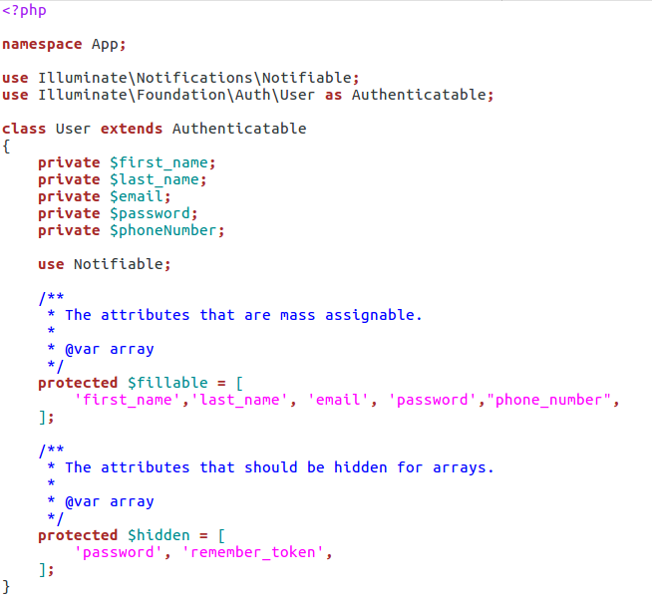

Diagram showing a user model with details to be captured in the registration form.

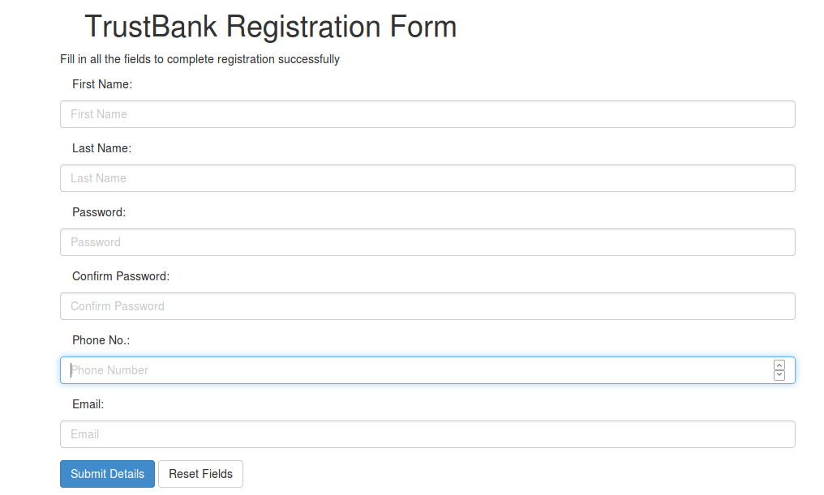

Diagram showing registration form to capture details of new users

The email address, password, and phone number are then stored in a database. The password is encrypted through **argon** algorithm before being stored in the database.

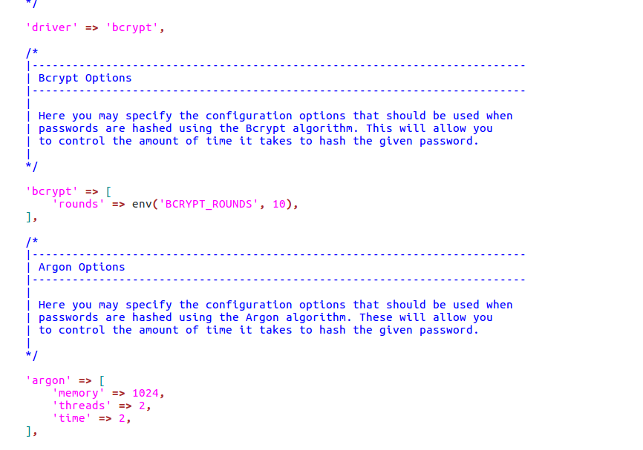

Diagram showing password hashing algorithm used in laravel.

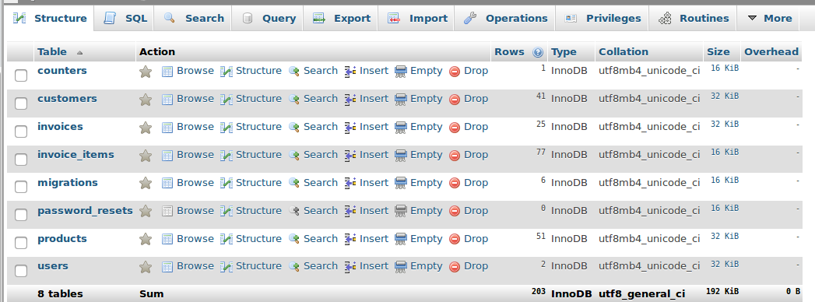

SMS authentication

If the u ser proceeding with login has SMS 2FA enabled, three additional PHP files are us sed to handle the login. First, the user clicks on login button, if correct login details are entered, they are redirected to verification where the user enters the sent Verification code from Afrikas’ talking Rest API as show in the figure below. The user is then redirected to a page that displays a form into which the SMS code has to be entered When the user enters s a code and clicks the validate e button, a 2FA controller file will check whether the code is correct and if so, then the user is granted access and redirect to online banking. If the code entered does not match, an error indicating incorrect code will be shown as in the figure below.

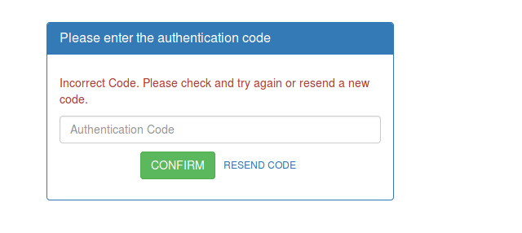

Figure: user authentication.

user-login

This page checks whether the user-name submitted in already exists in the database,

if exists then, it will again redirect to register throwing an error –username already

exist, please try another one. and if does not exist, It will perform the following

steps:

1. Inserts a new user login details in user-login table namely, username and

password. The user-id is an auto incremented field and increments its value

by 1.

1. Based on the last inserted user-id in user-login table, it will insert a new

record in user-details table updating all the contact details of the user.

1. Inserts a new record in user-balance table by a default value of zero in account balance.
2. Displays the login form and on submitting this form will redirect to login-

home.

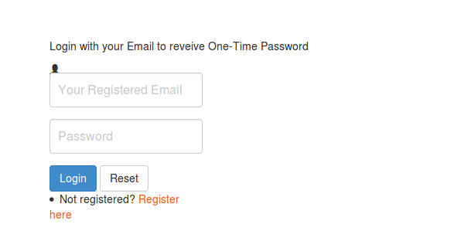

diagram showing TrustBank login screen

Testing

Testing is the process of detection errors. Testing performs a very quality role for assurance and for ensuring the ability of software. The results of testing are used latter on during maintenance also.

Testing Objectives

The main objective of testing is to uncover a host error, systematically and the minimum effort and time starting formally, we can say:

1. Test is the process executing a program with the intent of finding an error.

2. A successful test is one that uncovers as ad yet undiscovered error.

Functional Tests are used to exercise the code with nominal inputs (input values) for which the expected values are available. We also know the boundary conditions for these inputs. For instance, functional testing of matrix multiplication can involve some data (matrices) for which the results are known in advance.

Performance Tests are utilized in order to determine the widely defined performance of the software system such as an execution time associated with various parts of the code, response time (in case of embedded systems), and device utilization. The intent of this type of testing is to identify weak points of a software system and quantifying its shortcomings, leading to further improvements.

Achievements

The two main goals of the thesis project were met. A prototype 2FA solution was provided to TrustBank. Moreover, we analysed different 2FA methods in terms of cost, UX, deployment, and security. To analyse out-of-the-box solutions and how account recovery could be handled when implementing 2FA were goals as well.

We were also able to implement trade solutions to TrustBank web platform. The user can view up-to-date forex exchange displayed on the web application. We successfully made HTTP request from fixer.io using axios, a vue.js library for ajax call on API’s. Platform rich of information on Forex trade for our customers was put to consideration during development.

**conclusion**

The traditional single-factor authentication is considered as “inadequate” to protect the transactions

from criminal attacks such as account fraud and identity theft (FFIEC, 2005; Hong Kong Post 2007). A consensus regarding a more controlled protection over the security of online financial transactions has emerged and Kenyan Banks has been following a global trend to adopt multi-factor authentication. For example, the largest banks in Kenya are now offering the Short Message Service (SMS) payment security service using mobile phones as a different channel for authentication while others provide password-generating tokens to their Internet banking customers.

However, despite its increased security assurance, the two-factor authentication techniques are not

free from criticisms (Giessen 2006; Hoffman 2005). Schneider (2005) argues that two-factor

authentication will not prevent all the attacks happening in remote authentication environments over

the Internet. Moreover, although some two-factor authentication supporters argue that the customers

would feel confident and secured if they have an extra layer of security, there is a conception that two-factor authentication will be a barrier for users to adopt Internet banking services because it will

increase the amount of users’ efforts to access their bank account and perform financial transactions

(Matthews, 2006; Giessen 2006).

During the testing of the implementation, it was found that the system was working as expected and that our implementation of the two-factor authentication system was working and had better security compared to the conventional one-factor authentication system.

Appendix

PHP:

PHP: Hypertext PRE Processor, is a widely used, general-purpose and server side scripting language that was originally designed for web development, to produce dynamic web pages. We can embed PHP into HTML and that usually runs on a web server, before that we have to configure and process PHP code used to create web page content from it. That configuration can be deployed on most web servers and also into almost every operating system and platform for free of charge.

Statistics shows PHP was installed on over 20 million websites and 1 million web servers.

MYSQL:

MYSQL is a RDBMS, which can be abbreviated as relational database management system. The database management system that we used in this application was MySQL .[MySQL database will allows users to create a relational database management system structure on the web-server that may be present in somewhere to store data like fields or records or user details. This program runs like a server providing multi-user access to a number of databases.

CSRF:

Cross-site Request forgery is a type of attack that occurs when a malicious web site, email, blog, instant message, or program causes a user’s web browser to perform an unwanted action on a trusted site for which the user is currently authenticated. The impact of a successful CSRF attack is limited to the capabilities exposed by the vulnerable application. For example, this attack could result in a transfer of funds, changing a password, or purchasing an item in the user's context. In effect, CSRF attacks are used by an attacker to make a target system perform a function via the target's browser without knowledge of the target user, at least until the unauthorized transaction has been committed.

**Laravel**:

A php framework intended for development of web applications with an organized file structure. We used it to develop the back end -eloquent models, controllers, and authentication logic.

**Vue js**:

Javascript framework for building web interfaces – we used axios libraly for HTTP requests from fixer.io API

**Tailwind css**:

CSS framework for building custom user interfaces: We used it to develop the front end

**Africa’s talking** :

AN API to service sms, ussd, voice, payments and airtime applications.

**Fixer.io** :

An API used to capture the latest forex exchange prices

**composer**

Composer is a tool for dependency management in PHP. It allows you to declare the libraries your project depends on and it will manage (install/update) them for you.

## Dependency management

Composer is not a package manager in the same sense as Yum or Apt are. Yes, it deals with "packages" or libraries, but it manages them on a per-project basis, installing them in a directory (e.g. vendor) inside your project. By default it does not install anything globally. Thus, it is a dependency manager. It does however support a "global" project for convenience via the global command.

Argon:

argon is a password hashing scheme, which implements a memory-hard function with memory and time requirements as a parameter. It is designed so that any reduction of available memory imposes a significant penalty on the running time of the algorithm. Argon Collision and forgery resistance.

Argon is a parametrized scheme with two main parameters:

• Memory size m (m cost). Argon can occupy any number of kilobytes of memory, and its performance is a linear function of the memory size.

Bibliography

1. Michael Pearce, Ray Hunt, Sherali Zeadally. Assessing and Improving Au-

thentication Confidence Management, University of Canterbury, New Zealand

and University of the District of Columbia.

1. Subashini, K., and Sumithra, G., “Secure multi modal mobile authentication

using one time password.” 2 nd International Conference on Current Trends

in Engineering and Technology (ICCTET), 2014, pp. 151-155. IEEE, 2014.

1. Suzumura T, Trent S, Tatsubori M, Tozawa A, Onodera T. Performance

comparison of Web Service Engines in PHP, Java and C,IEEE International

Conference on Web Services 2008.

1. Naphtali Rishe, Khaled Naboulsi, Ouri Wolfson, Bryon Ehlmann. An Effi-

cient Web-based Semantic SQL Query Generator .High Performance Database

Research Center, Florida International University.

1. Muhammad Saleem, Kyung-Goo Doh. Generic Information System Using

SMS Gateway. Fourth International Conference on Computer Sciences and

Convergence Information Technology 2009.

1. ‘What is 2FA?’, securenvoy.com. [Online]. Available:

https://www.securenvoy.com/two-factor-authentication/what-is-2fa.shtm.

1. ‘National Information Assurance (IA) Glossary’. CNSS, 26-Apr-2010 [Online].

Available: https://www.ncsc.gov/nittf/docs/CNSSI-4009_National_Information_Assurance.pdf.

1. ‘Recommendations for the security of internet payments’, European Central Bank,

Frankfurt, Germany, Jan. 2013 [Online]. Available:

https://www.ecb.europa.eu/pub/pdf/other/recommendationssecurityinternetpayme

ntsoutcomeofpcfinalversionafterpc201301en.pdf.

1. ‘Text for ITU - T Recommendation X. 1254 | ISO/IEC DIS 2911 5 -- Information

technology – Security techniques – Entity authentication assurance framework’,

ISOIEC JTC 1SC 27, Nov. 2011 [Online]. Available: https://www.oasis-

open.org/committees/download.php/44751/285-17Attach1.pdf.

1. C. Mulliner, B. Ravishankar, P. Stewin, and J.-P. Seifet, ‘SMS-Based One-Time

Passwords: Attacks and Defense’, in International Conference on Detection of

Intrusions and Malware, and Vulnerability Assessment, Springer, Berlin,

Heidelberg, 2013, vol. 7967, pp. 150–159 [Online]. DOI: 10.1007/978-3-642-39235-

1_9

1. E. Feigen baum, ‘A more secure cloud for millions of Google Apps users’, Google

Cloud Official Blog. 20-Sep-2010 [Online]. Available:

https://cloud.googleblog.com/2010/09/a-more-secure-cloud-for-millions-of.html.

1. S. Beaudin, ‘An Empirical Study of Authentication Methods to Secure E-learning

System Activities Against Impersonation Fraud’. Nova Southeastern University, 2016

[Online]. Available:

http://nsuworks.nova.edu/cgi/viewcontent.cgi?article=1957&context=gscis_etd.

1. K. M. Apampa, G. Wills, and A. David, ‘User Security Issues in Summative E- Assessment Security’, Int. J. Digit. Soc