Data Analysis / Manipulation (awk)

1. Print EmployeeName and TotalPay who has BasePay greater than 10000

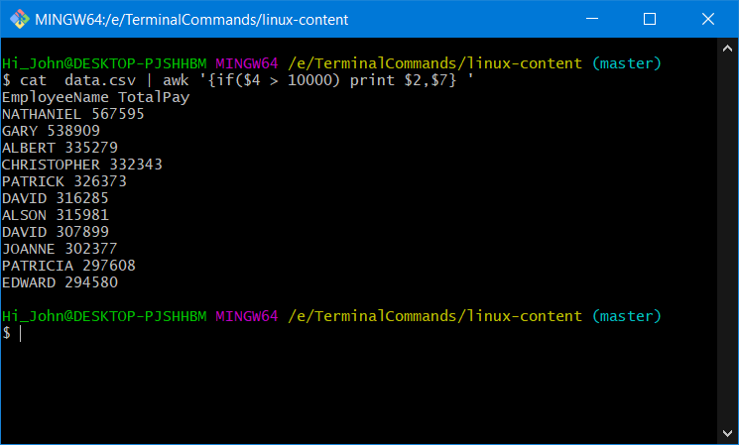

1. What is the aggregate TotalPay of employees whose jobtitle is ‘CAPTAIN’

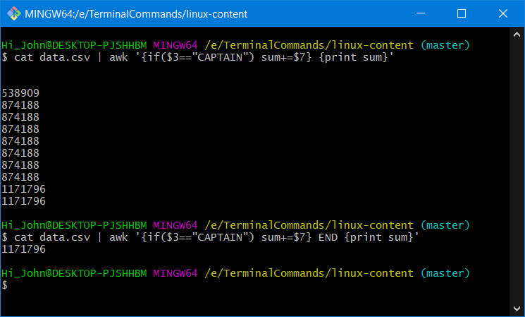

1. Print JobTitle and Overtimepay who has Overtimepay is between 7000 and 1000

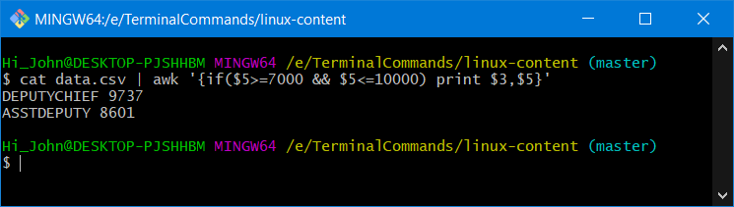

1. Print average BasePay

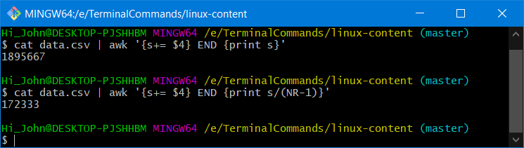

Move files from one folder to the respective folders

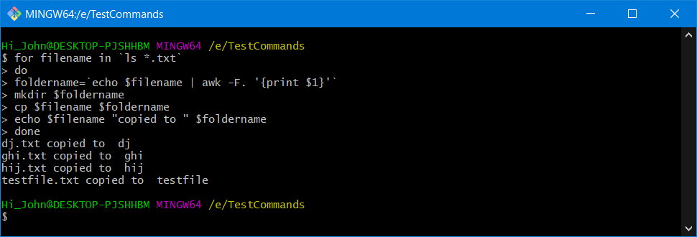

Check if the folder already exists or not. If its not present ,create it

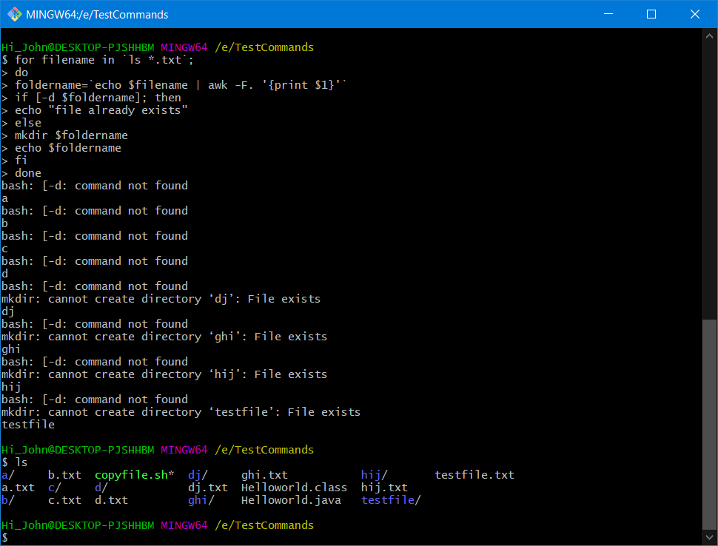

Find the difference between the original file and updated file. Apply changes in the original file

1. create 2 directories as original and updated

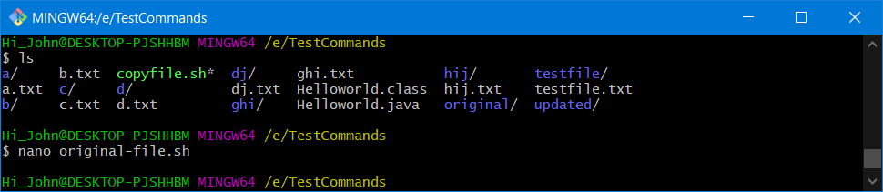

1. copy the given file original-file.sh to original and updated-file.sh to updated

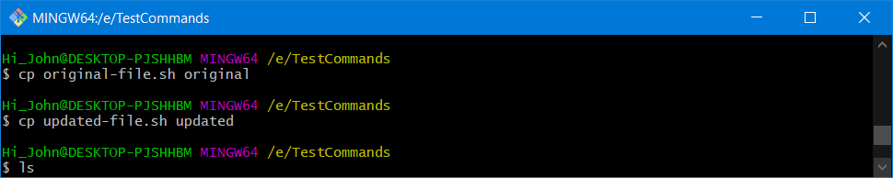

1. difference between these directories using linux command

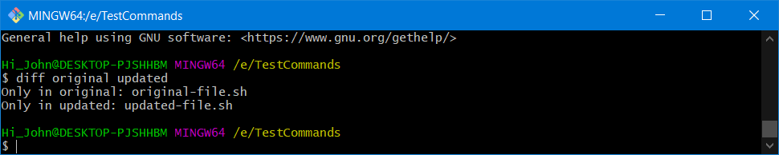

1. make copy of folder original to some other directory original-backup and apply changes to original-file.sh

