1. Use Random Function to get single digit
2. Use Random to get Dice number between 1 to 6
3. Add two Random Dice Number and Print the result

**CODE**

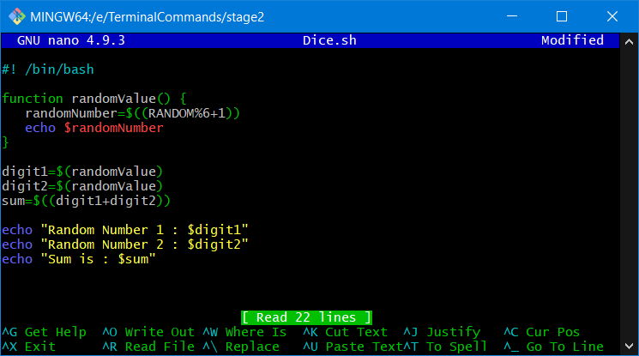

**Output**

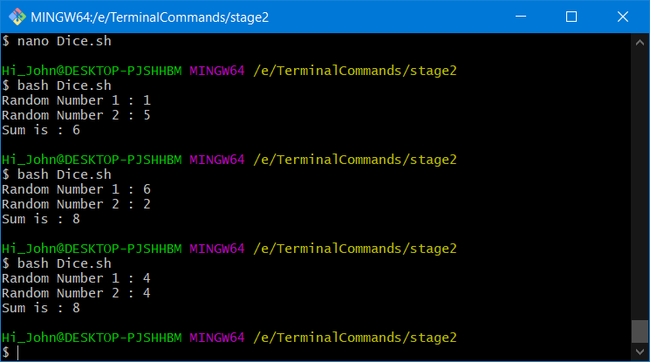

4. WAP that reads 5 Random 2 digit values then find their sum and the average

**CODE**

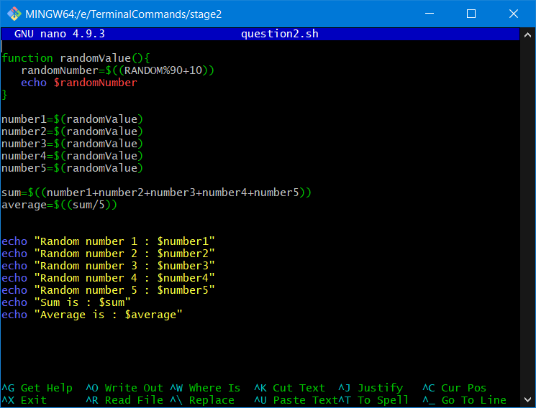

**Output**

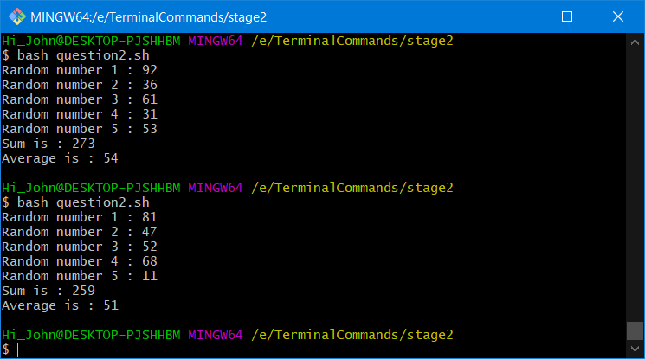

5.Unit Conversion

a)1ft=12 inch then 42 inch=?

b) Rectangular plot of 60 feet x 40 feet in meters

c) Calculate area of 25 such plots in acres

**CODE**

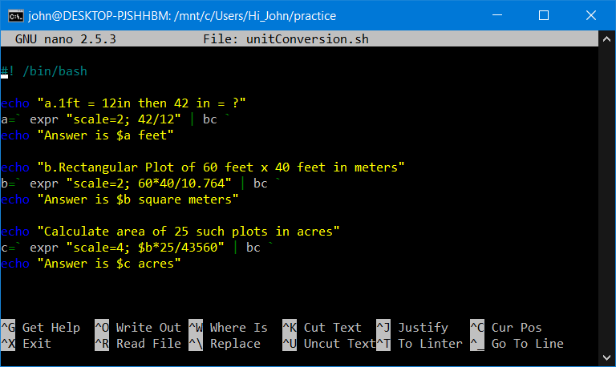

**Output**

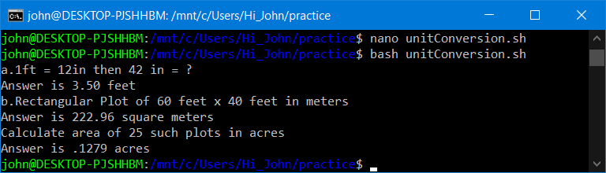

6.WAP that reads 5 random 3 Digit values and then outputs the minimum and the maximum value

**CODE:**

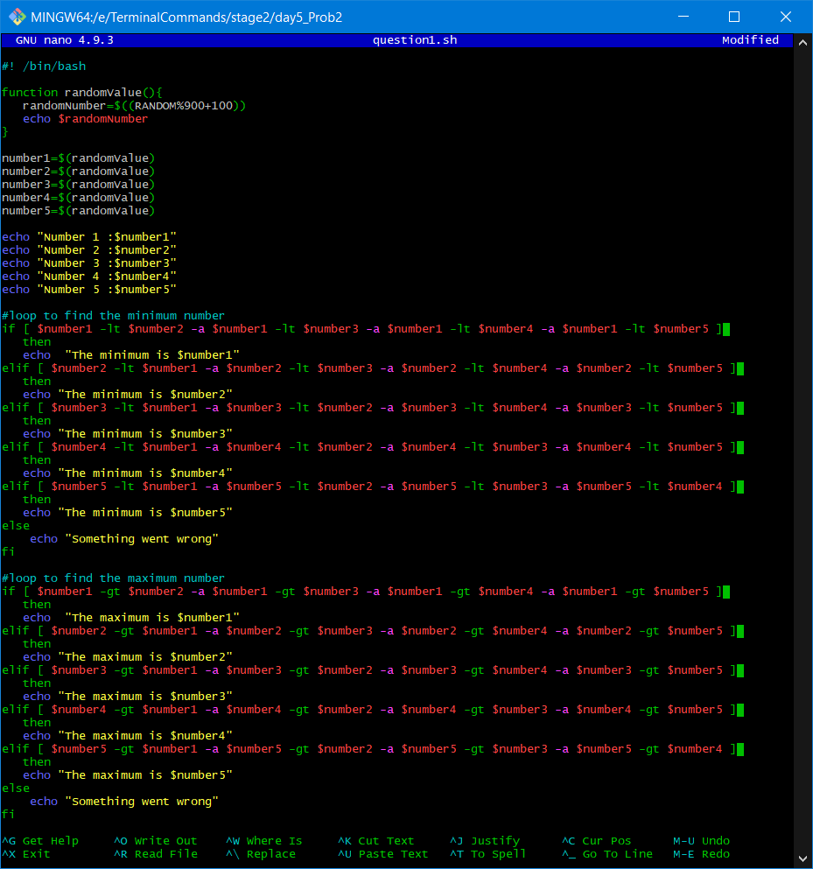

**OUTPUT:**

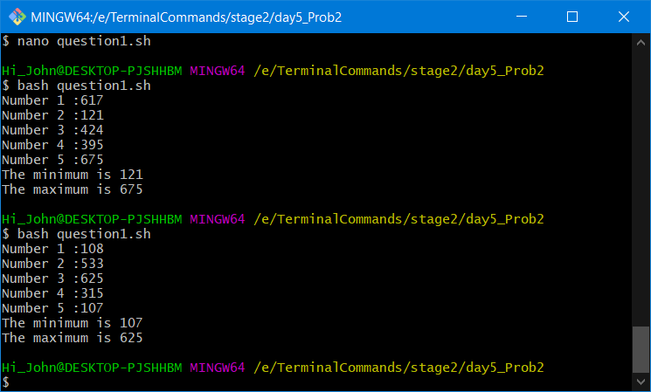

7.WAP that takes day and month from the command line and prints true or false if day of month is between March 20 and June 20. false otherwise

**CODE:**

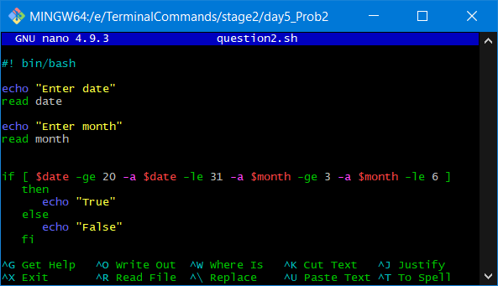

**OUTPUT:**

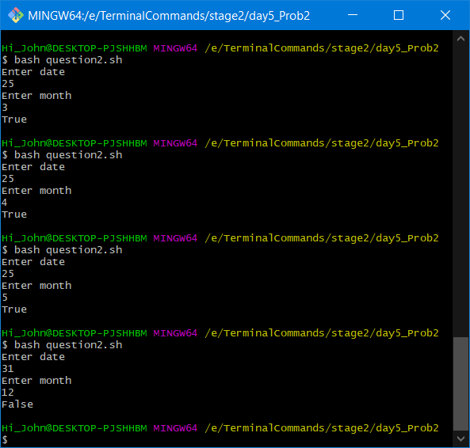

8.WAP that takes year as input and outputs the year is a Leap year or not a Leap year. A Leap year checks for 4 Digit Number, Divisible by 4 and not 100 unless divisible by 400

**CODE:**

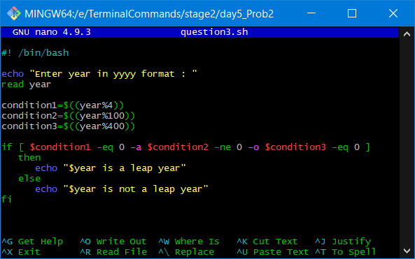

**OUTPUT:**

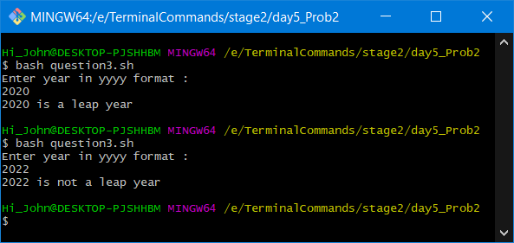

9.WAP to simulate a coin flip and prints out “Heads” or “Tails” accordingly

**CODE:**

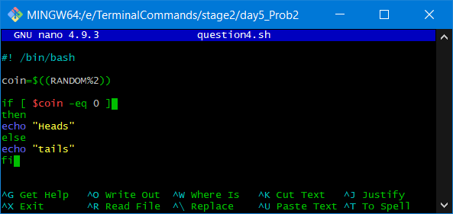

**OUTPUT:**

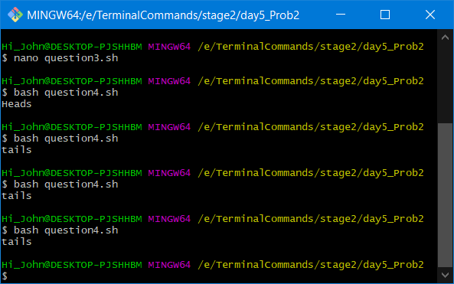

10.Read a single digit number and write the number in word

**CODE:**

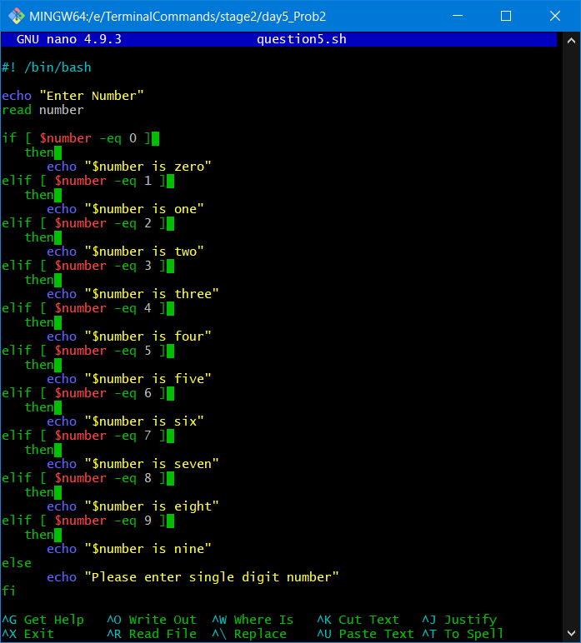

**OUTPUT:**

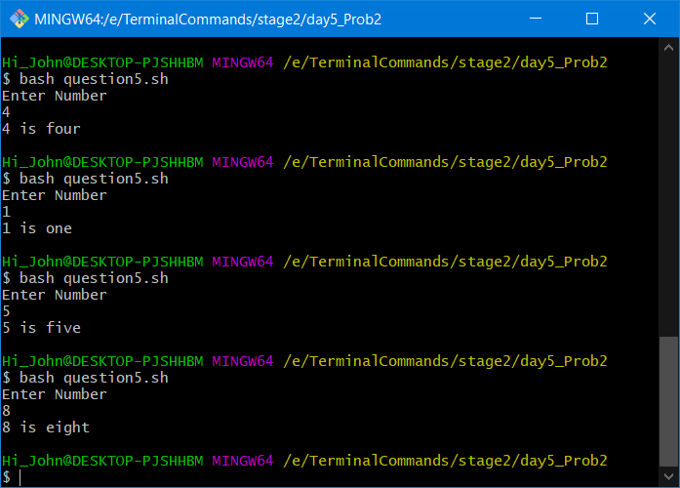

11.Read a Number and display the week day (Sunday, Monday,…)

**CODE:**

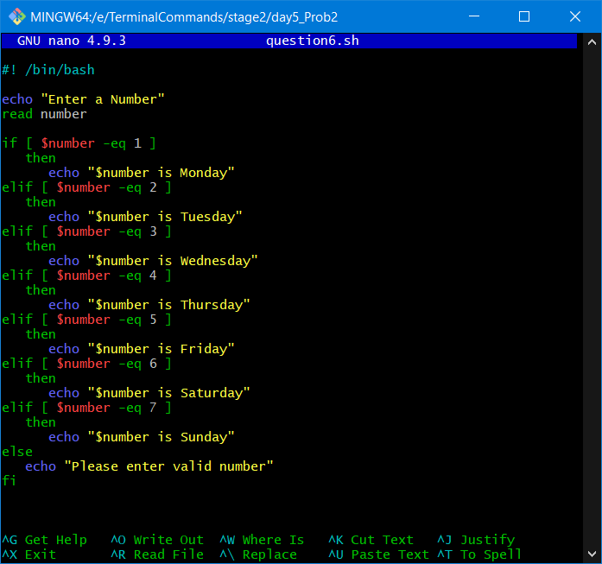

**OUTPUT:**

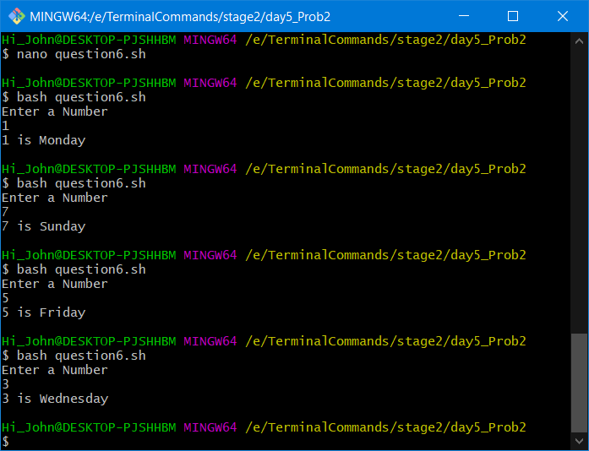

12.Read a Number 1, 10, 100, 1000, etc and display unit, ten, hundred, …

**CODE:**

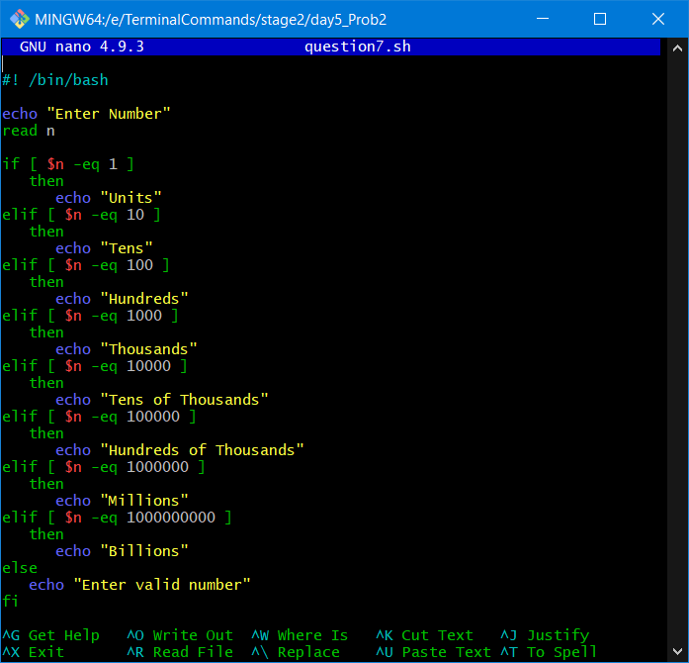

**OUTPUT:**

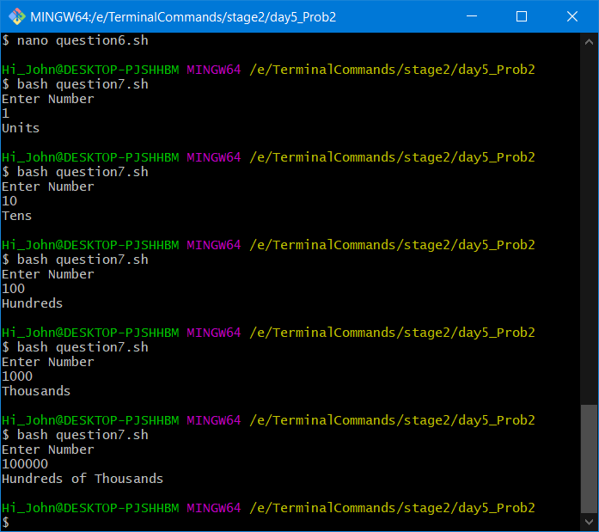

13.Enter 3 Numbers do following arithmetic operation and find the one that is maximum and minimum

1. a + b * c 2.a % b + c 3.c + a /b 4.a * b + c

**CODE:**

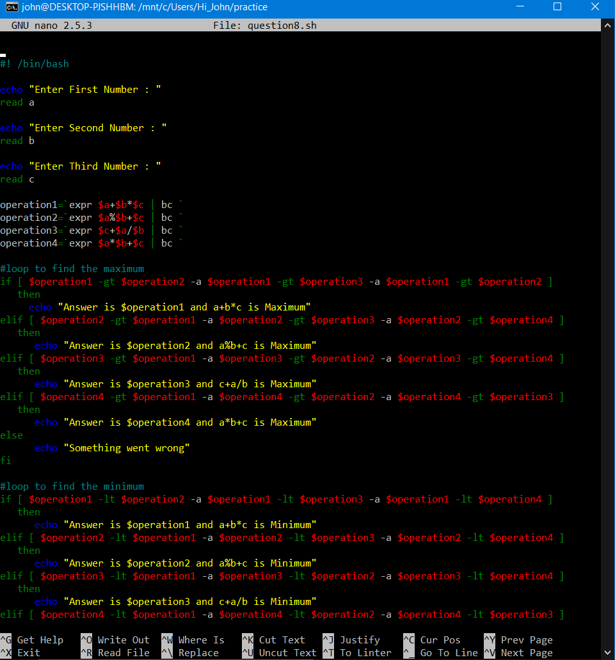

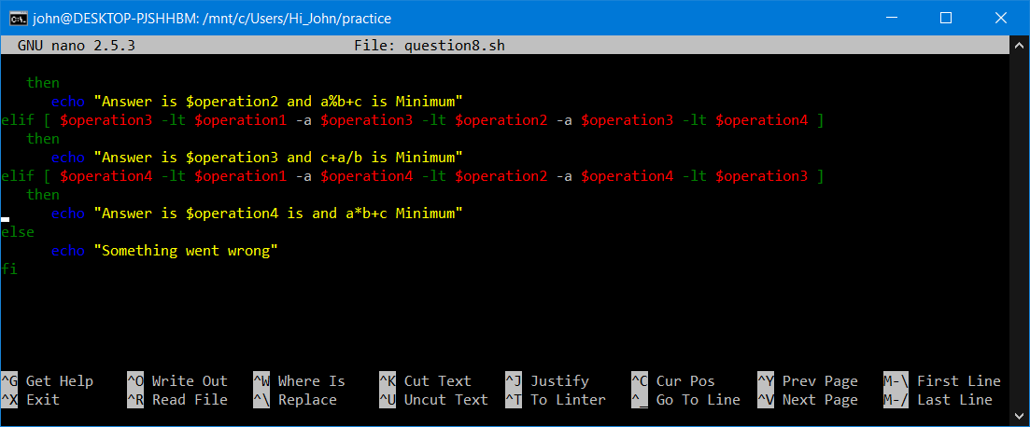

**OUTPUT:**

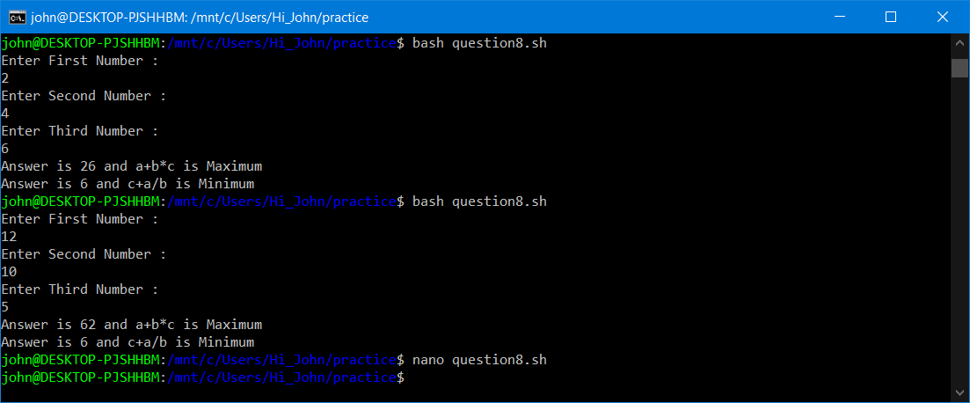

14.Read a single digit number and write the number in word using Case

**CODE:**

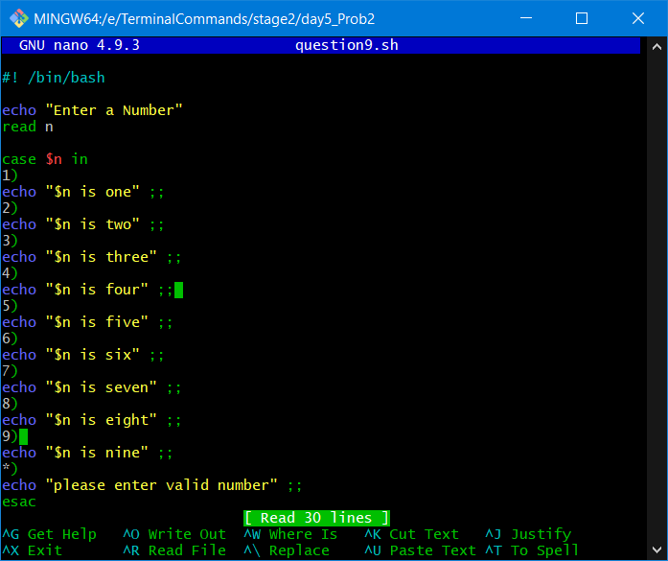

**OUTPUT:**

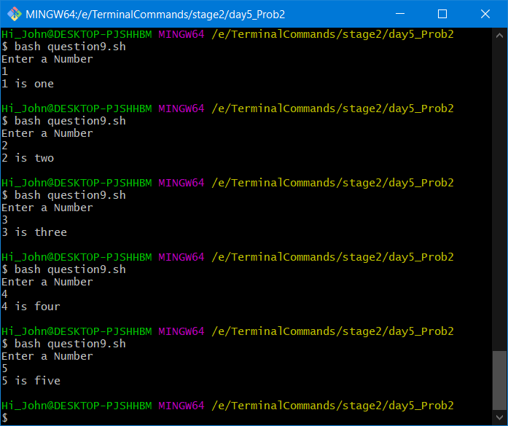

15.Read a Number and display the week day (Sunday, Monday,… using case

**CODE:**

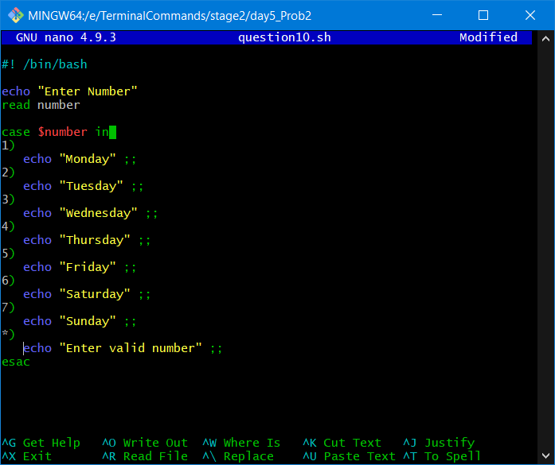

**OUTPUT:**

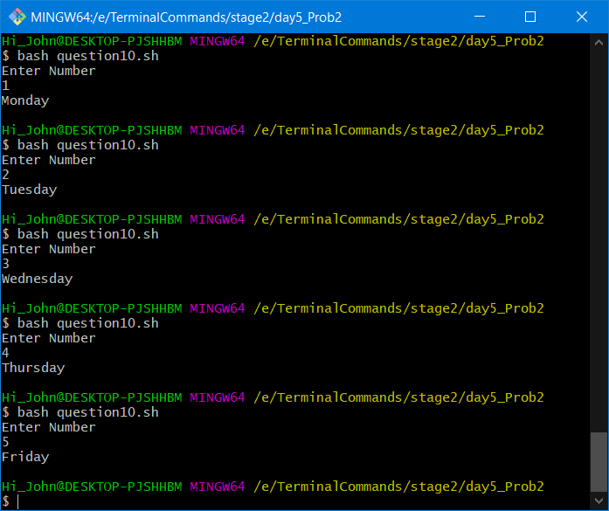

16.Read a Number 1, 10, 100, 1000, etc and display unit, ten, hundred, …using case

**CODE:**

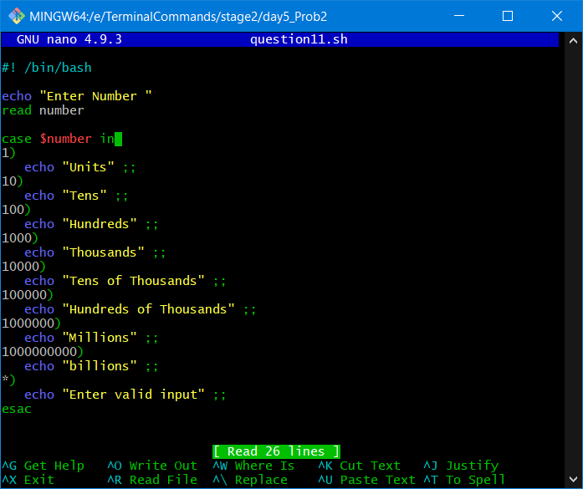

**OUTPUT:**

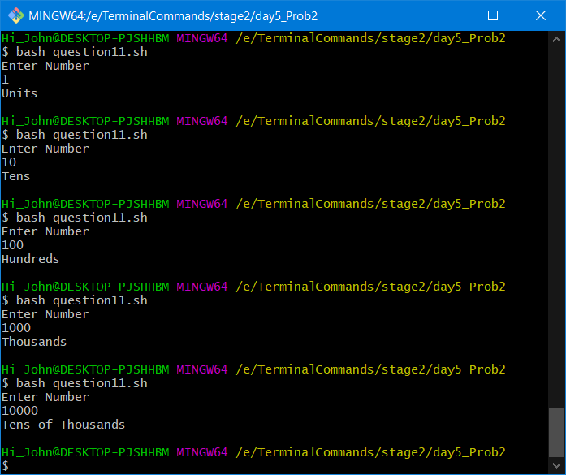

17.WAP that takes user inputs and does unit conversion of different length units

1.Feet to Inch

2.Feet to Meter

3.Inch to Feet

4.Meter to Feet

**CODE:**

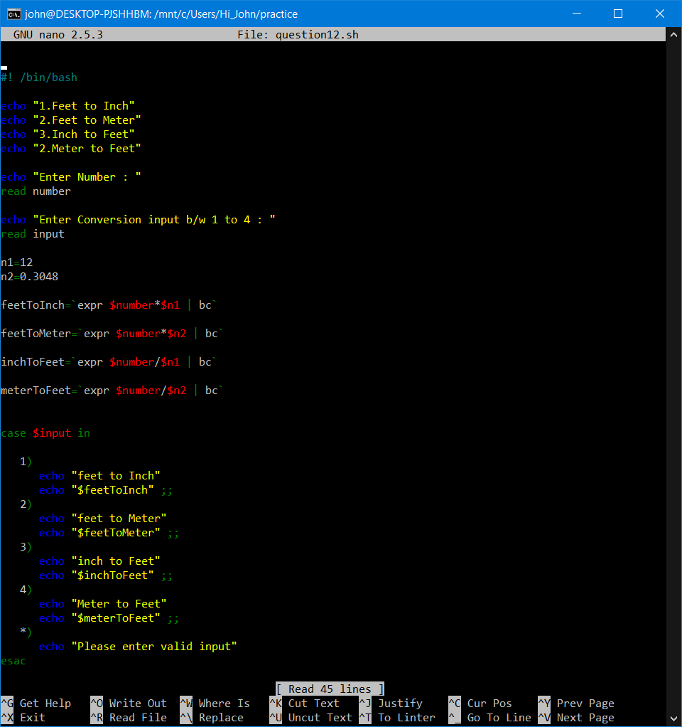

**OUTPUT:**

