1.WAP that takes a command line argument n and prints a table of powers of 2 that are less than or equal to 2^n.

**CODE:**

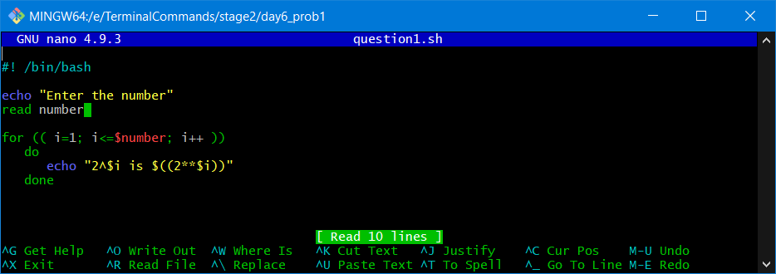

**OUTPUT:**

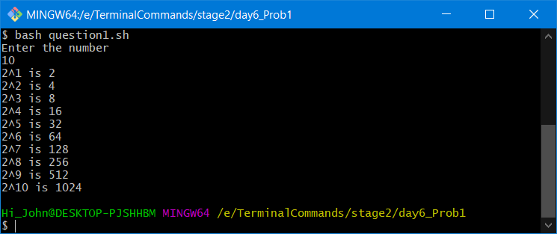

2.WAP that takes a command line argument n and prints the nth harmonic number. Harmonic number is in form

**CODE:**

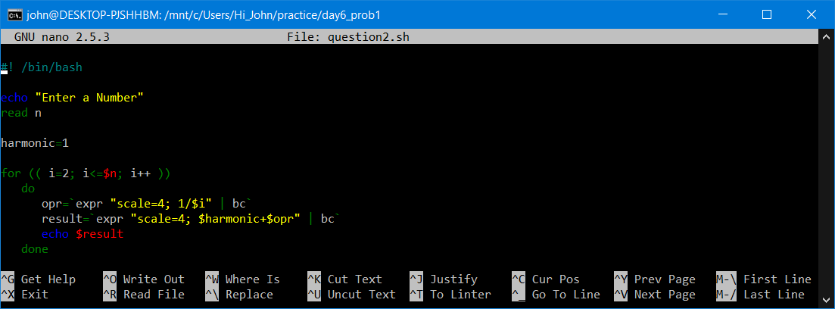

**OUTPUT:**

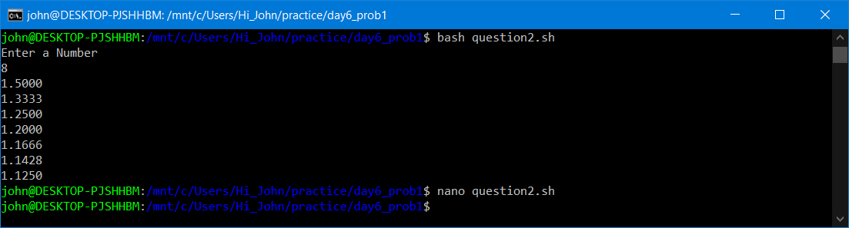

3.WAP that takes a input and determines if the number is a prime

**CODE:**

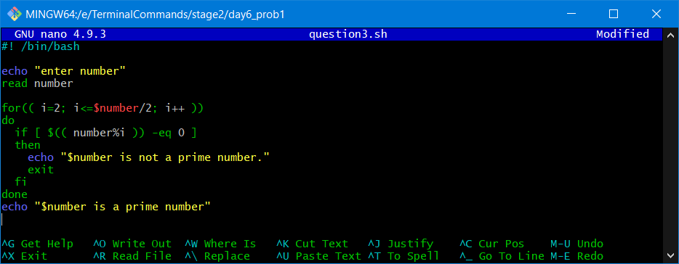

**OUTPUT:**

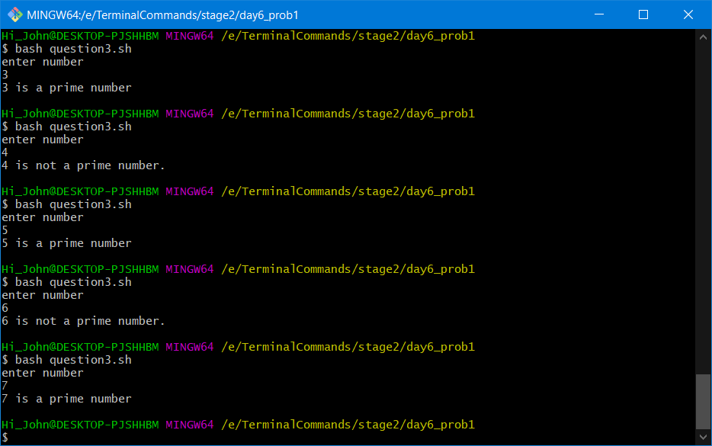

4.Extend the program that takes a range of number as input and output the prime numbers in that range

**CODE:**

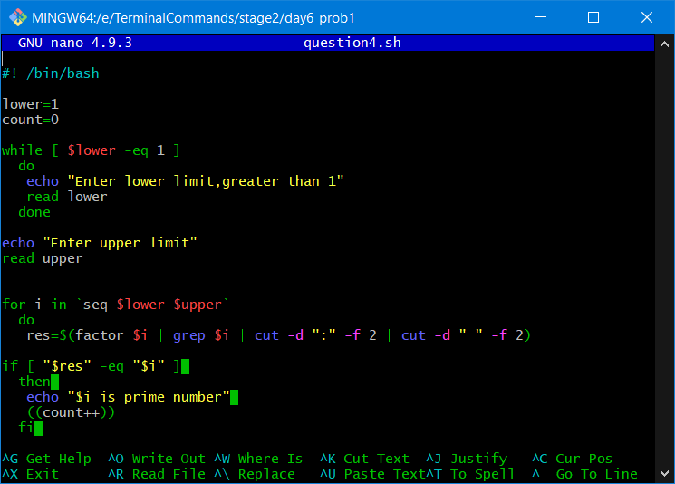

**OUTPUT:**

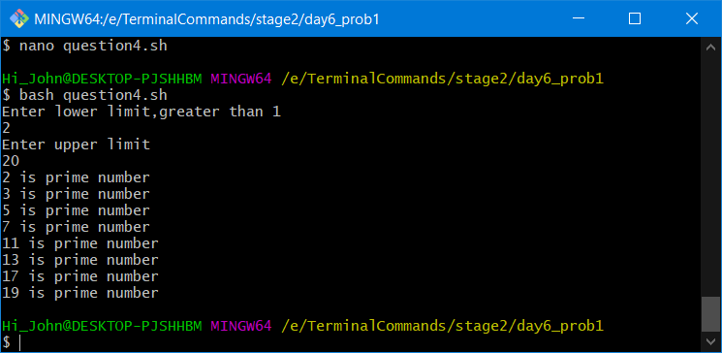

5.Write a program that computes a factorial of a number taken as input

5 factorial – 5!=1*2*3*4*5

**CODE:**

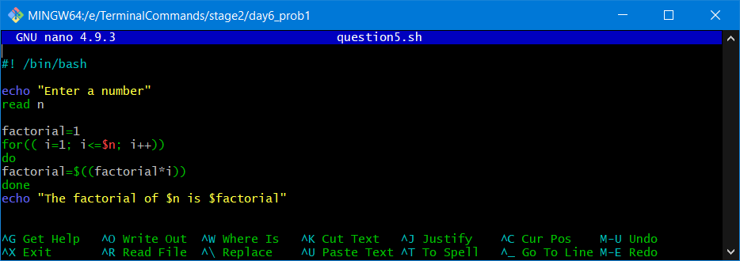

**OUTPUT:**

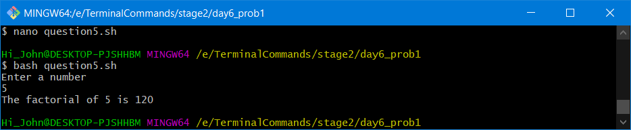

6.WAP that takes a command line argument n and prints a table of the power of 2 that are less than or equal to 2^n till 256 is reached.

**CODE:**

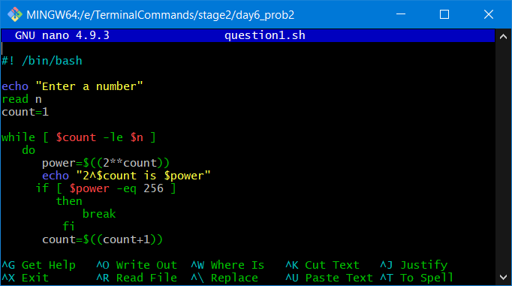

**Output:**

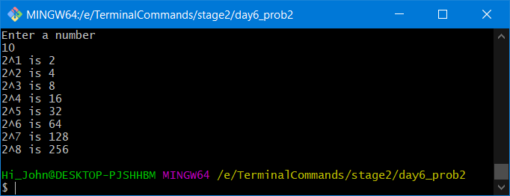

7.Find the Magic Number

a. Ask the user to think of a number n between 1 to 100

b. Then check with the user if the number is less then n/2 or greater

c. Repeat till the magic number is reached

**CODE:**

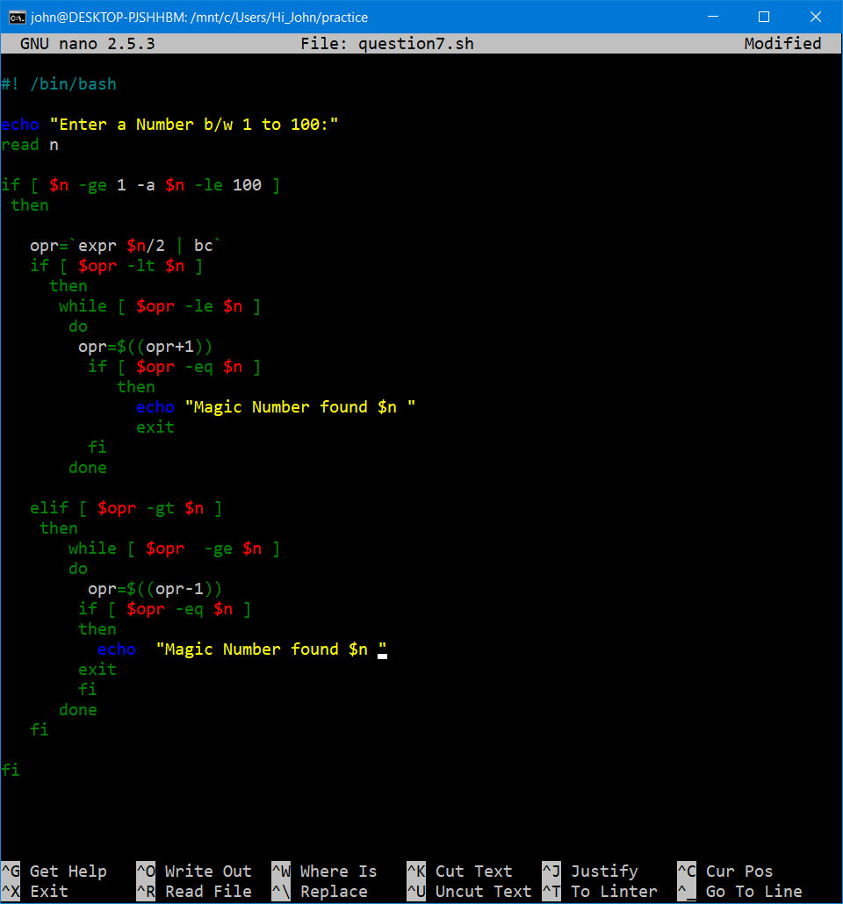

**Output:**

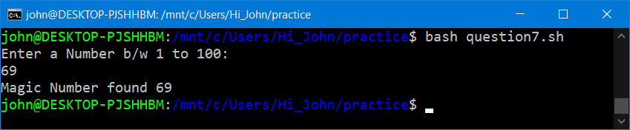

8.Extend the Flip coin problem till either Heads or Tails wins 11 times

**CODE:**

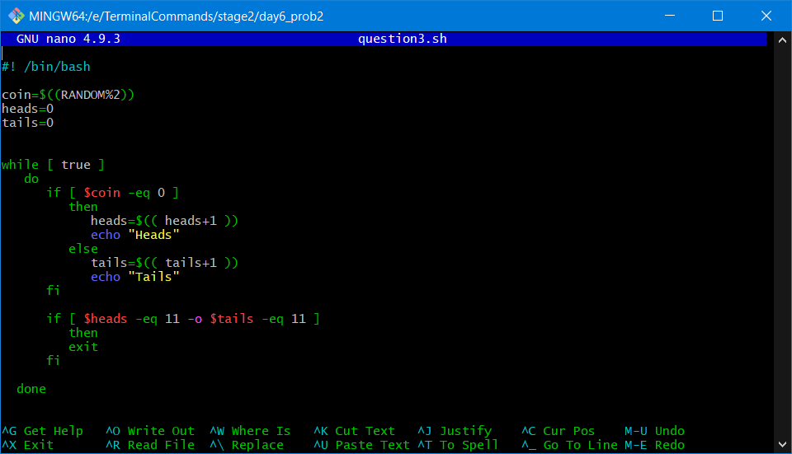

**Output:**

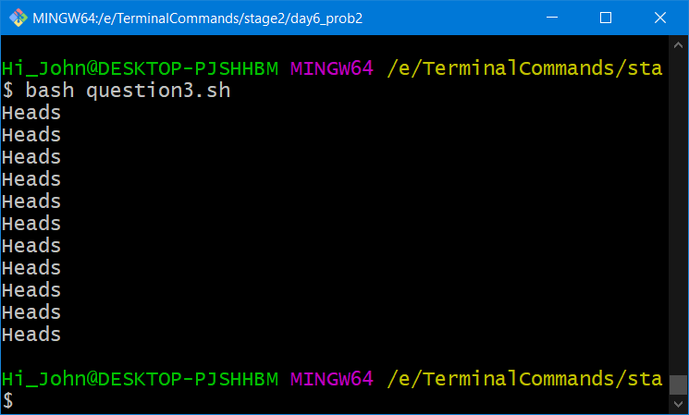

9.WAP where a gambler starts with Rs100 and places Rs1 bet until he/she goes broke i.e. no more money to gamble or reaches the goal of Rs 200. Keeps track of number of times won and number of bets made

**CODE:**

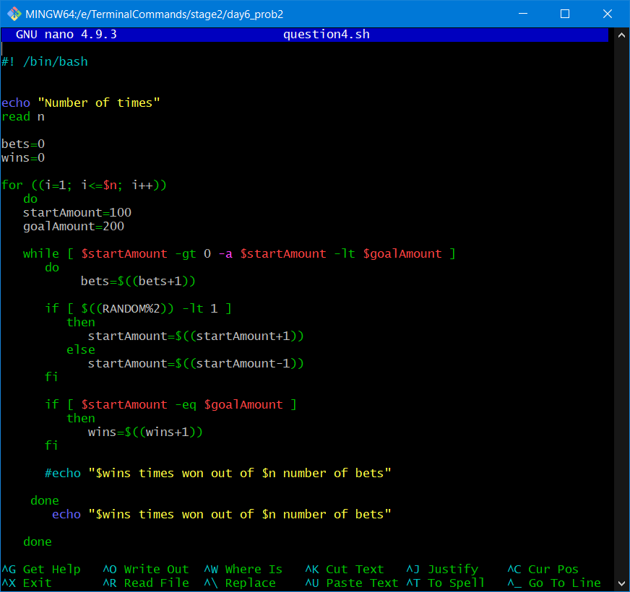

**Output:**

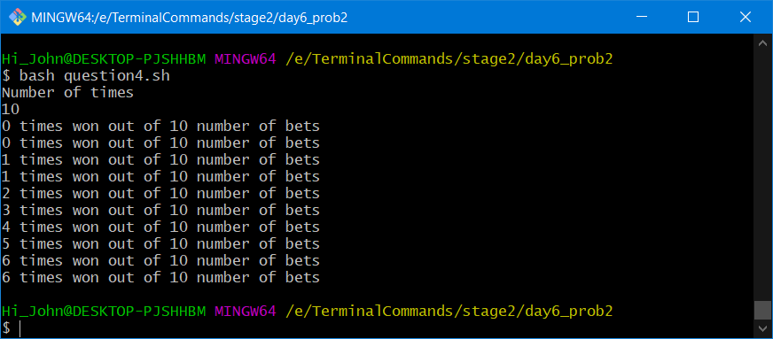

1. Help user find degF or degC based on their conversion selection. Use case statement and ensure that the inputs are within the freezing point(0C/32F) and boiling point of water

(100C/212F)

**CODE:**

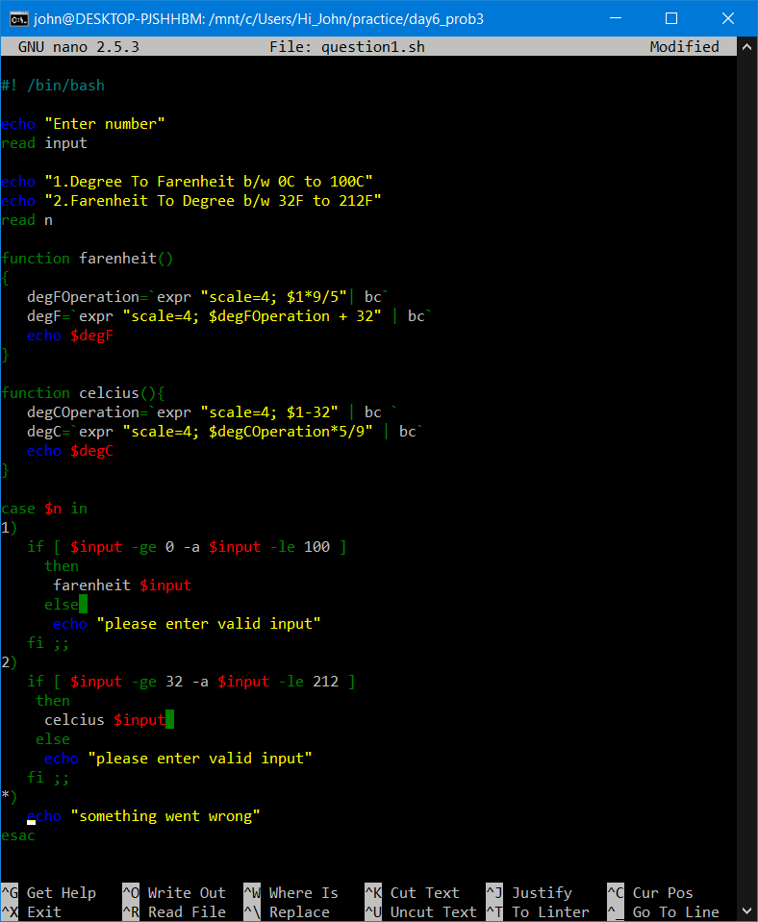

**OUTPUT:**

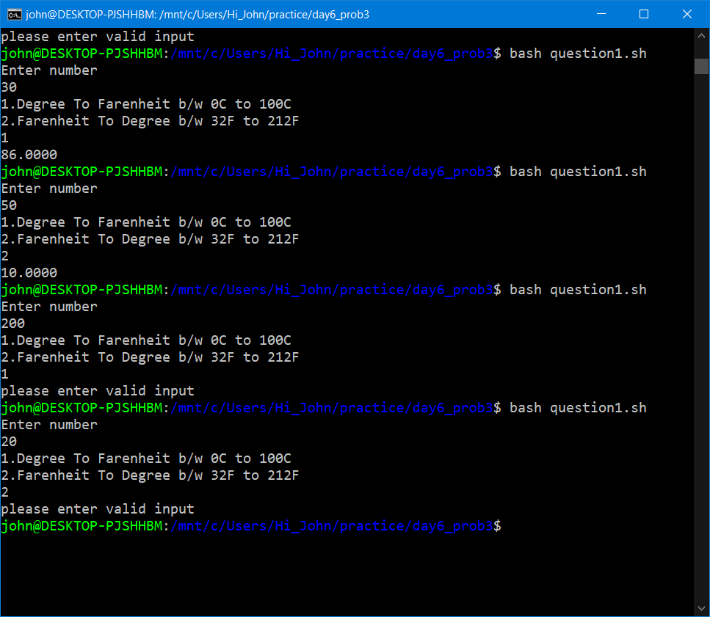

11.WAF to check if two numbers are palindrome

**CODE:**

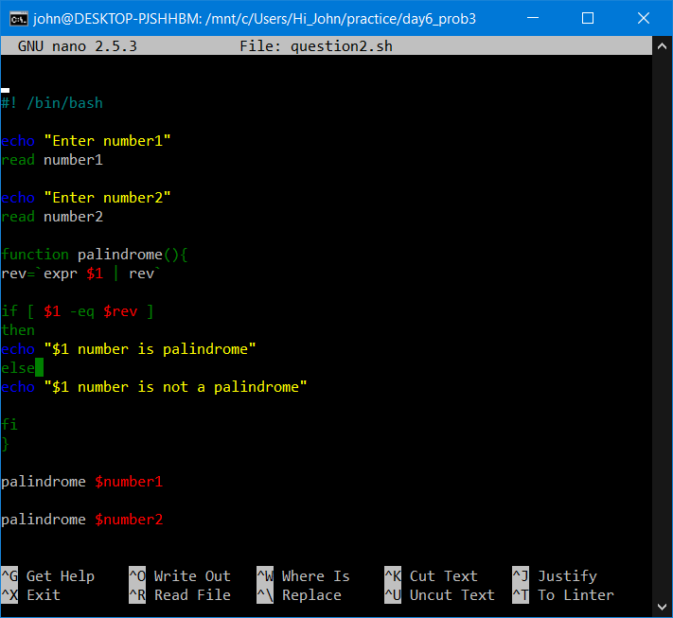

**OUTPUT:**

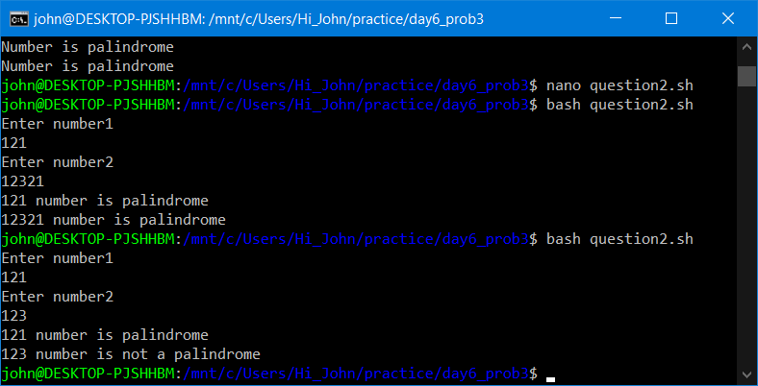

12.Take a number from user and check if the number is prime then show that its palindrome is also prime

a. write function check if number is prime

b. write function to get the palindrome

c. check if the palindrome number is also prime

**CODE:**

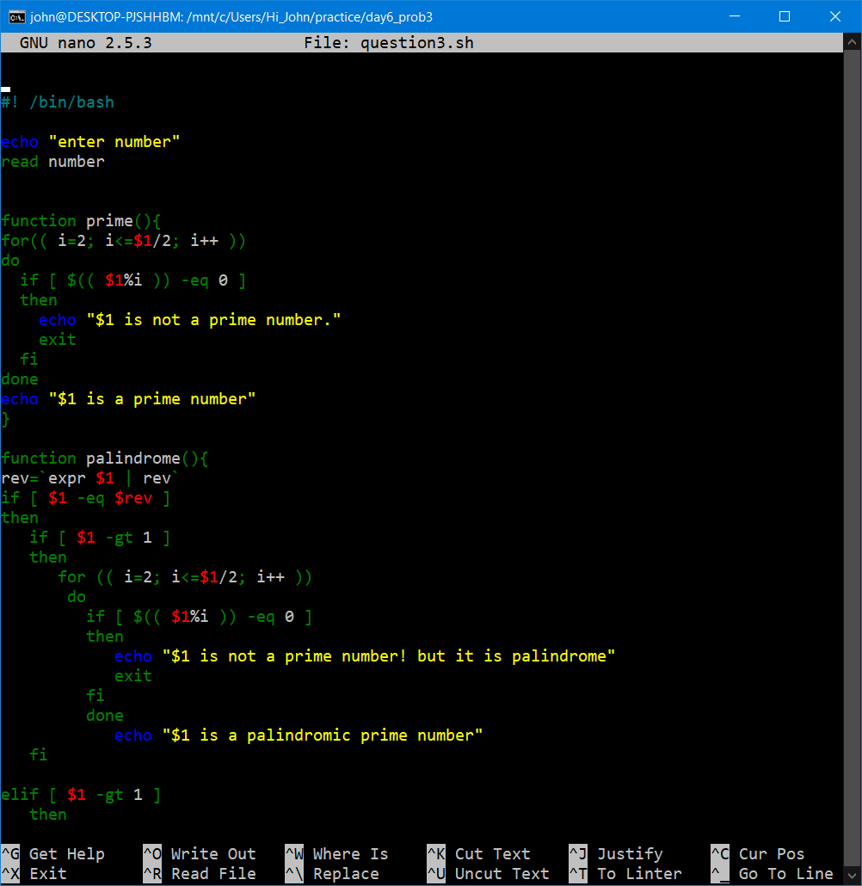

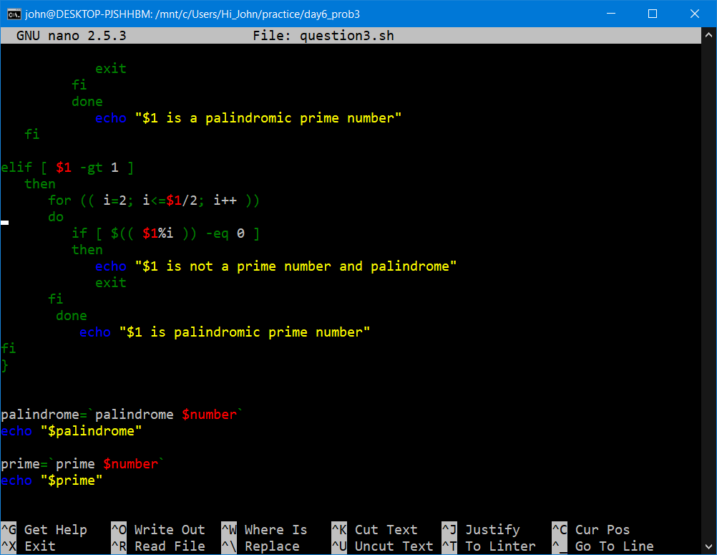

**OUTPUT:**

