1. WAP in following steps
2. Generates 10 random 3 digit numbers
3. Store this random numbers into a array
4. Then find the 2nd largest and the 2nd smallest element without sorting the array

CODE:

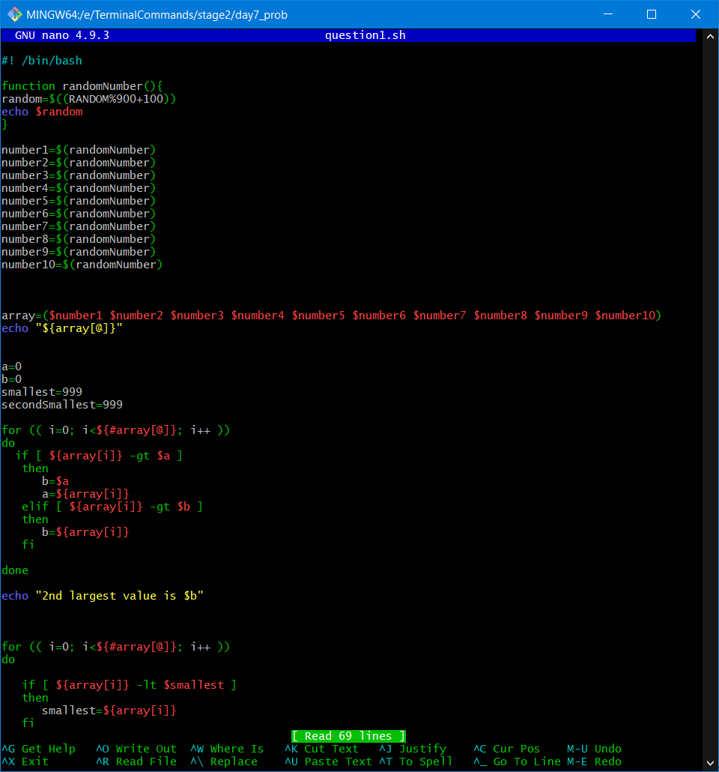

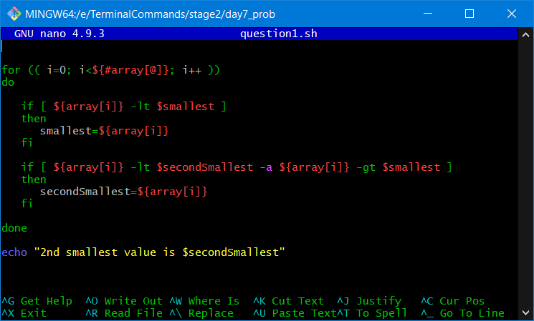

Output:

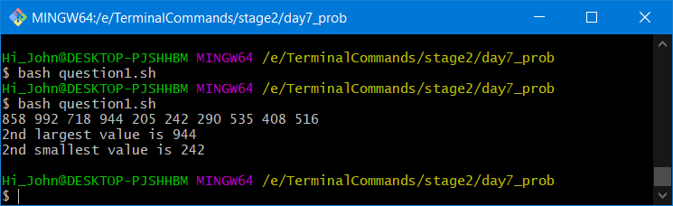

2.Extend the above program to sort the array and then find the 2nd largest and smallest element

CODE:

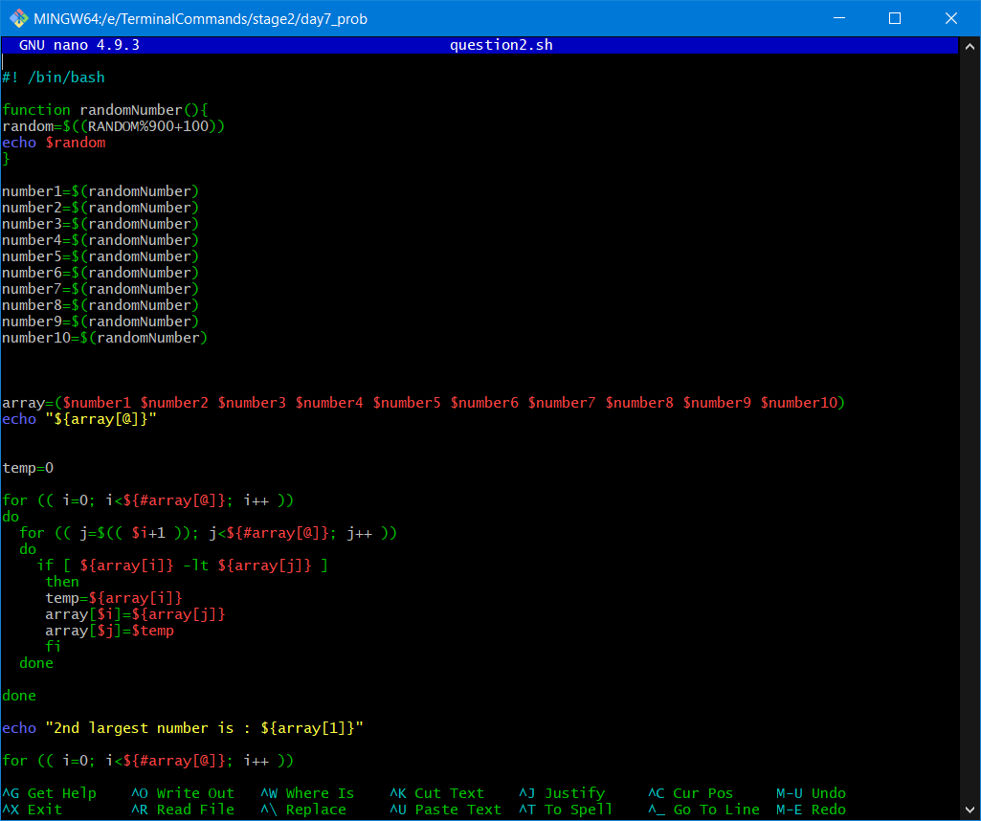

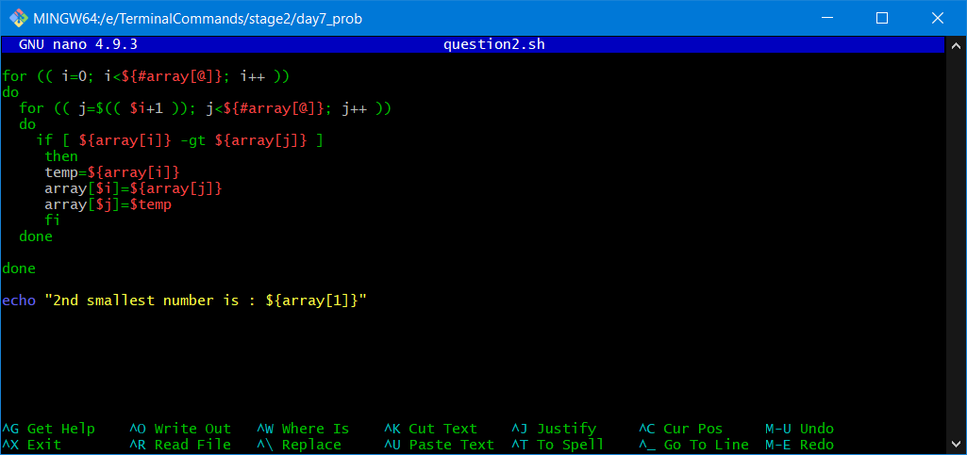

Output:

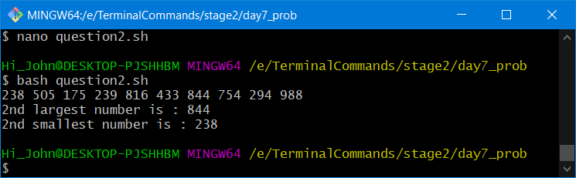

1. Extend the prime factorization program to store all the prime numbers of a number n into an array and finally display the output

CODE:

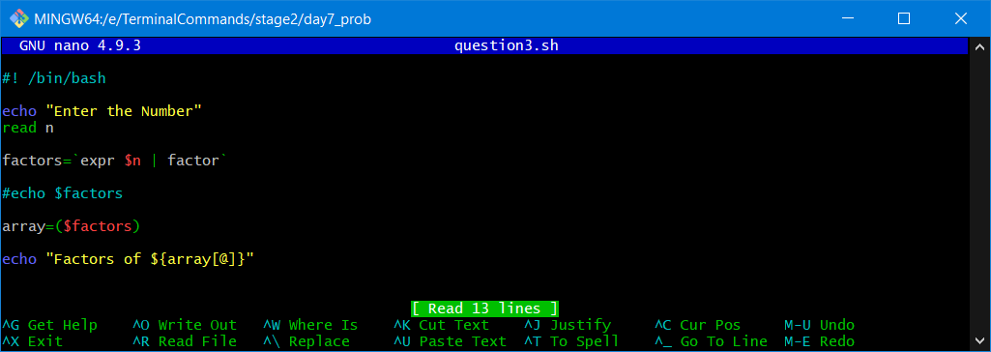

Output:

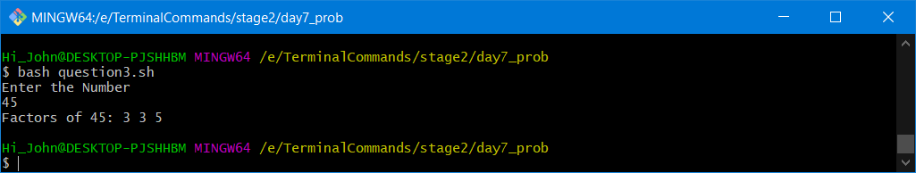

1. WAP to show sum of three integer adds to zero

CODE:

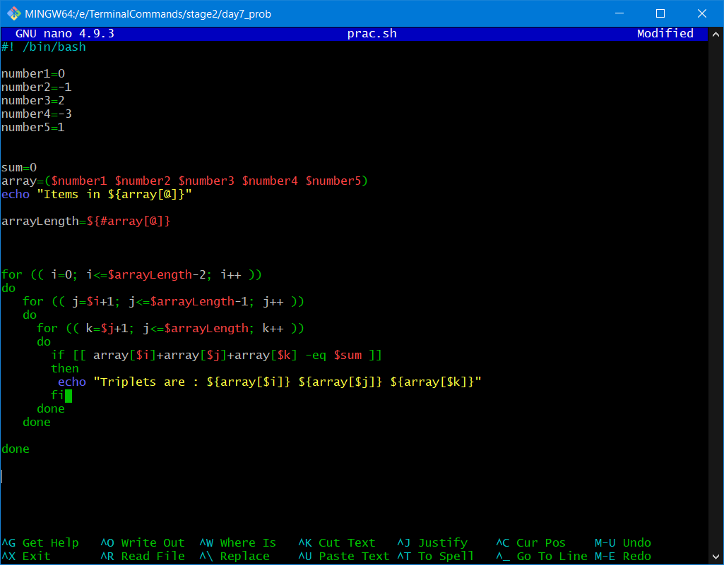

Output:

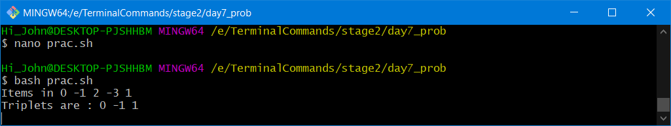

1. Take a range from 0-100 find the digits that are repeated twice like 33,77 etc and store them in an array

CODE:

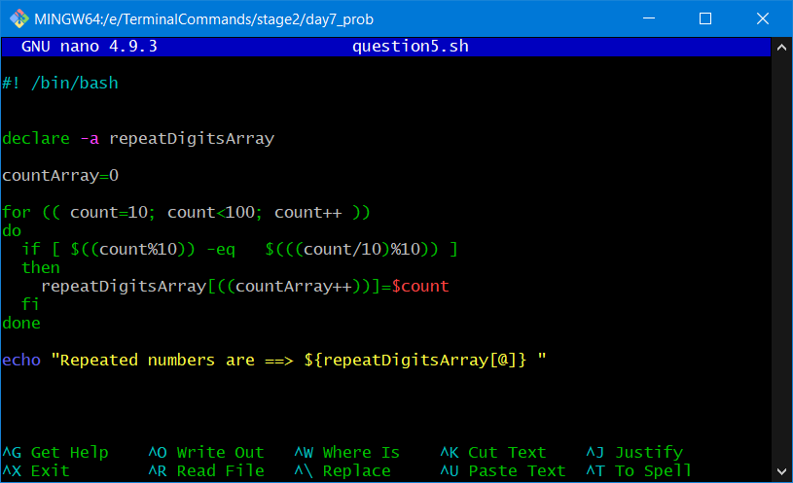

Output:

