1. WAP in following steps
2. Roll a die and find the number between 1 to 6
3. Repeat the die roll and find the result each time
4. Store the result in a dictionary
5. Repeat till any one of the number has reached 10 times
6. Find the number that reached maximum times and the one that was for minimum times

**CODE:**

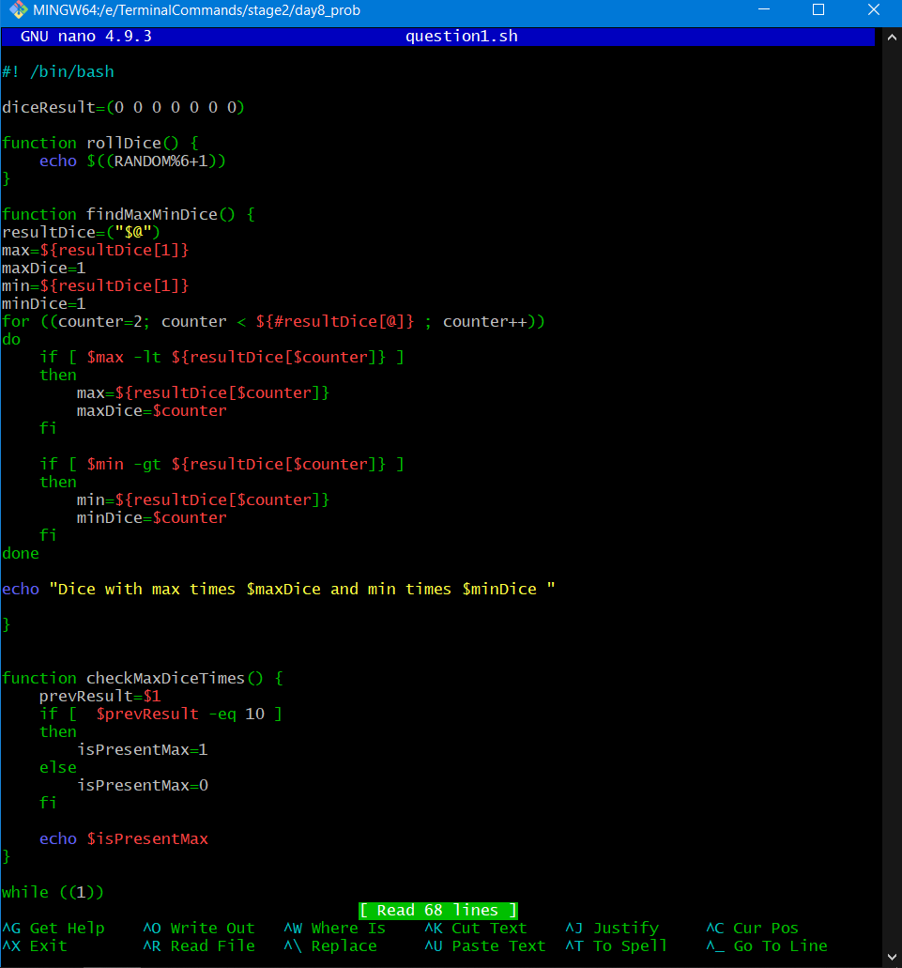

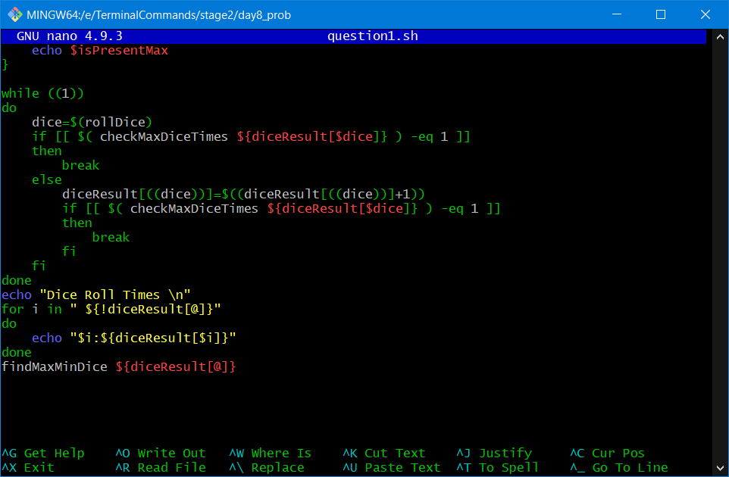

**Output**

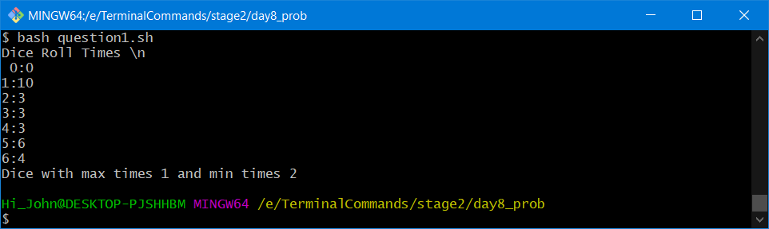

1. WAP to generate a birth month of 50 individuals between the year 92 and 93. Find all the individuals having birthdays in the same month. Store it to finally print

CODE:

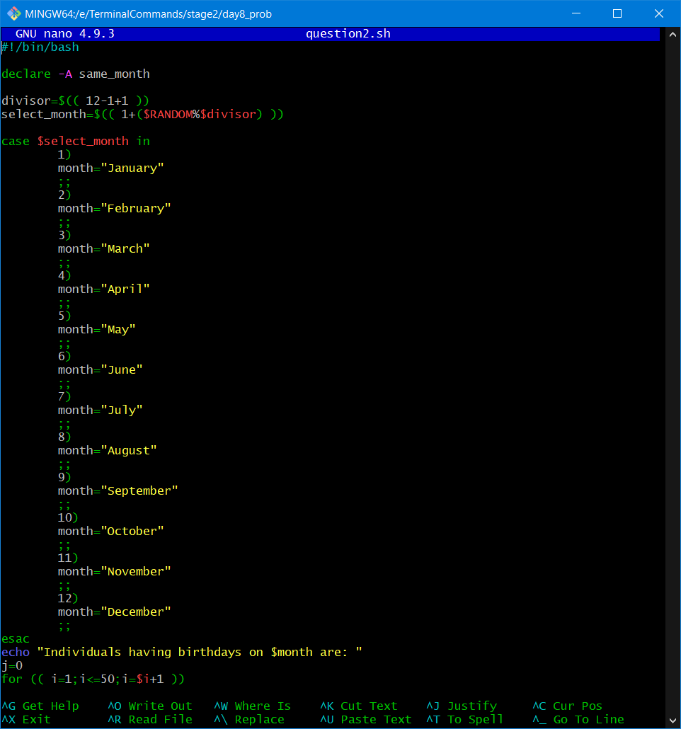

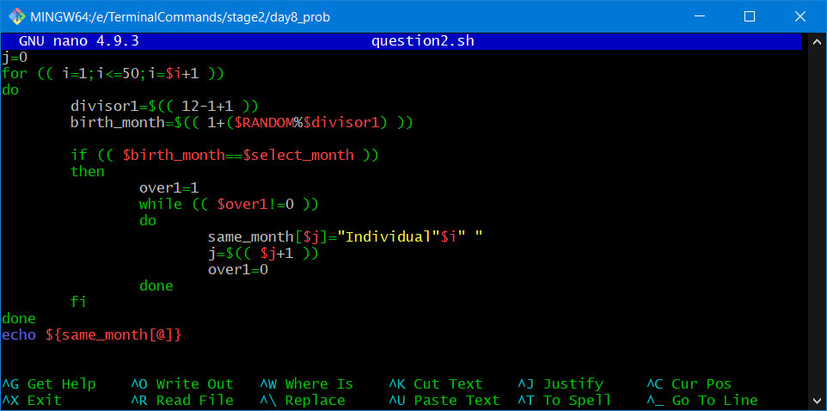

Output:

