**LinkedHU_CENG**

**Software Design Description**

1. **Revision History**

| ***Version*** | ***Date*** | ***Author*** | ***Change Description*** |
| --- | --- | --- | --- |
| 1.0 | 01.05.2022 | Uğur Can Kuşoğlu | The user interface was added and the interface.pdf was created. screenshots of the interface are added to pdf file. Sequence and statechart diagrams added to diagrams.pdf |
| 1.0 | 01.05.2022 | Cavit Bora Öztekeşin | Introduction chapter is completed.Sequence and statechart diagrams are added to diagrams.pdf. |
| 1.0 | 01.05.2022 | Meryem Ülkü Kara | Sequence and statechart diagrams are added to diagrams pdf. Comment standards, coding conventions and white space completed. |
| 1.0 | 01.05.2022 | Yusuf Sercan Tünk | Design constraints and decisions chapter is completed.Sequence and statechart diagrams added to diagrams pdf |
| 1.0 | 01.05.2022 | Mehmet Yıldız | Sequence and statechart diagrams are added to diagrams pdf. Coding standards introduction, description, naming standards and file organization completed. |

1. **INTRODUCTION**
   1. **Purpose and Scope**

The Software Design Description’s objective is to offer a detailed description of a system's design for solidifying the software development planning in terms of what will be developed and how it will be built.

* 1. **Document Overview**

The basic overview of the system including definitions and design restrictions, can be found in this paper. More extensive version of program description, software components, software behavior, data model, user interface design are explained in next chapters.

* 1. **System Overview**

LinkedHU_CENG is an online system for connecting students, graduates and academicians at Hacettepe University Computer Engineering Department in a web platform.LinkedHU_CENG system provides its users a platform to share information,chat with others, discuss and socialize via online meetings and events.

**Definitions, Acronyms, and Abbreviations**

| ***Term/Acronym*** | ***Definition*** |
| --- | --- |
| SRS | Software Requirements Specification |
| UML | Unified Modeling Language |
| GUI | Graphical User Interface |
| MVC | Model-View-Controller Design Pattern |
| SDD | Software Design Document |

* 1. **References**

## Software Requirements Specification Document Version 1.0

* https://www.academia.edu/10549583/Software_Requirements_Specification_Version_1_0_Annotated_Version_Web_Publishing_System

Software Design Description Document Version 1.0

* https://studylib.net/doc/10121962/sdd-version-1.0

1. **Design Constraints and Decisions**

LANGUAGE AND FRAMEWORK:

* In the backend of the system, the Java language will be used with the Spring framework.
* On the frontend of the system, the Javascript language will be used together with the React framework.

DATABASE:

* MySQL database will be used in the system.

ARCHITECTURAL PATTERN:

* MVC will be used as an architectural pattern.

PLATFORM:

* The application we developed is a web application.

DISTRIBUTION:

* Documents and source code distributed on github repository.

GUI:

* The GUI we will develop will be a GUI that can be easily learned by anyone between the ages of 18-70.

DEVELOPING ENVIRONMENT:

* Backend development IDE is an Intellij idea from JetBrains.
* Frontend development IDE is VS-Code from Microsoft.

DOCUMENTATION:

* Our team uses Google Drive while preparing required documents.
* After the documents are prepared, they are published to Git-hub.

PERFORMANCE:

* Response times should be under 5 seconds
* Situational response times like chatting should be instantly

MODELING TOOL:

* Visual Paradigm should be used for documenting and visualizing the system.

PRIVACY:

* System and users should make PIPL agreement on data manipulation and usage

1. **Design Details**

In general, the MVC design concept is employed in this project. The control mechanism has been altered in line with the project while attempting to keep to three essential structures: Controller, View, and Model. Changes to the software may be made more rapidly this manner, and more efficient code can be written.

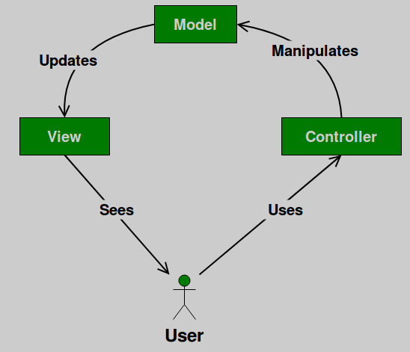

* 1. **Software Components**

Class diagram will be in the appendix file called “Diagrams.pdf”

* 1. **Software Behavior**

Sequence diagrams will be in the appendix file called “Diagrams.pdf”

* 1. **Data Model (E-R Diagram)**

Updated E-R Diagram will be in the file called “Diagrams.pdf”

* 1. **User Interface Design**

Screenshots of interface will be in the file called “Interface.pdf”

4.4.1 Login Or Register

If a user types our website's url into their browser, they will be sent to this page, where they must choose whether to proceed to the login page to sign in to our website or the register page to register with the system.

4.4.2.1 Register Student

Because there are so many different categories of students, there will be two distinct registration pages for our system. If a student wishes to be enrolled in our system, he or she must first specify which sort of student he or she is. There are three categories of students. Bachelor's, master's, and phd degrees are available.

4.4.2.2 Register Others

In the Register page for others there will be no selection for which student types they are because academics and grads are not required to enter that.

4.4.3 Login

You must use a legitimate email address to log in to the system; if the email address is invalid, an error will appear on the left-bottom side of the screen. You'll also get an error if your email is legitimate but you haven't registered with the system. If you have an email address and a password, the system will allow you to see the authorized page, and if you are an administrator, you will be able to change system data using the system.

4.4.4 Home Page

We haven't built the home page yet, but will do so in the future. There will be posts on users of all kinds on the main page.

4.4.5 Search Bar

Users of the system will be able to search for other users utilizing the system in the search bar. The user must type in the characters of another user's name in order to learn more about him or her. Our system will react immediately when the user enters the letters and return the results.

4.4.6.1 Announcement Academic-Graduate-Admin

Our system has an announcement page where academics, graduates, and administrators may post announcements. These users would be able to check announcement views (details about announcements), edit their announcements, and remove them from this page. These announcements might relate to students or other system users.

4.4.6.2 Announcement Student

Our system has an announcement page where academics, graduates, and administrators may post announcements. However, students are unable to make an announcement. Students can simply submit an application for an announcement. Because students may only apply for it, there will be minimal change between the academic announcement page and when students are signed in to the system.

4.4.7 Profile and Logout Buttons

When a user clicks on the profile image in the top-right corner of the page, buttons will be displayed. These are the "Profile" and "Logout" buttons, respectively. The "Profile" button takes users to their profile page, while the "Logout" button exits the system.

4.4.8 Publish Advertisement

In our system, there is an advertisement page where users may post their adverts. This function is available to all types of users. After the user has filled out all of the essential information for the advertising, he or she may either publish it or cancel it by hitting the related buttons. If he or she doesn't fill all the fields he or she can't publish their adverts.

4.4.9.1 Profile Academic

Users will be able to see their details on the profile page. Users can also make changes to these details. There is also a place for posting images, and they can delete them once they have been uploaded. If a person wishes to change his or her password, he or she can do so from the profile page. To do so, he or she must input both their old and new passwords. If he or she does not wish to update their password, user has to leave the "Password" column blank. If user types differ, this profile page provides information about the user's type, which is distinct for each user. This user type is academic.

4.4.9.2 Profile Admin

Same things apply from 4.4.9.1 and this user type is admin.

4.4.9.3 Profile Student

Same things apply from 4.4.9.1 and this user type is student.

4.4.10 Error Message

If a user enters an invalid email format or attempts to login with an unregistered email or incorrect password, an error message is displayed.

1. **Requirements Traceability**

[Establish traceability relationship between requirements and software design to show that all requirements are met. Demonstrate relationship between classes and requirements using traceability matrix.]

1. **Annexes**

In Interfaces.pdf there are GUI views

In Diagrams.pdf there are sequence, E-R, Class and Statechart diagrams.