CERTIFICATION PROCEDURE

INDEX

1.- OBJECT 3
2.- DEFINITIONS 3
3.- CERTIFICATION MEETING: 4
4.- CERTIFICATION PROCESS: 4
5.- SUPPORTIVE DOCUMENTATION PREPARATION AND MEASUREMENT: 5
6.- SUPPORTIVE DOCUMENTATION CONTRACTOR’s acceptance: CONS/QC 6
7.- CERTIFICATION SUBMISSION: 6
8.- INVOICING 7
9.- FILLING THE TEMPLATE CERTIFICATION. 7
10.- ATTACHMENT 9

- OBJECT

The present document establishes and defines the steps that SUBCONTRACTOR has to follow in order to fulfill the certification process.

- DEFINITIONS

CONTRACTOR: INTECSA/INITEC
SUBCONTRACTOR: Company awarded by CONTRACTOR for the execution of the activities described within his scope of Works: Construction, Pre-commissioning, Commissioning whatsoever for undertaking the activities within PROJECT NCIC-FCS.

SUBCONTRACT: The agreement between CONTRACTOR and SUBCONTRACTOR and its amendments with all annexes and appendices attached thereto, in which is foreseen the relationship between CONTRACTOR and SUBCONTRACTOR.

CHANGES VARIATION ORDER (CVO): Variations that affect the original scope of work which may adjust the SUBCONTRACT’s price.
Modifications will be considered as additional works only when it may be clearly demonstrated that they have not been previously included in the SUBCONTRACTOR´s Scope of Work.

All works which have to be done in order to rectify/correct/repair SUBCONTRACTOR´s defectives executed work will be solely SUBCONTRACTOR´s liability, therefore they will not be considered as a CVO.

SUBCONTRACTOR FIELD EXTRA WORK ORDER REQUEST (SFR): Initial document issued by SUBCONTRACTOR in order to initiate the FEWO process for CHANGES.

Abovementioned FEWO consist of: reference number (it shall follow a sequential numbers starting from 000), work description , method of evaluation ,initial estimated cost, estimated duration of the works and any other supportive documentation that may be required to enable CONTRACTOR for duly evaluating SUBCONTRACTOR cost calculation proposal.

When requested by CONTRACTOR, SUBCONTRATOR will provide an estimation of man-hour, auxiliary means and materials required for undertaking the Works. The SFR shall be submitted through official communication.

FEWOs shall be initiated by means of SFR, besides numbering will be maintained even for those cases by which CONTRACTOR does not accept it, for such cases rejected FEWO with be record with no value.

FIELD EXTRA WORK ORDER (FEWO): Document which closure the SFR, it is to say this document will contain all the information stated within the SFR, except from the final quantities which may vary according to the final Works measurement if relevant.

FEWOs shall be issued when the works have been fully achieved, thus the value of the FEWO will be final and no the estimated as in the SFR, it is to say FEWO should be considered as the SFR closure. Once approved, SUBCONTRACTOR shall be deemed as fully compensated for the work executed, therefore no further claims will be accepted for those Works already foreseen and afterwards closed within such SFR/FEWO.

FEWOs shall be submitted by official correspondence and shall be numbered accordingly (same number as corresponding SFR).

- CERTIFICATION MEETING:

Once SUBCONTRACT comes into force and upon duly submission of bonds and insurance as per SUBCONTRACT provision, PARTIES will appoint a dedicated Certification meeting in order to establish:

- Measurements, Breakdown, tables and any other documentation/information to be submitted by SUBCONTRACTOR in order to enable CONTRACTOR to measure the progress on SUBCONTRACTOR scope of work.
- Certification process and its needful steps.
- How certification form will be filled in and implemented.
- How Extra-works have to be dealt: SFR and FEWO.

SUBCONTRACTOR is responsible for duly and timely submitting of both progress certification and its supportive documentation needed for CONTRACTOR’s review and evaluation.

- CERTIFICATION PROCESS STEPS:

- Supportive documentation preparation and Measurement.
- Supportive documentation handover for CONTRACTOR’s acceptance.
- Progress Certification preparation.
- Progress Certification issuance.

- SUPPORTIVE DOCUMENTATION PREPARATION AND MEASUREMENT:

Prior to submitting related Certification (Progress Payment Certificate) SUBCONTRACTOR shall collect all needful supportive documentation which justifies and supports the Works that have been undertaken according to Project Requirement. Such documentation will depend on SUBCONTRACTOR’s scope and therefore will be based on:

Engineering: SUBCONTRACTOR shall support the engineering progress by submitting needful documentation, required list and logs where stated the documents status, drawings or whatsoever issued or approved by CONTRACTOR regarding the whole deliverable list.

Monthly progress shall be supported by submitting duly supported the documentation percentage undertaken by SUBCONTRACTOR as of Certification cutoff date regarding deliverable list.

Procurement/fabrication: Initially, SUBCONTRACTOR shall submit a breakdown list with all the material to be procured by him. Mentioned list/lists shall be split as per required information which enables CONTRACTOR to monitor the achieved progress: Items, quantities, measurement, etc.

Monthly progress shall be supported by submitting the required documentation which witnesses such achievement:

- Material Suborder: Bank swift of opening the L/C for imported materials and commercial invoice for the local materials (unpriced).

- Material Storage: Transport delivery notes and CONTRACTOR’s visual inspection at SUBCONTRACTOR’s yard with photo report duly signed. SUBCONTRACTOR will inform CONTRACTOR with a minimum of 2 weeks in advance.

- Fabrication & Painting: Monthly Progress Certification duly signed by CONTRACTOR.

- Delivery at Site: Monthly Progress Certification duly signed by Transport delivery note and CONTRACTOR’S visual inspection at site with photo report duly signed.

- Material Ownership transfer: CONTRACTOR is entitled to request the ownership transfer of the material to be certified.

Construction Work:

Prior of all, SUBCONTRACTOR shall submit all required documentation which support and justify the measurement to be certified. SUBCONTRACTOR is responsible to prepare dedicated tables and breakdown as required, as well as any other requested justification thereof. Measurements shall be agreed by PARTIES before SUBCONTRACTOR start certifying related scope (Items, quantities, measurement, milestones, etc.). If there are discrepancies in Measurements, SUBCONTRACTOR will not be entitled to certify any Quantities not acknowledged by CONTRACTOR unless SUBCONTRACTOR’s duly justification is subsequent expressly accepted by CONTRACTOR.

Monthly progress shall be supported by submitting the drawings package related to the executed Works. SUBCONTRACTOR shall set out by duly marking into referred drawing the works achieved as of Certification cutoff date. It is also under SUBCONTRACTOR scope of Works to provide all required QC documentation as defined in order CONTRACTOR can verify that Works have been performed as per PROJECT requirements and as established within SUBCONTRACT terms.

- SUPPORTIVE DOCUMENTATION CONTRACTOR’s acceptance: CONS/QC

Upon PARTIES’s measurements agreement, milestones or whatsoever valid for monitoring SUBCONTRACTOR’s progress which shall be in line with SUBCONTRACT BOQ and Measurement Criteria, SUBCONTRACTOR will start submitting on monthly basis the supportive documentation to be handed over to the assigned CONTRACTOR representatives: Construction and QC.

As per defined deadlines CONTRACTOR will revise and review SUBCONTRACTOR documentation which shall truly show in a clear manner the progress undertaken by SUBCONTRACTOR as of Certification cutoff date. CONTRACTOR’s representative either will approve/sign or make his comments on submitted documentation.

For the sake of clarity CONS and QC CONTRACTOR’s Representative will only acknowledge that Works have been duly performed. However, signature thereof on measurement within supportive documentation by CONS/QC CONTRACTOR representative will have no effect regarding measurement acceptance. Measurement is to be agreed with CONTRACTOR’s Subcontract department.

- CERTIFICATION SUBMISSION:

Once achieved steps Certification, and on monthly basis unless otherwise stated within SUBCONTRACT’s terms, documents should contain but not limited to, if required:

1. Certification form: it will be provided by CONTRACTOR and filled in by SUBCONTRACTOR on monthly basis.
2. Supportive documentation: to be attached to the certification and to be prepared by SUBCONTRACTOR and signed by CONS and QC CONTRACTOR’s representative as per agreed SCHEDULE.
3. Quantity Survey: should be approved before Certification approval.

Certification will be submitted on a monthly basis through written official communication by SUBCONTRACTOR for CONTRACTOR’s review and approval, if appropriate.

The summary and Schedule of the process is as follow, unless otherwise agreed by PARTIES:

- SUBCONTRACTOR shall certify as per BOQ unit prices the Woks progress which has to be justified by means of supportive documentation duly signed by CONTRACTOR’s representative regarding the scope already measured and agreed by PARTIES, for that reason process have to be dynamic.

- Quantity survey for approval: latest on 20th of each month for drawing which SUBCONTRACTOR considers to certify its progress. Taking into consideration that SUBCONTRACTOR should comply with the submission schedule for Quantity Survey approval.

- Regarding Progress to be certified, SUBCONTRACTOR will not consider/include within certification the progress reached beyond 20th of each month, therefore latest cut-off date will be considered as 20th of related certification month.

- Preparation of supportive documentation: to be done continuously by SUBCONTRACTOR in order to be ready as per deadline below.

- Submission of Supportive documentation for CONS and QC (CONTRACTOR) signature/ approval: SUBCONTRACTOR will provide/submit thereof from 20th to 25th of each month.

- Certification submission: 25th of each month.

- Deadline for Certification review and approval if appropriate: maximum period (tight deadline) 15 days from Certification submission date. Regardless to the above CONTRACTOR will do his best to expedite Certification review. In case of rejection because of SUBCONTRACTOR’s failure to duly comply with certification requirement, CONTRACTOR will officially notify certification’s rejection in order to SUBCONTRACTOR review and revise accordingly. Upon SUBCONTRACTOR official submission of the revised Certification, deadlines for CONTRACTOR’s review will be held as aforementioned (15 days).

- Both SUBCONTRACTOR Certification submission and CONTRACTOR’s review outcomes (approval/rejection) will be notified by official communication between PARTIES.

REMARK: As Certifications are based on accumulated amounts, prior to submitting a new Certification SUBCONTRACTOR shall have already approved the former one. SUBCONTRACTOR shall be aware that a rejection over a certification which is being currently revised will affect in full to forthcoming Certifications. SUBCONTRACTOR also informs that deadlines abovementioned are related to the certification that is ongoing. Thus SUBCONTRACTOR should not submit new ones unless approved the former one.

- INVOICING

CONTRACTOR hereby clarifies that invoicing and payment will be done through CONTRACTOR Financial department (CONTRACTOR office) as per SUBCONTRACT provision regarding payment terms.

- FILLING THE TEMPLATE CERTIFICATION.

  - The monthly certifications shall be always calculated from the origin up to date, it is to say the accumulated amount. That means that SUBCONTRACTOR will never fill in the amount related to the Cover corresponding to the column “This Period”.

For each concept, this shall be always calculated with the following formula:

“This Period” = “Up to date” – “Previous”

The only columns SUBCONTRACTOR will manually modify are the ones corresponding to “Up to date” and “Previous”.

Amounts in “Previous” column will be copied and pasted from the “Up to date” of the previous Certificate.

SUBCONTRACTOR shall take into account the following remarks:

- SUBCONTRACTOR will use the previous Monthly Certificate as a template for reviewing current month’s certificate, it is say, SUBCONTRACTOR will copy the previous month’s excel into a new folder and give it a proper name Change the certificate number and certification period.

- SUBCONTRACTOR will firstly work in the “Cover” tab, coping therefore the values of “advance payment and deductions” from “Up to date” column to the “Previous” Column (yellow highlighted), before changing any other figures.

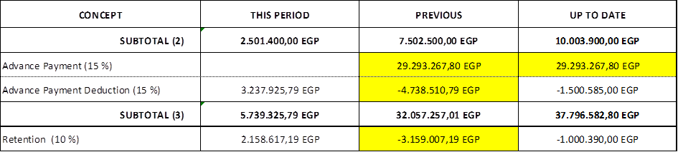

Then in the “Progress” tab, copy the values from “Up to date” column to the “Previous” Column (yellow highlighted).

Doing the same as per previous paragraph for the rest for the tabs in the excel file (“FEWO” tab, “Back Charge” Tab etc.).

Once SUBCONTRACTOR has updated all previous columns, he may start working on current month’s certification.

In case of a mistake is detected in previous certificates, the former “Up to Date” amount shall be kept as the “Previous” amount for the new certificate.

REMARK: The reason of working from the origin on monthly certificates is that mistakes can be easily corrected automatically just introducing the correct “Up to date” amount.

  - SUBCONTRACT PRICE

SUBCONTRACTOR shall ensure that certification reflects the updated SUBCONTRACT price in the top line of Monthly Certificate up to the amount corresponding to the last signed SUBCONTRACT Amendment (this will be the “Up to date”).

I.e. when CONTRACTOR approved Certification Nº3, SUBCONTRACT price value stands for 13.500.000 EGP (up to amendment 3). Once signed Amendment 4, updated SUBCONTRACT price will stand for 15.000.000 EGP.

The column of “This Period” should be calculated from the origin (“This Period” = “Up to date” – “Previous”) and should match with the amount corresponding only to SUBCONTRACT Amendment 4 (1.500.000 EGP).

Monthly Certificate Nº3 Cover:

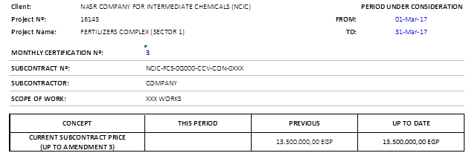

Monthly Certificate Nº4 Cover with a new Amendment 4:

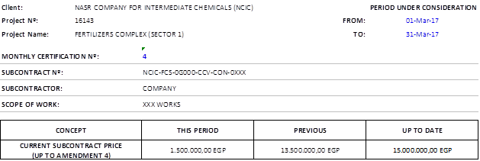

  - SUBTOTALS

There are 4 lines in the Cover tab which are referred to the Subtotals: Subtotal 1, Subtotal 2, Subtotal 3 & Subtotal 4.

- Subtotal 1 should sum: “Contract works Done” (or equivalent) + “Contract Milestones” (or equivalent).
- Subtotal 2 should sum: Subtotal 1 + FEWOs + Back Charges (in negative) + Claims Bonus + Penalties (in negative).
- Subtotal 3 should sum: Subtotal 2 + Advance Payment + Advance Payment Deduction (in negative)
- Subtotal 4 should sum: Subtotal 3 + Retention (in negative unless it’s the retention payment certification)

This shall apply for all columns (This period, Previous and Up to date)

- ATTACHMENT

- CERTIFICATION FORM.
- SFR TEMPLETE
- FEWO TEMPLATE

