INDEX

- DESCRIPTION AND COMPLIMENT OF THE FORMATS

- ANNEX 1 – CTI: ENGINEERING TRANSMITTAL

- ANNEX 2 – CTV: VENDOR TRANSMITTAL

- DESCRIPTION AND ACCOMPLISHMENT OF THE TEMPLATES

Annex 1 y 2 corresponds to the templates used on GID (Integral Documentation Manage Application).

Annex 1: CTI Engineering Transmittal
Annex 2: CTV Supplier Transmittal

Each one of the following formats include all the possibility is to make the distribution of the technical document for engineering within the project both as for the different Vendors.

For each project there will be a personal transmittal.

Generally, these configuration there will be fields which will be automatically completed in based on the information received on the GID program which corresponds to the following sections:

- ANNEX 1- CTI: ENGINEERING TRANSMITTAL

Generally, on the transmittal the documents of different disciplines will not be included

- Nº TTAL: Number of Transmittal, is associated with the documents and edition on them included cannot be duplicated
- Date TTAL: Issued date of the transmittal
- Description: A brief description wich indicating the type of document included in the transmittal.
- Distributed for: It will be completed with the information received for the options of GID program.

Comments Approved
Request for offer
Purchase order
Approved drawing
Approved for construction
Cancellation
As-Built

- Issued by Discipline: Means the discipline that appears on the document and corresponds to the following:
Project Control
Process
Civil
Statics Equipments
Dynamics Equipment
Piping
Piping materials
Stress and supports
Electricity
Instrumentation
S.C.I
HVAC
Construction
Procurement
Quality
Safety and Security
Document Control

- Nº of Document: Identification of the document issued and included in the transmittal
- Description: Title of the document
- Rev.: Revision of the document
- Date of the documentum: Date published on the documentum

- ANNEX 2- CTV: VENDOR TRANSMITTAL

In general, in the transmittal will not be included documents of a different orders

- Nº CTV: Transmittal number is the only one and associated to the documents and editions included.
- DATE: Issued date of the transmittal
- Nº ORDER: The P:O number in which the documents are included
- A full filled copy must be handed over to the person in charge of the order before: means the approximate date of GID in relation of the dated forecast for the project
- SUPPLIER: Company Location
- DESCRIPTION: Description of the order
- ACTIVITY: Speciality which corresponds to the order
- NÚMBER OF THE DOCUMENT: Identification of the suppliers document
- DESCRIPTION: Títle of the document
- ED.: Revision of the document
- SIT.: Location of the document registered in GID within of the following values.
D FOR INFORMATION ONLY
C NOT APPROVED WITH COMMENTS
B APPROVED FOR CONSTRUCTION WITH COMMENTS
A APPROVED FOR CONSTRUCTION WITHOUT COMMENTS
Z CANCELLED
- CLASS: Type of the document registered on the GID, according to the following:

Calculus
Data Sheets
Drawings
Lists
Order
Certificate
Procedure
Manual
Dossier
Planning of fabrication
Quality Plan

- ITEM: Reference of equipment included in the document

ANNEX 1 – CTI: ENGINEERING TRANSMITTAL
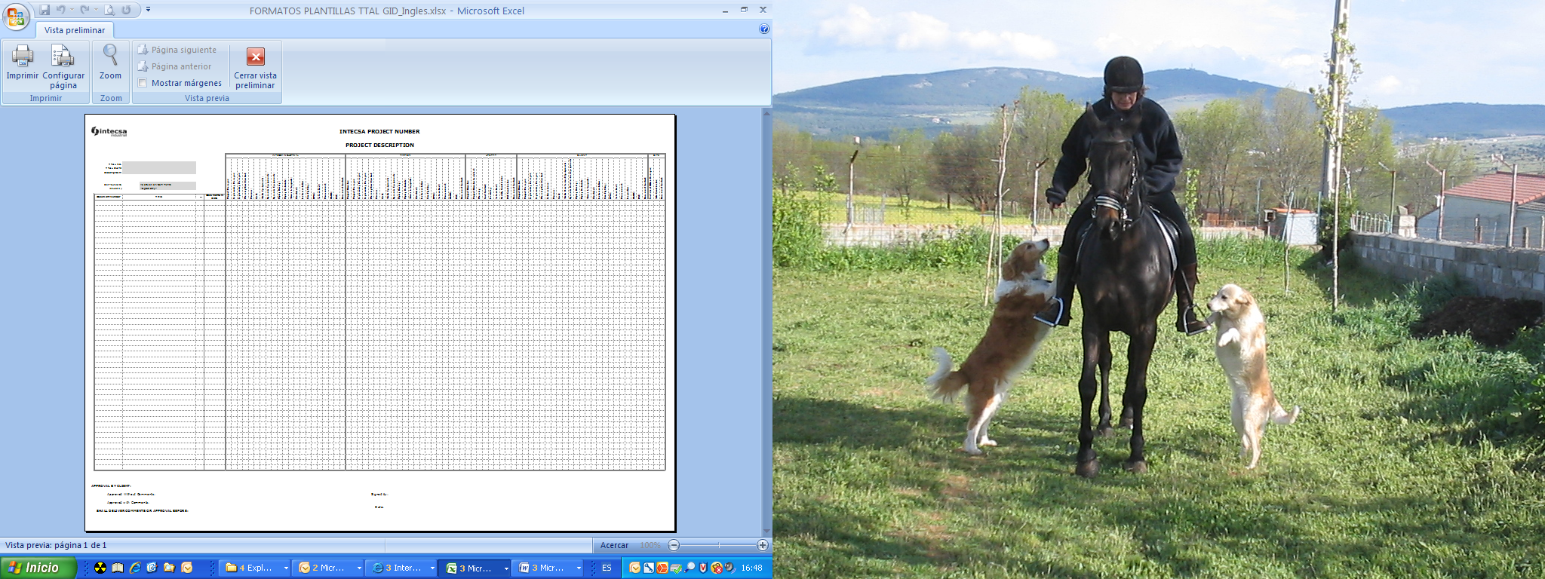

ANNEX 2- CTV: VENDOR TRANSMITTAL

