VENDOR ASSISTANCE PROCEDURE
RLLP | OMP/ DGB | OEO/ IRC | 1 | May 20 | Issuance
APPROVED | CHECKED | PREP. | EDITION | DATE | DESCRIPTION

INDEX
1. PURPOSE 3
2. SCOPE 3
3. ACRONYMS 3
4. DEFINITIONS 3
4.1 Vendor Coordinator 3
4.2 Vendor 4
4.3 Vendor Representative 4
4.4 Vendor Cost Forecast (MI-93) 4
4.5 Technical Assistance Information Request (MI-92) 4
4.6 Vendor Requisition Form (MI-94) 4
4.7 Contractor Daily Report (MI-91) 4
5. PROCEDURE 5
5.1 Preparation of the Vendor Cost Forecast and Vendor Information Request 5
5.2 Vendor Call out 8
5.3 Daily Report 10
6. templates 10
7. NUMBERING OF VENDOR REQUISITION form 10

- PURPOSE
The purpose of this document is to establish the procedure to be followed by the Project Team to request the assistance of Vendor Representatives from Vendors during Construction, Pre-Commissioning, Commissioning and Startup stages of the Project.
- SCOPE
This procedure shall be applied in all the Intecsa Industrial/ Initec Energía Projects by establishing the division of responsibilities to request the Vendor Representatives assistance as well as the control and reporting of the activities performed by the Technical Advisors.
- ACRONYMS
- COO: Chief Operating Officer
- CPO: Chief Projects Officer
- CCD: Corporate Construction Director
- PM: Project Manager
- SM: Site Manager
- CM: Construction Manager
- CS: Construction Supervisor
- CoM: Commissioning and Startup Manager
- CoS: Commissioning Supervisor
- VC: Vendor Coordinator
- VR: Vendor Representative
- GSD: General Services Department
- PCD: Project Control Department
- PCM: Project control Manager
- PPM: Project Procurement Manager
- DEFINITIONS

Vendor Coordinator
Person designated by the Project Manager to coordinate all the parties involved in the process to request the Technical Assistance from the Vendor.

Vendor
The Vendor is the party who entered into an agreement through the official PO as the seller to provide Equipment and/or materials, and provides the support services of a specialized Technical Person who will visit the Site to perform Vendor Assistance Services.

Vendor Representative
Technical specialized person employed by the Vendor, who will be sent to the Site to provide his specialized services as required during the Construction, Pre-Commissioning or Commissioning phase of the Project.

Vendor Cost Forecast (MI-93)
MI-93 is a template to be filled by the Vendor Coordinator in cooperation with the Construction Manager, Commissioning and Startup Manager, Project Procurement Manager and Project Control Manager and shall include a deviation report when necessary. MI-93 Shall be approved and signed by the Project Manager, Corporate Construction Director, Chief Projects Officer and Chief Operating Officer.

Technical Assistance Information Request (MI-92)
Template to be filled by the Vendor with information related to the resources, manpower and schedule of the activities to support Intecsa Industrial/ Initec Energía during the site assistance for Construction Pre-Commissioning, Commissioning or Startup when applicable.

Vendor Requisition Form (MI-94)
The MI-94 is a template to be filled by the Construction and Commissioning and Startup Managers to request the assistance of the Vendor representative.

Contractor Daily Report (MI-91)
MI-91 is the template to be filled by the Construction or Commissioning Supervisor with information related to the activities performed by the Vendor Representative during the Site assistance.
- PROCEDURE
The Construction Manager and Commissioning and Startup Manager, each within their scope of work, are responsible to follow this procedure.
The procedure is divided in three steps:

Preparation of the Vendor Cost Forecast and Vendor Information Request
The Vendor Cost Forecast, in revision 0, shall be prepared twelve (12) months after the award of the Project and shall be reviewed on quarterly basis from the moment the first edition is approved. In both cases the procedure shall be as detailed below.
The Vendor Coordinator shall prepare the Vendor Cost Forecast based on the information provided by the Construction Manager, Commissioning and Startup Manager, Project Procurement Manager and Project Control Manager.
The Project Control Manager shall provide the budget of the Vendor assistance of the project.
The Vendor Coordinator shall request to the Construction and Commissioning and Startup Managers the list of the Vendors that they consider shall be needed to assist during the Construction, Pre-Commissioning, Commissioning and Startup stages of the Project. This information shall also contain the mobilization and demobilization dates based on the Level III Project schedule baseline.
The Project Procurement Manager shall provide to the Vendor Coordinator the unit rates as well as the terms of the Agreement included in the Purchase Order related to the Vendors included in the MI-93. The Vendor Coordinator shall subsequently calculate the cost forecast of the Vendor assistance. In case the unit rates of a Vendor are not known, the Project Procurement Manager shall estimate the units rates based on information from previous experiences.
The Vendor Coordinator shall compare the cost associated to the Vendor assistance with the original budget or the previous Vendor Cost Forecast and include the deviation in the gap reserved for this purpose within the MI-93. If the forecast exceeds the budget, the deviation must be accompanied by a report reflecting the causes that led to the deviation. The Project Manager shall subsequently review and approve the Vendor Cost Forecast and request the approval also to the Corporate Construction Director, Chief Projects Officer, and Chief Operating Officer.
When approved, the Vendor Coordinator shall distribute the Vendor Cost Forecast to the Project Procurement Manager, Site Manager and Project Control Manager for information and action when required.
In parallel, the Vendor Coordinator shall request to the Vendors included in the MI-93, to fill the MI-92 related to Construction, Pre-Commissioning or Commissioning information as requested by the concerned Manager. When received, the Vendor Coordinator shall send the MI-92 to the Construction Manager, Commissioning and Startup Manager, Project Control Manager and the Site Manager to be aware in advance of the schedule and requirements during assistance. The Site Manager, Construction Manager and Commissioning and Startup Manager shall inform the Vendor Coordinator about any modification in the planned Site activities that affect the Vendor assistance dates.
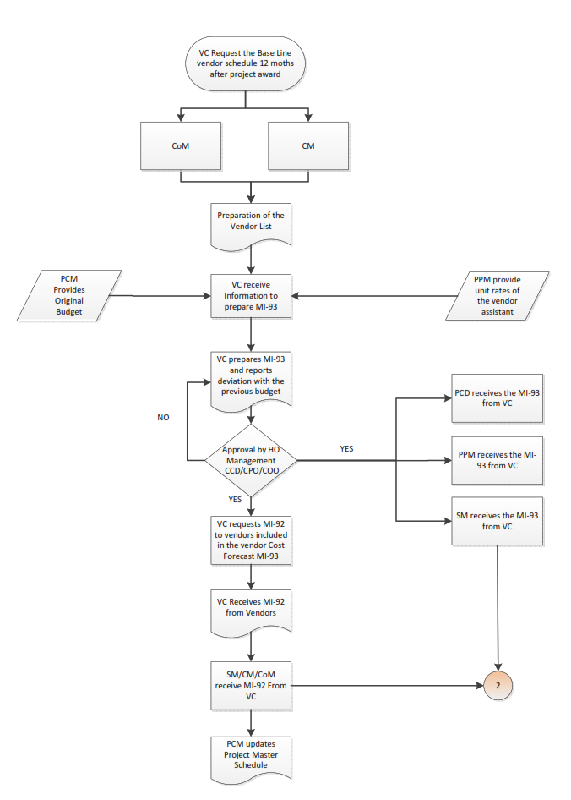
See Page 9

Vendor Call out
Two (2) months before the scheduled date for the assistance of a Vendor, the Construction and Commissioning and Startup Managers shall fill the Vendor Requisition Form (MI-94). The MI-94 shall be delivered to the Site Manager for review and approval. Once approved, the MI-94 shall be handed over to the Vendor Coordinator to get the approval of the Project Manager. When approved, the Vendor Coordinator shall contact the Vendor to confirm its availability to assist the Construction or Commissioning in the requested dates. In case there is not availability, the Construction or Commissioning and Startup Manager shall reschedule the assistance as per the available dates.
Once the assistance dates are confirmed, it is the responsibility of the Construction and Commissioning and Startup Managers to inform the Vendor Coordinator if there is any change in the Project that is affecting the Vendor schedule. The Vendor Coordinator, for his part, shall contact the Vendor on fortnight basis to confirm if the agreed dates are still valid, otherwise any change shall be put in knowledge of the Vendor.
The Project Control Manager shall be responsible to update the Project Master Schedule, if applicable, once the Vendor assistance dates are fixed.
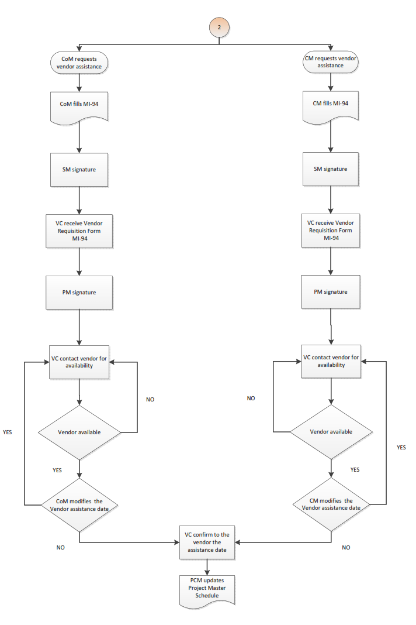

Daily Report
The Construction and Commissioning Supervisors are responsible to write the daily report providing information as indicating in the template (MI-91). This template consists of two sections, the first part has the purpose to list the activities performed along the day, and the second one refers to the incidences that impact the schedule of the Vendor assistance. When the Supervisor reports that there is any event related with the execution of the Vendor activities that could affect the cost or the planning of the Project, the Construction or Commissioning and Startup Manager shall inform to the Project Manager and Vendor Coordinator in order to confirm if there is well-founded contractual basis to support a claim to the Vendor. Regardless the above, the Construction and Commissioning and Startup Managers shall include the comments in the Vendor Time Sheet at the moment of the signature.
The Commissioning or Construction Manager shall sign the contractor daily report as well as the Vendor time sheet and attach them to the Vendor daily report. The referred documents shall be stored in soft copy in specific folders by the Construction or Commissioning and Startup Manager. The original documents, once signed, shall be handed over to the Project Control Manager for cost control as well as to the Procurement Project Manager and Vendor Coordinator for necessary actions with the Vendor when required.
- templates
- MI-91 Contractor Daily Report
- MI-92 Technical Assistance Information Request
- MI-93 Vendor Cost Forecast
- MI-94 Vendor Requisition Form
- NUMBERING OF VENDOR REQUISITION form
The Vendor Coordinator shall use reference number for each request for official communication with all departments as per this procedure.
The format numbering shall be as follows:
- Correspondence numbering will be:
PO-VR-XXXX/YY
- The correspondence will be identified using the following four groups of classifications:
“PO” Purchase Order Number
“VR” Vendor Requisition
“XXXX” the sequence numbering
“YY” Year: 19 for 2019

