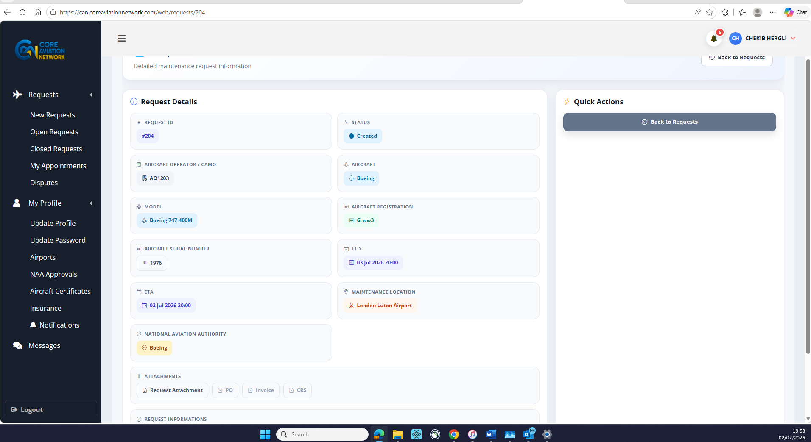
Apply
- Add a “Apply now button under quick actions and maybe a “Delete”.
Make this CRS Report
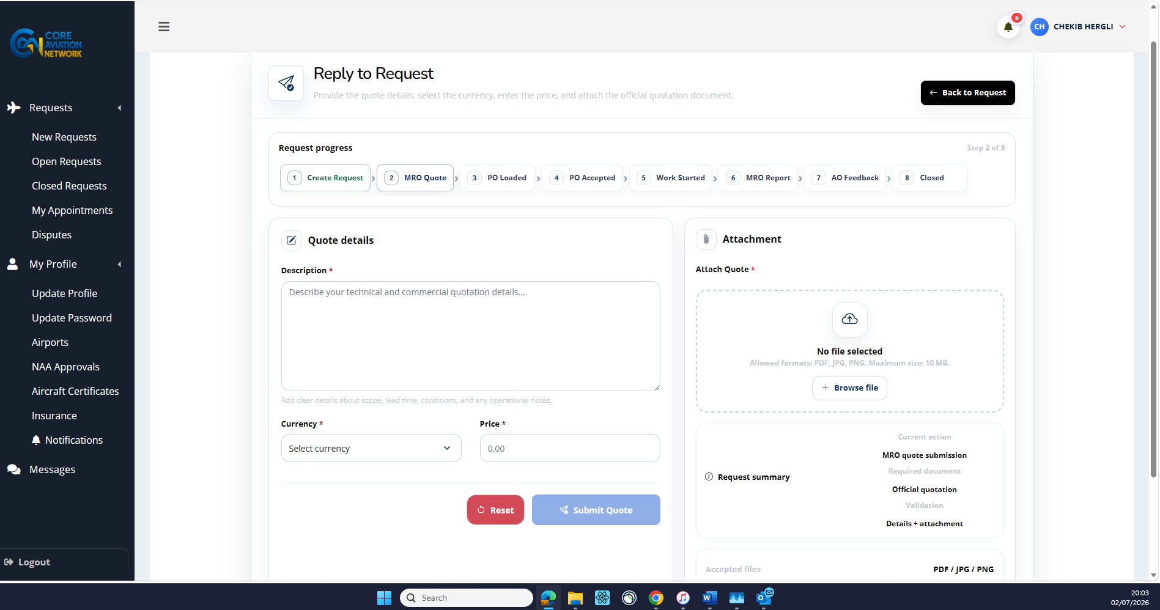
- Make the box/step we are in more bold, bigger and more visible. In this case #2
- Can we remove the apply once an MRO has already applied.
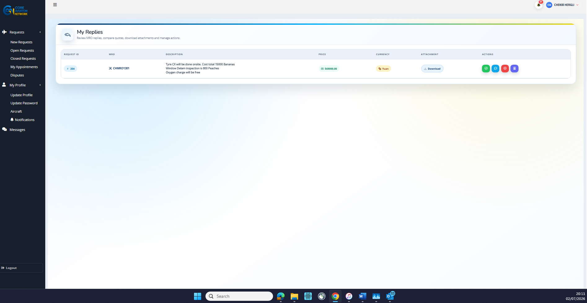
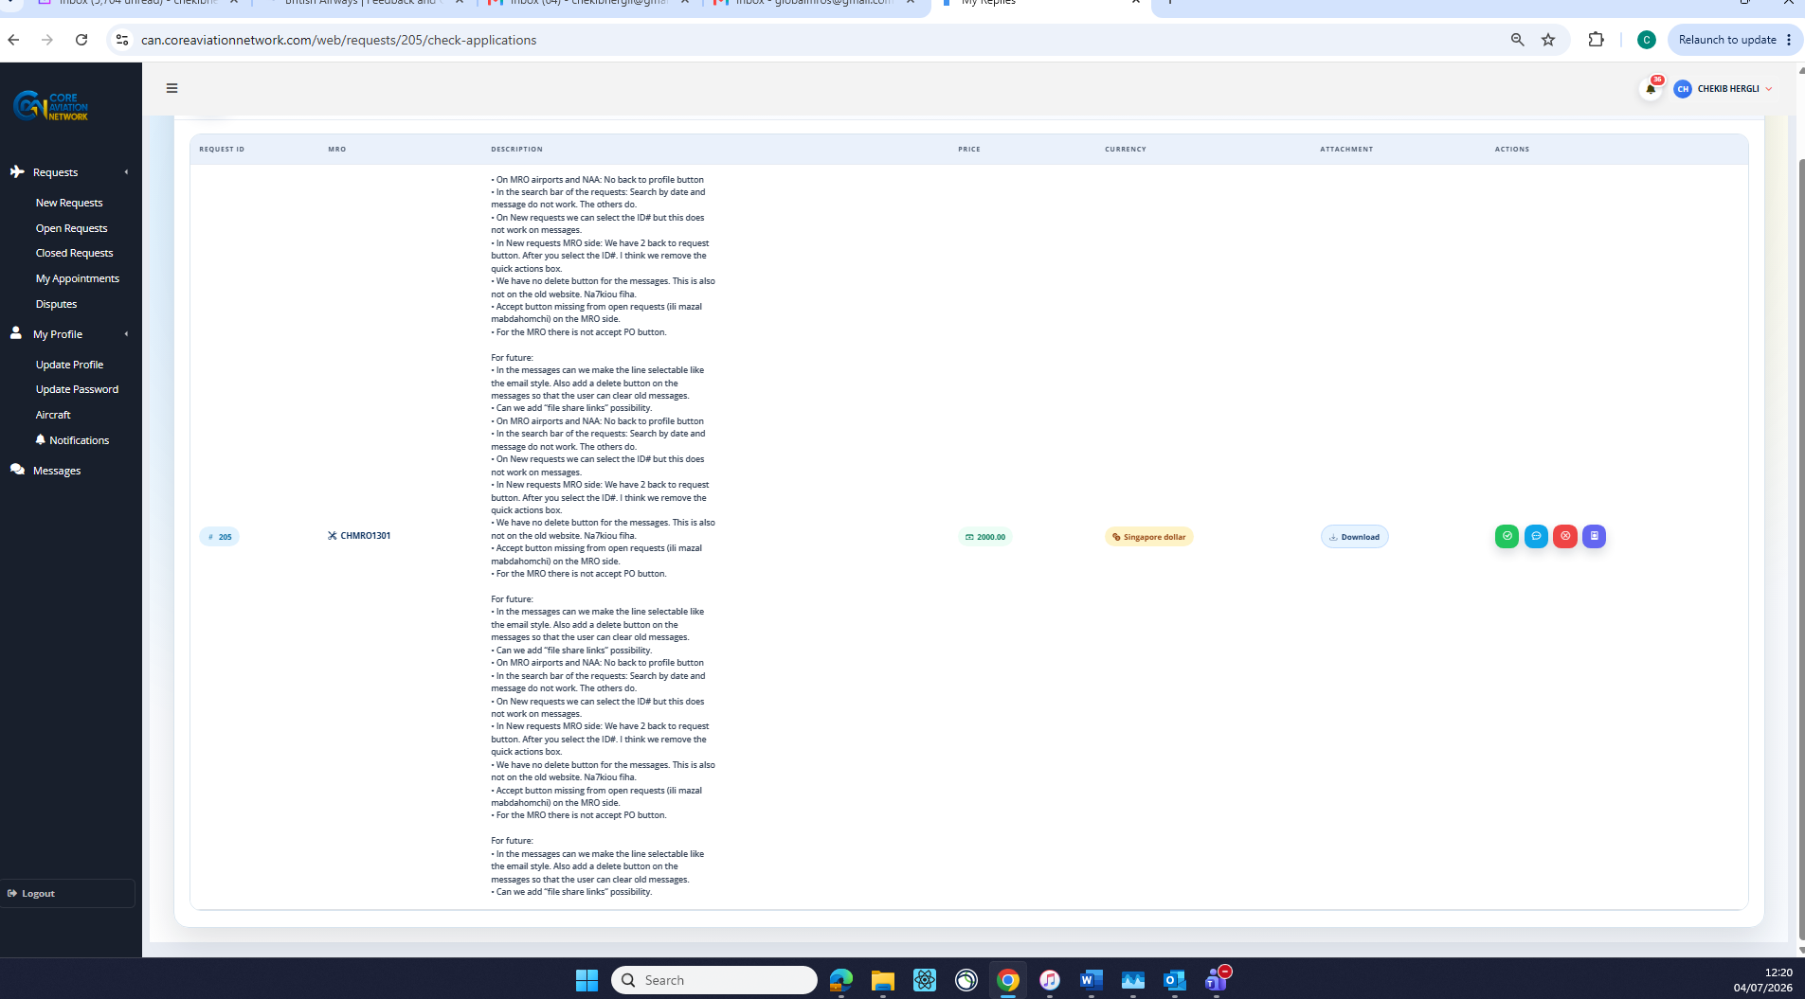
- As an AO I can’t open the reply to a request from the MRO. The reply can we make it selectable.
- Can the notifications be changed so that every time a new action happens, we get a banner or the bell border to turn red. Can we make the bell bigger.
- In the messages section can we make the lane selectable. 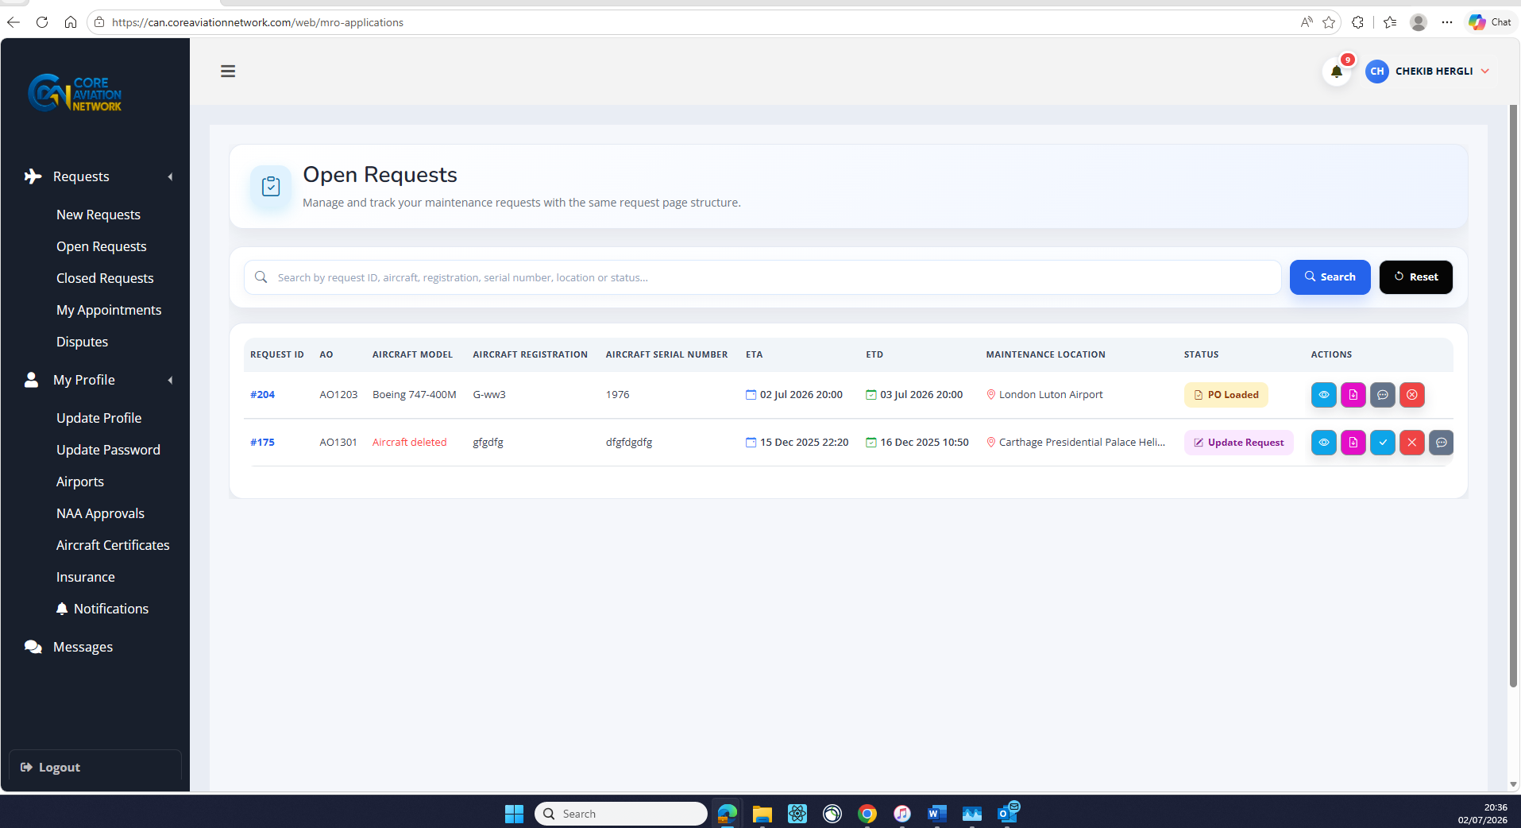
AO/CAMO
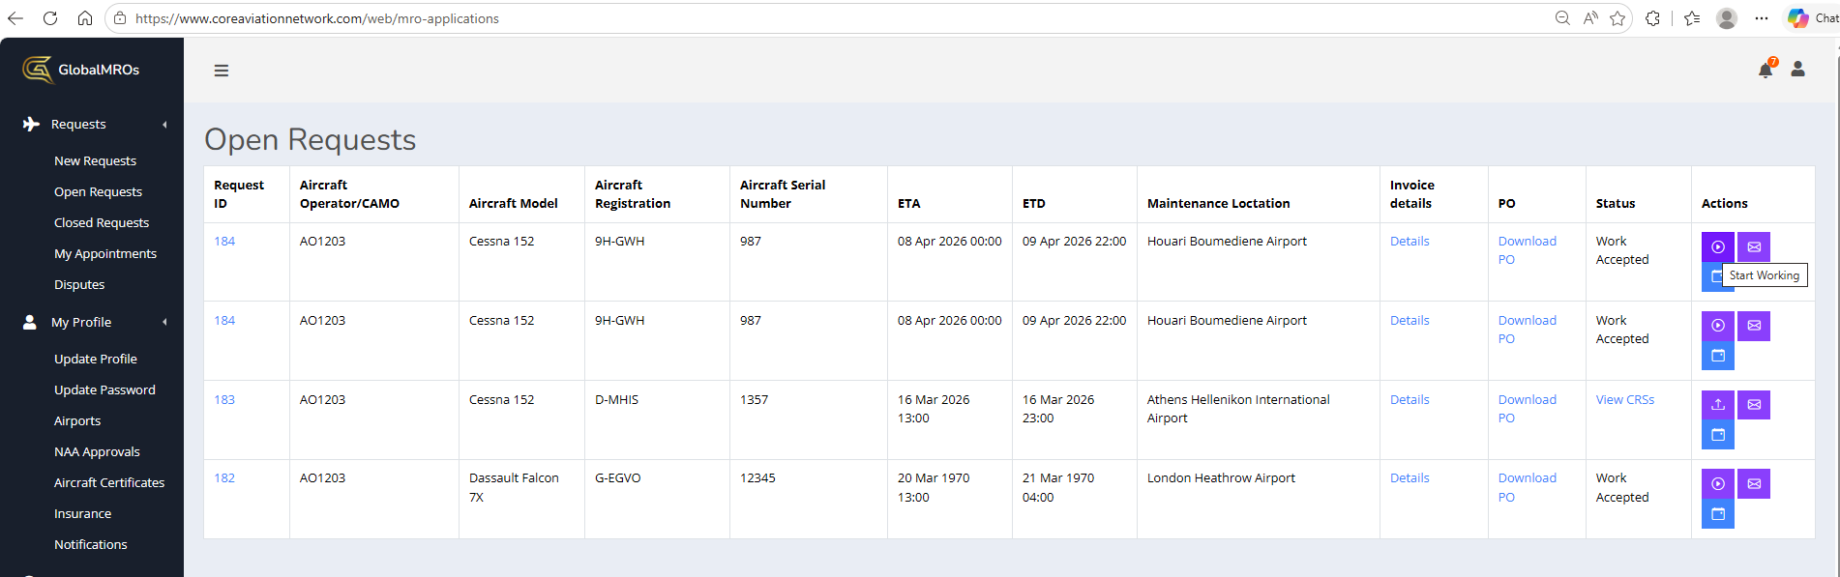
- There is no start work button, so the MRO can not progress. Old site has this option.
- All quick action section butttons to move to the top of the screen. On Bothe AO and MRO sides.
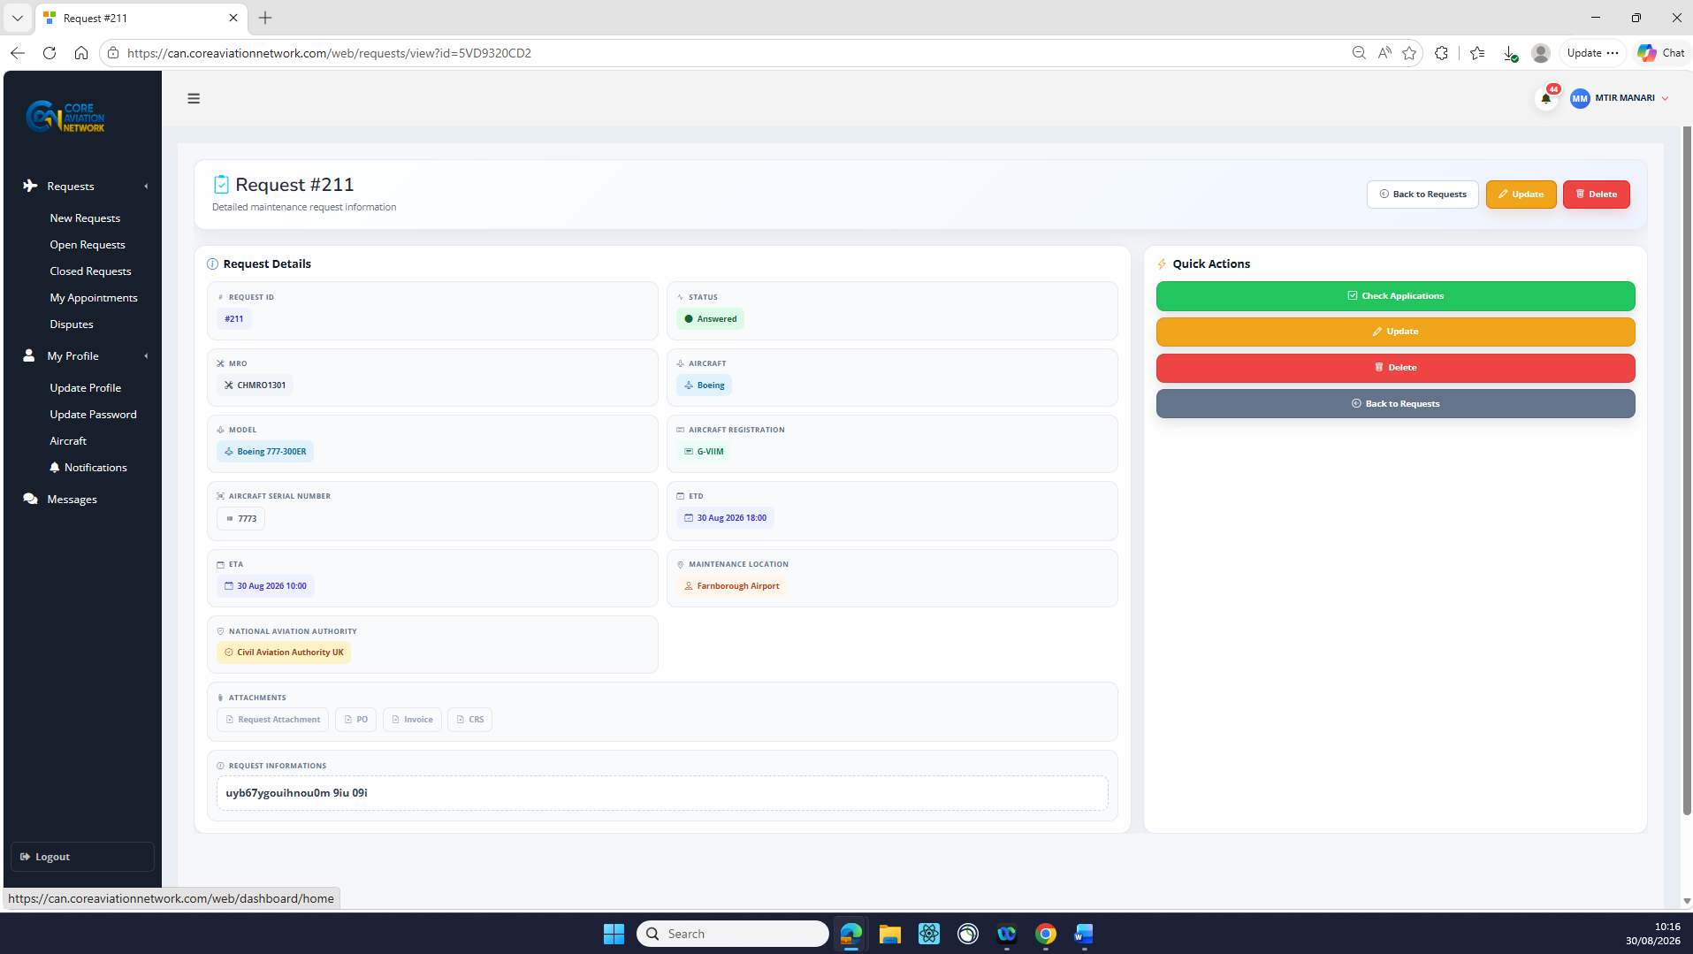

- In the image blew we need to check the certificates path because it is showing a 404 error. Both on the MRO and the AO side we can not open or download the certificates documents. Other docs are ok. 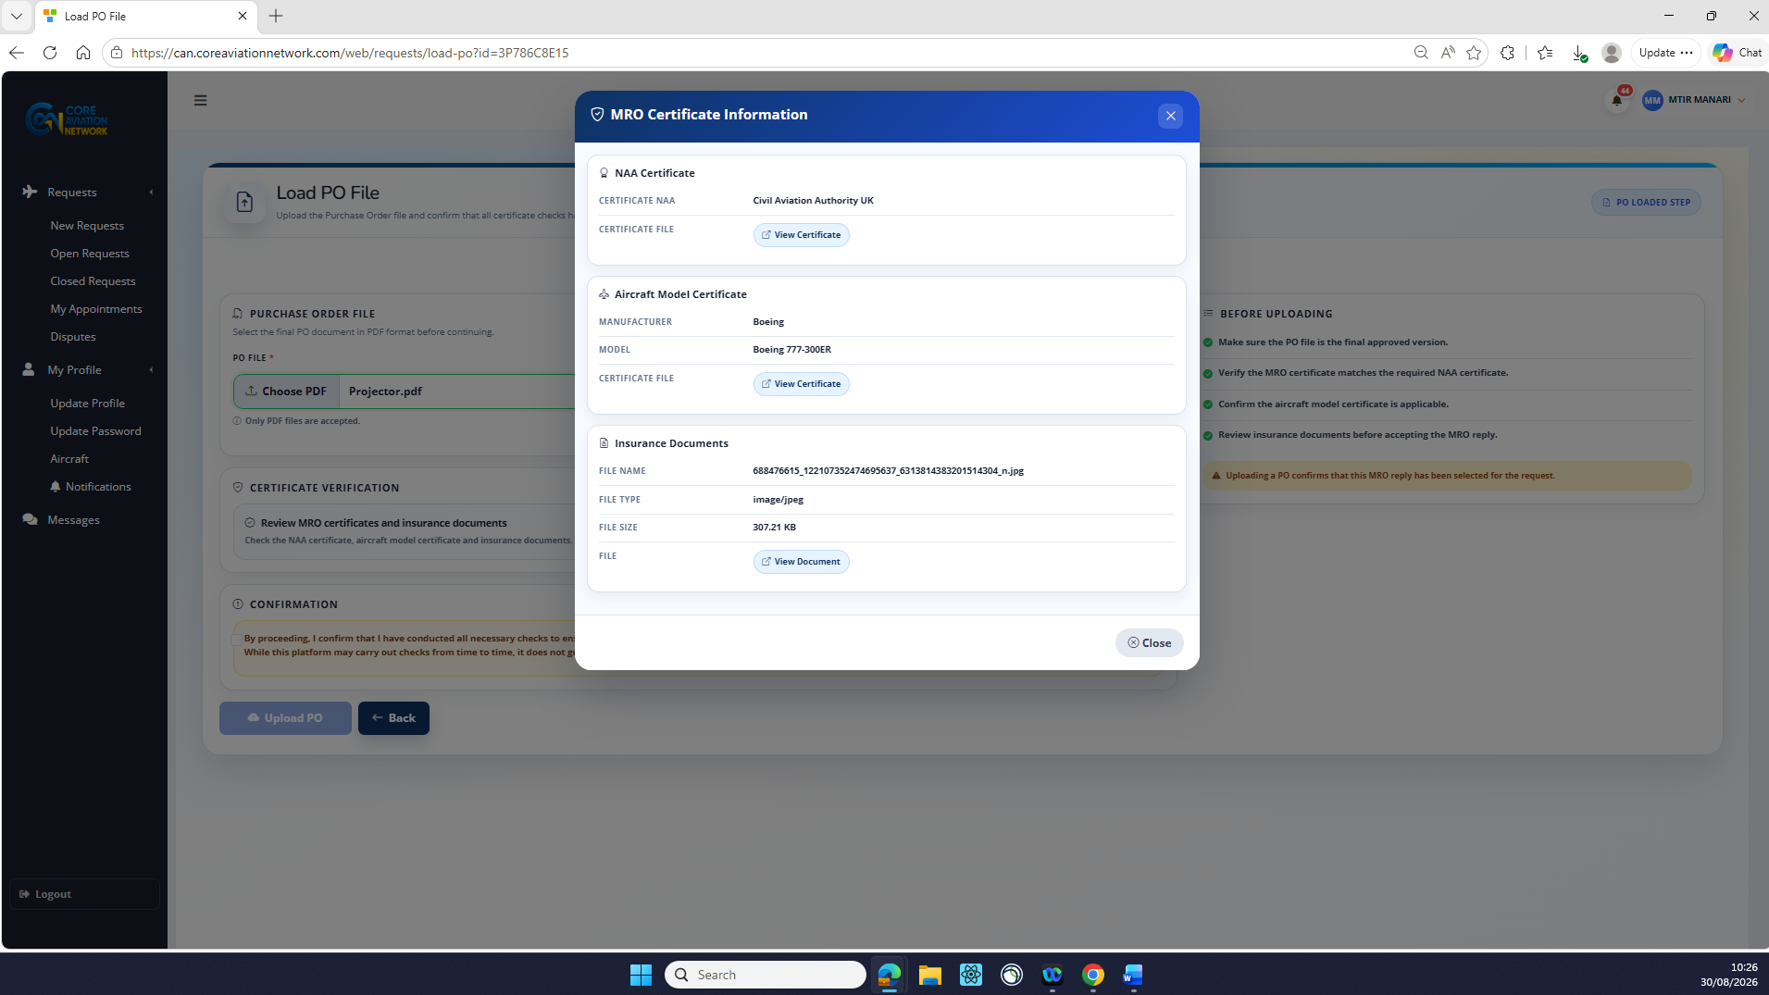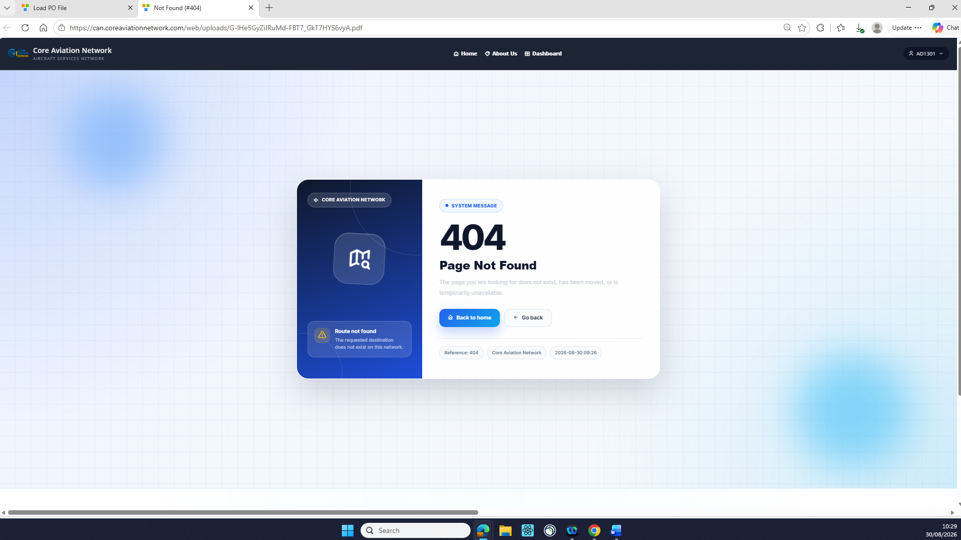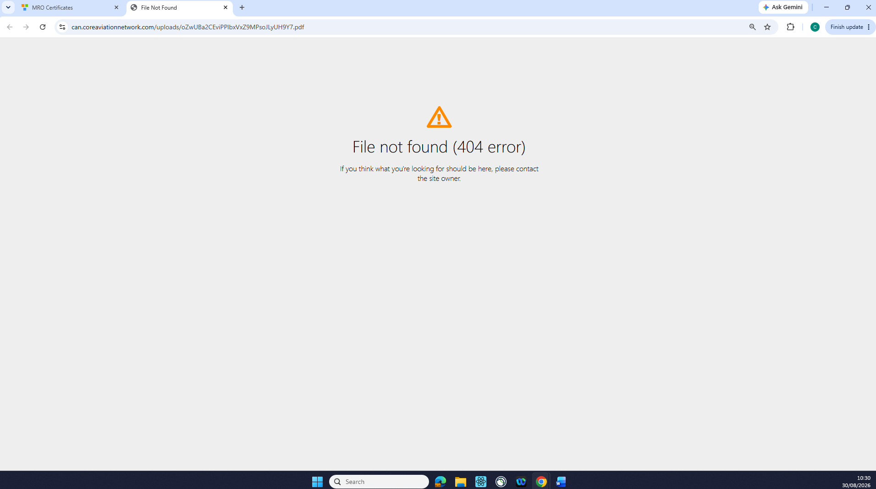
- Check boxes on all pages to be made clear and visable. 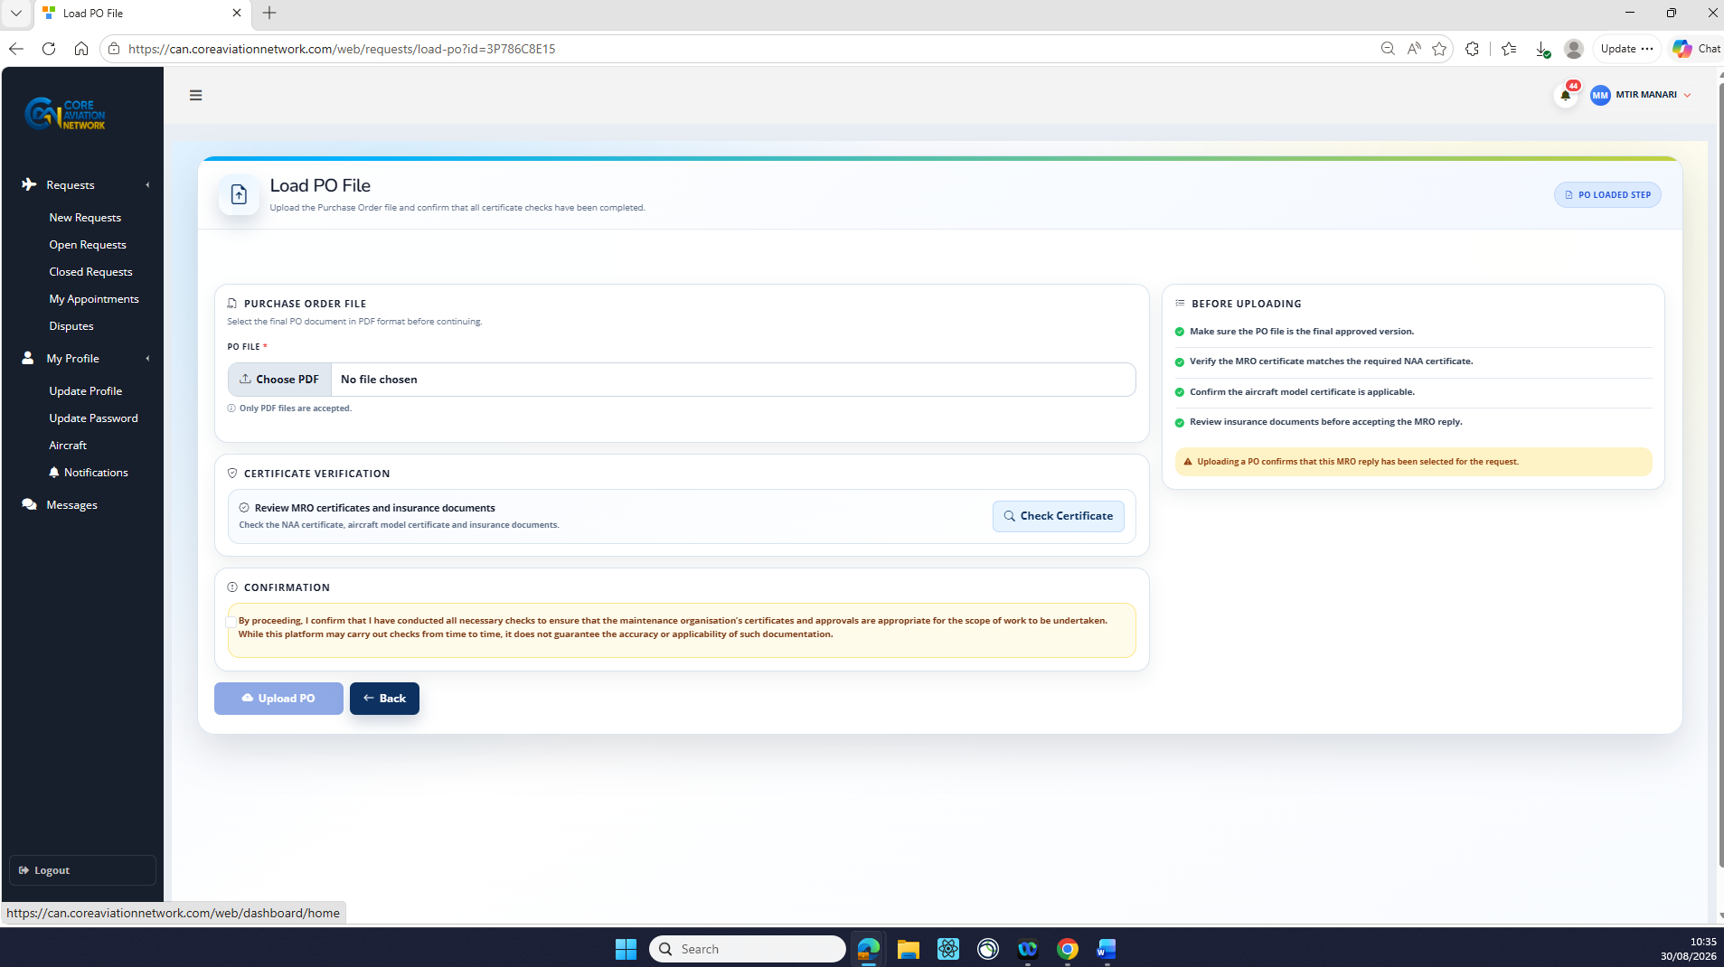
- Please make the completed steps to remain green but go back to smaller size and only the current step t be big and bold. 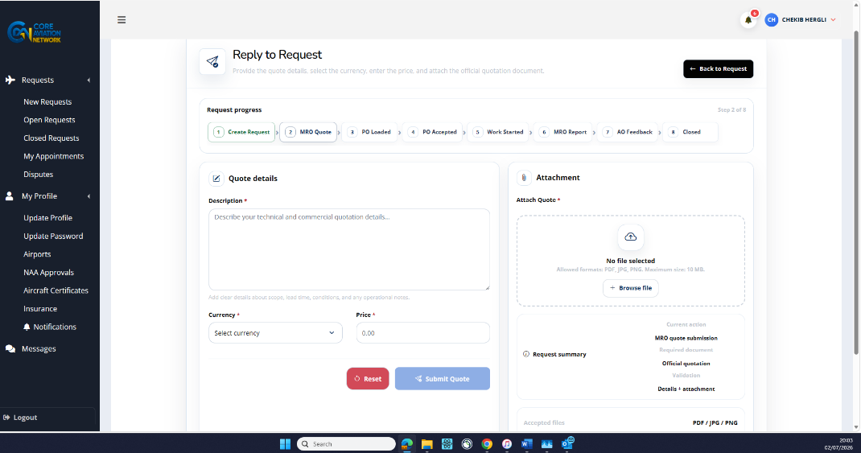
- Make each line selectable because maybe there will be many replies. And restrict the visible words to only 1 or 2 lines. 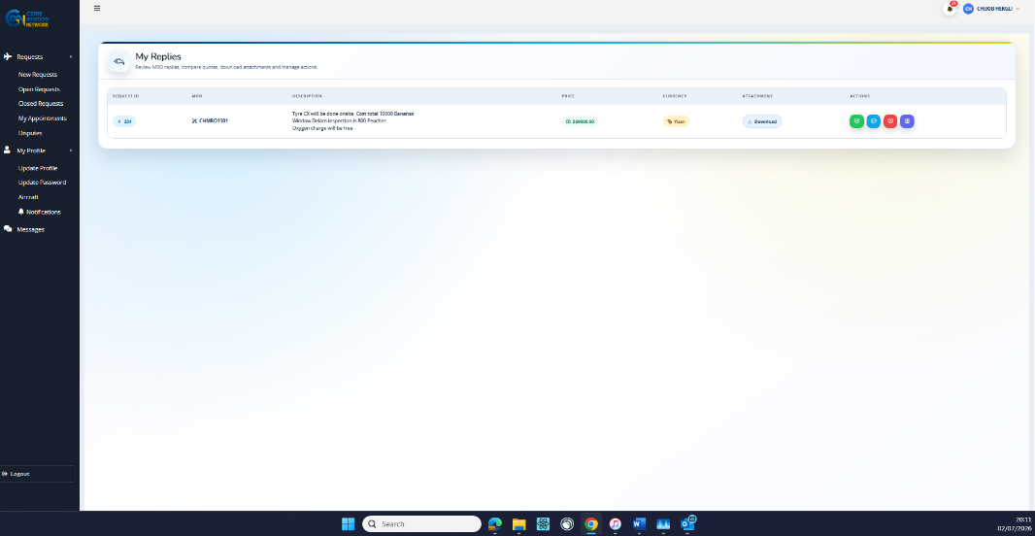
- Number of characters to increase and character countdown to be indicated. Also to add information that this should only be a short and brief description of main items worked. Also to make the submit button unselectable if the characters are too much and if the box is not checked.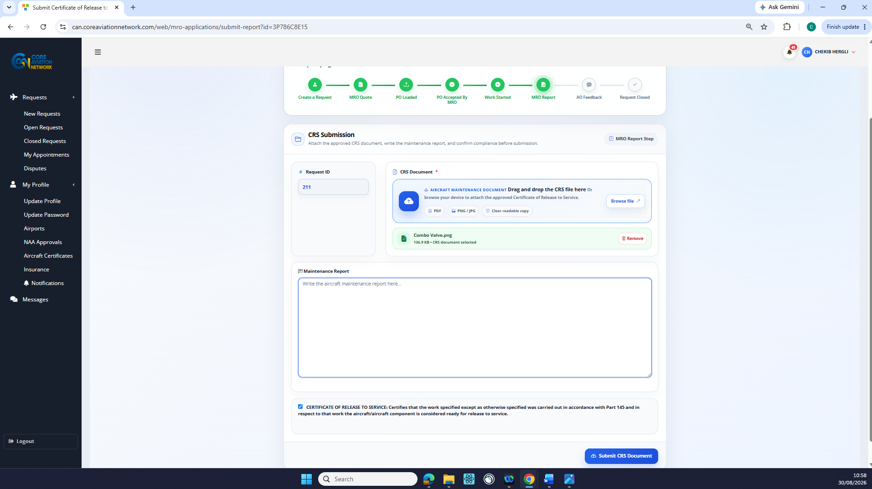
- Same as point 12 and also make it so that the AO can download the CRS not ony open. At the moment the download button is only opening the CRS.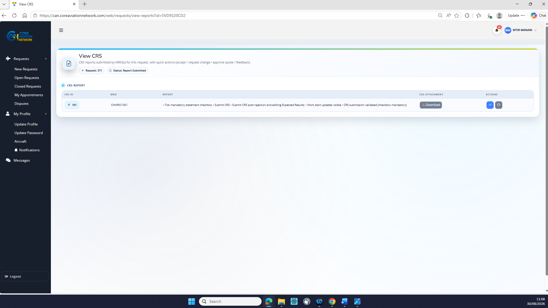
- The feebdack comment to be from top to bottom 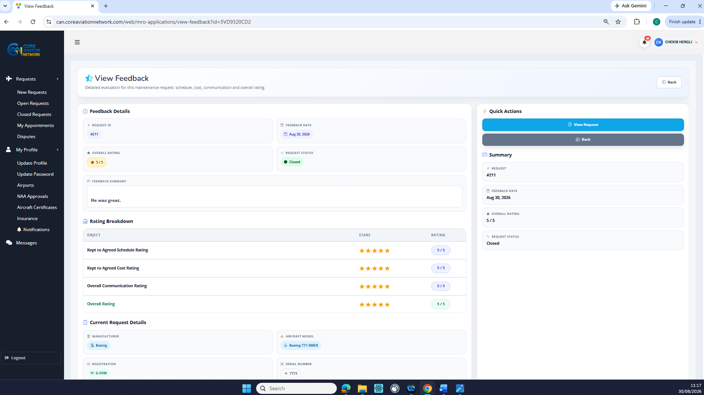
- On both Ao and MRO side set the closed request historic to default 3 months then they can select by year.
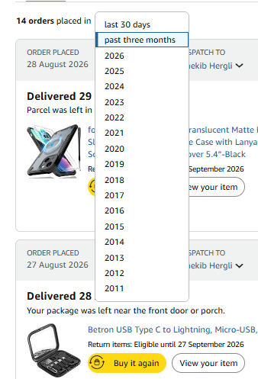
- The ID should be the request ID not a random ID so that the Admin, AO or MRO can link the dispute to the request easily. Also we need to add a view button on Admin, MRO and AO sides.
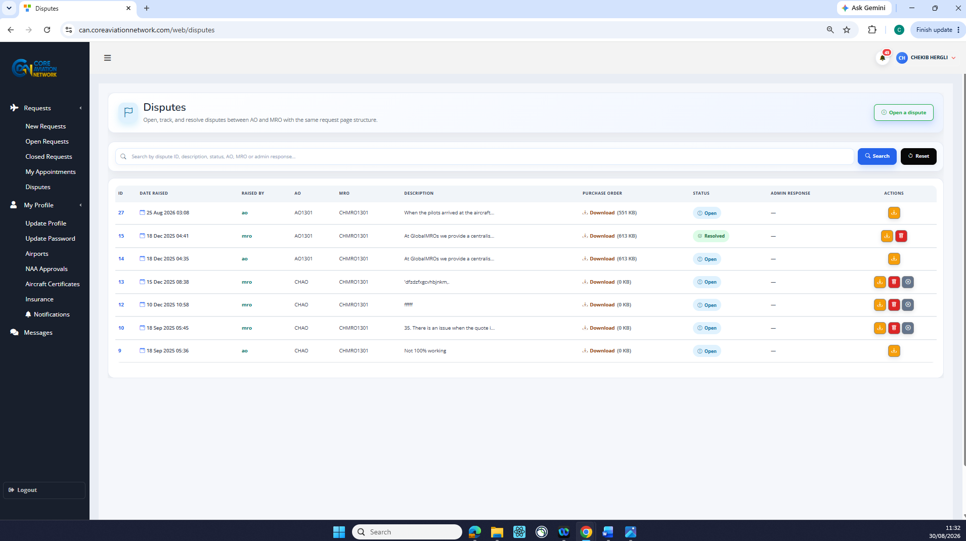
- Khaled suggested to add a dispute tab on the closed request page and on the view tab/page.
