strong Workout Tracker Gym
Page_Name | Description | Screenshot |  |  | Story
 | - Platform preparation |  | 8 | 16
Landing page | - Catchy Headline: A strong, motivating headline that encapsulates the app's purpose.  - Background Image: A visually appealing background that showcases people working out.  - Call-to-Action (CTA) Buttons: Register Login Continue with facebook |  | 2 | 2 | - as customer I can create my account online.  - as customer I can log in into my account using username or email and the password.
Register Page | Simple Sign up with only username,password & email | 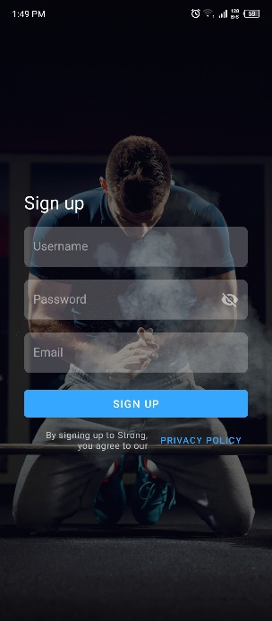 | 3 | 3
Home Page (workout) | - Workout Routine Selection: Choose from saved routines or create a new workout plan.  - Exercise List: Displays the exercises included in the workout with sets, reps, and weights.  - Timer: Integrated rest timer that helps track rest periods between sets.  - Add Exercise Button: Allows users to add new exercises on the fly.  - Notes Section: Users can add specific notes for each exercise or the overall workout.  - Quick Start Button: Allows users to quickly begin a workout by selecting a previously saved routine or starting a new session. | 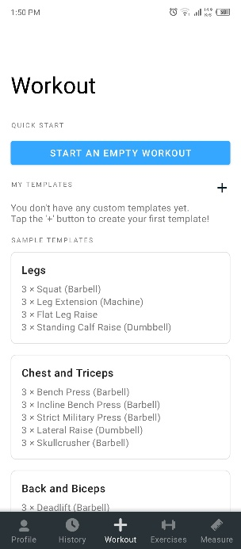 | 8 | 24 | - as customer I can see recommended workouts in the home page.  - as customer I can add start an empty workout via the button in the home page.
Start Empty Workout | Quick Start Button: Allows users to quickly begin a workout by selecting a previously saved routine or starting a new session. | 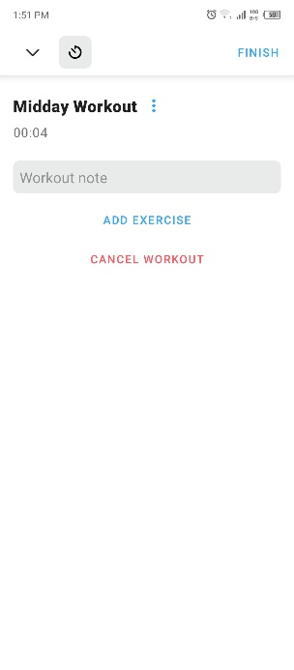 | 4 | 4 | - as customer I can add start an empty workout via the button in the home page.
Add Exercises | - Create Custom Routines: Users can build custom workout routines by selecting exercises and setting parameters for sets, reps, and rest times.  - Template Routines: Access to pre-built routines designed by fitness professionals, which can be customized to fit personal goals.  - Drag-and-Drop Interface: Allows for easy reordering of exercises within a routine.  - Save and Edit Routines: Save new routines or edit existing ones for future use. | 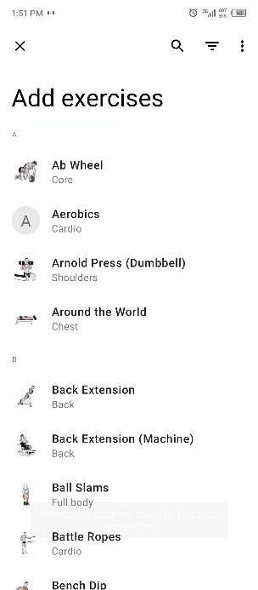 | 4 | 4 | - as customer I can see exercises list and I can choose one exercise to see the details and click in button in details to start workout.
Exemple of template | Exemple of execice | 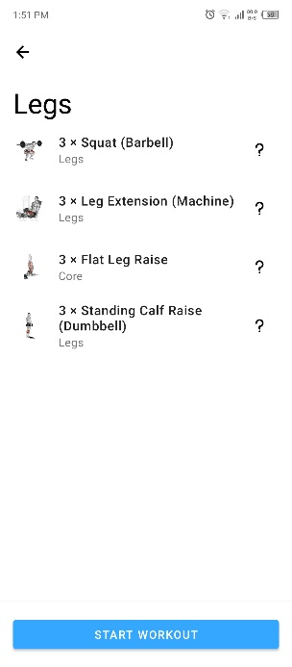 | 1 | 2 | - as customer I can add new exercise.
Profile Page | - Summary of Recent Workouts: A quick overview of your recent workout history, including the last few sessions.  - Weekly Activity Overview: Displays the total number of workouts, exercises, and time spent working out over the past week.  - Progress Charts: Visual representations of your progress over time, such as weight lifted or total reps. | 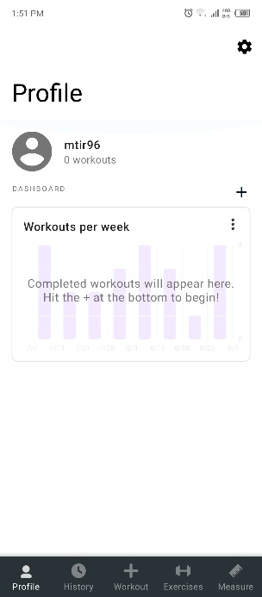 | 40 | 40 | - as customer I can enter to my profile page to see my Summary of Recent Workouts, Weekly Activity Overview, Progress Charts, Progress Tracking.
Profile Page | - Progress Tracking: Track metrics like weight, body measurements, and personal records for various exercises. | 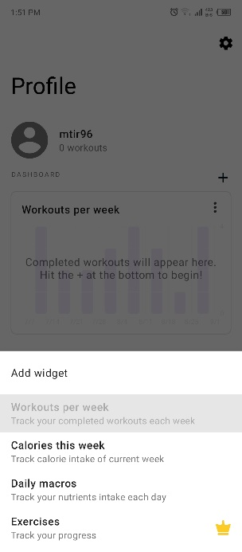 | 40 | 40
History Page | - Workout Log: A chronological log of all completed workouts with details on exercises, sets, reps, and notes.  - Search and Filter: Search past workouts by date, exercise, or routine name for quick access.  - Workout Replay: Ability to replicate a past workout by loading it directly into the Workout Page.  - Export Data: Options to export workout history to formats like CSV for personal records or sharing with a coach. | 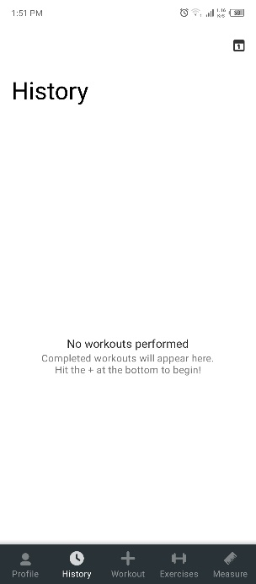 | 3 | 16 | - as customer I can enter my history page to see workout logs, workout replay, I can export my history and search and filter the history.
Exercices Page | - Exercise Search: A search bar to quickly find exercises by name or muscle group.  - Exercise Categories: Exercises are organized by categories such as muscle group (e.g., chest, back) or equipment (e.g., dumbbells, barbells).  - Exercise Details: Each exercise includes a description, instructional images or videos, and recommended form tips.  - Favorite Exercises: Mark exercises as favorites for easy access in future workouts. | 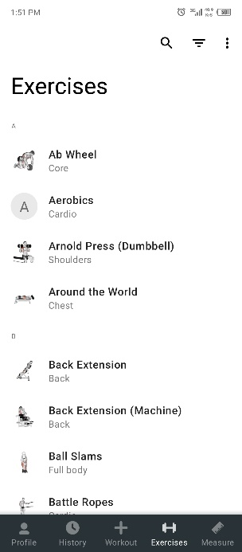 | 4 | 8 | - as customer I can see exercises page that I can search in it by exercise name or categories.  - as customer I can see exercise details and mark exercise to my favorite
New Exercise form |  | 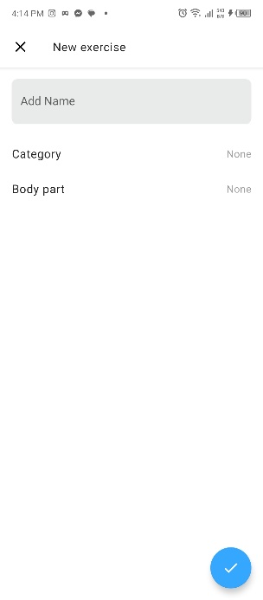 | 4 | 4
Measure Page | - Progress Tracking: Track metrics like weight, body measurements, and personal records for various exercises.  - Progress Graphs: Graphical representations of your progress over time, helping you visualize improvements.  - Body Stats: A section for entering and monitoring body metrics such as weight, body fat percentage, and measurements.  - Milestones: Display significant achievements, such as lifting a certain weight or completing a specific number of workouts. | 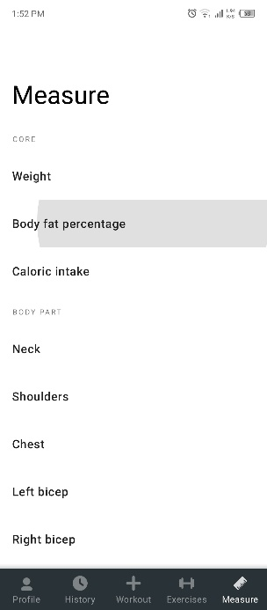 | 8 | 8 | - as customer I can see the Measure page to see my progress tracking, progress graphs, body stats and my milestones
Settings Page | - Profile Settings: Manage personal information like username, email, and profile picture.  - App Preferences: Customize app settings such as units of measurement (e.g., kilograms vs. pounds), notification preferences, and theme (light or dark mode).  - Backup and Sync: Options to back up your data and sync it across devices or cloud services.  - Connected Devices: Manage connections to fitness wearables or third-party apps like Apple Health or Google Fit. | 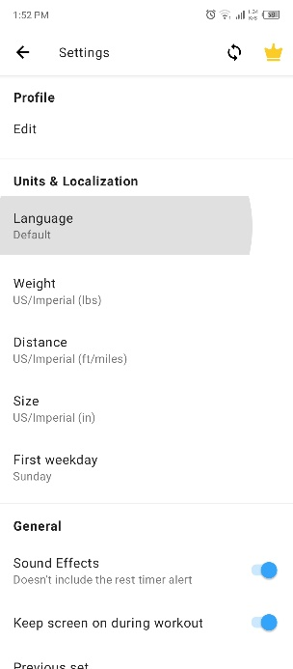 | 8 | 16 | - as customer I can see the settings page to set :  Profile Settings: Manage personal information like username, email, and profile picture.  App Preferences: Customize app settings such as units of measurement (e.g., kilograms vs. pounds), notification preferences, and theme (light or dark mode).  Backup and Sync: Options to back up your data and sync it across devices or cloud services.  Connected Devices: Manage connections to fitness wearables or third-party apps like Apple Health or Google Fit.
Settings Page |  | 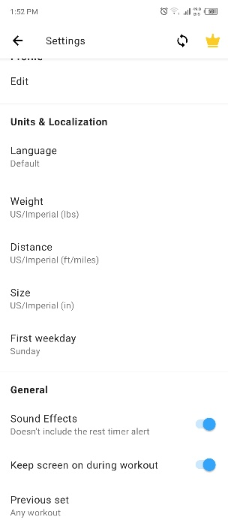

Fitness First
Page_Name | Description | Screenshot |  |  | Stories
Landing Page (member) | Login form for member | 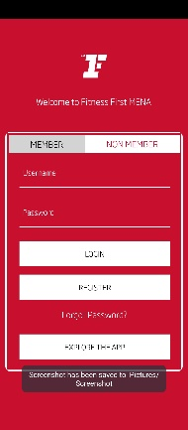 |  |  | as a visitor I can see login page that contains button discover
Landing Page (non member) | Login form for non-member | 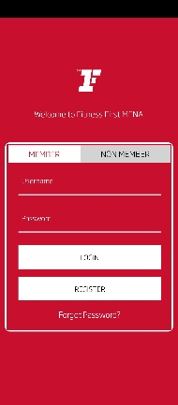 |  |  | - as a customer If am already registered in real life just u put the email and the reg number.
Explore the app | Slider and clickable images for informations | 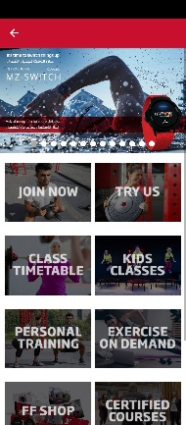 | 4 | 8 | - as a visitor I can see discover page that contains slider and clickable images to see more information about the club and classes
Click on one Button | - When clicking in any photo in the page before this descripting page shows | 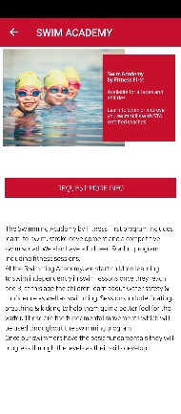 | 3 | 8 | - as a visitor I can see all pages that contains information about the club and classes.
Registration non membre | - Registration with all the informations | 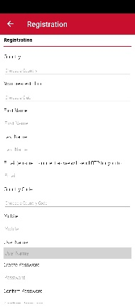 | Already done |  | - as a visitor when I register, I should confirm my email by clicking in the link I get in my email.
Registration non membre | - Registration with all the informations | 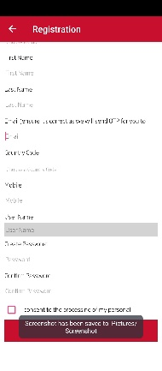 | Already done
Registration membre | - If u already registered in real life just u put the email and the reg number | 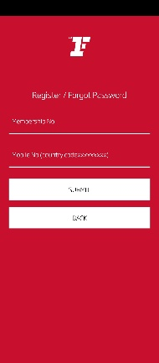 | Need admin interface |  | - as a customer If am already registered in real life just u put the email and the reg number.
Registration non membre  Only countries that have the gym | - Only countries with clubs are showing | 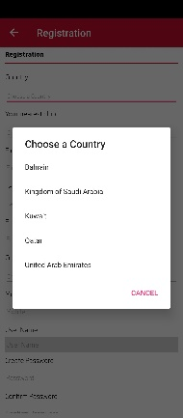 | 3 | 8 | - as a customer when I register, I can see only the available clubs and their countries they are in.
Registration non member  clubs | - List of the clubs that affiliated with the app | 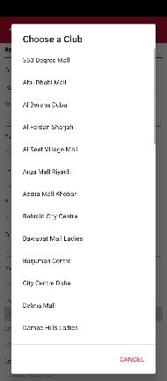 | 2 | 4
After login home page | - Daily Workout Overview: A summary of the day's workout plan, including exercises, sets, and reps.  - Personalized Suggestions: Workout recommendations based on user preferences, goals, and previous activity.  - Activity Summary: A quick look at steps taken, calories burned, and active minutes for the day.  - Quick Access Buttons: Shortcuts to start a workout, track a new activity, or view progress.  - Upcoming Classes: If the app is linked to a gym membership, it might show upcoming class schedules with the option to book a spot. | 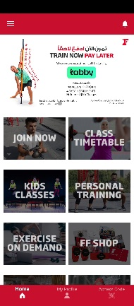 | 8 | 8
My profile page | - Personal Information: Manage personal details like name, email, and profile picture.  - Fitness Preferences: Set preferences for workout types, intensity levels, and fitness goals to tailor the app’s recommendations.  - Membership Details: View and manage gym membership details, including billing information and membership tier.  - Notifications Settings: Customize notification preferences for workout reminders, class bookings, and community updates.  - Privacy Settings: Control who can see your profile, posts, and activity within the app. | 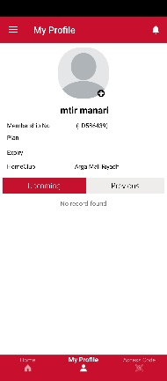 | Already calculated | Already calculated | - as a customer I can found those information in my profile page  - Personal Information: Manage personal details like name, email, and profile picture.  - Fitness Preferences: Set preferences for workout types, intensity levels, and fitness goals to tailor the app’s recommendations.  - Membership Details: View and manage gym membership details, including billing information and membership tier.  - Notifications Settings: Customize notification preferences for workout reminders, class bookings, and community updates.  - Privacy Settings: Control who can see your profile, posts, and activity within the app.
Acces code page | - After registration in real life they activate the account | 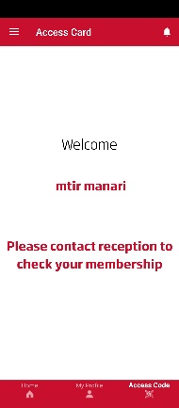 | 1  Need admin story | 1
Notifications page | - Reminders: Set reminders for workouts, classes, meal planning, and hydration.  - Achievements Alerts: Notifications about milestones reached, such as workout streaks or new personal records.  - Community Activity: Updates on activity within the community, such as new challenges, friend requests, or comments on posts.  - App Updates: Information about new features, updates, or special offers within the app. | 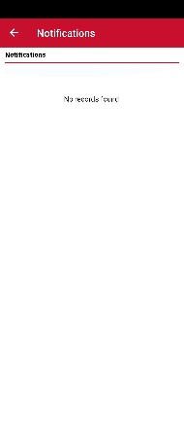 | 24 | 40 | - as a customer I can see notifications page with those information  - Reminders: Set reminders for workouts, classes, meal planning, and hydration.  - Achievements Alerts: Notifications about milestones reached, such as workout streaks or new personal records.  - Community Activity: Updates on activity within the community, such as new challenges, friend requests, or comments on posts.  - App Updates: Information about new features, updates, or special offers within the app.
Burger menu | Side menu | 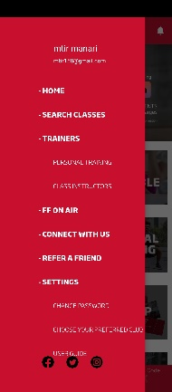 | 4 | 8 | - As a customer I can enter those pages in the burger menu:  - Class Schedule: A calendar view of available fitness classes, both in-person and virtual, with details on time, location, and instructor.  - Class Booking: Ability to book a spot in a class directly through the app, with notifications for reminders and cancellations.  - Class Descriptions: Information about each class type, including intensity level, duration, and the focus (e.g., yoga, spin, HIIT).  - Instructor Profiles: Detailed profiles of the instructors leading the classes, including their qualifications and teaching style with booking options.  - Join Live Classes: For virtual classes, an option to join live sessions directly from the app.  - FF on Air: Check subscription status  - Connect with us: Simple contact form  - Refer a friend: Refer a friend form  - Change password: Change password form  - Chose club: Chose a club form  - Termes : Termes & conditions page  - Delete account: A confirmation message to delete the account
Burger menu  Search classes | - Class Schedule: A calendar view of available fitness classes, both in-person and virtual, with details on time, location, and instructor.  - Class Booking: Ability to book a spot in a class directly through the app, with notifications for reminders and cancellations.  - Class Descriptions: Information about each class type, including intensity level, duration, and the focus (e.g., yoga, spin, HIIT).  - Instructor Profiles: Detailed profiles of the instructors leading the classes, including their qualifications and teaching style.  - Join Live Classes: For virtual classes, an option to join live sessions directly from the app. | 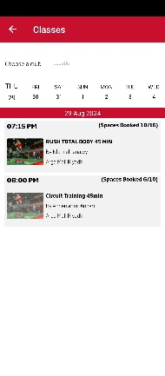 | 24 | 40
Burger menu  Personal Trainers | - List to choose the trainer | 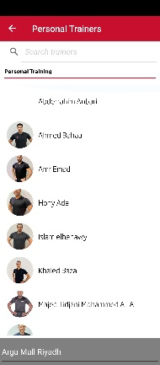 | 8 | 8
Burger menu  Class Instructors | - Chose a class by the instructor | 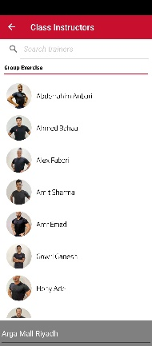 | 4 | 4
Burger menu  FF on Air | - Check subscription status | 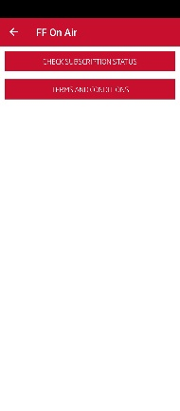 | 2 | 2
Burger menu  Connect with us | - Simple contact form | 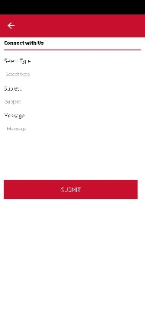 | 2 | 2
Burger menu  Refer a friend | - Refer a friend form | 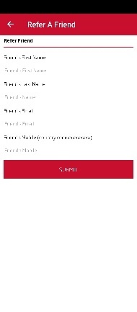 | 2 | 2
Burger menu  Change password | - Change password form | 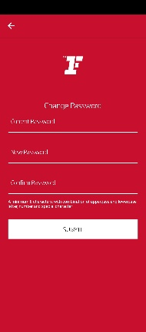 | 2 | 2
Burger menu  Chose club | - Chose a club form | 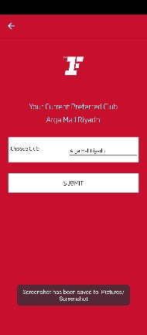 | 2 | 2
Burger menu  terms | - Terms & conditions page | 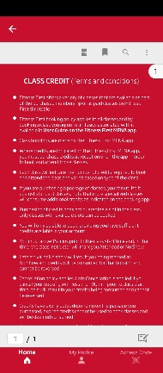 | 1 | 1
Burger menu  User guide | User guide that opens pdf file of the guide inside the app | 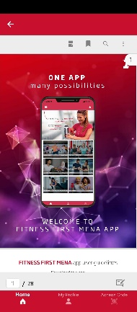 | Advised to be canceled | Advised to be canceled
Delete account | - A confirmation message to delete the account | 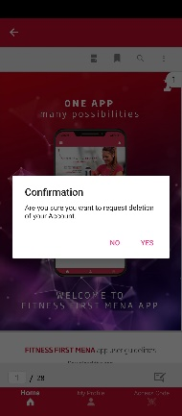 | 2 | 2

Admin stories
- as admin I can login to my account via the web application
- as admin I can view, create, update, delete, activate and disactivate and costumer profile.
- as admin I can add, view, delete and update clubs to the application
- as admin I can add, view, delete and update countries & cities to the applications
- admin I can add, view, delete and update workouts
- admin I can add, view, delete and update an exercise
- admin I can add, view, delete and update a coach profile
- admin I can add, view, delete and update a class
- admin I can add, view, delete and update a live class

Octiv : https://octivfitness.com/features/

