# APPLIED ARTIFICIAL INTELLIGENCE

### INDEX

|  |  |
| --- | --- |
| **Sr.no.** | **Practical** |
| **1** | **Design an Expert system using AIML.** |
| **2** | **Design a bot using AIML.** |
| **3** | **Implement Bayes Theorem using Python.** |
| **4** | **Implement Conditional Probability And Joint Probability usingPython.** |
| **5** | **Write a program to implement Rule Based System.** |
| **6** | **Design a Fuzzy based application using Python.** |
| **7** | **Write an application to simulate supervised and un-supervisedlearning model.** |
| **8** | **Write an application to implement clustering algorithm.** |
| **9** | **Write an application to implement BFS algorithm.** |
| **10** | **Write an application to implement DFS algorithm.** |

**PRACTICAL:1**

##### AIM: Design An Expert System Using AIML. Code:

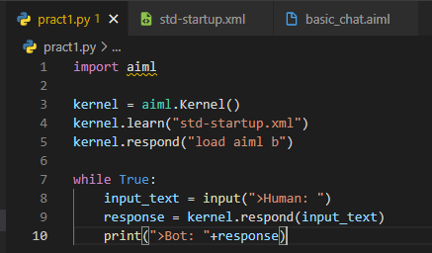

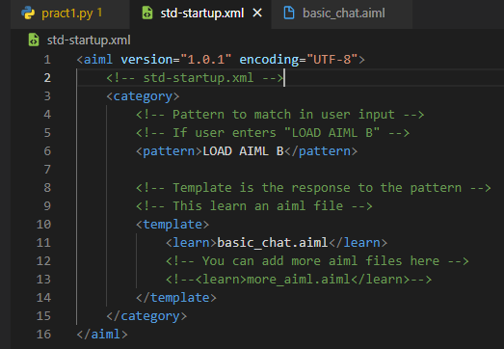

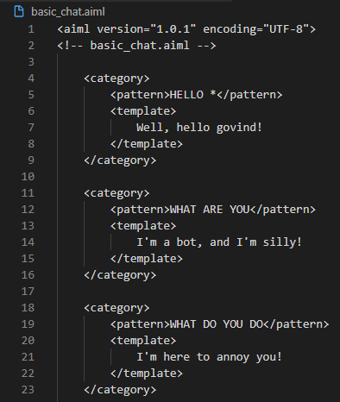

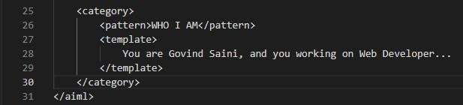

**Ouput:**

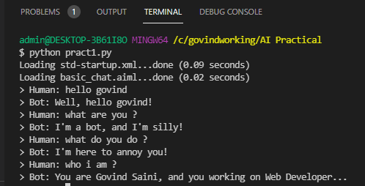

### PRACTICAL:2

##### AIM : Design A Bot Using AIML. Code:

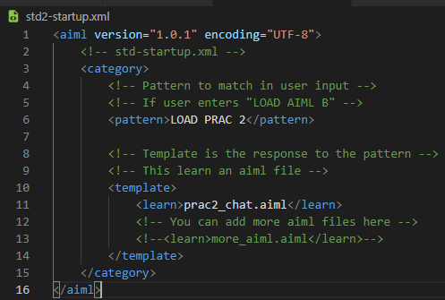

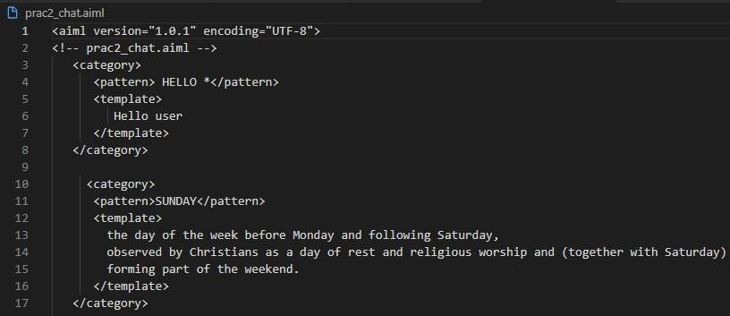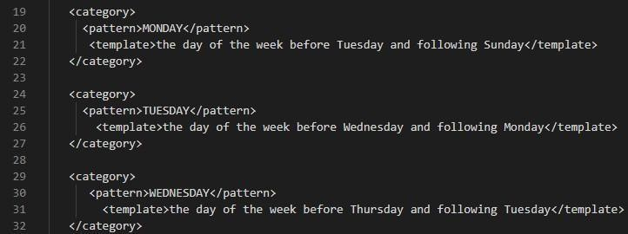

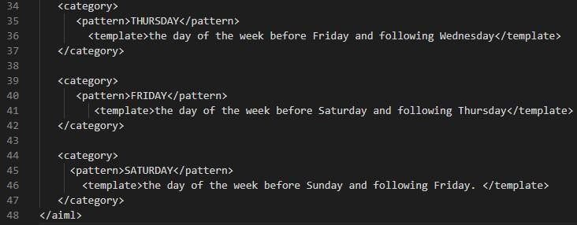

**Ouput:**

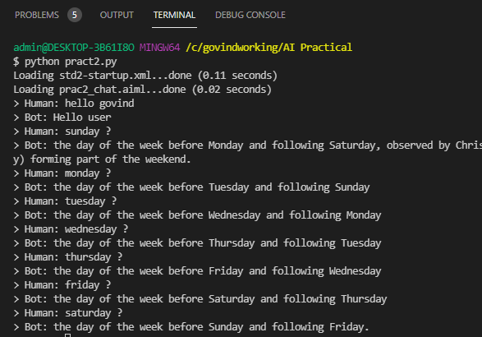

### PRACTICAL:3

##### AIM : Implement Bayes Theorem Using Python. Code:

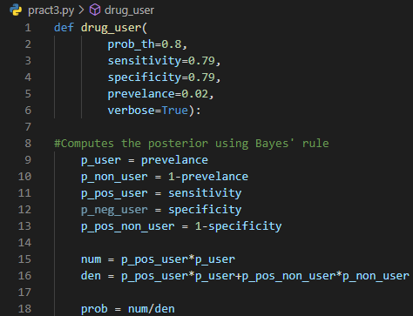

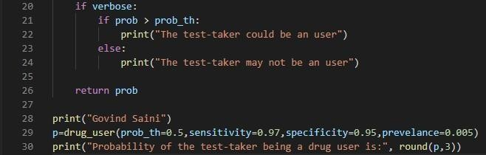

**Ouput:**

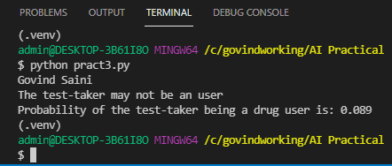

### PRACTICAL:4

##### AIM : Implement Conditional Probability And Joint Probability. Using Python.

**Code:**

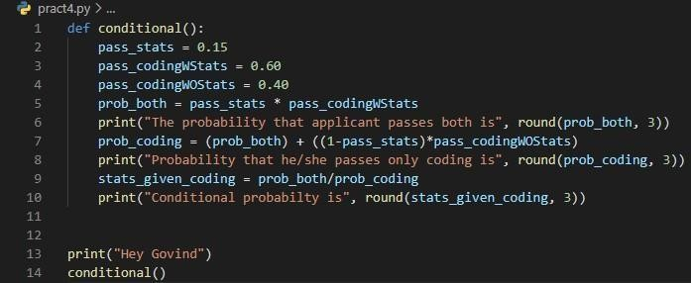

##### Ouput:

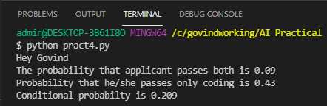

**Code:**

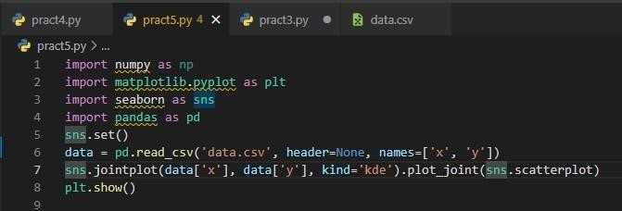

**Output:**

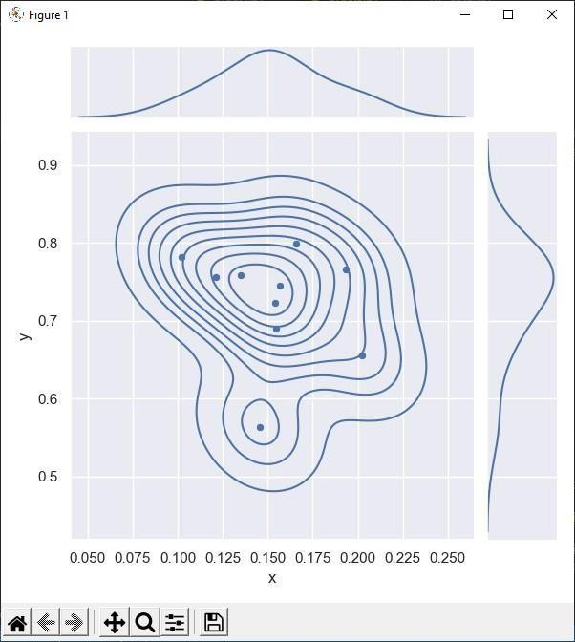

### PRACTICAL:5

##### AIM : A Program To Implement Rule Based System. Code:

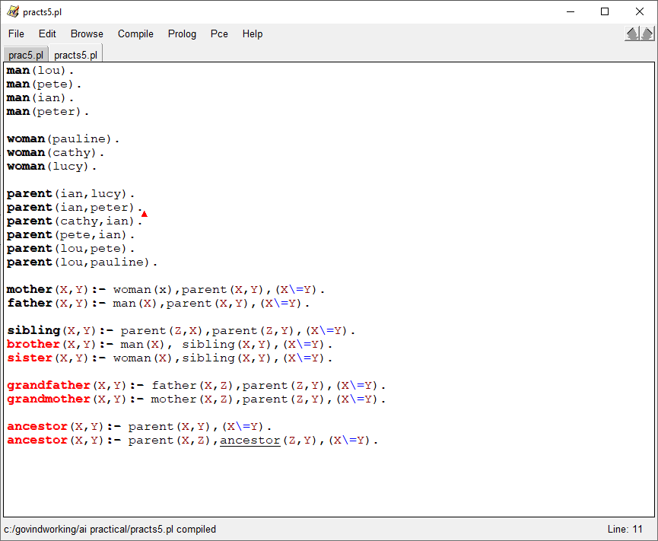

**Ouput:**

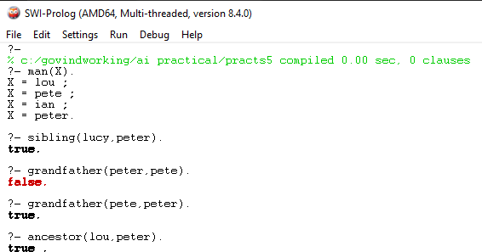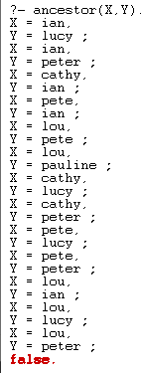

### PRACTICAL:6

##### AIM : Design A Fuzzy Based Application Using Python.

**Code:**

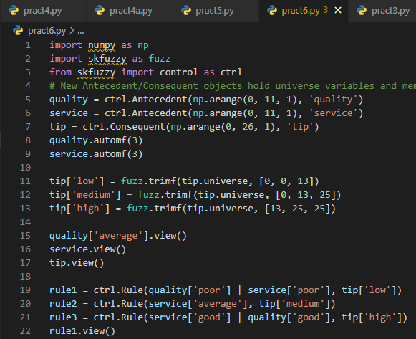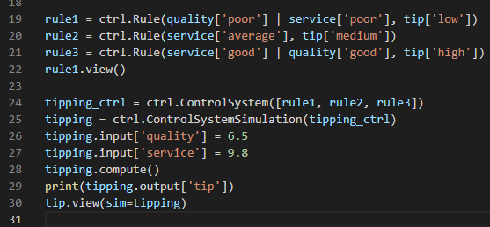

**Ouput:**

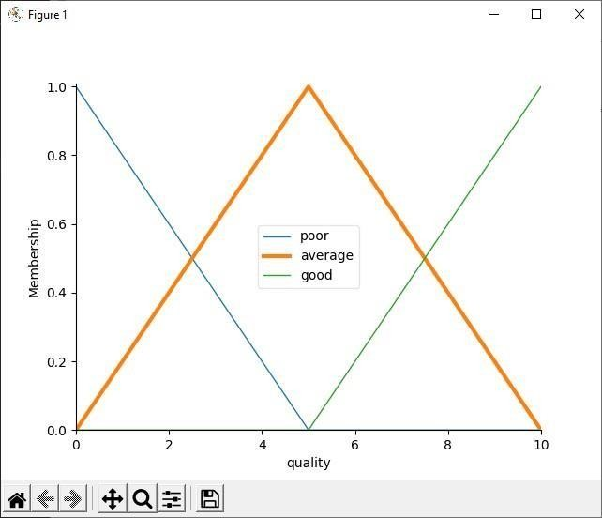

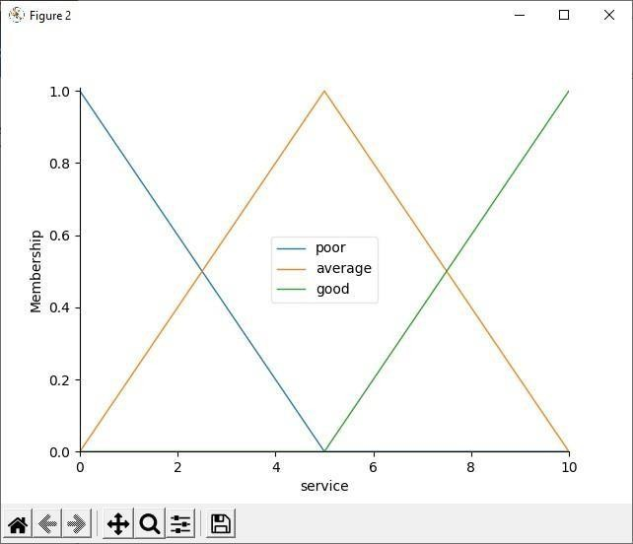

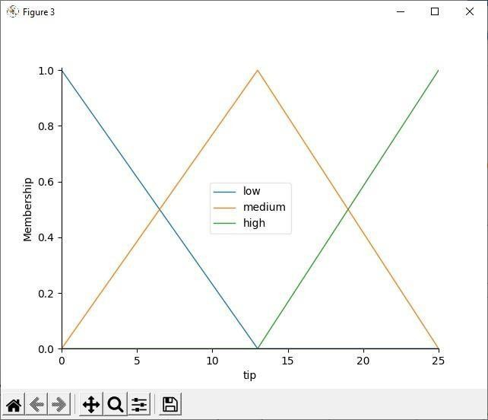

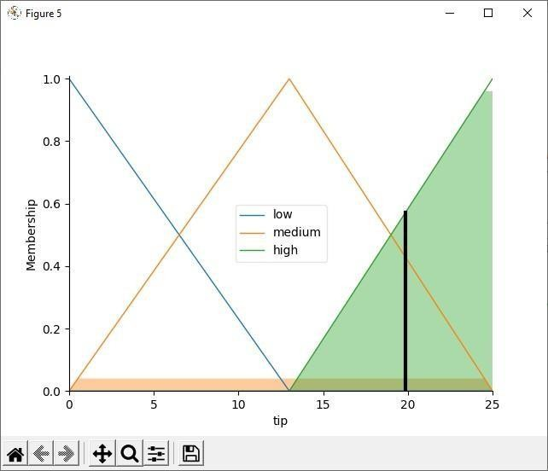

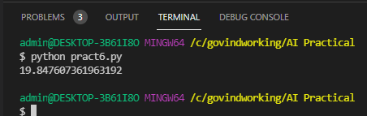

### PRACTICAL:7

##### AIM : Write And Application To Stimulate Supervised And Un-Supervised Learning Model.

**Code:**

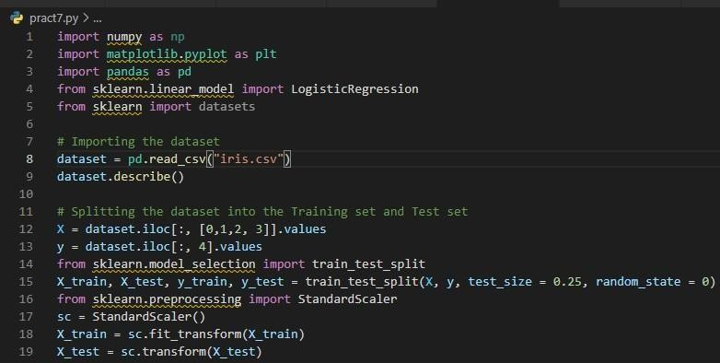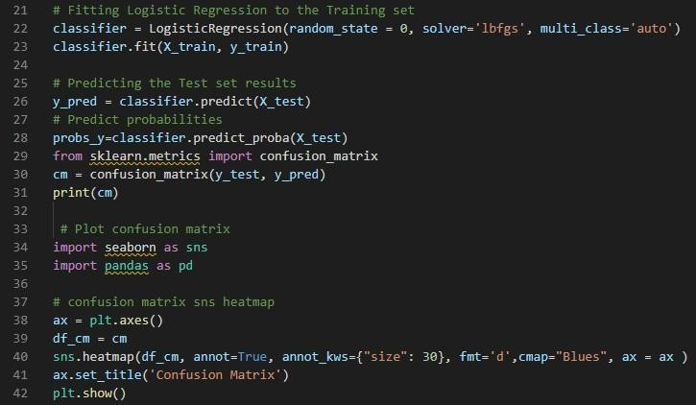

##### Ouput:

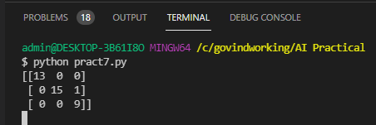

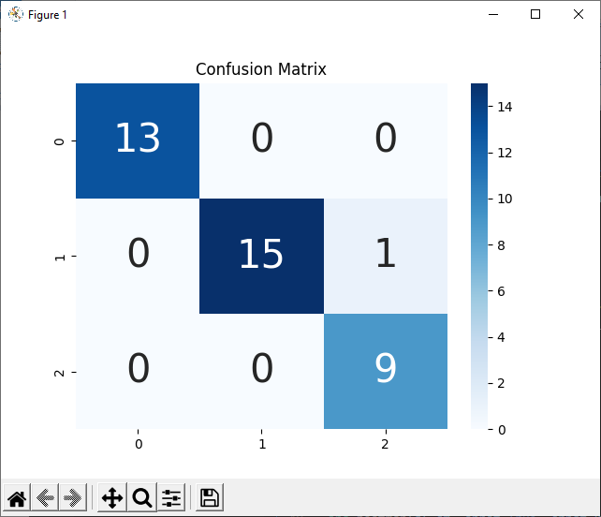

**Code:**

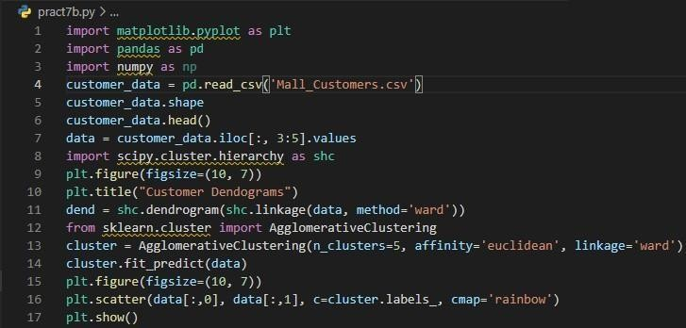

##### Ouput:

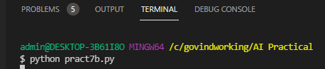

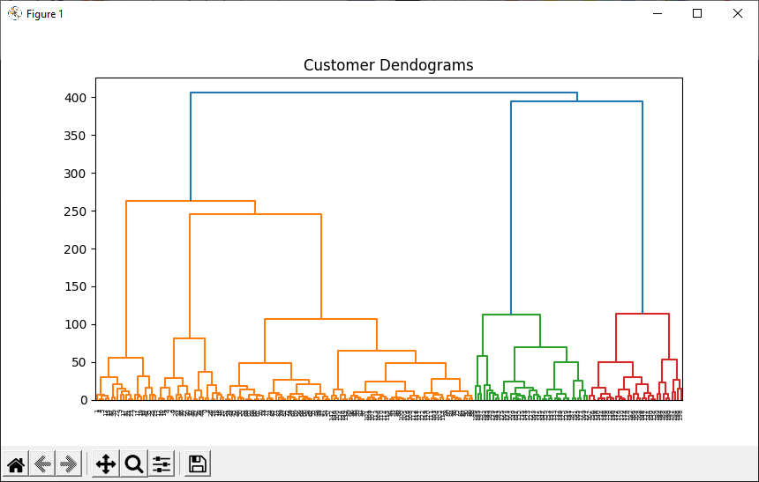

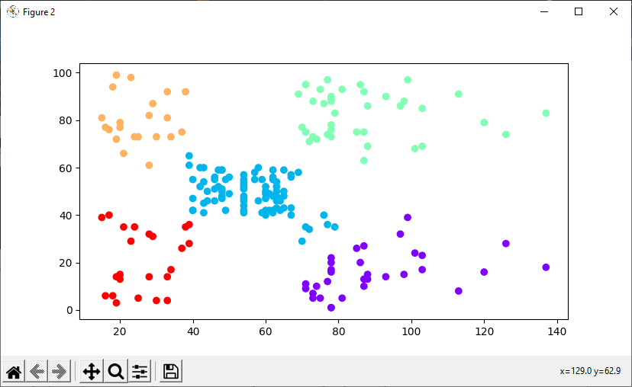

**PRACTICAL:8**

##### AIM:Write An Application To Implement Clustering Algorithm.

**Code:**

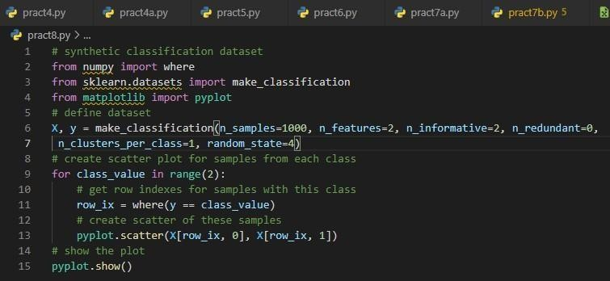

**Ouput:**

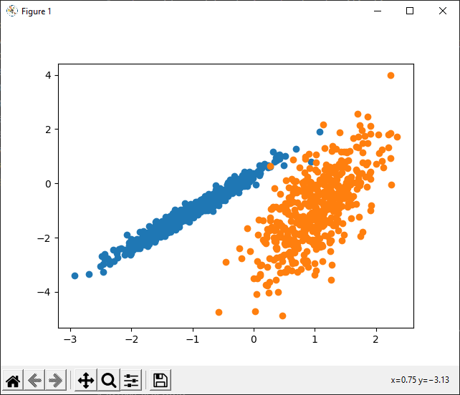

### PRACTICAL: 9

##### AIM:WriteAnProgramToImplement BFSAlgorithm. Code:

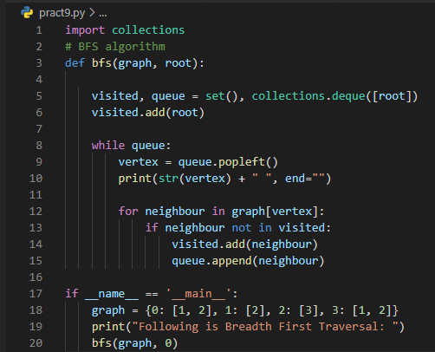

**Output:**

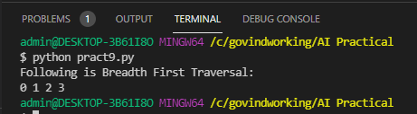

### PRACTICAL:10

##### AIM : Write An Program To Implement DFS Algorithm. Code:

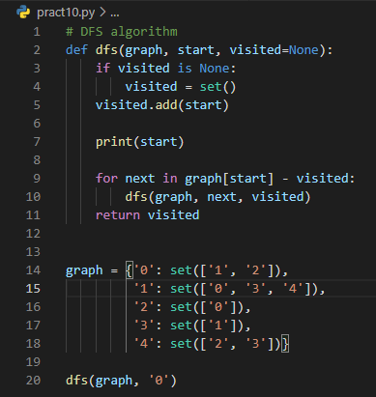

**Output:**

