# MACHINE LEARNING

## INDEX

|  |  |
| --- | --- |
| **Sr.no.** | **Practical** |
| **1** | **A]Design a simple machine learning model to train the training instances and test the**  **same.** |
|  | **B]Implement and demonstrate the FIND-S algorithm for finding the most specific hypothesis based on a given set of training data samples. Read the training data from a .CSV file** |
| **2** | **A]Perform Data Loading, Feature selection (Principal Component analysis) and Feature Scoring and Ranking.** |
|  | **B] For a given set of training data examples stored in a .CSV file, implement and demonstrate the Candidate-Elimination algorithm to output a description of the set of all hypotheses consistent with the training examples.** |
| **3** | **A]Write a program to implement the naïve Bayesian classifier for a sample training data set stored as a .CSV file. Compute the accuracy of the classifier, considering few test data sets.** |
|  | **B] Write a program to implement Decision Tree and Random forest with Prediction, Test Score and Confusion Matrix.** |
| **4** | **A]For a given set of training data examples stored in a .CSV file implement Least Square Regression algorithm.** |
|  | **B] For a given set of training data examples stored in a .CSV file implement Logistic Regression algorithm.** |
| **5** | **A]Write a program to demonstrate the working of the decision tree based ID3 algorithm.Use an appropriate data set for building the decision tree and apply this knowledge toclassify a new sample.** |
|  | **B] Write a program to implement k-Nearest Neighbour algorithm to classify the iris data set.** |
| **6** | **A]Implement the different Distance methods (Euclidean) with Prediction, Test Score and Confusion Matrix.** |
|  | **B]Implement the classification model using clustering for the following techniques with K-means clustering with Prediction, Test Score and Confusion Matrix.** |
| **7** | **A]Implement the classification model using clustering for the following techniques with hierarchical clustering with Prediction, Test Score and Confusion Matrix** |
|  | **B]Implement the Rule based method and test the same.** |

|  |  |
| --- | --- |
| **8** | **A]Write a program to construct a Bayesian network considering medical data. Use this model to demonstrate the diagnosis of heart patients using standard Heart Disease Data Set.** |
|  | **B]Implement the non-parametric Locally Weighted Regression algorithm in order to fitdata points. Select appropriate data set for your experiment and draw graphs.** |
| **9** | **A]Build an Artificial Neural Network by implementing the Backpropagation algorithm and test the same using appropriate data sets.** |
|  | **B] Assuming a set of documents that need to be classified, use the naïve Bayesian Classifier model to perform this task.** |
| **10** | **A]Write A Program To Demonstrate The Working Of The Decision Tree Based ID3Algorithm. Use An Appropriate Data Set For Building The Decision Tree And Apply ThisKnowledge To Classify A New Sample.** |
|  | **B] Build An Artificial Neural Network By Implementing The Backpropagation Algorithm And Test The Same Using Appropriate Data Sets.** |

### PRACTICAL: 1

##### 1A] Design a simple machine learning model to train the training instances and test the same.

import pandas as pd

from sklearn.linear_model import LogisticRegression from sklearn.model_selection import train_test_split import matplotlib.pyplot as plt

from sklearn.metrics import confusion_matrix import seaborn as sns

from sklearn.metrics import accuracy_score from sklearn.metrics import f1_score

from sklearn.metrics import roc_auc_score from sklearn.metrics import precision_score

from sklearn.ensemble import Random Forest Classifier

data = pd.read_csv("/content/drive/MyDrive/excledata/instagram dataset.csv")

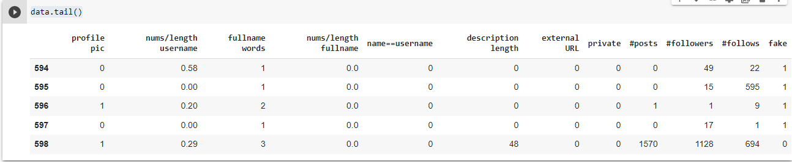

data.shape



plt.scatter(data["name==username"],data["fake"]) plt.show

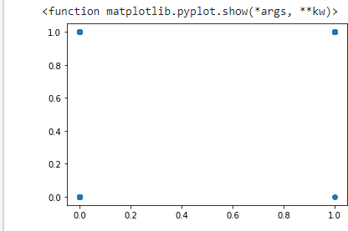

y_data = data[["fake"]]

x_data = data.drop(columns={'fake'}) y_data.head()

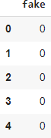

X_train , X_test , Y_train , Y_test = train_test_split(x_data, y_data, test_size= 0.2 , random_state

=1)

logistic_model = LogisticRegression() logistic_model.fit(X_train, Y_train) predicted = logistic_model.predict(X_test)

predicted

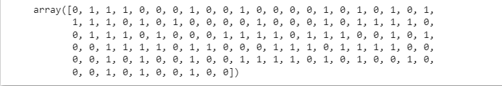

predicted_df = pd.DataFrame(data=predicted) predicted_df

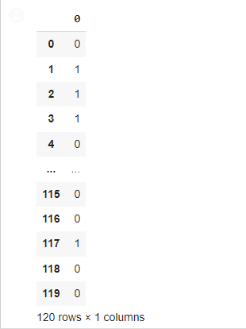

fc = confusion_matrix(Y_test, predicted_df)

sns.heatmap(fc, annot = True)

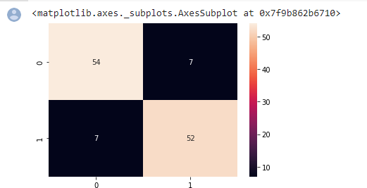

accuracy = ((fc[0,0] + fc[1,1]) /(fc[0,0]+fc[0,1]+fc[1,0]+fc[1,1]))*100 print(round(accuracy,2))



error = 100 - accuracy print(round(error,2))



score = logistic_model.score(X_test, Y_test) score*100



score1 = accuracy_score(Y_test, predicted_df) score1



print('Precision %.3f'% precision_score(Y_test, predicted_df))



print('Recall_score.%3f'% roc_auc_score(Y_test, predicted_df))



print('F1_score.%3f'% f1_score(Y_test, predicted_df))



* #random forest

clf = RandomForestClassifier() clf.fit(X_train, Y_train)

predicted =clf.predict(X_test)

predicted_df = pd.DataFrame(data=predicted) predicted_df

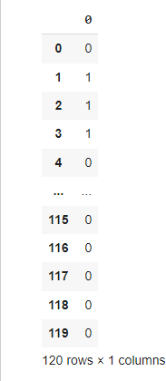

fc = confusion_matrix(Y_test, predicted_df) sns.heatmap(fc, annot = True)

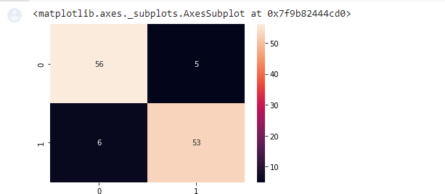

accuracy = ((fc[0,0] + fc[1,1]) /(fc[0,0]+fc[0,1]+fc[1,0]+fc[1,1]))*100 print(round(accuracy,2))



##### 1B] Implement and demonstrate the FIND-S algorithm for finding the most specific hypothesis based on a given set of training data samples. Read the training data from a .CSV file

# -*- coding: utf-8 -*- """Find S Algo.ipynb

Automatically generated by Colaboratory.

Original file is located at

# **PART1: IMPORTING PACKAGES** """

Importnumpy as np import pandas as pd

"""# **PART2: READING DATA**"""

data = pd.read_csv("ws.csv") data

data.shape

"""# **PART3: SPLITTING X AND Y PART FROM THE DATA**"""

concepts = np.array(data)[:,:-1] concepts

target = np.array(data)[:,-1] target

"""# **PART4: TRAINING PART**"""

def train(c,t):

for i, val in enumerate(t): ifval == "Yes":

specific_hypothesis = c[i].copy() break

for i, val in enumerate(c): if t[i] == "Yes":

for x in range(len(specific_hypothesis)):

ifval[x] != specific_hypothesis[x]: specific_hypothesis[x] = '?'

else:

pass returnspecific_hypothesis

"""# **PART 5: TESTING PART**"""

print(train(concepts, target))

**Output**

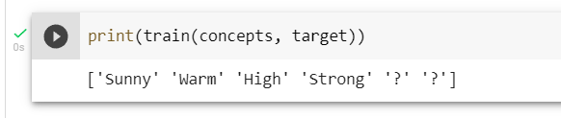

### PRACTICAL: 2

##### 2A] Perform Data Loading, Feature selection (Principal Component analysis) andFeature Scoring and Ranking.

import pandas as pd

df = pd.read_csv("/content/heart.csv") df.head()

df.shape

df.describe() df[df.Cholesterol>(df.Cholesterol.mean()+3*df.Cholesterol.std())]

df.shape df[df.MaxHR>(df.MaxHR.mean()+3*df.MaxHR.std())] df[df.FastingBS>(df.FastingBS.mean()+3*df.FastingBS.std())] df[df.Oldpeak>(df.Oldpeak.mean()+3*df.Oldpeak.std())]

df2 = df1[df1.Oldpeak<=(df1.Oldpeak.mean()+3*df1.Oldpeak.std())] df2.shape df[df.RestingBP>(df.RestingBP.mean()+3*df.RestingBP.std())]

df3 = df2[df2.RestingBP<=(df2.RestingBP.mean()+3*df2.RestingBP.std())] df3.shape

df.ChestPainType.unique() df.RestingECG.unique() df.ExerciseAngina.unique() df.ST_Slope.unique()

df4 = df3.copy() df4.ExerciseAngina.replace(

{

'N': 0,

'Y': 1

},

inplace=True)

df4.ST_Slope.replace(

{

'Down': 1,

'Flat': 2,

'Up': 3

},

inplace=True

)

df4.RestingECG.replace(

{

'Normal': 1,

'ST': 2,

'LVH': 3

},

inplace=True)

df4.head()

df5 = pd.get_dummies(df4, drop_first=True) df5.head()

X = df5.drop("HeartDisease",axis='columns') y = df5.HeartDisease

1. head()

from sklearn.preprocessing import StandardScaler

scaler = StandardScaler() X_scaled = scaler.fit_transform(X)

X_scaled

from sklearn.model_selection import train_test_split X_train.shape

X_test.shape

from sklearn.ensemble import RandomForestClassifier from sklearn.decomposition import PCA

pca = PCA(0.95)

X_pca = pca.fit_transform(X) X_pca

X_train_pca, X_test_pca, y_train, y_test = train_test_split(X_pca, y, test_size=0.2, random_state

=30)

from sklearn.ensemble import RandomForestClassifier model_rf = RandomForestClassifier() model_rf.fit(X_train_pca, y_train) model_rf.score(X_test_pca, y_test)

##### Output

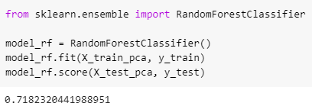

**2B] For a given set of training data examples stored in a .CSV file, implement and demonstrate the Candidate-Elimination algorithm to output a description of the set of all hypotheses consistent with the training examples.**

import numpy as np import pandas as pd

data = pd.read_csv('/content/drive/MyDrive/data set/sport.csv') concepts = np.array(data.iloc[:,0:-1])

print("\nInstances are:\n",concepts) target = np.array(data.iloc[:,-1]) print("\nTarget Values are: ",target)

##### Output

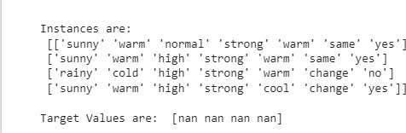

def learn(concepts, target): specific_h = concepts[0].copy()

print("\nInitialization of specific_h and genearal_h") print("\nSpecific Boundary: ", specific_h)

general_h = [["?" for i in range(len(specific_h))] for i in range(len(specific_h))] print("\nGeneric Boundary: ",general_h)

for i, h in enumerate(concepts): print("\nInstance", i+1 , "is ", h) if target[i] == "yes":

print("Instance is Positive ") for x in range(len (specific_h)):

if h[x]!= specific_h[x]: specific_h[x] ='?' general_h[x][x] ='?'

if target[i] == "no": print("Instance is Negative ") for x in range(len(specific_h)):

if h[x]!= specific_h[x]: general_h[x][x] = specific_h[x]

else:

general_h[x][x] = '?'

print("Specific Bundary after ", i+1, "Instance is ", specific_h) print("Generic Boundary after ", i+1, "Instance is ", general_h) print("\n")

indices = [i for i, val in enumerate(general_h) if val == ['?', '?', '?', '?', '?', '?']] for i in indices:

general_h.remove(['?', '?', '?', '?', '?', '?']) return specific_h, general_h

s_final, g_final = learn(concepts, target)

print("Final Specific_h: ", s_final, sep="\n") print("Final General_h: ", g_final, sep="\n")

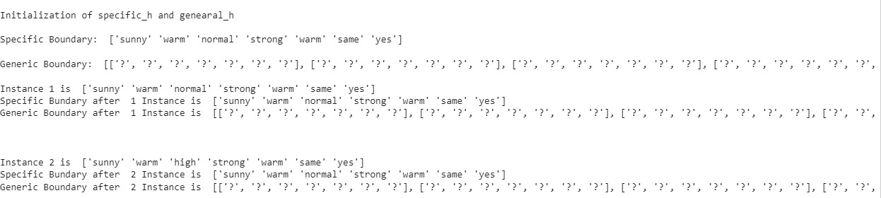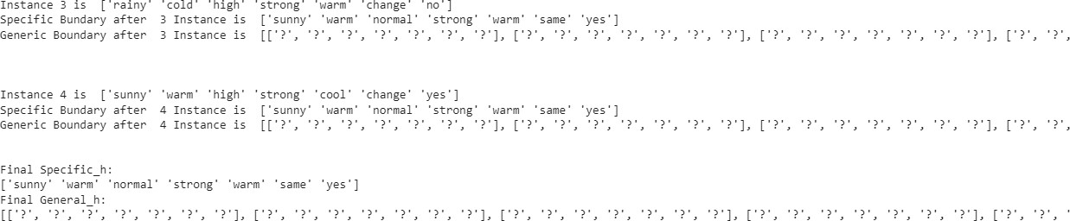

### PRACTICAL: 3

##### 3A]Write a program to implement the naïve Bayesian classifier for a sample training data set stored as a .CSV file. Compute the accuracy of the classifier, considering few test data sets.

import pandas as pd

df = pd.read_csv("spam.csv") df.head()

##### output

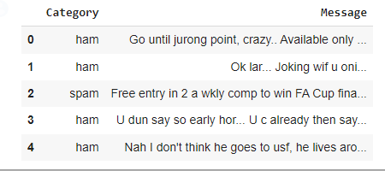

df.groupby('Category').describe()

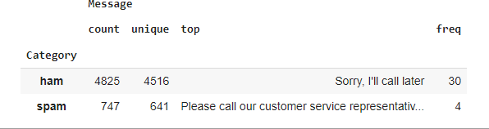

df['spam']=df['Category'].apply(lambda x: 1 if x=='spam' else 0) df.head()

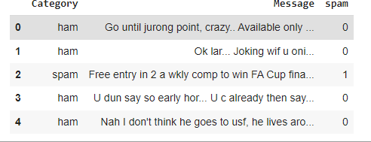

from sklearn.model_selection import train_test_split

X_train, X_test, y_train, y_test = train_test_split(df.Message,df.spam)

from sklearn.feature_extraction.text import CountVectorizer v = CountVectorizer()

X_train_count = v.fit_transform(X_train.values) X_train_count.toarray()[:2]



from sklearn.naive_bayes import MultinomialNB model = MultinomialNB() model.fit(X_train_count,y_train)



emails = [

'Hey mohan, can we get together to watch footbal game tomorrow?',

'Upto 20% discount on parking, exclusive offer just for you. Dont miss this reward!'

]

emails_count = v.transform(emails) model.predict(emails_count)



X_test_count = v.transform(X_test) model.score(X_test_count, y_test)



##### Sklearn Pipeline

from sklearn.pipeline import Pipeline clf = Pipeline([

('vectorizer', CountVectorizer()), ('nb', MultinomialNB())

])

clf.fit(X_train, y_train)

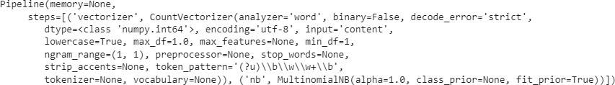

clf.score(X_test,y_test)



clf.predict(emails)



##### 3B]Write a program to implement Decision Tree and Random forest with Prediction, Test Score and Confusion Matrix.

import numpy as nm

import matplotlib.pyplot as mtp import pandas as pd

from sklearn.preprocessing import LabelEncoder from sklearn import preprocessing

from google.colab import drive drive.mount('/content/drive') #importing datasets

data_set= pd.read_csv("/content/drive/MyDrive/dataset/iris.csv") data_set

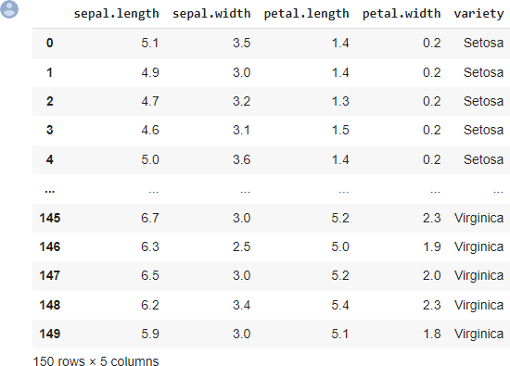

le = preprocessing.LabelEncoder()

data_set["variety"] = le.fit_transform(data_set["variety"]) data_set.head()

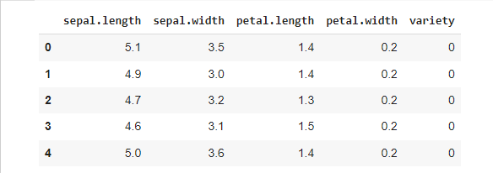

x_data= data_set.iloc[:, [0,1,2,3]].values y_data= data_set.iloc[:, 4].values

x_data

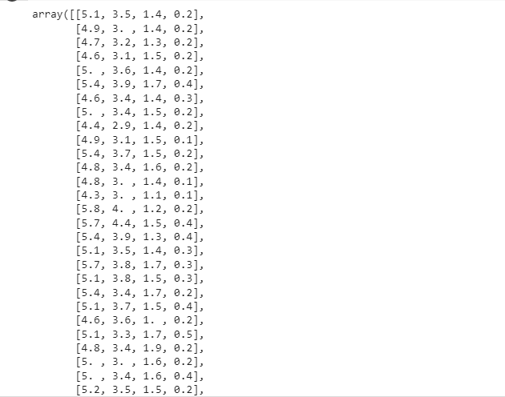

y_data

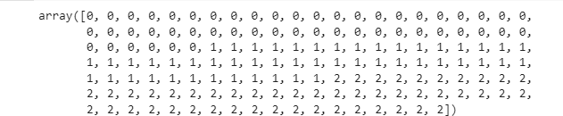

# Splitting the dataset into training and test set.

from sklearn.model_selection import train_test_split

x_train, x_test, y_train, y_test= train_test_split(x_data, y_data, test_size= 0.20, random_state=1) #feature Scaling

from sklearn.preprocessing import StandardScaler st_x= StandardScaler()

x_train= st_x.fit_transform(x_train) x_test= st_x.transform(x_test)

#Fitting Decision Tree classifier to the training set from sklearn.ensemble import RandomForestClassifier

classifier= RandomForestClassifier(n_estimators= 10, criterion="entropy") classifier.fit(x_train, y_train)

#Predicting the test set result y_pred= classifier.predict(x_test) y_pred



#Creating the Confusion matrix

from sklearn.metrics import classification_report, confusion_matrix, accuracy_score

print(confusion_matrix(y_test,y_pred)) print(classification_report(y_test,y_pred)) print(accuracy_score(y_test, y_pred))

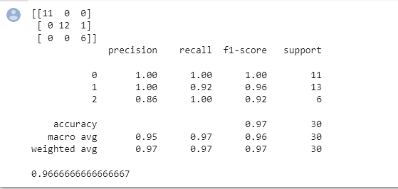

### PRACTICAL: 4

##### 4A]For a given set of training data examples stored in a .CSV file implement LeastSquare Regression algorithm.

**Code:**

importnumpy as np import pandas as pd

importmatplotlib.pyplot as plt

data= pd.read_csv('/content/drive/MyDrive/data set/pract4A.csv') data.head()

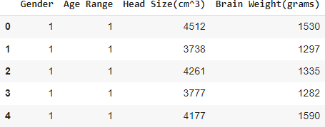

# Coomputing X and Y

X = data['Head Size(cm^3)'].values

Y = data['Brain Weight(grams)'].values # Mean X and Y

mean_x = np.mean(X) mean_y = np.mean(Y)

# Total number of values n = len(X)

# Using the formula to calculate 'm' and 'c' numer = 0

denom = 0

for i in range(n):

numer += (X[i] - mean_x) * (Y[i] - mean_y) denom += (X[i] - mean_x) ** 2

m = numer / denom

c = mean_y - (m * mean_x)

# Printing coefficients print("Coefficients") print(m, c)

# Plotting Values and Regression Line max_x = np.max(X) + 100

min_x = np.min(X) - 100

# Calculating line values x and y

x = np.linspace(min_x, max_x, 1000) y = c + m * x

# Ploting Line

plt.plot(x, y, color='#58b970', label='Regression Line') # Ploting Scatter Points

plt.scatter(X, Y, c='#ef5423', label='Scatter Plot')

plt.xlabel('Head Size in cm3') plt.ylabel('Brain Weight in grams') plt.legend()

plt.show()

##### output:

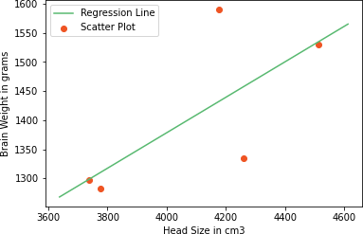

# Calculating Root Mean Squares Error rmse = 0

for i in range(n):

y_pred = c + m * X[i]

rmse += (Y[i] - y_pred) ** 2 rmse = np.sqrt(rmse/n) print("RMSE")

print(rmse)



##### 4B] For a given set of training data examples stored in a .CSV file implement Logistic Regression algorithm.

import pandas as pd import numpy as np

import matplotlib.pyplot as plt import seaborn as sns

%matplotlib inline

train = pd.read_csv('titanic_train.csv') [train.info](http://train.info/)()

sns.heatmap(train.isnull(),yticklabels=False,cbar=False,cmap='viridis') def impute_age(cols):

Age = cols[0] Pclass = cols[1]

if pd.isnull(Age): if Pclass == 1:

return 37

elif Pclass == 2: return 29

else:

return 24

else:

return Age

train['Age'] = train[['Age','Pclass']].apply(impute_age,axis=1) sns.heatmap(train.isnull(),yticklabels=False,cbar=False,cmap='viridis') train.drop('Cabin',axis=1,inplace=True)

train.dropna(inplace=True)

sex = pd.get_dummies(train['Sex'],drop_first=True)

embark = pd.get_dummies(train['Embarked'],drop_first=True) train.drop(['Sex','Embarked','Name','Ticket'],axis=1,inplace=True) train = pd.concat([train,sex,embark],axis=1)

from sklearn.model_selection import train_test_split

X_train, X_test, y_train, y_test = train_test_split(train.drop('Survived',axis=1),

train['Survived'], test_size=0.30, random_state=101) from sklearn.linear_model import LogisticRegression

logmodel = LogisticRegression() logmodel.fit(X_train,y_train) predictions = logmodel.predict(X_test)

from sklearn.metrics import classification_report print(classification_report(y_test,predictions))

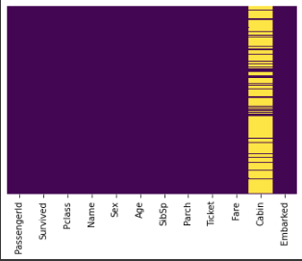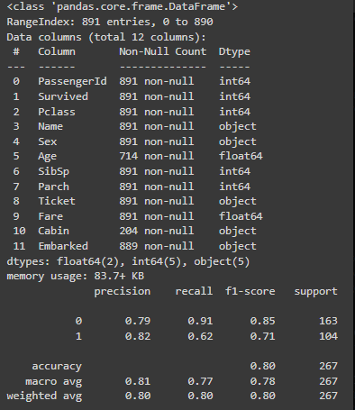

### PRACTICAL: 5

##### 5A]Write a program to demonstrate the working of the decision tree based ID3 algorithm. Use an appropriate data set for building the decision tree and apply this knowledge to classify a new sample.

import pandas as pd import math

import numpy as np

data = pd.read_csv("/content/drive/MyDrive/dataset/dataset.csv") features = [feat for feat in data]

features.remove("answer") class Node:

def init (self): self.children = [] self.value = "" self.isLeaf = False self.pred = ""

def entropy(examples): pos = 0.0

neg = 0.0

for _, row in examples.iterrows(): if row["answer"] == "yes":

pos += 1 else:

neg += 1

if pos == 0.0 or neg == 0.0: return 0.0

else:

p = pos / (pos + neg) n = neg / (pos + neg)

return -(p * math.log(p, 2) + n * math.log(n, 2)) def info_gain(examples, attr):

uniq = np.unique(examples[attr]) #print ("\n",uniq)

gain = entropy(examples) #print ("\n",gain)

for u in uniq:

subdata = examples[examples[attr] == u] #print ("\n",subdata)

sub_e = entropy(subdata)

gain -= (float(len(subdata)) / float(len(examples))) * sub_e #print ("\n",gain)

return gain

def ID3(examples, attrs): root = Node()

max_gain = 0 max_feat = ""

for feature in attrs: #print ("\n",examples)

gain = info_gain(examples, feature) if gain > max_gain:

max_gain = gain max_feat = feature

root.value = max_feat

#print ("\nMax feature attr",max_feat) uniq = np.unique(examples[max_feat]) #print ("\n",uniq)

for u in uniq: #print ("\n",u)

subdata = examples[examples[max_feat] == u] #print ("\n",subdata)

if entropy(subdata) == 0.0: newNode = Node() newNode.isLeaf = True newNode.value = u

newNode.pred = np.unique(subdata["answer"]) root.children.append(newNode)

else:

dummyNode = Node() dummyNode.value = u new_attrs = attrs.copy() new_attrs.remove(max_feat) child = ID3(subdata, new_attrs)

dummyNode.children.append(child) root.children.append(dummyNode)

return root

def printTree(root: Node, depth=0):

for i in range(depth): print("\t", end="")

print(root.value, end="") if root.isLeaf:

print(" -> ", root.pred) print()

for child in root.children: printTree(child, depth + 1)

def classify(root: Node, new): for child in root.children:

if child.value == new[root.value]: if child.isLeaf:

print ("Predicted Label for new example", new," is:", child.pred) exit

else:

classify (child.children[0], new) root = ID3(data, features)

print("Decision Tree is:") printTree(root)

print (" ")

new = {"outlook":"sunny", "temperature":"hot", "humidity":"normal", "wind":"strong"} classify (root, new)

##### Output

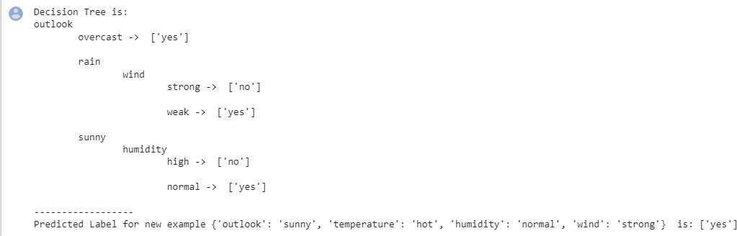

**5B] Write a program to implement k-Nearest Neighbour algorithm to classify the iris data set.**

from sklearn.model_selection import train_test_split from sklearn.neighbors import KNeighborsClassifier

from sklearn.metrics import classification_report, confusion_matrix from sklearn import datasets

iris=datasets.load_iris() x = iris.data

y = iris.target

print ('sepal-length', 'sepal-width', 'petal-length', 'petal-width') print(x)

print('class: 0-Iris-Setosa, 1- Iris-Versicolour, 2- Iris-Virginica') print(y)

x_train, x_test, y_train, y_test = train_test_split(x,y,test_size=0.3) #To Training the model and Nearest nighbors K=5

classifier = KNeighborsClassifier(n_neighbors=5) classifier.fit(x_train, y_train)

#To make predictions on our test data y_pred=classifier.predict(x_test)

print('Confusion Matrix') print(confusion_matrix(y_test,y_pred)) print('Accuracy Metrics') print(classification_report(y_test,y_pred))

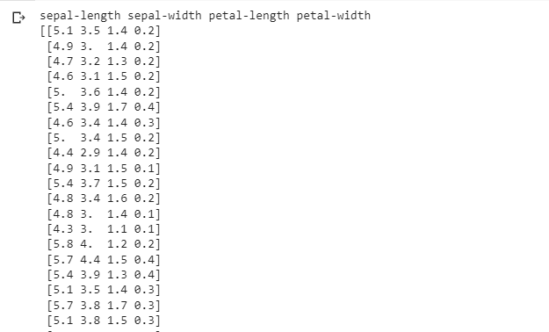

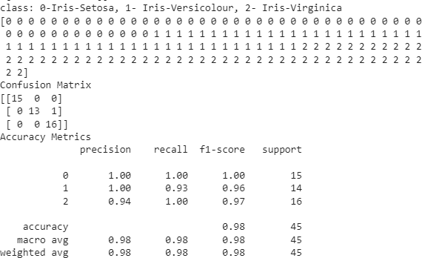

### PRACTICAL: 6

##### 6A]Implement the different Distance methods (Euclidean) with Prediction, Test Score and Confusion Matrix.

fromsklearn.neighbors import KNeighborsClassifier fromsklearn.metrics import confusion_matrix, accuracy_score fromsklearn.model_selection import train_test_split importnumpy as np

# Generate some random data for demonstration X = np.random.rand(100, 2)

y = np.random.randint(0, 2, 100)

# Split the data into training and test sets

X_train, X_test, y_train, y_test = train_test_split(X, y, test_size=0.2)

# Initialize the KNN classifier with the Euclidean distance metric clf = KNeighborsClassifier(metric='euclidean')

# Fit the model to the training data clf.fit(X_train, y_train)

# Make predictions on the test set y_pred = clf.predict(X_test)

# Calculate the test score (accuracy) test_score = accuracy_score(y_test, y_pred) print("Test Score: ", test_score)

# Calculate the confusion matrix

confusion_mat = confusion_matrix(y_test, y_pred) print("Confusion Matrix: \n", confusion_mat)

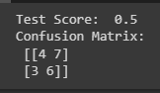

##### 6B]Implement the classification model using clustering for the following techniques with K means clustering with Prediction, Test Score and Confusion Matrix

fromsklearn.cluster import KMeans

fromsklearn.metrics import accuracy_score, confusion_matrix fromsklearn.model_selection import train_test_split importnumpy as np

# Generate some random data for demonstration X = np.random.rand(100, 2)

y = np.random.randint(0, 2, 100)

# Split the data into training and test sets

X_train, X_test, y_train, y_test = train_test_split(X, y, test_size=0.2) # Initialize the K-means clustering model

kmeans = KMeans(n_clusters=2) # Fit the model to the training data kmeans.fit(X_train)

# Assign labels to the test data based on the cluster centers y_pred = kmeans.predict(X_test)

# Create a mapping from the cluster labels to the original labels

# This step is needed because the k-means algorithm does not guarantee # that the clusters will correspond to the original labels

label_map = dict(zip(np.unique(y_train), np.unique(y))) y_pred = np.array([label_map[label] for label in y_pred]) print("Predicted Label for the new data point: ", y_pred ) # Calculate the test score (accuracy)

test_score = accuracy_score(y_test, y_pred) print("Test Score: ", test_score)

# Calculate the confusion matrix

confusion_mat = confusion_matrix(y_test, y_pred) print("Confusion Matrix: \n", confusion_mat)

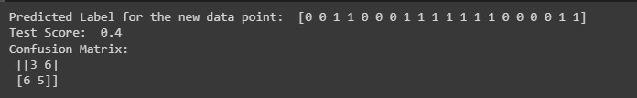

### PRACTICAL: 7

##### 7A]Implement the classification model using clustering for the following techniques with hierarchical clustering with Prediction, Test Score and Confusion Matrix

import pandas as pd import numpy as np

import matplotlib.pyplot as plt import seaborn as sns

comic_con = pd.read_csv('/content/CLUSTERING.csv', index_col=0) comic_con.head()

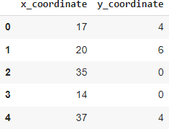

from google.colab import drive drive.mount('/content/drive')



from scipy.cluster.vq import whiten

comic_con['x_scaled'] = whiten(comic_con['x_coordinate']) comic_con['y_scaled'] = whiten(comic_con['y_coordinate'])

from scipy.cluster.hierarchy import linkage, fcluster # Use the linkage()

distance_matrix = linkage(comic_con[['x_scaled', 'y_scaled']], method='ward', metric='euclidean'

)

# Assign cluster labels

comic_con['cluster_labels'] = fcluster(distance_matrix, 2, criterion='maxclust')

# Plot clusters

sns.scatterplot(x='x_scaled', y='y_scaled', hue='cluster_labels', data=comic_con);

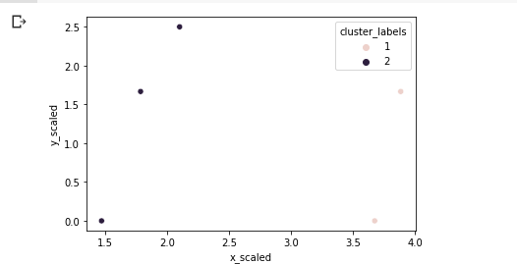

# Use the linkage()

distance_matrix = linkage(comic_con[['x_scaled', 'y_scaled']], method='single', metric='euclidea n')

# Assign cluster labels

comic_con['cluster_labels'] = fcluster(distance_matrix, 2, criterion='maxclust')

# Plot clusters

sns.scatterplot(x='x_scaled', y='y_scaled', hue='cluster_labels', data=comic_con);

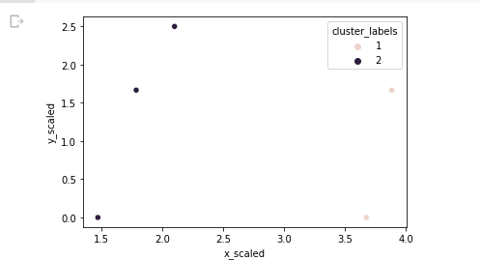

# Use the linkage()

distance_matrix = linkage(comic_con[['x_scaled', 'y_scaled']], method='complete', metric='euclid ean')

# Assign cluster labels

comic_con['cluster_labels'] = fcluster(distance_matrix, 2, criterion='maxclust')

# Plot clusters

sns.scatterplot(x='x_scaled', y='y_scaled', hue='cluster_labels', data=comic_con);

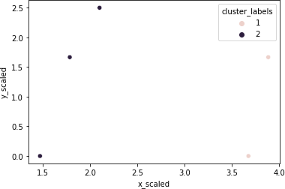

# Define a colors dictionary for clusters colors = {1:'red', 2:'blue'}

# Plot the scatter plot

comic_con.plot.scatter(x='x_scaled', y='y_scaled', c=comic_con['cluster_labels'].apply(lambda x: colors[x]));

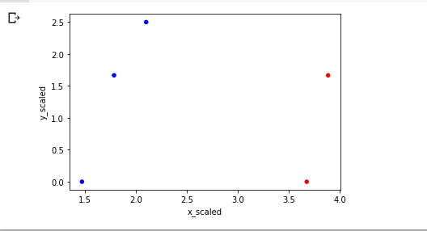

# Plot a scatter plot using seaborn

sns.scatterplot(x='x_scaled', y='y_scaled', hue='cluster_labels', data=comic_con)

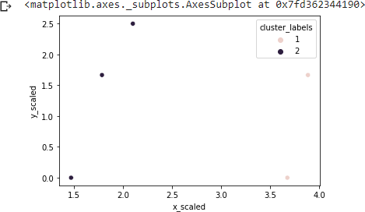

from scipy.cluster.hierarchy import dendrogram # Create a dendrogram

dn = dendrogram(distance_matrix)

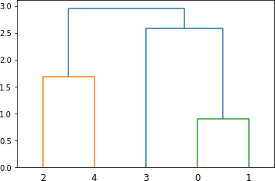

%timeit linkage(comic_con[['x_scaled', 'y_scaled']], method='ward', metric='euclidean')



fifa = pd.read_csv('/content/drive/MyDrive/data set/fifa18.csv') fifa.head()

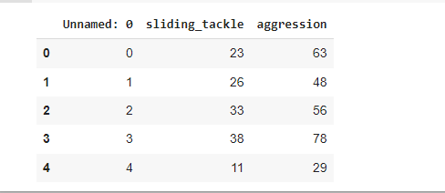

fifa['scaled_sliding_tackle'] = whiten(fifa['sliding_tackle']) fifa['scaled_aggression'] = whiten(fifa['aggression'])

# Fit the data into a hierarchical cluster

distance_matrix = linkage(fifa[['scaled_sliding_tackle', 'scaled_aggression']], method='ward')

# Assign cluster labels to each row of data

fifa['cluster_labels'] = fcluster(distance_matrix, 3, criterion='maxclust')

# Display cluster centers of each cluster

print(fifa[['scaled_sliding_tackle', 'scaled_aggression', 'cluster_labels']].groupby('cluster_labels'). mean())

# Create a scatter plot through seaborn

sns.scatterplot(x='scaled_sliding_tackle', y='scaled_aggression', hue='cluster_labels', data=fifa) plt.savefig('/content/drive/MyDrive/data set/fifa_cluster.png')

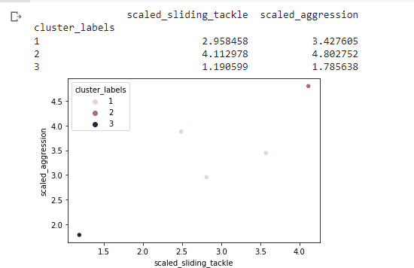

##### 7B]Implement the Rule based method and test the same.

from sklearn.metrics import accuracy_score, confusion_matrix from sklearn.model_selection import train_test_split

import numpy as np

# Generate some random data for demonstration X = np.random.rand(100, 2)

y = np.random.randint(0, 2, 100)

# Split the data into training and test sets

X_train, X_test, y_train, y_test = train_test_split(X, y, test_size=0.2)

# Define the rule-based classifier defrule_based_classifier(x):

if x[0] > x[1]: return 0

else:

return 1

# Make predictions on the test set using the rule-based classifier y_pred = np.array([rule_based_classifier(x) for x in X_test])

# Calculate the test score (accuracy) test_score = accuracy_score(y_test, y_pred) print("Test Score: ", test_score)

# Calculate the confusion matrix

confusion_mat = confusion_matrix(y_test, y_pred) print("Confusion Matrix: \n", confusion_mat)

**Output**

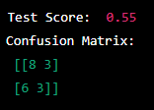

### PRACTICAL: 8

##### 8A]Write a program to construct a Bayesian network considering medical data. Use this model to demonstrate the diagnosis of heart patients using standard Heart Disease

**Data Set.**

pip install pgmpy import pandas as pd

from pgmpy.estimators import MaximumLikelihoodEstimator from pgmpy.models import BayesianModel

from pgmpy.inference import VariableElimination

data = pd.read_csv("/content/drive/MyDrive/ml dataset/DS4.csv") heart_disease = pd.DataFrame(data)

print(heart_disease)

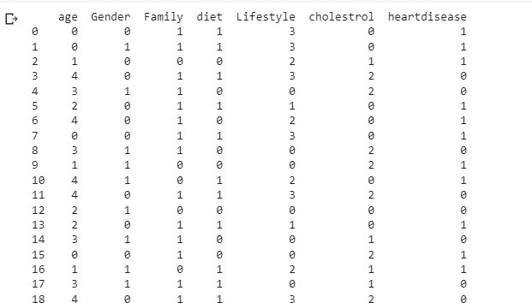

model = BayesianModel([ ('age', 'Lifestyle'),

('Gender', 'Lifestyle'),

('Family', 'heartdisease'),

('diet', 'cholestrol'),

('Lifestyle', 'diet'), ('cholestrol', 'heartdisease'), ('diet', 'cholestrol')

])

model.fit(heart_disease, estimator=MaximumLikelihoodEstimator) HeartDisease_infer = VariableElimination(model)

print('For Age enter SuperSeniorCitizen:0, SeniorCitizen:1, MiddleAged:2, Youth:3, Teen:4') print('For Gender enter Male:0, Female:1')

print('For Family History enter Yes:1, No:0') print('For Diet enter High:0, Medium:1')

print('for LifeStyle enter Athlete:0, Active:1, Moderate:2, Sedentary:3') print('for Cholesterol enter High:0, BorderLine:1, Normal:2')

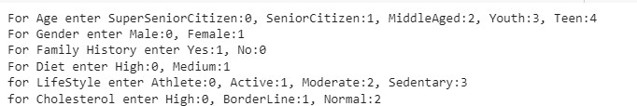

q = HeartDisease_infer.query(variables=['heartdisease'], evidence={ 'age': int(input('Enter Age: ')),

'Gender': int(input('Enter Gender: ')), 'Family': int(input('Enter Family History: ')), 'diet': int(input('Enter Diet: ')),

'Lifestyle': int(input('Enter Lifestyle: ')), 'cholestrol': int(input('Enter Cholestrol: '))

})

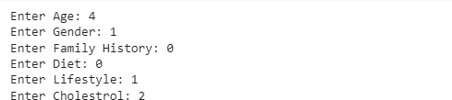

print(q)

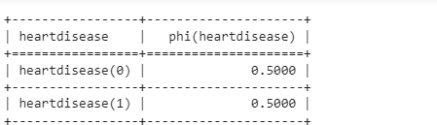

##### 8B]Implement the non-parametric Locally Weighted Regression algorithm in order to fit data points. Select appropriate data set for your experiment and draw graphs.

from sklearn.linear_model import LinearRegression from sklearn.metrics import mean_squared_error from sklearn.model_selection import train_test_split import numpy as np

import matplotlib.pyplot as plt

# Generate some random data for demonstration np.random.seed(0)

X = np.random.rand(100, 1)

y = np.sin(2 * np.pi * X) + np.random.randn(100, 1) * 0.1

# Split the data into training and test sets

X_train, X_test, y_train, y_test = train_test_split(X, y, test_size=0.2)

# Initialize the LWR model

lwr = LinearRegression(fit_intercept=True)

# Define the bandwidth parameter bandwidth = 0.2

# Fit the model to the training data predictions = []

for x in X_test:

weights = np.exp(-((X_train - x) ** 2) / (2 * bandwidth ** 2)) lwr.fit(X_train, y_train, sample_weight=weights) predictions.append(lwr.predict([x]))

# Calculate the test MSE

test_mse = mean_squared_error(y_test, predictions) print("Test MSE: ", test_mse)

# Plot the data points and the LWR model plt.scatter(X_train, y_train, label='Training Data') plt.scatter(X_test, y_test, label='Test Data') plt.plot(X_test, predictions, color='r', label='LWR Model') plt.legend()

plt.show()

**Output**



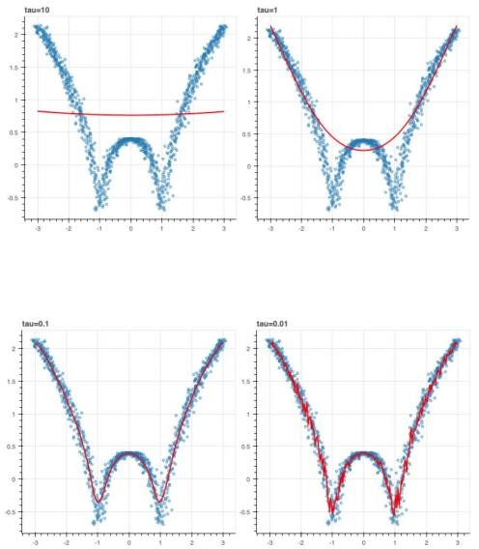

### PRACTICAL: 9

##### 9A]Build an Artificial Neural Network by implementing the Backpropagation algorithm and test the same using appropriate data sets.

import numpy as np

X = np.array(([2, 9], [1, 5], [3, 6]), dtype=float)

y = np.array(([92], [86], [89]), dtype=float)

X = X/np.amax(X,axis=0) # maximum of X array longitudinally y = y/100

#Sigmoid Function def sigmoid (x):

return 1/(1 + np.exp(-x)) #Derivative of Sigmoid Function def derivatives_sigmoid(x):

return x * (1 - x) #Variable initialization

epoch=5000 #Setting training iterations lr=0.1 #Setting learning rate

inputlayer_neurons = 2 #number of features in data set hiddenlayer_neurons = 3 #number of hidden layers neurons output_neurons = 1 #number of neurons at output layer #weight and bias initialization

wh=np.random.uniform(size=(inputlayer_neurons,hiddenlayer_neurons)) bh=np.random.uniform(size=(1,hiddenlayer_neurons)) wout=np.random.uniform(size=(hiddenlayer_neurons,output_neurons)) bout=np.random.uniform(size=(1,output_neurons))

#draws a random range of numbers uniformly of dim x*y for i in range(epoch):

#Forward Propogation hinp1=np.dot(X,wh) hinp=hinp1 + bh hlayer_act = sigmoid(hinp)

outinp1=np.dot(hlayer_act,wout) outinp= outinp1+ bout

output = sigmoid(outinp) #Backpropagation

EO = y-output

outgrad = derivatives_sigmoid(output) d_output = EO* outgrad

EH = d_output.dot(wout.T)

#how much hidden layer wts contributed to error hiddengrad = derivatives_sigmoid(hlayer_act) d_hiddenlayer = EH * hiddengrad

# dotproduct of nextlayererror and currentlayerop

wout += hlayer_act.T.dot(d_output) *lr wh += X.T.dot(d_hiddenlayer) *lr print("Input: \n" + str(X)) print("Actual Output: \n" + str(y)) print("Predicted Output: \n" ,output)

**Output**

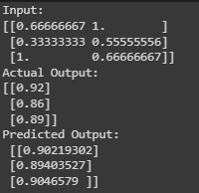

**9B] Assuming a set of documents that need to be classified, use the naïve Bayesian Classifier model to perform this task.**

pip install pgmpy import pandas as pd

from pgmpy.estimators import MaximumLikelihoodEstimator from pgmpy.models import BayesianModel

from pgmpy.inference import VariableElimination

data = pd.read_csv("/content/drive/MyDrive/ml dataset/DS4.csv") heart_disease = pd.DataFrame(data)

print(heart_disease)



model = BayesianModel([ ('age', 'Lifestyle'),

('Gender', 'Lifestyle'),

('Family', 'heartdisease'),

('diet', 'cholestrol'),

('Lifestyle', 'diet'), ('cholestrol', 'heartdisease'), ('diet', 'cholestrol')

])

model.fit(heart_disease, estimator=MaximumLikelihoodEstimator) HeartDisease_infer = VariableElimination(model)

print('For Age enter SuperSeniorCitizen:0, SeniorCitizen:1, MiddleAged:2, Youth:3, Teen:4') print('For Gender enter Male:0, Female:1')

print('For Family History enter Yes:1, No:0') print('For Diet enter High:0, Medium:1')

print('for LifeStyle enter Athlete:0, Active:1, Moderate:2, Sedentary:3') print('for Cholesterol enter High:0, BorderLine:1, Normal:2')



q = HeartDisease_infer.query(variables=['heartdisease'], evidence={ 'age': int(input('Enter Age: ')),

'Gender': int(input('Enter Gender: ')), 'Family': int(input('Enter Family History: ')), 'diet': int(input('Enter Diet: ')),

'Lifestyle': int(input('Enter Lifestyle: ')), 'cholestrol': int(input('Enter Cholestrol: '))

})



print(q)



### PRACTICAL: 10

##### 10A] Write A Program To Demonstrate The Working Of The Decision Tree Based ID3 Algorithm. Use An Appropriate Data Set For Building The Decision Tree And Apply This Knowledge To Classify A New Sample.

import pandas as pd import math

import numpy as np

data = pd.read_csv("/content/drive/MyDrive/dataset/dataset.csv") features = [feat for feat in data]

features.remove("answer") class Node:

def init (self): self.children = [] self.value = "" self.isLeaf = False self.pred = ""

def entropy(examples): pos = 0.0

neg = 0.0

for _, row in examples.iterrows(): if row["answer"] == "yes":

pos += 1 else:

neg += 1

if pos == 0.0 or neg == 0.0: return 0.0

else:

p = pos / (pos + neg) n = neg / (pos + neg)

return -(p * math.log(p, 2) + n * math.log(n, 2)) def info_gain(examples, attr):

uniq = np.unique(examples[attr]) #print ("\n",uniq)

gain = entropy(examples) #print ("\n",gain)

for u in uniq:

subdata = examples[examples[attr] == u] #print ("\n",subdata)

sub_e = entropy(subdata)

gain -= (float(len(subdata)) / float(len(examples))) * sub_e #print ("\n",gain)

return gain

def ID3(examples, attrs): root = Node()

max_gain = 0 max_feat = ""

for feature in attrs: #print ("\n",examples)

gain = info_gain(examples, feature) if gain > max_gain:

max_gain = gain max_feat = feature

root.value = max_feat

#print ("\nMax feature attr",max_feat) uniq = np.unique(examples[max_feat]) #print ("\n",uniq)

for u in uniq: #print ("\n",u)

subdata = examples[examples[max_feat] == u] #print ("\n",subdata)

if entropy(subdata) == 0.0: newNode = Node() newNode.isLeaf = True newNode.value = u

newNode.pred = np.unique(subdata["answer"]) root.children.append(newNode)

else:

dummyNode = Node() dummyNode.value = u new_attrs = attrs.copy() new_attrs.remove(max_feat) child = ID3(subdata, new_attrs)

dummyNode.children.append(child) root.children.append(dummyNode)

return root

def printTree(root: Node, depth=0):

for i in range(depth): print("\t", end="")

print(root.value, end="") if root.isLeaf:

print(" -> ", root.pred) print()

for child in root.children: printTree(child, depth + 1)

def classify(root: Node, new): for child in root.children:

if child.value == new[root.value]: if child.isLeaf:

print ("Predicted Label for new example", new," is:", child.pred) exit

else:

classify (child.children[0], new) root = ID3(data, features)

print("Decision Tree is:") printTree(root)

print (" ")

new = {"outlook":"sunny", "temperature":"hot", "humidity":"normal", "wind":"strong"} classify (root, new)

##### Output



**10B] Build An Artificial Neural Network By Implementing The Backpropagation Algorithm And Test The Same Using Appropriate Data Sets.**

import numpy as np

X = np.array(([2, 9], [1, 5], [3, 6]), dtype=float)

y = np.array(([92], [86], [89]), dtype=float)

X = X/np.amax(X,axis=0) # maximum of X array longitudinally y = y/100

#Sigmoid Function def sigmoid (x):

return 1/(1 + np.exp(-x)) #Derivative of Sigmoid Function def derivatives_sigmoid(x):

return x * (1 - x) #Variable initialization

epoch=5000 #Setting training iterations lr=0.1 #Setting learning rate

inputlayer_neurons = 2 #number of features in data set hiddenlayer_neurons = 3 #number of hidden layers neurons output_neurons = 1 #number of neurons at output layer #weight and bias initialization

wh=np.random.uniform(size=(inputlayer_neurons,hiddenlayer_neurons)) bh=np.random.uniform(size=(1,hiddenlayer_neurons)) wout=np.random.uniform(size=(hiddenlayer_neurons,output_neurons)) bout=np.random.uniform(size=(1,output_neurons))

#draws a random range of numbers uniformly of dim x*y for i in range(epoch):

#Forward Propogation hinp1=np.dot(X,wh) hinp=hinp1 + bh hlayer_act = sigmoid(hinp)

outinp1=np.dot(hlayer_act,wout) outinp= outinp1+ bout

output = sigmoid(outinp) #Backpropagation

EO = y-output

outgrad = derivatives_sigmoid(output) d_output = EO* outgrad

EH = d_output.dot(wout.T)

#how much hidden layer wts contributed to error hiddengrad = derivatives_sigmoid(hlayer_act) d_hiddenlayer = EH * hiddengrad

# dotproduct of nextlayererror and currentlayerop wout += hlayer_act.T.dot(d_output) *lr

wh += X.T.dot(d_hiddenlayer) *lr print("Input: \n" + str(X)) print("Actual Output: \n" + str(y)) print("Predicted Output: \n" ,output)

**Output**

