**Tugas Pertemuan Ke – 2**

**Bab 2 : Fragment**

|  |  |
| --- | --- |
| **Nama** | Mesach Habel W. P |
| **Nim** | 1918045 |
| **Kelas** | A |
| **Pemberi Tugas** | (Fernanda Kurnia Sella - 1918092) |

1. **Nama projek yang ditugaskan (**membuat 4 fragment didalam 1 Activity**)**
2. **Langkah – langkah pengerjaan**
3. Membuat *New Project* – *Empty Activity* – tugas2_*fregment*

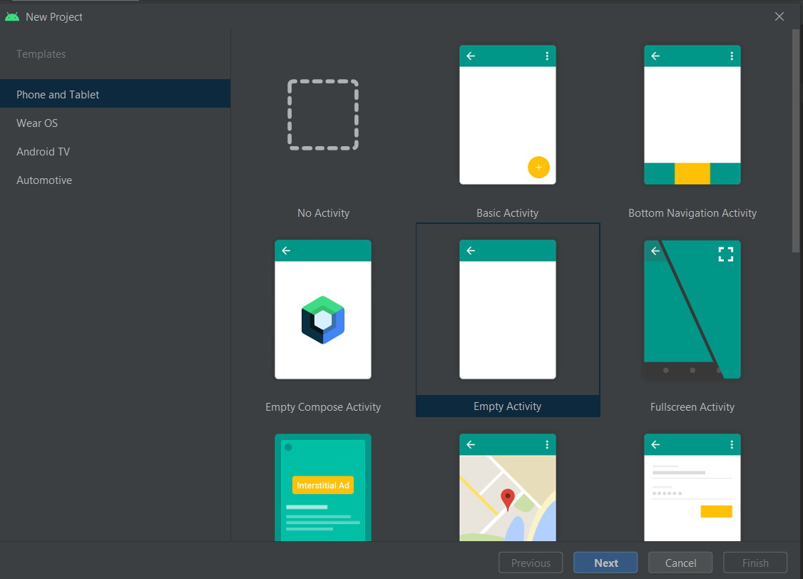

Gambar 2.1 : Halaman *New Item Project Android Studio*

1. Selanjutnya membuat 4 *fragment* pada folder *com.example.*tugas2*_fregment*

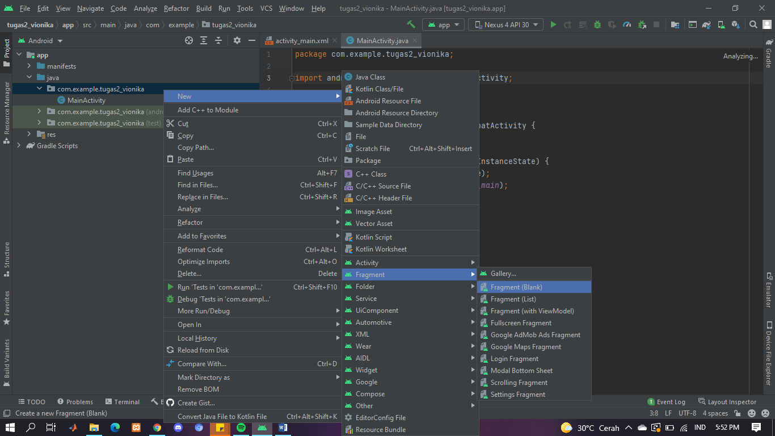

Gambar 2.2 : Tampilan Membuat *New Fragment*

1. Hasil file dari pembuatan *fragment*

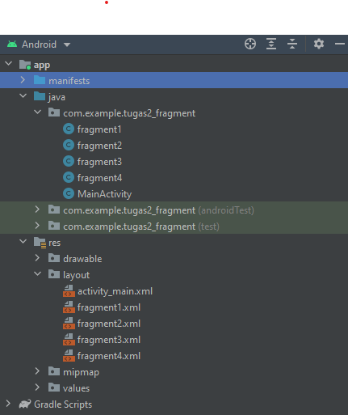

Gambar 2.2 : Tampilan File Fragment

1. Memberikan komponen pada masing – masing *fragment.xml*

|  |  |  |
| --- | --- | --- |
| No. | Nama Komponen | Keterangan |
| 1 | textView2 | Ini Adalah Fragment 1 |

1. Pada *Fragment* 1

Tabel 2.1 : Komponen *fragment1.xml*

1. Pada *Fragment* 2

Tabel 2.2 : Komponen *fragment2.xml*

|  |  |  |
| --- | --- | --- |
| No. | Nama Komponen | Keterangan |
| 1 | textView2 | Ini Adalah Fragment 2 |

1. Pada *Fragment* 3

Tabel 2.3 : Komponen *fragment3.xml*

|  |  |  |
| --- | --- | --- |
| No. | Nama Komponen | Keterangan |
| 1 | textView2 | Ini Adalah Fragment 3 |

1. Pada *Fragment* 4

Tabel 2.4 : Komponen *fragment4.xml*

|  |  |  |
| --- | --- | --- |
| No. | Nama Komponen | Keterangan |
| 1 | textView2 | Ini Adalah Fragment 4 |

1. Hasil dari penambahan komponen pada setiap *fragment*

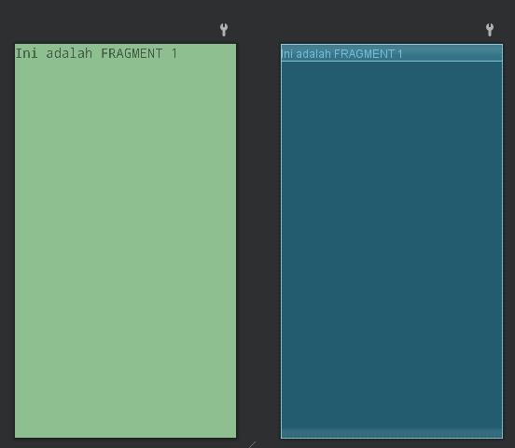

Gambar 2.5 : Tampilan *Fragment1*

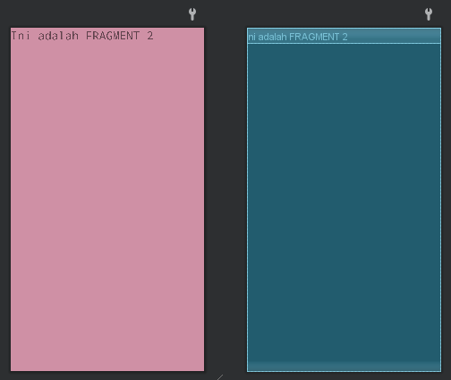

Gambar 2.6 : Tampilan *Fragment2*

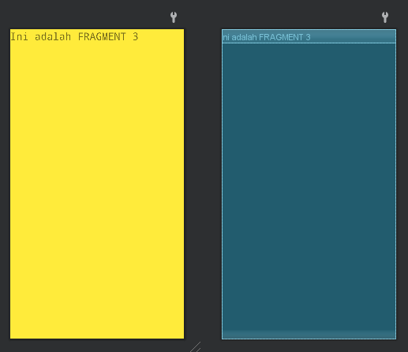

Gambar 2.7 : Tampilan *Fragment3*

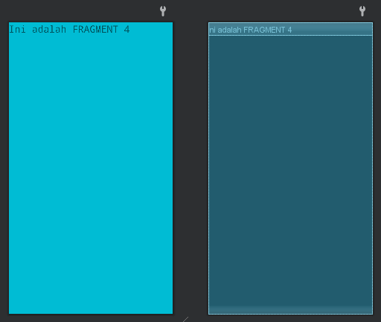

Gambar 2.8 : Tampilan *Fragment4*

1. *Source code* pada bagian *Activity_main.xml*

|  |
| --- |
| <?xmlversion="1.0"encoding="utf-8"?> <LinearLayout xmlns:android="http://schemas.android.com/apk/res/android"  xmlns:app="http://schemas.android.com/apk/res-auto"  xmlns:tools="http://schemas.android.com/tools"  android:layout_width="match_parent"  android:layout_height="match_parent"  android:orientation="vertical"  tools:context=".MainActivity">  <LinearLayout  android:layout_width="match_parent"  android:layout_height="0dp"  android:layout_weight="1"  android:orientation="horizontal">  <fragment  android:id="@+id/fragment1" android:name="com.example.tugas2_fregment.fragment1"  android:layout_width="170dp"  android:layout_height="match_parent"  android:layout_weight="1" />  <fragment  android:id="@+id/fragment2" android:name="com.example.tugas2_fregment.fragment2"  android:layout_width="405dp"  android:layout_height="match_parent"  android:layout_weight="1" />  </LinearLayout>  <LinearLayout  android:layout_width="match_parent"  android:layout_height="0dp"  android:layout_weight="1"  android:orientation="horizontal">  <fragment  android:id="@+id/fragment3" android:name="com.example.tugas2_fregment.fragment3"  android:layout_width="463dp"  android:layout_height="match_parent"  android:layout_weight="1" />  <fragment  android:id="@+id/fragment4" android:name="com.example.tugas2_fregment.fragment4"  android:layout_width="405dp"  android:layout_height="match_parent"  android:layout_weight="1" />  </LinearLayout> </LinearLayout> |

*Source code* diatas berfungsi untuk menampung dan mendefinisikan semua *fragment* pada setiap class java,yang digunakan oleh aplikasi.

1. *Source code* pada *fragment* 1

|  |
| --- |
| package com.example.tugas2_fregment;  import android.os.Bundle;  import androidx.fragment.app.Fragment;  import android.view.LayoutInflater;  import android.view.View;  import android.view.ViewGroup;  / * A simple {@link Fragment} subclass.  * Use the {@link fragment1#newInstance} factory method to  * create an instance of this fragment.  */public class fragment1 extends Fragment {  // TODO: Rename parameter arguments, choose names that match  // the fragment initialization parameters, e.g. ARG_ITEM_NUMBER  private static final String ARG_PARAM1 = "param1";  private static final String ARG_PARAM2 = "param2";  // TODO: Rename and change types of parameters  private String mParam1;  private String mParam2;  public fragment1() {  // Required empty public constructor  }  /**  * Use this factory method to create a new instance of  * this fragment using the provided parameters.  *  * @param param1 Parameter 1.  * @param param2 Parameter 2.  * @return A new instance of fragment fragment1.  */  // TODO: Rename and change types and number of parameters  public static fragment1 newInstance(String param1, String param2) {  fragment1 fragment = new fragment1();  Bundle args = new Bundle();  args.putString(ARG_PARAM1, param1);  args.putString(ARG_PARAM2, param2);  fragment.setArguments(args);  return fragment;  }  @Override  public void onCreate(Bundle savedInstanceState) {  super.onCreate(savedInstanceState);  if (getArguments() != null) {  mParam1 = getArguments().getString(ARG_PARAM1);  mParam2 = getArguments().getString(ARG_PARAM2);  }}  @Override  public View onCreateView(LayoutInflater inflater, ViewGroup container,  Bundle savedInstanceState) {  // Inflate the layout for this fragment  return inflater.inflate(R.layout.fragment1, container, false); } |

*Source code* diatas digunakan untuk menginisialisi *fragment* 1 yang nantinya dipanggil pada class *Activity_main.xml ,* untuk ditampilakan hasil *fragment* yang sudah dijadikan satu.

1. *Source code* pada *fragment* 2

|  |
| --- |
| package com.example.tugas2_fregment;  import android.os.Bundle;  import androidx.fragment.app.Fragment;  import android.view.LayoutInflater;  import android.view.View;  import android.view.ViewGroup;  / * A simple {@link Fragment} subclass.  * Use the {@link fragment2#newInstance} factory method to  * create an instance of this fragment.  public class fragment2 extends Fragment {  // TODO: Rename parameter arguments, choose names that match  // the fragment initialization parameters, e.g. ARG_ITEM_NUMBER  private static final String ARG_PARAM1 = "param1";  private static final String ARG_PARAM2 = "param2";  // TODO: Rename and change types of parameters  private String mParam1;  private String mParam2;  public fragment2() {  // Required empty public constructor  }  /**  * Use this factory method to create a new instance of  * this fragment using the provided parameters.  *  * @param param1 Parameter 1.  * @param param2 Parameter 2.  * @return A new instance of fragment fragment2.  */  // TODO: Rename and change types and number of parameters  public static fragment2 newInstance(String param1, String param2) {  fragment2 fragment = new fragment2();  Bundle args = new Bundle();  args.putString(ARG_PARAM1, param1);  args.putString(ARG_PARAM2, param2);  fragment.setArguments(args);  return fragment;  }  @Override  public void onCreate(Bundle savedInstanceState) {  super.onCreate(savedInstanceState);  if (getArguments() != null) {  mParam1 = getArguments().getString(ARG_PARAM1);  mParam2 = getArguments().getString(ARG_PARAM2);  }  }  @Override  public View onCreateView(LayoutInflater inflater, ViewGroup container,  Bundle savedInstanceState) {  // Inflate the layout for this fragment  return inflater.inflate(R.layout.fragment2, container, false);} |

*Source code* diatas digunakan untuk menginisialisi *fragment* 2 yang nantinya dipanggil pada class *Activity_main.xml ,* untuk ditampilakan hasil *fragment* yang sudah dijadikan satu.

1. *Source code* pada *fragment* 3

|  |
| --- |
| package com.example.tugas2_fregment;  import android.os.Bundle;  import androidx.fragment.app.Fragment;  import android.view.LayoutInflater;  import android.view.View;  import android.view.ViewGroup;  /**  * A simple {@link Fragment} subclass.  * Use the {@link fragment3#newInstance} factory method to  * create an instance of this fragment.  */  public class fragment3 extends Fragment {  // TODO: Rename parameter arguments, choose names that match  // the fragment initialization parameters, e.g. ARG_ITEM_NUMBER  private static final String ARG_PARAM1 = "param1";  private static final String ARG_PARAM2 = "param2";  // TODO: Rename and change types of parameters  private String mParam1;  private String mParam2;  public fragment3() {  // Required empty public constructor  }  /**  * Use this factory method to create a new instance of  * this fragment using the provided parameters.  *  * @param param1 Parameter 1.  * @param param2 Parameter 2.  * @return A new instance of fragment fragment3.  */  // TODO: Rename and change types and number of parameters  public static fragment3 newInstance(String param1, String param2) {  fragment3 fragment = new fragment3();  Bundle args = new Bundle();  args.putString(ARG_PARAM1, param1);  args.putString(ARG_PARAM2, param2);  fragment.setArguments(args);  return fragment;  }  @Override  public void onCreate(Bundle savedInstanceState) {  super.onCreate(savedInstanceState);  if (getArguments() != null) {  mParam1 = getArguments().getString(ARG_PARAM1);  mParam2 = getArguments().getString(ARG_PARAM2);  } }  @Override  public View onCreateView(LayoutInflater inflater, ViewGroup container,  Bundle savedInstanceState) {  // Inflate the layout for this fragment  return inflater.inflate(R.layout.fragment3, container, false);  }} |

*Source code* diatas digunakan untuk menginisialisi *fragment* 3 yang nantinya dipanggil pada class *Activity_main.xml ,* untuk ditampilakan hasil *fragment* yang sudah dijadikan satu.

1. *Source code* pada *fragment* 4

|  |
| --- |
| *package com.example.tugas2_fregment;*  *import android.os.Bundle;*  *import androidx.fragment.app.Fragment;*  *import android.view.LayoutInflater;*  *import android.view.View;*  *import android.view.ViewGroup;*  */\*\**  *\* A simple {@link Fragment} subclass.*  *\* Use the {@link fragment4#newInstance} factory method to*  *\* create an instance of this fragment.*  *\*/*  *public class fragment4 extends Fragment {*  *// TODO: Rename parameter arguments, choose names that match*  *// the fragment initialization parameters, e.g. ARG_ITEM_NUMBER*  *private static final String ARG_PARAM1 = "param1";*  *private static final String ARG_PARAM2 = "param2";*  *// TODO: Rename and change types of parameters*  *private String mParam1;*  *private String mParam2;*  *public fragment4() {*  *// Required empty public constructor*  *}*  */\*\**  *\* Use this factory method to create a new instance of*  *\* this fragment using the provided parameters.*  *\**  *\* @param param1 Parameter 1.*  *\* @param param2 Parameter 2.*  *\* @return A new instance of fragment fragment4.*  *\*/*  *// TODO: Rename and change types and number of parameters*  *public static fragment4 newInstance(String param1, String param2) {*  *fragment4 fragment = new fragment4();*  *Bundle args = new Bundle();*  *args.putString(ARG_PARAM1, param1);*  *args.putString(ARG_PARAM2, param2);*  *fragment.setArguments(args);*  *return fragment;*  *}*  *@Override*  *public void onCreate(Bundle savedInstanceState) {*  *super.onCreate(savedInstanceState);*  *if (getArguments() != null) {*  *mParam1 = getArguments().getString(ARG_PARAM1);*  *mParam2 = getArguments().getString(ARG_PARAM2);*  *}}*  *@Override*  *public View onCreateView(LayoutInflater inflater, ViewGroup container,*  *Bundle savedInstanceState) {*  *// Inflate the layout for this fragment*  *return inflater.inflate(R.layout.fragment4, container, false);*  *}}* |

*Source code* diatas digunakan untuk menginisialisi *fragment* 4 yang nantinya dipanggil pada class *Activity_main.xml ,* untuk ditampilakan hasil *fragment* yang sudah dijadikan satu.

1. Tampilan Hasil *Running*

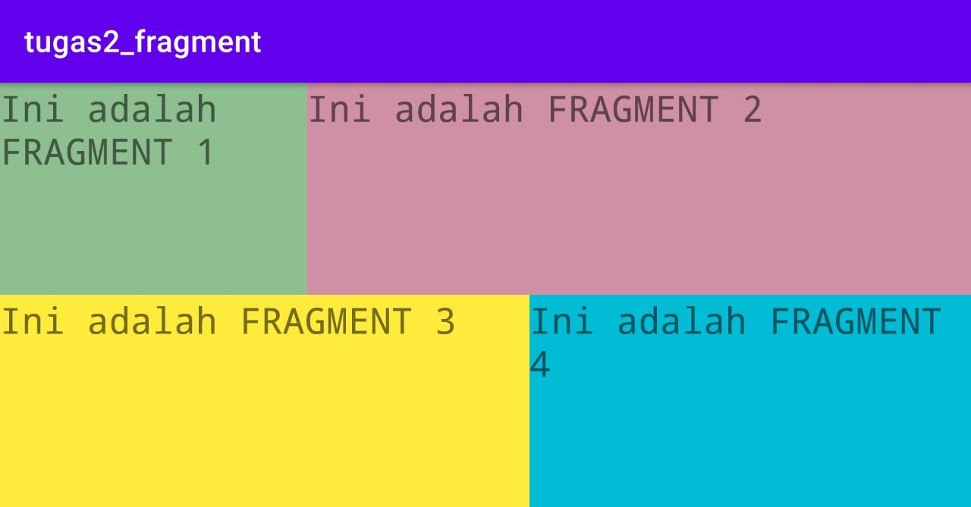

Gambar 2.9 : Tampilan Hasil *Running* Program

1. **Link repository github**

https://github.com/mesachhabel/tugas2-1918045-Mesach