CPE301 – fall 2019

Design Assignment 1A

Student Name: Henry Mesa

Student #: 1008099273

Student Email: mesah1@unlv.nevada.edu

Primary Github address: https://github.com/mesah1

Directory: https://github.com/mesah1/submissions

Submit the following for all Labs:

1. **COMPONENTS LIST AND CONNECTION BLOCK DIAGRAM w/ PINS**

List of Components used

Block diagram with pins used in the Atmega328P

1. **INITIAL/MODIFIED/DEVELOPED CODE OF TASK 1/A**

;

; DA1A.asm

;

; Created: 9/19/2019 9:20:55 PM

; Author : Henry M

;

.include<m328pbdef.inc>

.ORG 0

;INITIALIZING REGISTERS

LDI R25,0b00110101

LDI R24,0b10001110

LDI R23,0b00000010

LDI R22,0b01001010

LDI R20,0x00

LDI R19,0x00

LDI R18,0x00

LDI R17,0x00

;INSTRUCTIONS

L1:

ADD R17,R24

BRCS FLAG1

DEC R22

BRNE L1

JMP DEC2

L2:

ADD R18,R25

BRCS FLAG2

COM R23

DEC R23

JMP L2

DEC2:

COM R23

DEC R23

ADD R17,R24

BRCS FLAG1B

BRCC L1

DEC2B:

DEC R23

ADD R18,R25

BRCS FLAG1B

BRCC L2

FLAG1:

INC R18

ADD R18,R25

BRCS FLAG2

DEC R22

BRNE L2

JMP DEC2B

FLAG1B:

INC R18

ADD R18,R25

BRCS FLAG2

DEC R22

BRNE L2

JMP DEC2

FLAG2:

INC R19

ADD R19,R25

BRCS FLAG3

FLAG3:

INC R20

ADD R20,R25

COM R23

DEC R23

BREQ FLAG3

LDI R20,0x00

END: JMP END

1. **DEVELOPED MODIFIED CODE OF TASK 2/A from TASK 1/A**

Insert only the modified sections here

1. **SCHEMATICS**

Use fritzing.org

1. **SCREENSHOTS OF EACH TASK OUTPUT (ATMEL STUDIO OUTPUT)**



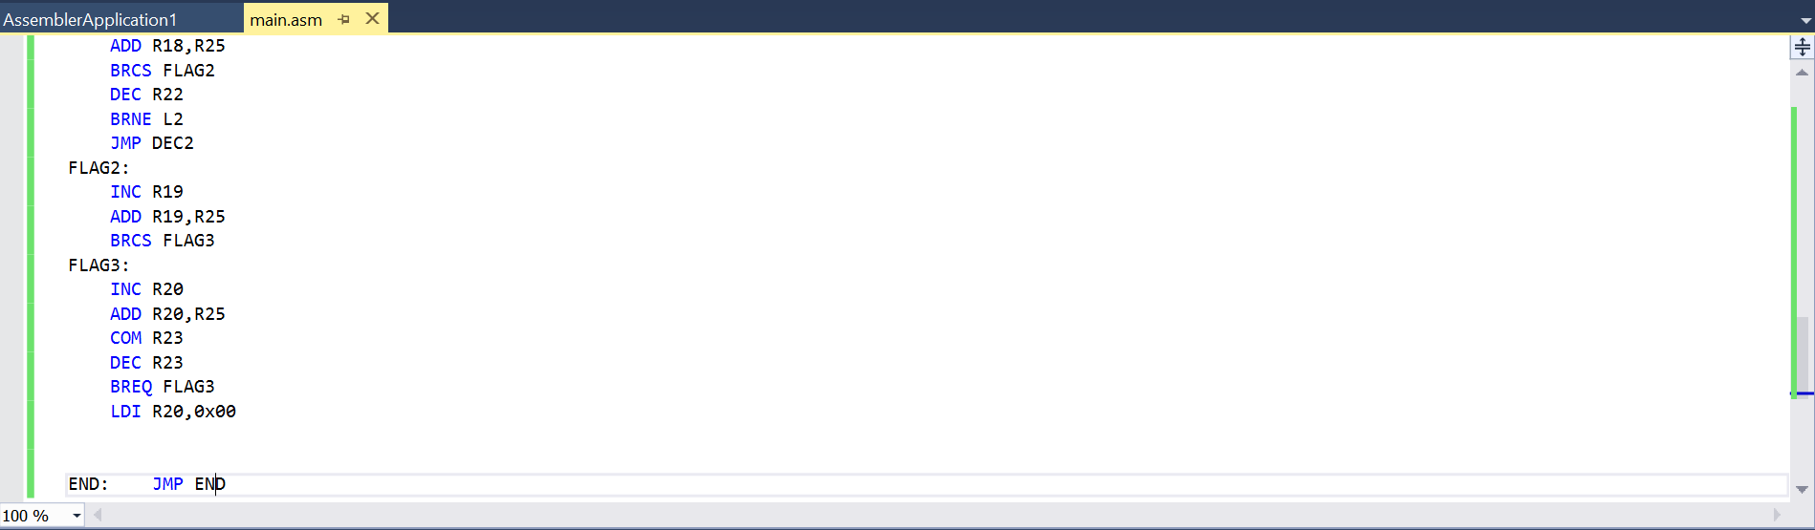

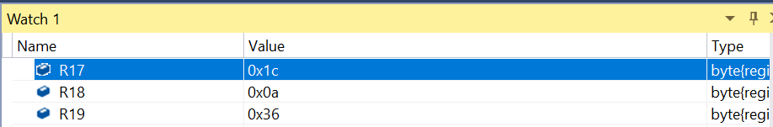

1. **SCREENSHOT OF EACH DEMO (BOARD SETUP)**
2. **VIDEO LINKS OF EACH DEMO**
3. **GITHUB LINK OF THIS DA**

**Student Academic Misconduct Policy**

<http://studentconduct.unlv.edu/misconduct/policy.html>

“This assignment submission is my own, original work”.

HENRY MESA