CPE301 – fall 2019

Design Assignment 1B

Student Name: Henry Mesa

Student #: 1008099273

Student Email: mesah1@unlv.nevada.edu

Primary Github address: https://github.com/mesah1

Directory: https://github.com/mesah1/submissions/DA1B

Submit the following for all Labs:

1. **COMPONENTS LIST AND CONNECTION BLOCK DIAGRAM w/ PINS**

List of Components used

Block diagram with pins used in the Atmega328P

1. **INITIAL/MODIFIED/DEVELOPED CODE OF TASK 1/A**
2. ;
3. ; DA1B.asm
4. ;
5. ; Created: 9/21/2019 5:48:38 PM
6. ; Author : Henry M
7. ;
8. .include<m328pbdef.inc>
9. .EQU STARTADDS = 0x0200
10. .ORG 0x0200
11. ;MATCHING VALUES FROM ADDRESS TO REGISTERS
12. LDI XL, LOW(STARTADDS)
13. LDI XH, HIGH(STARTADDS)
14. LDI YL, LOW(0x0300)
15. LDI YH, HIGH(0x0300)
16. LDI ZL, LOW(0x0500)
17. LDI ZH, HIGH(0x0500)
18. ;INITIALIZING COUNTER TO R16
19. LDI R20, 250
20. ;STARTING VALUES FROM 10 TO 260 CONSECUTIVELY
21. LDI R21, 10
22. ;STARTING TO LOAD VALUES INTO X-REGISTER
23. CALC:
24. ST X+, R21
25. MOV R22, R21
26. RJMP CHECK_DIV
27. ;LOOP CHECKING IF NUMBER IS DIVISIBLE BY 5
28. CHECK_DIV:
29. SUBI R22, 5
30. BRLO NO_DIVIS ;IF RESULT IS LESS THAN 0 GO TO NOT DIVISIBLE
31. BREQ DIVIS ;IF RESULT IS 0 THEN GO TO DIVISIBLE
32. RJMP CHECK_DIV
33. ;IF DIVISIBLE BY 5 STORE IN Y STARTING AT THE LOWEST BIT
34. DIVIS:
35. ST Y+, R21
36. ADD R16, R21 ;ADD NUMBER TO R16
37. ADC R17, R23 ;ADD CARRY IF ANY TO R17
38. JMP LOOP
39. ;IF NOT DIVISIBLE BY 5 STORE IN Z STARTING AT THE LOWEST BIT
40. NO_DIVIS:
41. ST Z+, R21
42. ADD R18, R21 ;ADD NUMBER TO R18
43. ADC R19, R23 ; ADD CARRY IF ANY TO R19
44. RJMP LOOP
45. ;COUNTER LOOP
46. LOOP:
47. INC R21 ; INCREMENT FROM SET VALUE
48. DEC R20 ; DECREMENT FROM 250
49. BRNE CALC ;IF R20 DOES NOT EQUAL ZERO KEEP LOOPING
50. ;ADDING FINAL RESULTS STORED
51. ADDITION:
52. ADD R16, R18
53. ADC R17, R19
54. END: JMP END ;END OF PROGRAM
55. **DEVELOPED MODIFIED CODE OF TASK 2/A from TASK 1/A**

Insert only the modified sections here

1. **SCHEMATICS**

Use fritzing.org

1. **SCREENSHOTS OF EACH TASK OUTPUT (ATMEL STUDIO OUTPUT)**

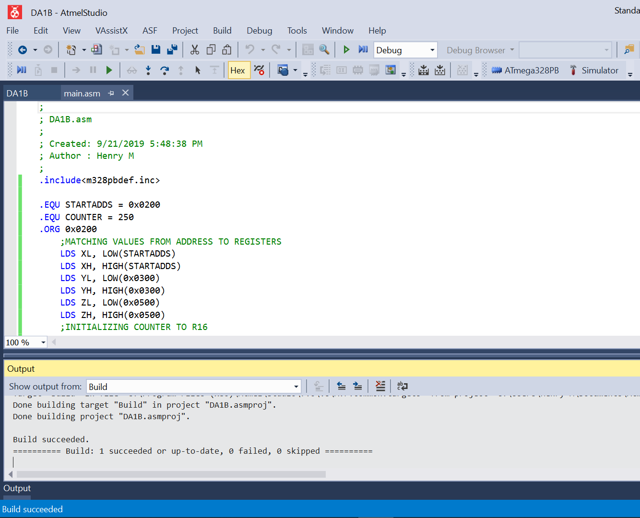

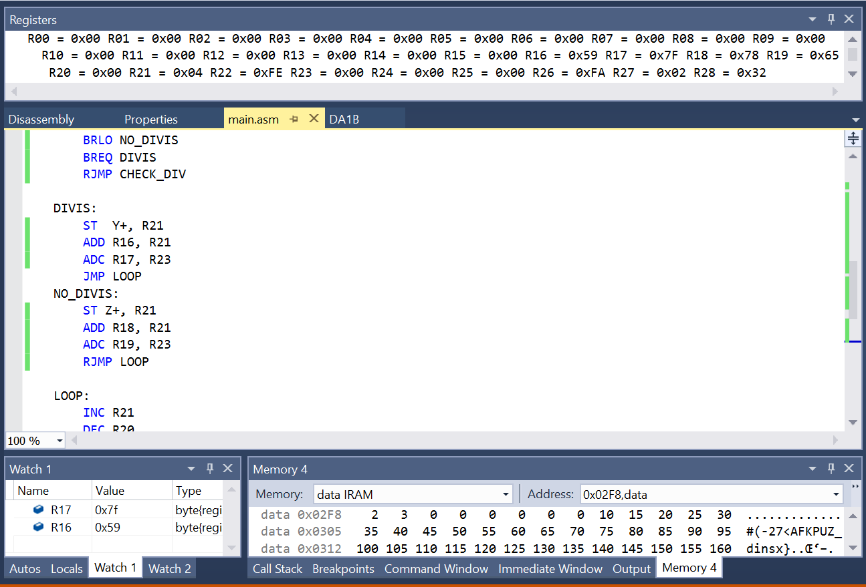

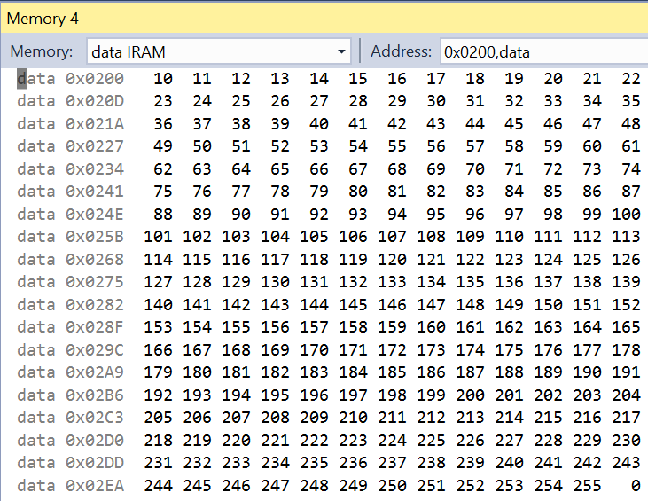

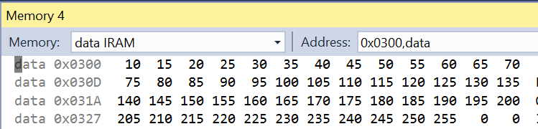

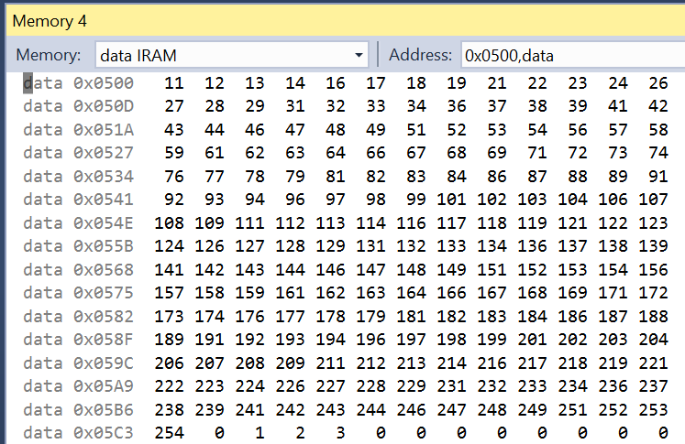

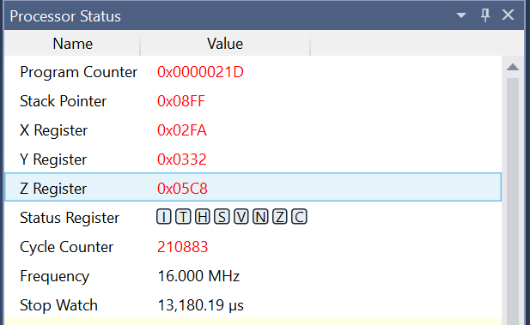

1. **SCREENSHOT OF EACH DEMO (BOARD SETUP)**
2. **VIDEO LINKS OF EACH DEMO**
3. **GITHUB LINK OF THIS DA**

**Student Academic Misconduct Policy**

<http://studentconduct.unlv.edu/misconduct/policy.html>

“This assignment submission is my own, original work”.

HENRY MESA